|  |  |
| --- | --- |
| cetlogo ***CHEMICAL ENGINEERING TRANSACTIONS***  ***VOL. 96, 2022*** | A publication of  aidiclogo_grande |
| The Italian Association  of Chemical Engineering  Online at www.cetjournal.it |
| Guest Editors: David Bogle, Flavio Manenti, Piero Salatino  Copyright © 2022, AIDIC Servizi S.r.l. **ISBN** 978-88-95608-95-2; **ISSN** 2283-9216 | |

Generation-aware electrified production: Optimal operation of a continuous zeolite crystallization plant

Robin Semraua,\*, Sebastian Engella

a TU Dortmund University, Biochemical and Chemical Engineering Process Dynamics and Operation Group, Emil-Figge-Straße 70, 44227 Dortmund, Germany

\*Robin.Semrau@tu-dortmund.de

The electrification of the production processes poses a main challenge for the modern process industry. The high volatility of the energy price provides a strong economic incentive for adapting to the electricity price level, which reflects the availability of power from renewable sources. In this work, the dynamic generation-aware operation of a zeolite production plant with a tubular COBR reactor is considered. The process and a rigorous model are introduced and a moving horizon approach for the dynamic optimization problem is presented. The performance of the proposed dynamic operation methodology is demonstrated with historic data of the electric energy price from the day ahead market. The results show a reduction of the electric energy cost by 17% and furthermore a reduction of the CO2 emission associated with the resulting mix of sources of electric power. The necessary investments to enable the flexible operation are taken into account and the payback period is estimated. Generation-aware production is profitable and promises even increasing benefits in the future.

* 1. Introduction

In order to meet the commitments of the 2015 Paris Climate Agreement, the European Union has set a target of the coverage of 32% of its total energy demand from renewable sources in 2030 in the Directive (EU) 2018/2001 (2018). The chemical industry has a share of 10.08% in the total energy consumption as reported by IEA (2017), therefore here as well a change of the primary energy source from fossil to renewables is necessary. The electrification of the process industry, along with hydrogen technology and bio fossils is expected to be the largest contributor to this change. However, the increased share of renewable sources in the mix of power in the electric grid (Germany: 65% by 2030) (EEG 2021) is expected to further amplify the variations of the electric energy price e.g. due to the influences of weather as demonstrated by Staffell and Pfenninger (2018).

The ability to adapt to the resulting strongly varying energy prices can lead to major economic benefits. Production plants as large consumers of electric power can participate in different markets for electric energy. The timeframes of these markets range from the next day in the day-ahead spot market, to down to 30 s in the frequency containment reserves. The participation in each of these markets is possible in principle, however adaptation to very fast changes is usually infeasible. In this work, the day-ahead spot market will be exploited since the fluctuations induced by daytime and weather happen within this timeframe and an adaptation of the production level within minutes to hours is possible. Many authors have presented strategies to deal with changing electric energy prices based on the day-ahead (electric) energy price referred to as demand site management e.g. by Leo et al. (2021) or Bree et al. (2018). In these works, scheduling models are used and the plant dynamics is neglected. However, for continuous processes with slow dynamics, it is necessary to consider the dynamics of the processes and non-linear dynamic models are needed to compute an optimal dynamic operation of the processes as demonstrated for an air separation plant Caspari et al. (2019).

In this work, the production of NaX zeolites in a COBR is used as a case study to show that dynamic demand side management methods are not only useful for highly energy intensive processes, but can be applied also to the production of chemical products.

* 1. Process

This work considers the flexible electrified production of zeolite NaX in a (COBR) tubular reactor concept, with a capacity of 1800 t/a. A schematic of the process is shown in Figure 1.



*Figure 1: Schematic representation of the zeolite production plant*

The reactor design is adapted from Ramirez et. al (2020) and Grimaldi et. al. (2021). The reactants, containing aluminate and silicate, are dissolved in an aqueous sodium hydroxide solution in the two feeding tanks. The streams are mixed, forming an amorphous solid suspension. Seed crystals are added to the feeding stream to ensure a correct crystal structure. The COBR outlet stream is used to preheat the amorphous solid suspension. The reactor is equipped with electrical heaters along the reactor length. The energy of these heaters can be set in three different zones, indicated in the Figure 1 as heater 1, heater 2 and heater 3. The three heaters use an electric energy of 51 kW to heat up the reaction mixture to an elevated temperature of approximately 120 °C. Within the reactor, the amorphous solid is dissolved and crystallizes into the NaX zeolite. The suspension leaving the reactor has a crystallinity of the solid of above 98%. The stream is cooled down within the heat exchanger, and the zeolites filtered in a belt filter. The sodium hydroxid solution is recycled. The process is designed for a flowrate of 0.48 kg/s of the suspension. However, the operational capacity is assumed in this work to be possible within a range of 0.32-0.6 kg/s (65% to 125% nominal capacity). The temperature of the reactor and the reaction medium is limited to 130 °C due to the metastability of the NaX phase.

* + 1. Model

The plant can be described by the following first principles model. The behavior of the tanks and the filter, as well as the dynamics of the heat exchanger can be neglected. The tubular reactor is described using the axial dispersion model with a mixed inlet boundary condition and a zero gradient outlet boundary condition. The zeolite crystallization can be described by the dynamic model as shown in (1). The zeolite crystallization consists of three main steps, the dissolution ($D$) of the amorphous solid ( $c_{gel})$ in the liquid phase ($c_{s})$, the heterogeneous nucleation ($B$) on the surface of the amorphous gel ($S$) as reported by Nikolakis et.al (1998) and the size independent linear growth ($G$) of the zeolite particles. The resulting population balance is solved using the method of moments resulting in the equations (1e) describing the volumetric reaction rates of the zeolite particle size distribution moments ( $μ_{k})$.

|  |  |
| --- | --- |
| $$D= {-k}_{D}\left(T\right){(c}_{gel}^{*}-c_{s})c_{gel}$$ | (1a) |
| $$r_{S}={-k}_{D}{\left(T\right)(c}_{gel}^{*}-c_{s}) \left({k_{S}c}_{gel}-S\right)$$ | (1b) |
| $$B = k_{n}\left(T\right) S ( c_{zeo}^{*}-c_{s})$$ | (1c) |
| $$G = k_{G}{\left(T\right) (c}_{zeo}^{*}-c_{s})$$ | (1d) |
| $$r_{μ_{k}}=kGμ_{k-1}+Bδ_{k,0} ∀k∈[0,3]$$ | (1e) |

The temperature of the reactor wall ($T_{w}$) and of the liquid reaction ($T$) medium are described by equation (2). Including the heat provided by the heaters, the heat loss to the environment and the heat transfer from the reactor wall to the suspension.

|  |  |
| --- | --- |
| $${ρ_{w}c_{p,w}∂}_{t}T_{w}={\dot{Q}}_{H_{j}}-{\dot{Q}}_{E}-{\dot{Q}}_{w}$$ | (2a) |
| $${ρc_{p}∂}_{t}T+ρc_{p}u∂_{z}T-ρc_{p}∂_{z}[λ∂_{z}T]={\dot{Q}}_{w}$$ | (2b) |

For the solution of the partial differential equation the method of lines is used, which transforms the partial differential equation system into a set of ordinary differential equations. For the approximation of the spatial derivatives, central differences are used and 40 discretization points were chosen.

* 1. Method

The optimal dynamic operation of the zeolite plant poses the optimization problem below.

|  |  |
| --- | --- |
|  | (3a) |
| $$s.t.:0=f\left(\dot{x},x,u\right)$$ | (3b) |
| $$0≥g\left(x,u\right)$$ | (3c) |
| $$0.98≤X(t)$$ | (3d) |
| $$F_{fix}=\frac{1}{t_{k+1}-t_{k}} \int_{t_{k}}^{t_{k+1} }{F\left(t\right) dt} ∀ k∈[0,1]$$ | (3e) |
| $$\int_{0}^{L}{T\left(0,z\right) dz}=\int_{0}^{L}{T\left(t_{f},z\right)dz}$$ | (3f) |
| $$\int_{0}^{L}{μ_{3}\left(0,z\right) dz}=\int_{0}^{L}{μ_{3}\left(t_{f},z\right)dz}$$ | (3g) |

The objective function consists of the normalized integrated cost of the electric energy and the revenue for the produced product. The cost of the electric energy is the product of the normalized energy price ($γ\left(t\right)$) and the energy consumption. The additional penalty term suppresses undesired oscillations of the flowrate and the heating powers. The process model and the operational limits are represented by the constraints (3b), (3c), and (3d). The constraint (3e) ensures a certain production level over a given averaging horizon. To avoid terminal sell-off effects, the total amount of crystalline particles ($μ_{3}$) and the temperature ($T)$, as a measure of the thermal energy stored in the process are enforced to be equal at the beginning and at the end of the horizon, this discussed im more detail in Semrau et. al.(2021). Nevertheless, terminal effects affect the solution close to the end of the optimization horizon. Therefore, the optimization problem is solved over two averaging horizons $\left[0, t_{1}\right]$ and $[t_{1}, t_{2}]$. The solution for the second horizon is discarded and the optimization is re-solved with a shifted time horizon. The method assumes knowledge of the day-ahead market price for the electric energy. In this work, a perfect knowledge is assumed, however, in reality this has to be predicted.The non-linear dynamic optimization problem is discretized in time using orthogonal collocation on finite elements using a second order Radau polynomials. The problem is implemented in the CasADi framework (Andersson et. al. 2019) and the optimization is performed using the IPOPT solver with the MA86 as a linear sparse solver.

* 1. Optimal dynamic operation of the zeolite production plant

The dynamic optimization is executed with historic data from the APEX Germany day-ahead spot market for the time from the 29.05.2020 to 01.06.2020, provided by Agora Energiewende (2022).Two integrating horizons were chosen. The first horizon has a length of $t_{1}$ =24 h, the second horizon of $t_{2}$ =12 h. A time step of 0.5 h is used, which results in an optimization problem containing 69.708 variables, which is solved within approx. 3 h.

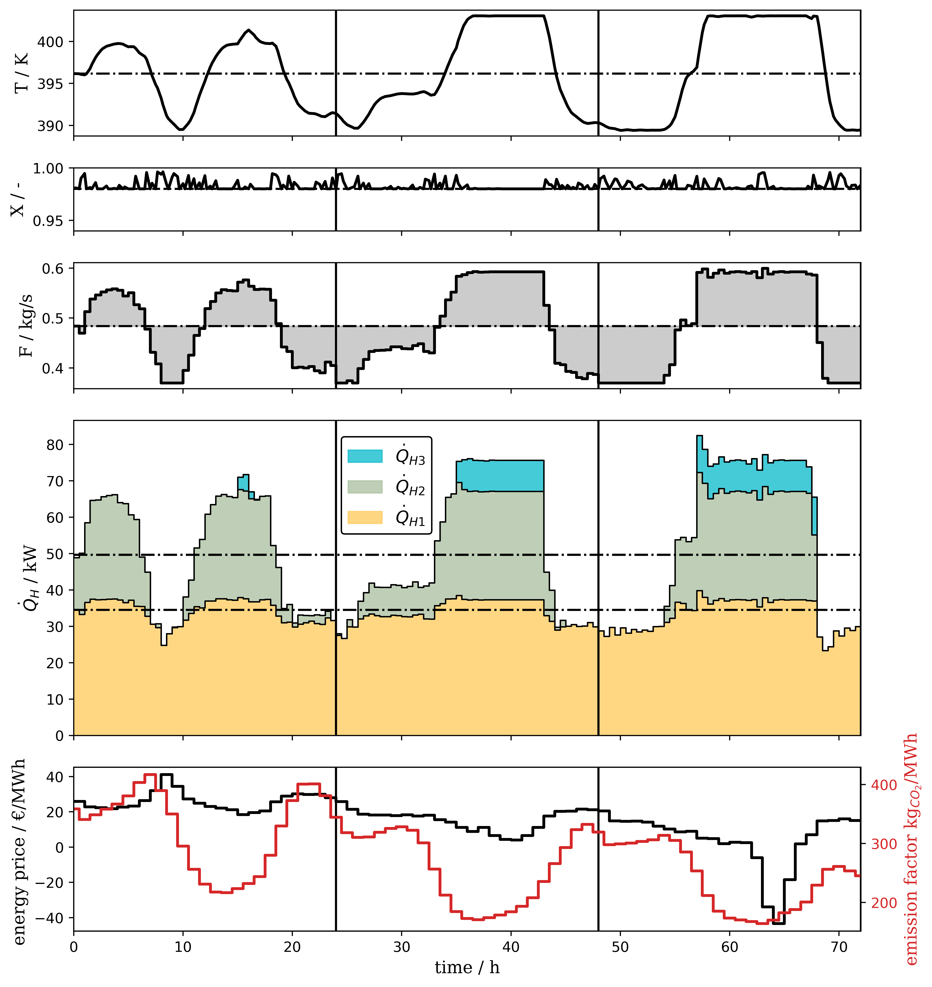

*Figure 2: Optimized dynamic schedule with energy data from 29.05.2020 to 01.06.2020*

The results of the dynamic optimization are shown in the Figure 2, in which, starting form below, the day-ahead price of electric energy (black) and the emission factor of the electric energy (red), the consumption of electric energy by the three heaters, the throughput of the zeolite suspension, the final crystallinity and the reaction temperature at the reactor outlet are shown over time. The optimal steady state operation for the required mean throughput is shown as a black dotted line. The results show a large deviation from the steady state operation, shifting the production to timeframes of lower energy prices. Using the optimized fully dynamic operation, the cost for the electric energy can be reduced by 17.04% compared to the optimal steady state operation. Additionally, the CO2 emissions caused by the used electric energy is reduced by 3.2%.

The CO2 emission of the used electric energy can further be decreased by an inclusion of the emission factor in the energy price of the optimization (3a). This leads to a trade-off between economic cost and ecological impact of the electric power. The optimization was executed for multiple weighting factors. The results are displayed in Figure 3. The CO2 emission of the used electric energy is plotted against the cost for the dynamic schedule in comparison to the steady state optimization. The results show a Pareto front, in which a lower emission leads to a higher cost. However, in general the dynamic optimal operation improves both the relative energy cost and the emission in comparison to the steady state operation. The cost of the electric energy and the associated emissions vary in a small interval which is caused by the high correlation between the emission factor and the price of the electric energy.

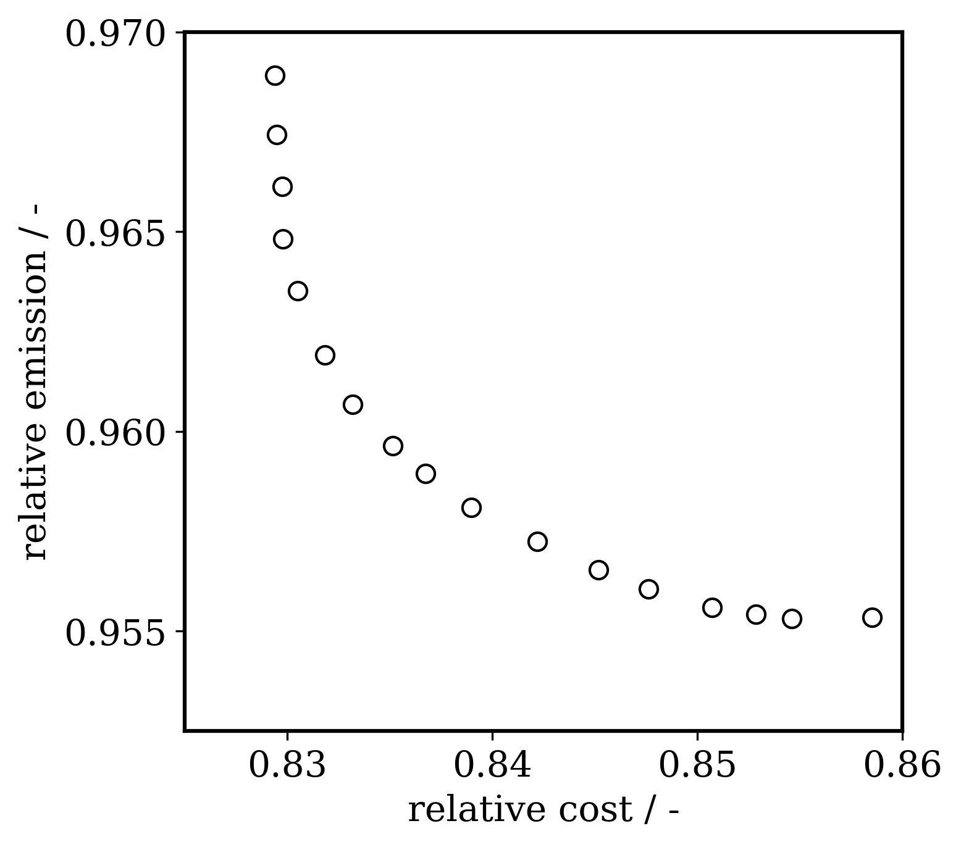

*Figure 3: Emissions of the used electric energy over cost of electric energy for the dynamic operation in relation to the optimal steady state operation*

* 1. Economic evaluation

The benefits in reduction of the energy cost were shown in the previous section. However, attention has to be paid to the fact that the operation range of the plant needs to be extended, to be able to vary the throughput while still achieving the same average amount of product. Therefore, critical components of the plant have to be enlarged. In the given process, these components are the aluminate and silicate feeding tanks, the feeding pumps, the high shear continuous mixer, the filtration unit and the heating elements of the reactor. The other components, e.g. the heat exchanger and the reactor are not operated at their limits which are included in the formulation of the optimization problem. The total cost ( ${∑E}_{k})$ of the additional equipment was estimated to be 109.8 k€, based on data provided by industrial suppliers. The fixed capital cost $(I_{ges}$) includes additional expenses for piping, equipment erection, structures and insulation for the components. The factorial approach according to Towler and Sinnott (2013) is used, which results in an investment cost of 243 k€. The factor $v=2.21$ is based on stainless steel and does not include changes in the electrical equipment for the enlarged parts. The difference of the investment cost from the enlarged to the nominal plant is calculated by equation (5) assuming a power law dependency of the throughput with a factor of 0.6. This results in additional expenses ($ΔI$) of 33.46 k€ for the larger equipment. The energy cost savings can be calculated using the total electric energy cost of 80.7 k€/a, with a saving potential of 17 % which results in a reduction of the costs for the electric energy $(ΔR$) by 13.7 k€/a.

|  |  |
| --- | --- |
| $$I_{ges}=v ∑E_{k}$$ | (4) |
| $$ΔI=I_{ges} \left({\frac{F_{max} }{F_{fix}}}^{0.6}-1\right)$$ | (5) |
| $$t_{payout}= \frac{ΔI [€]}{ΔR[€/a]}$$ | (6) |

For the calculation of the economic benefit, the payout method is used, which calculates the time after which the expenses are compensated. The resulting payout time calculated by equation (6) results as 2.43 years, which is slightly longer than the usually targeted time of 2 years. However, with increasing value and variation of the price for the electric energy and additional expenses e.g. by carbon taxes the benefit is supposed to grow further in the future. Furthermore, chemical plants typically have a residual capacity, which can be used for the flexible operation without additional expenses. Additionally, the methodology can be applied to more energy intensive zeolite synthesis e.g. for zeolite A. To prove the ecological advantages, the additional emissions by manufacture as well as the infrastructure have to be included in a life cycle analysis, which remains an open issue.

* 1. Conclusions

This work presents a moving horizon dynamic optimization approach to compute a flexible dynamic operation of a zeolite production plant based on the day-ahead price of the electric energy. The plant and the dynamic model are introduced and the potential and the restrictions for the flexible operation evaluated. The dynamic optimization method is presented, and the optimization problem is solved for several days of operation, in which the flexible operation of the plant enables the usage of energy at a lower price and with a lower emission factor, which results in substantial economic and ecological benefits over the steady state operation. Additionally, the trade-off between economic and ecological optimization is evaluated, resulting in only minor differences between an economic and an ecological penalization. Furthermore, the economics are evaluated taking into account additional expenses for the equipment, resulting in a payout of 2.4 years, which is expected to decrease in the future. Further work will include model mismatch and uncertainty in the dynamic optimal operation.

Nomenclature

B – nucleation rate, m-3 s-1

c – molar concentration, mol m-3

– heat capacity J kg-1 K-1

D – diffusion coefficient, m2 s-1

– equipment cost, €

f – plant model, -

F – Throughput ,kg s-1

I – Investment cost, €

k– kinetic reaction parameters, var

G – Growth rate, m-1

g – inequality constraint, -

L – reactor length, m

$\dot{Q}$– volumetric heat source/sink, W m-3

r – volumetric reaction rate, div. m-3

R – yearly savings, € a-1

S – volumetric inner surface of gel particles, m-1

T – temperature, K

t – time, s

tpayout – payout time, a

u – inputs of the model, var

X – crystallinity, -

x – states of the model, var

z – reactor length coordinate, m

$γ$– normalized energy price, -

$μ_{k}$– kth moment of the zeolite PSD, molk m-3

– density kg m-3

Acknowledgments

The project leading to this publication has received funding from the European Union’s Horizon 2020 research and innovation programme SIMPLIFY under grant agreement No 820716.

References

Agora Engergiewende, 2022. Agorameter < https://www.agora-energiewende.de/service/agorameter/> accessed 13.07.2022.

Andersson, J.A.E., Gillis, J., Horn, G., Rawlings, J.B., Diehl, M., 2019. CasADi: a software framework for nonlinear optimization and optimal control. Mathematical Programming Computation 11, 1–36.

Brée, L.C., Perrey, K., Bulan, A., Mitsos, A., 2019. Demand side management and operational mode switching in chlorine production. AIChE Journal 65,7, e16352.

Caspari, A., Offermanns, C., Schäfer, P., Mhamdi, A., Mitsos, A., 2019. A flexible air separation process: 2. Optimal operation using economic model predictive control. AIChE Journal 65,11, e16721.

Grimaldi, F., Ramirez, H., Lutz, C., Lettieri, P., 2021. Intensified production of zeolite A: Life cycle assessment of a continuous flow pilot plant and comparison with a conventional batch plant. Journal of Industrial Ecology,25,6, 1617-1630

International Energy Agency, 2017. Tracking clean energy progress 2017. Paris, France.

Leo, E., Dalle Ave, G., Harjunkoski, I., Engell, S., 2021. Stochastic short-term integrated electricity procurement and production scheduling for a large consumer. Computers & Chemical Engineering 145, 107191.

Nikolakis, V., Vlacho, D.G., Tsapatsis, M., 1998. Modeling of zeolite crystallization: the role of gel microstructure. Microporous and Mesoporous Materials 21, 337–346.

Ramirez, H., Valdez L. P., M., Van Gerven, T., Lutz, C., 2020. Continuous flow synthesis of zeolite FAU in an oscillatory baffled reactor. Journal of Advanced Manufacturing and Processing 2. e10038

Semrau, R., Yang, J., Engell, S., 2022. Process as a battery: Electricity price based optimal operation of zeolite crystallization in a COBR, Computer Aided Chemical Engineering,51,2, pp. 1165–1170.

Staffell, I., Pfenninger, S., 2018. The increasing impact of weather on electricity supply and demand. Energy 145, 65–78.

Towler, G.P., Sinnott, R.K., 2013. Chemical engineering design: principles, practice, and economics of plant and process design, 2nd ed. ed. Butterworth-Heinemann, Boston, MA.