 CHEMICAL ENGINEERING TRANSACTIONS  VOL. 96, 2022 | A publication of  
The Italian Association
of Chemical Engineering
Online at www.cetjournal.it

Guest Editors: David Bogle, Flavio Manenti, Piero Salatino
Copyright © 2022, AIDIC Servizi S.r.l.
ISBN 978-88-95608-95-2; ISSN 2283-9216

Recycling Waste from Film Packaging to 3D Printing Applications: A Prospective Study to Identify the Processing Temperature
Antonella Patti^{a,}*, Stefano Acierno^{b}, Gianluca Cicalaª, Domenico Acierno^{c}

ª Department of Civil Engineering and Architecture (DICAr), University of Catania, Viale Andrea Doria 6,95125 Catania, Italy
^{b} Department of Engineering, University of Sannio, Piazza Roma 21, 82100 Benevento, Italy.
^{c} CRdC Nuove Tecnologie per le Attività Produttive Scarl,Via Nuova Agnano 11, 80125, Naples, Italy
antonella.patti@unict.it
This study was devoted to promote eco-friendly processes and products in film packaging and 3D printer industries though sustainable and biodegradable resources, circular economy approach and recycling operation. A commercial bio-based filament, obtained by recycling of biobags, has been considered. An initial rheological characterization consisting both in dynamic (i.e., time sweep, frequency sweep) and transient (i.e., stress relaxation) mode testing, was conducted on pelletized recycled material. The complex viscosity trend over time at different testing temperatures (210°C, 190°C, 170°C) allowed to attest the polymer thermal stability as function of testing temperature. The shear modulus against time at different testing temperatures (130, 150, 170°C, and 210°C) provided information on the minimum temperature of extruded melted polymer, deposited on the printer platform, to ensure adhesion between layers. The storage and loss modulus vs oscillation frequency from 130°C to 170°C allowed to identify the temperature at which viscous behaviour of the processed material could be guaranteed during the extrusion process. Then, attempts to print the recycled polymer were carried out at 180°C, 190°C, 210°C, respectively. Finally, thermo-mechanical characteristics of 3D specimens, printed at 190 and 210°C, have been compared in terms of storage modulus and dissipation factors.
  - Introduction
Packaging is a product that is used to ship, store, and protect food, beverages, medications, cosmetics, and a variety of other everyday items. Conventional materials like petroleum-derived plastics (polyethylene terephthalate, polyvinylchloride, polyamide, polystyrene, polypropylene, polyethylene) are used in food packaging due to rigidity, flexibility, excellent barrier properties, low cost, and ease in production. Despite these benefits, plastic packaging has a significant impact on human health and environment given the non-biodegradable nature of adopted materials, air emission during the production and transportation, energy consumption, and finally disposal operation and waste accumulation in landfill.(Sid et al., 2021)
In Europe, film packaging is the common use of plastics. It accounts for approximately 40% of total plastic production and generates 61% of total plastic waste. In this perspective, European Commission proposed more circular and resource efficiency economy. (“EUR-Lex - 52020DC0098 - EN - EUR-Lex,” n.d.)
Bio-sourced packaging materials are emerging as alternative solutions to conventional polymers (Sid et al., 2021). A closed-loop structure based on principles of 6R (Reduce, Reuse, Recycle, Recover, Redesign, Remanufacture) is arising as essential part of the industrial system (Mikula et al., 2021).
However, the quality of recycled products is mainly determined by changes in material properties that occur during use, handling, and reprocessing. In this perspective, it is worthwhile to examine how the reprocessing steps affect plastic packaging recycling. (Hahladakis and Iacovidou, 2018)
Additive manufacturing (AM), also known as 3D printing, is developing as an important industrial technology allowing freedom of design, mass customisation, and the ability to manufacture complex structures, in rapid prototyping as well as in revolutionary applications (biomedical, aerospace, buildings and protective structures) (Ngo et al., 2018). Fused deposition modeling (FDM) is a common Additive Manufacturing (AM) technology that involves the extrusion of melted filaments (neat or filled polymer) through a nozzle and their deposition on a heated platform, by using a layer-by-layer technique (Patti et al., 2021b).
However, the processing parameters (especially the thermal conditions) are not yet fully discussed. A narrow temperature range for printability of nylon, and a significant influence of the printing temperature on the thermal cycling, porosity content and mechanical performance have been shown (Guessasma et al., 2021). The mechanical properties (tension, compression, and bending) of PLA and polyethylene terephthalate glycol (PETG) were increased by increasing printing temperatures (Hsueh et al., 2021). Yet, the higher the printing temperature, the greater the volatile organic compounds (VOCs) emissions during the printing process that determined an increased environmental impact of this technology (Patti et al., 2022a)
In this framework, the authors aimed to study the feasibility in recycling waste products coming from packaging application in 3D printing technology. Preliminary material characterization was carried out through rotational rheology tests to study thermal stability, flow behaviour, and potential adhesion conditions between layers. Then, the recycled filament was extruded in a 3D printer, and developed specimens were characterised using DMA analysis.
  - Materials and methods
This investigation dealt with a poly(lactide) acid (PLA)-based filament resulting from waste production of bio bags used for waste and separate collection (cod. PLA EUBIO, Eumakers. Italy). The constituting material of bio-bags is a biaxially oriented film, available in pellets form (cod. Ingeo™ Biopolymer 4043D, Naturework, USA). The recycled material possesses a glass transition around 60°C (by differential scanning calorimetry), melting temperature of 150°C, and initial decomposition temperature at 313°C (Patti et al., 2022b).
A preliminary viscoelastic characterization, consisting in time sweep, stress relaxation, and frequency sweep tests, was conducted on molten pelletized filament in linear regime. A strain-controlled rotational rheometer (mod. ARES, by TA Instruments, New Castle, DE, USA), equipped with parallel plates (25 mm in diameter), and a forced-convection oven for the temperature control, was used.
Time sweep tests were conducted at three different temperatures (210°C, 190°C, 170°C) by setting small–amplitude oscillations, at a frequency of 1 rad/s and a strain amplitude of 1%, for a duration of 1800 s.
Shear relaxation modulus (G(t)) as function of time was obtained though stress relaxation test, performed at temperatures of 130, 150, and 170°C, 210°C for a duration of 100 sec.
Frequency sweep tests were developed at four different temperatures (from 130°C to 170°C), and frequency range from 100 rad/s up to 0.1 rad/s.
Rectangular specimens (nominal size 2x5x25 mm³), suitable to be tested by dynamic mechanical analysis (DMA), were prepared by using Zortax (M200) printer. Three different extruder temperatures (180, 190, 210°C) were examined. Figure 1 shows the unsuccessful printing attempt at 180°C.

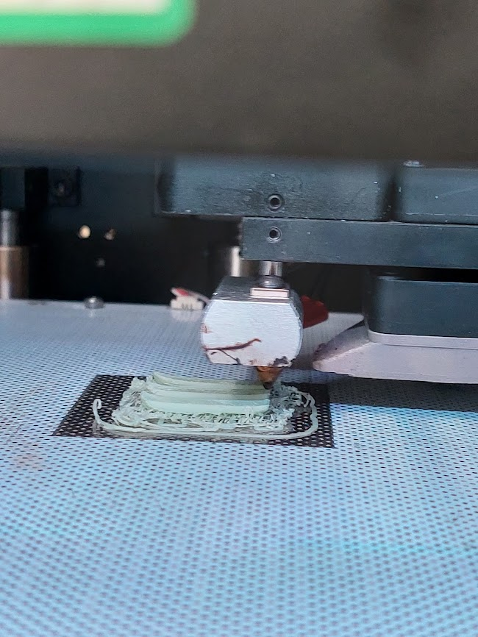
Figure 1: Failed 3D printing of recycled filament by fixing an extruder temperature of 180°C.
A summary of chosen printing parameters was reported in Table 1. The other printing parameters, such as printing speed, extruder flow rate, fan speed, were left at their default settings.
The material was dried in an oven for 10 hours at a temperature of 70 °C prior to 3D process, and rheological testing.
Table 1: Processing conditions to print DMA specimens
Printing Parameters
Layer thickness | 0.09 mm
Infill density | 100%
Pattern | Linear
Bed temperature | 70°C
First layer gap | 0.30 mm
Retraction distance | 2.7 mm
Retraction speed | 27 mm/s
Top surface layer | 6
Bottom surface layer | 6
Nozzle Diameter | 0.4 mm

The thermo-mechanical properties of PLA filaments, processed at 190°C and 210°C through FDM technology, were investigated using a Tritec 2000 machine (Triton Technology Ltd., Leicestershire, UK), in single cantilever mode, at a frequency of 1 Hz and a support distance of 12 mm, from room temperature to 70°C.
  - Experimental Results
    - Time sweep
In general, the main issue of PLA recycling resides in the poor thermal stability due to the presence of moisture, lactic acid residues and metal catalysis that lead to reduce the molecular weight and, consequently the polymer viscosity (Pillin et al., 2008). Thermal stability of the recycled filament was studied through time sweep test, performed at three different temperatures (170 ◦C, 190 ◦C, 210 ◦C). Experimental results are shown in Figure 2 in terms of complex viscosity (η*) as a function of time (~1800 s).
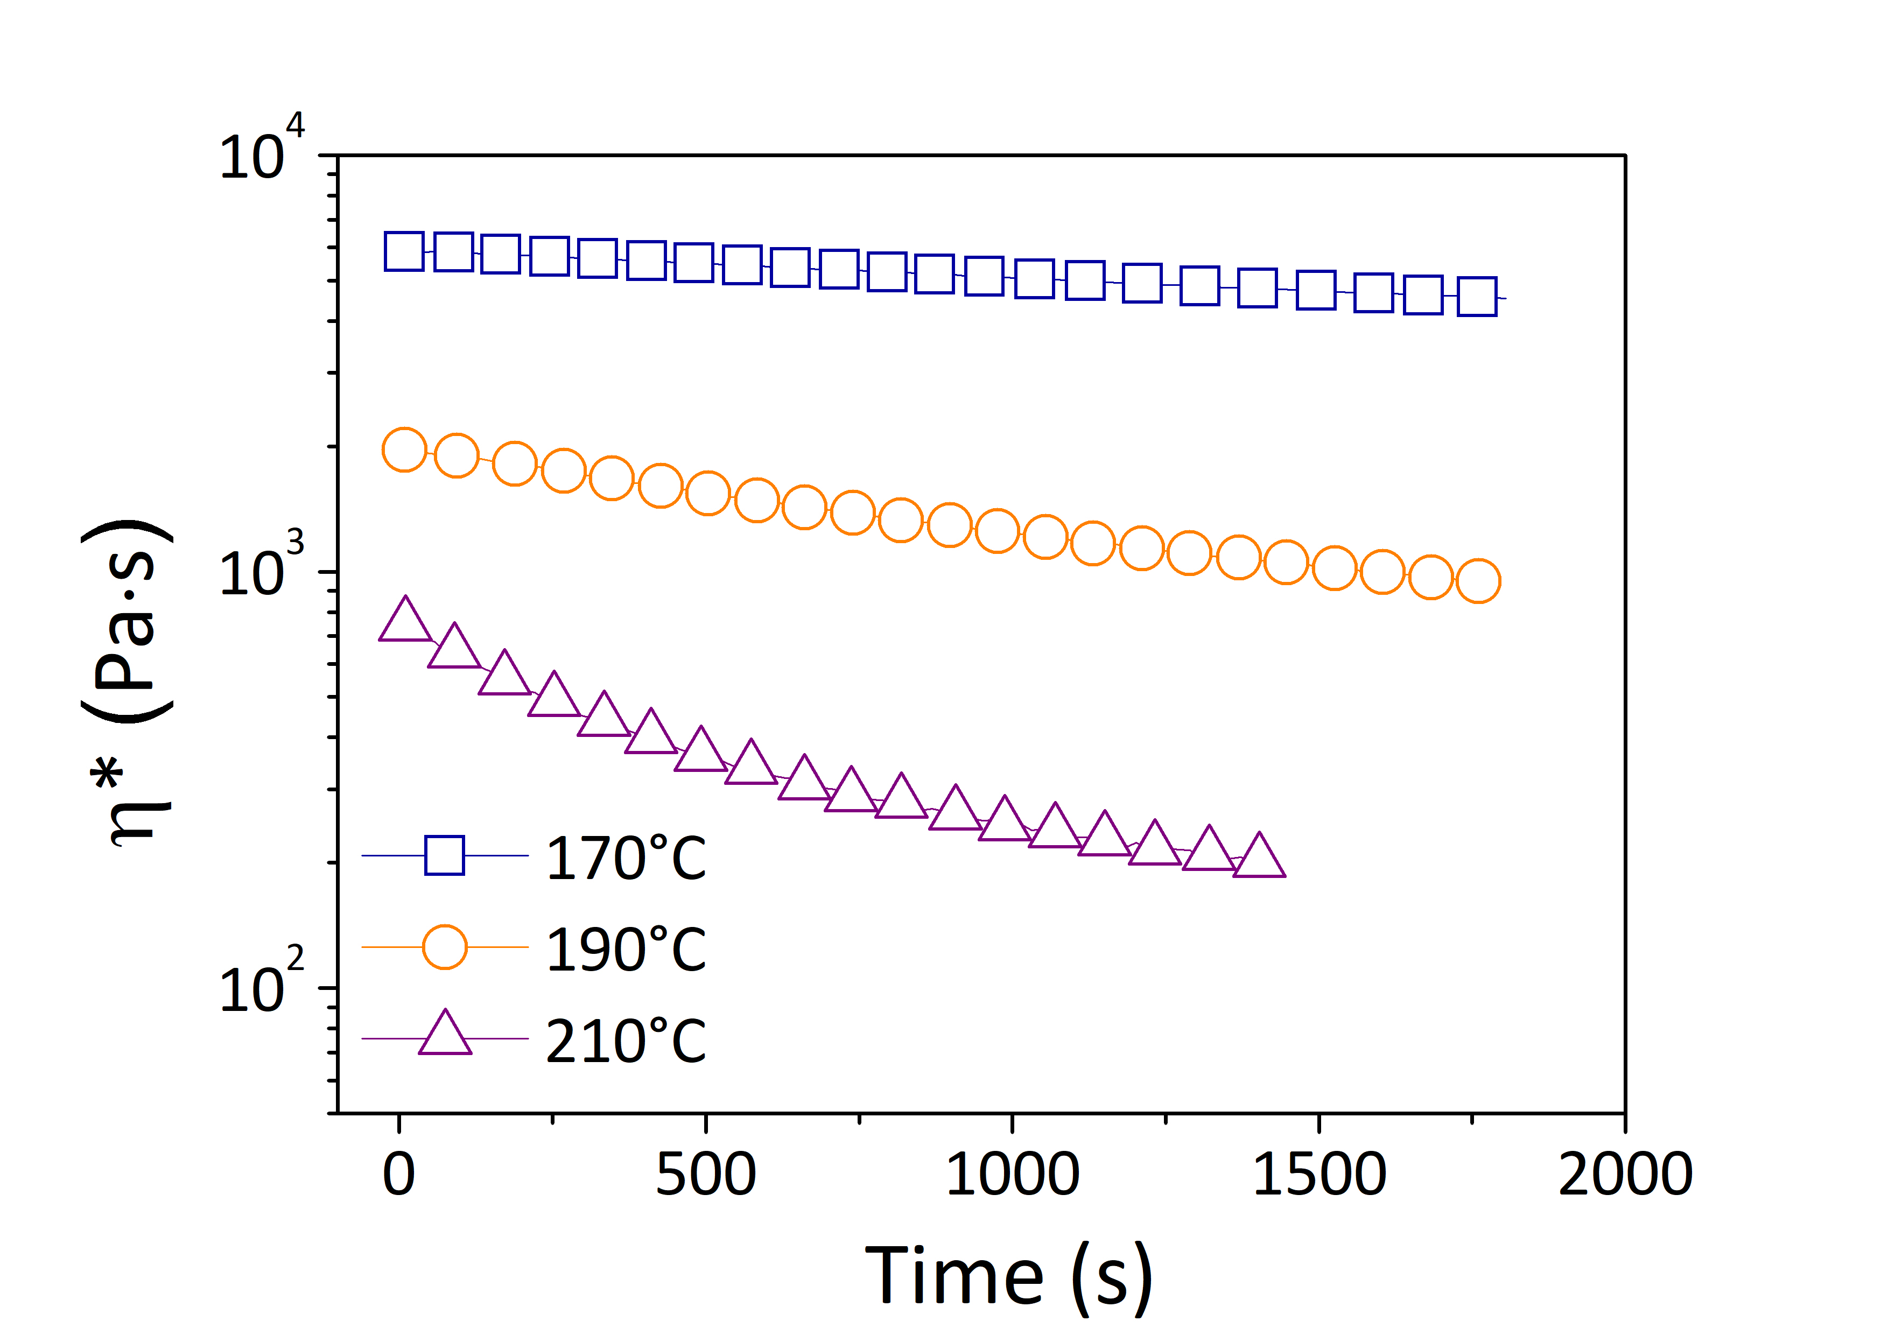
Figure 2: Complex viscosity (η*) as a function of time for recycled PLA-based filament.
From the data, a strong effect of the testing temperature on the rheological response of the resin was attested. In details, at temperature of 210°C, the complex viscosity showed a decreasing trend, starting from a value approximately around 8x10² Pa•s and achieving the value of 2x10² Pa•s after 1500 s. Then, when the testing temperature was decreased, the rheological signal attained an increasing stabilization over the entire duration of the experiment. At 190°C, the complex viscosity was initially equal to 2x10³ Pa•s and arrived to 9 x10² Pa•s after 1500s. Then, at 170°C, the value of η* was around 5.8 x10³ Pa•s at t=0, and 4.5 x10³ Pa•s at t=1500 s. The reduction in complex viscosity has been attributed to the reduction in molecular weight of polymer chains, negligible at temperature of 170°C, relevant at 190°C and even more at 210°C, that was considered a direct consequence of thermal degradation (Patti et al., 2021a).
    - Stress relaxation
The interlayer adhesion, or bonding between layers, is another important aspect of additive manufacturing because it determines the quality of printed specimens in terms of mechanical properties. The interlayer adhesion is achieved through molecular inter-diffusion of polymer chains across the interface between two layers in contact, and is strongly influenced by material’s viscoelastic properties (Calafel et al., 2020). Firstly established in the case of adhesive materials, the Dahlquist criterion refers to the ability to create a bond and to resist to debonding. By analysing the rheological properties as a function of time and temperature, Dahlquist found that only materials with sufficiently high compliance at the testing temperature were sticky. In other words, he attested the existence of a minimum value of compliance (3x10⁻⁶ Pa ⁻¹), or equivalently a maximum value of modulus (3x10⁵ Pa) to ensure good tack or instantaneous adhesion for each material. Meeting these values guarantees that the material is able to be sufficiently deformed, to wet the surface, and form a good bond (Pocius and Dillard, 2002). This criterion has been applied in the case of FDM technology to determine adhesion conditions. In this case, stress relaxation experiments have been conducted to identify the temperature at which the Dahlquist criterion, and consequently a good adhesion between layers, has been satisfied.
Figure 3 (a) displays that the shear stress (G(t)) always decreased over time with an effect more pronounced by increasing the testing temperature. Then, already after 0.01 s, the value of shear stress was lower than the Dahlquist limit. By plotting G(t) value at 0.01 s as a function of testing temperature (Figure 3(b)), the critical Dahlquist value was met in correspondence of 120°C. Thus, it could be assumed that a good adhesion seemed to be granted at limit temperature of about 120°C. The limit printing conditions (support and extruder temperatures, printing speed) should be set by considering that, once deposited on platform, the extruded material should be at higher temperatures than 120 °C at least for 1s to realize good bonding between the layers. The reference time of 1 sec has been taken as a usual cooling time for polymers at which the welding occurred (Calafel et al., 2020).
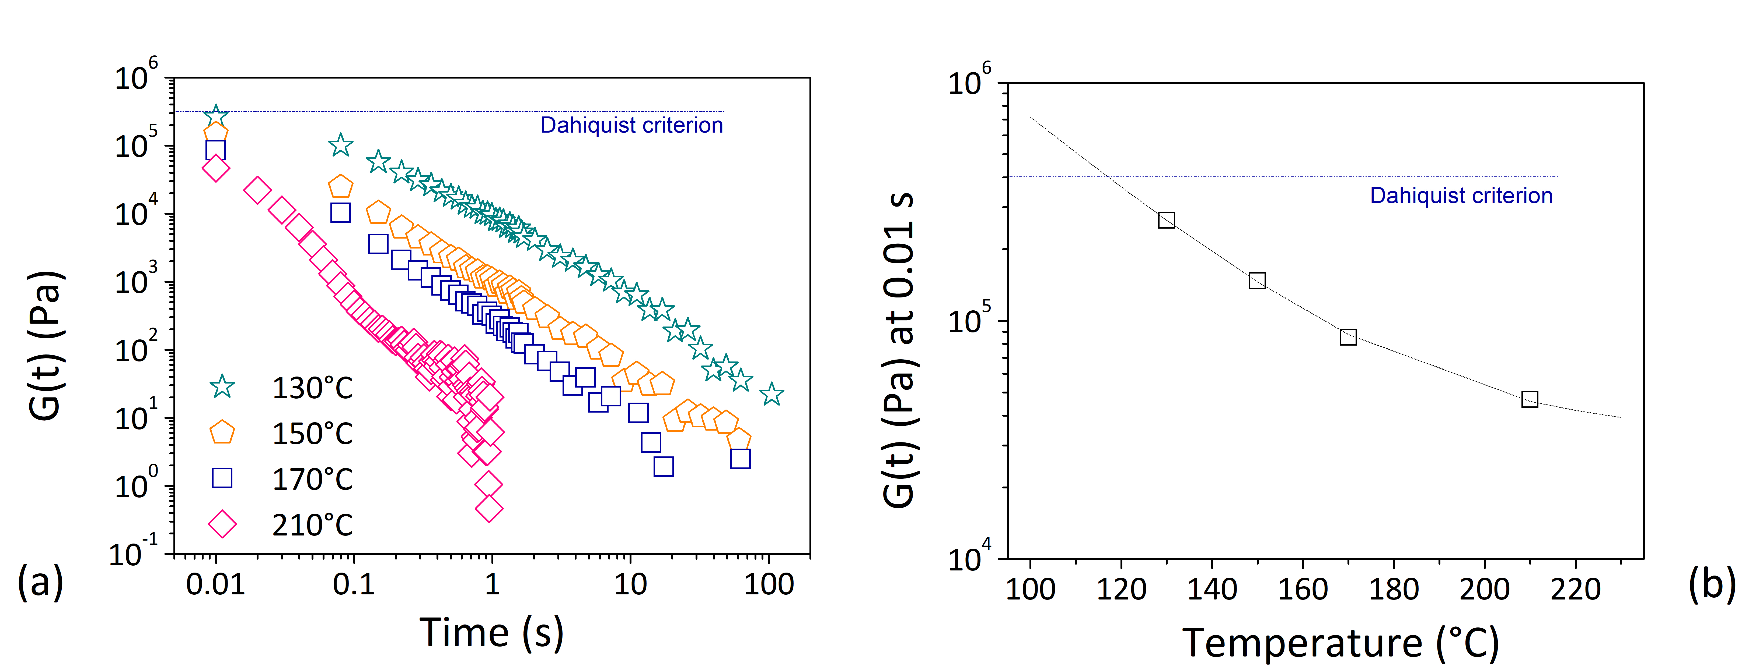
Figure 3: (a) Shear stress as function of time during stress relaxation experiment; (b) Shear stress measured at 0.01 s as function of testing temperature.
    - Frequency sweep
In Figure 4(a), the storage (G’) and the loss (G’’) moduli of recycled filament were reported as a function of the oscillatory frequency (ω) at four different temperatures (130°C, 140°C, 150°C, and 170°C).
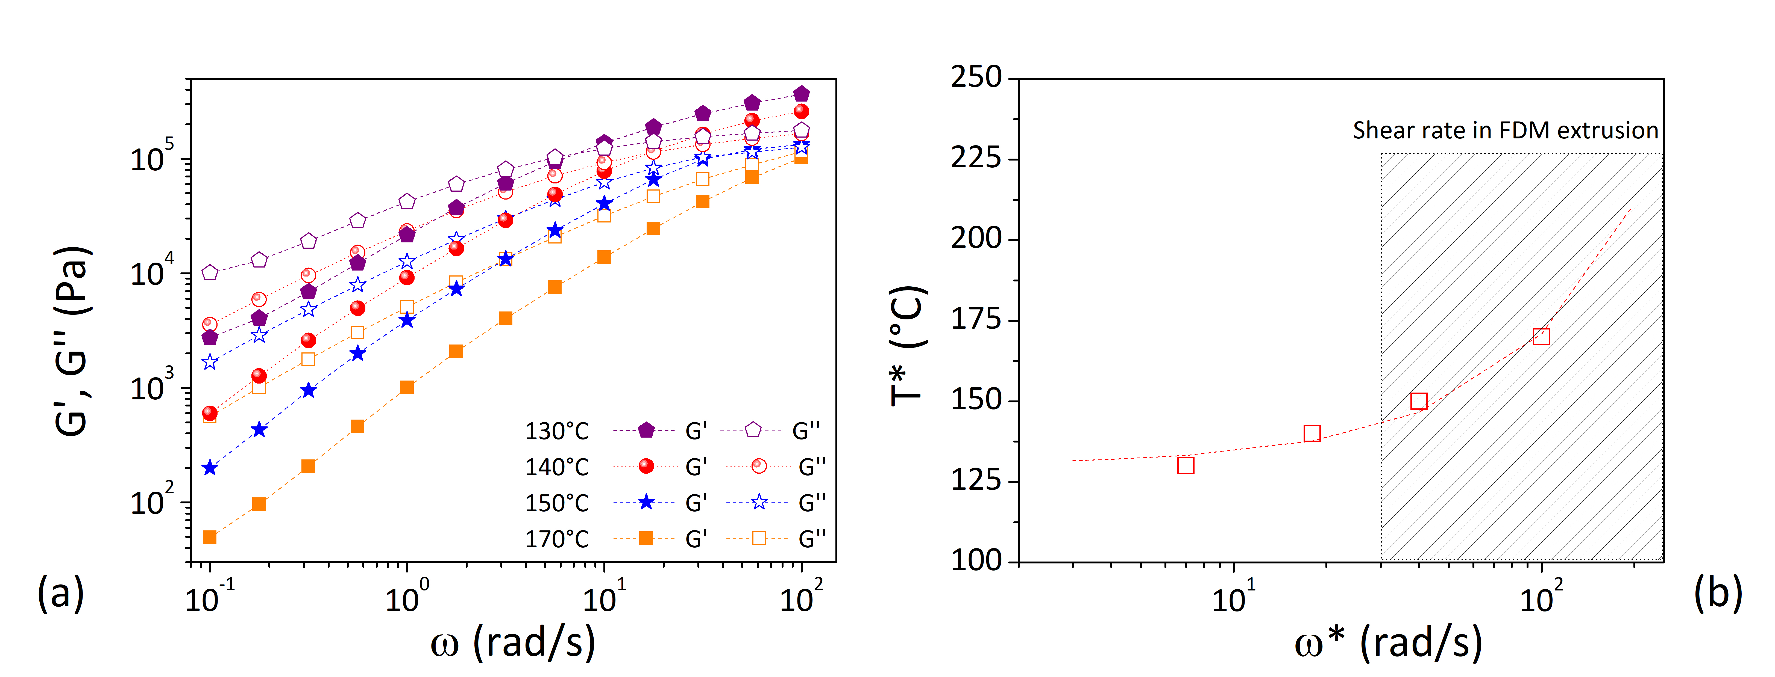
Figure 4: (a) Storage (G’) and loss (G’’) moduli as a function of oscillation frequency (ω); (b) Temperature (T*) and frequency (ω*) in correspondence of crossover point (G’=G’’) at four different testing temperatures.
At 130°C the material exhibited a typical viscoelastic behaviour of an entangled melted polymer with loss modulus (G’’) dominating at low frequency (ω<10 rad/s), storage modulus (G’) prevailing at high frequency (ω>10 rad/s), and a crossover point at intermediate frequency of about 10 rad/s. Then, by increasing temperatures from 130 to 170°C, the crossover point was shifted towards high frequency (~10² rad/s), and a predominantly viscous behaviour (G’’ > G’) was verified in the entire range of frequency (from 0.1 to 10² rad/s). The trend of crossover temperature (T*) against crossover oscillatory frequency (ω*) was reported in Figure 4(b). Based on these findings, it has been possible to predict that, at the typical shear rates for the material extrusion in additive manufacturing (30-500 s⁻¹ or rad/s (Das et al., 2021)), the extruder temperature should be increased more than 150°C in order to ensure a predominantly viscous behavior of the material (Calafel et al., 2020).
    - Dynamic Mechanical Analysis (DMA)
Figure 5 displays thermo-mechanical properties of 3D printed parts, made from recycled filament, processed at two temperatures, 190°C and 210°C, in terms of storage modulus (E’) (Fig.5(a)) and dissipation factor (Tan delta) (Fig.5(b).
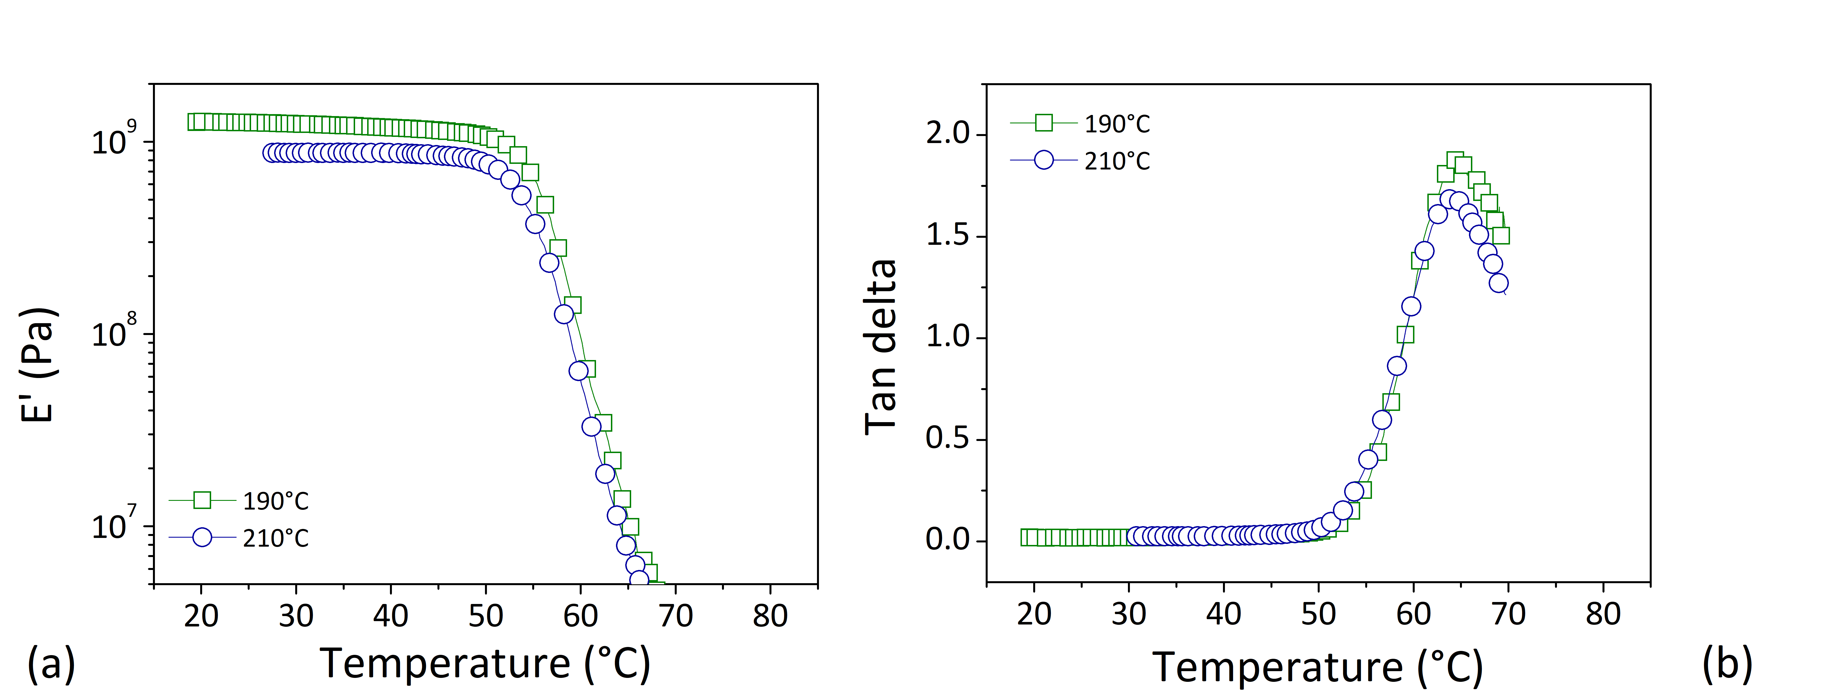
Figure 5: Comparison of DMA results of extruded samples at 190°C and 210°C in terms of: storage modulus (a) and tan delta (b).
In general, low fluidity and high viscosity of melted polymer at low temperature are considered responsible of poor bonding between layers of 3D printed parts, and of a high porosity inside the 3D structure. This determines poor mechanical properties as the printing temperatures is decreased (Hsueh et al., 2021).
Contrary to expectations, in this case, a higher storage modulus (~20%) was detected for 3D samples processed at 190°C compared to those processed at 210°C. A slight reduction of glass transition temperature was verified for specimens processed at 190°C (average values of 65.8°C) against those processed at 210°C (average values of 65.1°C). The reduction in storage modulus (E’) was ascribed to the thermal degradation of polymer chains during 3D printing extrusion, more pronounced at 210°C compared to 190°C (as already attested through time sweep test). Average values (based on three tested specimens) of storage modulus at 30°C, glass transition temperature, and peak height in tan delta were summarized in Table 2.
Table 2: DMA results
Sample | Storage Modulus  (E’) at 30°C | Glass Transition Temperature (°C) | Peak Height in tan delta
PLA_190°C | 1.2x10⁹ ±5.2x10⁷ | 65.8±0.99 | 2.0±0.06
PLA_210°C | 9.8x10⁹ ±1.2x10⁸ | 65.1±1.25 | 1.7±0.04
  - Conclusions
In this study, a preliminary viscoelastic characterization of recycled bio-based filament was performed both in the melt (through rheological testing) and solid (through DMA measurements) state to gain information on potential processing temperature in FDM technology.
At 210°C a strong thermal instability of rheological features was attested over time (attributed to degradation), which disappeared by reducing temperature up to 170°C. However, a temperature greater than 150°C ensured a viscous behaviour of recycled material during extrusion, and consequently a potential good printability. Experimental assessments confirmed failed printing attempts for an extrusion temperature of 180 °C Then, according to Dahlquist criterion, the extruder temperature should be set high enough to maintain the deposited layer on platform at temperature not lower than 120°C. Finally, by changing the processing temperature from 190°C to 210°C, the thermo-mechanical properties of 3D printed parts were decreased. In conclusion, an optimal printing temperature was equal to 190°C. Such value was considered a good compromise to limit the thermal degradation, to ensure sufficiently viscous behaviour of the material during the extrusion, and to avoid an excessive cooling of deposited layer on platform.
Acknowledgments
A. Patti wishes to thank the Italian Ministry of Education, Universities and Research (MIUR) in the framework of Action 1.2 “Researcher Mobility” of The Axis I of PON R&I 2014-2020 (E66C18001370007). S. Acierno and G. Cicala acknowledge the support of the Italian Ministry of University, project PRIN 2017, 20179SWLKA “Multiple Advanced Materials Manufactured by Additive technologies (MAMMA)”.
References
Calafel, I., Aguirresarobe, R.H., Peñas, M.I., Santamaria, A., Tierno, M., Conde, J.I., Pascual, B., 2020, Searching for Rheological Conditions for FFF 3D Printing with PVC Based Flexible Compounds. Materials (Basel), 13, 178.
Das, A., Gilmer, E.L., Biria, S., Bortner, M.J., 2021. Importance of Polymer Rheology on Material Extrusion Additive Manufacturing: Correlating Process Physics to Print Properties, ACS Applied Polymer Material, 3, 1218–1249.
EUR-Lex - 52020DC0098 - EN - EUR-Lex [WWW Document], n.d. URL https://eur-lex.europa.eu/legal-content/EN/TXT/?qid=1583933814386&uri=COM:2020:98:FIN (accessed 6.4.20).
Guessasma, S., Belhabib, S., Nouri, H., 2021, Effect of printing temperature on microstructure, thermal behavior and tensile properties of 3D printed nylon using fused deposition modeling, Journal of Applied Polymer Science, 138, 50162.
Hahladakis, J.N., Iacovidou, E., 2018, Closing the loop on plastic packaging materials: What is quality and how does it affect their circularity?, Science of Total Environment, 630, 1394–1400.
Hsueh, M.H., Lai, C.J., Wang, S.H., Zeng, Y.S., Hsieh, C.H., Pan, C.Y., Huang, W.C., 2021, Effect of Printing Parameters on the Thermal and Mechanical Properties of 3D-Printed PLA and PETG, Using Fused Deposition Modeling. Polymers (Basel), 13, 1758.
Mikula, K., Skrzypczak, D., Izydorczyk, G., Warchoł, J., Moustakas, K., Chojnacka, K., Witek-Krowiak, A., 2021, 3D printing filament as a second life of waste plastics—a review, Environmental Science and Pollution Research, 28, 12321–12333.
Ngo, T.D., Kashani, A., Imbalzano, G., Nguyen, K.T.Q., Hui, D., 2018, Additive manufacturing (3D printing): A review of materials, methods, applications and challenges, Composites Part B Engineering, 143, 172–196.
Patti, A., Acierno, S., Cicala, G., Tuccitto, N., Acierno, D., 2022a, Refining the 3D Printer Set-up to Reduce the Environmental Impact of the Fused Deposition Modelling (fdm) Technology, Chemical Engineering Transaction, 91, 415–420.
Patti, A., Acierno, S., Cicala, G., Zarrelli, M., Acierno, D., 2022b, Recovery of Waste Material from Biobags: 3D Printing Process and Thermo-Mechanical Characteristics in Comparison to Virgin and Composite Matrices. Polymers (Basel), 14, 1943.
Patti, A., Cicala, G., Acierno, S., 2021a, Rotational Rheology of Wood Flour Composites Based on Recycled Polyethylene. Polymers (Basel), 13, 2226.
Patti, A., Cicala, G., Tosto, C., Saitta, L., Acierno, D., 2021b, Characterization of 3D Printed Highly Filled Composite: Structure, Thermal Diffusivity and Dynamic-Mechanical Analysis, Chemical Engineering Transaction, 86, 1537-1542.
Pillin, I., Montrelay, N., Bourmaud, A., Grohens, Y., 2008, Effect of thermo-mechanical cycles on the physico-chemical properties of poly(lactic acid), Polymer Degradation Stabity, 93, 321–328.
Pocius, A.V., Dillard, D.(Eds), 2002, Surfaces, Chemistry and Applications, Adhesion Science and Engineering. Elsevier Science B.V., Amsterdam, The Netherlands
Sid, S., Mor, R.S., Kishore, A., Sharanagat, V.S., 2021. Bio-sourced polymers as alternatives to conventional food packaging materials: A review, Trends in Food Science & Technolology, 115, 87–104.

