CHEMICAL ENGINEERING TRANSACTIONS  VOL. 96, 2022 | A publication of
The Italian Association
of Chemical Engineering
Online at www.cetjournal.it

Guest Editors: David Bogle, Flavio Manenti, Piero Salatino
Copyright © 2022, AIDIC Servizi S.r.l.
ISBN 978-88-95608-95-2; ISSN 2283-9216

A Graphical Technique for Net-Zero Emissions Planning Based on Marginal Abatement Cost (MAC) Curves
Maria Victoria Migo-Sumagangª, Kathleen B. Avisoª, Purusothmn Nair S. Bhasker Nair^{b}, Michael Short^{c}, Raymond R. Tanª, Dominic C. Y. Foo^{b*}
ªDepartment of Chemical Engineering, De La Salle University, 2401 Taft Avenue, 0922 Manila, Philippines
^{b}Department Chemical and Environmental Engineering/Centre of Excellence for Green Technologies, University of Nottingham Malaysia, Broga Road, 43500 Semenyih, Selangor, Malaysia
^{c}Department of Chemical and Process Engineering, University of Surrey, Guildford, Surrey GU2 7XH, United Kingdom
dominic.foo@nottingham.edu.my
Net-zero emission targets are being set by countries and companies globally. To meet net-zero targets, negative emission technologies (NETs) such as bioenergy with carbon capture and storage (BECCS) and biochar (BC) can be implemented alongside replacing traditional energy sources with renewables. Various high-level tools for energy planning are available but rarely consider NETs and net-zero emissions planning. In this work, a graphical procedure was developed using marginal abatement cost (MAC) curves for net-zero emissions planning. Carbon dioxide (CO₂)-emitting energy sources are arranged in increasing order of specific costs, on a specific cost vs cumulative CO₂ emissions diagram. NETs are then plotted to counterbalance the emissions in order to determine the negative emission targets. The methodology is illustrated with a case study in the power generation sector. In this case, coal and natural gas (500 MW each) are used to generate power for users. In order to reach net-zero emission for this sector, a BECCS plant (500 MW) and a reduction in the power rating of coal by around 200 MW is necessary. Besides, an additional 1.59 Mt/y of CO₂ sequestration is to be carried out through BC. The proposed technique provides a simple and clear method for net-zero emissions planning.
  - Introduction
Climate models and projections show that reaching net-zero CO₂ emissions by mid-century is key to limiting global warming according to the Paris Agreement targets (IPCC, 2021). The “net-zero framing” provides a tangible target that is effective for planning future emissions reduction, and countries such as the UK, Canada, France, China, and Japan have committed to net-zero emissions pledges (Iyer et al., 2021). Countries are not the only actors in pledging net-zero emissions. Many companies and businesses in various sectors, e.g. airlines, consumer products, energy, etc. have pledged emissions reduction (Chrobak, 2021).
To economically achieve net-zero emissions, negative emissions technology (NETs) is necessary to support the hard-to-abate emissions from certain sectors (Tatarewicz et al., 2021). NETs are also needed to counterbalance the residual emissions in the energy sector (IPCC, 2022). NETs function by removing CO₂ from the atmosphere and storing it in a separate environmental compartment e.g., biomass, soil, underground, or ocean (The Royal Society, 2018). The most prominent NETs used in modelling scenarios are nature-based solutions, afforestation/reforestation (AR), and bioenergy with carbon capture and storage (BECCS) (IPCC, 2014). Both solutions take advantage of the carbon neutrality of biomass, with AR being less permanent and BECCS more stable in storing the carbon underground or in sub-surface minerals (The Royal Society, 2018). Another biomass-based solution is the mixing of biochar (BC) in the soil. This solution has an expected lifespan of around 500 years (Smith et al., 2019). Both BECCS and BC have the advantage of providing energy aside from their negative emission functions (Smith et al., 2019).
To achieve net-zero emissions, it is important to plan and integrate NETs into existing energy systems. Energy systems models may be used to integrate NETs into energy systems during the transition toward net-zero, (Köberle, 2019). For example, a linear program is used to model the impact of BECCS on the global energy mix by minimizing the system cost while meeting technological and environmental constraints (Selosse and Ricci, 2014). Value chain optimization is also used to plan BECCS supply chains with existing energy systems. For example, a study optimized a BECCS supply chain starting from cultivation/sourcing, to processing, transport, and energy conversion with carbon capture and storage (CCS) using mathematical programming (Fajardy and Mac Dowell, 2017). Mathematical programs were also used in another study to achieve negative emissions targets through NETs portfolios considering environmental footprints and synergistic interactions (Migo-Sumagang et al., 2022).
While mathematical programming approaches have the advantage of handling large, complex problems with great detail, graphical solutions provide a simple and easy visualization that is advantageous in the first steps of decision-making (Klemeš et al., 2013). Studies using graphical techniques to plan NETs with energy systems and/or emissions reduction measures are available in the literature. Pinch Analysis (PA) has been used to plan NETs with existing energy systems using renewables and fossil fuels, to determine the minimum negative emissions required (Nair et al., 2020).
Another graphical approach is the minimum abatement cost (MAC) curve which originated from energy conservation supply curves (Meier et al., 1982) and was more recently popularized to determine the cost-effective emissions reduction measures to mitigate climate change (Enkvist et al., 2007). In a MAC vs cumulative CO₂ emissions reduction graph, the emissions reduction measures are arranged by increasing MAC so that the most cost-effective solutions can easily be determined visually. The MAC curve has recently been extended to include an algebraic targeting method while determining the minimum MAC (mini-MAC) of matched CO₂ emissions sources and sinks (Lameh et al., 2022). It has been demonstrated in CO₂ capture, utilization, and storage (CCUS), energy mix planning, as well as NETs planning (Lameh et al., 2022).
MAC curves are logically analogous to WaterPinch™ developed by Dhole et al. (1996) for water integration problems. The limitations of this approach were subsequently pointed out by Hallale (2002). The latter work also proposed an improved methodology using the areas enclosed by the composite curves. This technique was shown to be able to identify the correct optimal solutions in quality-constrained source-sink allocation problems. An alternative method was then developed by El-Halwagi et al. (2003) for resource conservation networks using dynamic programming to provide rigorous proof of optimality. The latter approach was used by Foo (2017) for optimizing carbon management portfolios.
Aside from the PA, high-level graphical technique studies on NETs and net-zero emissions planning are currently lacking. The MAC approach visually shows the cost-effective solutions but does not include planning the CO₂-emitting sources with the NETs to reach net-zero emissions. To address this research gap, this work develops a graphical procedure based on MAC curves for net-zero emissions planning. CO₂-emitting sources are arranged in increasing specific costs (or the cost associated per unit CO₂ emitted), on a specific cost vs cumulative CO₂ emissions diagram. The available NETs are then plotted to counterbalance the emissions and to determine any additional negative emission targets. The proposed technique provides a simple and clear method for net-zero emissions planning. The rest of the paper is organized as follows. The problem statement is presented in Section 2. The proposed methodology is discussed in Section 3. A case study in the power generation sector is illustrated in Section 4. The conclusions of this paper are given in Section 5.
  - Problem Statement
The net-zero emissions planning problem is formally stated as follows: given a set of CO₂-emitting sources ($P_{1}, P_{2},…P_{i}$), their specific costs ${(PC}_{i})$, and emissions ($∆G_{i}$). Given a set of available NETs ($N_{1}, N_{2},…N_{i}$), their specific costs ${(NC}_{i})$ (or the cost associated per unit CO₂ removal by NETs), and negative emission capacities ($∆A_{i}$). The graphical technique should determine the negative emissions “deficit” to meet net-zero emissions. The technique should also enable the visual determination of cost-effective technologies, as well as the calculation of the total costs of a technology (or group of technologies).
  - Proposed Method
This section describes the proposed net-zero emissions graphical procedure based on MAC curves. The assumption is that the specific costs and emissions (for CO₂-emitting sources) and emissions reduction capacities (of NETs) are available. The procedure has the following steps.
- Arrange the CO₂-emitting sources in increasing specific costs.
- Plot the cumulative CO₂ emissions on the horizontal axis and the specific costs on the vertical axis. Plot the CO₂-emitting sources on the graph in increasing specific costs beginning at the origin, such that the emissions are cumulative, and the plot resembles a staircase as shown in Figure 1a.
- Arrange the NETs in decreasing specific costs. Plot the NETs on the same graph in decreasing specific costs, beginning from where the last CO₂-emitting source ends, such that the plot resembles a staircase in the opposite direction (see Figure 1b). Note that the NET curve can be above or below the CO₂-emitting source curve, depending on the specific costs. In this example, the NETs have higher specific costs, and thus are above the CO₂-emitting source curve.
- Analyse the graph by identifying any net-zero deficit (or surplus). The net-zero deficit refers to the amount of negative emissions required to reach net zero and is represented when the end of the NET curve does not cross the vertical axis. The net-zero deficit is the horizontal distance from the end of the NET curve to the vertical axis. The net-zero surplus is represented by the opposite scenario where the NET curve crosses the vertical axis, and is also determined by the horizontal distance from the end of the NET curve to the vertical axis. The example in Figure 2a shows a net-zero deficit.
- In the case of net-zero deficit, the decisionmaker may want to meet net-zero emissions by shifting the graph, and reducing the CO₂-emitting sources as shown in Figure 2b. Other options include adding NETs, replacing the CO₂-emitting sources with renewables, or changing the composition of the CO₂-emitting sources (e.g. reducing higher emitting sources and increasing lower-emitting sources) to meet net-zero. In the rare case of a net-zero surplus, the decisionmaker may opt to reduce the NETs to save on cost or to keep the NETs for extra negative emissions.
- Determine the total cost of the selected technologies by calculating the area under the curves.

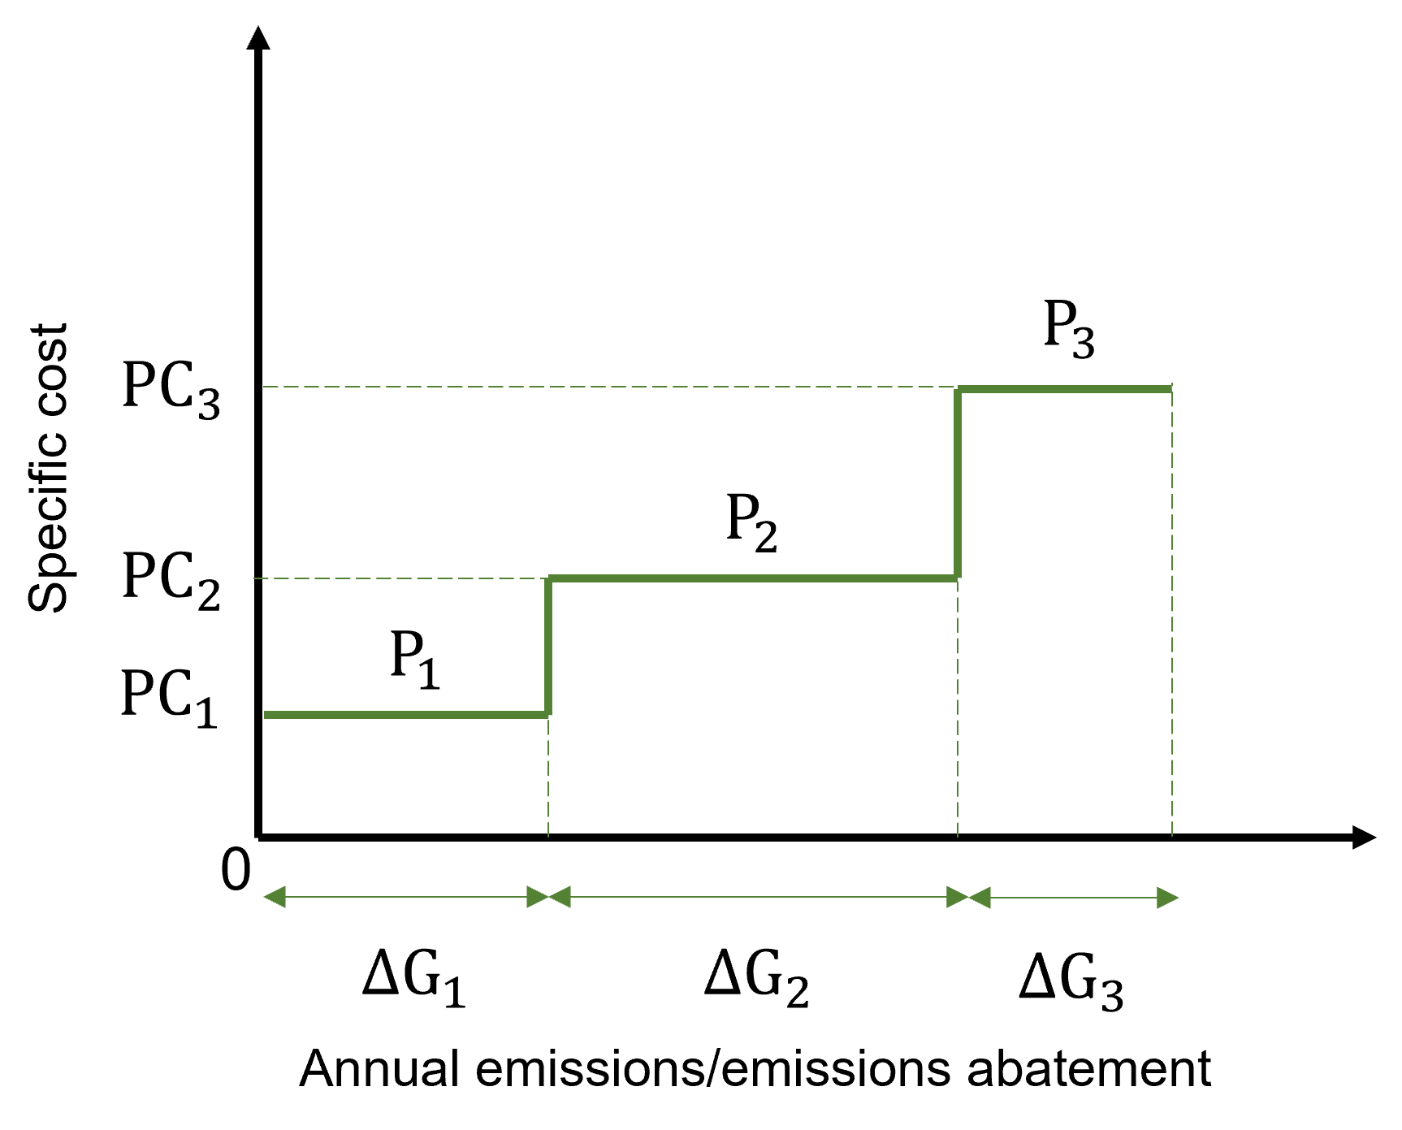  (a) | 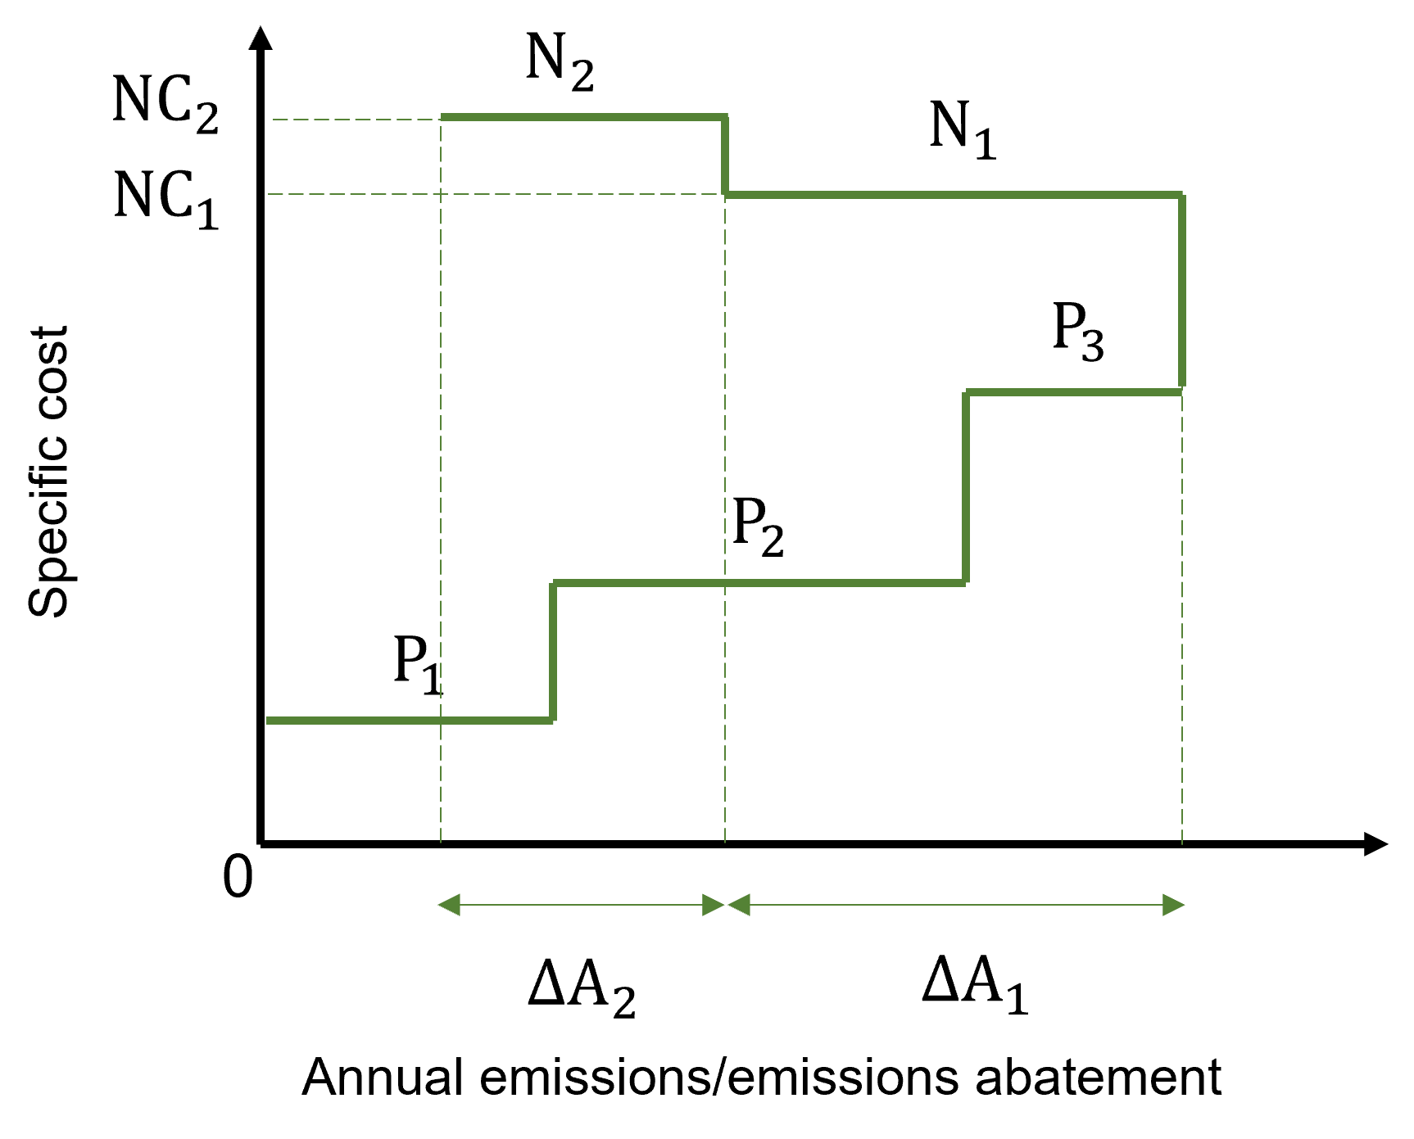  (b)
Figure 1: (a) Plotting of the CO₂-emitting sources; (b) plotting of the NETs
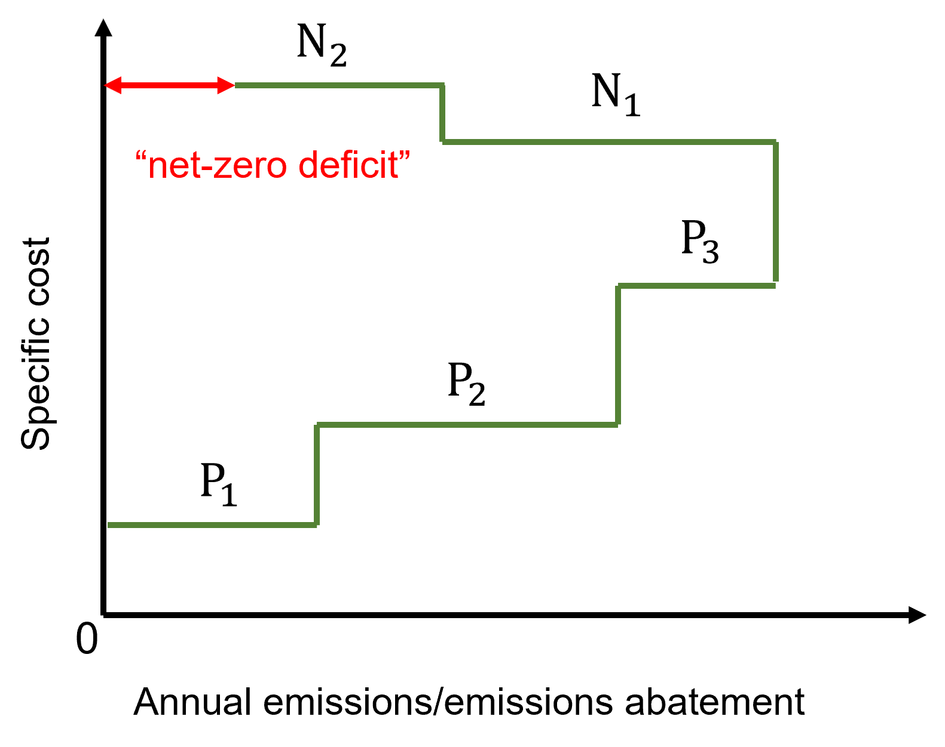  (a) | 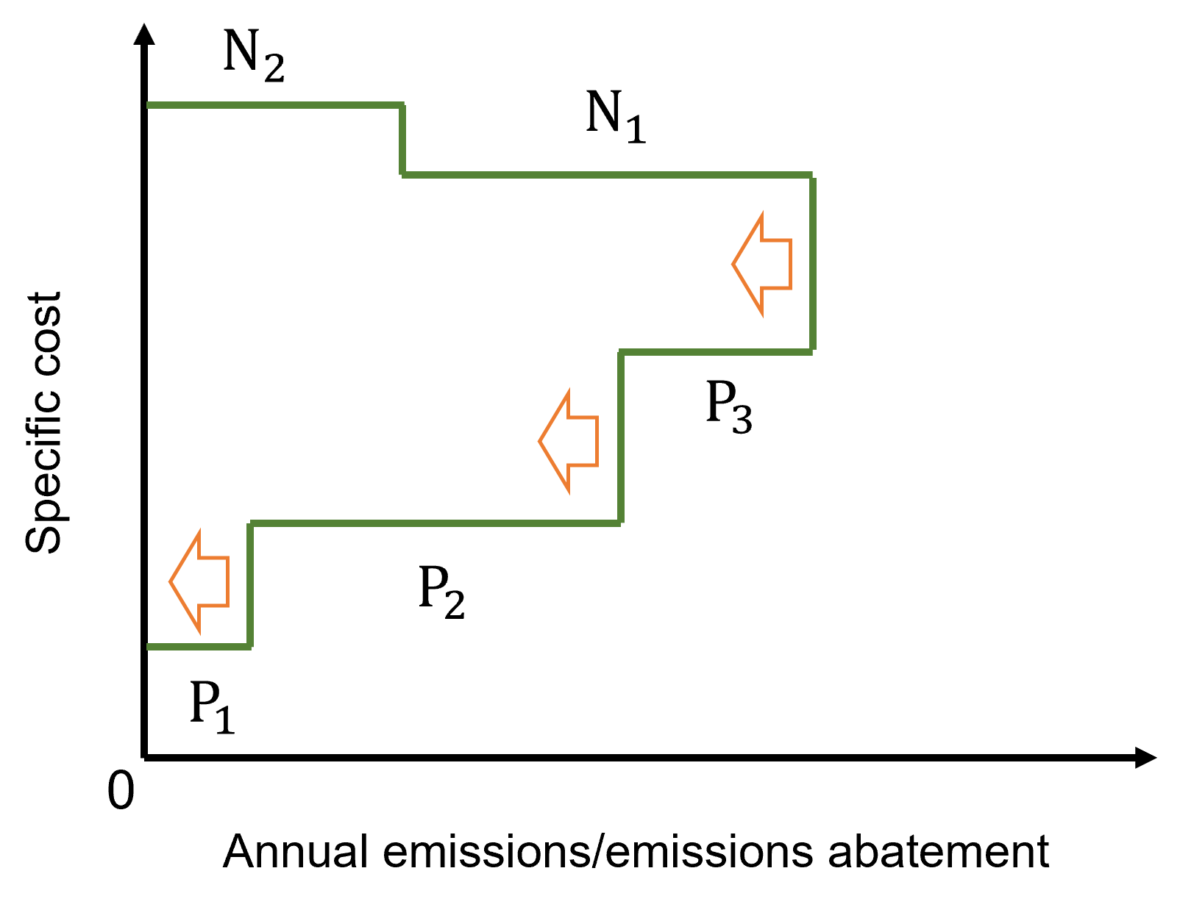  (b)
Figure 2: (a) Identifying the net-zero deficit; (b) reducing the CO₂-emitting sources by shifting the graph after step 4 (b)
  - Case Study
The following case study is based on a power industry that uses the traditional energy sources, coal, and natural gas (NG); with BC and BECCS as NETs. Table 1 shows the power plant data using the traditional energy sources adapted from Lameh et al. (2022). The power plants both have 500 MW capacities, and the CO₂ intensities were calculated using the published emission factors and 39% and 52% efficiencies for coal and natural gas (Lameh et al., 2022). The annual emissions were determined assuming 8,700 annual operational hours. The specific costs were calculated by dividing the total operating cost by the emissions, obtaining the values in Table 1.
Table 1: Power plant data using traditional energy sources adapted from Lameh et al. (2022)
Energy Source | Power Rating  (MW) | Total Operating Cost  (USD/MWh) | CO₂ intensity  (t CO₂/MWh) | Annual Emissions  (Mt CO₂/y) | Specific Cost  (USD/t CO₂)
Coal power plant | 500 | 9.41 | 0.95 | 4.14 | 9.91
Natural Gas power plant | 500 | 4.76 | 0.39 | 1.69 | 12.21

Table 2 shows the NETs data. The power rating and capacity of BECCS were obtained from a study assuming an 85% operating capacity and a 33% thermal efficiency delivering up to 2.99 Mt CO₂/y sequestration (Donnison et al., 2020). The energy product of BC was assumed to be thermal energy and was excluded from the power generation. The cost of negative emissions from BC and BECCS corresponds to the lowest value within the ranges, as reported by Fuss et al. (2018), while the capacity of BC was based on the global capacity (Fuss et al., 2018) relative to the emissions considered in the case study. It was assumed that the NETs do not emit secondary emissions and that their energy requirements are from renewable energy sources (Lameh et al., 2022).
Table 2: NETs data
NET | Power Rating  (MW) | Sequestration Capacity  (Mt CO₂/y) | Cost  (USD/t CO₂)  (Fuss et al., 2018)
BC | 0 | 1.25 (Fuss et al., 2018) | 30
BECCS | 500 MW (Donnison et al., 2020) | 2.99 (Donnison et al., 2020) | 100

Implementing the proposed methodology, the initial results are found in Figure 3. Both NETs have higher specific costs and are positioned above the CO₂-emitting sources. The two traditional energy sources result in a total emission equal to 5.83 Mt CO₂/y while the negative emission available from the NETs is only 4.24 Mt CO₂/y. Based on the figure, a net-zero deficit amounting to 1.59 Mt CO₂/y exists for this scenario. The graph also visually shows that although BECCS has a major contribution to reaching net-zero, implementing BECCS significantly raises the cost of the scenario. The total cost is calculated, beginning with the area under the curve of the CO₂-emitting sources (represented by the dark green shade), then adding the area under the curve of the NETs (represented by both the light and dark green shades under the NET curve). The cost of power generation through the traditional sources is 6.16x10⁷ USD/y while the cost of the NETs is 3.37x10⁸ USD/y. The total cost of implementation is 3.98x10⁸ USD/y (= 6.16x10⁷ + 3.37x10⁸ USD/y).

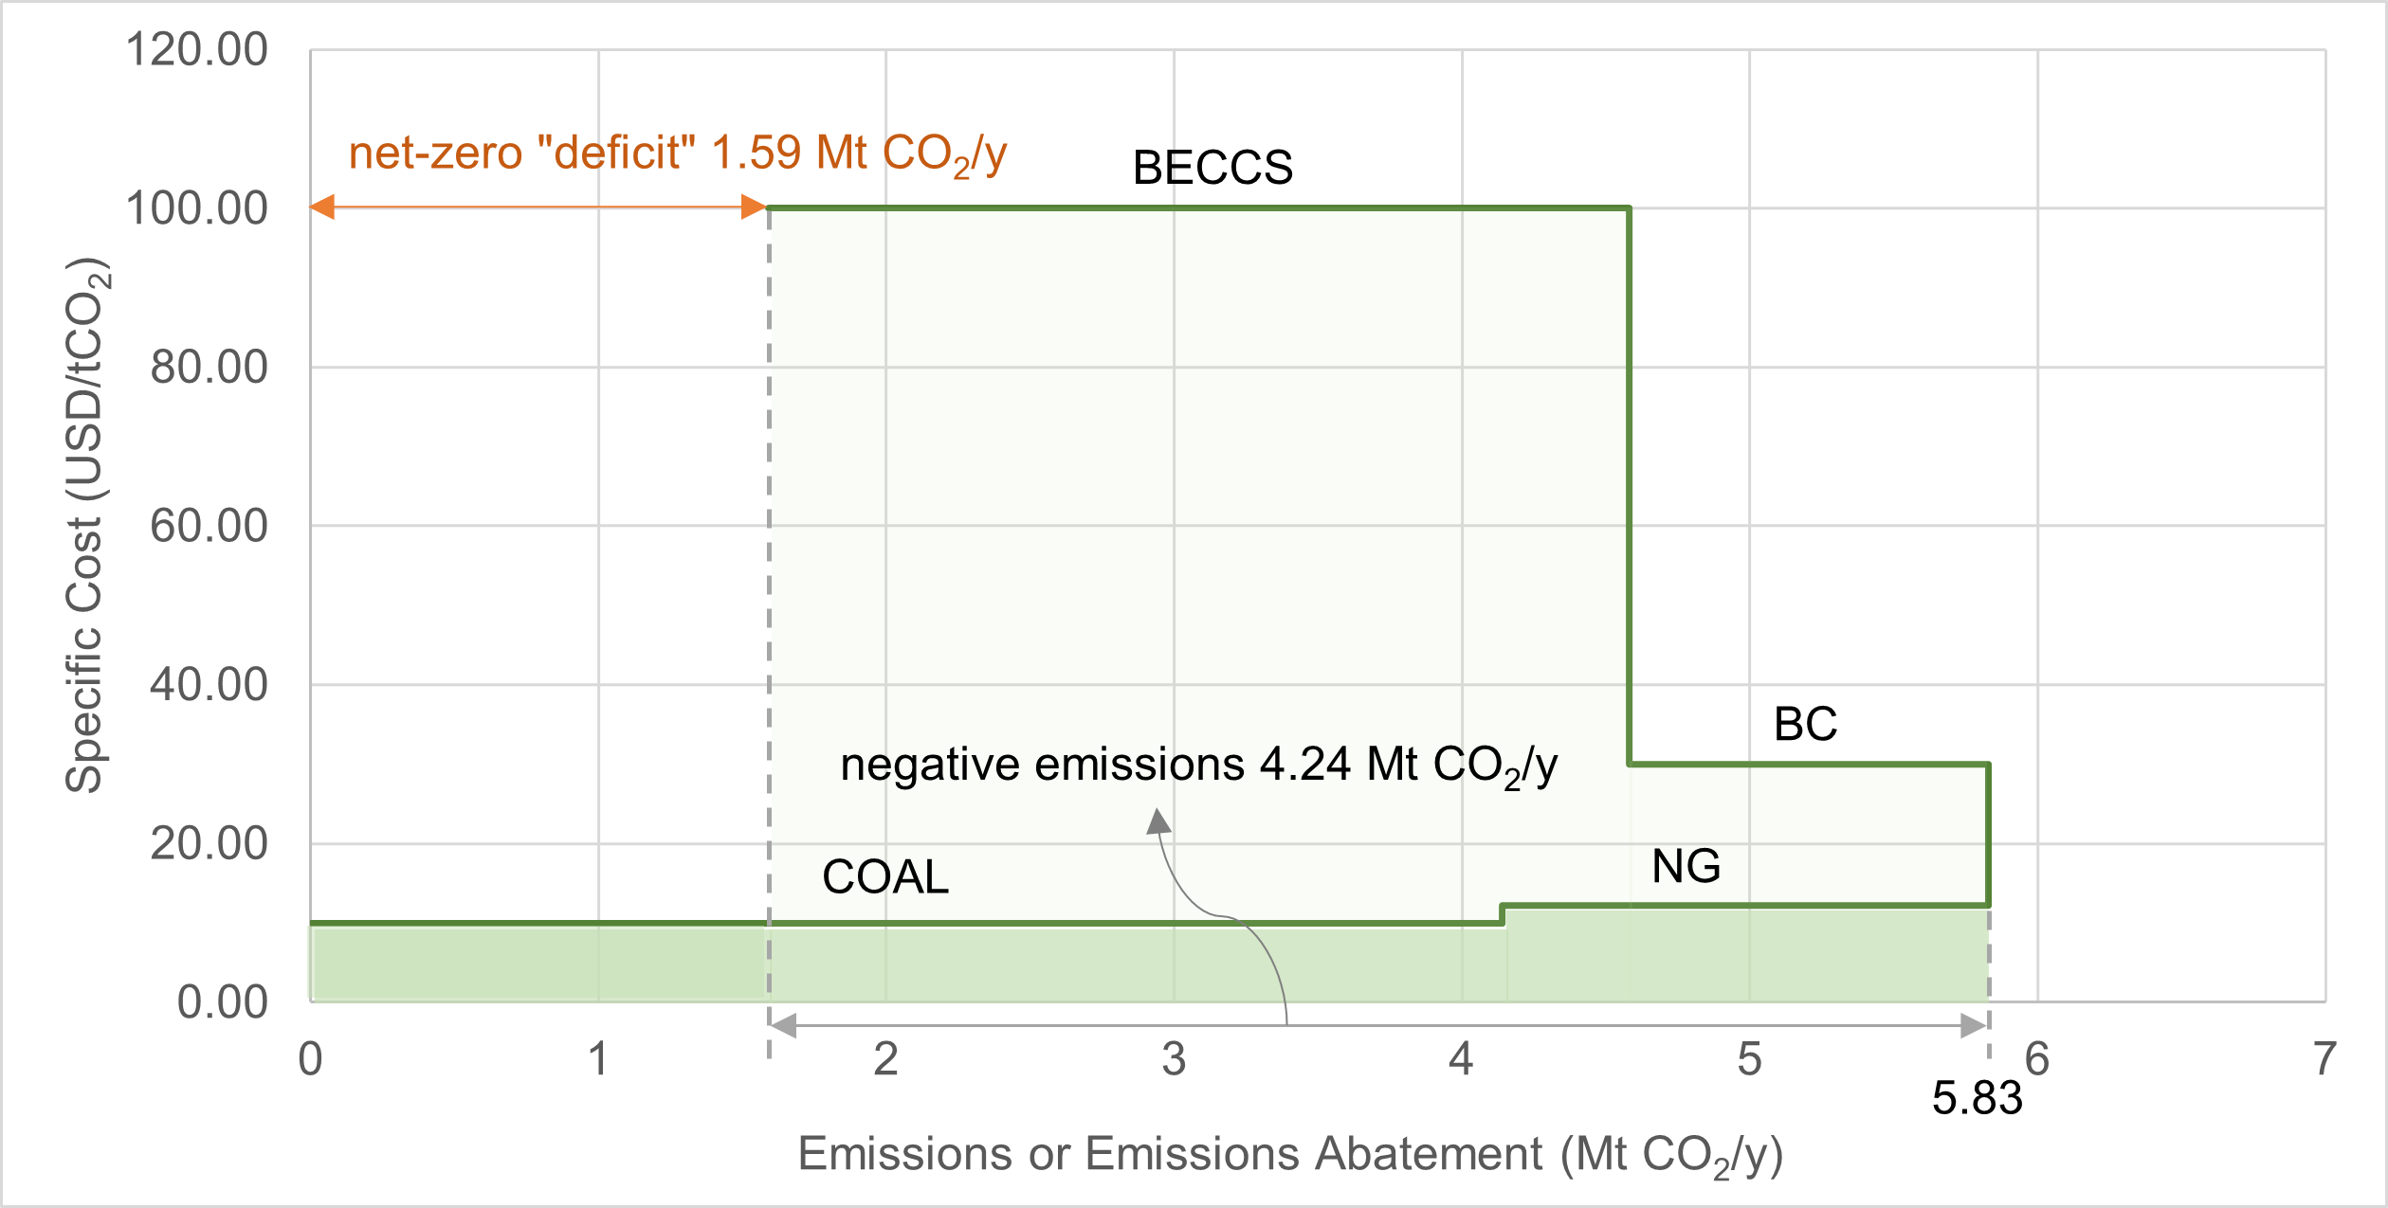
Figure 3: Net-zero planning case study initial results
To meet net-zero emissions and to comply with the coal reduction mandate, the decisionmaker reduces the amount of coal by shifting the graph as shown in Figure 4. Here, the emission from coal is reduced by the net-zero deficit amount from the initial results to achieve net-zero emissions. With the reduced emissions (2.55 Mt CO₂/y), using the emission factor in Table 1 (0.95 t CO₂/MWh), and assuming 8,700 operational hours per year, the new power rating of the coal power plant is calculated to be 308.53 MW to meet net-zero emissions. This value is approximately 200 MW lower than the coal power rating in the original case study, indicating a reduction in the supply. Alternatively, the decisionmaker may opt to install another NET or use renewables for the additional power generation requirements to reach net-zero, or to change the composition of the CO₂-emitting sources (e.g. reducing coal and increasing NG) to compensate for the power requirement. The cost of power generation through the traditional sources in the shifted graph is 4.59x10⁷ USD/y while the cost of the NETs is 3.37x10⁸ USD/y. The total cost of implementation is 3.82x10⁸ USD/y (= 4.59x10⁷ + 3.37x10⁸ USD/y), which is slightly lower than the original case study.
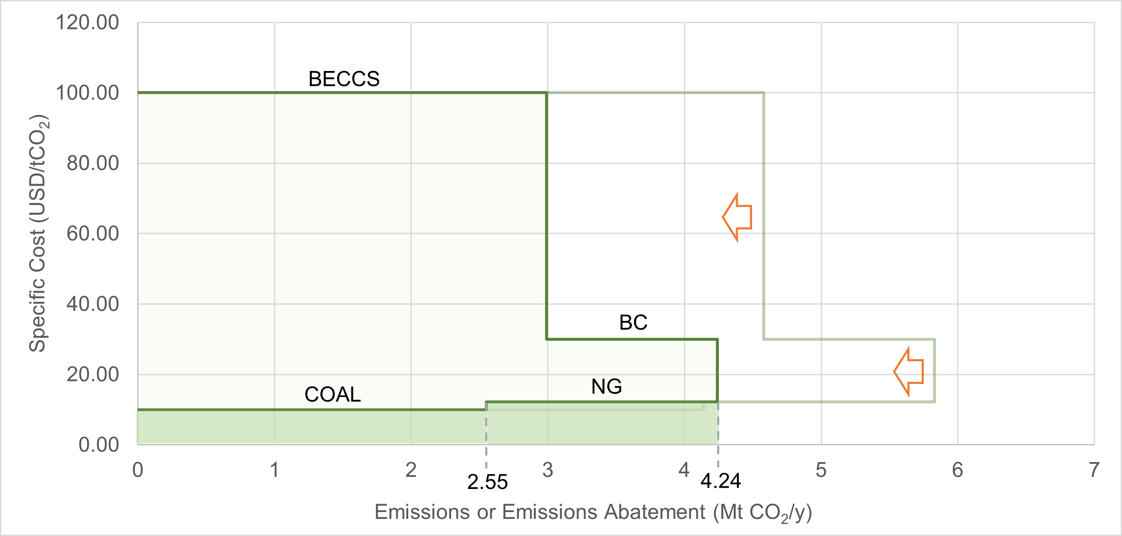
Figure 4: Net-zero planning case study after shifting the graph
  - Conclusions
A graphical net-zero emissions planning method is proposed based on MAC curves. The method allows for the visual determination of the net-zero deficit or the amount of additional negative emissions required to meet net-zero emissions given a set of CO₂-emitting sources and NETs. The resulting graph shows the emissions or negative emissions of each technology and their specific costs. The total costs of implementation can be obtained by calculating the areas under the curves. The decisionmaker can add additional NETs, shift the graph, or change the composition of the CO₂-emitting sources to meet net zero. The case study shows that a scenario using 500 MW each of coal and natural gas power plants alongside a 500 MW BECCS plant and an additional 1.25 Mt CO₂/y sequestration thru BC results in a net-zero deficit equal to 1.59 Mt CO₂/y that needs to be met to reach net-zero emissions. Shifting the graph by reducing the emission from coal can achieve net-zero emissions but at a reduced power rating for coal (308.53 MW). The proposed technique provides a simple and clear method for net-zero emissions planning with the specific cost in view. Future work can involve algebraic targeting extensions, demonstration in manufacturing industries, and using co-generation for negative specific costs. Aside from costs, benefits can also be taken into account (e.g., profits), such that when benefits exceed the costs, the curves for these technologies are below the x-axis. This technique can also be combined with game theory to account for the inherently multi-agent nature of real carbon management problems.
Acknowledgments
Maria Victoria Migo-Sumagang would like to acknowledge the financial support of the Department of Science and Technology (DOST), Republic of the Philippines, via the Engineering Research and Development for Technology (ERDT) scholarship program, and the support of the Chemical Engineering Department (DChE), College of Engineering and Agro-Industrial Technology (CEAT), University of the Philippines Los Baños (UPLB). Dr Short, Dr Nair, and Prof Foo would like to acknowledge the funding of the British Council under the COP26 Trilateral Research Initiative programme.
References
Chrobak U., 2021, Corporate Climate Pledges Pile Up—Will It Matter?, Engineering, 7(8), 1044–1046.
Dhole V.R., Ramchandani N., Tainsh R.A., Wasilewski M., 1996, Make your process water pay for itself, Chemical Engineering, 103, 100-103.
Donnison C., Holland R.A., Hastings A., Armstrong L.M., Eigenbrod F., Taylor G., 2020, Bioenergy with Carbon Capture and Storage (BECCS): Finding the win–wins for energy, negative emissions and ecosystem services—size matters, GCB Bioenergy, 12(8), 586–604.
Enkvist P.A., Nauclér T., Rosander J., 2007, A cost curve for greenhouse gas reduction, Mckinsey, 1–34.
Fajardy M., Mac Dowell N., 2017, Can BECCS deliver sustainable and resource efficient negative emissions?, Energy and Environmental Science, 10(6), 1389–1426.
El-Halwagi M.M., Gabriel F., Harell D., 2003, Rigorous Graphical Targeting for Resource Conservation via Material Recycle/Reuse Networks, Industrial and Engineering Chemistry Research, 42(19), 4319–4328.
Foo D.C.Y., 2017, Extended Graphical Technique for the Evaluation of Carbon Dioxide Emission Reduction Projects, Process Integration and Optimization for Sustainability, 1(4), 269–274.
Fuss S. Fuss S., Lamb W.F., Callaghan M.W., Hilaire J., Creutzig F., Amann T., Beringer T., De Oliveira Garcia W., Hartmann J., Khanna T., Luderer G., Nemet G.F., Rogelj J., Smith P., Vicente J.V., Wilcox J., Del Mar Zamora Dominguez M., Minx J.C., 2018, Negative emissions - Part 2: Costs, potentials and side effects, Environmental Research Letters, 13, 063002.
Hallale N., 2002, A new graphical targeting method for water minimisation, Advances in Environmental Research, 6(3), 377–390.
IPCC, 2014, Synthesis Report, Climate Change 2014: Contribution of Working Groups I, II and III to the Fifth Assessment Report of the Intergovernmental Panel on Climate Change, Geneva, Switzerland.
IPCC, 2021, Summary for Policymakers, Climate Change 2021: The Physical Science Basis. Contribution of Working Group I to the Sixth Assessment Report of the Intergovernmental Panel on Climate Change, Cambridge University Press, Cambridge, UK and New York, USA.
IPCC, 2022, Summary for policymakers, Climate change 2022: Mitigation of climate change. Contribution of Working Group III to the Sixth Assessment Report of the Intergovernmental Panel on Climate Change. Cambridge University Press, Cambridge, UK and New York, USA.
Iyer G. Clarke L., Edmonds J., Fawcett A., Fuhrman J., McJeon H., Waldhoff S., 2021, The role of carbon dioxide removal in net-zero emissions pledges, Energy and Climate Change, 2(6), 100043.
Klemeš J.J., Varbanov P.S., Kravanja Z., 2013, Recent developments in Process Integration, Chemical Engineering Research and Design, 91(10), 2037–2053.
Köberle A.C., 2019, The Value of BECCS in IAMs: a Review, Current Sustainable/Renewable Energy Reports, 6(4), 107–115.
Lameh M., Al-Mohannadi D.M., Linke P., 2022, Minimum marginal abatement cost curves (Mini-MAC) for CO2 emissions reduction planning, Clean Technologies and Environmental Policy, 24, 143–159.
Meier A., Rosenfeld A.H., Wright J., 1982, Supply curves of conserved energy for California’s residential sector, Energy, 7(4), 347–358.
Migo-Sumagang M.V., Tan R.R., Tapia J.F.D., Aviso K.B., 2022, Fuzzy mixed-integer linear and quadratic programming models for planning negative emissions technologies portfolios with synergistic interactions, Cleaner Engineering and Technology, 9, 100507.
Nair P.N.S.B., Tan R.R., Foo D.C.Y., 2020, Extended Graphical Approach for the Deployment of Negative Emission Technologies, Industrial and Engineering Chemistry Research, 59(42), 18977–18990.
Selosse S., Ricci O., 2014, Achieving negative emissions with BECCS (bioenergy with carbon capture and storage) in the power sector: New insights from the TIAM-FR (TIMES Integrated Assessment Model France) model, Energy, 76, 967–975.
Smith P., Adams J., Beerling D.J., Beringer T., Calvin K.V., Fuss S., Griscom B., Hagemann N., Kammann C., Kraxner F., Minx J.C., Popp A., Renforth P., Vicente Vicente J.L., Keesstra S., 2019, Land-Management Options for Greenhouse Gas Removal and Their Impacts on Ecosystem Services and the Sustainable Development Goals, Annual Review of Environment and Resources, 44, 255–286.
Tatarewicz I., Lewarski M., Skwierz S., Krupin V., Jeszke R., Pyrka M., Szczepá Nski K., Sekuła M., Szczepański K., Sekuła M., 2021, The Role of BECCS in Achieving Climate Neutrality in the European Union, Energies, 14, 7842.
The Royal Society, 2018, Greenhouse Gas Removal. London, UK.

