Energy Management of an Industrial Dairy Plant for Assesing Sustainable Operational Conditions
Guillermo Valencia Ochoa¹, Jaime Díaz Ruíz¹, and Rafael Díaz Herazo¹
¹ Mechanical Engineering Department, Universidad del Atlántico, Carrera 30 Número 8-49, Puerto Colombia, Barranquilla 08007, Colombia;
guillermoevalencia@mail.uniatlantico.edu.co (G.V.) jaimemdiaz@mail.uniatlantico.edu.co (J.D.) rediaz@mail.uniatlantiCO.EDU.CO (R.D.).

Among the great challenges for humanity are to reduce the effects of climate change and to reduce the carbon footprint produced; for this reason, energy management is vital, since, by doing so, about 43% of greenhouse gas emissions can be reduced. This article presents the development of the PEVI industrial evaluation program at Coolechera Ltda. The energy performance of its production processes was evaluated, from which the production energy diagram was constructed. Subsequently, the company's overall energy consumption was calculated, which was 518,213 kWh/month, and the annual energy costs of electricity and natural gas, which were $ 792982.6 and 916309.3 USD. From the energy analysis, the carbon footprint of the process was calculated, which was 0.04 Ton CO2/L. Finally, it was quantified that the boiler's improvement potential exceeds 11%, which, if implemented, would drastically reduce thermal energy costs and its impact on the carbon footprint.
  - Introduction
Greenhouse gases are the main pollutants responsible for climate change on our planet, since it stores greenhouse gases, and is in a continuous global warming (Lu et al., 2022) (Jakučionytė-Skodienė, Krikštolaitis and Liobikienė, 2022) (Qin et al., 2020). Such pollutant emissions are mainly emitted in energy transformation processes; for this reason, research and industry should focus on more efficient production processes in order to obtain significant energy savings, which translates into a substantial decrease in environmental impact and production costs (Jaiboon et al., 2021) (Javed and Cudjoe, 2022) (Li et al., 2022).
Researchers around the world have focused their efforts on increasing the overall efficiency of production processes in industry by efficient energy management (Kalantzis and Niczyporuk, 2022)(Raza and Lin, 2022), because it is the most effective way for industry to mitigate pollutant emissions (García-Quevedo and Jové-Llopis, 2021). For that reason, different mathematical models have been developed to predict the energy behavior of a production plant and thus increase its performance (Cai et al., 2022).
One of the most important ways to characterize the energy performance of a piece of equipment or a production plant is through baselines, which allow evaluating the energy performance with respect to production (Wang et al., 2022). Another resource to evaluate energy characterization is the use of meta lines, through which energy performance goals can be set using the operational management of a production line (Vrionis, Tsalavoutis and Tolis, 2020).
The implementation of efficient energy management not only brings as benefits the reduction of greenhouse gases and significant savings of energy services and fuels; in different countries, depending on the legislation in force, the industrial sector is encouraged to practice such practices by reducing taxes and obtaining subsidies (Vogt et al., 2022) (Nie et al., 2021), in the same way, there are other countries where the political and economic model involves taxing those companies that include energy in their energy matrix (Gan and Smith, 2006). Additionally, studies have shown that efficient energy management has a social impact on the economic security of the community, because it reduces economic dependence on imported energy, thus providing stability, reducing inflationary pressures caused by the rise in international prices of energy raw materials, generating employment and positively influencing human physical and mental health (Ryan and Campbell, 2012).
Among the equipment to which operational management can be performed are compressors, boilers, refrigeration equipment, chillers, among others, so that the energy consumed is much lower, by making changes in their operating conditions, obtaining significant energy savings from low investments (Chang et al., 2021) (Khaljani et al., 2021). Among the operational management studies carried out, the research applied to industrial boilers in Hunan province in China stands out; in it, quantitative analysis methods of effective energy and exergy were applied to obtain the efficiency of industrial boilers, with which a reasonable regional standard of energy efficiency of industrial boilers was proposed (Chen et al., 2021). In another case study, a computational algorithm was applied to a boiler of a thermal power plant in Cuba. The results of this research indicate that the gross efficiency of the boiler is 92%, its specific fuel consumption is 238g/kWh, and the required mitigation cost per ecological footprint was reduced by 3.1 USD/h. The proposed algorithm foresees technical-organizational actions in the steam boiler to improve its energy performance, which if implemented will allow significant thermal energy savings (Camaraza-Medina et al., 2021).
In this article, the energy characterization of a milk and dairy products production plant is carried out, showing the productive energy diagram, a Pareto analysis with the main consumption equipment, an energy performance analysis through baselines and meta lines, and finally, an analysis through thermography of the boiler of the milk factory; with the procedures carried out, the company was energetically characterized and energy saving potentials were identified.
  - Methodology
In order to carry out the energy management in the industrial plant, information was collected on the distribution of the production processes operating in the plant and the records provided by the network operator in the monthly invoices, in order to make the respective energy calculations concerning this study. The energy consumption of the equipment was estimated according to its nominal power, in order to have an estimate of the total consumption of the company. Among the energy characterization tools used, the use of baselines and meta lines stand out.
The baseline represents the significant linear model of energy consumption, when compared to production. The meta line, on the other hand, is a linear model that allows setting goals with those consumptions below the baseline. The next step of the energy characterization was to calculate energy performance indicators, which are shown in equations (1) through (3):

$$Reliability of Performance=\frac{Time of good performance}{Total evaluation time}$$ | (1)
$$Frequency Loss of Performance=\frac{Total evaluation time}{Times it recovers from poor performance}$$ | (2)
$$Average recovery time from poor performance =\frac{Time of poor performance}{Times it recovers from poor performance}$$ | (3)

The indicators were also calculated on a hundred basis, which are presented in equations (4) and (5).
$${Base Consumption}_{100}=\frac{Base consumption}{Real consumption}×100$$ | (4)
$${Goal consumption}_{100}=\frac{Goal consumption}{Real consumption}×100$$ | (5)

Subsequently, the ecological energy footprint that the company has left over time and its equivalent value in terms of ecological footprint was calculated.
Afterwards, the energy characterization of the boiler was carried out by means of thermography analysis, in order to find improvement potentials.
  - Results and discussion
    - Energy Matrix
In the first instance, the productive energy diagram was made, in which all the energy sources demanded by the organization and the process flowchart are presented in Figure 1. Based on this, it was found that the company has two primary energy sources: Electric power and natural gas. Natural gas accounts for 53.61% of the total primary energy, which is used to generate the steam required in the milk sterilization stages. Electrical energy makes up the remaining 46.39% and is used to generate compressed air and power the refrigeration systems. The rest of the energy is used in the process stages, with pasteurization and ultra pasteurization being the processes that demand the most energy in the liquid milk production process. The annual costs of electricity and natural gas were 792982.6 and 916309.3 USD, respectively.

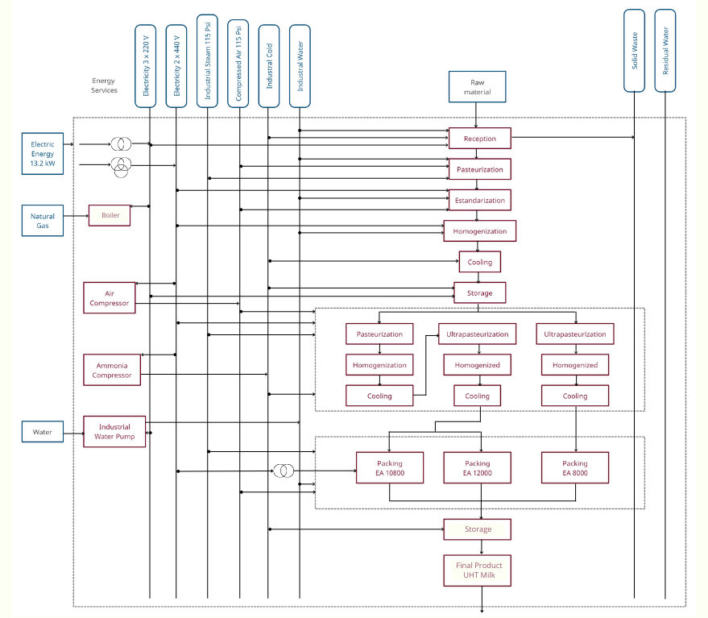
Figure 1. Energy production diagram
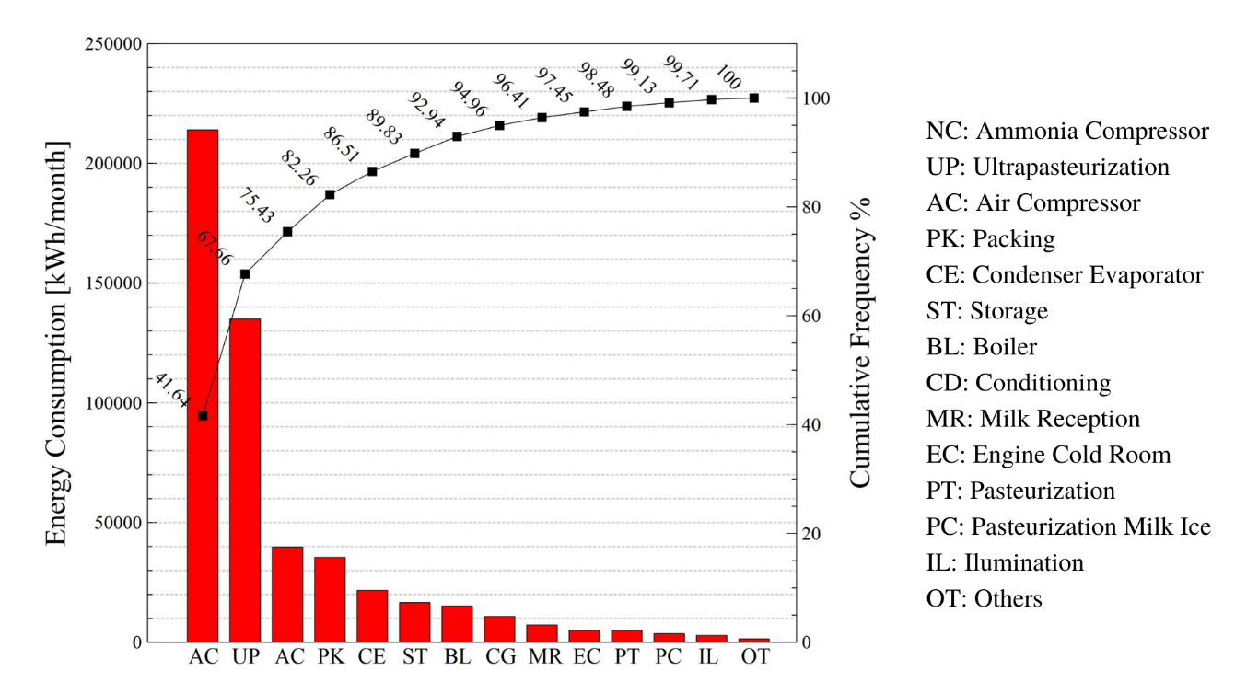
Figure 2. Pareto diagram of energy consumption.

Based on the results presented in Figure 2, the ammonia compression system by electric power and the natural gas generation system were selected as the significant energy uses, since a high potential for energy savings was identified. As for gas, the steam generation system was chosen because there is a high potential for improvement.
    - Energy, Production vs. Time Graphs
With the data obtained on the company's total energy consumption per month, energy consumption and milk production were plotted for each month, in order to compare changes in energy consumption with changes in production, and thus find the months with the highest and lowest energy performance. Figure 3.a and 3.b shows the change in consumption and production month by month, according to which there were two months where there was a large gap between the two variables, with respect to the adjacent months. Next, Figure 3c and 3d, where the annualized trend of energy consumption and production is presented, shows that there was a good energy performance from December 2020 to June 2021.

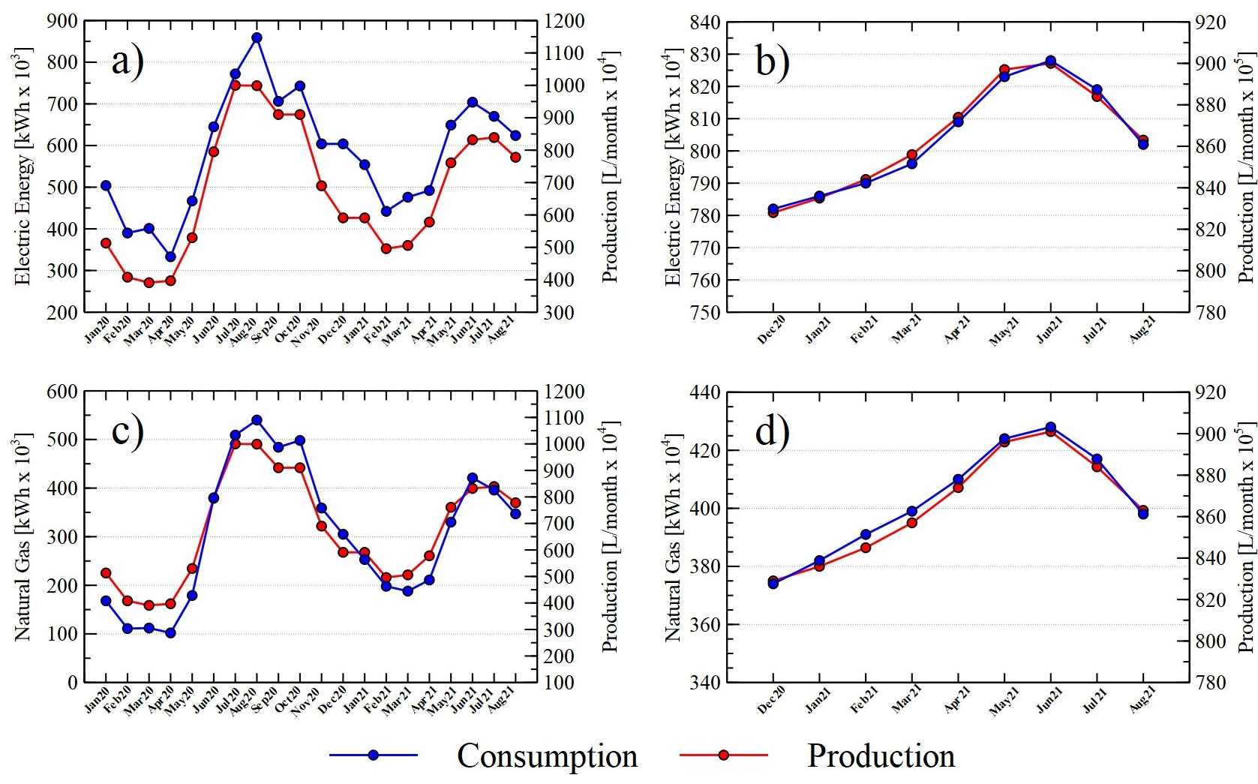
Figure 3. Energy, Production vs. Time Diagram
The values of production VS consumption of electricity and natural gas were plotted, as shown in Figure 4. The linear models obtained in each graph allowed determining the baseline and the meta line in each case.
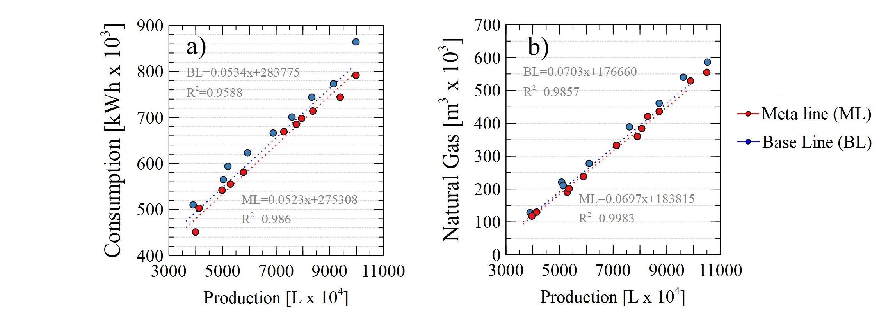
Figure 4. Baseline and goal graph for a) electric energy, and b) natural gas
Figure 4 shows the baseline and meta natural gas consumption. It is observed that 283775 kWh/month of electric energy and 176660 m3 of natural gas are not associated with production. Regarding the meta line, a potential for energy management of production for electric energy and natural gas of 2.4% and 3.7%, respectively, was found. Following, based on the results of the baselines and meta lines, the base 100 performance indicators were plotted, the results of which are shown in Figure 4, and the months with efficient or inefficient energy performance can be identified depending on the value obtained in the baselines and meta lines, taking as performance criteria the difference between the value of the indicator in base 100 with respect to 100%. With the results obtained in Figure 5, the results of the energy management analysis were described, which are presented in detail in Table 1:

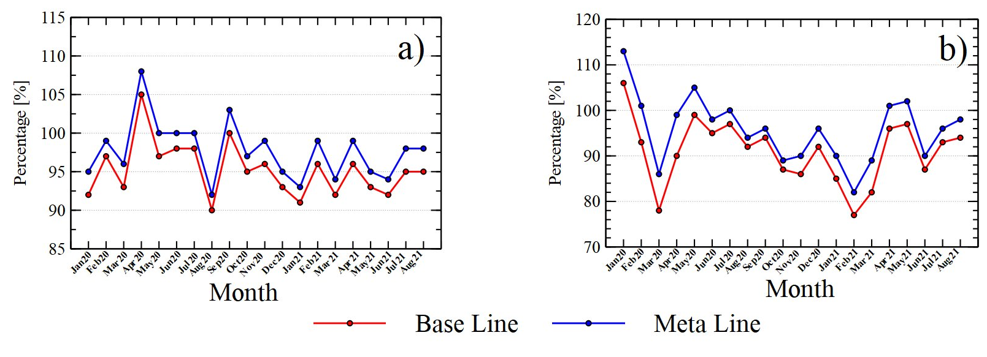
Figure 5. Performance indicators in base 100 for a) electric energy, and b) natural gas
Table 1. Results of the analysis for the period.
Description | Value
Time of good performance | 9
Total evaluation time | 19
Times recovering from bad performance | 3
Time of bad performance | 10
Reliability of performance | 47.37
Frequency of loss of performance | 6.33
Average performance recovery time | 3.33
    - Thermal Analysis
Finally, an energy diagnosis of the steam boiler was carried out, starting with the application of thermography to identify potential improvements in the equipment for thermal insulation.
In this section of the boiler, hot areas are observed, especially those located in the part of the exhaust gas duct, it can be seen in Figure 6a, that the central part of the boiler handles a temperature range between 80 and 90 °C, and in Figure 6b, it can be seen in detail the areas of high temperatures.
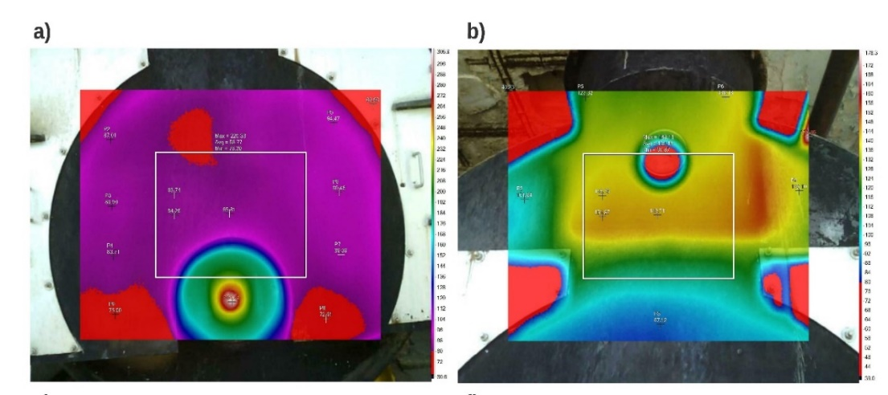
Figure 6. Thermographic images of the steam boiler at the flue gas outlet.
This is an indication of a lack of insulation, and therefore, an opportunity for improvement, since the equipment has been in operation for twenty-five years, and current commercial insulation materials have a much better quality standard. A potential for improvement was also identified by the implementation of an automatic combustion system, which allows savings of about 5% with a simple payback time of 0.78. Another potential improvement project identified was the installation of a blowdown recovery system with savings of about 6% and a payback period of 1.9 years, which add up to approximately 11% of the energy consumed by the boiler.
  - Conclusions

The energy characterization of the company was carried out with a global energy analysis of the company and a diagnosis of two USES. The quantitative analysis of the energy consumed in the production process allowed characterizing the energy performance during the evaluated time, thus identifying the potential for improving consumption by production management through the respective indicators. In addition, it was possible to evaluate technological measures that, when implemented, will provide significant energy savings, reducing the use of fossil fuels and reducing the ecological footprint generated by the production process.
References
Cai, W. et al. (2022) “Energy saving and high efficiency production oriented forward-and-reverse multidirectional turning: Energy modeling and application,” Energy, 252, p. 123981. doi:https://doi.org/10.1016/j.energy.2022.123981.
Camaraza-Medina, Y. et al. (2021) “Energy efficiency indicators of the steam boiler in a power plant of Cuba,” Thermal Science and Engineering Progress, 23, p. 100880. doi:https://doi.org/10.1016/j.tsep.2021.100880.
Chang, K.-H. et al. (2021) “Optimizing the energy efficiency of chiller systems in the semiconductor industry through big data analytics and an empirical study,” Journal of Manufacturing Systems, 60, pp. 652–661. doi:https://doi.org/10.1016/j.jmsy.2021.07.004.
Chen, B. et al. (2021) “Investigations on the energy efficiency limits for industrial boiler operation and technical requirements—taking China’s Hunan province as an example,” Energy, 220, p. 119672. doi:https://doi.org/10.1016/j.energy.2020.119672.
Gan, J. and Smith, C.T. (2006) “A comparative analysis of woody biomass and coal for electricity generation under various CO2 emission reductions and taxes,” Biomass and Bioenergy, 30(4), pp. 296–303. doi:https://doi.org/10.1016/j.biombioe.2005.07.006.
García-Quevedo, J. and Jové-Llopis, E. (2021) “Environmental policies and energy efficiency investments. An industry-level analysis,” Energy Policy, 156, p. 112461. doi:https://doi.org/10.1016/j.enpol.2021.112461.
Jaiboon, N. et al. (2021) “Greenhouse gas mitigation potential from waste heat recovery for power generation in cement industry: The case of Thailand,” Energy Reports, 7, pp. 638–643. doi:https://doi.org/10.1016/j.egyr.2021.07.089.
Jakučionytė-Skodienė, M., Krikštolaitis, R. and Liobikienė, G. (2022) “The contribution of changes in climate-friendly behaviour, climate change concern and personal responsibility to household greenhouse gas emissions: Heating/cooling and transport activities in the European Union,” Energy, 246, p. 123387. doi:https://doi.org/10.1016/j.energy.2022.123387.
Javed, S.A. and Cudjoe, D. (2022) “A novel grey forecasting of greenhouse gas emissions from four industries of China and India,” Sustainable Production and Consumption, 29, pp. 777–790. doi:https://doi.org/10.1016/j.spc.2021.11.017.
Kalantzis, F. and Niczyporuk, H. (2022) “Labour productivity improvements from energy efficiency investments: The experience of European firms,” Energy, 252, p. 123878. doi:https://doi.org/10.1016/j.energy.2022.123878.
Khaljani, M. et al. (2021) “Experimental and modelling analysis of efficiency enhancement in a liquid piston gas compressor using metal plate inserts for compressed air energy storage application,” Journal of Energy Storage, 43, p. 103240. doi:https://doi.org/10.1016/j.est.2021.103240.
Li, S. et al. (2022) “Trajectory, driving forces, and mitigation potential of energy-related greenhouse gas (GHG) emissions in China’s primary aluminum industry,” Energy, 239, p. 122114. doi:https://doi.org/10.1016/j.energy.2021.122114.
Lu, L.-C. et al. (2022) “Sustainability efficiency of climate change and global disasters based on greenhouse gas emissions from the parallel production sectors – A modified dynamic parallel three-stage network DEA model,” Journal of Environmental Management, 317, p. 115401. doi:https://doi.org/10.1016/j.jenvman.2022.115401.
Nie, H. et al. (2021) “Evaluation of the efficiency of Chinese energy-saving household appliance subsidy policy: An economic benefit perspective,” Energy Policy, 149, p. 112059. doi:https://doi.org/10.1016/j.enpol.2020.112059.
Qin, P. et al. (2020) “Assessing concurrent effects of climate change on hydropower supply, electricity demand, and greenhouse gas emissions in the Upper Yangtze River Basin of China,” Applied Energy, 279, p. 115694. doi:https://doi.org/10.1016/j.apenergy.2020.115694.
Raza, M.Y. and Lin, B. (2022) “Energy efficiency and factor productivity in Pakistan: Policy perspectives,” Energy, 247, p. 123461. doi:https://doi.org/10.1016/j.energy.2022.123461.
Ryan, L. and Campbell, N. (2012) “Spreading the Net: the Multiple Benefits of Energy Efficiency Improvements",” IEA Energy Papers, 8.
Vogt, M. et al. (2022) “Energy efficiency of Heating, Ventilation and Air Conditioning systems in production environments through model-predictive control schemes: The case of battery production,” Journal of Cleaner Production, 350, p. 131354. doi:https://doi.org/10.1016/j.jclepro.2022.131354.
Vrionis, C., Tsalavoutis, V. and Tolis, A. (2020) “A Generation Expansion Planning model for integrating high shares of renewable energy: A Meta-Model Assisted Evolutionary Algorithm approach,” Applied Energy, 259, p. 114085. doi:https://doi.org/10.1016/j.apenergy.2019.114085.
Wang, J. et al. (2022) “A line-based flash heating method for numerical modeling and prediction of directed energy deposition manufacturing process,” Journal of Manufacturing Processes, 73, pp. 822–838. doi:https://doi.org/10.1016/j.jmapro.2021.11.041.

