|  |  |
| --- | --- |
| cetlogo ***CHEMICAL ENGINEERING TRANSACTIONS***  ***VOL. 96, 2022*** | A publication of  aidiclogo_grande |
| The Italian Association  of Chemical Engineering  Online at www.cetjournal.it |
| Guest Editors: David Bogle, Flavio Manenti, Piero Salatino  Copyright © 2022, AIDIC Servizi S.r.l. **ISBN** 978-88-95608-95-2; **ISSN** 2283-9216 | |

Photocatalytic Degradation of Tetracycline using Visible-light-driven Porous g- C3N4 Nanosheets Catalyst

Nothando A. Phakathi\*, Shepherd M. Tichapondwa, Evans M. N. Chirwa

Water Utilisation and Environmental Engineering Division, Department of Chemical Engineering, University of Pretoria, Pretoria 0002

abigailphakathi64@gmail.com

Tetracycline is one of the most widely prevalent antibiotics, and it is used for both veterinary and human medical care purposes. Tetracycline is not fully absorbed in the digestive tract of humans and animals, and it is estimated that approximately 50% is excreted through urine and faeces and enters the environment as the parent compound of one of its metabolites. Conventional wastewater treatment processes have been shown to be inefficient in degrading tetracycline resulting in bioaccumulation of the compound. Advanced Oxidation Processes (AOPs) such as heterogeneous photocatalysis have been shown to be an efficient and eco-friendly technology for the removal of refractory organic pollutants from wastewater. This study investigates the use of graphitic carbon nitride as a photocatalyst for the degradation of tetracycline in wastewater. The catalyst was synthesized through pyrocondensation polymerization. X-ray diffraction analysis confirmed formation of the desired material. The efficacy of the synthesized material was investigated using a batch reactor set-up under ultraviolet and visible light irradiation. The control adsorption experiments showed 4.4 % tetracycline removal after 2 h, while visible light photolysis resulted in 21.9 % degradation in the same period. These results were markedly lower than the 76.7 % degradation observed under visible light activated photocatalysis conditions. Process parameter optimization experiments revealed that a catalyst loading of 1 gL-1 and pH of 7.00 resulted in 77 % tetracycline degradation after 2 h of visible light irradiation.

* 1. Introduction

Water is a valuable resource, vital for sustaining life and it is associated with major human activities such as agriculture, industry, and domestic uses. There is an increasing concern about water pollution resulting from the release of multiple compounds in water bodies emanating from agriculture, industry, and domestic practices worldwide (Deblonde et al., 2011). Micro-pollutants are among the growing list of emerging pollutants released from various anthropogenic activities into water bodies, and they pose a threat to the environment and human health. Micro-pollutants are persistent and toxic in various water matrices and tend to be bio-accumulative in living organisms resulting in negative effects to the environment and human health, even at trace concentration (Sauvé and Descrosiers, 2014). This group of pollutants contains, but is not limited to: pharmaceutically active compounds (phACs), personal care products, endocrine disruptors, pesticides and industrial chemicals. Pollution due to micro-pollutants in groundwater, surface water bodies and soil environment has been associated with the collective negative effects along multigenerational contact in aquatic organisms and distress human health by becoming a part of the ecosystem (Daughton, 2010).

The representative pharmaceuticals found in wastewater influent, surface and groundwater samples are antibiotics, anti-inflammatory drugs, lip regulators, beta-Blockers and X-ray contrast media (Fekadu et al., 2019). Global antibiotics usage exceeds 100 000 tons per year (Danner et al, 2019). There is a growing concern over the fate, effects and risks of these compounds and their metabolites substances when released in aqueous systems. Tetracycline is regarded as one of the most widely used antibiotics, and it is used to treat and prevent bacterial infections in human and veterinary medicine. After administration, tetracycline is not fully absorbed in the digestive tract of humans and animals, and it is estimated that approximately 50 % is excreted through urine and faeces and enters the environment as the parent compound of one of its metabolites (Saadati et al., 2016). The extensive use of this antibiotic in various settings has resulted in its continuous discharge via sewage, improper disposal, drain water or industries into receiving water bodies leading to its persistence in the environment (Ben et al, 2019). Conventional water and wastewater treatment processes are found to be inadequate for efficient removal of tetracycline antibiotics (Daghrir and Drogui, 2013).

Photocatalysis, an advanced oxidation process has been shown to be an efficient and eco-friendly technology for the removal of refractory organic pollutants from wastewater. Tetracycline can be degraded and mineralized effectively through a semiconductor photocatalysis, however selection of an appropriate photocatalyst is vital to achieve remarkable efficiency (Gheytanzadeh et al., 2022). Lately, g-C3N4 has received considerable attention as an efficient photocatalyst for the remediation of various organic pollutants from water due to its exceptional properties such as suitable band gap, high stability, unique electronic properties, affordability, eco-friendly and easy modification. However, pure g-C3N4 suffers limitations such as low surface area, rapid recombination of photo induced charge carriers, low visible-light absorption and low electronic conductivity (Zhang et al., 2019). Various strategies have been explored to overcome these shortcomings. Examples include; controlling catalyst morphology, element doping, surface modification and constructing heterojunctions to improve the photocatalyst activity (Liang et al, 2021). Porous g-C3N4 was reported to enhance the photocatalytic capability by increasing surface area which in turn increases the number of active sites and ultimately preventing the fast recombination of photo-induced electron and holes pairs (Liu et al., 2020). In this study, porous g-C3N4 nanosheets photocatalyst was synthesised by co-pyrolyzing melamine and ammonium bicarbonate. The degradation efficiency of the resultant material was tested on tetracycline polluted water under simulated visible-light irradiation. The synthesised photocatalyst was characterised by X-ray diffraction (XRD) to analyse the crystal structure of the material.

* 1. Material and methods
     1. Chemicals and reagents

Melamine powder, ammonium bicarbonate (NH4HCO3), tetracycline (the organic pollutant) and HPLC grade methanol (≥ 99.9 %) were purchased from Sigma Aldrich. All chemicals and reagents were of analytical grade and used without further purification. Ultrapure and deionised water was used during the experiment.

* + 1. Catalyst Synthesis

Porous g-C3N4 nanosheets were prepared though pyrocondensation polymerization with melamine and ammonium bicarbonate technique adopted and modified from (Liu et al., 2020). 10 g of each material, melamine and ammonium bicarbonate was dissolved in 150 mL of ultrapure water then dried at 95˚C for approximately 24 hours. The material was then added to an alumina crucible with cover and calcined at 600˚C for 2 hours in muffle furnace. After cooling to room temperature, the bulk yellow g-C3N4 was grounded into powder and heated at 600˚C for another 2 hours to obtain much thinner g-C3N4 nanosheets. The resulting light-yellow material was washed with ethanol (98 %) and ultrapure water three times then dried at 80˚C.

* + 1. Characterisation

The X-ray diffraction (XRD) spectra of the prepared samples were analysed using a PANalytical X’Pert Pro powder diffractometer in θ–θ configuration with an X’Celerator detector and variable divergence- and fixed receiving slits with Fe filtered Co-Kα radiation (λ=1.789Å). The mineralogy was determined by selecting the best–fitting pattern from the ICSD database to the measured diffraction pattern, using X’Pert Highscore plus software.

* + 1. Photocatalytic tests

Tetracycline stock solution of 100 mg/L concentration was prepared by dissolving 0.1 g of TC in 5 mL of methanol before being topped with deionised water to the 1 L mark, thereafter dilutions were prepared from these stock solutions to make desired concentrations. The photocatalytic experiments were carried out at 25˚C using a sealed batch glass photo-reactor with the capacity of 1 L, equipped with a 450 W visible lamp for visible light experiments and 450 W ultraviolet (UV) lamp for UV light experiments. The typical test solutions consisted of 500 mL of TC solution (10 mg/L), 0.5 g of the synthesised photocatalyst and a magnetic stirrer to ensure a homogeneous solution of the pollutant and catalyst. The test solution was stirred in the dark for 30 minutes to reach adsorption-desorption equilibrium. Thereafter, the suspension was irradiated and a 5 mL of aliquots samples were collected at certain time interval. These aliquots were centrifuged for the removal of photocatalyst before analysis.

* + 1. Degradation analytical method

The concentration of Tetracycline and progressive degradation was analysed using a UV/Visible spectrophotometer (Jenway 7205) at a wavelength of 357 nm. The total degradation of tetracycline after 2 h was evaluated using the expression shown in equation 1.

|  |  |
| --- | --- |
| $$\% Degradation=\frac{(C_{0}-C_{t})}{C_{0}}×100$$ | 1) |

Where, $C_{0}$ is the initial tetracycline concentration and $C_{t}$ is the concentration of tetracycline at any given time, t.

* 1. Results and discussion
     1. Catalyst Characterization

The XRD analysis was conducted to investigate the purity and crystalline structure of the synthesised material. The XRD spectra of the material are shown in Figure 1 below. The XRD pattern shows that a hexagonal g-C3N4 (JCPDS 87-1526) was formed as shown by the distinct diffraction peaks at a 2θ angles of 15˚ and 32˚ which correspond to (100) and (002) planes (Praus et al., 2021). The low intensive peak (100) at 2θ = 15˚ correspond to the in-plane structuring packing of nitrogen-linked tri-s-triazine unit and the more intensive peak (002) at 2θ = 32˚ is related to the interlayer stacking of aromatic structures indexed for graphitic material (Smýkalová et al., 2021). The more intensive peak (002) and less intensive peak (100) indicates that the materials were well crystallised, a graphite-like structure of g-C3N4 was formed (Starukh et al., 2021).

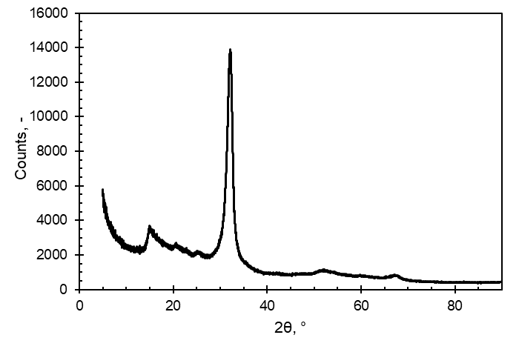

Figure 1: XRD spectra of the as prepared graphitic carbon nitride photocatalysts

* + 1. Photocatalytic Activity

The photocatalytic degradation of tetracycline (10 mg/L) using the prepared porous g-C3N4 nanosheets at a loading of 1 g/L was evaluated under UV and visible-light irradiation. Control experiments were performed to investigate the direct effect of UV and visible-light irradiation on tetracycline (photolysis) as well as the adsorptive properties of the catalyst in the absence of light irradiation. The adsorption, photolysis and photocatalysis degradation activity are shown in *Figure 2*.The catalysis experiment (adsorption) without light irradiation had 4 % degradation in 2 hours which could be the result of the adsorption-desorption equilibrium of tetracycline compounds to the surface of photocatalyst in the dark. These results indicate a negligible degradation of adsorption in the removal of TC. The photolysis test where tetracycline is degraded without catalyst under visible-light and UV light irradiation had 21.9 % and 28.62 % over 2 hours which shows that there is little bond cleavage based on light exposure only. Degradation by direct photolysis is possible for some contaminants at a radiation that has wavelength in the range of 200-400 nm (Ichipi et al., 2021). Tetracycline is yellow in colour therefore has a major absorption range in wavelength 300-430 nm. This improves TC photodegradation by enabling TC molecules to be activated by visible light and to be easily adsorbed on the surface of photocatalyst. A photodegradation of approximately 76.28 % and 76.79 % was exhibited under UV and visible-light in 2 hours. The outstanding photocatalytic activity is attributed to the enhanced visible light absorption, large surface area and efficiency separation of photoexcited carriers of porous g-C3N4 nanosheets photocatalyst (Zhang et al., 2021).The effect of pH on photodegradation of pollutant was investigated under visible light irradiation at selected pH 3, 7, 9 and 11 which represents the acidic, neutral and basic conditions and the results are presented in *Figure 3.* At pH 3, 7, 9 and 11, the degradation was 38.18 %, 77.06 %, 61.84 % and 55.06 % over 2 hours. The results indicates that TC degradation is minimal under acidic, optimal under neutral and moderate under basic pH conditions. Previous researches reported that tetracycline is an amphoteric molecule cationic at pH less than 3.3, zwitterionic in the pH range of 3.3 – 7.68 and anionic at pH above 7.68 (Guo et al., 2021). The surface charge of g-C3N4 has been reported to be positive at pH 3 and negative from pH 7-10. The photocatalytic degradation of TC will be minimal at pH 3, optimal at pH 7 and moderate at pH 9-11 as a result of TC speciation and g-C3N4 surface charge. Tang et.al (2022) reported a degradation of 99.3% of TC (5 mg/L) at pH 7 using g-C3N4 powder catalyst after 4 hours which is lesser as compared to that of the as-synthesized porous g-C3N4 nanosheets catalyst which had 77 % degradation of TC (10 mg/L) at pH 7 after 2 hours from this study. This can be the results of the catalyst morphology and structure (Saadati et al., 2016).

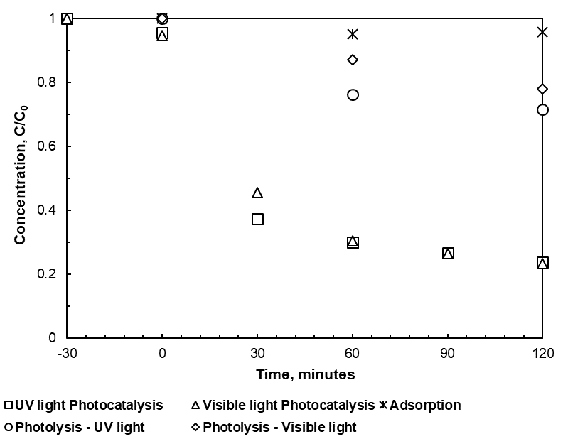

*Figure 2: Adsorption (without light), photolysis without catalyst (under UV and visible light irradiation) and photocatalysis test (Under UV and visible light irradiation)*

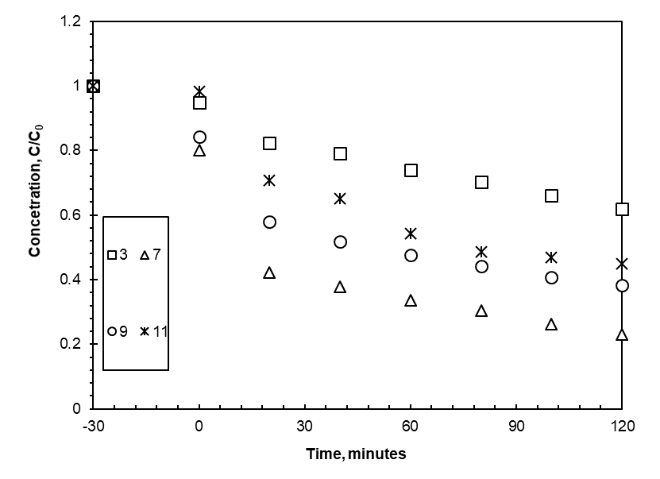

*Figure 3: Effect of pH on degradation under visible light irradiation.*

* 1. Conclusions

The photocatalytic degradation of tetracycline using the synthesized porous g-C3N4 nanosheets as a photocatalyst was investigated. XRD characterization revealed the crystallinity of the synthesized material. The photodegradation test indicated that the interaction between catalyst and light is required for a significant degradation of TC. The porous g-C3N4 nanosheets catalyst is efficient under both UV and visible light irradiation, which is attributed to the exceptional intrinsic properties of the material. It is interesting to note that the efficacy of visible light photocatalysis was similar to the UV light conditions even though the later provides higher energy photons. pH optimization studies showed that TC degradation is pH dependent, optimum degradation can be achieved at pH 7. This study shows the potential use of a visible-light activated g-C3N4 for remediation of tetracycline in the aquatic environment.

References

Adenuga D., Skosana S., Tichapondwa S., Chirwa E., 2021, Synthesis of a plasmonic AgCl and oxygen-rich Bi24O31Cl10 composite heterogeneous catalyst for enhanced degradation of tetracycline and 2,4-dichlorophenoxy acetic acid, RSC Advances, 11, 36760-36768.

Bena Y., Fua C., Hua M., Liua L., Wonga M.H., Zhenga C., 2019, Human health risk assessment of antibiotic resistance associated with antibiotic residues in the environment: A review, Environmental Research, 169, 483-493.

Daghrir R., Drogui P., 2013, Tetracycline antibiotics in the environment: A review, Environmental Chemistry Letter, 11, 209–227.

Danner M-C., Robertson A., Behrends V., Reiss J, 2019, Antibiotic pollution in surface fresh waters: Occurrence and effects, Science of the Total Environment, 664,793–804.

Daughton C.G., 2010, Pharmaceutical Ingredients in Drinking Water: Overview of Occurrence and Significance of Human Exposure, American Chemical Society, 1048, 9-68.

Deblonde T., Cossu-Leguille C., Hartemann T., 2011, Emerging pollutants in wastewater: a review of the literature, International Journal of Hygiene and Environmental Health, 214 (6), 442-448.

Fekadu S., Alemayeh E., Dewil R., Van der Bruggen B., 2019, Pharmaceuticals in freshwater aquatic environment: A comparison of African and European challenge: A Review, Science of the Total Environment 654, 324-337.

Gheytanzadeh M., Baghban A., Habibzadeh S., Jabbour K., Esmaeili A., Mohaddespour A., Abida O., 2022, An insight into tetracycline photocatalytic degradation by MOFs using the artificial intelligence technique. Scientific Reports, 12, 6615.

Gou J., Jiang L., Liang J., Xu W., Yu H., Zhang J., Ye S., Xing W., Yuan X., 2021, Photocatalytic degradation of tetracycline antibiotics using delafossite silver ferrite-based Z-scheme photocatalyst: Pathways and mechanism insight, Chemosphere, 270, 128651.

Ichipi E., Tichapondwa S., Chirwa E.M., 2021, Photocatalytic Activity of Visible-light-driven Ternary Ag/Ag2S/ZnO Nanocomposites for Phenol Degradation in Water, Chemical Engineering Transactions, 86, 817-822 DOI:10.3303/CET2186137

Liang J., Yeng X., Wang Y., He P., Fu H., Zhao Y., Zou Q., An Z., 2021, A review on g-C3N4 incorporated with organics for enhanced photocatalytic water splitting, Journal of Material chemistry A, 9, 12898.

Liu G., Zhang Z., Lva M., Wang H., Chen D., Feng Y., 2020, Photodegradation performance and transformation mechanisms of sulfamethoxazole by porous g-C3N4 with ammonia bicarbonate, Separation and Purification technology.

Praus P., Smýkalová A., Foniok K., 2021, Comparison of Graphitic Carbon Nitrides Synthetized from Melamine and Melamine-Cyanurate Complex: Characterization and Photocatalytic Decomposition of Oflfloxacin and Ampicillin, Materials, 14, 1967.

Saadati F., Keramati N., Ghazi M.H., 2016, Influence of parameters on the photocatalytic degradation of tetracycline in wastewater: A review, Critical Reviews in Environmental Science and Technology, 46:8, 757-782.

Saadati F., Keramati N., Ghazi M.M., 2016, Influence of parameters on the photocatalytic degradation of tetracycline in wastewater: A review, Critical Reviews in Environmental Science and Technology, 48:8, 757-782

Sauvé S., Desrosiers M, 2014, A review of what is an emerging contaminant, Chemistry Central Journal 8, 15.

Smýkalová A., Foniok K., Cvejn D., Górecki K.M., Praus P., 2021, The role of guanidine hydrochloride in graphitic carbon nitride synthesis, Scientific Reports, 11:21600.

Starukh H., Koštejn M., Matějka V., Praus P., 2021, Graphitic Carbon Nitride as a Platform for the Synthesis of Silver Nanoclusters, Nanoscale Research Letters, 16,166.

Tang J., Wang J., Tang L., Feng C., Zhu X., Yi Y., Feng H., Yu J., Ren X., 2022, Preparation of floating porous g-C3N4 photocatalyst via a facile one-pot method for efficient photocatalytic elimination of tetracycline under visible light irradiation, Chemical Engineering Journal, 430, 132669.

Zhang R., Zhang X., Liu S., Tong J., King F., Sun N., Han X., Zhang Y, 2021, Enhanced photocatalytic activity and optical response mechanism of porous graphitic carbon nitride (g-C3N4) nanosheets, Materials Research Bulletin.

Zhang S., Gu P., Ma R., Luo C., Wen T., Zhao G., Cheng W., Wang X., 2019, The developments in fabrication and structure regulation of visible-light-driven g-C3N4-based photocatalysts towards water purification: A critical review, Catalysis Today, 335, 65-77.