CHEMICAL ENGINEERING TRANSACTIONS  VOL. 96, 2022 | A publication of
The Italian Association
of Chemical Engineering
Online at www.cetjournal.it

Guest Editors: David Bogle, Flavio Manenti, Piero Salatino
Copyright © 2022, AIDIC Servizi S.r.l.
ISBN 978-88-95608-95-2; ISSN 2283-9216

Improving Energy Efficiency and Identifying Low-Carbon footprint solutions at early plant design stage: a practical approach
Barbara Picutti^{(a)}*, Damiano D’Alessandro^{(b)}, Stefania Taraschi^{(c)}, Alessandro Buonomini^{(c)}, Michela Rossi^{(a)}, Francesca Rabino^{(a)}, Guido Franzoni^{(a)}
ªTecnimont S.p.A., via G. De Castillia 6A, 20124 Milan
^{b} Maire Tecnimont S.p.A., Viale Castello della Magliana 27, 00148 Rome
^{c}Kinetics technology S.p.A., Viale Castello della Magliana 27, 00148 Rome

B.Picutti@tecnimont.it
The paper describes the methodology developed in Maire Tecnimont Group for the assessment of Greenhouse Gases (GHG) emissions, applied to the design of a new plant or to the revamping of an existing one. Such a methodology can support, starting from a very early stage of design, and even during proposal phase, the decision-making process of EPC Contractors when evaluating different design alternatives, to select the best available and environmentally sustainable options.
A study was carried out, aimed at identifying innovative design solutions for the improvement of energy efficiency and the consequent reduction of GHG emissions. The economic impact (saving or cost increase) of such solutions was also assessed in the study.
The case study was a petrochemical plant designed, built, and put in operation in the last decade. Based on the existing design, thirty-two innovative ideas, covering all the plant sections, were identified as potentially interesting. All the ideas (in some case more alternative solutions could be developed for the same idea) were identified and evaluated in terms of energy consumption, cost, Scope 1 and Scope 2 emissions, as defined in the Greenhouse Gas Protocol. Each alternative solution was compared with the original design to assess its effectiveness.
Alternative solutions were classified in four categories, identified with colours: Green (GHG emission saving and cost saving); Yellow (GHG emission saving and cost increase); Orange (GHG emission increase and cost saving) and Grey (GHG emission increase and cost increase).
While the “Orange” and “Grey” solutions cannot be obviously considered in the design of a new plant matching the objectives of environmental sustainability, the “Yellow” solutions may be proven to be profitable when considering the application of a potential Carbon Tax to the plant GHG emissions, and, under some circumstances, when considering the costs of power and fuels required for their operation.

  - Introduction
The mitigation of the adverse effects of global warming and their associated climate changes represents one of the greatest challenges of our times. Greenhouse Gases (GHG) emissions, mainly responsible of global warming are continuously growing, but this trend must be reversed to match the goal of reaching net zero emissions, to limit the rise in global temperature. In the industry sector, the reduction of GHG emissions is one of the key issues for the demonstration of the environmental sustainability and social acceptability for building and operating any plant. The paper presents a methodology for the evaluation of different technical solutions applicable during the design of an industrial plant and for the selection of the more environmentally sustainable ones.
  - GHG emissions accounting for plant design solutions
When initiating a Project for the construction of a new plant or the revamping of an existing one, the accurate early estimation of the GHG emissions associated to plant future operation is an added value. If such activity is performed during plant early design phase, when different and alternative design solutions are evaluated for implementation, it allows to address the Project towards a greater environmental sustainability. Also, it complies with the requirements of the Equator Principles, applied by a growing number of financial Institutions when financing projects for the construction of industrial plants and large infrastructures.
The evaluation of the solutions under analysis from the point of view of plant global GHG emissions can be done by applying common principles for GHG accounting.
The Greenhouse Gas Protocol is the most widely used international accounting tool, adopted by government agencies and business leaders, and allows an accurate accounting of GHG emissions, supported by credible and robust standards.
Specifically, emissions are divided into three “scopes”, schematically represented in Figure 1:

- “Scope 1” (direct) GHG emissions are those emissions that occur from sources that are owned or controlled inside the plant, for example, emissions from combustion in owned or controlled process equipment, boilers, furnaces, vehicles, etc.,
- “Scope 2” (indirect) GHG emissions are those emissions deriving from the generation of the electricity purchased and consumed for the plant.
- “Scope 3” (other indirect) GHG emissions are a consequence of the activities of the plant but occur from sources not owned or controlled inside the plant itself. Scope 3 emissions include extraction and production of purchased materials; transportation of purchased fuels; and use of sold products and services.
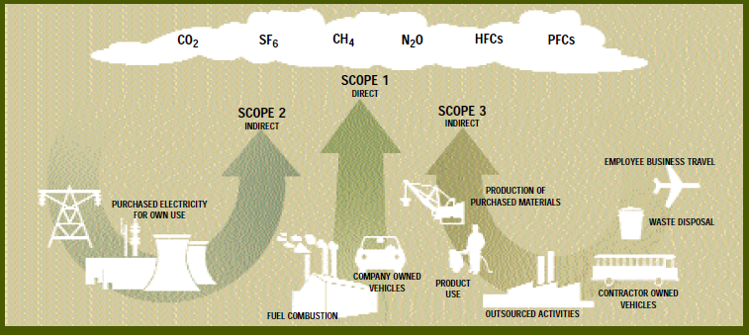
Figure 1: GHG emissions by Scope. From “GHG Protocol- A Corporate Accounting and Reporting Standard”, Revised Edition 2004
From the perspective of an EPC Contractor, whose scope is limited to the design and the construction of a plant for its client, who owns and operates it, the assessment of GHG emissions associated to the design solutions to be implemented corresponds to the evaluation of Scope 1 and Scope 2 GHG emissions of the plant. Reducing the GHG emissions associated with the design solutions that are proposed and implemented, is therefore in principle advantageous for the Client of an EPC Contractor.

  - Towards the design of low carbon footprint plant: the case study
Maire Tecnimont Group Sustainability Strategy aims at offering products, services and solutions that are environmentally sustainable. In this context, the “Energy Efficiency and Carbon Footprint Reduction Project” was launched, aimed at developing a methodology to identify and study innovative engineering solutions leading to the reduction of the overall plant carbon footprint, to be implemented in EPC Projects. A multidisciplinary design team, composed by different engineering specialists, was formed. The first task of the team was the identification of the case study. It was selected among the plants recently (in the last decade) designed, built and commissioned by Maire Tecnimont Group. The project chosen – a petrochemical plant - presented a number of possible technical alternatives that could be proposed in place of the solutions currently implemented.
The selected plant was divided into its functional sections and technical alternatives were identified for each section (Figure 2).

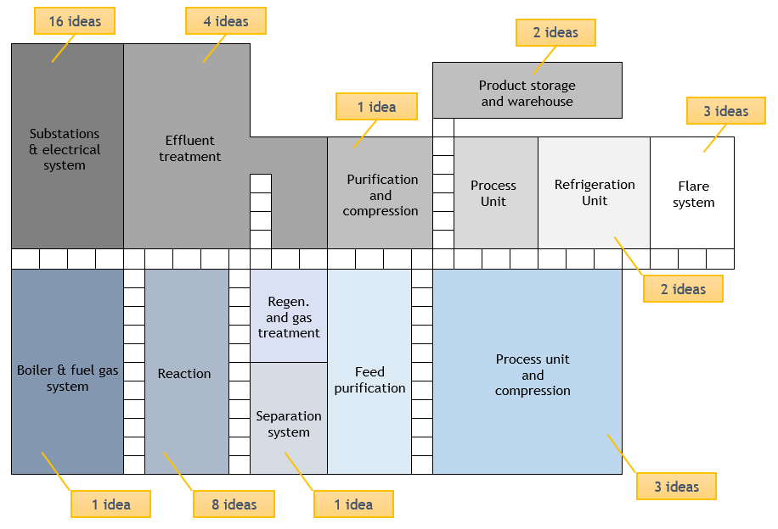
Figure 2: Selected plant, divided into its functional section. Each idea represents one alternative solution.
  - Methodology of analysis
    - From the identification of plant functional sections to the selection of the alternative solutions.
After the selection of the Case Study for the “Energy Efficiency and Carbon Footprint Reduction Project”, the multidisciplinary design team methodically proceeded as detailed below:

- Plant review, identification of main functional sections, including all process and auxiliary units.

- Analysis, for each functional section, of the technical solutions already in place (base case), characterization of the battery limits, identification of the main elements (itemized components, structural elements, etc.).

- Identification of some possible technical alternatives for each base case: identification of the main elements.

- Validation of the hypotheses and assumptions (see Section 4.2) for each base case and its alternative solutions.

- Assessment and comparative phase. A comparison on a cost-benefit basis was adopted, focused on the evaluation of the following three resulting factors for each base case and its alternative solutions:

- Energy consumption: considering the solutions implemented and the plant in operation.
- GHG emissions of Scope 1 and Scope 2: associated to the energy consumption, expressed in tons of CO₂ equivalent per year (tCO₂eq/y).
- Cost: based on the results of the cost estimation, done for each base case and for each alternative solution.

- Categorization and selection of alternative solutions. The comparison allowed to categorize the solutions in four groups and to select the ameliorative alternative ones.

All the process above described is summarized in Figure 3.

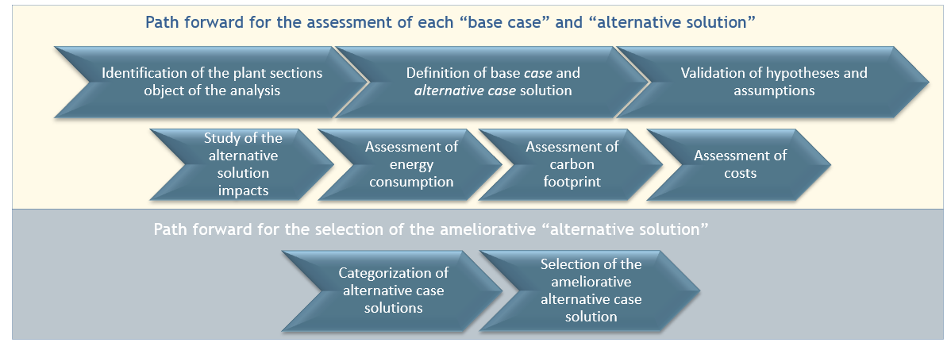
Figure 3: Methodology steps.
The methodology was applied to thirty-two technical solutions currently implemented and to the forty-one alternative solutions that were identified as possible improvements. This means that, in some cases, a currently implemented design solution could generate more than one alternative.

    - Main assumptions and their validation
The methodology requires the introduction of some main assumptions, to be verified and validated for each technical solution under evaluation.

- Each technical solution is considered as ‘stand-alone’, i.e., the impact of one alternative solution, when implemented, is assessed regardless of the implementation of the other ones.
- While each technical solution is characterized by a defined physical boundary, which, in general, is inside the plant, the impact of the solution is evaluated on the overall plant.
- The assessment of the cost of the technical solution is based on the cost of all the itemized components and, only when relevant, on the cost of bulk material associated with the solution.
- The assessment does not include the cost for the design development and the cost for the transportation and the erection at site, since considered as first approach the same for each base case and for its alternatives.
- The assessment of GHG emissions is limited to Scope 1 (direct) and Scope 2 (indirect), associated with each solution. Scope 3 emissions are not part of the present assessment.
- The impact of other technical solutions specifically addressed to the energy improvement of the construction phase of the plant (e.g.: solutions for temporary facilities and laydown areas) have not been considered in the present study.

    - Assessment and categorization of the results
The categorization of the alternative solutions was done on the basis of cost saving/increase and on the GHG emissions saving/increase in comparison with the corresponding base case solution. As shown in Figure 4, alternative solutions were classified in four categories, identified with colours: Green (GHG emission saving and cost saving); Yellow (GHG emission saving and cost increase); Orange (GHG emission increase and cost saving) and Grey (GHG emission increase and cost increase).
With reference to this scheme, while the “Orange” and “Grey” solutions cannot be obviously considered in the design of a new plant matching the objectives of environmental sustainability, “Green” solutions are undoubtedly ameliorative and worthy to be implemented.
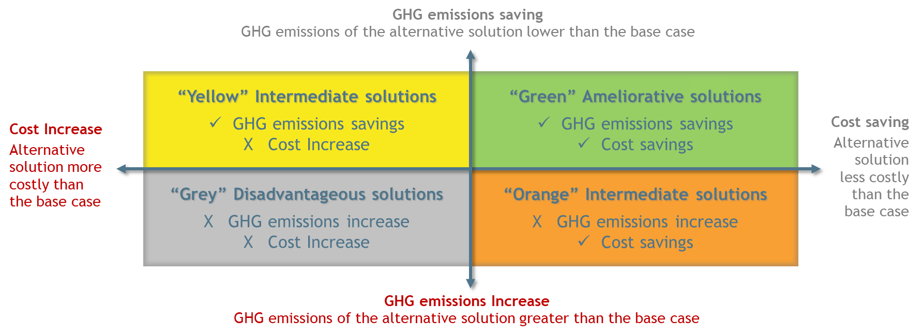
Figure 4: Classification of the “Alternative design solutions”
For what concerns the “Yellow” solutions, they may become profitable when considering the application of a potential Carbon Tax to the plant GHG emissions, and, under some circumstances, when considering the costs of power and fuels required for their operation (see Section 5).
Surprisingly, as a result of the application of the methodology, the “alternative” solutions proposed, which were initially expected to be all environmentally beneficial, not always turn out to be ameliorative after the analysis. This conveys the idea of the importance of such a methodology based on the combined analysis of the selected parameters.

    - Economic sustainability of intermediate “yellow” solutions
Effect of the application of a potential Carbon Tax
Assuming that, during the plant lifetime, the rate of consumption of fuels and electricity on a yearly average is constant, the yearly rate of GHG emissions is constant too. So, the plant GHG cumulated emissions increase linearly year after year and correspondingly, the cumulated potential tax paid by the Plant owner on GHG emissions.
For a plant, subject to the application of a Carbon Tax indicated as “CT” and emitting every year the amount “EP” of GHG emissions, the cumulated taxation of GHG emissions after t years is:

$$TAXGHG\left(t\right)=EP∙t ∙CT$$ | (1)

Assuming that the Carbon Tax is shared among the different technical solutions based on their contribution to the overall plant emissions, the cost of each solution would then be surcharged with an extra cost proportional to the associated emissions. After t years of operation, the effective cost of a generic design solution “a” is:

$$C_{a}\left(t\right)=C_{0,a}+E_{a}∙t ∙CT$$ | (2)

where C_{0,a} is the initial cost of the design solution at its implementation, E_{a} is the amount of GHG emitted over one year associated with the operation of the solution “a”.
When “yellow” solutions are compared to their base cases under the application of a carbon tax, assuming that they are implemented at the plant start-up and kept in operation for the same number of years, the cost growth rate (E_{a}*t) of the alternative solution is lower than the base case. For a given value of the Carbon Tax (CT*) the two solutions have the same cost: for a Carbon Tax greater than CT*, the alternative solution becomes less expensive than the base case (Figure 5).

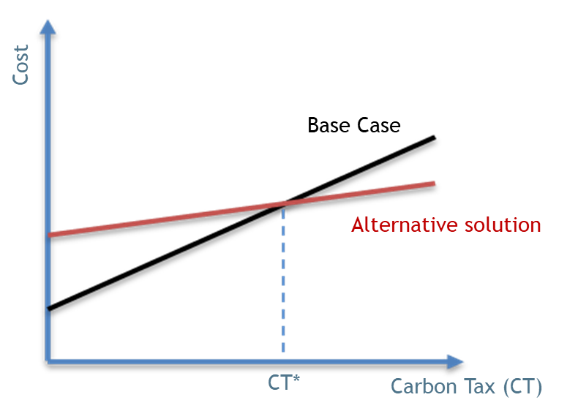
Figure 5: Effect of the application of a Carbon Tax CT to the cost of “base” and “alternative” design solutions.
By applying formula (2) to the “base” and “alternative” solutions and by equating the two results, the break-even value of CT (CT*) is obtained:

$${CT}^{*} = \frac{ΔC (Alternative-Base)}{ΔE \left(Base-Alternative\right)*t}$$ | (3)

where ΔC (€) is the difference of the costs of implementation of the alternative solution and the base case, ΔE (tCO₂eq/year) is the difference between the carbon footprint of the base case and the alternative solution, and t (years) is the plant operation time.
The formula does not consider other key factors impacting on the effective economic profitability of a solution (e.g.: the effect of its implementation on the Plant OPEX, its technical complexity, the need of additional operations for its implementation and maintenance, etc.); nevertheless, the calculation of CT* provides a criterion to compare and rank different alternative solutions that are environmentally sustainable but, for the moment, not economically attractive with respect to their ‘base’ cases. In this view, for any alternative solution environmentally sustainable, the lower is the associated carbon tax threshold value, the higher is its economic attractiveness.

Effect of the operating costs
The economic profitability of an alternative “yellow” solution can be argued when considering the operating costs. The operating costs considered in this analysis are only those associated with the consumption of fuels and electricity: they are zero at the time when the solution is implemented and increase with the plant operation time. Since a “yellow” solution requires less energy than its corresponding base case, its operating cost, associated with the consumption of fuel and electricity, can be lower than the operating cost of the corresponding base case.
Knowing the unitary costs and the consumption rates of fuels and electricity required for their operation, it is possible to compute the time to profitability T_{p}, i.e., the time when the alternative solution, considering its operating costs, would become as costly as its corresponding base case. From this time T_{p} onwards, the alternative solution would become more economically profitable than its corresponding base solution.
Applying an analogous mathematical procedure as in the previous case, for constant prices for fuels and electricity, and assuming that the denominator in the formula is greater than zero, the time T_{p} can be calculated as:

$$T_{p}=\frac{ΔC (Alternative-Base)}{ P_{f}*{ΔW}_{f} \left(Base-Alternative\right)+P_{e}*{ΔW}_{e} \left(Base-Alternative\right)}$$ | (4)

Where ΔC (€) is the difference of the costs of implementation of the alternative solution and the base case, P_{f} (€/t), P_{e} (€/kWh) are the unitary prices of fuel and electricity, ΔW_{f} (t/y), ΔW_{e} (kWh/y) are the differences of the consumptions, on a yearly basis, of fuels and electricity associated with the operation of the base and the alternative solutions.
The denominator in the formula (4) does not represent the difference in Plant OPEX, that depends also on many other variables not considered here.
However, the formula provides a criterion to compare and to rank different alternative solutions that are environmentally sustainable but, for the moment, not economically attractive. In this view, for any alternative solution environmentally sustainable, the lower is the associated time to economic profitability, the higher is its attractiveness since it would also become economically profitable in a shorter time.

  - An example of methodology application: improving the flare system
As an example of the alternative design solutions that have been investigated, Figures 6a and 6b show the results obtained for the possible implementation of a flare gas recovery system. With respect to the technical solution currently implemented (the gas is directly flared, without any recovery), two different alternative designs for the flare gas recovery have been considered, respectively based on the implementation of a system including a liquid ring compressor or, alternatively, on an ejector for flare gas recompression, both requiring electrical power.
Although the design alternatives are more expensive than the base design solution (Figure 6a), the proposed ones allow to reduce the plant carbon footprint. For the base case, the complete combustion of the gas discharged to flare turns into the production of almost 6000 t of CO₂ every year, to be computed as Scope 1 emissions. Conversely, for the design alternatives, the flare gas is recovered for other purposes (e.g.: used in replacement of fuel gas in other plant sections), and therefore, shall not be accounted for the carbon footprint. Additional electrical power required for the motors, turns into an equivalent production of a few hundreds kg of CO₂ per year only (Figure 6b), to be computed as Scope 2 emissions.
According to the categorization above, the alternative solutions 1 and 2 for this example results to be “yellow”. Indeed, they are more expensive than the base case, but they emit less CO₂.
a)
b)
Figure 6: Cost (a), total power and carbon footprint (b) associated to a flaring system (base case) and two alternative design solutions (flare gas recovery systems) based on liquid ring compressor and ejector.
Their profitability has been assessed to find the Carbon Tax and the time T_{p} after which the alternative solution becomes less expensive than its base case.
It results that, both the alternative flare recovery systems can become less expensive than the base case when a plant operation time of 20 years is considered and a Carbon Tax CT of approx. 12 €/tCO₂ is applied, which is, to make an example, lower than the current European Union Allowances.
Moreover, if considering the operating cost, the alternatives could become less expensive than the base case in a time between 5 to 10 years of operation, making it an attractive option, since their extra cost of implementation can be repaid in a time compatible with the plant lifetime.

  - Conclusions
When initiating a Project for the construction of a new plant or for the revamping of an existing one, an accurate early estimation and accounting of the GHG emissions associated to plant future operation allows to address the Project towards a greater environmental sustainability.
Such an activity can be performed during the very early design phase, and even from the proposal, when different and alternative design solutions are under evaluation for their future implementation.
A methodology for assessing the environmental sustainability of alternative design solutions has been developed. Starting from a real case, a plant designed, built, and commissioned in recent times by Maire Tecnimont Group, a team composed by different engineering specialists analyzed the technical solutions currently implemented in the entire plant with the objective to identify possible alternatives, characterized by a lower impact on the plant carbon footprint.
For each original design solution and for each new proposed alternative solution a quantitative assessment of the related cost of implementation, of the energy consumption, and of the associated GHG emissions was carried out.
Each alternative solution was categorized based on its cost impact and on its GHG emission impact. In view of the potential application of a Carbon Tax, also those alternative solutions which generate lower GHG emissions, although apparently more expensive, are worthy to be considered for their implementation, since they may result cost effective in the long run. The economic profitability of such design solutions can also be demonstrated when considering, during plant operation life, the costs associated with the consumption of fuels and electricity required for their operation.
Although the case study was based on a petrochemical plant, with a specific technology, the methodology developed for the identification of potential ameliorative solutions can be in principle applied to any plant.

References
Greenhouse Gas Protocol – www.ghgprotocol.org

The Equator Principles – July 2020 – A financial industry benchmark for determining, assessing and managing environmental and social risk in projects – www.equator-principles.com.

