CHEMICAL ENGINEERING TRANSACTIONS  VOL. 96, 2022 | A publication of
The Italian Association
of Chemical Engineering
Online at www.cetjournal.it

Guest Editors: David Bogle, Flavio Manenti, Piero Salatino
Copyright © 2022, AIDIC Servizi S.r.l.
ISBN 978-88-95608-95-2; ISSN 2283-9216

Generation-Aware Electrified Production: Optimal Continuous Industrial Production of Paint Thickeners
Maximilian Cegla*, Sebastian Engell
TU Dortmund University, Biochemical and Chemical Engineering, Process Dyanmics and Operation Group,
Emil-Figge-Straße 70, 44227 Dortmund, Germany
*maximilian.cegla@tu-dortmund.de
In this work, the generation aware production planning for a paint thickener production is investigated. In this production, products of different grades and therefore varying energy requirements are produced by electrified twin-screw extruders. The energy grid information is based on the German grid in 2020. For the investigated method, the results of the optimization of a very detailed and computationally demanding process model are used to build a computationally efficient surrogate model. This model maps the optimal minimal energy requirement to a given throughput and product grade at the optimal operating conditions. Based on this surrogate model and the price information, the optimization problem for the production planning is formulated. Constraints for the optimization problems are the satisfaction of the production demands of quantity and grade. The objective function is the minimization of the energy costs and the carbon footprint of the product caused by different energy mixes of the grid. To increase the industrial acceptance and to obtain a smoother solution, the use of a coarser time discretization is compared to penalizing the throughput changes in the cost function. The optimization problem is solved for a weekly production schedule and hourly changing energy costs and carbon footprints. The results are discussed and the performance is compared to a non-generation aware production planning. Lastly, the application at a larger scale with multiple parallel production machines is discussed.
  - Introduction
Just recently, representatives of over 200 countries agreed on the phasing down the power generation from coal at the 2021 United Nations climate change conference. Moosmann (2021) gives a detailed overview on the current political actions of the European Union. Furthermore, independence of fossil fuels has gained a drastically increasing interest from a geopolitical point of view. This further increases the interest in the use of renewable energy sources and in more energy efficient as well as more flexible production methods. Up to now, fossil fuel power plants supply a substantial fraction of the baseload word-wide. The phasing out of coal and natural gas fired power plants will lead to larger fluctuations in the overall power generation and consequently to higher fluctuations in the hour-to-hour energy price. The chemical industry as one of the large energy consumers worldwide can benefit from these fluctuations, both economically and ecologically by adjusting their production according to the availability of renewable energy. Palensky (2011) gives a broad overview on demand side management strategies depending on the process time scale. In contrast to slow processes that operate at time scales of hours for which the process itself can be used as energy storage, the application investigated here, the production of paint thickeners, can benefit from fast and flexible changes in the production. Paint thickeners are long-chained polymers that make up for up to two percent of the final paint and adjust the processing properties for application with brushes and paint rollers. The thickening efficiency can be adjusted by the polymer length as discussed by Bhavsar (2019). Conventionally paint additives are produced in batches of 10 m³ with durations of multiple hours. As these additives are highly viscous, during the batch runs long and energy consuming mixing as well as a long formulation step with water as well as a cleaning step are required. As a fully electrified, more energy efficient and more flexible alternative, the production using reactive extrusion in a twin-screw extruder has been proposed. In contrast to the inflexible batch production, the reactive extrusion process can change between different product grades and throughputs within minutes and is therefore suitable for an optimized generation-aware electrified production. More viscous product grades require higher energy input during the production and should therefore be scheduled when energy is cheap. Besides the energy costs, the carbon dioxide emissions are considered that result from the time varying mix of power sources and affect the overall sustainability of the product.
  - Method
    - Energy Grid Data
Within this investigation, data from the German electricity grid provided by Kleiner (2021) for 2015-2020 is used. By the choice of data from early 2020, the study is not impacted by the effects of the Corona crisis on the generation and consumption. The data includes information on the day-ahead price, the energy grid mix and consumption. The resolution of the data is hourly.
    - Plant model
For the production of the paint thickeners, here hydrophobically modified ethoxylated urethanes (HEUR), a twin-screw extruder is used in contrast to the conventional batch production. For this production, long chained polyethylene glycol (PEG) reacts with di-isocyanates and octanol as short chained alcohol endcapper as proposed by Reuvers (1999). For the optimization of the steady-state set points, the mechanistic twin-screw extruder model developed by Eitzlmayr (2014) has been extended in Cegla (2021) for the reactive extrusion case. The two main contributions to the energy demand of the twin-screw extruders are the electricity required for the motor and the electrical power for the heating elements attached to each block. In addition, cooling water is used at ambient temperatures but this contribution is negligible as it can be provided by small cooling towers. First, an optimization of the operation of the extruder was performed for a fixed throughput by varying the screw rotation speed, the feed rate of octanol as well as the barrel temperature for two different product grades. As the extruder, a Coperion 76mm MV extruder with a length to diameter ratio of 60 is considered. The first product has a weight average molecular weight M_{W} of 40 to 45 kg/Mol, the second product in the range of 50 to 55 kg/Mol. Production of a product with higher molecular weight requires longer residence times or higher temperatures. Furthermore, a product with a higher molecular weight is more viscous and therefore the extruder requires a higher mechanical energy input. The screw geometry was fixed as it cannot be adjusted between set-point changes during normal operation. The results of the optimization of the rigorous model are shown in Figure 1. The optimization was performed using the interior-point algorithm of the fmincon solver in MATLAB. The production of the second product requires significantly more energy as it is more viscous. The extruder operates most efficiently at throughputs of about 650 kg/h. At lower throughputs, the high residence time of the viscous paint thickeners makes the production inefficient while at higher throughputs the process becomes more inefficient due to more dissipation of energy by a faster rotation speed of the screw. 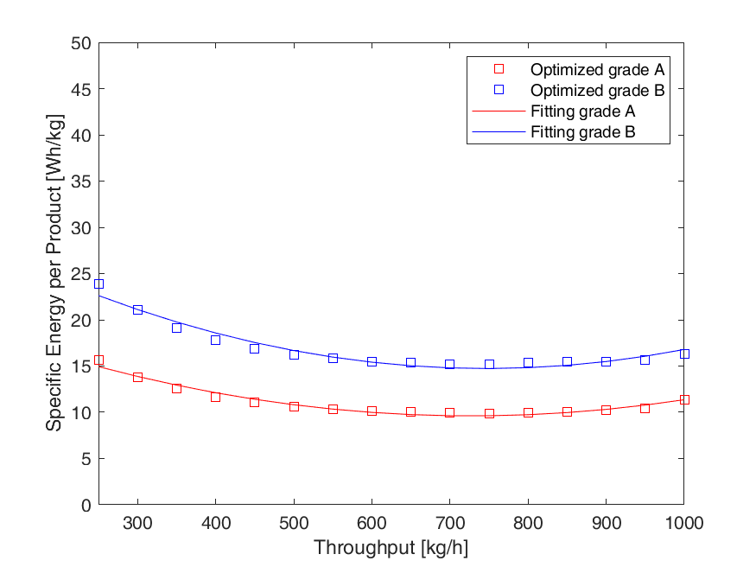

Figure 1: Optimized energy demand as a function of the throughput for the two product grades and quadratic approximations of the energy demand.

As shown in Figure 1, the total energy consumption Q of the extruder as function of the throughput can be approximated as a 3rd order polynomial and is only a function of the throughput:
$${\dot{Q}}_{t,A}={2.34⋅{10}^{-5}⋅\dot{m}}_{t,A}^{3}-{0.0340⋅\dot{m}}_{t,A}^{2}+21.98⋅{\dot{m}}_{t,A}$$ | (1)
$${\dot{Q}}_{t,B}={3.20⋅{10}^{-5}⋅\dot{m}}_{t,B}^{3}{- 0.0478⋅\dot{m}}_{t,B}^{2}+32.57⋅{\dot{m}}_{t,B}$$ | (2)
Consequently, the optimal energy input per kg of throughput is described by a quadratic function.
    - Optimization Problem
For the optimal generation-aware production planning, the goal is the minimization of the overall costs for a given time frame while satisfying the production demand d of the i different products. The cost c_{t} at a given time can either be of economic nature, in this work the day-ahead electricity price is used, or of ecologic nature for example the energy generation emission factor. The optimization variables are the throughput of a machine at each point in time that is used for the calculation of the energy demand using Equations 1 and 2. Using a big M constraint it is enforced that only one product can produced at a time. To improve the industrial acceptance of the solution, changes in the throughputs are penalized to generate a smoother solution. The optimization problem can be stated as follows:
$$\min{\sum_{t}{\sum_{i}{{\dot{Q}}_{t,i}\left({\dot{m}}_{t,i}\right)⋅c_{t}}+\sum_{t=1}^{t_{end}-1}{\sum_{i}{α⋅({\dot{m}}_{t+1,i}-{\dot{m}}_{t,i})²}}}}$$ | (3)
$$s.t \sum_{t}{{\dot{m}}_{t,i}}≥d_{i} ∀i{ , \dot{m}}_{t,i}≤{\dot{m}}_{max,i}$$
$${ \dot{m}}_{t,i}-M{⋅x}_{t,i}≤0 , x_{t,i}∈\{0,1\}$$
This optimization problem can be solved in different ways. For two products, the original mixed integer nonlinear programming (MINLP) problem can be reformulated as a nonlinear programming (NLP) problem with a single throughput as optimization variable at given time point. This reformulation facilitates the solution process significantly. In this case, a positive throughput represents the first product and negative throughputs represents the production of the second product. The adapted optimization problem can be stated as follows:
$$\min{\sum_{t}{{\dot{Q}}_{t,1}\left(max⁡(0,{\dot{m}}_{t})\right)⋅c_{t}+\sum_{t}{{\dot{Q}}_{t,2}\left(abs(min⁡(0,{\dot{m}}_{t})\right)⋅c_{t}+}\sum_{t=1}^{t_{end}-1}{\sum_{i}{α⋅({\dot{m}}_{t+1,i}-{\dot{m}}_{t,i})²}}}}$$ | (4)
$$s.t \sum_{t}{max⁡(0,{\dot{m}}_{t}})<d_{1} , \sum_{t}{abs\left(\min\left(0,{\dot{m}}_{t}\right)\right)}<d_{2} , {{-\dot{m}}_{max,1} ≤\dot{m}}_{t}≤{\dot{m}}_{max,2}$$
  - Results
    - Economic Optimization
The first investigated case is the optimization of the energy cost. The demands for the two products are assumed as 50 tons of grade A and 15 tons of grade B during one week (168 h). In the considered period between 13.01.2020 00:00 and 20.01.2020 00:00, the day-ahead price for electricity was in the range between 0.11 and 52.93 €/MWh with an average price of 32.4 €/MWh. To meet the demands, an average throughput of 386 kg/h is required. The problem was solved with a time resolution of 1 h using the interior-point algorithm of the fmincon solver in MATLAB. As it is a local solver, the optimization was carried out 10,000 times using different random initializations as well as initializing once with a previous optimization result with a coarser time discretization. The results are shown in Figure 2. As expected, the results show that the production of the more energy intense product B is favored at times of low energy prices at the maximum available production capacity. At times with higher energy prices just before or after the minima of the energy prices, the product B is produced at lower throughputs and therefore with a higher energetic efficiency. At further increasing prices for electric power, the product of grade A is produced with decreasing throughputs. The flexible adjustment of the production to the operating region of higher energy efficiency leads to a more sustainable and economical production in contrast to a strategy to either operate the equipment at full load or not at all. Important to notice is that the optimal production planning following this strategy is dependent on the relative energy demands of the products and of the shape of the energy price curve. If the differences of the energy demand are small, the optimal schedule is a production at maximum capacity during the periods of the lowest costs. For the case of little variations of the energy price, production at energetically optimal throughputs is favored. The case investigated here is that of large differences in energy demand and large variations in the price curve.
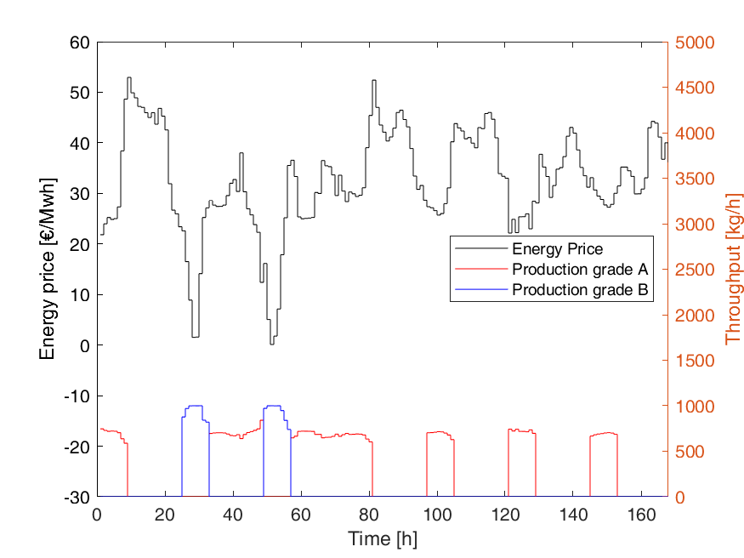
Figure 2: Optimization results for the week ahead schedule for the economic objective. The optimal throughputs are presented for the two product grades and the day-ahead price of the electric power.
    - Ecological Optimization
The second investigated case is the minimization of the carbon dioxide emissions that are caused by the production of the two products. The same timespan as in the first case is considered to quantify the ecological impact of the production process. For the considered period, the CO₂ emissions were in the range of 212 to 507 kg CO₂/MWh with an average of 358 kg CO₂/MWh. The optimization results are shown in Figure 3. In general, the results follow the same pattern as described for the economic optimization. Worthwhile noticing is that the variation of the CO₂ emissions over time is less pronounced and therefore the optimal schedule is at the maximum production rate in the period between 20 and 70 hours. In the same timeframe, one can also observe that the electricity price is not necessarily following a similar trend as the CO₂ emissions as for increasing demand the price goes up even if generation is mainly from renewables.
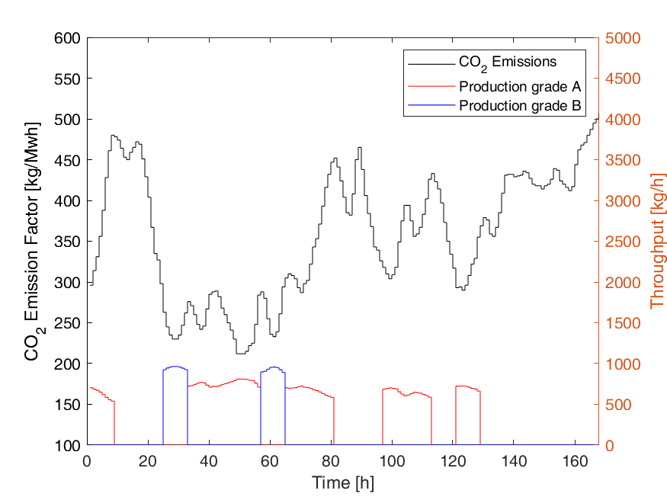
Figure 3: Results for the ecological optimization of the process for one week. The optimal throughputs of the different products A and B are shown in red and blue with the corresponding CO₂ emission factor.
    - Comparison
In order to evaluate the tradeoff between solution quality and operator acceptance for this optimization, the influence of the discretization interval and the throughput change penalty term is investigated. The aim of both strategies is to reduce the number of product changes, shutdowns and throughput changes to facilitate regular smooth production. The results for the variation of the discretization time are shown in Table1:
Table 1: Comparison of the results of different discretization lengths for the schedule
Time Discretization | relative Energy Costs [-] | relative CO2 Emissions [-]
Batch production  1h – energy price  2h - energy price  4h – energy price  8h – energy price | 172.3%  100.0%  100.2%  101.1%  102.7% | 155.7%  100.7%  100.7%  100.7%  101.2%
1h – energy emission  2h – energy emission  4h – energy emission | 110.1%  111.4%  111.4% | 100.0%  100.6%  100.6%
8h – energy emission | 114.4% | 101.0%

The reference case for this investigation is the batch production case. This case is completely non-generation aware and schedules the two products directly after each other at a constant throughput. The production is performed at 386 kg/h which is an inefficient production rate. Therefore, the performance of the schedule is the worst for both criteria as the time periods of very high CO₂ emissions or high prices are not avoided. The optimization was performed for a discretization of one, two, four or eight hour production at constant throughputs for the economic and ecologic objective function. For both objectives, the benefit of the hourly resolution compared to the bi-hourly scheduling is insignificant. The further reduction of the changes in the production to two or one change per 8h shift increases the costs by 1.1% and 2.7%. This good performance can be explained by the nature of the energy price evolution. Important for the optimality of the schedule is that the production can be adjusted to the slow dynamics of the price. For the case that within a region of low energy prices, the price shortly spikes down, the production is already at a high throughput.
Additionally, the variation of the weights in the cost function was investigated for the economic case for an hourly discretization. Important metrics for this investigation were the loss in optimality and the number of complete shutdowns of the machine, the number of product changeovers and the number of significant throughput changes >10%. The results are shown in Table 2:
Table 2: Comparison of the performance for different weights on throughput changes for 1 h discretization
Penalty weight [€ h²/ kg²] | relative Energy costs [-] | # shutdowns | # changeovers | # throughput changes >10%
0  10⁻⁶  10⁻⁵  10⁻⁴  10⁻³  10⁻²  10⁻¹  1 | 100.0%  100.0%  100.1%  101.0%  107.1%  140.0%  159.7%  166.1% | 5  5  5  5  3  1  0  0 | 3  3  3  4  3  5  1  1 | 18  17  15  44  83  58  37  19

For values up to 10⁻⁵, only a small decrease in significant throughput changes can be observed without effect on the cost function. For further increasing weights, the number of significant throughput changes is increasing as a larger number of smaller changes is favored by the cost function over one abrupt change. This is the case until only one changeover is occurring. In addition, the number of shutdowns and product changeovers is decreasing with higher weights and the solution is evolving towards the batch production case. Comparing the performance to the variation of the time discretization, the coarser discretization should be preferred due to a better economic performance, an easier and more intuitive tuning as well as the benefit for the operators of being able to maintain a certain throughput over longer periods instead of implementing hourly throughput changes. Regarding the decision of the weighting of the economic or ecologic objective, the choice of the compromise point is a managerial decision.
    - Multiple Machines
In industrial practice, the production on several extruders in parallel is common practice. Analyzing this optimization problem, one can come to the following conclusion: since a unique mapping between throughput and energy demand for each product exists, the case of parallel production units producing different products can be solved similar to the single machine problem with higher throughputs and adjusted cost function. This assumption holds as long as the required production amount of each product and the timespan are sufficiently large. In the worst case, the solution will be suboptimal at one time-step per product for the case where a transition between products occurs. Given the length of the optimized timespan and the general uncertainty of the model, this sub optimality is negligible.
  - Conclusions
This work presented an approach to the energy aware production of paint thickeners for different product grades and throughputs. An accurate surrogate model was created based on data generated by the optimization of a detailed dynamic process model for different operating conditions. The use of this computational inexpensive model enabled the optimization of the production schedule for a week ahead in computation times in the range of seconds. It was shown that the proposed method outperforms a naive scheduling and is able to generate significant improvements of both the ecological and the economic objective. To improve the operator acceptance of the solution, a coarser time discretization should be used instead of an adjustment of the term that penalizes throughput changes. A coarser discretization leads to less throughput changes, less changeovers and less shutdowns without a significant loss of optimality and it can easily be tuned. The approach is applicable for multiple machines in parallel without increasing the complexity of the optimization problem. For a real application, it is recommended to constantly update the throughput to energy consumption mapping based on real production data. Furthermore, the application of a predictive model for the forecast of the energy prices and of the CO₂ emissions based on market and weather data should be embedded.
Nomenclature
c – price or carbon emissions, €/MW or kg/MW
d – demand of product, kg

i – product type, -
ṁ – extruder throughput, kg/h
M_{W} – weight average molecular weight, kg/Mol
Q̇ – energy demand, MW
t – discrete time, h
α – penalty for the input change,€ h²/kg² or h²/kg
Acknowledgments
The project leading to this publication has received funding from the European Union’s Horizon 2020 research and innovation programme SIMPLIFY under grant agreement No 820716.
References
Bhavsar, R., Nehete, K., 2019, Rheological approach to select most suitable associative thickener for water-based polymer dispersions and paints. Journal of Coatings Technology and Research, 16(4), 1089–1098.
Cegla, M., Engell, S. 2021, Application of Model Predictive Control to the reactive extrusion of ε-Caprolactone in a twin-screw extruder, IFAC-PapersOnLine, 54(3), 225–230.
Eitzlmayr, A., Koscher, G., Reynolds, G., Huang, Z., Booth, J., Shering, P., Khinast, J., 2014, Mechanistic modeling of modular co-rotating twin-screw extruders, International Journal of Pharmaceutics, 474(1–2)
Moosmann, L. et al., 2021, The COP26 Climate Change Conference, Status of climate negotiations and issues at stake, Study for the ENVI committee, European Parliament, Luxembourg.
Palensky, P., Dietrich, D., 2011, Demand side management: Demand response, intelligent energy systems, and smart loads. IEEE Transactions on Industrial Informatics, 7(3), 381–388.
Peng, Z., Barzegar, B., Yarahmadi, M., Motameni, H., Pirouzmand, P., 2020, Energy-Aware Scheduling of Workflow Using a Heuristic Method on Green Cloud, Scientific Programming.
Reuvers, A.J., 1999, Control of rheology of water-borne paints using associative thickeners, Progress in Organic Coatings, 35, 171–181.
Kleiner, M., Litz, P., Sakhel., A., Hein, F., 2021, Agora Energy Transition (2021): Agorameter, Data Source, Agora Energiewende, Berlin, Germany

