- CHEMICAL ENGINEERING TRANSACTIONS  VOL. 96, 2022 | A publication of
The Italian Association
of Chemical Engineering
Online at www.cetjournal.it

Guest Editors: David Bogle, Flavio Manenti, Piero Salatino
Copyright © 2022, AIDIC Servizi S.r.l.
ISBN 978-88-95608-95-2; ISSN 2283-9216
Eco-friendly removal of methylene blue from aqueous medium using low cost sawdust-biochar adsorbent.
Emmanuel O. Ichipiª*, Shepherd M. Tichapondwa^{b}, Evans M. N. Chirwa^{b}
ªWater Utilisation and Environmental Engineering Division
^{b} Department of Chemical Engineering, University of Pretoria, Pretoria 0002.
Email: u17227870@tuks.co.za
This study reports on the facile synthesis and viability of sawdust-derived-biochar adsorbent for the effective removal of methylene blue dye pollutant from aqueous medium. The crystallinity, morphology and surface functional groups of the synthesised materials were determined using XRD, SEM and FTIR characterisation techniques. The adsorption efficiency of sawdust biochar was investigated by observing the removal of methylene blue dye (MB) from an aqueous system while varying process parameters like the adsorbent loading and initial concentration. Results showed that the sawdust biochar achieved remarkable removal of 98.7 % MB in 90 minutes and a complete removal after 120 minutes. The adsorption kinetics were best described by the pseudo-first-order kinetics model and had a R² value higher than 0.97. Additionally, the Langmuir adsorption isotherm model, which points to monolayer adsorption, fit the results best and showed the material to have an adsorption capacity of 151.3 mg/g. Finally, the results obtained from this study depicts the efficiency of sawdust biochar in the removal of organic dye and points a way forward in achieving zero pollution and a toxic-free environment.
  - Introduction
Over the years, widespread attention has being paid to the removal of organic colorants (dyes) from wastewater due to their toxic and harmful effects to ecosystem and its environment. Dyes (Azo and reactive) are additives used in several industries like food, textile, leather, paper and printing of colourful merchandises (Yusuf, 2019). Dyes are highly soluble, non-biodegradable and toxic pollutants that can cause severe damages when exposed to the ecosystem. The introduction of dye pollutants in water bodies increases the chroma level and consequently blocking the penetration of sunlight needed by aquatic life for dissolved oxygen (Franca et al., 2020). In the soil, dye pollutants combat and kill microbes, which are vital nutrients for plant germination (Yusuf, 2019). Toxic effects of dye exposure to humans include irritation of the eyes and skin, dermatitis, conjunctivitis, occupational asthma and many other allergic reactions (Chung, 2016). Hence, it is essential to find treatment strategies aimed at an efficient removal this toxic organic dye recalcitrant from water for the sustainability of the ecosystem and its surrounding environment.
Among many wastewater treatment technologies, adsorption has been regarded as a facile and efficient method for the elimination of a wide range of organic colorants.The removal of dye pollutants by Adsorption has been widely adopted attributing to its cheap operational cost and process simplicity (Franca et al., 2020). Activated carbon and other carbon-based materials have proven to be very efficient adsorbents due highly active surface and pore areas (Creamer and Gao, 2016). Biochar is a carbonaceous charcoal material produced from the thermochemical decomposition of organic waste biomass. Based on their natural source, biochar from agricultural biomass, animal and organic wastes are considered techno-economically feasible and environmentally friendly adsorbent materials (Srivatsav et al., 2020). Studies have reported the effectiveness of dye removal using biochar derived from various biomass precursors such as crop straw, plant residues, animal waste, domestic wastes, food leftovers, bagasse, forestry wastes etc. (Srivatsav et al., 2020). The availability, cost and environmental hazard are important factors to be considered in the selection of a biochar precursor. Additionally, the development of “low-cost” biochar adsorbent requires a green facile synthesis process and abundance of the precursor in nature. The valorization of sawdust waste for wastewater treatment is regarded as an effective form of waste management and a quota contribution towards achieving a green, clean and sustainable environment (Adegoke et al., 2022). Sawdust is a common global waste material that is abundantly generated from the production and utilization of wood. They are sometimes discarded inappropriately in uncontrolled environment, thereby contributing largely to the problem of environmental pollution (Zhang et al., 2018). The main constituents of sawdust are hemicellulose, cellulose and lignin (Le Tan et al., 2021). Production of biochar mainly involves modifying the precursor via acidic and alkali treatments to enhance its adsorptive properties (Shimanskaya et al., 2018). In this study, sawdust biochar was prepared using a chemical activation method, characterised by various techniques and applied in the removal of methylene blue dye pollutant. The main purpose of this work is to develop a highly efficient adsorbent that can remove organic dye pollutants from water using sawdust as a base material.
  - Materials and Methods
    - Materials
Sawdust waste was collected from a wood processing workshop at the University of Pretoria (South Campus), South Africa. Sodium hydroxide, sodium hypochlorite, sulphuric acid and methylene blue dye were purchased from Sigma-Aldrich (Merck), South Africa. All these chemicals and reagents were used as obtained without any modification or further purification. Deionized water was used throughout the experiment and in preparation of 1 g/L of MB stock solutions.
    - Synthesis of Adsorbent material
Sawdust biochar was prepared through a chemical activation method, which involved an alkali pre-treatment, bleaching and acid hydrolysis. First, 25 g of the raw sawdust was boiled in deionized water for 30 minutes to remove the hemicellulose constituent. This was followed by an alkali treatment with 500 mL of 2.0 M NaOH under magnetic stirring for 2 hours at 100 °C. The mixture was rinsed with warm water followed by bleaching for 1 hour to remove all impurities using 5 % w/v of NaOCl₂ at a 1:20 residual to bleach ratio. Approximately 20 g/L of the purified residual sawdust was impregnated with 64 % w/w of H₂SO₄, which acts as the dehydrating chemical agent for the formation of pores in the biochar. The mixture was sonicated for 2 hours at 60 °C to ensure that acid hydrolysis reaction had occurred, after which, it was diluted with deionized water to stop the reaction. The suspension was washed several times with hot water, each time centrifuged at 12000 rpm for 20 minutes to remove the unreacted chemicals and by-products. Finally, the decanted residual was dried in an oven at 70 °C overnight to form a highly efficient sawdust biochar adsorbent. A pictorial summary of the synthesis procedure for sawdust-biochar is illustrated in Figure 1.
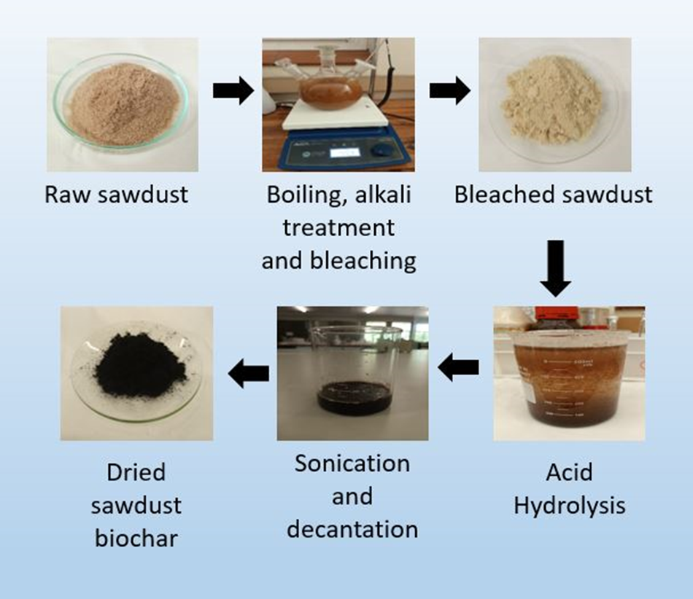
Figure 1: A pictorial preparation steps for sawdust-biochar.
    - Characterisation Techniques
A XRD powder analysis was conducted using a PANalytical X’Pert Pro powder diffractometer in θ–θ configuration with Fe filtered Co-Kα radiation (ʎ =1.789 Å). The crystallography of the materials was obtained by choosing the best–matching standards from the ICSD database, using X’Pert Highscore plus software. The surface morphology images were taken on a Zeiss Ultra PLUS FEG SEM installed with an Oxford instruments detector and AZtec 3.0 software SP1. A PerkinElmer 100 FTIR spectrometer, MIRacle Zn/Se instrument was used to identify the chemical and functional groups present in the sample. The spectra scan were detected within a wavelength range from 4000 to 400 cm⁻¹.
    - Batch Adsorption Studies: Analytical method, Kinetic and Isotherm
The stock solution of MB dye was prepared by dissolving a pre-calculated amount of the dye powder in deionized water. Batch adsorption experiments were carried out on various methylene blue dye concentrations and sawdust biochar loadings in a 400 mL beaker. The mixture was magnetically stirred at 200 rpm under room temperature conditions for 90 minutes. Samples were withdrawn at every 15 minutes time intervals and analysed using a BioChrom WPA lightwave II UV-Visible Spectrophotometer measured at absorbance wavelength (λ_{max}) of 663 nm. Adsorbent dosages (0.1, 0.25, 0.5, 0.75, 0.9 g/L) and initial dye concentration levels (5, 10, 15, 20 ppm) were varied to determine the optimum adsorption parameter. The adsorbent MB uptake was calculated using the expression:
$q= \frac{\left(C_{i}-C_{0}\right)V}{M}$ (1)
Where q is the amount of dye uptake by the adsorbent (mg/g), C_{i} and C₀ are the initial and final MB dye concentration respectively, V is the volume of the dye solution (100 mL) and M is the mass of adsorbent (g).

The percentage dye removal obtained from each batch experiment was calculated using the expression:
$\%D_{Removal}= \frac{\left(C_{i}-C_{0}\right)}{C_{0}}×100$% (2)
The kinetic constants were evaluated using pseudo-first order and Langmuir adsorption isotherm model was applied to study the adsorption capacity and surface property of the adsorbent.
  - Results and Discussions
    - Material Characterisation
The XRD diffraction patterns of raw sawdust and sawdust biochar in Figure 2 indicates two distinct peaks at (101) and (002) at scanning angles (2θ), 18.2° and 26.2° respectively. The sharp peaks of raw sawdust depicts the presence of crystalline cellulose but is noticed to have reduced in intensity for biochar due to the presence of carbon in its amorphous phase and destruction of the cellulose component. The broadening of biochar diffraction peak confirmed a decrease in its crystallinity and presence of unidentified inorganic components (Chellappan et al., 2018).
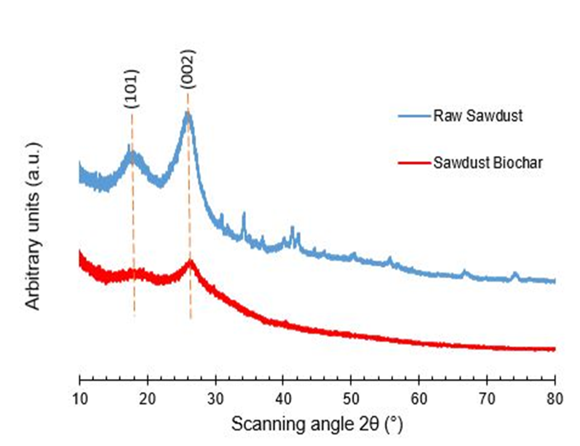
Figure 2: XRD patterns for Raw Sawdust and Sawdust Biochar.
The morphology of the materials was analysed by SEM, the captured images are presented in Figure 3a, and b. SEM images revealed particles agglomerated like a honeycomb with pores on the surface of the materials. This material structure is likely attributed to the biological capillary skeleton of raw sawdust and carbonized biochar. However, sawdust biochar is observed to possess good particle and pore size distribution among other properties such as specific surface area and hydrophobicity compared to raw sawdust (Zakil et al., 2021).
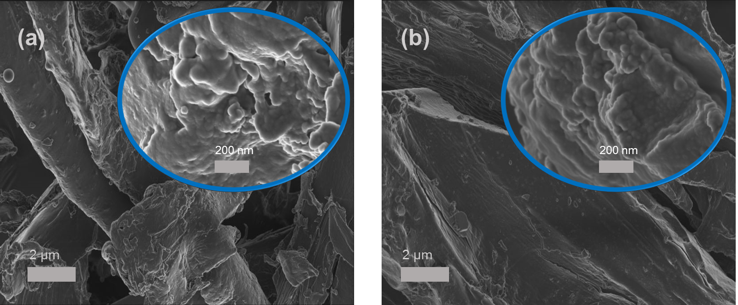
Figure 3: SEM micrographs of (a) Raw Sawdust and (b) Sawdust Biochar.
FTIR analysis of the materials showed the presence of functional groups on their surfaces as seen in Figure 4. The absorption peaks around 3410 cm⁻¹ is assigned to the -OH stretching vibration of hydroxyl functional phenolic groups. The absorption band at approximately 2880 cm⁻¹ corresponds to the C–H stretching vibration in alkanes/alkyl groups suggesting the loss of aliphatic compounds. The peaks between at 1554 to 1364 cm⁻¹ may be assigned to an aromatic C=C stretching vibration related to arykalkyl ethers (-OCH₃). The signal around 1058 cm⁻¹ could be attributed to –C–O–C– stretching vibrations of polysaccharides or from the phenolic hydroxyl bending vibration of –C–OH. The formation of pores in the biochar matrix is attributed to the loss of -OH and C-H functional groups. Sawdust biochar is observed to have lost some acidic functional groups like phenol and carboxylic acid but equally gained basic functional groups like quinone and carbonyl, which are responsible for a highly efficient adsorbent material (Shaaban et al., 2013).
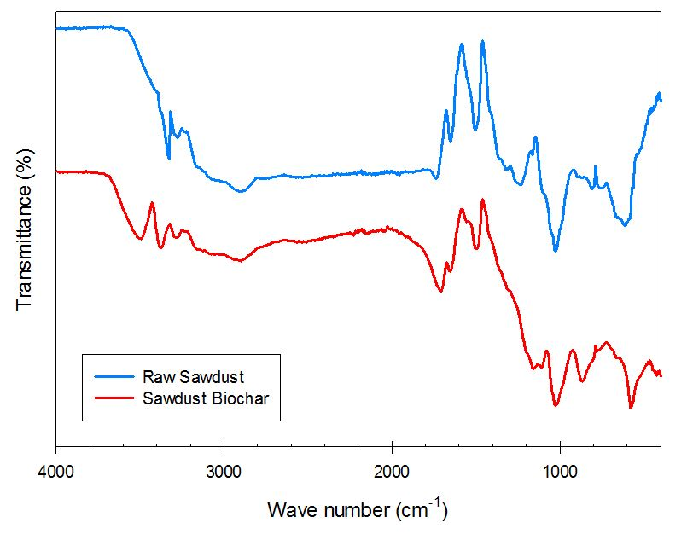
Figure 4: FTIR spectra of Raw Sawdust and Sawdust Biochar
    - Batch Adsorption Experiments
Adsorption efficiency correlates with surface area (porosity) and crystallinity such that a crystalline adsorbent would have less pores and active surface area (Wei et al., 2015). In Figure 5a, sawdust biochar with lower crystallinity as obtained by the XRD spectra had a higher adsorption performance than raw sawdust. The dosage of sawdust biochar was varied to investigate the effect of adsorbent loading in removal efficiency of MB Maximum MB removal of 98.7 % was achieved at 0.5 g/L adsorbent loading. When the dosage was increased to 0.9 g/L, there was no significant difference in efficiency. However, lower dosages of adsorbent at 0.25 g/L and 0.1 g/L achieved a lower removal efficiency of 89.9 % and 77.8 % respectively. The improved performance of the adsorbent as the dosage was increased is attributed to the presence of more pores and adsorption sites (Zhang et al., 2018). According to Laing (1991) as much as 10 – 50 mg/L of dye pollutants are present in textile effluent. In Figure 5b, a decrease in dye removal efficiency is observed with an increase in the initial MB concentration. The optimum adsorbent dose (0.5 g/L) is limited to a specific number of pores and active adsorption sites. When the adsorbent takes more pollutant molecules than it can accommodate, it becomes saturated and no further adsorption occurs. Whereas, at lower initial dye concentrations, there is adequate active sites for highly efficient adsorption of the pollutant (Nadeem et al., 2019). From the results obtained, 0.5 g/L of the adsorbent had completely removed 5 ppm of MB after 75 minutes of contact time as seen in Figure 5b.
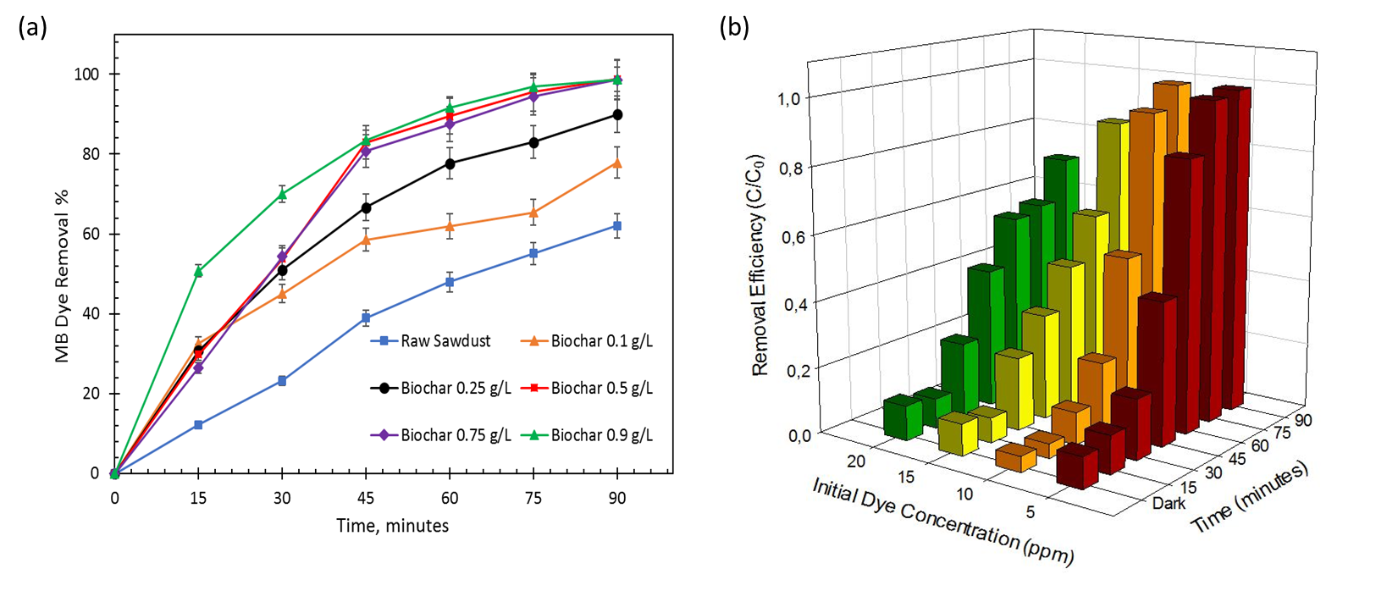
Figure 5: Effect of varying (a) adsorbent dosage of Sawdust Biochar and (b) initial concentration of MB dye.
    - Adsorption Kinetic and Isotherm Models
The adsorption kinetics and mechanism of MB removal was evaluated by fitting the experimental data to a pseudo-first-order equation and a Langmuir isotherm expressed in equation 3 and 4:
$q_{t}=q_{e}\left(1-e^{{-k}_{1}t}\right)$ (3)
$q_{e}=\frac{q_{max}k_{L}C_{e}}{1+k_{L}C_{e}}$ (4)
where q_{e}, q_{max} and q_{t} (mg/g) are the dye uptake of MB per unit mass of the adsorbent at equilibrium, at maximum adsorption capacity and at time, t respectively. k₁ is the adsorption rate constant (min ⁻¹), k_{L} is the Langmuir rate constant (L/mg) and C_{e} is the equilibrium dye concentration (ppm).
The pseudo-first-order kinetics model was applied to evaluate the performance of varying adsorbent dosages (0.1, 0.25, 0.5, 0.75 and 0.9 g/L) on the removal 10 ppm MB dye as shown in Table 1. The correlation coefficient R² were higher than 0.97, which indicates that adsorption was well described by the pseudo-first-order kinetics model. The increase in rate constants k₁ with increasing adsorbent loading is attributed to a good solid/liquid interface capacity between the adsorbent and dye pollutant due to the increased number of pores and surface active sites. For example, as the dosage was increased from 0.1 g/L to 0.5 g/L the dye uptake (q_{e}) increased from 49.12 mg/g to 51.15 mg/g. The experimental data of varying adsorbent dosages were found to follow the Langmuir adsorption isotherm model for heterogeneous adsorption surface reactions. The Langmuir isotherm suggests that adsorption occurs on monomolecular layer at the surface of the biochar by chemical adsorption without interacting with absorbed molecules of MB (Heraldy et al., 2016). However, at any dosage of adsorbent, the maximum monolayer adsorption capacity (q_{max}) was estimated to be 151.3 mg/g as seen in Table 1.
Table 1: Kinetic constants and fitting parameters of MB dye adsorption on Sawdust Biochar
Adsorbent Dose | Pseudo-first-order |  |  |  | Langmuir Isotherm
 | q_{e} (mg/g) | k₁ (min ⁻¹) | R² |  | q_{max} (mg/g) | k_{L} (L/mg) | R²
0.1 | 49.12 | 0.00034 | 0.9763 |  | - | 0.053 | 0.79
0.25 | 50.33 | 0.00183 | 0.9782 |  | - | 0.048 | 0.87
0.5 | 50.64 | 0.00645 | 0.9843 |  | 151.3 | 0.023 | 0.90
0.75 | 50.92 | 0.01125 | 0.9826 |  | - | 0.017 | 0.95
0.9 | 51.15 | 0.01361 | 0.9913 |  | - | 0.013 | 0.99
  - Conclusions
The preparation of biochar from raw sawdust via a chemical activation method involving alkali treatment, bleaching and acid hydrolysis is an efficient method for the production of high-performance adsorbent for dye removal. The physicochemical properties of the prepared biochar showed improvement in surface area, creation of pores, breakdown of its crystallinity and acidic functional groups which were attributed to its enhanced adsorption activity. Optimum adsorbent dosage and initial dye concentration was found to be 0.5 g/L and 10 ppm respectively. Experiments showed that at the optimum conditions, sawdust-biochar exhibited an excellent dye adsorption capacity (q_{max =} 151.3 mg/g) by removing 98.7 % of methylene blue from water. Adsorption kinetics and isotherm models suggested that the spontaneous chemisorption between the solid/liquid interface was responsible for an efficient adsorption mechanism. Recovery, regeneration and recycling of sawdust biochar is a prominent niche in the study of adsorbent materials. Future studies on the removal of dye pollutants using waste-derived-biochar is recommended as the issue of dye-contaminated water is a global concern.
  - References
Adegoke, K. A., Adesina, O. O., Okon-Akan, O. A., Adegoke, O. R., Olabintan, A. B., Ajala, O. A., Olagoke, H., Maxakato, N. W. & Bello, O. S. 2022. Sawdust-Biomass Based Materials For Sequestration Of Organic/Inorganic Pollutants And Potential For Engineering Applications. Current Research In Green And Sustainable Chemistry, 100274.
Chellappan, S., Nair, V., Sajith, V. & Aparna, K. 2018. Synthesis, Optimization And Characterization Of Biochar Based Catalyst From Sawdust For Simultaneous Esterification And Transesterification. Chinese Journal Of Chemical Engineering, 26, 2654-2663.
Chung, K.-T. 2016. Azo Dyes And Human Health: A Review. Journal Of Environmental Science And Health, Part C, 34, 233-261.
Creamer, A. E. & Gao, B. 2016. Carbon-Based Adsorbents For Postcombustion Co2 Capture: A Critical Review. Environmental Science & Technology, 50, 7276-7289.
Franca, R. D. G., Pinheiro, H. M. & Lourenço, N. D. 2020. Recent Developments In Textile Wastewater Biotreatment: Dye Metabolite Fate, Aerobic Granular Sludge Systems And Engineered Nanoparticles. Reviews In Environmental Science And Bio/Technology, 19, 149-190.
Heraldy, E., Hidayat, Y. & Firdaus, M. The Langmuir Isotherm Adsorption Equation: The Monolayer Approach. Iop Conference Series: Materials Science And Engineering, 2016. Iop Publishing, 012067.
Laing, I. 1991. The Impact Of Effluent Regulations On The Dyeing Industry. Review Of Progress In Coloration And Related Topics, 21, 56-71.
Le Tan, N. T., Dam, Q. P., Mai, T. P. & Nguyen, D. Q. 2021. The Combination Of Acidic And Alkaline Pretreatment For A Lignocellulose Material In Simultaneous Saccharification And Fermentation (Ssf) Process. Chemical Engineering Transactions, 89, 43-48.
Nadeem, F., Jamil, N., Moazzam, A., Ahmad, S. R., Lateef, A., Khalid, A., Qadir, A., Ali, A. & Munir, S. 2019. Synthesizing And Characterizing Sawdust Biochar/Fe3o4 Nanocomposites And Its Potential Application In Textile Wastewater Treatment. Polish Journal Of Environmental Studies, 28, 2311-2319.
Shaaban, A., Se, S.-M., Mitan, N. M. M. & Dimin, M. F. 2013. Characterization Of Biochar Derived From Rubber Wood Sawdust Through Slow Pyrolysis On Surface Porosities And Functional Groups. Procedia Engineering, 68, 365-371.
Shimanskaya, E. I., Rebrov, E., Filatova, A. E., Matveeva, V., Sulman, M. G. & Sulman, A. M. 2018. Catalytic Hydrogenolysis Of Different Types Of Lignin Obtained From Sawdust Softwood. Chemical Engineering Transactions, 70, 361-366.
Srivatsav, P., Bhargav, B. S., Shanmugasundaram, V., Arun, J., Gopinath, K. P. & Bhatnagar, A. 2020. Biochar As An Eco-Friendly And Economical Adsorbent For The Removal Of Colorants (Dyes) From Aqueous Environment: A Review. Water, 12, 3561.
Wei, W., Yang, L., Zhong, W., Cui, J. & Zhenggui, W. 2015. Mechanism Of Enhanced Humic Acid Removal From Aqueous Solution Using Poorly Crystalline Hydroxyapatite Nanoparticles. Digest Journal Of Nanomaterials And Biostructures, 10.
Yusuf, M. 2019. Synthetic Dyes: A Threat To The Environment And Water Ecosystem. Textiles And Clothing, 11-26.
Zakil, F. A., Sueb, M. S. M., Isha, R. & Kamaluddin, S. H. 2021. Efficiency Of Charcoal As Supporting Growth Material In Pleurotus Ostreatus Mushroom Cultivation On Various Agricultural Wastes Mixed With Rubber Tree Sawdust (Sr). Chemical Engineering Transactions, 89, 415-420.
Zhang, X., Zhang, L. & Li, A. 2018. Eucalyptus Sawdust Derived Biochar Generated By Combining The Hydrothermal Carbonization And Low Concentration Koh Modification For Hexavalent Chromium Removal. Journal Of Environmental Management, 206, 989-998.

