CHEMICAL ENGINEERING TRANSACTIONS  VOL. 96, 2022 | A publication of
The Italian Association
of Chemical Engineering
Online at www.cetjournal.it

Guest Editors: David Bogle, Flavio Manenti, Piero Salatino
Copyright © 2022, AIDIC Servizi S.r.l.
ISBN 978-88-95608-95-2; ISSN 2283-9216

Numerical investigation of the expansion devices applied in
modern vapour compression refrigeration unit considering
specific entropy and entropy generation analyses
Rafal Fingas^{a,b,*}, Michal Haidaª, Jacek Smolka^{a,} Giorgio Besagni^{b}, Michal Palaczª, Jakub Bodysª, Andrzej J. Nowakª
^{(a)}Department of Thermal Technology, Silesian University of Technology, Konarskiego 22, 44‐100 Gliwice, Poland
^{(b)}Department of Energy, Politecnico di Milano, Via Lambruschini 4a, 20156 Milano, Italy
* Corresponding e-mail: rafal.fingas@polsl.pl
Ejector-based refrigeration cycles working with natural refrigerants have already gained industry attention. Replacing throttling valve with an ejector in vapour-compression cycles brings high improvement of the cycle efficiency due to the ejectors potential of recovering part of throttling losses. With the rapidly growing market for heat pumps, they are also being implemented in those cycles, but this requires redesigning the ejector geometry for new natural working fluids for different operating conditions and applications. Typical approach to perform the ejector shape optimization is to use the ejector mass entrainment ratio or overall efficiency as an objective function. However, an entropy generation analysis seems to be more efficient. For this reason, the aim of this work was to perform the numerical analysis of the entropy generation of the two-phase ejector for R744 and assess its potential as a tool for efficiency improvement in the shape optimization algorithms. The ejector PL tool utilizing the homogeneous equilibrium model approach was complemented with the entropy generation model implemented using an additional transport equation to the computational fluid dynamics software. The numerical results of the mass flow rates were used for validation purposes. The entropy generation module allowed for the entropy generation analysis in terms of maximum values and their location showing critical areas of irreversibility characterizing different working fluids usage and ejector applications.
  - Introduction
Many activities are being performed in order to reduce the influence of human mankind on our environment. One of the areas implementing necessary changes is a refrigeration industry, which focuses on substituting harmful hydroflurocarbons (HFC), that are expected to be discontinued in use as coolants by 2022. This creates a need to develop technologies of natural refrigerants featured by low Global Warming Potential (GWP), that will bring the natural refrigeration systems to a point in which they become competitive. Carbon dioxide with GWP equal to 1, as a fluid with low environmental impact, being relatively cheap, non-toxic and non-flammable, has again found its application in cooling systems. Nevertheless, due to its low critical temperature and high critical pressure, the effective heat rejection from the system has to be done through a transcritical cycle, which requires proper system customization. First studies of the R744 refrigeration vapour compression system made by Lorentzen (1983) comparing this system with HFCs pointed out the lower system coefficient of performance (COP) comparing to other synthetic refrigerants systems working at similar pressures due to high throttling losses of R744 system. Few of ideas for cycle improvements and flash gas handling were proposed to align its performance with systems utilizing harmful working fluids, including two-stage or parallel compression, implementing liquid separator, mechanical subcooling and more. As usage of typical expansion valve in R744 system entails difficulties with operation, different expansion devices were proposed to replace the throttling valve. One of the solutions is implementation of the two-phase ejector that pumps the liquid from liquid separator or vapour from the evaporator. It is a device with two inlet nozzles, converging-diverging motive nozzle and suction nozzle, that expand the high temperature and high pressure motive stream coming from gas cooler and draws a low pressure gas or liquid through the suction nozzle. The motive stream passing the nozzle throat reaches the supersonic flow which results in shockwave propagation inside mixing section and as result lifts up the pressure of the mixed streams to intermediate outlet nozzle pressure, thereby reducing throttling losses. The implementation of ejector reduces the compressor pressure ratio, which can bring the COP increase between 10 and 30%, as reported by Elbel and Lawrence (2016).
Apart from the system control methods, in a pursuit of maximizing the refrigeration cycles efficiency, a number of studies and experiments to investigate single ejector performance have been conducted by creating their numerical and mathematical models. One of the common approaches in numerical investigations is homogeneous equilibrium model (HEM) that assumes mechanical and thermodynamic equilibrium the ejector two-phase flow. Smolka et al. (2013) used homogeneous real fluid approach and introduced the enthalpy-based energy equation instead of standard temperature-based one in the ANSYS Fluent software by User Defined Functions (UDF). The mass flow rate predictions validated against experimental data were given with the average accuracy of 10%. As a drawback the authors stated the inaccuracy of HEM with decreasing motive nozzle temperature at closer distance to the saturation line. After preparing high accuracy CFD models of ejectors, plenty of methods of ejector geometry optimization based on CFD were described in the literature. One trend was devoted to geometry parameters optimization using Genetic Algorithm (GA). Palacz et al. (2016) used the mass entrainment ratio (MER) as objective function to maximize the ejectors performance. Another approach was to analyze the irreversibility sources inside the ejector in order to find the area for design improvements. Since the entropy generation is directly connected with irreversibilities inside the ejector connected with mass transfer and turbulent flow, analysis of its nature, value and location can be applied for the optimization of the the ejectors efficiency. One can distinguish two methods of calculating entropy generation in turbulent convective heat transfer problems: indirect and direct. Indirect method uses an integral entropy time-averaged transport equation, which is less accurate, as it involves several approximations. Banasiak et al. (2014) made an analysis of the R744 ejectors performance using indirect method as one of the tools to assess the local irreversibilities based on close examination of flow variable profiles. The objective function was the overall increase of entropy calculated from the entropy balance across the ejector. The direct method determines the entropy generation by solving differential entropy transport equation post-processingly in the CFD software. Providing local and accurate information about irreversibilities, it can also be utilized for searching the entropy generation locations. Sierra-Pallares et al. (2016) performed this kind of investigation for three different R134a ejector mixing sections. The value of entropy generation calculated post-processingly for the whole volume of investigated domain. It showed that fluctuating viscous dissipation corresponds to 75% of the entropy generation in the considered HFC ejector, indicating it as the most important effect dragging down ejector performance.
In the ejector-based refrigeration cycles, it is critical to design the ejector for the specific operating conditions in order to use its full potential and achieve the maximal COP improvement for a given case. Therefore, it is necessary to have a better insight into its operation for a proper optimization. The aim of this study was to perform the entropy generation and specific entropy analysis in the CFD environment of widely applied R744 two-phase ejector. The entropy transport equation implemented to ANSYS Fluent software as a User-Defined Scalar (UDS) ensures both local and global analysis of the entropy generation. Furthermore, it allows to find the location of major entropy generation sources.
  - Computational model
The implemented entropy model was first verified against the entropy generation results of one of the single-phase R134a geometries examined in the work of Sierra-Pallares et al. (2016). The Geometry A is a classical ejector geometry with a 30◦ half-angle conical entry and constant area mixing section. The length to diameter ratio of mixing section is 8.6. It concerned the 2D mesh sensitivity study, turbulence model choice and solver settings. Then, the 3D geometry of already optimized two-phase ejector (Palacz et al., 2016) was used for CFD analysis using experimental results as boundary conditions and validation data. Finally, the entropy generation of throttling process has been analyzed for the R744 two-phase ejector for R744 transcritical operation from the work of Palacz et al. (2016) for a set of experimental points from the R744 vapour compression rack placed at the High Temperature Processes laboratory at the Institute of Thermal Technology of Silesian University of Technology in Gliwice, Poland (Haida et al., 2021).
    - Numerical meshes
The numerical meshes for the considered geometries were prepared in Ansys ICEM CFD software as structural meshes with refinements in critical parts for each unit for proper numerical representation of the flow. The mesh of 2-D R134a ejector was prepared in a manner to resemble the mesh used in Sierra-Pallares et al. (2016). The meshes of five different number of elements in the range from 24k to 291k were created for the purpose of sensitivity analysis for best reproduction of mass flow rates and field results. The mesh was not refined in the regions of supersonic shock wave occurrence in mixer section as it was presented in Sierra-Pallares et al. (2016), as similar strategy regarding ejector modelling without such a refinement methodology was characterized by high accuracy and proper representation of the flow physics. The 3D mesh of the R744 ejector has been analyzed in terms of mesh influence on results in work of Majchrzyk et al. (2022). The 3D model of 1 million hexagonal elements consists of axial motive inlet and tangential suction inlet to introduce the swirl flow of entrained stream. The areas expected to have high pressures or velocity gradients for case of ejectors were refined comparing to the rest of domain to detect the local effects of shockwave propagation
    - Mathematical model
The CFD model used in this study was HEM approach developed by Smolka et al. (2013). It is suitable for modelling single-, two-phase and supercritical flows. The model has been thoroughly tested for different ejector geometries and variety of operating conditions in the work of Palacz et al. (2015). It is characterized by high mass flow rates accuracy with relative errors below 10% in the area close to and above the critical point for motive nozzle operating conditions. Its application range for best accuracy are supercritical region and subcritical region with pressure above 80 bar. The HEM approach was completed with entropy transport equation derived from work of Sierra-Pallares et al. (2016) which has been restructured as an additional transport equation. The entropy balance equation for a single phase, non-reacting single component flow in general form is presented in Eq. 1.
$$ρ\frac{Ds}{Dt}=-∇⋅\left(\frac{q}{T}\right)-\frac{1}{T^{2}}q∇T-\frac{1}{T}τ:∇v$$ | (1)
The entropy generation module will be implemented in the Ansys Fluent using UDS feature. Therefore, Eq. 1 needs to be rearranged into:
$$ρ\frac{δs}{δt}+ρ∇\left|\left(v⋅s\right)-Γ_{k}-∇s\right|=-∇⋅\left(\frac{q}{T}\right)-\frac{1}{T^{2}}q∇T-\frac{1}{T}τ:∇v$$ | (2)
Since the scope of the research concerns only steady state problems and there is no diffusion of the specific entropy, the Eq. 2 can be simplified to the form in Eq. 3, which comprises entropy flux vector (Eq. 4) and the total entropy generation (Eq. 5).
$$ρ∇\left|v⋅s\right|=-∇⋅\left(\frac{q}{T}\right)-\frac{1}{T^{2}}q∇T-\frac{1}{T}τ:∇v$$ | (3)
$$σ=-∇⋅\left(\frac{q}{T}\right)$$ | (4)
$$s_{g}=-\frac{1}{T^{2}}q∇T-\frac{1}{T}τ:∇v$$ | (5)
The relevant source terms representing the entropy flux vector and each contribution to entropy generation need to be implemented to the UDS by means of the separate source terms written as a C code UDF. All the fluid transport properties for the CFD computations were calculated as functions of the absolute pressure and the specific enthalpy using the NIST REFPROP libraries. This ensured that the working fluid was treated as a real gas and the flow as compressible. The properties functions were created as UDF and employed to the solver.
    - Operating conditions
For all cases, the inlet and outlet boundary conditions have been introduced as pressure type boundary conditions with the prescribed pressure and specific enthalpy using the literature data in case of R134a ejector and experimental data in case of the R744 ejector. At the inlet boundary conditions, the specific entropy for UDS equation determined as a function of pressure and temperature was prescribed. At the outlet boundary conditions, the UDF calculating specific enthalpy and specific entropy profiles from neighbouring cell row was prescribed. The mass flow rates were used to validate the numerical model. All cases were simulated as adiabatic with all model walls prescribed with a constant heat flux boundary condition equal to 0. The R134a ejector validation was based on a single operating condition named A-2, being the only one for the considered geometry for which field results were presented in Sierra-Pallares et al. (2016). The motive inlet conditions were near critical point. The operating conditions for the R744 ejector were based on the results of ejector experimental campaign. All the examined operating conditions are presented in Table 1.

Table 1: Operating and boundary conditions used for the R134a and R744 ejectors simulations.
 | P_{MN} | T_{MN} | P_{SN} | T_{SN} | P_{OUT} | T_{OUT} | $\dot{M}$_{MN} | $\dot{M}$_{SN}
 | bar | °C | bar | °C | bar | °C | kg/h | kg/h
R134a #A2 | 29.2 | 95.2 | 4.1 | 20.1 | 6.8 | 47.05 | 131.8 | 51.8
R744 #1 | 90.7 | 35.7 | 27.2 | 11.6 | 37.7 | 3.1 | 255.7 | 52.7
R744 #2 | 76.4 | 24.8 | 27.7 | 4.8 | 32.0 | -3.2 | 337.7 | 81.2
R744 #3 | 79.6 | 32.4 | 27.5 | 8.7 | 32.3 | -2.8 | 206.4 | 74.4
R744 #4 | 90.6 | 35.4 | 27.8 | 10.7 | 31.7 | -3.5 | 258.0 | 52.1
R744 #5 | 88.5 | 28.2 | 26.6 | 6.5 | 32.2 | -2.9 | 338.2 | 77.2
3. Entropy model validation
The aim of this validation was to reconstruct the supersonic flow inside an ejector and obtain similar results of the entropy generation referring to the results presented in the above mentioned work. The usage of a different approach of thermodynamic modelling in CFD led to the necessity of adjusting solver settings compared to the original work of Sierra-Pallares et al. (2016). The authors were utilizing the thermodynamic model implemented to ANSYS Fluent using the density-based solver. It has to be noted however that the HEM model used in this work was designed for the pressure-based solver, thus this type of solver was used in this work. The model was validated against the results of Mach number and entropy generation presented in Sierra-Pallares et al. (2016). First, different mesh sizes were tested to validate the mass flow rate results obtained for the selected turbulence model with those reported in Sierra-Pallares et al. (2016). The mesh study was performed to eliminate the effect of grid size on the results. Increasing the mesh size resulted in decrease of mass flow rates, which for the CFD model had overestimated values comparing to experimental results. The mesh of 78k elements was chosen resulting in 5.3% and 11.3% relative error for motive and suction nozzle mass flow rates’ respectively. Then the analysis of turbulence models for modelling flow inside refrigeration components, namely Realizable k-epsilon (RKE), Standard k-epsilon (SKE) and SST k-omega (SST) turbulence models, was carried out. The SST turbulence model presented best flow pattern representation inside the studied ejector compared to the original work results. Looking at the entropy generation, the SST model brought the best representation of this parameter in the diffuser section in terms of the maximum values and their location. However, all the models showed much higher values of the entropy generation at the interface of the motive and suction streams in the mixing section compared to the results from Sierra-Pallares et al. (2016), which may be caused by usage of different mesh and solver type. The RKE and SKE models presented different flow pattern and much higher values of entropy generation at the beginning of the diffuser. The high accuracy of the results employing the SST model is possibly due to the used HEM model, which achieves more physical results of supersonic flow inside ejector for this particular turbulence model compared to the others. Hence, the SST model was used for further calculations. The entropy generation and Mach number comparison results for the R134a ejector are presented in Figure 1.
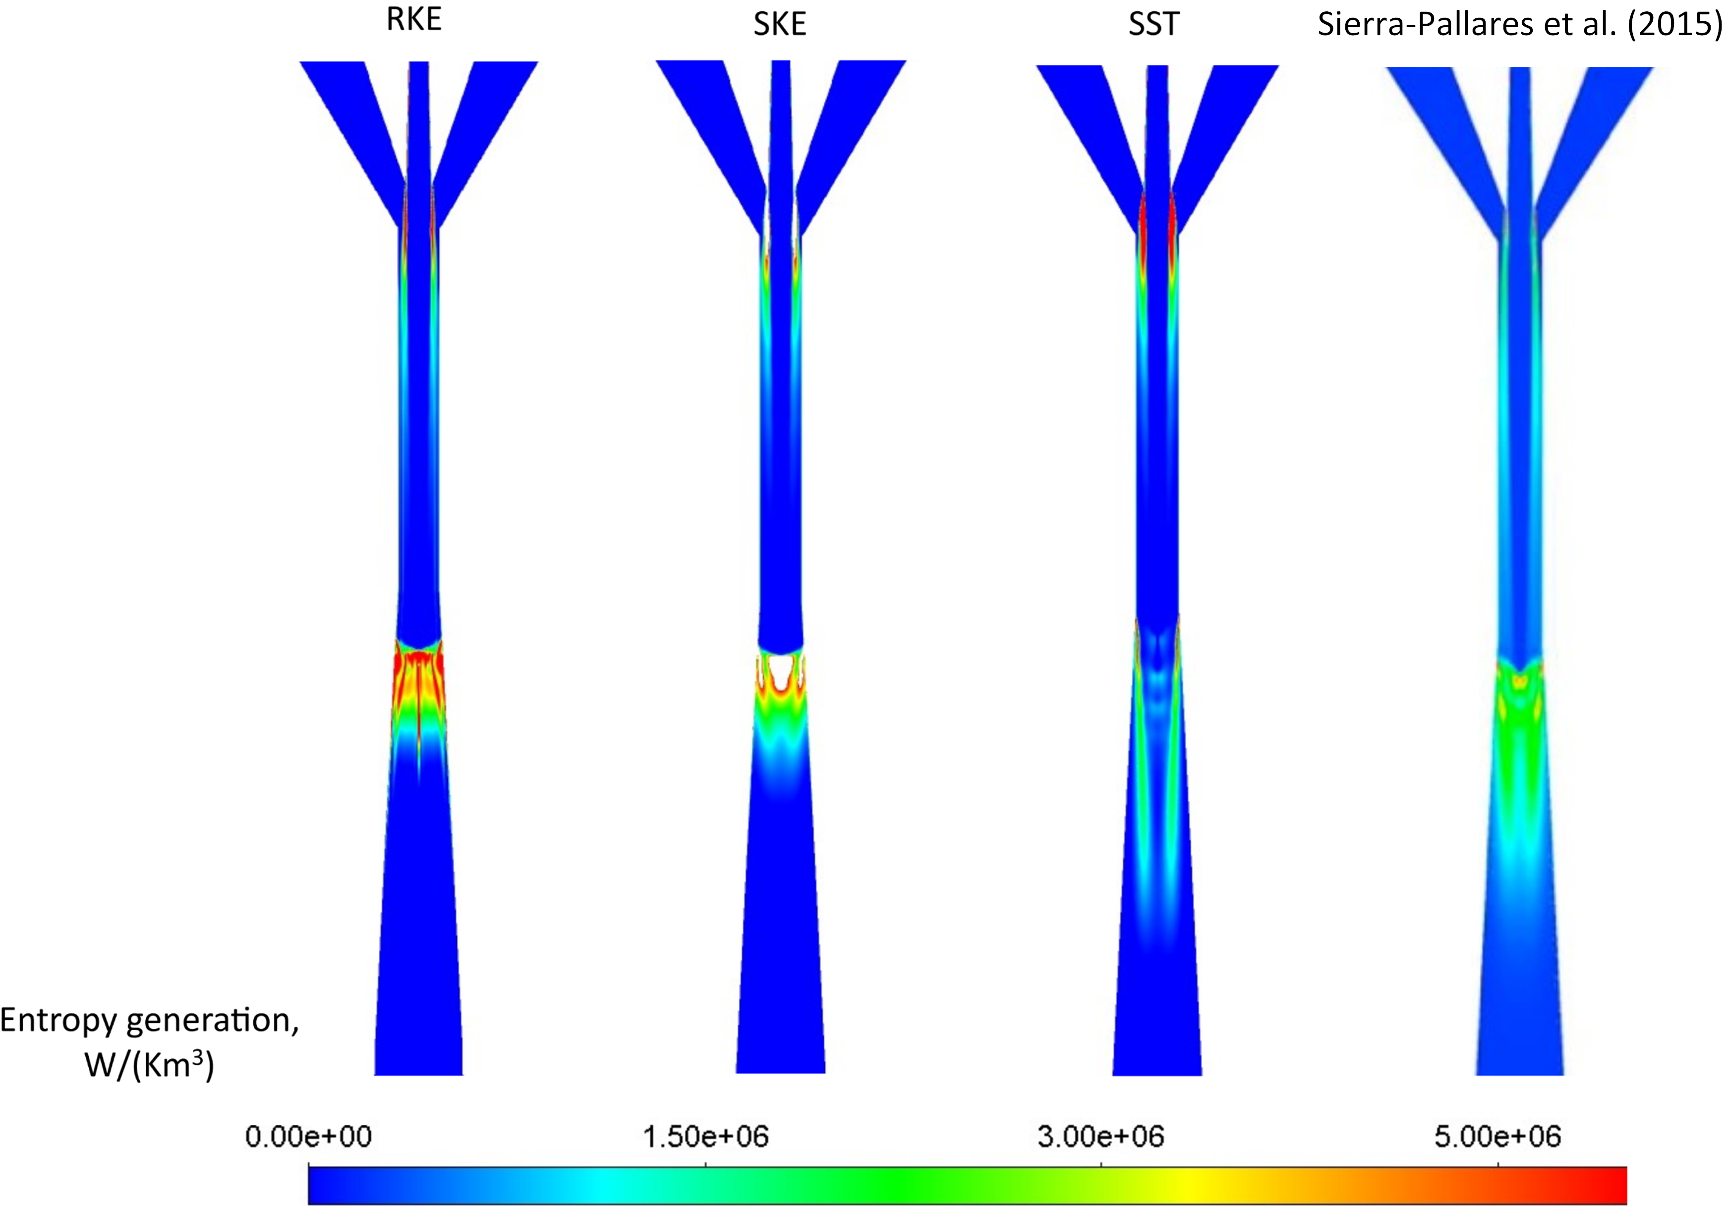
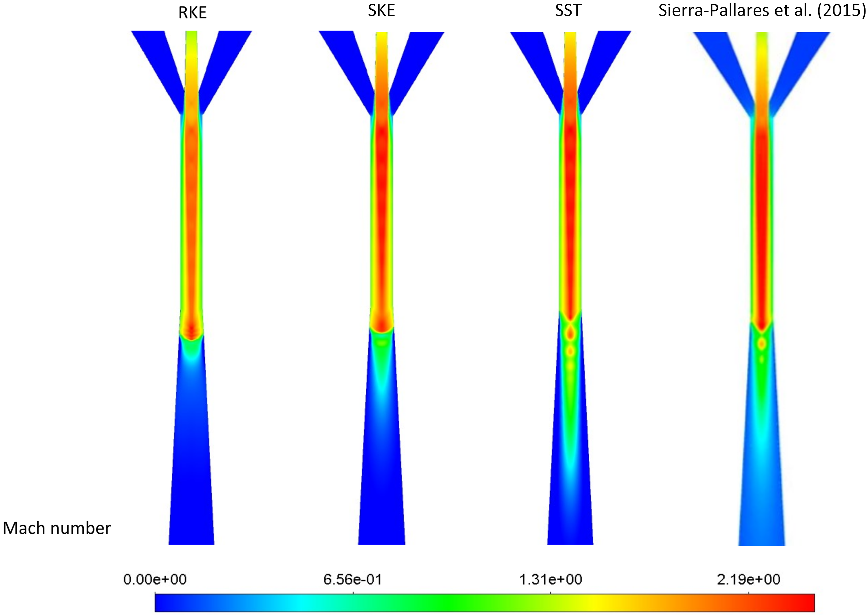
Figure 1: Mach and Entropy generation field in W/(Km³) obtained for three turbulence models for Geometry A of the R134a ejector and compared with the results provided by Sierra-Pallares et al. (2016)
4. Results and discussion
The main objective of this study was to examine the entropy generation the R744 ejector widely applied in refrigeration systems. The aim was to analyze the entropy generation for this kind of throttling device for different operating conditions and various flow characteristics. The CFD model was executed on the basis of experimentally tested unit, therefore it allowed to obtain high accuracy results. Moreover, the proposed 3D mesh used in this study has been already validated in one of the previous work (Majchrzyk et al., 2022). The CFD results of the mass flow rates obtained for the operating conditions were compared with the experimental data in Table 2. It can be observed that as long as the cases concerning motive nozzle pressure above 80 bar are concerned (R744 #1, R744 #4, R744 #5), the mass flow rates obtained in the numerical model are highly accurate with the relative errors below 10%, meeting the requirements of a good practice in ejector modeling. Cases R744 #2 and R744 #3 are located outside the area of HEM best performance envelope, thus the inaccuracy is high, with the highest error of 35% and 23% for motive and suction nozzle at R744 #2.
Table 2: The numerical mass flow rate results of the R744 two-phase ejector compared with experimentally obtained values.
 | $\dot{M}$_{MN_EXP} | $\dot{M}$_{MN _CFD} | $\dot{M}$_{SN_EXP} | $\dot{M}$_{SN_CFD} | δ$\dot{M}$_{MN} | δ$\dot{M}$_{SN}
 | kg/h | kg/h | kg/h | kg/h | % | %
R744 #1 | 255.7 | 270.0 | 52.7 | 57.6 | 6 | 9
R744 #2 | 337.7 | 219.2 | 81.2 | 100.8 | 35 | 23
R744 #3 | 206.4 | 234.0 | 74.4 | 82.8 | 13 | 11
R744 #4 | 258.0 | 280.8 | 52.1 | 82.8 | 9 | 1
R744 #5 | 338.2 | 309.6 | 77.2 | 81.0 | 8 | 5

The entropy generation in the ejectors takes place mainly through viscous dissipation mechanism. The fields of entropy generation for the R744 ejector are presented in Figure 2. The highest values of the entropy generation can be observed at the mixing section, where supersonic motive stream draws the entrained suction stream, and then decreases velocity along the mixing section where the swirl flow of the suction nozzle is mixing with the core fluid flow. As for the entropy generation, the case R744 #1 with higher pressure ratio and lower MER show that the majority of the entropy generation takes place at the interface of the motive and suction streams along the mixing section. Cases R744 #2 and R744 #3 indicate strong entropy generation at the premixing section. This can be connected with much higher MER and low pressure ratio. The third entropy generation pattern can be observed at R744 #4 and R744 #5, which indicates the location of entropy generation in both mixing and diffuser sections, where the streams are still mixing in rotating manner but the pressure of the two-phase flow decreases. This phenomenon is not visible in field of entropy generation of case R744 #1, for which the entropy is generated throughout the whole mixing section but not in the diffuser.
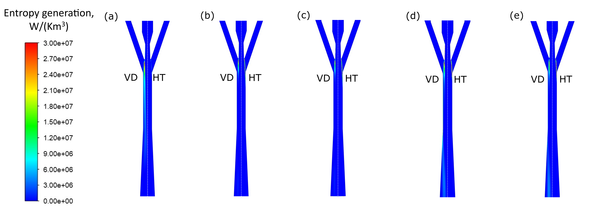
Figure 2: Entropy generation fields in W/(Km³) from contribution of heat transfer (HT) and viscous dissipation (VD) for the R744 ejector for: (a) R744 #1, (b) R744 #2, (c) R744 #3, (d) R744 #4 and (e) R744 #5.
Similar conclusion can be drawn from the streamlines of specific entropy presented in Figure 3, which shows that the suction nozzle swirl flow rotating around the motive stream is not present in the diffuser section at R744 #1. The cases R744 #2 and R744 #3 present slightly more intensive rotation throughout the mixing section than at R744 #4 and R744 #5. This mixing process is directly connected with entropy generation due to the viscous contribution. The heat transfer contribution to the entropy generation for all the analyzed cases was observed only in the premixer section, where the two streams from the motive and suction nozzles of different qualities come into contact.
  - Conclusions
In conclusion, the presented entropy generation fields for the R744 ejector show that the location and value of generation for the same ejector geometry depends on boundary conditions and the mixing intensity. Therefore, higher MER values and velocities impose higher entropy generation caused by viscous forces between suction and motive streams. There was no substantial entropy generation in the vicinity of walls. Additionally, the entropy generation of the R744 ejector occurs mainly in the premixer section and there is no significant generation of entropy in the diffuser section, which was observed for case of R134a single-phase ejector.
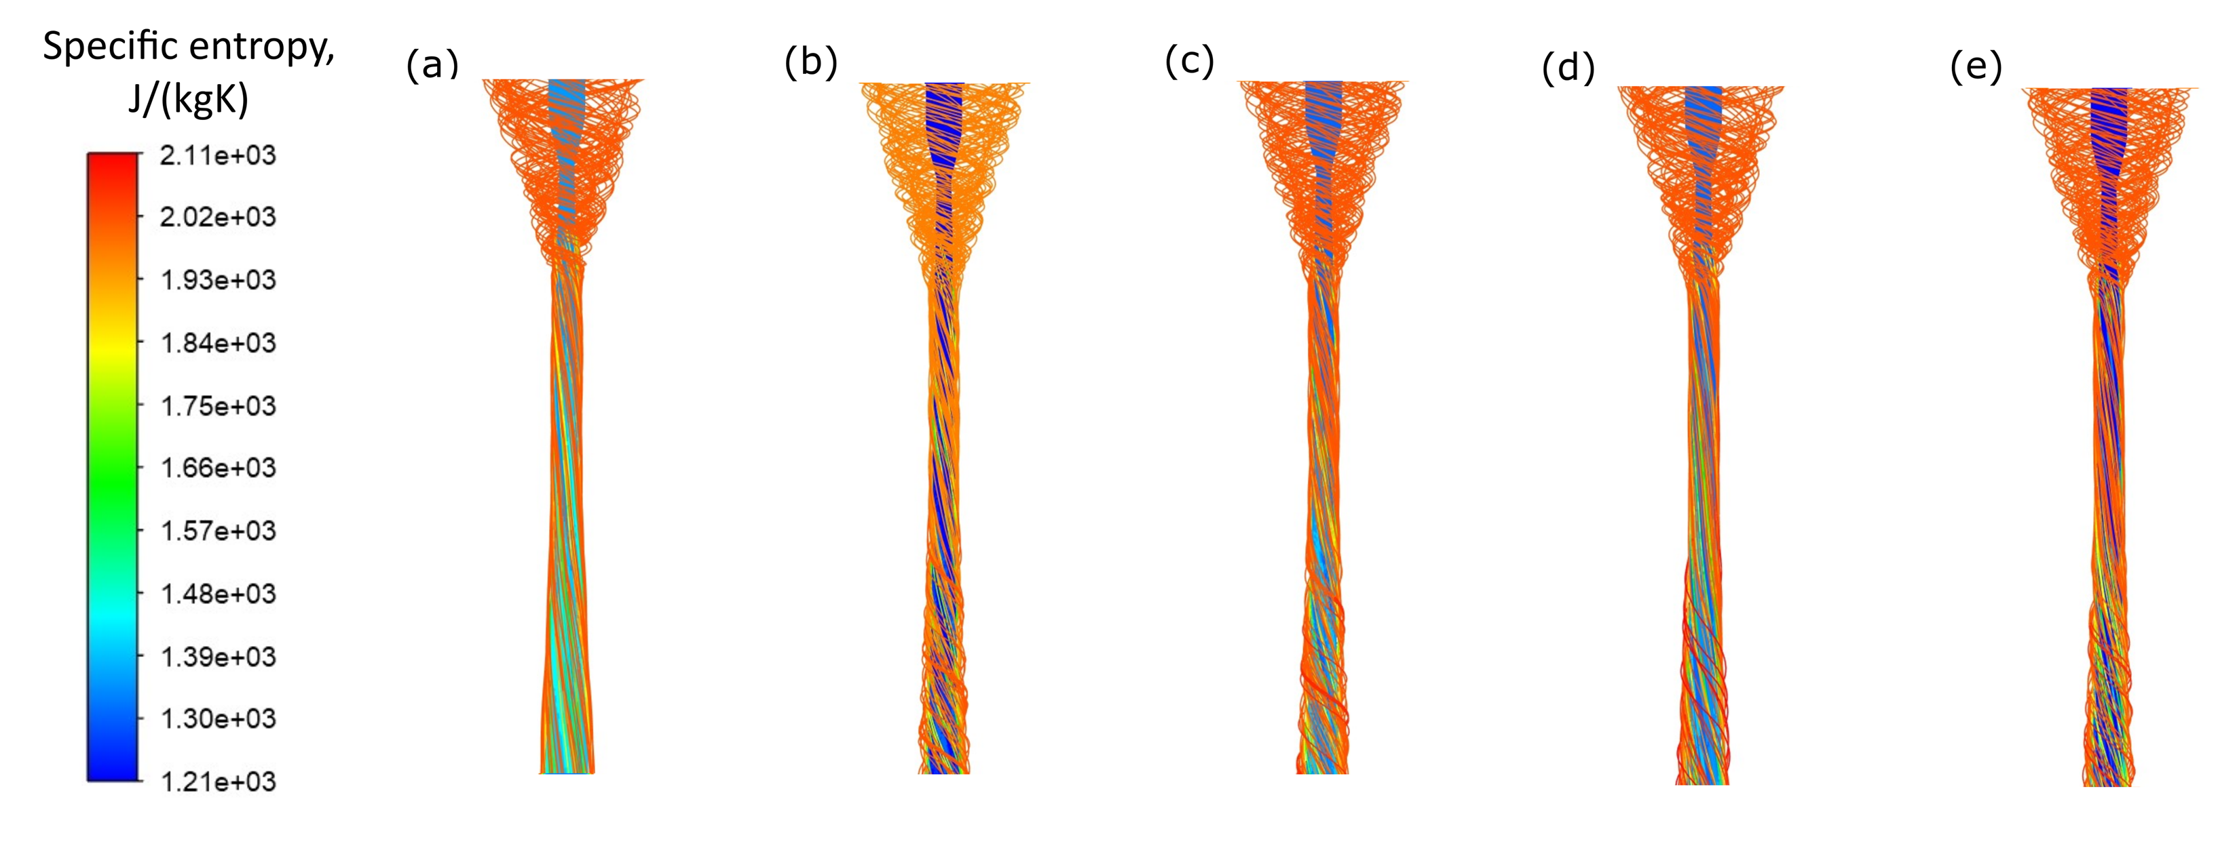
Figure 3: Specific entropy streamlines in J/(kgK) for the R744 ejector for: (a) R744 #1, (b) R744 #2, (c) R744 #3, (d) R744 #4 and (e) R744 #5.

The implemented entropy model after verification with the proposed CFD models of the R744 ejector showed that the module can be applied for both single- and two-phase flow, which significantly extends its possibilities of application, for example for other components of refrigeration systems, such as heat exchangers. However, to assess the potential of its usability for shape optimization algorithms for the ejector design, further analysis needs to be carried out to check whether the entropy model is able to predict the irreversibilities associated with throttling when ejectors of different geometries are concerned.
Nomenclature
$\dot{M}$ – mass flow rate, kg/h  T – temperature, °C  $v$ – velocity vector, m/s  $q$ – Heat flux, W/m²  MN – motive nozzle  SN – suction nozzle  OUT – outlet nozzle | $s$ – specific entropy, J/kgK  $s_{g}$– volumetric rate of entropy generation, W/Km³  $ρ$ - density, kg/m³  $σ$ – Entropy flux vector, W/m2K  $τ$ – Stress tensor – N/m²  $Γ_{k}$ – effective diffusion coefficient, m²/s
References
Banasiak K. Palacz M., Hafner A., Bulinski Z., Smolka J., Nowak A.J., Fic A., 2014, A CFD-based investigation of the energy performance of two-phase R744 ejectors to recover the expansion work in refrigeration systems: An irreversibility analysis, International Journal of Refrigeration, vol. 40, pp. 328–337.
Smolka J., Bulinski Z., Fic A., Nowak A.J., Banasiak K., Hafner A., 2013, A computational model of a transcritical R744 ejector based on a homogeneous real fluid approach, Applied Mathematical Modelling, vol. 37, pp. 1208–1224.
Sierra-Pallares J., Garcia del Valle J., Garcia Carrascal P., Castro Ruiz F., 2016, A computational study about the types of entropy generation in three different R134a ejector mixing chambers, International Journal of Refrigeration, vol. 63, pp. 199–213.
Haida M., Palacz M., Bodys J., Smolka J., Gullo P., Nowak A.J., 2021, An experimental investigation of performance and instabilities of the R744 vapour compression rack equipped with a two-phase ejector based on short-term, long-term and unsteady operations, Applied Thermal Engineering, vol. 185, p. 116353.
Palacz M., Smolka J., Fic A., Bulinski Z., Nowak A.J., Banasiak K., Hafner A., 2015, Application range of the hem approach for CO2 expansion inside two-phase ejectors for supermarket refrigeration systems, International Journal of Refrigeration, vol. 59, pp. 251–258.
Palacz M., Smolka J., Kus W., Fic A., Bulinski Z., Nowak A.J., Banasiak K., Hafner A., 2016, CFD- based shape optimisation of a CO2 two-phase ejector mixing section, Applied Thermal Engineering, vol. 95, pp. 62–69.
Majchrzyk M., Dziurowicz D., Haida M., Palacz M., Bodys J., Fingas R., Smolka J., Nowak A.J., 2022, Detailed numerical investigation of the R744 two-phase ejector 3-D CFD model using flow visualisation measurements, Chemical Engineering and Processing: Process Intensification.
Elbel S., Lawrence N., 2016, Review of recent developments in advanced ejector technology, International Journal of Refrigeration, vol. 62, pp. 1–18.
Lorentzen G., 1983, Throttling, the internal haemorrhage of the refrigeration process, Proceedings of Institute of Refrigeration, vol. 80.

