|  |  |
| --- | --- |
| cetlogo ***CHEMICAL ENGINEERING TRANSACTIONS***  ***VOL. 96, 2022*** | A publication of  aidiclogo_grande |
| The Italian Association  of Chemical Engineering  Online at www.cetjournal.it |
| Guest Editors: David Bogle, Flavio Manenti, Piero Salatino  Copyright © 2022, AIDIC Servizi S.r.l. **ISBN** 978-88-95608-95-2; **ISSN** 2283-9216 | |

Underground Hydrogen Storage in depleted gas reservoirs: opportunity identification and project maturation steps

Chiara Trittoa, Michela De Simonia, Ernesto Roccaroa, Marco Pontiggiaa, Paola Panfilia, Lucilla del Gaudioa, Luca Viscontia, Vanessa S. Iorioa, Gianluca dell’Elcea

aEni S.p.A, San Donato Milanese (MI), Italy

chiara.tritto@eni.com

Depleted gas reservoirs represent a great opportunity for Hydrogen underground storage(UHS).

Eni’s portfolio contains several late-life assets that indeed may provide significant storage capacity. These fields, identified as potential storage sites, are producing for several decades, thus they are accompanied by deep reservoir knowledge and infrastructure availability. Moreover, the caprock, that was able to store hydrocarbon during the past centuries, represents a containment potentially effective also when the reservoir acts as H2 storage site.

In the framework of the energy transition, Eni has adopted a robust workflow allowing for the identification of UHS opportunities among its depleted assets portfolio. Starting from a first selection of the sites based on multidisciplinary available data, the most promising opportunities are then deepened through lab analyses, 3D numerical modelling and special studies. The special studies are devoted to understanding interactions among injected H2 and the reservoir fluids/rock but also with the active communities of microorganisms. Accurate studies are also needed to evaluate the effects of H2 during interaction with wells materials.

In this paper, we will show the steps that lead Eni to identify and mature UHS opportunities.

* 1. Introduction

Eni has set clear and ambitious targets for the decarbonization of the entire life-cycle of its activities within 2050. To achieve this, Eni has designed the evolution of products and processes towards sustainability, by adopting a synergistic approach in which hydrogen represents one of the key decarbonization levers.

On the R&D side, Eni is interested in exploring, and is already exploring, the issues of producing hydrogen in a technologically neutral way, covering the entire supply chain: production, storage and use. Therefore, so-called green hydrogen (from both renewable sources and biomass), blue hydrogen (CCS) and turquoise hydrogen (from pyrolysis) are currently under active consideration. Eni's goal for hydrogen is to decarbonize both its own processes and the industrial and civil processes for which we supply energy. Therefore, the selection criteria are those of effectiveness in terms of decarbonization for entire sectors and, consequently, also scalability to large volumes.

Hydrogen can be an important player in the decarbonization path also because it can be used as an energy vector and stored in order to compensate for the fluctuations due to renewable energy production.

* 1. Underground Hydrogen Storage

Hydrogen has a higher energy density per mass (~120 MJ kg-1)) than hydrocarbons. However, its low density (0.084 kg m-3 at 20°C and 0.1 MPa) means it will require a greater volumetric storage capacity compared to natural gas to deliver the same energy output (Heinemann et al., 2021).

Therefore, storage of large volumes of hydrogen will be needed and subsurface structures are the most suitable options.

Underground Hydrogen Storage can be a safe and long-term solution for the accumulation of a large quantity of energy when production peaks occur, and it quickly responds to changes in the energy demand.

UHS has strong long-term growth potential, expected by 2050 in the order of 20-100 million tons (about 10-20% of total hydrogen production depending on the scenarios to 2050) (Wood Mackenzie, 2021). Suitable sites for storage could be salt caverns, gas-depleted reservoirs and aquifers.

Some examples of UHS in salt caverns already exist in USA and UK (Kruck et al, 2013), where pure hydrogen is stored for industry needing; two recent pilot projects (Perez et al 2016, RAG 2017) were conducted to inject hydrogen mixtures in former gas producing fields in Austria and Argentina.

In this framework, Eni set up an R&D project on underground hydrogen storage (UHS), with a focus on gas-depleted fields. The main advantages of gas depleted fields are:

* Large volumes availability;
* Facilities already in place, to be converted, minimizing emissions and investment/operating costs;
* Known geological structure and detailed specialist field studies already performed;
* Successfully underground containment for natural gas.

The objective of the project is to develop an integrated approach that will help identify possible storage opportunities in Eni assets.

* 1. An integrated approach

The opportunity offered by depleted fields needs a very detailed investigation of all the processes which might be generated by the hydrogen injection and the associated risks.

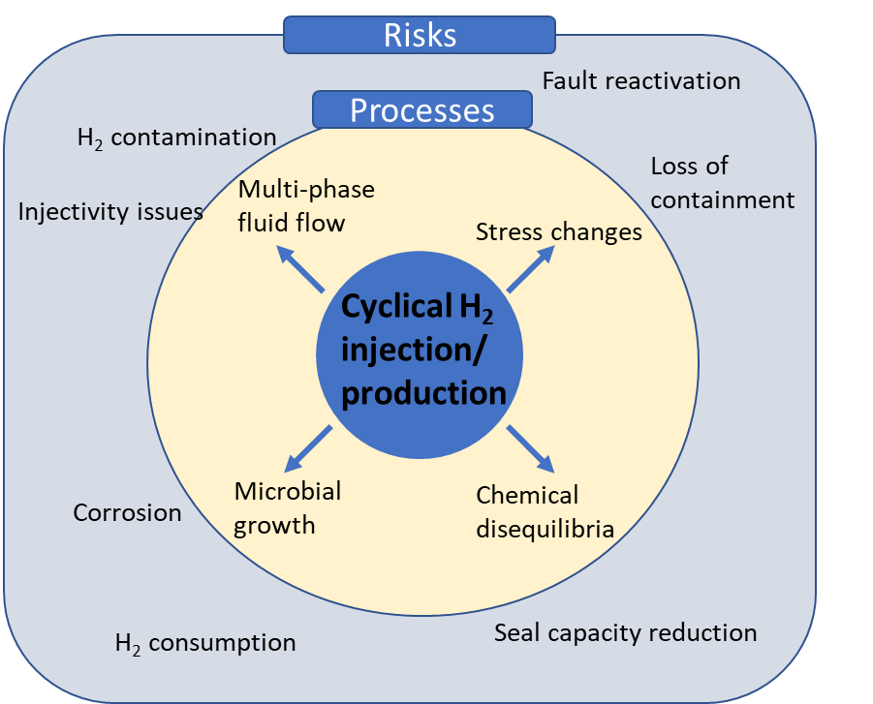

Figure 1: Aspects involved in the storage of hydrogen in porous media

First, cyclical hydrogen injection and production can lead to stress changes on the rocks of both the reservoir and the caprock. Moreover, hydrogen can react with the subsurface minerals and the existing fluids in the reservoir and hydrogen presence can also lead to microbial growth indeed influencing the fluid flow.

Eni is currently focusing on the development of an integrated approach, called Hynergy. It comprises the investigation of all these aspects related to the cycles of injection and production of hydrogen in gas-depleted fields.

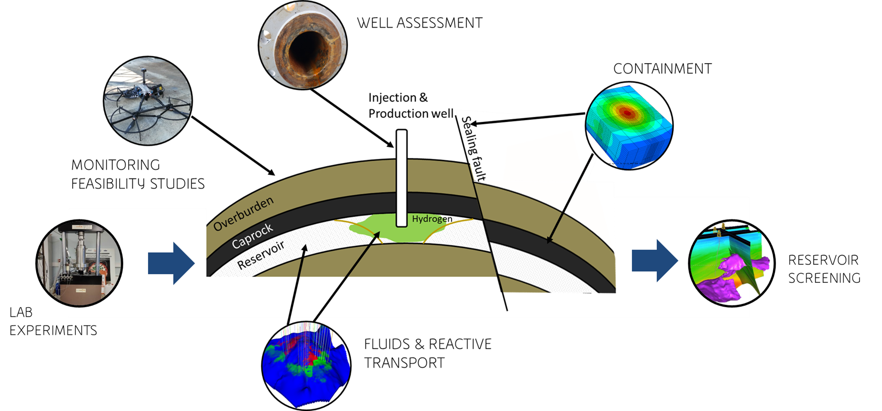

Figure 2: Hynergy integrated workflow, based on lab experiments, developed in Eni R&D

* + 1. Fluids and reactive transport

Usually, former gas fields can be successively used for storage. The composition of originally resident hydrocarbons can be useful to evaluate possible reactions between hydrogen and impurities in the reservoir fluid. The study of the phase behaviour of involved fluids as well as of the variations of physical properties as functions of pressure and temperature conditions experienced during injection is crucial for the optimization of surface facilities and injection operations.

Equations of State (EoS’s) are the core analytical models adopted to predict such phase behaviour. The choice of the EoS type and its calibration on the available experimental data is one of the key points for accurate numerical forecasts of the storage operations.

The hydrogen critical point is around 33 K, 1.3 MPa, with slight differences between its isomeric forms. Since critical temperature is close to absolute zero, hydrogen phase splitting can take place only at extremely low temperatures. Therefore, pure hydrogen can be present at reservoir conditions only in a monophasic supercritical state.

However, it cannot be neglected that the injection stream may contain impurities like CO2, CH4, and other heavier chemical species, mainly coming as by-products of industrial processes which lead to hydrogen production. The impact of all these contaminants on the injection stream has to be considered for accurate reproduction of the thermodynamic fluid properties and phase behaviour at all the operating conditions of interest.

For these reasons, the study of thermodynamic properties and behaviour of hydrogen-rich hydrocarbon gas mixtures are recommended in the framework of underground storage projects, as well as the subsequent numerical reproduction through calibration of the EoS available in commercial simulators.

This workflow requires additional effort on the experimental side since direct measurement of hydrogen-rich mixtures is not typically performed in PVT laboratories, usually devoted to hydrocarbon production projects.

Another key aspect to be considered when studying UHS is that subsurface environments where hydrogen storage takes place, can host diverse and active microbial communities (indigenous or anthropogenically introduced by operations), whenever environmental conditions (e.g., water, essential elements, electron acceptors, temperature) allow it (Gregory et al., 2019). Consequently, microbial growth is known to be an important aspect to be investigated for the feasibility of hydrogen storage.

A schematic view of major pathways for H2 consumption by biomass is given in Figure 3: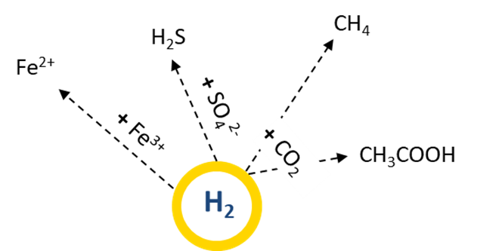

Figure 3. Main metabolic pathways and microorganisms involving hydrogen consumption/production

Potential adverse effects include the microbial transformation of stored H2, resulting in hydrogen losses and unwanted side products (such as hydrogen sulfide, methane and acids), corrosion, clogging etc.

As microbial community and activity is field specific, in-depth investigations from many sites in the selected storage field are of major importance to make general predictions about these risks.

Another process that can potentially contribute to hydrogen consumption and or generation in the subsurface is the interaction of hydrogen with the inorganic part of the reservoir rock. This is considered to be non-negligible only over a long time (Hassannayebi et al., 2019) due to the redox reactions that may change the reactivity of the system leading to the dissolution of some minerals (such as pyrite and carbonates) and the precipitation of others (such as clinochlore and pyrrhotite).

* + 1. Containment

The evaluation of the sealing efficiency of caprocks and faults is a widely studied topic in the oil and gas industry, with a huge number of works.

In the same way as underground natural gas storage (UGS), hydrogen storage (UHS) in depleted gas fields involves phases of fluid injection in the reservoir alternated to fluid production phases that correspond, from a mechanical point of view to unloading/reloading cycles of both reservoir and cap rocks. Hypothetically, cyclic loading of rocks can potentially lead to a degradation of rock properties but the actual importance of this phenomenon on reservoir and cap rocks has not been extensively studied in the O&G business. In the scenario of UHS, the definition of the fatigue life of the rocks can be fundamental. Fatigue failure is related to a cyclic loading whose magnitude would not lead to failure if applied monotonously. In order to evaluate the impact of hydrogen cycles on the rocks, dedicated experimental procedures for the evaluation of possible risks caused by mechanical fatigue can be essential.



Figure 4: Typical cyclic loading

The cyclic injection and production of hydrogen can impact fault stability too. An analysis of the behavior of faults, when subjected to cyclic loading, is therefore an important element in the evaluation of a potential underground storage site. Evaluation of hydrogen losses due both to the diffusion in the caprock and to the overcoming of the breakthrough capillary pressure of the seal are also aspects to be considered when performing a caprock seal assessment. A number of different approaches can be used to obtain breakthrough pressures, starting from the widely used step-by-step method (Thomas et al., 1968) to other approaches like the dynamic one (Egermann et al., 2006).

As regards the diffusion in the caprock, the main parameters to be deeply investigated seem hydrogen solubility in water and hydrogen-water diffusion coefficient.

Finally, understanding the impact of H2 on fault sealing behavior is of utmost importance for the validation of lateral containment in UHS projects.

* + 1. Well Assessment

Generally, the completion design for typical natural gas underground storage can be used for hydrogen storage because the safety requirements are independent of the type of stored media (DBI Gut, 2017). However, hydrogen interactions in UHS are a perplexing topic due to their foreign nature and therefore their behavior in the subsurface could be not predictable. In the subsurface, hydrogen can instigate several changes such as and not limited to promoting mineral precipitation and dissolution in cement, corrosion of steel materials, physical and chemical change in elastomers. However, the sealing effectiveness and corrosion resistance of all materials used for completion (steel alloys, cement, elastomers and seals) have to be guaranteed.

It is well known that the interaction of steel alloys with hydrogen can have an impact on the material properties and performances due to hydrogen blistering, induced cracking, and embrittlement. This leads to mandatory compatibility tests of metallurgy with hydrogen in order to assess the limits of applicability.

The hydrogen interaction with cement can cause potential integrity issues. (Boersheim et. al., 2019) Therefore, an investigation is required into this interaction to quantify and mitigate potential integrity issues of UHS.

The cement-hydrogen interaction tests (Iorio et al, in press) were conducted using autoclave as key instrumentation to simulate reservoir temperature and pressure conditions. The tests were designed and conducted using the methodological approach typical of the materials/fluids compatibility tests.

This compatibility study of Hydrogen is the first important step to further de-risk activities.

* + 1. Monitoring

The monitoring phase is a crucial element of the risk assessment and management and has to be implemented starting from the early phase of the project, in order to make a baseline during the injection phase and post of injection phase. Prefeasibility studies are mandatory in order to assess which techniques already known for the O&G industry and CCS are appropriate for Hydrogen storage.

The application of electrical and electromagnetic methods for continuous monitoring purposes during and after the injection of hydrogen can be beneficial. In fact, potential effects on electrical and electromagnetic properties due to hydrogen injection into the subsoil are expected (Henkel et Al., 2014). These effects can be both physical and chemical in nature. A significant increase in the "bulk electrical resistivity" of the host rocks is generally expected due to the high resistivity of hydrogen. Therefore, laboratory experiments are of utmost importance to obtain quantitative estimates about the actual expected variations in different types of materials caused by the presence of hydrogen with different saturation values and in rocks with variable physical properties (porosity, permeability, clayey mineral content, etc).

As generally performed for CCS studies, time lapse seismic modelling can also be supportive in order to simulate different injection scenarios, in terms of saturation and pressure. Petroelastic models, enriched by ultrasonic lab analysis, can be used to simulate the impact of H2 injection on well log data and variations in the synthetic log data can be evaluated in the seismic domain.

Finally, feasibility studies on techniques aimed at monitoring potential ground deformations, microseismic activity, and investigating possible leakages from the storage complex need also to be carried out in a comprehensive risk assessment of UHS.

* + 1. Reservoir screening

The final objective of Eni integrated approach is the integration of all the aforementioned technical aspects in a screening tool which will allow the selection of reservoirs with best features for UHS with a grade of uncertainty.

Main parameters to be considered are related to petrophysical properties, lithotype, geochemistry, caprock thickness and integrity, presence of faults, number of drilled wells and depth, to which temperature and pressure are linked (Pontiggia, 2022). For example, temperature should be high enough to guarantee sterilization of the reservoir (some archaea can survive at temperatures up to 92 °C (Panfilov, 2015)), but not to the level of favoring matrix reactions with H2. In fact, reactions in the mineral matrix seem to proceed very slowly below 100 °C under atmospheric pressure and in the absence of catalysts (Tarkowski, 2019).

Since the target reservoir would be depleted, pressures will generally be low. In literature wide ranges are proposed (e.g. 10-100 bar, Kruck et al, 2013).Constant updates are needed in order to de-risk the ranking of depleted Eni operated assets.

* 1. Conclusions

UHS has strong long-term growth potential, expected by 2050 in the order of 20-100 million tons (about 10-20% of total hydrogen production depending on the scenarios to 2050). Salt caverns and depleted gas reservoirs, if properly selected, can offer a feasible solution for storage large quantity of hydrogen in a long term and safe way. Eni has developed an integrated workflow, Hynergy, which will take into account all the aforementioned aspects in order to get a screening tool which will allow the ranking of Eni exhausted fields.

References

Clemens Boersheim E., Reitenbach V., Albrecht D., 2019, SPE-195555-MS Experimental Investigation of Integrity Issues of UGS Containing Hydrogen, Clausthal University of Technology; Dieter Pudlo, FSU Jena; Leonhard Ganzer, Clausthal University of Technology, SPE

DBI Gas, RAG, 2017, The Effects of Hydrogen Injection in Natural Gas Networks for the Dutch Underground Storages.

Ebrahimiyekta A., 2017, Characterization of geochemical interactions and migration of hydrogen in sandstone sedimentary formations: application to geological storage. EarthSciences. Université d’Orléans. English. NNT:2017ORLE2016.

Egermann, Patrick & Lombard, J.-M & Bretonnier, P., 2006, A fast and accurate method to measure threshold capillary pressure of caprocks under representative conditions. In: International Symposium of the Society of Core Analysts, Trondheim, Norway 12e16 September 2006.

Gregory Simon P, Barnett Megan J., Field Lorraine P., Milodowski Antoni E., 2019, "Subsurface Microbial Hydrogen Cycling: Natural Occurrence and Implications for Industry" Microorganisms 7, no. 2: 53. https://doi.org/10.3390/microorganisms7020053.

Hassannayebi N., Azizmohammadi S., De Lucia M., Ott Holger, 2019, Underground Hydrogen Storage: application of geochemical modelling in a case study in the Mulasse Basin, Upper Austria.

Heinemann N., Alcalde J., Miocic J. M., Hangx S. J. T., Kallmeyer J., Ostertag-Henning C.,Hassanpouryouzband A., Thaysen E. M., Strobel G. J., Schmidt-Hattenberger C., Edlmann K., Wilkinson M., Bentham M., Haszeldine R. S., Carbonell R., Rudloff A., 2021, Enabling Large Scale Hydrogen Storage in Porous Media: The Scientific Challenges

Henkela S., Pudloa D., Wernera L., Enzmannb F., Reitenbachc V., Albrechtc D., Würdemannd H., Heistere K., Ganzerc L., Gauppa R., 2014, Mineral Reactions in the Geological Underground Induced by H2 and CO2 Injections”, in Energy Procedia · December 2014

Iorio V. S., Cracolici F., Sabatino L. M. F., Previde Massara E., Consonni A., Parrozza F., Tritto C., De Simoni M., 2022, Cement to safeguard the wells integrity in Underground Hydrogen Storage: an experimental investigation, CEt Chemical Engineering Transactions – AIDIC in press

Kruck O., Crotogino F., Prelicz R., Rudolph T., 2013, Overview on all Known Underground Storage Technologies for Hydrogen. HyUnder 14.08.2013

Panfilov M., 2015, Underground and pipeline hydrogen storage. In: Compendium of Hydrogen Energy, Ed. Gupta R.B., Elsevier, Chapter 4, p. 92 - 116

Pérez A., Pérez E., Dupraz S., Bolcich J., 2016, Patagonia Wind - Hydrogen Project: Underground Storage and

Methanation, 21st World Hydrogen Energy Conference 2016. Zaragoza, Spain. 13-16th June 2016

Pontiggia M, 2022, Hydrogen Storage In Depleted Fields: An Integrated Approach For Screening And Selection, SPE Bullettin April 2022

RAG Austria AG, 2017, UNDERGROUND SUN STORAGE, Final Report 31. October 2017

Royer‐Carfagni G, Salvatore W., 2000, The characterization of marble by cyclic compression loading: experimental results. Mechanics of Cohesive‐frictional materials: An International Journal on Experiments, Modelling and Computation of Materials and Structures 5:535-563

Tarkowski R., 2019, Underground hydrogen storage: Characteristics and prospects. Renewable and Sustainable Energy Reviews 105, 86–94

Thomas, L.K., Katz, D.L., Tek, M.R., 1968, Threshold pressure phenomena in porous media. Soc. Petrol. Eng. J. 8 (2), 174-184.

Wood Mackenzie, 2021, Subsurface CCUS and low carbon energies- 5 things to look for in 2022, December 2021