CHEMICAL ENGINEERING TRANSACTIONS  VOL. 96, 2022 | A publication of
The Italian Association
of Chemical Engineering
Online at www.cetjournal.it

Guest Editors: David Bogle, Flavio Manenti, Piero Salatino
Copyright © 2022, AIDIC Servizi S.r.l.
ISBN 978-88-95608-95-2; ISSN 2283-9216

Effect of composition variability of a syngas in a spark ignition engine: an experimental study
Y. Sehiliª, K. Loubar^{a,}*, L. Tarabet^{b}, M. Cerdoun^{b}, C. Lacroixª
ªGEPEA, UMR 6144 DSEE, IMT Atlantique, 44307 Nantes, France
^{b}LES Laboratory, EMP, Algiers, Algeria
khaled.loubar@imt-atlantique.fr
The waste derived syngas allows the recovering of its energy using conventional technologies of energy production like internal combustion engines. However, its major drawback is its low calorific value and low stoichiometric air fuel ratio leading to higher specific fuel consumption and difficulties when using injection mode due to the required long injection duration. Recently, many studies aimed to improve the calorific value of the syngas, either by enriching it with methane or by optimizing the production techniques and the used feedstock like the refused derived fuel (RDF). Syngas produced by the pyrolysis of RDF is a methane rich syngas (40-60%) with a relatively high calorific value and stoichiometric air fuel ratio. This work is an experimental study on the combustion, performance and emissions of this type of syngas in spark ignition engine taking into consideration its composition variability. Pure methane was also tested and is considered as a reference fuel for comparison. The results show a faster and smoother combustion of syngas, lower emissions of total hydrocarbons, and higher emissions of nitrogen oxides and carbon monoxide. Beside, syngas improved the brake thermal efficiency while still maintaining higher brake specific fuel consumption with respect to methane.
  - Introduction
According to the International Energy Outlook the world will encounter a significant growth in the worldwide energy demand over the 28-year period from 2012 to 2040, so that the total world consumption of marketed energy is expected to expand by 48% during this period. This growth is accompanied by environmental constraints following Kyoto protocol 1997 and lately COP21 in 2015.
Many researchers have studied the application of syngas in engines (Fiore et al, 2020). It can be used as a dual fuel of diesel-syngas in the compression ignition engine (Ramalingam et al, 2019), in the spark-ignition engine (Nadalet and Przybyla, 2018), and also in the HCCI engine (Wiemann, 2018).
Syngas is a promising fuel for internal combustion engines because it can be efficiently and cleanly burned (Verhelst et al,2018). In addition, syngas is used as energy carrier for transportation vehicles (Jaspers et al, 2021). It can be used in either spark-ignition engines or compression-ignition engines, burning either pure methanol directly or a blend of methanol with gasoline or diesel (Li et al, 2021). To improve the thermal efficiency of the engine, the method of blending methanol with dissociated methanol gas was proposed (Xie, 2016) and later (Wen, 2018).
The effect of H₂/CO ratio has been studied by (Bika, 2010). A 50% H₂ / 50% CO mixture has been reported to have the advantage in terms of efficiency (32%) and combustion stability (COV (IMEP) less than 10% for all operations compared to other H₂/CO mixtures. Also, (Shivapuji et al, 2015) investigated the influence of the fuel hydrogen fraction on syngas fuelled SI engine. The study showed that the adiabatic flame temperature and the flame laminar speed increase with the hydrogen fraction leading to higher convective heat flux. The cooling load is about 10 ± 3% higher than the typical higher hydrocarbon cooling load. As a consequence, the brake thermal efficiency that increases initially with hydrogen reduces at higher hydrogen levels.
(Hagos et al, 2015) investigated the methane enrichment of a H₂/CO syngas by 20%. Wider operation range of load was observed compared to H₂/CO syngas with a little effect on the brake emissions of CO, NOx, and THC.
The objective of the current work is to show that RDF based syngas is a reliable alternative fuel for SI engines with minor modifications despite its composition variability. The combustion characteristics, performance and emissions of different syngas compositions are to be studied under different loads at a constant speed of 1500 rpm.
  - Experimental procedure
In the following section, the experimental procedure is detailed, and the different inputs are explained.
    - Engine test and methods
A single cylinder AVL 5401 SCRE stationary research engine is employed for this study. The engine initially works on indirect injection of gasoline. Its specifications are given in Table 1. It is mounted on a test bench and connected to an eddy current dynamometer D2T DE 220, which also allows to control the torque and speed. An electronic control unit (ECU) is implemented with a control interface via PC INCA and was installed to regulate the ignition advance and the gas flowrate as a function of the inlet air pressure and the engine speed. The experimental setup of the test engine is shown in Figure 1.
Table 1: Engine specifications
General details | Single cylinder, Spark ignition 4-Stroke, naturally aspirated
Cooling system | Closed circuit water cooling
Displaced volume | 499.6 cc
Bore x Stroke | 86 mm x 86 mm
Rated power output | 25 kW @ 6000 rpm
Compression ratio | 10.5:1
Exhaust Valve Open | 74° BTDC
Exhaust Valve Close | 14° ATDC
Inlet Valve Open | 34° BTDC
Inlet Valve Close | 54° ATDC
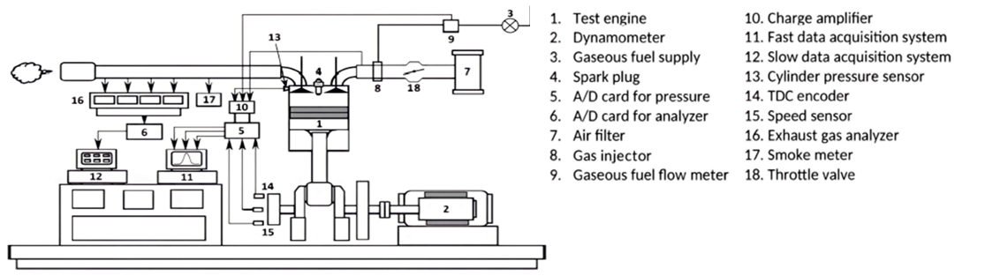
Figure 1: Schematic of the experimental setup
The fuel composition is entered in the LabView program by specifying the percentage of each gas. In this study, seven gases are used to create various syngas compositions: CH₄, C₂H₆, C₃H₈, C₄H₁₀, CO₂, H₂ and CO. All gases are supplied from pressurized bottles through successive pressure regulators that are intended to reduce the pressure of each gas from 150 bars in the main tanks to 6 bars in the mixing rail. The intake air flow is measured by a flow meter IN-FLOW F-106AI. It is placed upstream of a buffer capacity for attenuating the pressure oscillations propagating in the intake line. The required gas flow is controlled according to a predefined map of equivalence ratio which takes the air flow as an input. The required flow of each gas is then calculated, and delivered to the mixing rail via five Brooks 5850S mass flow controllers with an accuracy of ±0.1% full scale. A mass flow meter EL-FLOW F-112AC placed after the mixing rail is used to measure the produced gas flow.
    - Syngas used in the experiments
The composition of the gases is taken from the RDF pyrolysis experiments carried out at lab-scale reactor. RDF is mostly composed of heavy hydrocarbons. Throughout the pyrolysis process, these hydrocarbons start to break down into small chains to form lighter ones and eventually methane. Therefore, RDF based syngas is a methane rich syngas which gives it higher stoichiometric air-fuel ratio and higher calorific value. The remaining non-cracked hydrocarbons are mostly of second order (C₂H₄ and C₂H₆), and then third and fourth order hydrocarbons depending on the residence time and the temperature involved. Most of the times only methane is produced with a negligible percentage of higher order hydrocarbons. Table 2 and 3 shows the compositions and characteristics of the used syngas respectively:
Table 2 Compositions of the used syngas
Gas | SG1 | SG2 | SG3 | SG4 | CH₄
CH₄ (%) | 48.84 | 54.70 | 24.12 | 50 | 100
CO (%) | 23.38 | 19.06 | 19.32 | 23 | 0
CO₂ (%) | 13.49 | 12.71 | 14.19 | 7 | 0
H₂ (%) | 12.71 | 8.53 | 14.76 | 20 | 0
C₂H₆ (%) | 1.58 | 5 | 16.59 | 0 | 0
C₃H₈ (%) | 0 | 0 | 7.41 | 0 | 0
C₄H₁₀ (%) | 0 | 0 | 3.61 | 0 | 0
Table 3 Characteristics of the used syngas
Gas | SG1 |  | SG2 |  | SG3 |  | SG4 | CH₄
Density (kg/m3) @STP | 0.935 |  | 0.957 |  | 1.16 |  | 0.802 | 0.717
Methane number | 91.3 |  | 88.3 |  | 58.6 |  | 78.8 | 100
Flammability limits | 0.39 - 1.82 |  | 0.41 - 1.74 |  | 0.46 - 2.3 |  | 0.44 - 1.87 | 0.54 - 1.69
Stoichiometric AFR | 7.71 |  | 9.02 |  | 9.43 |  | 9.28 | 17.09
LHV (kJ/kg) | 23768.6 | 27384.8 |  | 28878 |  | 28711.8 |  | 50125.6
    - Predefined engine maps
Two maps were initially defined for the engine to operate efficiently despite the variation in the syngas composition: spark advance map and equivalence ratio map.
The power delivered by the engine is directly related to the spark advance. Advancing the spark to its optimal value improves the performance and generates higher power. However, this creates a high-pressure environment where it is risky for some gases, with low methane numbers, to detonate and cause knock. The ignition advance was adjusted to the maximum brake torque (MBT) timing of SG1 which has the highest methane number.
The gas flow rate is specified to each gas to follow a certain curve of equivalence ratio. The form of the curve must satisfy the stability of combustion at all loads. Under partial load conditions, the engine is able to operate with leaner mixtures providing good economy. At full load, the throttle is set to its fully open position (WOT), where the engine is inquired to develop its maximum power, which requires enriching the mixture. Some experiments were done with all the fuels to specify limits for leaning and enriching the mixture. Experiments preformed with pure methane with an equivalence ratio (ɸ) greater than 0.8 produced CO in the exhaust higher than 6000 ppm which is the saturating limit of the infra-red detector (MIR 2M). This result sets the maximum allowed limit of ɸ to be 0.8. SG1 was tested at low ɸ in the range of [0.52-0.6]. The instability of the combustion was obvious especially at low loads, as the COV of IMEP increased and high values of unburned HC and CO were detected. Experiments show better combustion of SG3 with higher range of ɸ [0.55-0.65], leaving lower amount of unburned CO and HC. SG2 and SG4 gases were also tested for ɸ [0.65-0.75] and [0.6-0.7] respectively. HC and CO emissions were also reduced compared to those of SG3, despite the fact that the initial content of hydrocarbons in SG2 and the initial value of CO in SG4 are higher than those of SG3. This indicates that better combustion with reduced CO and HC emissions is obtained as the equivalence ratio is increased. However, the only drawback is the increasing NOx emissions which require no further mixture enriching. Therefore, the range of equivalence ratio was set to [0.65-0.75]. The gas flow rate is then calculated by the following equation:
$Q_{gas}=∅*\frac{1.204*Q_{air}}{11.95*\left({\%CH}_{4}\right)+2.851*\left(\%CO\right)+3.03*\left({\%H}_{2}\right)+20.174*\left(\%C_{2}H_{6}\right)}$ (1)
  - Results and discussion
The following section summarizes the main characteristics of combustion.
    - Combustion characteristics
Figure 2 presents the coefficient of variations of IMEP versus IMEP for the five gases tested. COV of IMEP quantifies variability in indicated work per cycle and the stability of combustion. This explains its increase at low loads where the combustion instability is higher due to the misfiring caused by the poor turbulence of the mixture and higher residual gases. All the fuels are shown to operate with COV (IMEP) less than 10%, which indicates good combustion stability. However, syngas is observed to operate with lower COV than pure methane at all loads, especially at low loads where pure methane shows a high sensitivity to load variation.
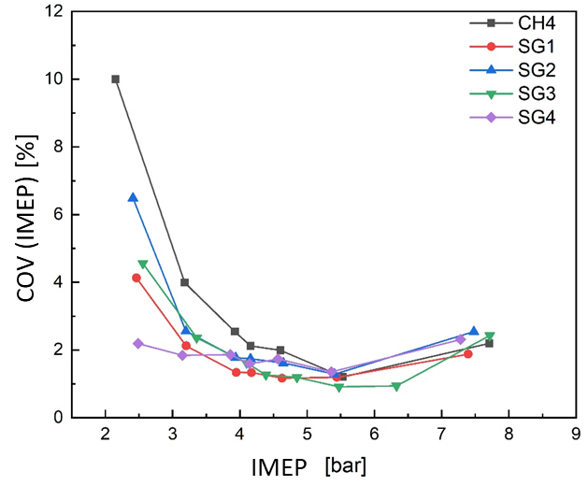
Figure 2 Coefficient of variations of IMEP versus IMEP
Initial flame development phase
The combustion parameters indicate the higher reactivity of syngas compared to pure methane. This response can be attributed to the thermo-physical properties of the syngas. The presence of hydrogen in the syngas decreases the minimum ignition energy required. Though, the spark energy remains constant for all the compositions leading to an increasing excess energy as the hydrogen content increases.
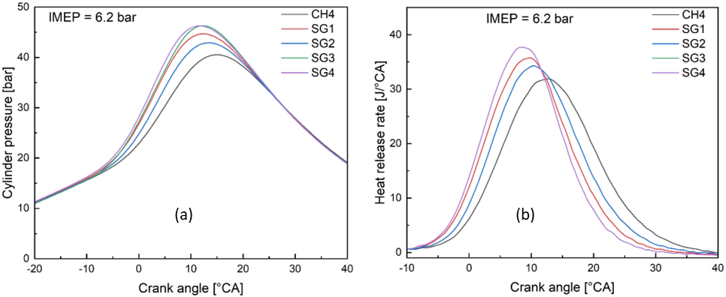
Figure 3 In-cylinder pressure (a) and Heat release rate (b)
Fast burn phase
The combustion behaviour in the fast burn phase shown in Figure 3 indicates an advance in the combustion phasing of syngas compared to that of methane which is attributed to the enhanced mixture reactivity of syngas. Pure methane has the lowest peak cylinder pressure of 40.49 bars at 15.5 °CA after top dead centre (ATDC) and the lowest peak heat release rate of 31.89 J/CA at 13°CA ATDC. Moreover, SG4 has the highest peak cylinder pressure of 46.27 bars at 11.5 CA ATDC and the highest peak of heat release rate of 37.71 J/CA at 8.5 CA.
    - Engine performance
Figures 4a and 4b show the variation of the brake thermal efficiency and the brake specific fuel consumption (BSFC), respectively, for all compositions in terms of the brake power at 1500 rpm at WOT conditions. The maximum engine power at this speed varies depending on the fuel used. Methane and SG3 allows the engine to produce a higher power than other compositions. A maximum thermal efficiency of 34.6% is obtained by the combustion of SG1 despite its lower calorific value, while acquiring the maximum BSFC at all loads shown in Figure 4b. On the other hand, the minimum thermal efficiency is achieved by the combustion of methane, while having the minimum BSFC because of its higher stoichiometric AFR and calorific value.
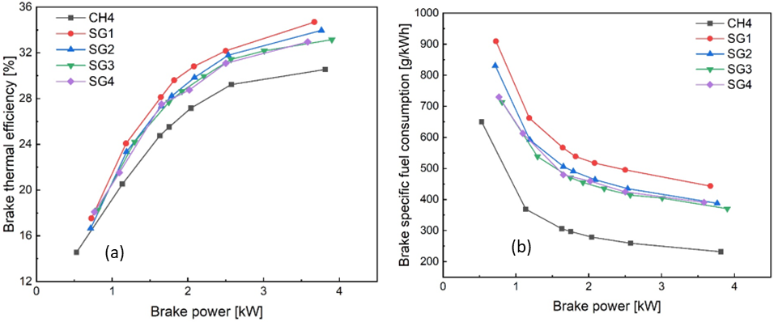
Figure 4 Brake thermal efficiency (a) and brake specific fuel consumption (b) versus power output
    - Emission characteristics
The following section summarizes the main results about pollutant emissions.
Total hydrocarbons THC
Figure 5a shows the THC emissions of all compositions as a function of the brake power at 1500 rpm. All fuels show a trend of increasing THC emissions at low loads because of the weak flame propagation and the incomplete combustion at these conditions. However, a sharp increase of THC emissions at low loads is observed for pure methane which seems to be more sensitive to load variation than syngas. Besides, all compositions show lower THC emissions than pure methane by 38 % at intermediate and high loads. This result is attributed to the lower level of hydrocarbons initially contained in the syngas than methane.
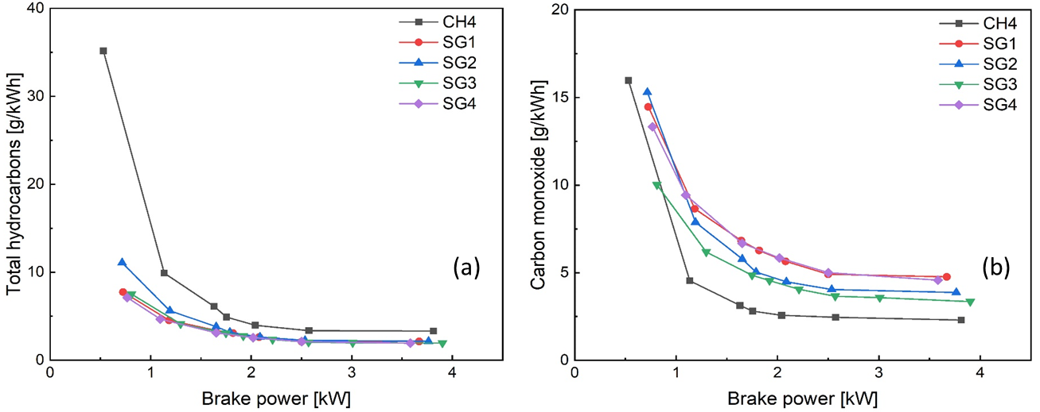
Figure 5 THC emissions (a) and CO emissions (b) versus power output
CO emissions
The decreasing trend of CO with the load is detected with all fuels in Figure 5b. It is observed that pure methane emits less CO than syngas. The CO emitted by syngas is basically the unburned CO fractions initially contained in the syngas due to the inhomogeneous distribution of the fuel in the chamber where some portions are too lean to burn completely. CO can also occur by the dissociation of CO₂ molecules (already formed in the cylinder or found in the fuel) under the action of high temperatures. The results show that SG1 and SG4 emit more CO followed by SG2 and SG3. This order corresponds to the order of the gases according to their CO content.
NO_{x} emissions
The brake specific emission of nitrogen oxides (NO_{x}) is given by the sum of that of nitric oxide (NO) and nitrogen dioxide (NO₂). NO is produced during combustion and results from the oxidation of the atmospheric nitrogen following the Zeldovich mechanism (Zeldvich,1946). According to the latter, NO formation requires the presence of oxygen and nitrogen at high temperatures. The temperature at which combustion occurs is a first consideration in determining the NO_{x} production. The adiabatic flame temperature curves of all compositions are consolidated in Figure 6b as a function of the brake power. The distribution of the temperature curves coincides perfectly with the distribution of NO_{x} levels shown in Figure 6a. It can be noticed that pure methane emits less NOx than syngas due to the presence of hydrogen in the syngas which increase the adiabatic flame temperature.
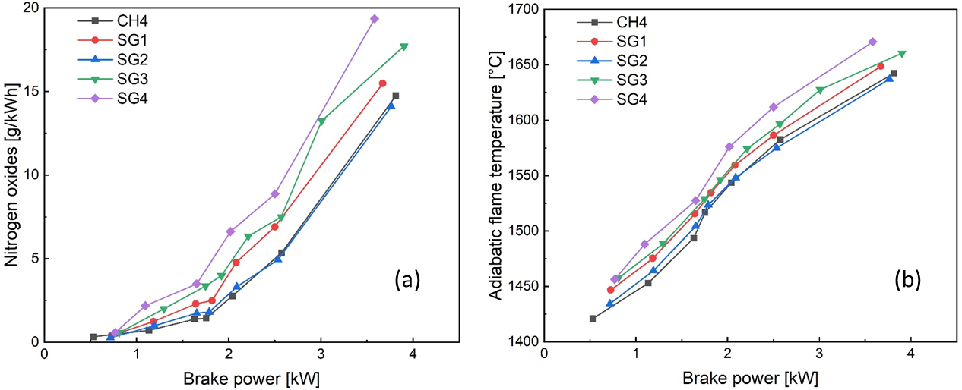

Figure 6 NOx emissions (a) and adiabatic flame temperature (b) versus power output
  - Conclusions
The present work is based on an experimental study on the combustion, performance and emissions of a syngas in spark ignition engine taking into consideration its composition variability. Pure methane was also tested and then considered as a reference of comparison. The results show a faster and smoother combustion of syngas, lower brake emissions of total hydrocarbons, and higher brake emissions of nitrogen oxides and carbon monoxide. Besides, syngas improved the brake thermal efficiency while still maintaining higher brake specific fuel consumption with respect to methane.
Nomenclature
MBT | : Maximum Break Torque | BTDC | : Before Top Dead Center
IMEP | : Indicated Mean Effective Pressure | Q_{gas} | : Gas flow rate, nl/min
ɸ | : Equivalence ratio | Q_{air} | : Air flow rate, nl/min
ATDC | : After Top Dead Center

References
Anand, M. Shivapuji, A.M., Dasappa, S. "Influence of fuel hydrogen fraction on syngaz fueled SI engine: Fuel thermo-physical property analysis and in-cylinder experimental investigations, " International Journal of Hydrogen Energy, 40, 10308-10328, 2015.
Bika, A.S., "Synthesis Gas Use in Internal Combustion Engines» Ph.D. thesis, University of Minnesota. 2010
Hagos, F.Y., Rashid, A., Aziz, A., Shaharin, A.S. " Methane enrichment of syngas (H₂/CO) in a spark- ignition direct injection engine: Combustion, performance and emissions comparison with syngas and Compressed Natural Gas," Energy 90, 2006 – 2015, 2015.
Jaspers, B. C., Kuo, P.-C., Amladi, A., van Neerbos, W., and Aravind, P. V. (2021). Negative CO₂ Emissions for Transportation. Front. Energ. Res. 9, 1–5. doi:10.3389/fenrg.2021.626538
Li, R., Wang, Z., Tang, C., and Meng, X. (2021). Study on Particulate Structure Characteristics of Diesel Engines Fueled with a Methanol/Biodiesel Blend. ACS Omega 6, 6081–6087. doi :10.1021/acsomega.0c04371
M. Fiore, V. Magi, A. Viggiano. Internal combustion engines powered by syngas: a review. Appl Energy, 276 (2020), 10.1016/j.apenergy.2020.115415
S. Ramalingam, M. Ezhumalai, M. Govindasamy. Syngas: derived from biodiesel and its influence on CI engine. Energy, 189 (2019), 10.1016/j.energy.2019.116189
S. Wiemann, R. Hegner, B. Atakan, C. Schulz, S.A. Kaiser. Combined production of power and syngas in an internal combustion engine – experiments and simulations in SI and HCCI mode. Fuel, 215 (2018), pp. 40-45, 10.1016/j.fuel.2017.11.002
Verhelst, S., Turner, J. W., Sileghem, L., and Vancoillie, J. (2019). Methanol as a Fuel for Internal Combustion Engines. Prog. Energ. Combustion Sci. 70, 43–88. doi :10.1016 j.pecs.2018.10.001
W.C. Nadaleti, G. Przybyla. Emissions and performance of a spark-ignition gas engine generator operating with hydrogen-rich syngas, methane and biogas blends for application in southern Brazilian rice industries. Energy, 154 (2018), pp. 38-51, 10.1016 j. energy.2018.04.046
Wen, X. (2018). Study on the Ignition Characteristics of Methanol Syngas. [dissertation/master's thesis]. Wuhan: Huazhong University of Science and Technology.
Xie, M. (2016). Experimental Study on Mixed Combustion of Dissociated Methanol in SI Engine. [dissertation/master's thesis]. Wuhan: Huazhong University of Science and Technology.
Zeldvich, Y. B. (1946). The oxidation of nitrogen in combustion and explosions.

