 CHEMICAL ENGINEERING TRANSACTIONS  VOL. 96, 2022 | A publication of  
The Italian Association
of Chemical Engineering
Online at www.cetjournal.it

Guest Editors: David Bogle, Flavio Manenti, Piero Salatino
Copyright © 2022, AIDIC Servizi S.r.l.
ISBN 978-88-95608-95-2; ISSN 2283-9216

Anaerobic co-Digestion Feedstock Blending Optimization
Federico Moretta, Alessia Goracci, Flavio Manenti, Giulia Bozzano*
Politecnico di Milano, piazza Leonardo da Vinci, 32, 20133, Milan (MI), Italy
giulia.bozzano@polimi.it
Anaerobic Digestion represents an economically and environmentally friendly technology that allows the production of biogas starting from substrates made of waste (e.g., animal manure, agro-industrial and organic waste types, sludges) while also disposing and valorising them. Single substrate digestion frequently unexploits the true bacterial capacity, resulting in low methane production. On the other hand, it has been demonstrated that it might be significantly increased by combining two or more substrates, performing an anaerobic co-digestion. In the last years, many studies have been carried out to understand how different feedstocks interact with each other when put together. However, an easy-to-use and quick technology for the calculation of their optimal blending ratios doesn't exist in the literature, being able to estimate the optimal feedstock composition of co-digestion configurations. Consequently, this work aims to develop a tool that, by understanding how substrates should be combined, allows to obtain the highest possible methane yield. The high number of possible raw materials and the high variability of their composition depending on their source reflects the high complexity of the problem, leading to the creation of a wide database where data about commonly used substrates have been collected from literature. These data have been then analysed and exploited to build a data-driven optimization algorithm – elaborated using PythonTM programming language – that, through the maximization of an objective function, it can evaluate the optimal blending ratios of the substrates entering industrial batch and CSTR-based digesters. Furthermore, the model considers supply-chain issues such as substrate availability and storage options to be more trustworthy in a wide range of industrial settings. Finally, the model was validated by comparing it to experimental batch tests published in the literature as well as industrial data provided by two Italian companies, yielding satisfactory and practical findings.
  - Introduction
Anaerobic Digestion (AD) consists of the spontaneous degradation of waste through anaerobic bacteria, that in absence of oxygen convert its organic matter (OM) into biogas – gas composed mainly of methane (50-70%) and carbon dioxide (30-50%) – and a liquid-solid residue called digestate, which is then stabilized (e.g., bacteria depletion) and used as a fertilizer or soil additive (Nazifa et al., 2021; Scarlat et al., 2018). At industrial level, AD can be carried out through a discontinuous or a continuous layout, and the efficiency of the process highly depends on the operating conditions (e.g., temperature) and on the nature of the Feedstock (Panigrahi and Dubey, 2019). Furthermore, it is common knowledge (Vivekanand et al., 2018) that AD of a single kind of feedstock (e.g., animal manure, agro-industrial and organic waste types, sewage sludge) might lead to low methane yields due to inappropriate characteristics, such as the lack of some nutrients (i.e., potassium, phosphorous). To improve it, co-Digestion (AcoD) can be exploited, involving the simultaneous use of multiple feedstocks that show complementary properties and obtaining optimal feeding conditions (Siddique and Wahid, 2018). Consequently, methane yield and process stability can both be significantly improved, and synergistic effects may be observed too. On the other hand, an improper choice of co-substrates could lead to a system imbalance and create antagonistic effects. The aim of this work, therefore, is to create a model able to predict the best blending conditions to maximize the methane yield.
  - Feedstock’s parameter
To build a model that properly optimize the feedstock composition, it is important to focus on specific substrates properties, and the most relevant ones are the Carbon-Nitrogen (C/N) ratio and the Biodegradability (BD) of the substrates.
    - Carbon-Nitrogen ratio
The ratio between the organic carbon and nitrogen content is a parameter commonly used to characterize feedstock’s nutrients. To obtain good methane yields, it has been demonstrated that the C/N should be in a range between about 20 and 40: below this range the degradation may cause an increase in ammonia concentration that could inhibit the digestion process by microbial growth impediment; on the other hand, above the range, the substrate results to be rich in carbon sources (e.g., lignin, hemicellulose), leading to the production of high concentrations of VFAs, which are another cause of inhibition due to bacteria deactivation (Kainthola et al., 2020; Zhang et al., 2016).
    - Biodegradability
This parameter represents the degradable fraction of the substrate: the organic fraction – expressed as percentage Volatile Solids (VS) – may be composed both of readily degradable components and by hardly degradable compounds. Many definitions of biodegradability can be found, and one of the most important is shown in equation 1 (Carrere et al., 2016).
$BD=\frac{EBMP}{TBMP}$ | (1)
The TBMP (measured in mL/g_{VS}) is the Theoretical Biomethane Potential, that is the theoretical methane yield that could be achieved if the OM would be completely degraded, and it function of its elemental composition. By expressing the OM with the chemical formula $C_{n}H_{a}O_{b}N_{c}S_{d}$, where n, a, b, c and d are the number of atoms per mole of the relative specie in the formula, the TBMP ca ben evaluated through the modified Buswell formula (Hidalgo and Martín-Marroquín, 2015):
$TBMP=\frac{\left(\frac{n}{2}+\frac{a}{8}-\frac{b}{4}-\frac{3c}{8}-\frac{d}{4}\right)∙22415}{12n+a+16b+14c+32d}$ | (2)
On the other hand, the EBMP (mL/g_{VS}) is the Experimental Biomethane Potential, which is the cumulative methane yield obtained in lab-scale batch tests, namely BMP tests, performed at controlled operating conditions. Due to its nature, it is always lower than the TBMP, since the latter does not consider the non-degradable fraction of the substrates, being this an ideal parameter.
    - Other parameters
Secondary parameters that can be considered are the Total Solids content (TS, [%w/w]), VS [%TS], and the content of the main macro-nutrients – i.e., lipids, proteins, sugars, starch, easily-degradable carbohydrates, cellulose, hemicellulose, lignin, and ash (evaluated as %TS).
  - Previous studies
Numerous experimental studies have been carried out to calculate the optimal blending conditions of mixtures of substrates by performing BMP tests with DoE techniques such as Central Composite Design associated to Response Surface Methodology. However, the results that were obtained from these are not general and can be applied only on the analysed mixture. In addition, they are time-consuming and require the use of analytical methods. On the other hand, some attempts to build models able to predict the optimal feedstocks have been done in the past years: in particular, a control model based on a linear programming (García-Gen et al., 2015) and an optimization based on an ant-colony approach (Palma-Heredia et al., 2021) have been proposed. However, they are both intended to be applied as in-line control systems and involve the implementation of hardly measurable variables. The purpose of this work, instead, is the development of an easy-to-use and quick tool that with few, simple inputs can estimate with good precision the optimal blending ratios of mixtures of substrates, aiming at supporting industrial realities with decision-making processes related to the feedstock management.
  - Feedstock Database
The high number of possible raw materials and the high variability of their composition depending on their source reflects the high complexity of the problem. Therefore, a database was created, collecting data about many substrates, and organizing them into four macro-categories. Here, for each substrate, data about the main parameters characterizing them – TS, VS, C/N ratio, lipids, proteins, sugars, starch, easily degradable carbohydrates, lignin, cellulose, and hemicellulose content, TBMP, EBMP, BD – were collected from more than eighty scientific articles. Due to the high variability of the compositions of substrates, even of the same nature, their parameters are characterized by a value distribution. Consequently, to obtain general, reliable values for each parameter, an averaging process was carried out, associating to each one a standard deviation. The obtained mean values were used to build the Primary Averaged Database (PAD), that was then used to identify correlations between these parameters through regression tools. Then, a Secondary Averaged Database (SAD) was built by calculating general mean values and respective standard deviations for each macro-category.
  - Mathematical Correlations
The data from the PAD were analysed to demonstrate the existence of mathematical dependences of the EBMP on substrate’s parameters such as the C/N ratio, the BD, and the content of macro-nutrients as lipids and lignin. By using a multi-dimensional regression analysis, it was possible to create two, three and four-dimensional relationships between these parameters. For the sake of brevity, only the three-dimensional plots are reported (Fig. 1). It can be observed that clear relationships between these parameters exist. The EBMP generally reaches a maximum as function of the C/N ratio, revealing an optimal range. Moreover, it increases with BD and decreases at the increase of the lignin content – lignin is indeed the main non-degradable component. Furthermore, EBMP shows a maximum with respect to lipids content. In fact, high lipids content might lead to VFA deactivation. Consequently, the production of methane strictly depends on the substrate’s characteristics and makes it possible to properly estimate the BMP by only knowing the value of some of its parameters.
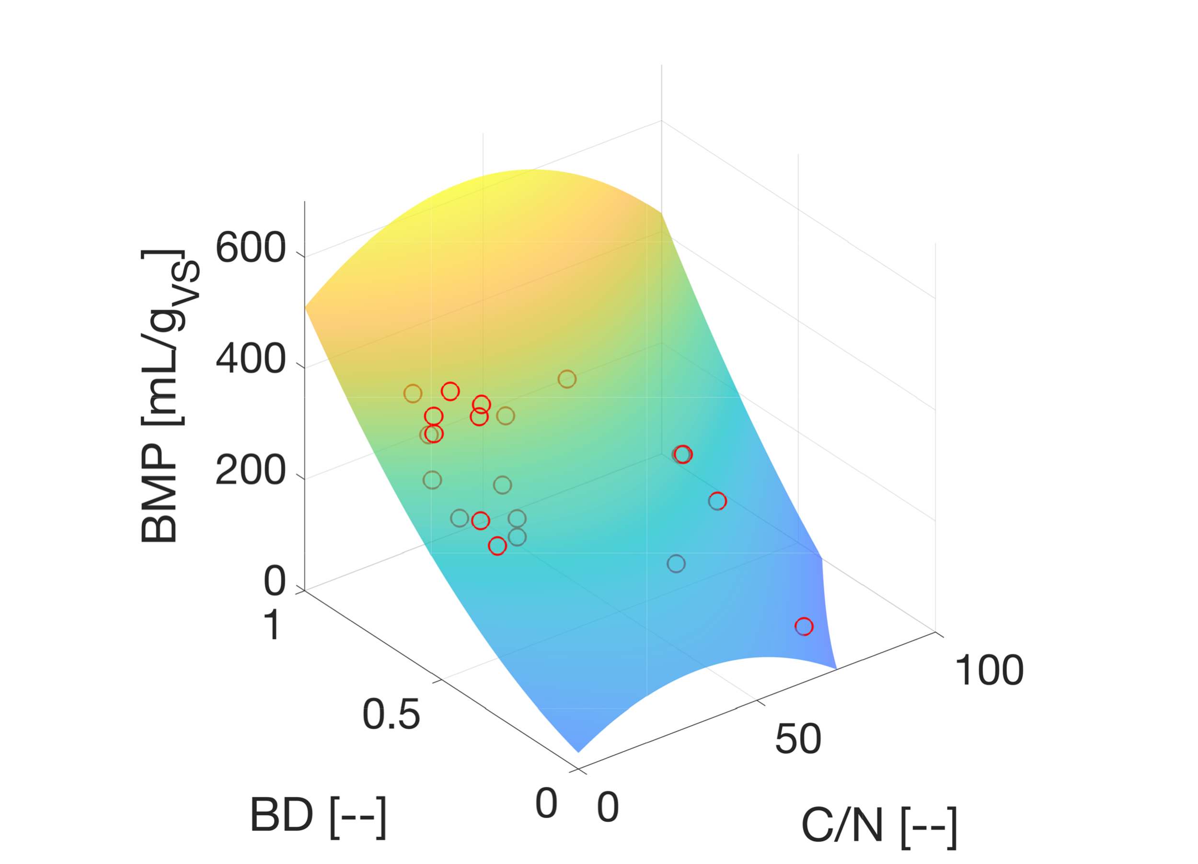 | 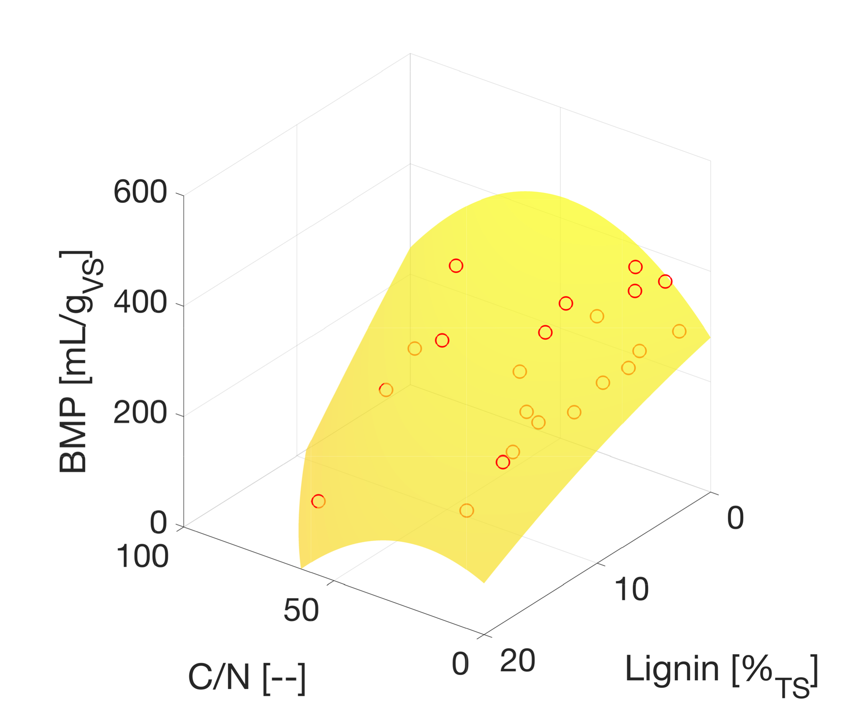 | 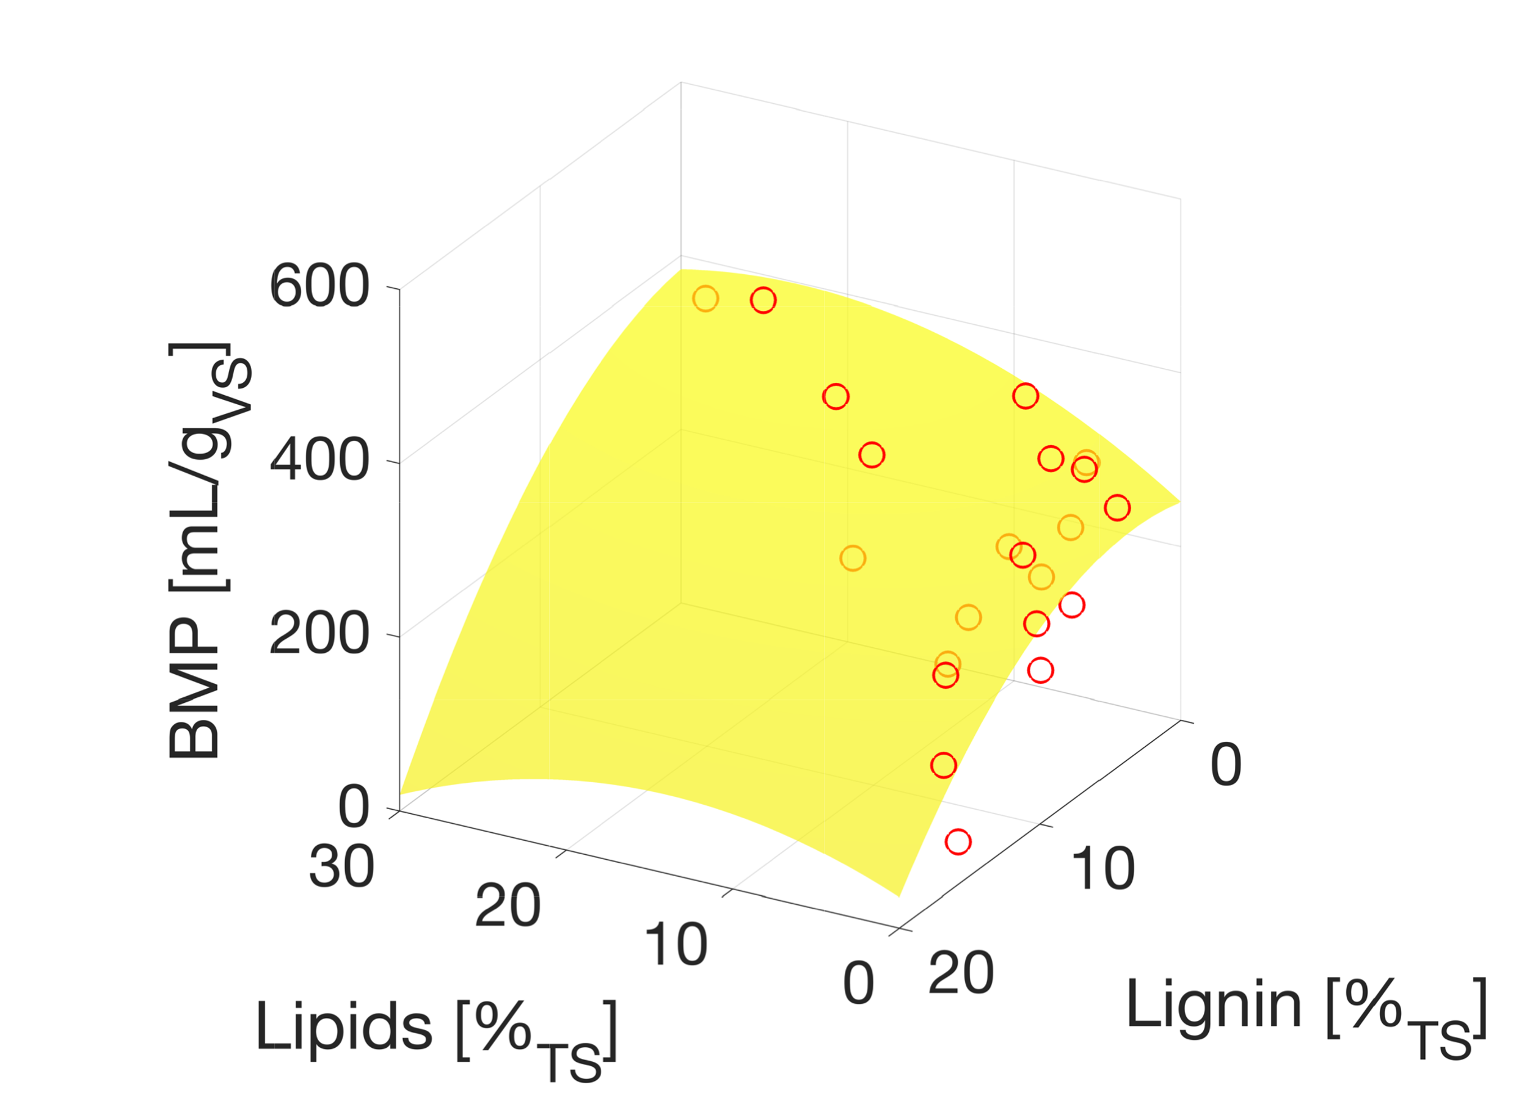
(a) | (b) | (c)
Figure 1. 3D plots of EBMP as function of (a) C/N ratio and biodegradability; (b) C/N ratio and lignin content; (c) lipids and lignin content. (o) EBMP experimental points; (surface) BMP model prediction.
  - Model for Blending Optimization
Being the aim of this study the maximization of the methane production of feedstock mixtures, besides the BMP of the single substrates, synergistic effects should be considered too. Consequently, the objective function representing the BMP of a mixture of substrates has been defined such that, when maximized, it returns the highest possible BMP and the corresponding feedstock composition in terms of mass fractions of the selected substrates. The objective function has been defined for the anaerobic co-digestion of two and three components (Eq. 3-4).
$$f_{obj,NC=2}={BMP}_{AcoD}=x_{1}{BMP}_{1}+x_{2}{BMP}_{2}+x_{1}x_{2}{BMP}_{mix}$$ | (3)
$f_{obj,NC=3}={BMP}_{AcoD}=x_{1}{BMP}_{1}+x_{2}{BMP}_{2}+x_{3}{BMP}_{3}+(x_{1}x_{2}+x_{1}x_{3}+x_{2}x_{3}+x_{1}x_{2}x_{3}){BMP}_{mix}$ | (4)
Where x_{i} represents the mass fractions of each i-th substrate in the mixture. As it is possible to notice, equations 3 and 4 are built in a way that, if a mono-digestion is performed, the f_{obj} is equal to the BMP_{i} of the single substrate. Moreover, the interaction terms are added so that the final BMP_{AcoD} includes synergistics effects. These interaction terms need the definition of the quantity named BMP_{mix}. After many tests, BMP_{mix} has been defined by exploiting one of the three-dimensional correlations shown in the previous section, particularly the one between the EBMP and the C/N ratio and BD: BMP_{mix} is indeed defined as the BMP of a pseudo-single substrate characterised by weighted C/N ratio and BD with respect to the mixed substrates (Eq. 5-6).
${\left(\frac{C}{N}\right)}_{mix}= \sum_{i=1}^{NC}{x_{i}{\left(\frac{C}{N}\right)}_{i}}$ | (5)
${BD}_{mix}= \sum_{i=1}^{NC}{x_{i}{BD}_{i}}$ | (6)
The BMP_{mix} is therefore calculated using the expression of the surface of figure 1(a), as function of the mix parameters (Eq. 7):
${BMP}_{mix}=β_{0}+β_{1}{\left(\frac{C}{N}\right)}_{mix}+β_{2}{BD}_{mix}+β_{3}{\left(\frac{C}{N}\right)}_{mix}^{2}+β_{4}{BD}_{mix}^{2}$ | (7)
Where the coefficients $β$_{i} are obtained through the multi-dimensional regression analysis, performed with the respond surface algorithm (Eq. 8). It is necessary to point out that this regression is done considering all the data from both the SAD and the PAD, to be the most accurate and general possible.
$\left\{\begin{aligned}β_{0}=21.7 \\ β_{1}=1.26 \\ β_{2}=445.7 \\ β_{3}=-0.02 \\ β_{4}=-7.82 \end{aligned}\right.$ | (8)
Once having chosen two or three substrates for which the EBMP, C/N ratio and BD are known, through the maximization of the f_{obj} by varying the mass fractions x_{i}, it is possible to calculate the optimal mixture composition. Such maximisation must be constrained by equation 9.
$\sum_{i=1}^{NC}{x_{i}=1}$ | (9)
The quality of this procedure has been validated by comparing the model’s results with the ones obtained in BMP tests of variable mixtures found in literature. Overall, eight tests were done: five of them involving mixtures of two substrates, and the remaining ones with mixtures of three. For the sake of brevity, two tests’ results are shown in in figure 2, specifically: in figure 2a the comparison between the results of BMP tests performed at different mixing ratios of Food Waste (FW) and Pig Manure (PM) (Dennehy et al., 2016) and the model’s BMP estimation is shown: It can be observed that, while the BMP of the tested compositions range between 260 and 510 mL/g_{VS}, the BMP using the composition obtained from the optimization (x_{FW,opt} = 0.84 wt., x_{PM,opt} = 0.16 wt.) reveals a maximum BMP value of 530 mL/g_{VS}. A similar situation is observed in figure 2b where the results of tests on a ternary mixtures of Dairy Manure (DM), Pig Manure (PM), and Straw (ST), are shwon (Wang et al., 2013). In this case the test results shown a paraboloidal trend with a maximum BMP value of 310 mL/g_{VS} (x_{FW} = 0.66 wt., x_{PM} = 0.17 wt., x_{ST} = 0.17 wt.). Also in this case, the results obtained by the model are reliable both in terms of BMP estimation (290 mL/g_{VS}) and composition prediction (x_{FW,opt} = 0.64 wt., x_{PM,opt} = 0.27 wt., x_{ST,opt} = 0.09 wt.).
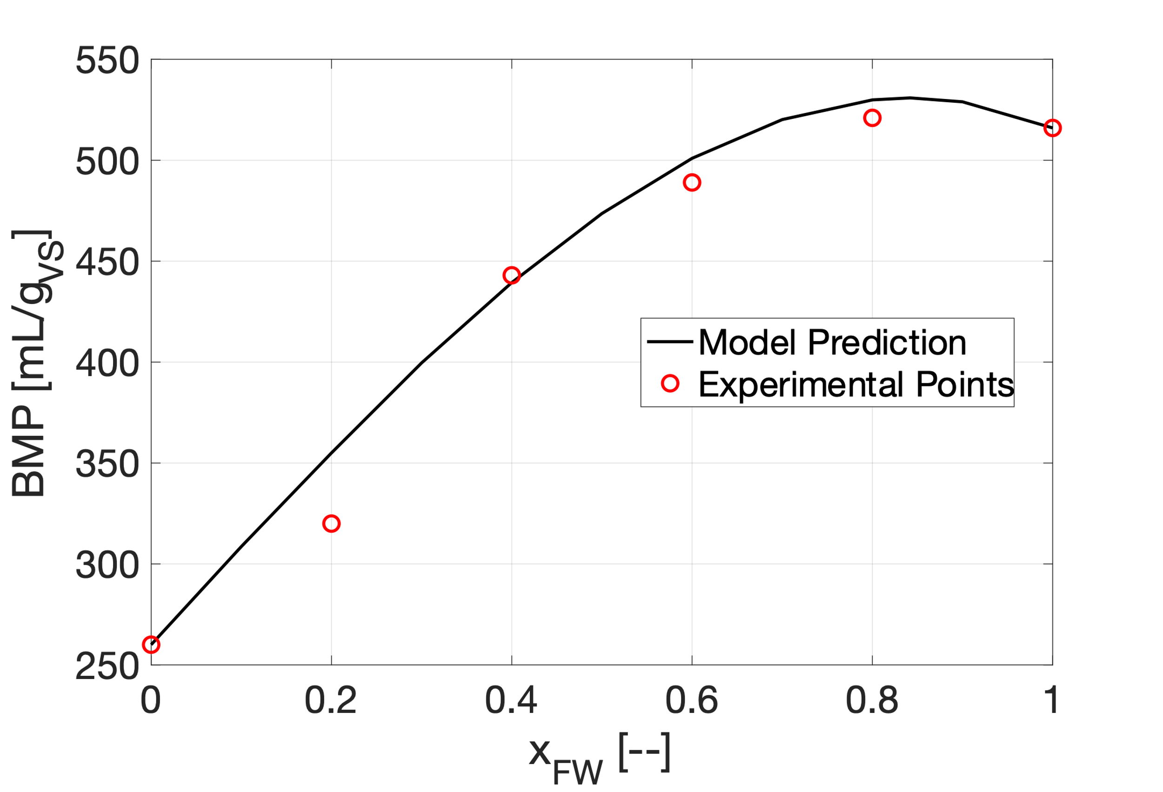 | 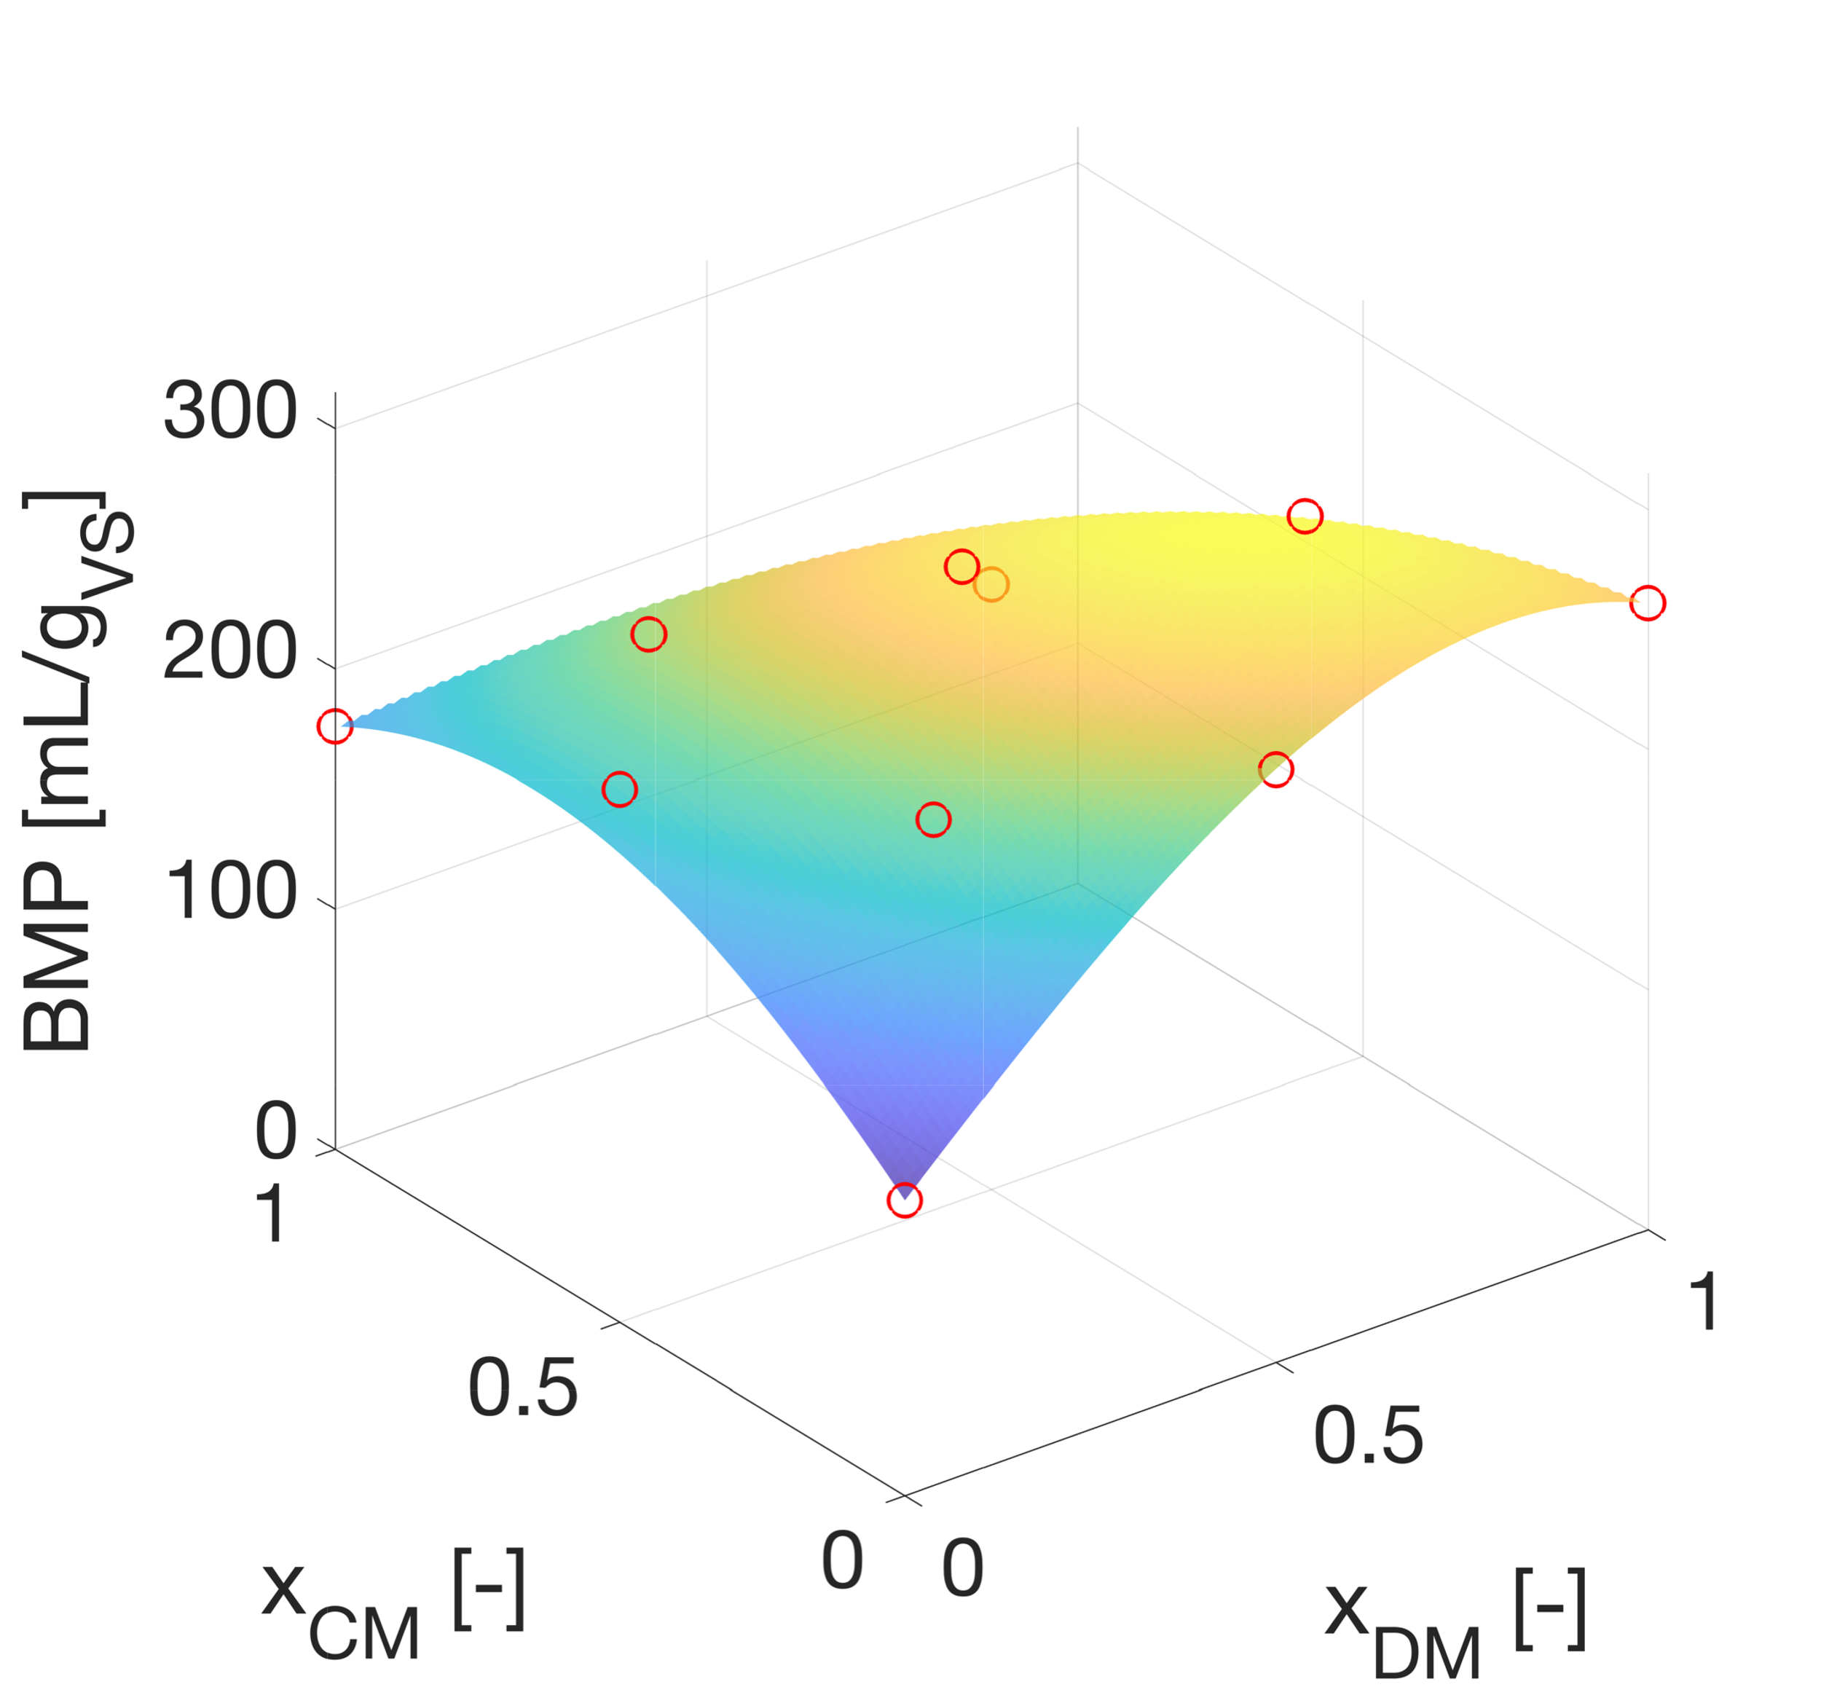
(a) | (b)
Figure 2. (a) Comparison between the experimental BMPs for a variable mixture of FW and PM and the model’s results; (b) Comparison between the experimental BMPs for a variable mixture of DM, PM and ST, and the model’s results.
The results obtained in these two trials and in the remaining ones have made it possible to validate the model, confirming its predictions as trustworthy, even though, at times, a BMP overestimation is observed. Sometimes an absence of synergy is observed, therefore in those cases another model was built, where the ${BMP}_{AcoD}$ is expressed as the weighted average of the single EBMPs of the substrates (Eq. 10).
${BMP}_{AcoD}=\sum_{i=1}^{NC}{x_{i}∙{EBMP}_{i}}$ | (10)
This model was also validated with two additional tests, but it was not possible to automatically predict when this applies.
  - Model Improvements for Industrial Layouts
In case of industrial realities, besides the composition of the optimal mixture in terms of highest methane potential, other issues must be faced, like the real availability of the substrates and the storage capability of the plant. Therefore, to consider these additional factors, the model presented in the previous section has been improved with new constraints both in case of batch and CSTR-based anaerobic digesters.
    - Batch digestion reactor
In case of batch digesters, when optimizing the feedstock, it must be considered that each substrate has its own availability (in terms of tons per cycle) and that the plant has a certain storage capability for these, determining the minimum quantity of each substrate that must be disposed in each cycle. Supposing to fix the total substrates’ quantity that can be loaded into the reactor, named m_{TOT}, it is possible to impose that each load must be comprised between a lower limit, represented by the minimum required consumption, and a higher limit, represented by the maximum availability, plus, the sum of all loads must be equal to m_{TOT}, and so the mass fractions of each substrate can then be calculated (Eq. 11-13)
$m_{i,min}≤m_{i}≤m_{i,max}$ | (11)
$m_{TOT}=\sum_{i=1}^{NC}{m_{i}}$ | (12)
$x_{i}=\frac{m_{i}}{m_{TOT}}$ | (13)
The objective function can be then calculated and maximised by varying the load values instead of their mass fractions. Consequently, the feedstock optimization is performed considering supply-chain requirements.
    - Continuous (CSTR) digestion reactor
In case of a CSTR, the modification of the model is analogue to the discontinuous batch case, except for the fact that instead of loads, massive flow rates (expressed in ton/d) are involved. In this case a total massive flow rate $\dot{m}$_{TOT} must be fixed, and a lower and higher threshold for each flow rate $\dot{m}$_{i} can be defined depending on the storage capability and availability of substrates. Equations 11 to 13, therefore, are valid in this case too, and the objective function maximisation can be performed by varying the massive flow rates. Consequently, optimal streams for each substrate, complying with the supply-chain requirements, are obtained. To validate the CSTR based model configuration, an industrial case-study was developed, based on data received from Thӧni s.r.l. from a 1 MW (~999 kW) biogas plant. As result, an optimized feedstock schedule over the month of January 2021 was calculated using this tool, showing a rising value of BMP of about 25%, reaching a value of 420 mL/g_{VS} from the original 340 mL/g_{VS} (Fig. 3).

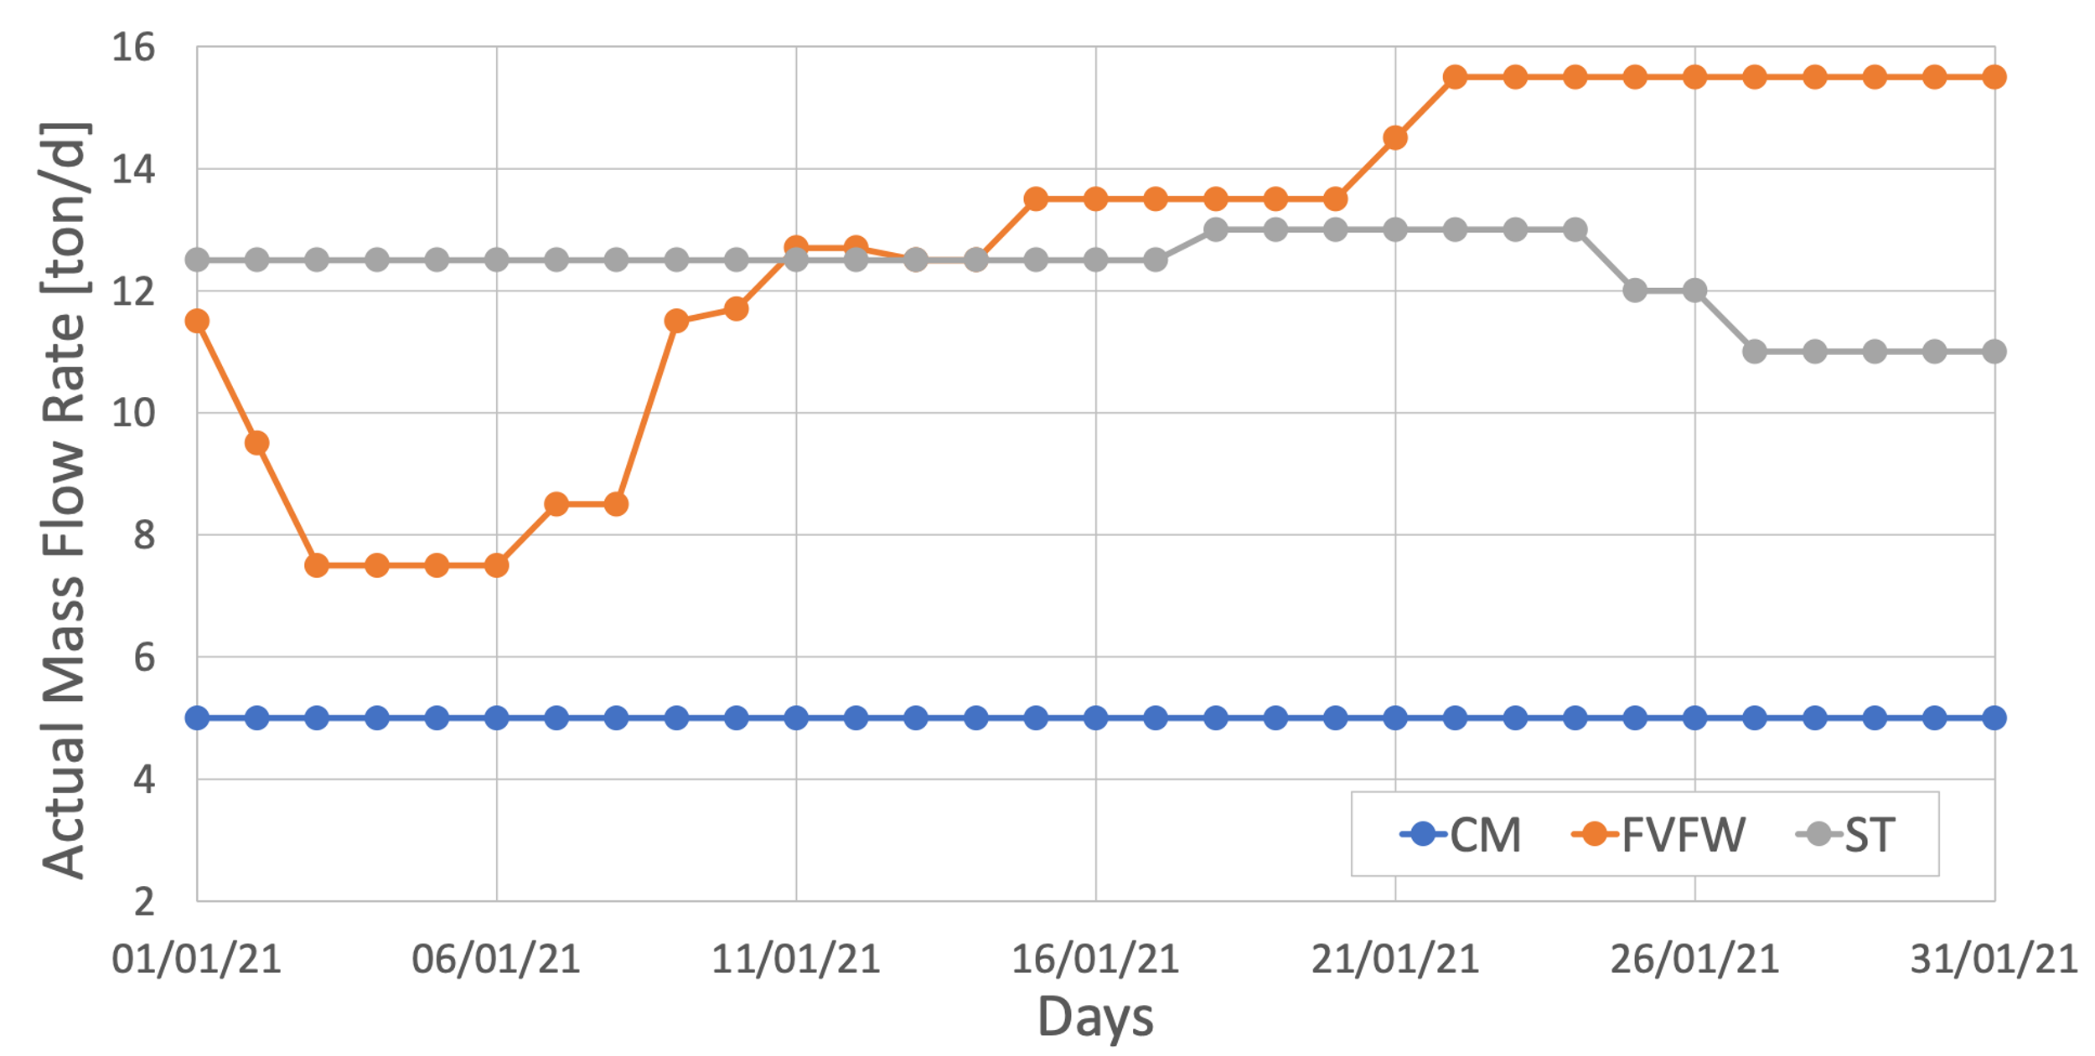 | 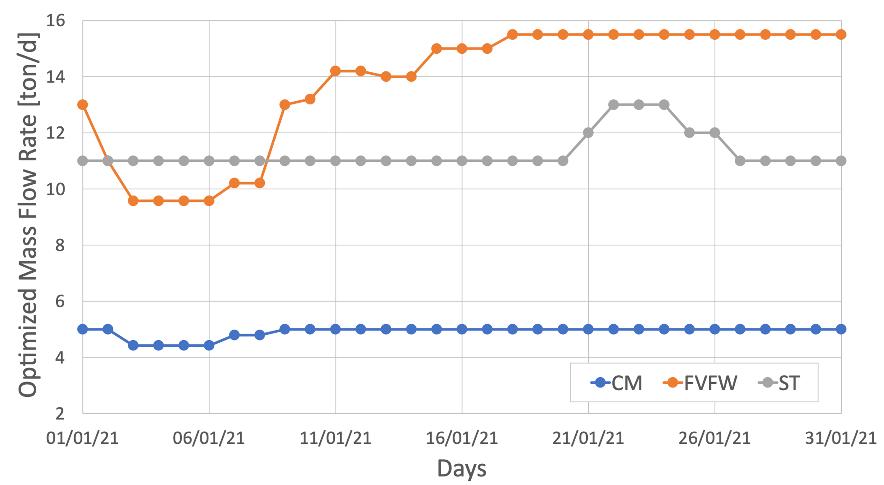
(a) | (b)
Figure 3. Actual (a) mass flow rates and optimized (b) mass flow rates during the month of January 2021.
  - Conclusions and Future Developments
The aim of the project was to develop an optimization tool able to calculate in a trustworthy way the optimal feedstock’s conditions in different industrial settings. The optimization model was developed starting from a database obtained by the analysis and averaging of data got from more than eighty scientific papers and was first validated with the comparison with batch experimental tests. Then, it was made suitable for applications at industrial level to comply to supply-chain issues. The final optimization model demonstrated to yield satisfactory and practical results, and was validated by the comparison with industrial data provided by Thӧni s.r.l. To obtain even more reliable and flexible results, improvements should be done to the model. Some of the possible improvements are the addition of information about the localization of the plant, to extend the consideration of supply-chain factors; connecting the tool to anaerobic digestion models such as ADM1; the introduction of correction factors in the objective function to predict the synergy between substrates; extending the objective function expression to an indefinite number of substrates; validating the model with dedicated experimental tests.
  - Acknowledgments
Acknowledgments go to Thӧni s.r.l for the sharing of data through which the model could be evaluated.
References
Carrere, H., Antonopoulou, G., Affes, R., Passos, F., Battimelli, A., Lyberatos, G., Ferrer, I., 2016. Review of feedstock pretreatment strategies for improved anaerobic digestion: From lab-scale research to full-scale application. Bioresource Technology 199, 386–397. https://doi.org/10.1016/j.biortech.2015.09.007
Dennehy, C., Lawlor, P.G., Croize, T., Jiang, Y., Morrison, L., Gardiner, G.E., Zhan, X., 2016. Synergism and effect of high initial volatile fatty acid concentrations during food waste and pig manure anaerobic co-digestion. Waste Management 56, 173–180. https://doi.org/10.1016/j.wasman.2016.06.032
García-Gen, S., Rodríguez, J., Lema, J.M., 2015. Control strategy for maximum anaerobic co-digestion performance. Water Research 80, 209–216. https://doi.org/10.1016/j.watres.2015.05.029
Hidalgo, D., Martín-Marroquín, J.M., 2015. Biochemical methane potential of livestock and agri-food waste streams in the Castilla y León Region (Spain). ﻿Food Research International 73, 226–233. https://doi.org/10.1016/j.foodres.2014.12.044
Kainthola, J., Kalamdhad, A.S., Goud, V. V., 2020. Optimization of process parameters for accelerated methane yield from anaerobic co-digestion of rice straw and food waste. Renewable Energy 149, 1352–1359. https://doi.org/10.1016/j.renene.2019.10.124
Kalra, M.S., Panwar, J.S., 1986. Anaerobic Digestion of Rice Crop Residues, Agricultural Wastes.
Nazifa, T.H., Cata Saady, N.M., Bazan, C., Zendehboudi, S., Aftab, A., Albayati, T.M., 2021. Anaerobic digestion of blood from slaughtered livestock: A review. Energies. https://doi.org/10.3390/en14185666
Palma-Heredia, D., Verdaguer, M., Molinos-Senante, M., Poch, M., Cugueró-Escofet, M., 2021. Optimised blending for anaerobic co-digestion using ant colony approach: Besòs river basin case study. Renewable Energy 168, 141–150. https://doi.org/10.1016/j.renene.2020.12.064
Panigrahi, S., Dubey, B.K., 2019. A critical review on operating parameters and strategies to improve the biogas yield from anaerobic digestion of organic fraction of municipal solid waste. Renewable Energy. https://doi.org/10.1016/j.renene.2019.05.040
Scarlat, N., Fahl, F., Dallemand, J.F., Monforti, F., Motola, V., 2018. A spatial analysis of biogas potential from manure in Europe. Renewable Sustainable Energy Rev. 94, 915–930. https://doi.org/10.1016/j.rser.2018.06.035
Siddique, M.N.I., Wahid, Z.A., 2018. Achievements and perspectives of anaerobic co-digestion: A review. ﻿Journal of Cleaner Production. https://doi.org/10.1016/j.jclepro.2018.05.155
Vivekanand, V., Mulat, D.G., Eijsink, V.G.H., Horn, S.J., 2018. Synergistic effects of anaerobic co-digestion of whey, manure and fish ensilage. Bioresource Technology 249, 35–41. https://doi.org/10.1016/j.biortech.2017.09.169
Wang, X., Yang, G., Li, F., Feng, Y., Ren, G., Han, X., 2013. Evaluation of two statistical methods for optimizing the feeding composition in anaerobic co-digestion: Mixture design and central composite design. Bioresource Technology 131, 172–178. https://doi.org/10.1016/j.biortech.2012.12.174
Zhang, Z., Zhang, G., Li, W., Li, C., Xu, G., 2016. Enhanced biogas production from sorghum stem by co-digestion with cow manure. ﻿International Journal of Hydrogen Energy 41, 9153–9158. https://doi.org/10.1016/j.ijhydene.2016.02.042

