|  |  |
| --- | --- |
| cetlogo ***CHEMICAL ENGINEERING TRANSACTIONS***  ***VOL. 96, 2022*** | A publication of  aidiclogo_grande |
| The Italian Association  of Chemical Engineering  Online at www.cetjournal.it |
| Guest Editors: David Bogle, Flavio Manenti, Piero Salatino  Copyright © 2022, AIDIC Servizi S.r.l. **ISBN** 978-88-95608-95-2; **ISSN** 2283-9216 | |

Microwave-assisted steam reforming in an ultracompact catalytic reactor

Eugenio Meloni\*, Marco Martino, Vincenzo Palma

a Department of Industrial Engineering, University of Salerno, Via Giovanni Paolo II 132, 84084 Fisciano (SA), Italy

emeloni@unisa.it

In the last years the decarbonization of industrial chemical processes has become necessary and in this sense the use of H2 as an energy vector is strategic. Electrified hydrogen production may allow to avoid energy-related emissions. In this work, the use of microwaves as energy source for the methane steam reforming (MSR) process is proposed. Therefore, starting from commercial silicon carbide monoliths, two Ni/Ceria/Alumina structured catalysts able to absorb microwaves (with two different Ni loadings) were prepared, characterized, and tested at a gas hourly space velocity (GHSV) of 3300 h-1 by means of a specifically set-up laboratory plant. The results showed that the catalyst with the higher Ni loading (15wt% with respect to Ceria and alumina) approached the thermodynamic equilibrium values for both methane conversion and hydrogen yield at about 780°C. In terms of energy efficiency, both the systems showed an average value of 50%. These results evidenced that an effective and feasible process intensification is possible with this innovative system, mainly for a distributed hydrogen production

* 1. Introduction

Hydrogen is a most promising green energy vector (Bolt et al., 2020; Siddiqui et al., 2020). The heating of reforming processes, commonly used for the hydrogen production, is normally obtained by burning hydrocarbons, with a significant impact on the CO2 levels in the environment (Meloni et al., 2020). Moreover, one of the most critical issues in the MSR process is the heat transfer to the catalytic bed, due to the high heat fluxes required to obtain high methane conversions. Consequently, it is necessary to realize complex reactor geometries, moreover, the need to reach temperatures above 1000°C, requires expensive construction materials and large reaction volumes, which result in slow thermal transients (Palma et al., 2020). These aspects increase the plant costs (both operative and fixed) as well as cause a decrease in the whole process efficiency. The heat transfer limitations, due to the endothermicity of MSR reaction could be effectively overcome by microwave (MW) heating (Nigar et al., 2019). The MW heating technique depends only on the dielectric properties of the materials, so it is considered an efficient method for directly heating the catalytic volume (Palma et al., 2020). In literature, different studies are present regarding the use of MW in reforming processes. Interesting results have been reported starting by Zhang et al. (2003), who studied the performance of Pt-based catalysts in CO2 reforming of methane. The dry reforming reaction in presence of MW has been also studied by the research group of Fidalgo et al., 2011 and 2012, which studied the use of different catalysts, such as char (Dominguez et al., 2007) or mixtures of carbon and Ni-based catalysts (Fidalgo et al., 2011; Fidalgo et al., 2012). In this work, two Ni-based structured catalysts, with two different nickel loading, i.e. 7 and 15 wt% with respect to the coating, were prepared by washcoating technique. The catalysts were characterized by means of several techniques and tested in the MW-assisted MSR reaction. Furthermore, with the aim of evaluating its feasibility in the distributed production of hydrogen, the energy balance of the entire process was carried out for the calculation of the energy efficiency. The results of the preliminary tests highlighted the high susceptivity of the prepared structured catalysts to the MW radiation, and demonstrated that, in the presence of the MSR reaction, the system is able to reach a temperature of 900°C. The activity tests results showed that the CH4 conversion approached to the thermodynamic equilibrium values starting from temperatures of about 780°C, at a gas hourly space velocity (GHSV) of 3300 h-1. The energy efficiency of the lab-scale system, calculated as the ratio among the energy absorbed by the system and the energy supplied by the microwaves, was about 50%.

* 1. Materials and methods
     1. The Silicon carbide (SiC) carriers

Two quasi-circular SiC monoliths (Mon1 and Mon2, respectively) were obtained by cutting and shaping commercial honeycomb monolith (Pirelli Ecotechnologies). Their geometric characteristics are reported in Table 1.

Table 1: geometric features of the SiC monoliths used as carriers of the structured catalysts

|  |  |  |
| --- | --- | --- |
| Geometric characteristic | Mon 1 | Mon 2 |
| Diameter [cm] | 4.1 | 6 |
| Length [cm] | 10.1 | 9 |
| Number of channels | 308 | 559 |
| Walls thickness [mm] | 0.6 | 0.6 |
| Channels length [mm] | 1.6 | 1.6 |
| Total volume [cm3] | 133 | 254 |

The as shaped monoliths, before proceeding with the deposition of washcoat and active species, were preliminarily heat-treated at 1000 °C for 48 hours, in order to increase the washcoat adherence to the monolith, due to the formation of SiO2 streaks on the SiC granules (Palma et al., 2020).

* + 1. Preparation procedure of the structured catalysts

The washcoat slurry was prepared by dispersing 19 wt% of CeO2 powder (Opaline®; Actalys HAS; Rhodia) in a colloidal solution of 1 wt% of pseudobohemite (Pural SB; Sasol) and 1 wt% of methyl cellulose (Viscosity 4,000 cP; Sigma-Aldrich) at pH = 3 (adjusted by HNO3). The monolith was coated by dip-coating procedure, the contact time was 20 minutes while the excess of slurry was removed by centrifugation at 1500 rpm for 5 minutes. Subsequently, the washcoated monoliths were dried at 120°C for two hours and then calcined at 850°C for three hours (the temperature increasing was of 10°C/min). This procedure was repeated until reaching a loading of 13wt% with respect the total weight. The active species were deposited onto the washcoated monoliths by impregnation in a Ni(NO3)2 aqueous solution, by using Ni(NO3)2· 6H2O (99.999% trace metals basis, Sigma-Aldrich) as precursor. The same heat-treating procedure used after the washcoat deposition was used after the catalyst deposition. The Ni loading obtained on the monoliths was of 7wt% on Mon1 and of 15wt% on Mon2, with respect to the washcoat weight, corresponding to about 1wt% and 2wt% with respect to the total weight of the structured catalyst. The two samples were named, respectively, CatMon1 and CatMon2.

* + 1. Characterization of the structured catalysts

Some physico-chemical analytical techniques were used for the catalyst characterization. The chemical composition was determined by using an ARL QUANT’X ED-XRF spectrometer (Thermo Scientific). The adherence of the washcoat to the monolith was evaluated by stressing the samples, immersed in a 100 mL petroleum ether (Carlo Erba reagenti) containing beaker, with an ultrasonic bath CP104 (EIA S.p.A.) (Palma et al., 2020). The procedure implied using 60% of the rated power for a total of six cycles of 5 minutes each, at 25°C. After each cycle, the monoliths were heat-treated at 120°C for 1 hour, cooled, and the weight loss percentage was evaluated. The Specific Surface Areas (SSA) of the samples were obtained through N2 physisorption at -196 °C, by means of SORPTOMETER Kelvin 1040 Costech instrument, applying BET method. A Scanning Electron Microscope (SEM mod. LEO 420 V2.04, ASSING), coupled to an Energy Dispersive X-Ray analyser (EDX mod. INCA Energy 350, Oxford Instruments) was used for obtaining the element mapping on the final structured catalysts in order to verify the homogeneity of the active species distribution.

* + 1. MW-assisted catalytic activity tests

The preliminary MW-assisted catalytic activity tests were performed by using a properly designed laboratory plant, constituted by the feeding, reaction and analysis sections (Meloni et al., 2021). The feeding section is composed by different mass-flow controllers (Bronkhorst) for the controlled providing of the reactants (gases from SOL S.p.A.) to the reactor. All the gases were fed cold, apart from H2O, which was preliminarily vaporized through a heated coil placed at the inlet of the reactor before its mixing to the reactants. In the reaction section, a 2.45GHz water cooled Magnetron head was used, in combination with a controller able to smoothly and stepless adjust the magnetron output power up to its maximum nominal power of 2 kW. The magnetron is connected to a circulator with a water dummy load, in order to be protected from the reflected power, in any case minimized by using a motorized three stub tuner fitted on the waveguide at the coupler output. The tests were carried out in a stainless-steel cylindrical reactor (internal diameter = 900 mm) at atmospheric pressure, by feeding N2 at various flow rates, and by varying the microwave power. The experimental plant was designed in order to be compact, therefore the magnetron was placed directly in front of the monolith, preliminary entrapped in a thermo-expandable ceramic mat (3M) before being placed in the reactor, thus avoiding any bypass phenomena. The analysis section is composed by pressure sensor and K-type thermocouples for their continuous monitoring. The latter were placed at the center of the inlet and outlet sections of the monolith. The gas stream leaving the reactor was online monitored on dry bases after the condensation of the water vapor, using an on-line ABB analyzer, equipped with a non-dispersive infrared analyzer Uras 14 and a thermal conductivity detector Caldos 17, for the continuous monitoring of CO, CO2, CH4 and H2.

The catalytic activity tests were performed by feeding a stream characterized by H2O/CH4 ratio of 3 and N2/CH4 ratio of 3, at gas hourly space velocity (GHSV) of 3300 h-1, with a total flow rate of 0.44 Nm3/h. This last parameter was calculated as the ratio between the volumetric flow rate and the overall volume, included the monolith, of the structured catalyst. The desired reaction temperature was reached by properly adjusting the MW power. Before the reaction, the structured catalysts were preliminarily in-situ reduced through a feed stream (flow rate of 1000 mL/min) composed of 24% of H2 balanced in N2, in the temperature range 20 - 900°C. The catalytic performance was evaluated in terms of CH4 conversion (XCH4) and H2 yield (YH2), defined in (1) and (2), respectively.

|  |  |
| --- | --- |
|  | (1) |
|  | (2) |

In (1) and (2), Qi are the molar rates of the indicated species entering and exiting the system.

* 1. Results and discussion
     1. Characterization

The chemical composition obtained by ED-XRF evidenced loadings of Ni of 0.8wt% and 1.7wt%, for CatMon1 and CatMon2, respectively, very close to the wanted one (1wt% and 2wt%), thus demonstrating the good replicability of the coating procedure, and confirming the formation of a homogeneous washcoat slurry. The N2 physisorption at -196°C highlighted that the adding of the washcoat to the bare monoliths resulted in the increasing of the SSA from 1.5 up to 10 m2/g, as reported in previous works (Palma et al., 2020). The adhesion tests evidenced a weight loss of about 9%, further highlighting the good contact between the washcoat and the carrier. The SEM-EDS element mapping is shown in figure 1 for the CatMon2 catalyst, as example of prepared catalyst.

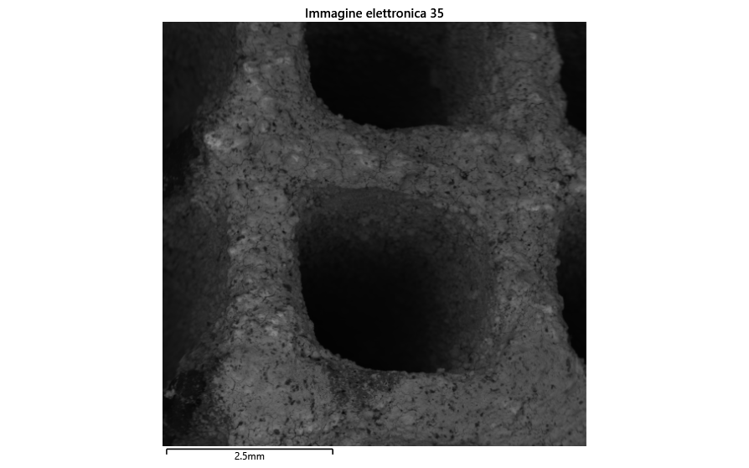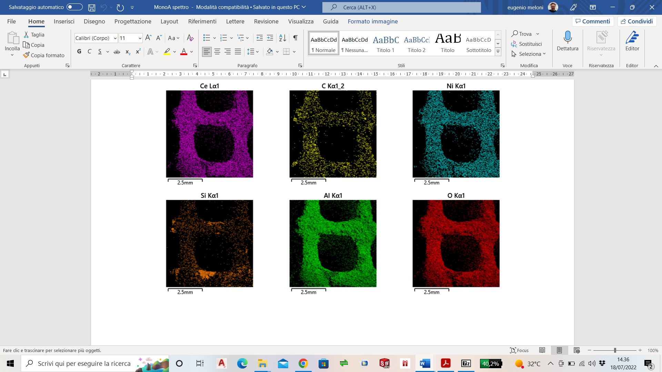

Figure 1: SEM-EDS element mapping for the CatMon2 structured catalyst

The data reported in figure 1 evidenced a very homogeneous distribution of the active species (washcoat and Ni) on the SiC carrier.

* + 1. MW-assisted catalytic tests

The results of the MW-assisted catalytic tests are shown, in terms of both CH4 conversion (XCH4) and H2 yield (YH2) vs temperature, in Figure 2a and Figure 2b, for the CatMon1 and CatMon2 samples, respectively.

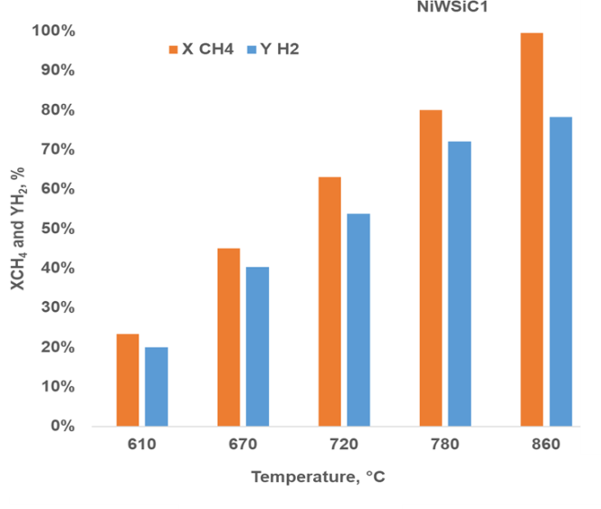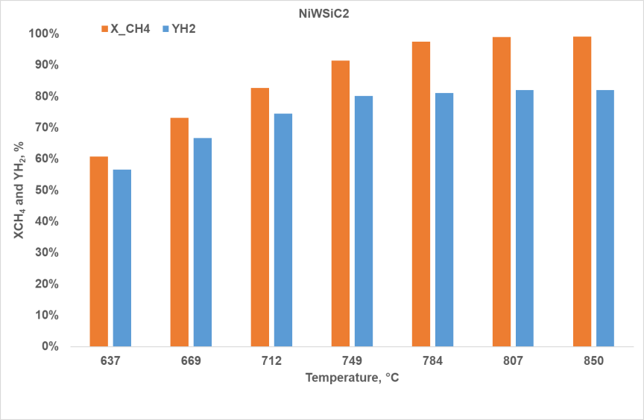

**a**

**b**

**CatMon1**

**CatMon2**

Figure 2: XCH4 and YH2 for (a) the CatMon1 and (b) the CatMon2 samples in the MW-assisted MSR test. GHSV = 3300 h-1

The reported data evidenced the good performance of both the structured catalysts, characterized by a CH4 conversion higher than 95% and a H2 yield of about 80% at temperatures higher than 850°C. But an important difference can be observed: the catalyst with the higher Ni loading reached these values starting from 780°C, temperature at which the CatMon2 catalyst approached the thermodynamic equilibrium values. In this way, the beneficial effect of the Ni content was also evidenced, since the CatMon1 catalyst approached the thermodynamic equilibrium values only at temperatures higher than 860 °C. The MW power supplied in the two MW-assisted catalytic tests is shown in Figure 3.

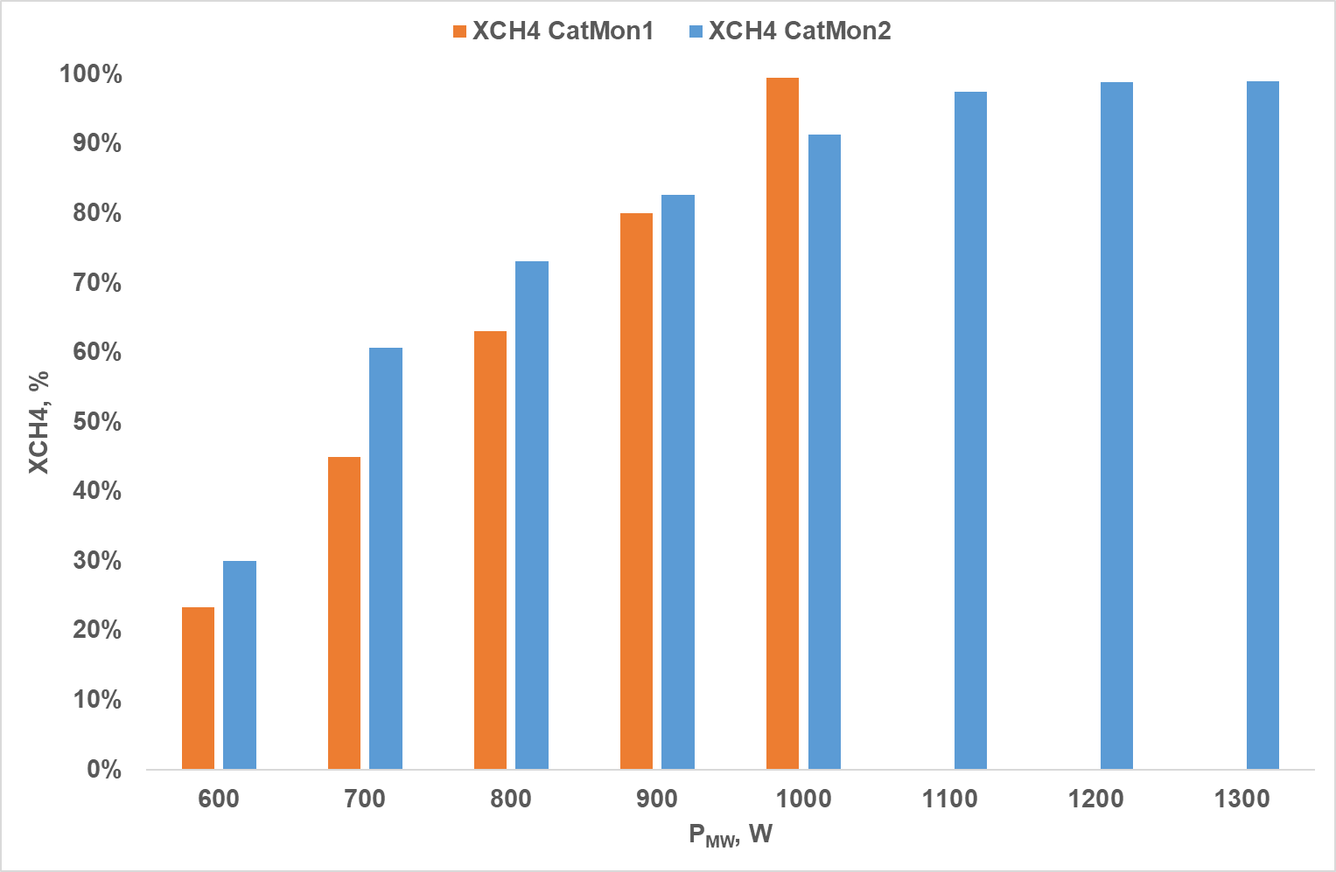

Figure 3: CH4 conversion reached during the MW-assisted MSR process as function of the MW power for the two structured catalysts

The above reported data evidenced the different MW power needed by the two catalytic systems for increasing the CH4 conversion. A superficial analysis of these data could lead to the conclusion that the CatMon1 sample has better performance since it needs, for example, 1000W for reaching a CH4 conversion of about 99%, while the same conversion is reached by the CatMon2 sample with about 1200W. These data, coupled to the ones reported in Figure 2 (the CatMon1 sample reached that CH4 conversion value at about 880°C, the CatMon2 sample reached this performance at about 780°C) seems to lead to the conclusion that the former sample is the most performing in terms of energy saving. But a deeper investigation is needed, since the two catalysts have two different volumes (133 and 254 cm3, for CatMon1 and CatMon2, respectively), requiring more power for heating the latter.

Therefore, the calculation of the energy efficiency is mandatory to understand if the two catalytic systems have a different energy consumption. The energy efficiency was calculated as the ratio between the heat effectively absorbed by the system, calculated by applying the classical equation of the thermal balance (3), and the heat supplied by microwaves.

IN – OUT + GEN = ACC (3)

in which ACC = 0 since the thermal balance refers to the stationary state.

The results of the thermal balance evidenced that for both the catalytic systems the energy efficiency had an increasing trend as the MW power, and consequently the temperature, increased. In fact, the energy efficiency was about 40% at 400W (about 600 °C) and raised up to 50% at 700 W (about 750°C). This lower energy efficiency at lower MW power, is due to the dissipative effects that overcome the material microwaves absorption, affecting the thermal management of the system. Moreover, the same average value for both the catalytic systems is due to the peculiarity of the microwave heating, that is dependent only on the dielectric properties of the material (in this case the catalysts differ only by Ni loading). Therefore, the catalyst with the higher Ni loading (CatMon2) revealed the best performance also in terms of energy saving since at the same flow rate showed the best H2 productivity (the highest CH4 conversion at the lowest temperature).

In these last conditions the energy consumption was calculated as the ratio between the energy needed for sustaining the reactive system (expressed in kWh) and the produced H2 (expressed in Nm3/h). The calculation resulted in the value of 3.8 kW/Nm3H2, a value comparable with the energy consumption of the electrolysers.

All these results, coupled to the fact that the Ni loading on the CatMon2 catalyst is lower than the one of the commercial Ni-catalysts (usually about 40wt%) used in the MSR process, which makes this catalyst cheaper, are important evidence of the feasibility of the proposed technology, mainly focused to the distributed H2 production.

* 1. Conclusions

Two MW-susceptible structured catalysts characterized by a different Ni loading were prepared starting from commercial SiC monoliths. The preparation procedure implied first the deposition of a Ceria/Alumina slurry and then the impregnation in a nickel nitrate solution. The prepared catalysts were tested for the microwave-assisted methane steam reforming reaction, by means of a properly designed laboratory plant. The activity tests, performed at a GHSV of 3300 h-1 showed that the Ni loading influenced the catalyst performance, both in terms of methane conversion and hydrogen yield: the higher the Ni loading is, the better the performance is. The two catalytic systems showed an average energy efficiency of 50%. The comparison of the energy consumption expressed in kW/Nm3H2 of the microwave-assisted steam reforming with different kinds of electrolysers for H2 production showed an energy consumption for the MW-assisted process comparable (and in some cases lower) with respect to that of the electrolysers. These results highlighted how an effective and feasible process intensification is possible with this innovative system, mainly for a distributed hydrogen production. Future studies will deal with microwave reactor optimization, aiming to increase the energy efficiency of the system, as well as to obtain a higher CH4 conversion and H2 yield at lower temperatures.

References

Bolt A., Dincer I., Agelin-Chaab M., Experimental study of hydrogen production process with aluminum and water. International Journal of Hydrogen Energy 2020, 45, 14232 – 14244. 10.1016/j.ijhydene.2020.03.160

Dominguez A., Fernandez Y., Fidalgo B., Pis J.J., Menéndez J.A., Biogas to Syngas by Microwave-Assisted Dry Reforming in the Presence of Char, Energy Fuel 2007, 21, 2066–2071, doi:10.1021/ef070101j.

Fidalgo B., Arenillas A., Menéndez J.A., Mixtures of Carbon and Ni/Al2O3 as Catalysts for the Microwave-Assisted CO2 Reforming of CH4, Fuel Process. Technol. 2011, 92, 1531–1536, doi:10.1016/j.fuproc.2011.03.015.

Fidalgo B., Menéndez J.A., Study of Energy Consumption in a Laboratory Pilot Plant for the Microwave-Assisted CO2 Reforming of CH4, Fuel Process. Technol. 2012, 95, 55–61, doi:10.1016/j.fuproc.2011.11.012.

Meloni E., Martino M., Palma V., A Short Review on Ni Based Catalysts and Related Engineering Issues for Methane Steam Reforming, Catalysts 2020, 10(3), 352, 1-38; doi:10.3390/catal10030352

Meloni E., Martino M., Ricca A., Palma V., Ultracompact methane steam reforming reactor based on microwaves susceptible structured catalysts for distributed hydrogen production, International Journal of Hydrogen Energy 46, 2021, 13729 – 13747. doi: 10.1016/j.ijhydene.2020.06.299

Nigar H., Sturm G.S.J., Garcia-Baños B., Peñaranda-Foix F.L., Catalá-Civera J.M., Mallada R., Stankiewicz A., Santamaría J., Numerical analysis of microwave heating cavity: Combining electromagnetic energy, heat transfer and fluid dynamics for a NaY zeolite fixed-bed, Applied Thermal Engineering 2019, 155, 226–238, https://doi.org/10.1016/j.applthermaleng.2019.03.117

Palma V., Meloni E., Renda S., Martino M., Catalysts for Methane Steam Reforming Reaction: Evaluation of CeO2 Addition to Alumina-Based Washcoat Slurry Formulation, C 2020, 6, 52; doi:10.3390/c6030052

Palma V., Barba D., Cortese M., Martino M., Renda S., Meloni E., Microwaves and Heterogeneous Catalysis: A Review on Selected Catalytic Processes, Catalysts 2020, 10(2), 246; 1-58, doi:10.3390/catal10020246

Sharifvaghefi S., Shirani B., Eic M., Zheng Y., Application of Microwave in Hydrogen Production from Methane Dry Reforming: Comparison Between the Conventional and Microwave-Assisted Catalytic Reforming on Improving the Energy Efficiency, Catalysts 2019, 9, 618, doi:10.3390/catal9070618.

Siddiqui O., Ishaq H., Chehade G., Dincer I., 2020, Experimental investigation of an integrated solar powered clean hydrogen to ammonia synthesis system. Applied Thermal Engineering 2020, 176, 115443. 10.1016/j.applthermaleng.2020.115443

Zhang X., Lee C.S.M., Mingos D.M.P., Hayward D.O., Carbon Dioxide Reforming of Methane with Pt Catalysts Using Microwave Dielectric Heating, Catal. Lett. 2003, 88, 129–139, doi:10.1023/A:1024049403422.