 CHEMICAL ENGINEERING TRANSACTIONS  VOL. 96, 2022 | A publication of  
The Italian Association
of Chemical Engineering
Online at www.cetjournal.it

Guest Editors: David Bogle, Flavio Manenti, Piero Salatino
Copyright © 2022, AIDIC Servizi S.r.l.
ISBN 978-88-95608-95-2; ISSN 2283-9216

Evaluation of the diffusive capacity of hydrogen through 9Cr-1Mo ferritic steel in the dual environment of a furnace: a simulation study in COMSOL Multiphysics®
David A. Méndezª, Brayan E. Uribeª, Juan Orozco-Agamezª, Dario Y. Peña-Ballesterosª, Anibal Alviz-Meza^{a,b,*}
ªGrupo de Investigaciones en Corrosión, Universidad Industrial de Santander, Parque Tecnológico Guatiguará, Piedecuesta 681011, Colombia
^{b}Grupo de investigación en Deterioro de Materiales, Transición energética y Ciencia de Datos DANT3, Universidad Señor de Sipán, Facultad de Ingeniería, Arquitectura y Urbanismo, Chiclayo, Pimentel 14001, Peru
alvizanibal@crece.uss.edu.pe

Hydrogen transport and storage represent a challenge due to its high diffusivity capacity, which causes the pitting of pipes. This study focused on addressing this problem by simulating the effect caused by the hydrogen generated during the heating pre-processing step of crude oil before addressing it to the distillation unit. For this purpose, the software COMSOL Multiphysics® was employed to determine how the hydrogen diffusion across ferritic steel containers increases the corrosion rate in a furnace. Then, a dual corrosion process was assessed at 650 °C, simulating the flow of water vapor at the outer part of the pipe whereas hydrogen sulfides -as contamination from crude oil- at the inner part. The ferritic steel selected for this research was the 9Cr-1Mo steel due to its usual implementation in processes developed at high temperatures in industry. Besides, we also studied the corrosion rate of both pipe’s faces independently, omitting the effect of the other fluid on the other side of the pipe -singular environments-. The influence of hydrogen sulfide on the corrosion rate on the water vapor side was found negligible. Meanwhile, water vapor boosted the corrosion rate on the hydrogen sulfide side, making it 1.2 times greater compared to its singular estimation. The corrosion rate induced by the water vapor is higher due to the higher number of corrosion products -current density- that it delivers when reacting with the steel elements at high temperatures. These approaches aimed to quantify the hydrogen diffusion contribution to the corrosion rate of the ferritic steels used in oil refining furnaces.
  - Introduction
The influence of two corrosive media on metallic structures is common in equipment such as furnaces, boilers, heaters, super-heaters, turbines, etc. For instance, dual corrosion occurs in pipes of refinery furnaces: fireside corrosion by flue gases on the external face and internal corrosion at the inner tube face. A few researchers have studied dual environments, demonstrating that ferritic steels undergo accelerated corrosion rates (Alnegren et al., 2016; Chandra et al., 2014; Coelho, 2014). Dual corrosion has attracted the attention of the scientific community beginning from the Lobnig & Grabke (1990) research work, which studied the simultaneous oxidation-sulfidation of Fe-20Cr-12Ni and Fe-20Cr steels in H₂-H₂O-H₂S/H₂-H₂-H₂O mixtures between 700 °C and 1150 °C, finding out that both phenomena were stimulated simultaneously, increasing the alloys’ corrosion rates. In general, in studies based on ferritic steels with different chromium percentages (2-14%), temperatures (550-750 °C), and corrosive environments, it has been found that one environment influences the corrosion rate of the other by up to a factor of 3, compared with their deterioration rate in isolated -singular- environments (Alnegren et al., 2016; Alviz et al., 2020; Chandra et al., 2014; Coelho, 2014; Huenert et al., 2010; Mosquera, 2019; Nakagawa et al., 2001). This augmentation in corrosion rate has been linked to the permeability of hydrogen through the wall thickness of alloys, which enhanced mass transfer processes (Chandra et al., 2014; Huenert et al., 2010; Reisert et al., 2021).
Ferritic steels such as Fe-9Cr-1Mo (P91) are commonly used in the metallic infrastructure of diverse equipment due to their good mechanical properties and acceptable corrosion resistance at high temperatures (Alviz et al., 2018). P91 steel Corrosion rates have been deeply studied in water vapor and H₂S-containing environments (Ehlers et al., 2006; Rebak, 2011) whereas under the dual effect of the dual environment of furnaces from oil refineries, where crude oil flows in the inner pipes’ face and flue gases in the outer face, it hasn’t been assessed. To sum up, the gap that covers this work is the lack of experimental and theoretical studies to determine the role of H₂ in the corrosion rate of P91 alloy in the dual environment of a furnace from the oil refining sector. The influence of H₂ is evaluated through simulation by COMSOL Multiphysics®, limiting the dual environment of the furnace to H₂O and H₂S as representative compounds from flue gas and crude oil, respectively.
  - Materials and methods
The mass transfer conservation model was stated based on Fick's law, Faraday's law, and Navier Stokes equations, including the required boundary conditions. The equations (1) and (2) were used to determine the corrosion rate induced by each environment. The complete model can be extracted from the thesis work of Uribe & Méndez (2021) and Auinger et al., (2011), which due to its extension could not be included in this paper. The geometrical model used in COMSOL Multiphysics® is based on the image shown in Figure 1.

$V_{corr}\left(mpy\right)=FD_{H_{2}O-N_{2}}\left[\left(\frac{∂C_{H_{2}O_{(g)}}}{∂y}\right)+\left(\frac{∂C_{H_{2}O_{(g)}}}{∂x}\right)\right]\left(\frac{mA}{cm^{2}}\right)*129\frac{M}{d}$ (1)
$V_{corr}\left(mpy\right)=FD_{H_{2}S-N_{2}}\left[\left(\frac{∂C_{H_{2}S_{(g)}}}{∂y}\right)+\left(\frac{∂C_{H_{2}S_{(g)}}}{∂x}\right)\right]\left(\frac{mA}{cm^{2}}\right)*129\frac{M}{d}$ (2)
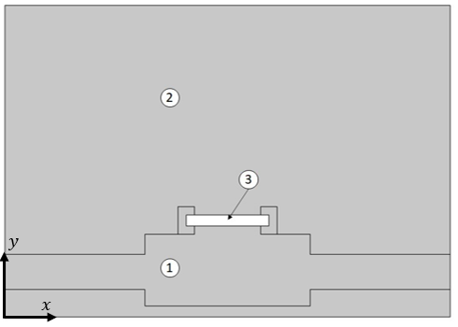
Figure 1: The geometry of the Comsol Multiphysics ® model. The figure shows that in section (1) flows a mixture of H₂S_{(g)}+N_{2(g)} while in section (2) H₂O_{(g)} +N_{2(g)}. Point (3) represents the P91 steel sample.
The conservation of momentum and continuity equations were used in the chemical species transfer model and solved using Comsol Multyphysics® Version 5.6 (COMSOL Multiphysics®, 2019). The velocity profile was obtained from the above equations, which combined with the diffusion coefficient allowed us to determine either the concentration gradient. The current density and the corrosion rate were obtained once defined the concentration gradient. The equations set were resolved using the finite element method, which involves the division of the geometric model into different geometric elements of different sizes, by employing the physics of dilute species transport and laminar flow.

Table 1 shows the operating values of an oil refinery’s furnace while Table 2 shows the elemental weight fraction of the studied alloy. The steam concentration was taken as 6.96 mol/m³ and its volumetric flow as 250 mL/min according to the previous work reported by Alviz et al., (2021). The H₂S concentration was selected as 0.146 mol/m³ based on data from the oil refining industry whereas its flow remained the same as the water vapor.
In order to include the effect of one environment on the other in the simulation, we assume that this influence is due to the diffusion of hydrogen in the alloy’s bulk, generating discontinuities in the material and accelerating corrosion due to greater participation of the presented chemical species. Thus, we first solve the system for calculating the hydrogen diffusion effect on each side, further adding it to the current density generated in each isolated singular environment.

Table 1: Refinery Furnaces operating conditions
Energy source | Operating pressure | Volumetric flow | Temperature
Refinery gas | 1 atm | 250 ml/min | 650 ºC

Table 2: Elemental weigh a fraction of P91 steel
%Mo | %C | %Si | %Mn | %P | %W | %Ni | %Cr | %V | %S | %Co | %Fe
0.85 | 0.1 | 0.5 | 0.7 | 0.02 | 3.5 | 0.2 | 9.5 | 0.3 | 0.008 | 3.5 | 80.82

The proposed model includes the following limitations:
- It only considers H₂S and water vapor as the chemical species involved in the corrosion process of each pipe side.
- The simulation was carried out taking into account a 2D geometric model due to its axial symmetry and less troubling simulation process.
- It was considered a transient state to contemplate the fluctuating concentration.
- The model is diffusion-controlled: the kinetic of reactions are omitted considering an instantaneous process (Mosquera, 2019).
  - Results and discussion
    - Simulation of singular environments.
This section presents the graphs obtained after the simulation, for which a variation of the flow rates was taken into account. The shape observed in the steam and H₂S curves is explained by the concentration profile developed in the scheme shown in Figure 1, which follows the gas flow gradient on the x-axis, as observed in the thesis of Uribe & Méndez (2021). The concentration is higher at the borders of the coupon on the steam side, which explicates the higher corrosion rates shown in Figure 2 at the extremes of the x-axis. In the case of the H₂S side, the highest concentration and therefore corrosion rate is located at the origin of the x-axis in Figure 3. This particular behavior is related to the low concentration of H₂S in the inner duct gas flow. The maximum corrosion rate on the steam side is 390 mpy, doubling the minimum value obtained at the center of the coupon after 30 seconds of reaction when the steady state is reached (see Figure 2). The rapid stability of the system is linked to the large flow rates introduced, compared to the dimensions of the geometry, as well as the consideration of instantaneous reaction kinetics in the system.
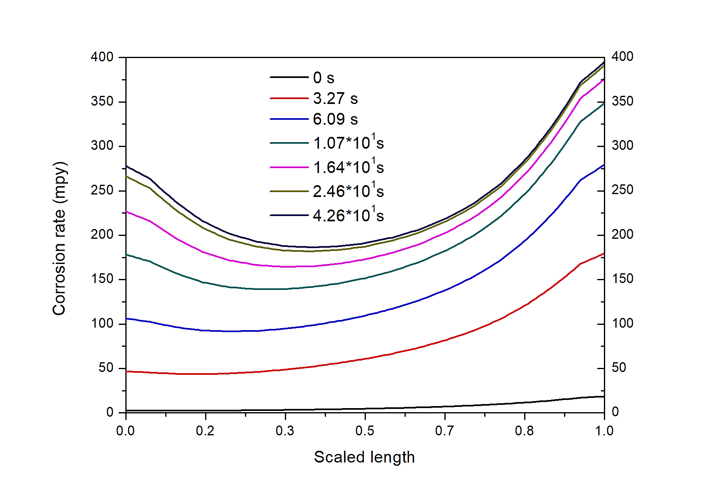
Figure 2: Corrosion rate in the steam singular environment at 650°C

Regarding sulfidation corrosion, Figure 3 shows that the corrosion rate reached a maximum value of 87 mpy and a minimum of 37 mpy for a stabilization time of close to 1 second. In this case, the stabilization time was shorter due to a higher gas flow velocity due to the 5.5 times smaller diameter of the inner duct in comparison with the outer one.
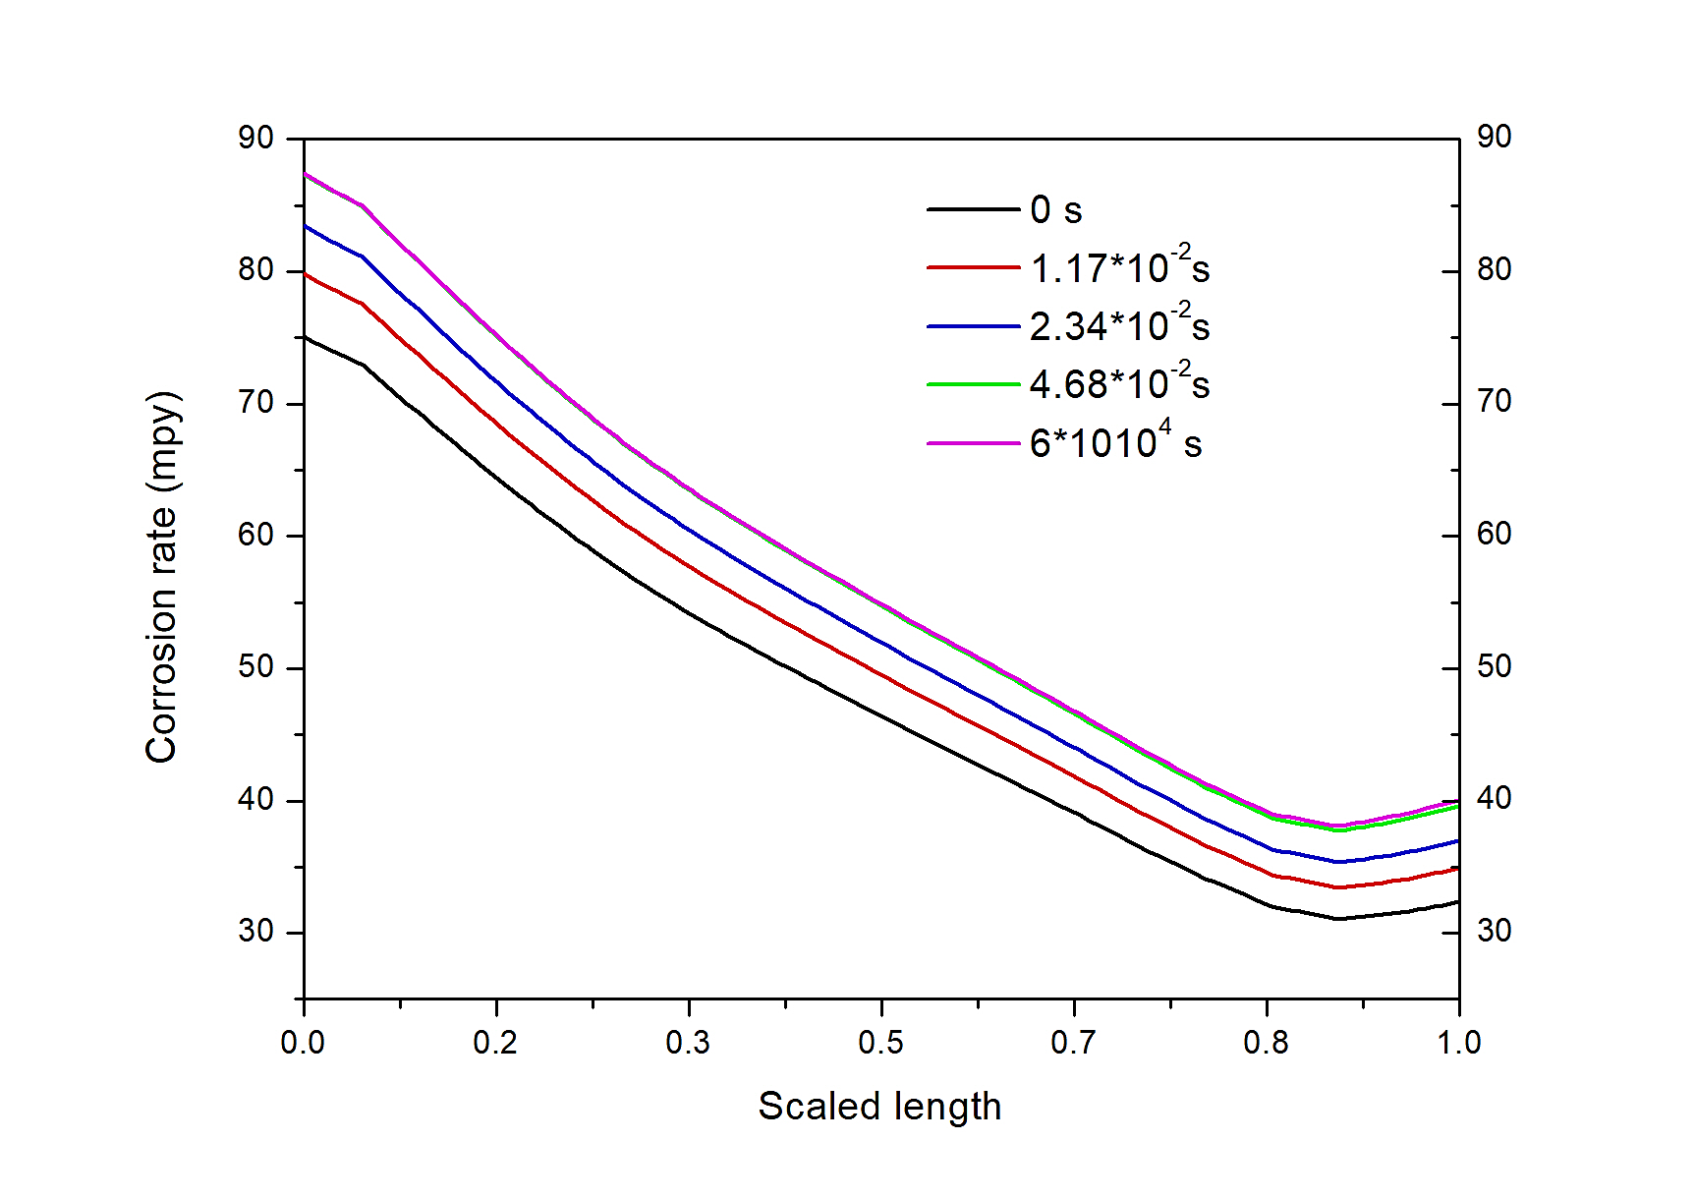
Figure 3: Corrosion rate due to H₂S at 650°C
    - Results in the dual environment.
As demonstrated in studies done by Chandra & Kranzmann, (2018), Alnegren et al., (2016) y Nakagawa et al., (2001), in environments hydrogen-rich, H₂ diffuses through ferritic steels creating discontinuities, favoring the diffusion of chemical species from one side to the other, and augmenting their corrosion rate, as we obtained in Figure 4 and Figure 5. The influence of H₂S on the water vapor side multiply 1.008 times its corrosion rate in the dual environment, compared to its singular baseline effect at 650 °C. Otherwise, water vapor multiplies 1.2 times the corrosion rate on the H₂S side in the dual environment, regarding the H₂S behavior under singular conditions at 650 °C. These results are explained by the hydrogen diffusion throughout the alloy, as suggested by other researchers (Mosquera, 2019; Nakagawa et al., 2001). Chandra & Kranzmann, (2018) showed similar trends in a dual environment of flue gas and water vapor: the corrosion rate of the ferritic alloy increased about 3 times the value obtained in the singular flue gas environment. Likewise, Alviz et al., (2021) found a corrosion rate for the P91ferritic steel 1.6 times higher in the dual environment than in the singular one of an industrial simulated boiler.
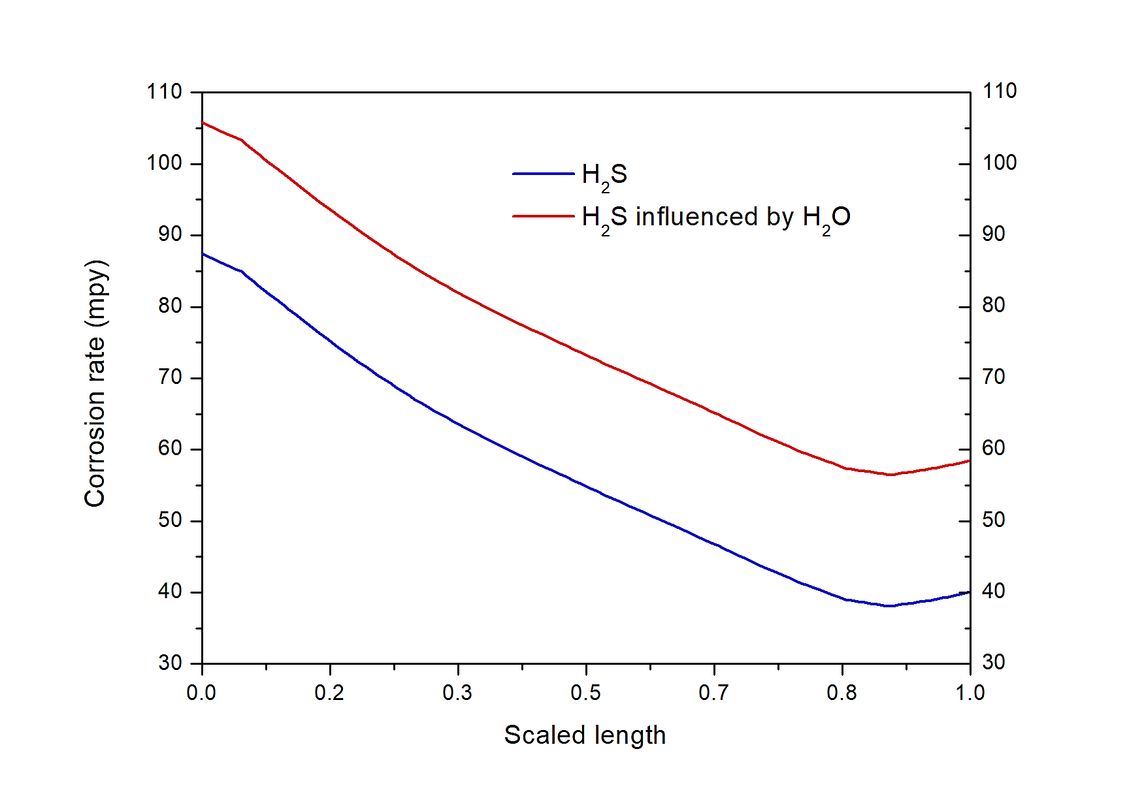
Figure 4: Corrosion rate due to the influence of water vapor on H₂S 650°C and 6x10⁴ s

Figures 6 and 7 show the corrosion rate obtained by different authors under similar singular conditions, compared with values gotten for singular cases in the present work. The conditions for steam of each author's studies are as follows: Laverde studied T91 steel at 550°C for 250 h in a mixture of Ar+H₂O; Ehlers a P91 steel at 650°C for 60 h in an environment of N₂-O₂-H₂O; Alviz et al., (2021) a P91 steel at 650°C for 200 h in flue gas/steam; Alviz et al., (2020) a P91 steel at 650°C for 200 h in N₂-O₂-H₂O-H₂S. On the other hand, the conditions used in the H₂S studies are the following: Gao tested an API 5L steel at 120°C for 504 hours, in H₂S-N₂, and Dong a T91 steel at 700°C for 70 hours in N₂-(0.5,2.5)H₂S %molar.
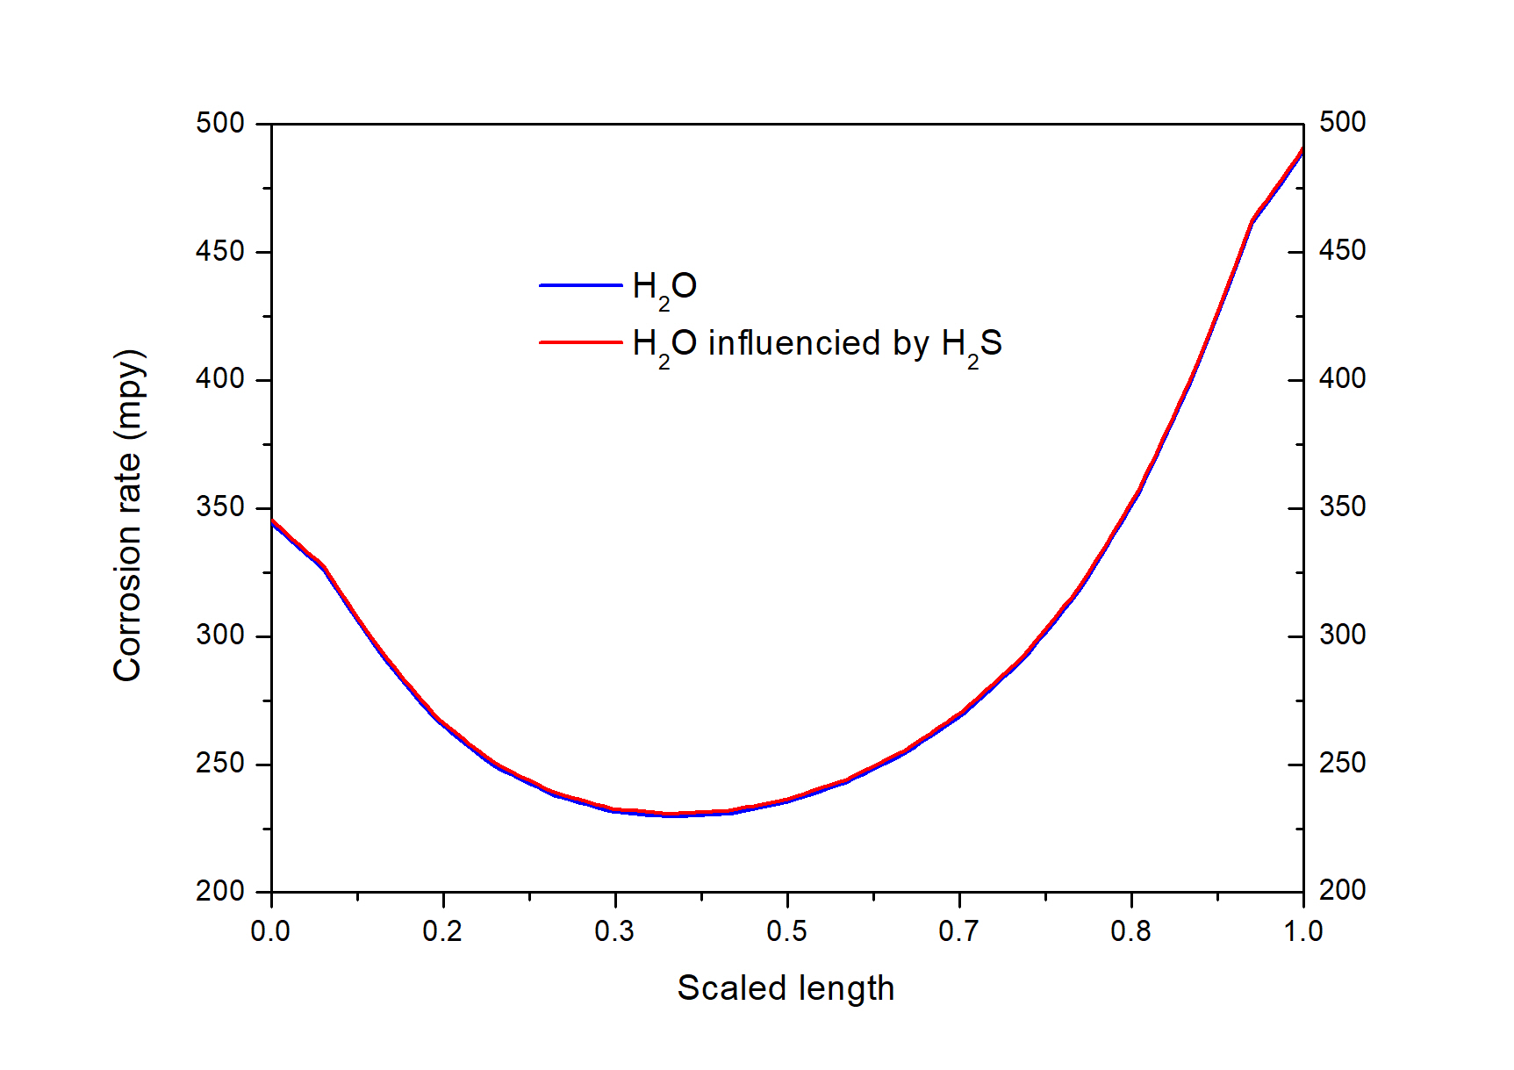
Figure 5: Corrosion rate due to the influence of H₂S on Steam at 650°C and 6x10⁴s

A comparison of results for each singular environment is separately presented below to determine how well our model matches the reported values. In the water vapor case, our corrosion rate was found higher than in the selected research works; being the most distant 2.75 times lower (Alviz et al., 2021) whereas the closest 1.22 times lower (Alviz et al., 2020). This is associated with the difference in the corrosive agents presented in reactants. On the other hand, the H₂S corrosion rate was 3.5 times lower in our work than the one found by Dong (2016) and 1.2 times higher than that of Gao (2017). The large difference with Duong’s research is explained by the 3.5 times higher concentration of H₂S employed by him.

Figure 6: Comparison of corrosion rate obtained for the H₂O side

Figure 7: Comparison of corrosion rate obtained for the H₂S side
  - Conclusions
Based on a proposed model for the P91 steels’ corrosion rate estimation in a dual environment, a simulation was carried out in Comsol Multiphysics®, using the physics of dilute species’ transport and a laminar flow. The flow rate employed was 250 mL/min for both environments, with concentrations of 6.96 mol/m³ and 0.146 mol/m³ for H₂O and H₂S, respectively. It was determined that the corrosion rate of the system is higher in water vapor (between 275-400 mpy) than in H₂S (between 32-87 mpy) at 650 °C. In the dual environment, the corrosion rate obtained in the H₂S environment was 1.2 times higher due to the H₂ effect. Meanwhile, for the H₂O side, it was 1.008 times higher due to the same effect from the hydrogen released by H₂S. These results were compared with scientific literature, obtaining acceptable corrosion rate matchings, and agreeing with the explanation given to the hydrogen contribution: it enhances the diffusive processes through the alloy’s bulk. In short, the contribution of hydrogen in corrosive environments should be considered a key factor to select the best alloy in equipment working at high temperatures in dual environments.
Acknowledgments
The authors express their gratitude to professor Jeferson Oswaldo Ruiz Lizarazo for his support in the development of the simulation system in COMSOL Multiphysics®.
References
Alnegren, P., Sattari, M., Svensson, J. E., & Froitzheim, J. (2016). Severe dual atmosphere effect at 600 °c for stainless steel 441. Journal of Power Sources, 9. https://doi.org/10.1016/j.jpowsour.2015.10.001
Alviz, A., Duong, A., Orozco, J., Kafarov, V., Cárdenas, Y., Carrillo, G., & Peña, D. (2021). Study of early P91 dual corrosion in steam and simulated combustion gases from a gas-fired boiler. Journal of Materials Research and Technology, 13(May), 271–282. https://doi.org/10.1016/j.jmrt.2021.04.071
Alviz, A., Kafarov, V., Cardenas, Y., & Pa-Ballesteros, D. Y. (2020). Simultaneous sulfidation/oxidation of a ferritic steel under a simulated mixture of flue gas from an oil refinery. Journal of Physics: Conference Series, 1708(1). https://doi.org/10.1088/1742-6596/1708/1/012006
Alviz, A., Kafarov, V., & Peña, D. Y. (2018). Evaluation of corrosion damage obtained during the combustion process in a boiler. Case study: Ferritic steel ASTM A335 P91. Chemical Engineering Transactions, 70, 6. https://doi.org/10.3303/CET1870183
Auinger, M., Naraparaju, R., & Rohwerder, M. (2011). Modelling High Temperature Oxidation in Iron – Chromium Systems : Combined Kinetic and Thermodynamic Calculation of the Long-Term Behaviour and Experimental Verification. Oxid Met, 247–258. https://doi.org/10.1007/s11085-011-9252-8
Chandra, K., & Kranzmann, A. (2018). High temperature oxidation of 9–12% Cr ferritic/martensitic steels under dual-environment conditions. The international Journal of Corrosion Processes and Corrosion Control, 8. https://doi.org/10.1080/1478422X.2017.1374049
Chandra, K., Kranzmann, A., Saliwan Neumann, R., Oder, G., & Rizzo, F. (2014). High Temperature Oxidation Behavior of 9–12 % Cr Ferritic/Martensitic Steels in a Simulated Dry Oxyfuel Environment. 26. https://doi.org/10.1007/s11085-014-9521-4
Coelho, D. M. (2014). High temperature corrosion of steels in single and dual conditions using atmospheres related to the oxyfuel process Daniel Massari de Souza Coelho High temperature corrosion of steels in single and dual conditions using atmo. Pontifícia Universidade Católica Do Rio de Janeiro.
COMSOL Multiphysics®. (2019). Introduction To Comsol Multiphysics (pp. 1–26). https://doi.org/10.1142/9789812773302_0001
Ehlers, J., Young, D. J., Smaardijk, E. J., Tyagi, A. K., Penkalla, H. J., Singheiser, L., & Quadakkers, W. J. (2006). Enhanced oxidation of the 9%Cr steel P91 in water vapour containing environments. Corrosion Science, 48(11), 3428–3454. https://doi.org/10.1016/j.corsci.2006.02.002
Huenert, D., Schulz, W., & Kranzmann, A. (2010). Corrosion behavior of ferritic and martensitic power plant steels under conditions of dual atmospheres. Corrosion, 66(12), 7. https://doi.org/10.5006/1.3524836
Lobnig, R. E., & Grabke, H. J. (1990). Mechanisms of simultaneous sulfidation and oxidation of FeCr and FeCrNi-alloys and of the failure of protective chromia scales. Corrosion Science, 30(10), 1045–1071. https://doi.org/10.1016/0010-938X(90)90211-M
Mosquera, M. (2019). Influence of surface ash layer on dual corrosion. Universida de Vigo.
Nakagawa, K., Matsunaga, Y., & Yanagisawa, T. (2001). Corrosion behavior of ferritic steels on the air sides of boiler tubes in a steam/air dual environment. Materials at High Temperatures, 6. https://doi.org/10.3184/096034001783640658
Rebak, R. B. (2011). Sulfidic corrosion in refineries - A review. Corrosion Reviews, 29(3–4), 123–133. https://doi.org/10.1515/CORRREV.2011.021
Reisert, M., Anisur, M. R., Lee, L., Aphale, A. N., Hong, J., Yaginuma, M., Shiomi, T., Dale, N., Hussain, A. M., & Singh, P. (2021). Corrosion of Chromia-Forming and Alumina-Forming Ferritic Stainless Steels under Dual Atmosphere Exposure Conditions. Journal of The Electrochemical Society, 168(11), 111506. https://doi.org/10.1149/1945-7111/ac38f9
Uribe, B., & Méndez, D. (2021). Estudio la velocidad de corrosión del acero ferrítico ASTM A335 P91 en un ambiente dual de vapor de agua y H2S a altas temperaturas en condiciones simuladas de un horno de refinería, a través del software Comsol Multiphysics®.

