Spectrophotometric Detection of Copper in Water by Lab-on-a-chip Technology: Application to Electroplating
Giulia Mossotti, Monica Periolatto*, Felice Catania, Francesco Perrucci, Luciano Scaltrito and Sergio Ferrero
Politecnico di Torino, C.so Duca degli Abruzzi, 24 10129 Torino - Italia
monica.periolatto@polito.it
Copper electroplating requires baths with high metal concentration, as far as 100 g/L. The monitoring is mandatory in terms of good results of the process and safety of the wastewater products. A colorimetric method was chosen to detect Cu concentration, effective both for high and low metal amounts. In the range 1-20g/L, the spectrophotometric analysis shows a well-defined absorbance peak, due to Cu in solution, at about 805 nm, giving rise to a calibration curve with good linearity toward metal concentration. The detection field can be enlarged at least from 100 g/L to 10 ppm easily by proper dilution, for higher concentrations, or by adjusting the optical length, for small copper amounts. The influence of pH and aging was also investigated.
Meanwhile, for concentrations lower than 10 ppm, the addition of Zincon™ as a complexing agent is required. Zincon-Cu complex solutions show in fact a new absorbance peak at 665 nm, well visible even on 100 ppb copper solutions, useful for the drawing of a linear calibration curve. Moreover, even in this case the increase of the optical path allows the detection of copper ions in concentrations as small as few ppb.
Collected results point out the proposed colorimetric method as a good candidate to address the need for capillary and frequent monitoring of copper in water, in a wide range of concentrations. The aim is to design an affordable and versatile sensor for routine monitoring. The laboratory process can be easily optimized and adapted with the lab-on-a-chip technology applied to a microfluidic technology, by reducing the volumes of samples and reagents, miniaturizing the sensors, and automatizing the whole process, from sampling to data recovery.
  - Introduction
In the field of electronic manufacturing, electrodeposition not only plays an important role but also shows a major advantage over other traditional processes of thin film deposition, such as plasma vapor deposition and metal-organic chemical vapor deposition. In fact, electrodeposition can accomplish high-quality deposits at normal low conditions of pressure and temperature, with relatively low equipment costs. (Ortiz et al. 2019)
Aluminium is normally used as an interconnection material for integrated circuits. However, among other metals, copper is considered a good alternative and it is wildly used to coat either metal or polymeric substrates in many electrical devices. This is due to its peculiar properties, namely low bulk electrical resistivity, malleability, corrosion resistance and high resistance to electromigration and stress migration. Copper electroplating exploits an electrochemical mechanism where the substrate, either metal or polymeric, is put in an electrolytic bath, that is an aqueous solution of around 100g/L copper sulphate (CuSO₄) and additives. The electric current is used to cause copper ions to adhere to the surface of the base material and the result is a thin copper coating on the surface. In the presence of electrodes, two main reactions occur: the oxidation at the counter electrode (1) and the reduction at the working electrode (2). As result, metallic copper adheres to the substrate surface as a thin copper seed layer that provides a pattern for the electroplating current.

Cu → Cu²⁺ + 2 e⁻ (1)

Cu²⁺ + 2 e⁻ → Cu (2)

The control of the bath composition during the whole process, mainly in terms of copper sulphate concentration, is crucial for the good management of the plating process.
Another main issue for this process is that the electroplating plant must ensure that the post-process water treatments remove all traces of copper ions before the outlet. The release of large quantities of Cu²⁺ ions in water and soil can in fact lead to harmful long-term consequences on the environment, organisms, and ecosystem health. Noteworthy, the Environmental Protection Agency (EPA) has limited the level of Cu²⁺ in tap water to 20 μM and World Health Organization (WHO) has regulated drinking water at 30 μM.
In the last years, due to the rising demand for technological devices, there has been a fast increase in this type of process, showing the considerable emissions of wastewater polluted by heavy metals as the main disadvantage. The pollution of water by copper is particularly dangerous, first for the environment, since it is not bio-degradable and long-term persistent, but also for human health since it may induce a variety of illnesses when taken in high doses. (Shrivastava, 2009)
To the best of our knowledge, the standard approach for copper detection analysis is colorimetry, based on the well-known Lambert & Beer law.
The analysis is carried out in a lab, on a discrete number of samples collected at fixed times; adjustments to the process parameters or wastewater treatment will occur after a certain delay, due to technical analysis time.
The aim of this preliminary study is to verify the possibility of developing and integrating into a microfluid device a sensor, based on a colorimetric evaluation by UV-Vis spectroscopy coupled with the lab-on-a-chip technology, for the detection of a wide range of copper concentrations in water.
In such a way, the whole process can be automatized, increasing the monitoring frequency and allowing an immediate intervention in case of anomalies in the concentration levels of the metal; in fact, there is no longer a time-consuming gap between the sampling in situ and the analysis in the laboratory. Moreover, through IoT technologies, the transmission of the data to competent authorities can be immediate. This sensor, characterized by easy use, speed, sensitivity, selectivity, reliability, portability, robustness and safety, will be able to detect a broad range of copper concentrations in water and might be used for a variety of purposes. Firstly, for a successful outcome of the electroplating process, online monitoring of the copper sulphate bath, allowing the fast detection of any change in salt concentrations, is of great importance for a ready and sudden action of adjustment. Solutions with a higher concentration of copper, between 10 ppm and 100 g/L, can be directly detected by UV-Vis spectroscopy. On the other hand, related to wastewater, for samples with lower metal concentration, down to 100ppb, the direct analysis was not possible since they are colorless, so they were added of a complexing agent, ZinconTM (2-Carboxy-2′-hydroxy-5′-sulfoformazylbenzene), that is able to make visible and detectable even these low copper amounts.
Previous studies about colorimetric analysis applied to microfluidic devices aimed at online monitoring of metal ions in water were carried out by the same authors. A prototype was arranged for the detection of Chromium (VI) while Nichel and Zinc were further investigated. (Manachino et al. 2020, Periolatto et al. 2020)
  - Materials and method
Copper solutions with increasing metal concentrations were prepared and analyzed by UV-vis spectroscopy to assess the detection limits, in terms of Cu concentration, and the linearity of the calibration curve. The quality of spectra and the absorbance peak were also investigated. A commercial high-purity quality pentahydrate copper sulphate powder (Sigma-Aldrich) was used to prepare 50 mL samples of distilled water solutions with different copper concentrations, in the range of 1 – 75 g/L. A vigorous magnetic stirring coupled with heating at 100°C for about 10 min was needed to assure the complete salt dissolution in water, for Cu concentrations higher than 50 g/L. Noteworthy, these sample pre-treatments are required only for the calibration curve, while samples coming from the plants can be analyzed as they are, even at high ions concentration, since the complete salt dissolution is assured by process parameters.
ZinconTM sodium salt 85%w/w (Merck) solution 1.6×10⁻² M was prepared by dissolving the proper salt amount in a 0.02 M NaOH solution. A fixed volume of 20mL of the sample was added to 3 mL of Zincon solution and 10mL of a pH 4 buffer solution. The as-prepared samples were analyzed by a UV-Vis spectrophotometer (LAMBDATM 35, PerkinElmer), in an optical glass cuvette (10 or 20 mm optical path), versus pure distilled water as a reference. To evaluate the quality of the spectra and the peak wavelength the solutions were first analyzed, at room temperature and neutral pH without any dilution. Then pH 4 and pH 10 buffer solutions (Merck) were used as liquid media for a pH-controlled test.

3. Results and discussion
3.1 Colorimetric evaluation
Due to a simple detection technique, colorimetric methods are particularly useful for copper monitoring. The experimental study starts from the higher ions concentrations, namely from 1 g/L to 75 g/L. The strong dependence between the vivid blue color intensity, developed by copper solutions with increasing concentrations, and the amount of dissolved copper is clear even at necked eye (Figure 1). The 1g/L solution still shows a light cyan coloration, clearly detectable by spectrophotometry.
Figure 2a shows the spectra related to Cu solutions in the range 1-22 g/L and depicts also the maximum absorbance detectable at the well-defined wavelength of 805 nm, against distilled water as a reference. The magnification shows an increasing noise detected on peaks referred to higher Cu concentrations, conferring uncertainty to the read values, so 20 g/L (red curve in Figure 2a) is assumed as the highest detectable concentration for the investigated asset. In Figure 2b the calibration curve obtained by absorbance values at 805 nm is reported; the high linearity toward metal concentrations from 1 to 22 g/L is confirmed by the R² value, close to 1 (R²=0,9983).
Tests with higher concentration solutions were also carried out, but saturated spectra were obtained. Similarly, the minimum detectable concentration was investigated, considering a concentration range of 0.05-1 g/L. In this case, the color was hardly visible to the necked eye but UV-vis can appreciate differences: spectra are similar in the form to the previous ones, showing again the peak at the same wavelength (Figure 3a), and also the calibration curve, in Figure 3b, depicts good linearity (R²=0,9872). The absorbance peak disappears for Cu concentrations lower than 0.1g/L, assumed as the lowest concentration detectable with this asset.
To further decrease the lower detection limit, tests were carried out by increasing the optical path, that is doubling it. In this way, the detectable concentration can be lower, according to the well-known Lambert and Beer law. Copper solutions in the concentration range from 0.05 to 0.12 g/L were tested, increasing the length of the optical path of the cuvette from 1cm to 2cm. Figure 4b shows that in this range the solutions completely lose the color detectable by the naked eye, however Figures 4a and 4c show that, even at such low concentrations, the increased optical path still allows to reveal the absorbance peak, and the calibration line maintains good linearity (R²=0,9986).
This result suggests that the detectable concentration can be further reduced by simply increasing the optical path. It can also be supposed that the higher limit of concentration can be increased by decreasing the optical path; tests are planned for the near future. Despite the optical length change required to cover a wide range of detectable copper concentrations, the wavelength remains constant for all analyses at 805nm. It indicates the possibility of implementing a more economical monochromatic LED source inside the sensor, suitable for industrial applications.
3.1.1 Colorimetric evaluation: influence of pH
The influence of pH was tested on three Cu solutions 0,05 g/L in both acid and basic medium. The salt dissolution in water is promoted by the acidic media, occurring in a short time at room temperature, as expected. The neutral solution appears not completely transparent, denouncing that the salt was not completely dissolved and confirming the need for stirring and heat to reach complete salt dissolution. For basic pH, precipitation occurs (Figure 5). The acid solution, buffered at pH 4, was chosen for a deeper investigation in the concentration range of 1-10 g/L. With respect to neutral pH, acidification causes a slight shift of the maximum absorbance peak and also higher absorbance values, due to the better salt dissolution (Figure 6a). However, considering the absorbance in the range 760-780 nm, where the absorbance peak occurs, the calibration curves show good linearity, with a value of R² almost close to 1 regardless of the wavelength considered. (Figures 6b – 6c)
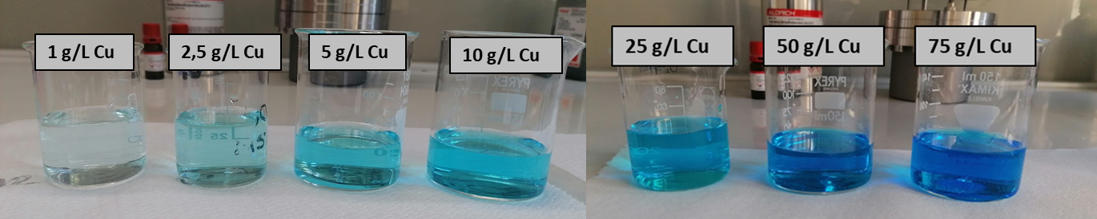
Figure 1: Copper sulphate solutions with increasing metal concentration, from left to right.
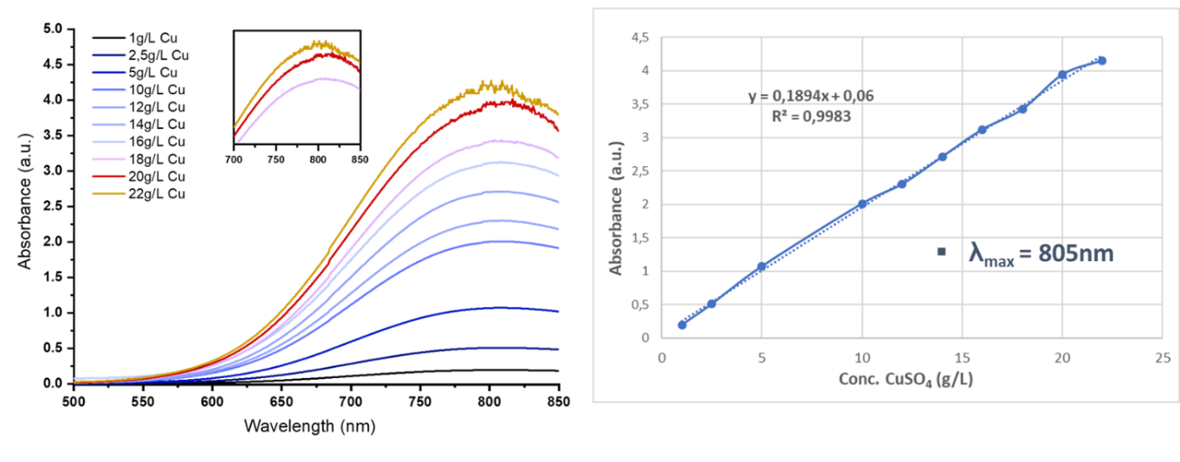
(b)
(a)
Figure 2: (a) UV-vis spectra of Cu solutions at high concentrations; (b) Calibration curve (λ_{MAX} = 805 nm).
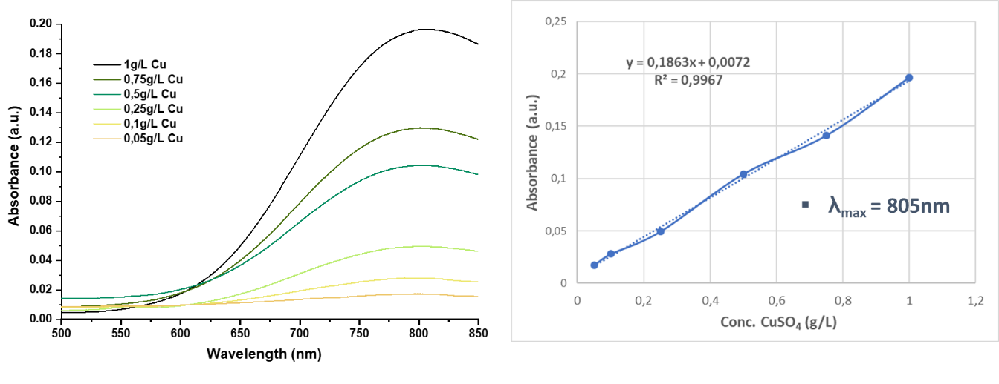
(b)
(a)
Figure 3: (a) Spectra of Cu solutions at low concentrations and (b) Calibration curve (λ_{MAX} = 805 nm)
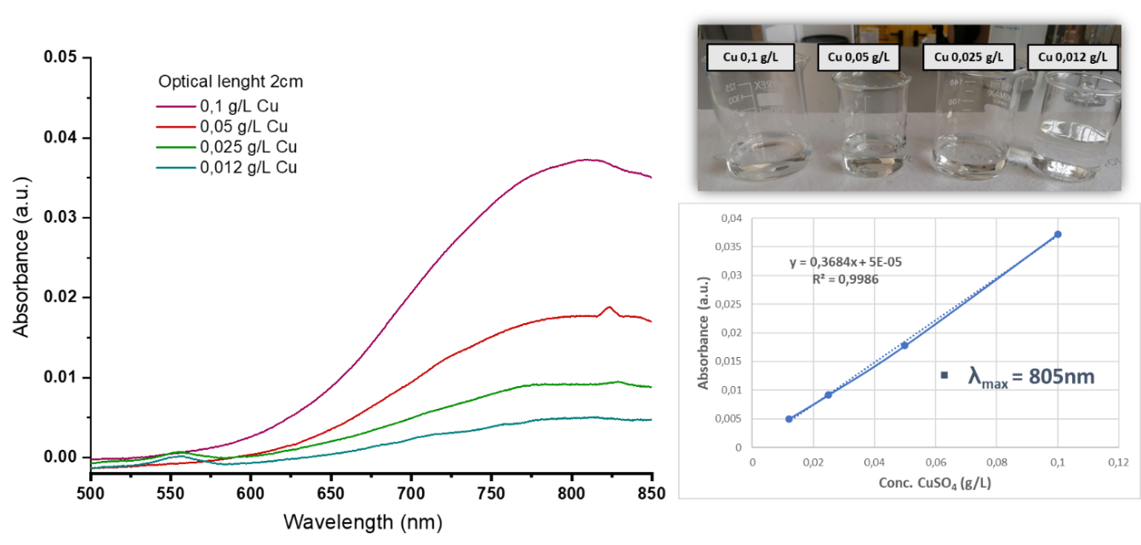
(c)
(b)
(a)
Figure 4: (a) Spectra of Cu solutions analysed by 20mm optical path, (b) Colourless solutions with low Cu concentration of and (c) Calibration curve.
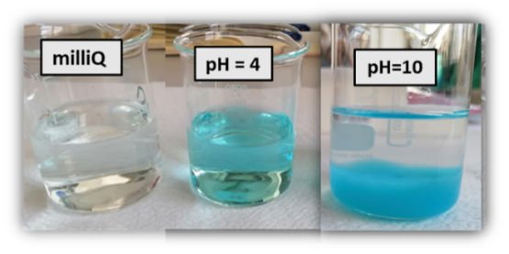
Figure 5: Influence of pH on 0,05 g/L Cu solutions
3.1.2 Colorimetric evaluation: aging test and dilutions
Aging tests were first carried out after 24h from the preparation of different solutions in a concentration range from 1 to 10 g/L, without dilution. The aim was the evaluation of possible degradation or color changing of the samples, due to metal deposition. The results show that the linearity of the calibration line was maintained, with spectra perfectly overlapping those referred to freshly prepared solutions.
The complete dissolution of the salt at high concentrations (from 20g/L) is difficult. Three methods were investigated to enhance the salt solution: magnetic stirring, heating at about 100°C and resting time. Among them, a resting time of 24 hours gave the best results (Figure 7). Anyway, even if salt dilution is a real problem, it is not relevant for the application. The calibration curve will in fact be drawn by low concentration solutions while the samples to be analyzed are homogeneous by sure, and can be properly diluted to fall in the linear calibration range.
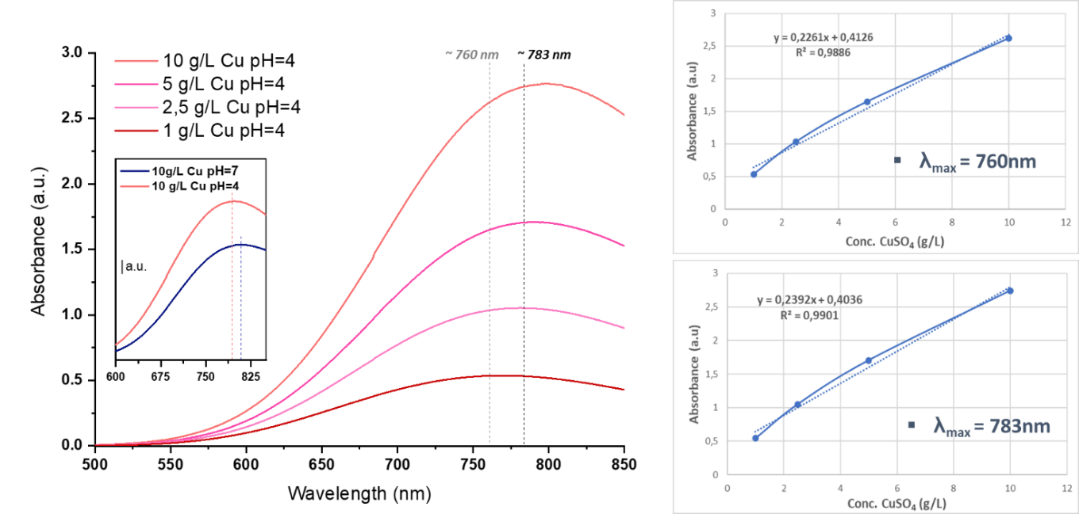
(b)
(c)
(a)
Figure 6: (a) Spectra of Cu solutions in acid medium: the magnification shows the absorbance increase respect to neutral pH; (b) Calibration curves considering different wavenumber.
3.2 Colorimetric evaluation by ZinconTM
The Zincon method was investigated in the concentration range lower than 5ppm, where the color of the Cu solution is relivable neither by spectrophotometry. Zincon solution shows an orange coloration, turning to blue in presence of copper ions, due to the formation of the Zincon-metal complex (Figure 8a).
Increasing copper amount in solution, the UV-visible peak at about 450 nm, related to free Zincon, is progressively replaced by the new peak at 600 nm, as shown in Figure 8b; it can be spectrophotometrically read versus distilled water or versus the same Zincon solution without any copper ions. Collected spectra were clear and well defined, and the desired trend of peak absorbances was confirmed. The reliability of the proposed method was confirmed by the determination of the calibration curves. Two concentration ranges were investigated: 250ppb – 2ppm and 10-100ppb. Test at lower concentrations showed some problems due to a high amount of Zincon still present in the solution in its un-complexed form, keeping the orange color. The problem was solved by using the same Zincon solution as a reference for the spectrophotometric analysis, cleaning the signal of the orange peak. In such a way, a good calibration curve was obtained, with good linearity in the whole considered range (Figure 9a). Considering the 250ppb – 2ppm range, the same test was carried out, finding any difference between the two references, namely water or Zincon solution. In both cases, the calibration curve showed an R² near 1 and the peak of interest was not affected by the unreacted Zincon. (Figure 9b). Hence Zincon solution was finally chosen as a reference for both the concentration ranges, to standardize the procedure.
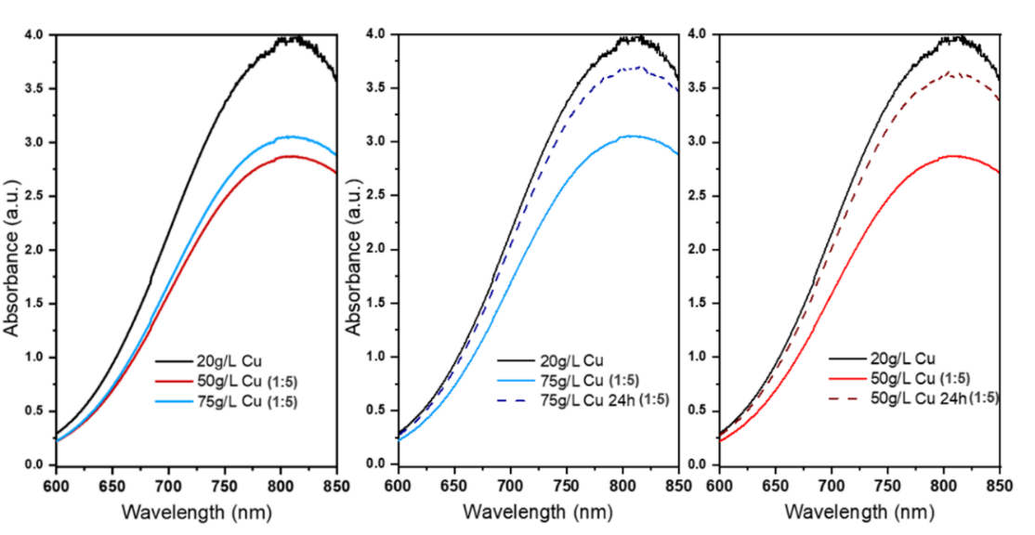
(c)
(b)
(a)
Figure 7: (a) Sample dilution for Cu concentrations higher than 20 g/L; (b) and (c) Increase of salt dissolution due to 24h resting time.
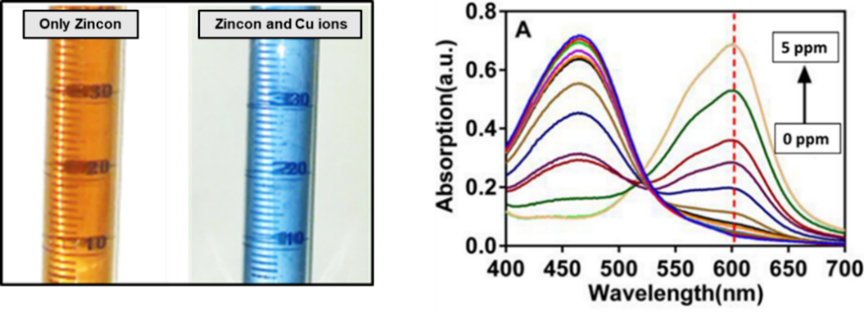
(b)
(a)
Figure 8: (a) Zincon solution without and with copper metal ions. (b) Spectra of Zincon treated samples.
(b)
(a)
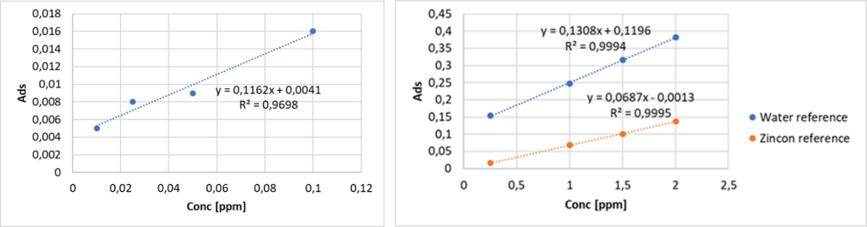
Figure 9: (a) Calibration curve for Cu concentration 10-100 ppb, Zincon solution as reference. (b) Calibration curves for Cu concentration 0.25-2 ppm.
4. Conclusions
The monitoring of metal ions presence in water media is of great relevance both in industrial field, to optimize process control, and in environmental field, to reveal the possible pollution of water sources.
Due to the simplicity and safety of colorimetric analyses, the process is suitable to be integrated into a sensor employed by a microfluidic system. Moreover, obtained results give rise that, for high concentrations of copper ions in water, the colorimetric analysis allows the detection of metal in a wide range of concentrations, with a good reliability, properly adjusting the sample dilution and the optical path. Properly adjusting the optical length, lower concentrations up to 0.01 g/L (10ppm) can be detected using the UV-Vis direct method. The salt dissolution is enhanced by acidic environment, while a resting time of about 24h is required in standard conditions, namely RT and neutral pH.
Moreover, the use of Zincon as a copper chelating agent allows the detection of metal traces in water samples. Test carried out with an optical length of 10mm can reveal copper concentrations of just 10 ppb, but this limit can be probably further decreased by increasing the optical length, reaching copper detections of a few ppb. Both methods are simple, cheap, and easily implementable in a portable device. In such a way, by coupling the two investigated methods, both based on spectrophotometric measurements, copper presence in water can be detected in a wide range of concentrations, from 100000 ppm to 10 ppb, opening great possibilities for applications, not only in electroplating control but also in water contamination monitoring.

References
Rosa-Ortiz SM, Khorramshahi F, Takshi A, 2019, Study the impact of CuSO₄ and H₂SO₄ concentrations on lateral growth of hydrogen evolution assisted copper electroplating, J. Appl. Electrochem. 49, 1203–1210.
Shivrastava AK, 2009, A review on copper pollution, Indian J. Environmental Protection 29, 552–560.
Manachino M, Periolatto M, Catania F, Scaltrito L, Pirri F, Ferrero S, 2020, Miniaturization and Optimization of the Standard Spectrophotometric Analysis for Autonomous, Continuous and On-site Heavy Metal Detection in Water, Chemical Engineering Transactions, 82, 181-186.
Periolatto M, Catania F, Manachino M, Scaltrito L, Pirri F, Ferrero S, 2020, Direct online environment monitoring of water pollution, Chemical Engineering Transactions, 82, 193-198.

