|  |  |
| --- | --- |
| cetlogo ***CHEMICAL ENGINEERING TRANSACTIONS***  ***VOL. 82, 2020*** | A publication of  aidiclogo_grande |
| The Italian Association  of Chemical Engineering  Online at www.cetjournal.it |
| Guest Editors: Bruno Fabiano, Valerio Cozzani, Genserik Reniers  Copyright © 2020, AIDIC Servizi S.r.l. **ISBN** 978-88-95608-80-8; **ISSN** 2283-9216 | |

Microscopic Traffic Simulation for the Safer Process and Environment in the City

Katerina Vichova\*, Radek Dvoracek, Pavel Taraba, Robert Pekaj

Tomas Bata University in Zlín, Faculty of Logistics and Crisis Management, Studentské náměstí 1532, 686 01 Uherské Hradiště, Czech Republic

[kvichova@utb.cz](mailto:kvichova@utb.cz)

Climate change and global warming. Those are two words that are inflected much more frequently. Several reasons could cause climate change. One of them is the consumption of fossil fuels- e.g., oil. So few vehicles already operate on electric flow. There is a higher production of carbon dioxide and nitrous oxide based on the increased number of cars in the cities. For this purpose, the authors of the paper would like to simulate the selected intersection. Based on the results, the authors will present a recommendation for the safer process and environment in the city.

* 1. Introduction

Transport infrastructure elements such as road and railway structures are used every day by more and more people, and disruption to or failure of these elements would have a broad impact. (Partman et al., 2019) Considering the failure of typological elements, it is possible to assume that the failure of a certain type of a very common element (e. g. intersections). (Dvorak et al., 2017) Nowadays, with the increase of vehicles on roads, traffic congestion has become a more and more serious topic. (Kaur, 2020) An increase in the fleet of cars increases the traffic intensity, and the aim is to increase the capacity of roads, primarily along the main lines, and create city roundabouts. (Volkova, 2019)

The rapid development of the transport industry brings comfort to our lives, but also traffic jams. Road capacity needs to be improved based on the current transport infrastructure. (Chen et al., 2019) Increasing transport requirements are a challenge both in terms of logistics performance and in terms of related environmental impacts. (Bjørgen et al., 2019) Rapid urbanization and motorization causing millions of annual deaths by deteriorating air quality. (Zalakeviciute, 2018) Air pollution is currently one of the foremost environmental health problems. (Schneidemesser, 2019) Coelho states that the traffic sector is responsible for the increase of emissions and fuel consumption from year to year. (Coelho, 2011)

These are just the primary impacts of transport. There are also a number of important impacts such as accidents, congestion and so on.

Furthermore, we must also say the production of greenhouse gases that enter the atmosphere, which is causing climate change - global warming and, consequently, many other consequences for life on Earth. The Wall Street Journal states that in 2018, there are about 1.3 billion passenger cars on the globe and are growing every year. The same increasing situation is in the Czech Republic too (see Figure 1).

Transport is strongly linked to cities and affects planning related to their future. Due to this increasing tendency, current spatial planning in the field of transport is becoming insufficient. Trends such as population and aging growth, livable cities, resilience to infrastructure, are changing the movement of people and goods in urban areas. (Bjørgen et al., 2019) Due to the high proportion of cars, long traffic columns are formed at previously planned hubs, where cars spend more time in service and thus increase air pollution from exhaust gases. Therefore, it is essential that urban planning is adapted to today's conditions and, where appropriate, a change in the type of traffic intersections to ensure better throughput. At present, the research on urban traffic flow are divided into three levels: macroscopic traffic, mesoscopic traffic and microscopic traffic.

Transport modelling using computer is in the field of traffic engineering and building effective working of the multiple expansion options to solve the complex tasks and problems. (Konfant, 2017) This paper is focused for the microscopic traffic simulation.

Figure 1: Road transport in the Czech Republic (Czech Statistical Office, 2019)

The aim of this paper will be to select one intersection and simulate the current state of the traffic. Based on the results, there will be added recommendations, which will be eco-friendlier. The paper will be divided into five parts. Firstly, there will be an introduction to the literature review. Secondly, there will be a methodology with a description of the used simulation software and other methods. Next, there will describe the current state of the selected intersection. In the fourth part - results will simulate the current state of the chosen intersection and recommendation. For the simulation will be used microscopic simulation software PTV Vissim. Here, a hypothesis is prepared that says that traffic jams form at a given intersection, especially at rush hour. Finally, there will be a discussion about the simulation and influence on the environment.

* 1. Methodology

In this paper was used several research methods. Firstly, there was a used method of observation. In the Zlín region, one intersection was selected, which is critical. Secondly, there was used the method of analysis, where we take data from the National Census on Highway and Road Network in the Czech Republic. Thirdly, there was used the simulation; the simulation was used simulation software PTV Vissim. PTV Vissim is proven to be the world’s standard for traffic and transport planning and a valid reason: It gives you a realistic and detailed overview of the status quo of the traffic flow and impacts, with the possibilities to define multiple what-if scenarios. With our links and connectors concept in PTV Vissim, you can map your network in detail and model different geometries – from a standard node to complex intersections. (PTV Group, 2020)

* 1. Results

The aim of this part is to present the results of the simulation in the software PTV Vissim. There, a hypothesis is prepared that says that traffic jams form at a given intersection, especially at rush hour, especially at shoulder B and C.

**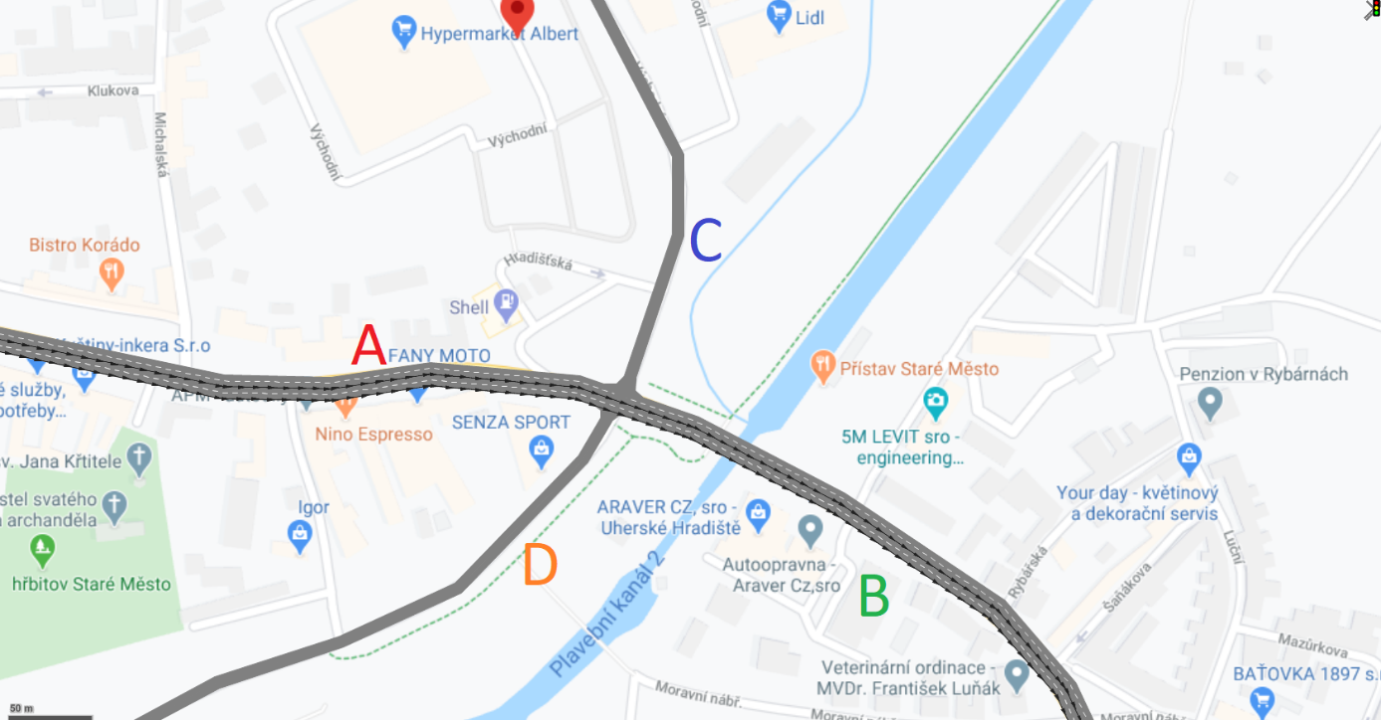**

Figure 2: Critical intersection

Figure 2 shows the shoulders of the intersection (A – D). As can be seen, the shoulder A and B have two lanes. On the other hand, shoulders C and D have only one path. The data for the simulation we take from the National Census on Highway and Road Network in the Czech Republic.

For a better understanding of the situation, we will give some information on the paths leading to each shoulder.

Arm A is from municipalities located in the district of Uherské Hradiště. Here are many citizens who go to Uherské Hradiště in the morning. They use mostly passenger cars for this purpose. However, many buses provide public transport. This transport is used primarily by students and seniors. For many people who own cars, this journey is inconvenient, and at the expense of the environment, they drive in a passenger car alone.

Arm B is the main road from the town of Uherské Hradiště, which, on the other hand, is the main route to the surrounding villages. Here is the same issue as for the A-arm. However, citizens with passenger cars still have the option of buying while traveling home from work. Besides, the citizens of the city go shopping in shopping centers.

The C arm forms the departure route from the shopping center. There are many shops in this center, which must be supplied and also used by customers. Everyone, both freight and passenger, follows the same path. Besides, the citizens of the city go shopping in shopping centers. They then go back to the town of Uherské Hradiště. Again over shoulder C.

Arm D is the route that is least used from all arm. Here are only two stores. There is also a path to a garden colony. The activity is, therefore, the smallest of all arm in both directions. As an impact, arm D was not added to the national census. Thus, numbers are not shown in the Table 1. Unit measures is vehicles per day. For the simulation, the expert estimates of observations were given by the authors.

Table 1: Results of National Census on Highway and Road Network for the critical intersection (National Traffic Census, 2016)

|  |  |  |  |  |
| --- | --- | --- | --- | --- |
|  | A | B | C | D |
| Annual average of daily intensities working day  Annual average of daily intensities – free days | 14146  10323 | 28203  20285 | 8127  5596 |  |
| Hour traffic intensity | 1428 | 2663 | 903 |  |
| Bycicle transport | 7 | 515 | 510 |  |
| Emission | 2115 | 4202 | 1058 |  |

Based on the Table 1 was prepared the simulation of the critical intersection.

**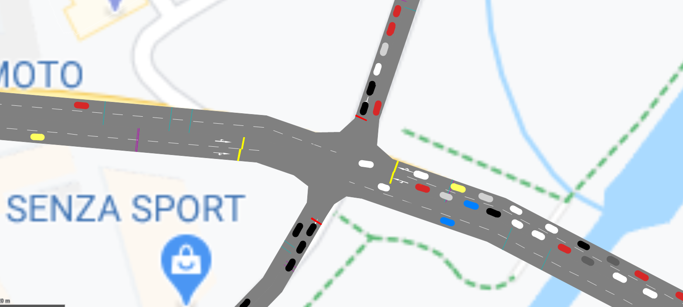**

Figure 3: 2D simulation of the critical intersection

**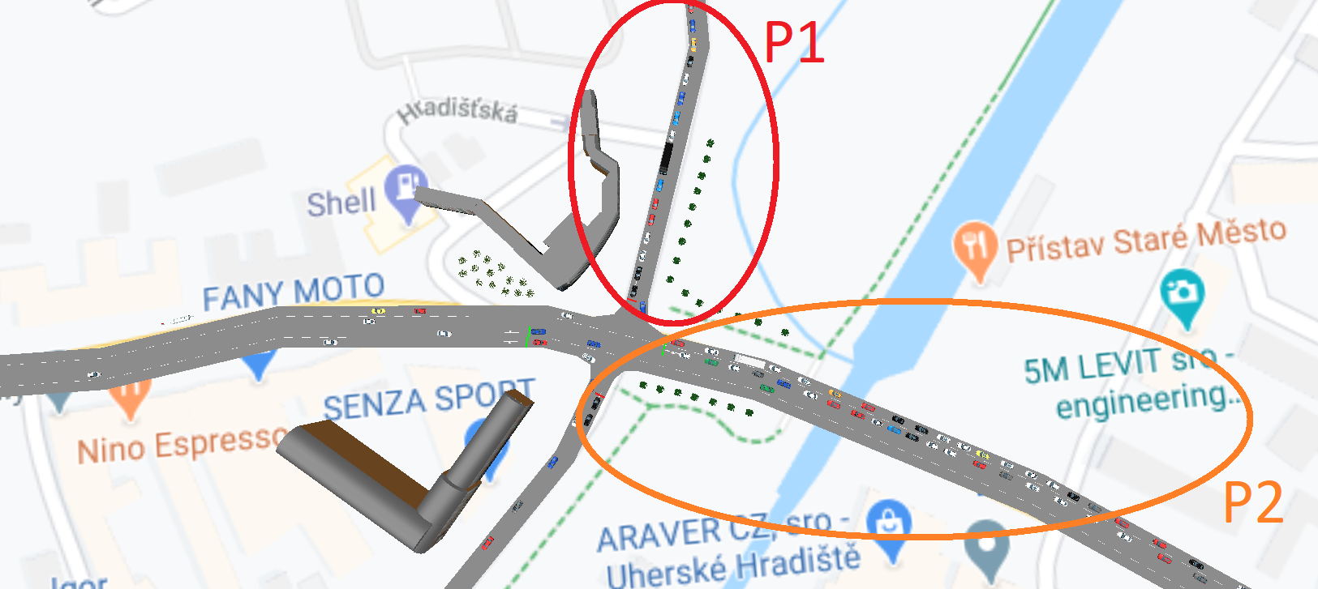**

Figure 4: 3D simulation of the critical intersection with the problem places

Figures 3, 4 show the final simulation with the problem parts. As can be seen, figure 4 shows two problems.

Problem 1 (P1) shows that in the case of the rush hour (4 p.m.), there is a problem with the traffic jam. This rush hour is each weekday. The situation is getting worse on Friday. There is a situation of further accumulation of vehicles and impossibility to enter from other side streets. As mentioned, arm C is the path that leads to the shopping center. On Friday, several citizens visit these shopping centers. There is a situation that it is not possible to leave the shopping center, and other columns arise. Based on the results, we could confirm, that the hypothesis was confirmed.

Problem 2 (P2) shows the road that leads from the town of Uherské Hradiště. Here again, the situation arises that the columns are formed. This column is divided into three parts. The first part is trying to get to the shopping center. There is, however, the problem that the flow of traffic is slowed down during the boom. Subsequently, there is a situation where drivers are trying to get out of one lane too late into a pathway that is designed to turn and thus cause complications in both lanes. And the final problem is with the situation when some car wants to go to shoulder D. In the case, when cars going from the shoulder A, the vehicles must stop and wait for the free time. It is to stop the flow of traffic and to form columns again.

These situations have cascading effects. When the cars would like to go from the side street, they must wait for the solidarity of the others cars in the lanes, which enable entrance to the road from the shoulder A. This could be seen at the following figures 5 a, b, which are not simulated; however, there is the column of the shoulder B.

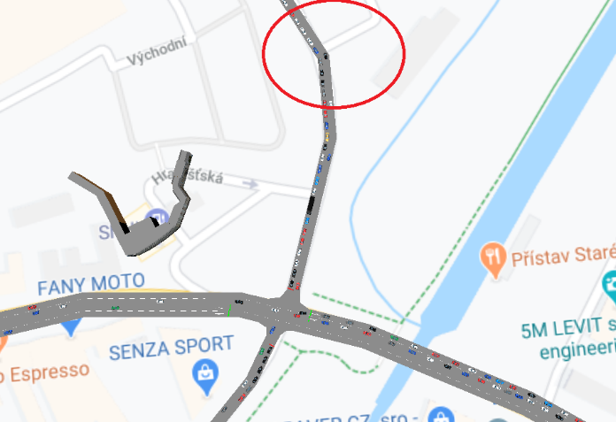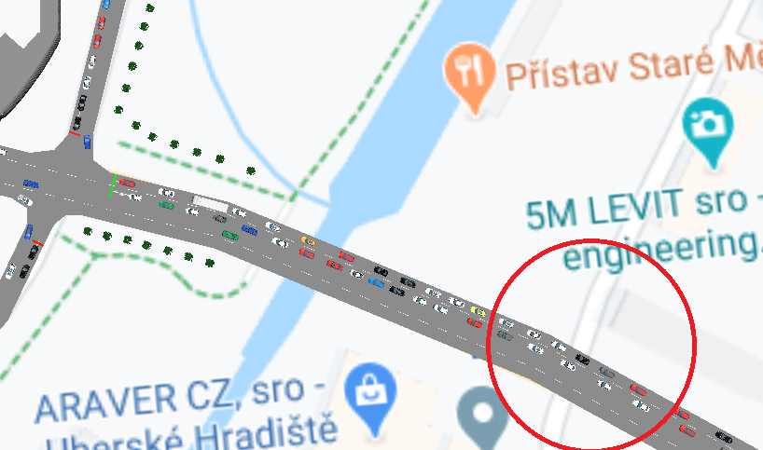

Figure 5a, 5b: Cascading effects

At the final part, we would like to add recommendations:

* The situation could be solved by changing the junction type – roundabout.
* Better adjustment of traffic lights - here is the problem that the situation is different at different times of the day. The programming of the traffic lights would, therefore, have to be dynamic and adapt to the current situation.
* Land-use change - the extension of the existing intersection for more lanes.
* Restricting passenger transport - making more use of public transport by bus.
* In the case of using cars, but also buses to switch to more environmentally friendly methods of combustion - a hybrid, electro.
  1. Conclusion

The aim of this paper was to select one intersection and simulate the current state of the traffic, for this purpose was used simulation software PTV Vissim. Based on the results, there are two problems with the columns in the selected intersection and their cascading effect. There was a chosen intersection, which is on the main road to/from the city Uherské Hradiště and in the close to the shopping center. As was mentioned, there are two problems with the columns. These situations cause daily environmental pollution and, thus, other effects. One effect could be climate change. It also causes many other cascading effects. One example is the increasing number of natural disasters. In the final part of the results, there are recommendations for the city.

Based on the proposed measures, it can be expected that the risk in traffic at the selected intersection will be reduced. Thanks to the introduction of the turbo roundabout, higher throughput can be expected. It is an aspect that results in a reduction in the accumulation of cars in one section. Thanks to this, there is no braking into the column and possible collisions of vehicles. In general, higher junction permeability results in increased safety.

Acknowledgments

This research was supported by the Internal Grant Agency of Tomas Bata University in Zlín under the project number IGA/FLKŘ/2020/001.

References

Bjørgen, A., Seter, H., Kristensen, T., & Pitera, K. (2019). The potential for coordinated logistics planning at the local level: A Norwegian in-depth study of public and private stakeholders. Journal of Transport Geography, 76(March), 34–41.

Coelho, M.F., Bandeira J.M., Coelho M.C., 2011, Impact of Road Traffic Incidents on Pollutant Emissions, IEEE Forum on Integrated and Sustainable Transportation Systems, Viena, Austria, 312–316.

Czech Statistical Office, 2019, Good transport by road, <https://www.czso.cz/csu/czso/nakladni\_doprava\_casove\_rady> accessed 5.3.2020

Chen, Y. F., Gao, Z., Zhou, H., Wang, Y., Zhang, T., Che, K., & Xiang, Z. T. (2019). Traffic flow guidance algorithm in intelligent transportation systems considering the effect of non-floating vehicle. Soft Computing, 23(19), 9097–9110.

Dvorak, Z., Sventekova, E., Rehak, D., Cekervec, Z., 2017, Assessment of Critical Infrastructure Elements in Trasport. 10th International Scientific Conference Transbaltica 2017: Transportation Science and Technology. 187, 548-555.

Kaur, D., Sharma, S., 2020, A new two-lane lattice model by considering predictive effect in traffic flow. Physica A: Statistical Mechanics and Its Applications, 539, 122913.

Konfant. M., Gogola, M., 2017, Possibilities of using traffic planning software in Bratislava. TRANSCOM 2017: International scientific conference on sustainable, modern and safe transport, 192, 433-438.

National Traffic Census, 2016, Results of the National Census of Transport on the Road and Motorway Network of the Czech Republic in 2016, <http://scitani2016.rsd.cz/pages/shop/default.aspx> accessed 1.3.2020.

Partman, D., Splichalova, A., Rehak, D., Onderkova, V., 2019, Factors Influencing the Performance of Critical Land Transport Infrastructure Elements. 13th International Scientific Conference on Sustainable, Modern and Safe Transport (TRANSCOM 2019). 40, 1518-1524.

PTV Group, 2020, PTV Vissim is the world’s most advanced and flexible traffic simulation software, <https://www.ptvgroup.com/en/solutions/products/ptv-vissim/> accessed 17.3.2020.

Stave, C., Carlson, A., 2017, A case study exploring firefighters’ and municipal officials’ preparedness for electrical vehicles. European Transport Research Review, 9(2), 1–10.

Schneidemesser, E., Stainmar, K., Weatherhead, E.C., Bonn, B., Gerwig, H., Quedenau, J., 2019, Air pollution at human scales in an urban environment: Impact of local environment and vehicles on particle number concentrations, Science of the Total Environment, 688, 691–700.

Volkova, E., Stepanenko, A., 2019, Traffic intensity on highway R-255 Siberia in Irkutsk region. IOP Conference Series: Materials Science and Engineering, 667(1).

Zalakeviciute, R., Buenaño, A., Sannino, D., Rybarczyk, Y., 2018, Urban Air Pollution Mapping and Traffic Intensity: Active Transport Application, Air Pollution, IntechOpen.

Ze-Rui, S., Li-Lin, Z., Wen-Xing, Z., 2020, Study on minimum emission control strategy on arterial road based on improved simulated annealing genetic algorithm, Physica A, 537, 122691.