CHEMICAL ENGINEERING TRANSACTIONS  VOL. 82, 2020 | A publication of
The Italian Association
of Chemical Engineering
Online at www.cetjournal.it
Guest Editors: Bruno Fabiano, Valerio Cozzani, Genserik Reniers
Copyright © 2020, AIDIC Servizi S.r.l.
ISBN 978-88-95608-80-8; ISSN 2283-9216

Application of Multivariate Statistical Methods to the Modelling of a Flue Gas Treatment Stage in a Waste-to-Energy Plant
Giacomo Muratori, Alessandro Dal Pozzo*, Giacomo Antonioni, Valerio Cozzani
LISES – Dipartimento di Ingegneria Civile, Chimica, Ambientale e dei Materiali - Alma Mater Studiorum - Università di Bologna, via Terracini n.28, 40131 Bologna, Italy
a.dalpozzo@unibo.it
Among all the macro-pollutants released by waste combustion, acid contaminants such as sulphur dioxide, hydrogen chloride and hydrogen fluoride have the lowest emission standards in environmental regulations in EU, USA and China. Their removal is thus a key step of flue gas treatment in waste-to-energy (WtE) plants. A widespread approach for acid gas removal is by in-duct injection of dry powdered sorbents, which neutralize the acid pollutants by gas-solid reaction. However, systems based on dry injection, albeit cost-effective and easy to operate, suffer from a limited knowledge of the gas-solid reaction process at industrial operating conditions. High excess of sorbent feed rate is generally required to obtain high acid gas removal efficiencies.
The present study proposes a multivariate statistical approach to the modelling of acid gas treatment units, with the aim of extracting information from real process data in order to derive a predictive model of dynamic acid gas removal efficiency. Specifically, process data regarding the composition of the flue gas, the sorbent feed and other operating conditions were elaborated to characterise the different phenomena that influence acid gas abatement. Eventually, a partial least squares (PLS) regression was set up to predict the outlet concentration of hydrogen chloride as a function of the measured process variables. The resulting model is a step forward with respect to previously available stationary models. Its simplicity and low computational cost could make PLS a promising candidate for model-based process control. Nonetheless, a linear approach such as PLS still comes short of predicting large instantaneous deviations from the typical range of operation (e.g. abrupt peaks in inlet acid gas load), for which a modification of the PLS model to incorporate non-linear behaviour is envisaged.
  - Introduction
Waste incineration is a waste-to-energy (WtE) process that allows the volume and hazard reduction of unsorted waste, while recovering energy and thus reducing the use of fossil fuels. Waste combustion transfers 75-80 wt% of the burnt matter (Biasenbauer et al., 2020) into a flue gas that is mainly composed of CO₂ and water vapour but contains several pollutants that are potentially harmful for human health and the environment. In Europe, the Industrial Emissions Directive (IED) prescribes stringent emission standards to ensure the environmental sustainability of WtE operation.
The atmospheric emission of acid pollutants, namely hydrogen chloride (HCl), sulphur dioxide (SO₂) and hydrogen fluoride (HF), is of particular concern (Zhang et al., 2019). Acid gas abatement is frequently performed by means of dry treatment systems (DTS). DTS configurations are diverse and highly customized, depending on the amount and type of waste burnt, but they all consist in the in-duct injection of solid sorbents that remove acid pollutants via gas-solid neutralization reactions (Vehlow, 2015). The injection of sorbents for acid gas removal is usually the first pollution control step downstream of the heat recovery section and upstream of the de-dusting equipment (electrostatic precipitator of fabric filter) used for the separation of particulate matter released by waste combustion. In case a fabric filter is used, the injected sorbents settle on the filter bags, forming a reactant cake that acts as a fixed bed for acid gas conversion, hence leading to a higher abatement performance (Antonioni et al., 2016; Chisholm and Rochelle, 1999).
DTS configurations have proved to be reliable and versatile systems, often preferred to wet scrubbing alternatives thanks to their low investment cost, ease of operation and absence of “rain-out” issues at stack (Margraf, 2015). On the other hand, the understanding of gas-solid reactions at relevant process conditions is still relatively scarce (Foo et al., 2016) and the operation of DTS units is still highly empirical. To ensure safe operation, the sorbent is typically injected in high excess. The resulting overproduction of solid process residues represents both an extra cost and an environmental burden, as they are typically disposed of in landfills, although some valorization routes are currently under study (Dal Pozzo et al., 2018a; Dal Pozzo et al., 2019a).
Simplified operational models have been proposed to describe the relation between sorbent feed rate and resulting acid gas removal efficiency of the DTS (Harriott, 1990; Dal Pozzo et al., 2016). These pseudo-stationary approaches are effective at describing the overall average performance of DTS and particularly suitable for process optimisation studies (Dal Pozzo et al., 2020). However, they do not consider the high time variability of waste composition (and, thus, raw flue gas composition) and so come short of describing the instantaneous behaviour of the DTS in presence of abrupt variations in the operating conditions (e.g. temporary peaks of the acid pollutant load entering the system). There is need of models capable of capturing such a dynamic behaviour.
The present study – to the best of the authors’ knowledge – is a first attempt at employing the tools of chemometric analysis for the interpretation of acid gas removal process data. Like a chemical process unit, a DTS is equipped with instrumentation measuring process variable at high frequencies for monitoring and control purposes. These data represent a great deal of information that by means of statistical methods can be extracted and employed to study the DTS ruling phenomena and calibrate a statistical model aimed at producing reliable instantaneous predictions of system performance.
  - Modelling approach
Chemometrics is the application of mathematical and statistical tools on a chemical system in order to characterise the mutual relations among the available measures and study the state of the system (Wold et al., 2001). This approach is typically applied to on-purpose designed experiments, performed on controlled conditions, where high precision data are collected with high reliability. A flue gas treatment system, having online measurement of several process variables, is a suitable proving ground for chemometric techniques. However, given that process data are not acquired primarily for the chemometric analysis, they must be checked and cleaned to comply with specific requirements of type, ordering and quality (Wise and Gallagher, 1995). Once a preliminary data cleansing is performed, the available dataset can be studied to characterise the system.
Process sensors measure several variables at high frequencies, providing a large amount of data. These data might present an amount of correlated and redundant information that, even if relevant for some control systems, may not significantly affect the whole process. This can make visual and basic statistical analysis ineffective, suggesting more advanced approaches to seek and extract the important information and neglect what is not of interest. This so-called data mining procedure can be performed with several techniques, among which latent variable techniques (LVs) have been found to be the most simple and relevant for this work.
LVs are based on the following assumption. If the whole variables dataset is thought as a n multi-dimensional space where each measure is represented on a different space dimension, in case that some redundancy or correlation among variables exists the actual dimensions of the space on which the process data vary can be reduced. LVs are algebraic methods that rearrange such a multidimensional space to find new dimensions called latent variables, on which the information is maximized. After determining a proper LVs set, a compression of the space dimensions is possible by choosing only the most important latent variables, i.e. the ones that retain the largest amount of information. As such, problems of process analysis, monitoring, and control are greatly simplified: also highly populated multivariate systems can be reduced. The reduced LVs set can then be used to formulate a model that, if correctly validated, can predict with a certain accuracy grade the system state.
    - Latent variable methods
The most common latent variable technique is the principal component analysis (PCA), a method which is successfully applied to the analysis and monitoring of batch and continuous chemical processes. Mathematically speaking, PCA relies on the eigenvector decomposition of the covariance matrix of the starting dataset X consisting of m measures of the n available process variables:
$cov(X)=\frac{X^{T} X}{m-1}$ (1)
The eigenvectors of the cov(X) matrix are the so-called principal components and are put in descending order with regards to the magnitude of the corresponding eigenvalue: the first accounts for the space trajectory with the highest variance (i.e. carried information) and each succeeding component in turn, orthogonal to the previous, carries the highest remaining variance. PCA is useful for understanding the variance-covariance structure of the original dataset, but is not particularly suited for multivariate regression, as no importance is given to how each predictive variable is related to a dependent variable that is selected as outcome of the model. To overcome this limit, a different technique, partial least square (PLS) regression, can be used. PLS is a regression-aimed LVs technique where the starting dataset is preliminarily divided into two sets of predictive (or explanatory) variables, also known as predictors, and predicted (or dependent) variables. Then, the dataset space rearrangement is performed on the predictor dataset, not only pursuing the maximisation of the information on the new latent variables of the predictors space, but also maximising the correlation of the LVs with the predicted variables.
Formally, if X and Y are the original predictors and predicted variables sets, they can be linearly decomposed as:
$X=T∙P^{T}+E$ (2)
$Y=U∙Q^{T}+F$ (3)
where matrices T and U are the latent variables space basis, P e Q the loadings (i.e. the weights for each original variable projected on the new latent variables) and E and F the residuals. The decomposition is performed to maximise covariance between T and U:
$max\left[cov^{2}\left(T,U\right),var\left(T\right)*var\left(U\right)\right]$ (4)
Once this new "modelling conscious" reference system has been constructed, only a number of the LVs is retained, hence performing a reduction of the predictors dataset and removing redundant and unnecessary information, condensed inside the residual matrices E and F.
The retained LVs can then take part finally as features in a linear regression model:
$Y=Θ_{0} +Θ_{1} f_{1} +Θ_{2} f_{2} + ... +Θ_{n} f_{n}$ (5)
where f are the model features and $θ$ the model weights. Compared to a linear regression performed directly on the dataset of the original variables, the regression performed on LVs generally avoids overfitting issues, thanks to the dimension reduction of the problem (Faber and Rajko, 2007). At the same time, PLS regression produces very simple linear models requiring low computational expense. Moreover, in addition to the system state prediction, the model features and parameters can be analysed for an integrative investigation of the dataset. Specifically, by the inverse projection of the final PLS weights, resulting from the linear model training and validation, on the starting variables set X it is possible to estimate the relative influence of each original variable on the system performance.
- Case study
  - The reference system
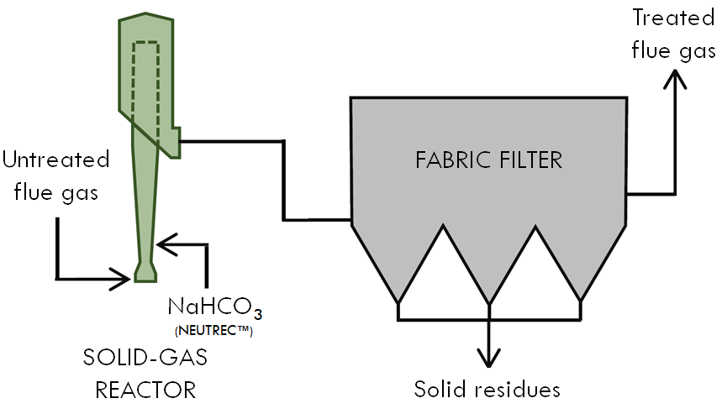
Figure 1: Scheme of the selected DTS with sodium bicarbonate injection.
A DTS of a WtE plant located in Northern Italy was taken as case study for the application of PLS regression. The selected DTS, sketched in Figure 1, is based on the injection of powdered sodium bicarbonate (NaHCO₃), which is one of the most common reactants adopted for dry acid gas treatment (Dal Pozzo et al., 2019b; Tsubouchi et al., 2020). With reference to HCl capture, the overall neutralisation reaction is the following:
${NaHCO}_{3}+HCl=NaCl+H_{2}O+{CO}_{2}$ (6)
The DTS receives the raw flue gas coming from the combustion chamber. The feed rate of bicarbonate injected in the unit is regulated by a feedback loop whose controlled variable is the combined outlet mass flow of HCl and SO₂. The injected bicarbonate undergoes a mean residence time of 2 s inside a contacting tower and then adheres on the filter bags of the downstream fabric filter. Here, bicarbonate continues reacting as part of a reactant filter cake until the bags are cleansed by periodic pulse jet cleaning. As such, the system is continuous for the gaseous acid pollutants and semi-batch for the solid reactant.
  - Available measures and choice of dataset
Table 1 lists the relevant process variables that are continuously measured in the DTS of Fig. 1. FTIR spectrometers positioned upstream and downstream of the DTS monitor flue gas composition (concentrations of HCl, SO₂, H₂O, CO₂ and O₂). Temperature and flow rate of the inlet flue gas are also measured, allowing to convert the measured concentrations of gas species into molar flows. In addition, the system registers the bicarbonate feed rate and the pressure drop at the fabric filter, which is a proxy measurement of the accumulation of solids on the filter bags. The variables in Table 1 are acquired with a frequency of 1/min. In the present study, all these variables were used as predictors of system performance. For the bicarbonate feed rate, instead of the instantaneous measurement, a cumulated feed rate on a 15-min timespan was considered. This approach allowed taking into account the contribution to acid gas removal given by the reactant cake accumulated on the fabric filter.
The outlet molar flow rate of HCl was chosen as estimator of system performance, i.e. the predicted variable Y in eq. 5. It should be noted that the PLS method does not have any co-domain restriction, i.e. the outlet molar flow rate of HCl can assume any value. A physical constraint was introduced by imposing that the predicted value of outlet HCl molar flow rate n_{HCl,out} must lie in the interval [0, n_{HCl in}].
The considered dataset of measurements covered two weeks of DTS operation. This dataset was divided into three subsets, aimed respectively at the training of the model (training set), the determination of its structure (cross-validation set) and its final performance validation (validation set). Each subset gives a complete and equivalent representation of the system behaviour.
Table 1: Original variables measured in the DTS and their use as predictors and performance estimators.
Variable | Flue gas flow rate | Flue gas  T | n_{HCl,in} | n_{SO2,in} | y_{CO2,in} | y_{H2O,in} | NaHCO₃ feed rate | ΔP at fabric filter | n_{HCl,out}
U.M. | Nm³/h | °C | kmol/h | kmol/h | vol% | vol% | kmol/h | mbar | kmol/h
Time resolution | 1/min | 1/min | 1/min | 1/min | 1/min | 1/min | 1/min | 1/min | 1/min
Predictor
Performance estimator
- Results and discussion
Starting from the previously assembled datasets, it was possible to obtain a PLS model that allows: i) a characterisation of the influence of the original variables on the system behaviour, and ii) the prediction of system performance. By the application of the LVs technique, the initial number of 8 original predictors in Table 1 was reduced to a variable space of 3 dimensions, retaining most of their predicting capability. In other words, given the existing mutual correlations between the original variables and the minor role of some of them in determining system performance, the predictor dataset could be reduced to just 3 latent variables, used as final features of the PLS model (see eq. 5).
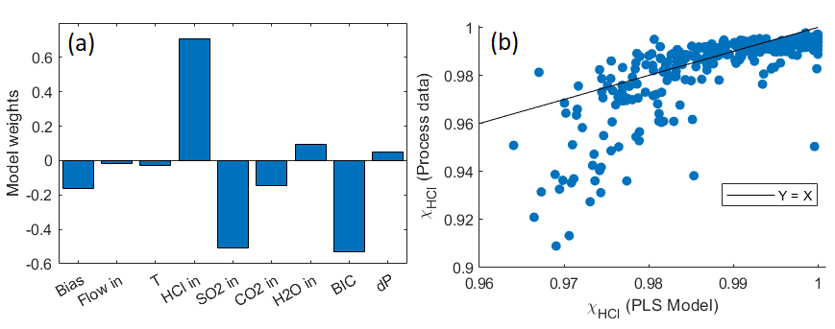
Figure 2: a) PLS weights referred to the original predictive variables, b) parity plot of HCl conversion.
Figure 2a shows the final PLS weights of each original variable in the 3-feature PLS model. In addition to the bias term, only three variables appear to have a significant influence on the outlet HCl molar flow. A positive contribution means that an increase in the predictor translates into an increase of outlet HCl, while a negative contribution is an indicator of an inverse correlation between predictor and outlet HCl. Clearly enough, the strong positive contribution of the inlet HCl molar flow, as well as the strong negative contribution of the bicarbonate feed rate, are expected given the neutralisation reaction (eq. 6). Less expected is the strong negative contribution of the inlet SO₂ molar flow, i.e. the fact that a high SO₂ load entering the system is correlated to a low HCl outlet flow. This effect has to be ascribed indirectly to the control system, which increases the amount of injected bicarbonate also when an increase of outlet SO₂ is observed, as mentioned in section 3.1. Bicarbonate as a sorbent has a higher reactivity towards HCl than SO₂ (Dal Pozzo et al., 2019b), hence the excess feed rate induced by the latter generates a relevant abatement of the former. The contributions of the remaining variables are relatively negligible: their dynamic variation is modest and does not significantly influence HCl capture.
The PLS model was obtained from eq. 5 with the PLS weights of Fig. 2a. The verification of its performance in predicting DTS behaviour was tested against process data collected in the validation dataset. Fig. 2b shows the parity plot of HCl conversion (X_{HCl}). The comparison of model predictions against process data (each dot is the average HCl conversion over 20 min) demonstrates a satisfactory performance for HCl conversions > 98%, while for lower values the model tends to overestimate the real HCl conversion. This can be also seen in the time series of outlet HCl molar flow rate shown in Fig. 3a, where the model fits satisfactorily the typical range of outlet HCl molar flow rate (0.01-0.06 kmol/h) but fails to predict sudden peaks of HCl breakthrough. This phenomenon is likely due to intrinsic inability of a linear model such as PLS to approximate effectively on a wide range of HCl loads the non-linear relation between bicarbonate feed and HCl conversion (Dal Pozzo et al., 2018b).
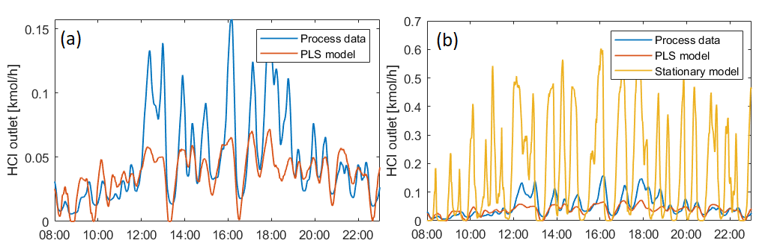
Figure 3: time series of outlet HCl molar flow: a) process data vs. PLS model, b) process data vs. PLS model and stationary model.
Nonetheless, to put things into perspective, in Fig. 3b the predictive performance of the PLS model is compared to the results obtained by fitting the process data with a stationary operational model. The chosen stationary model, proposed in Dal Pozzo et al. (2018c), has the following formulation:
$$X_{HCl}=\frac{{SR}^{n}-SR}{{SR}^{n}-1}\left(1-X_{F}\right)+X_{F}$$ | (3)
where SR is the stoichiometric ratio of bicarbonate feed, while n and X_{F} are two fitting parameters accounting for the acid gas removal contributions of the reaction tower and the filter cake, respectively. By design, this simplified model takes into account the non-linearity of acid gas removal and, once calibrated on the plant data, it has been proven capable of providing a satisfactory simulation of average DTS behaviour, more than sufficient for process optimisation purposes (Dal Pozzo et al., 2018c). Here, it is shown that, when applied to the dynamic simulation of HCl removal at high time resolution (Fig. 3b), this non-linear stationary model is way less capable of handling the fluctuations of operating conditions than the linear PLS model. Thus, the performance of the PLS model, albeit lacking when the system deviates significantly from normal operation, represent a clear improvement compared to stationary model in view of monitoring and control applications.
  - Conclusion
The present study explored the potential of a chemometric approach to the modelling of HCl removal in WtE plants, an industrial operation characterised by highly fluctuating operating conditions and the possible influence of several variables on the instantaneous HCl removal efficiency. Latent variable techniques allowed considering the large amount of data made available by the plant instrumentation, while at the same time reducing the complexity of the system variable structure. PLS regression proved to be a useful tool for the modelling of the HCl abatement system, coupling the interpretability of the model (i.e. the study of the influence of the different variables on the final model outcome) with a decent performance in predicting instantaneous HCl conversion. The PLS approach represents a step forward towards the dynamic modelling of such systems if compared to the pseudo-stationary models available in literature. Yet, the inability of the PLS model, linear by nature, to reproduce specific non-linear features of the system does not allow the final prediction performance to be acceptable for a reliable implementation e.g. in model-based control strategies. A necessary follow-up will be the use of more advanced PLS variants that allow introducing non-linearity in the model.
References
Antonioni, G., Dal Pozzo, A., Guglielmi, D., Tugnoli, A., Cozzani, V., 2016, Enhanced modelling of heterogeneous gas–solid reactions in acid gas removal dry processes, Chem. Eng. Sci. 148, 140-154.
Blasenbauer, D., Huber, F., Lederer, J., (...), Wégner, K., Fellner, J., 2020, Legal situation and current practice of waste incineration bottom ash utilisation in Europe, Waste Manage. 102, 868-883.
Chisholm, P.N., Rochelle, G.T., 1999, Dry absorption of HCl and SO2 with hydrated lime from humidified flue gas, Ind. Eng. Chem. Res. 38 (10), 4068–4080.
Dal Pozzo, A., Antonioni, G., Guglielmi, D., Stramigioli, C., Cozzani, V., 2016, Comparison of alternative flue gas dry treatment technologies in waste-to-energy processes, Waste Manage. 51, 81-90.
Dal Pozzo, A., Armutlulu, A., Rekhtina M., Müller C.R., Cozzani V., 2018a, CO2 Uptake Potential of Ca-Based Air Pollution Control Residues over Repeated Carbonation–Calcination Cycles, Energy Fuels 32 (4), 5386-5395.
Dal Pozzo, A., Guglielmi, D., Antonioni, G., Tugnoli, A., 2018b, Environmental and economic performance assessment of alternative acid gas removal technologies for waste-to-energy plants, Sustainable Prod. Consumption 16, 202– 215.
Dal Pozzo, A., Giannella, M., Antonioni, G., Cozzani, V., 2018c, Optimization of the Economic and Environmental Profile of HCl Removal in a Municipal Solid Waste Incinerator through Historical Data Analysis, Chem. Eng. Trans. 67, 463-468.
Dal Pozzo, A., Carabba, L., Bignozzi, M.C., Tugnoli, A., 2019a, Life cycle assessment of a geopolymer mixture for fireproofing applications, Int. J. Life Cycle Assess. 24, 1743-1757.
Dal Pozzo, A., Moricone, R., Tugnoli, A., Cozzani. V., 2019b, Experimental Investigation of the Reactivity of Sodium Bicarbonate toward Hydrogen Chloride and Sulfur Dioxide at Low Temperatures, Ind. Eng. Chem. Res. 58 (16), 6316-6324.
Dal Pozzo, A., Lazazzara, L., Antonioni, G., Cozzani, V., 2020, Techno-economic performance of HCl and SO2 removal in waste-to-energy plants by furnace direct sorbent injection, J. Hazard. Mater. 394, 122518.
Faber, N.M., Rajko, R., 2007, How to avoid over-fitting in multivariate calibration—The conventional validation approach and an alternative, Anal. Chim. Acta 595, 98-106.
Foo, R., Berger, R., Heiszwolf, J.J., 2016, Reaction Kinetic Modeling of DSI for MATS Compliance, In Proceedings of the Power Plant Pollutant Control and Carbon Management “MEGA” Symposium, Baltimore, MD, USA, 16–19 August 2016
Harriott, P., 1990, A Simple Model for SO2 Removal in the Duct Injection Process, J. Air Waste Manage. Assoc. 40, 998-1003.
Margraf, R., 2015, Simple and Effective – the Conditioned Dry Sorption Process for Flue Gas Treatment Downstream Waste Incinerators, in: Waste Management, Thomé-Kozmiensky, K. J., Thiel, S., Eds.; TK Verlag: Neuruppin, Germany, 2015; Vol. 5, pp 253– 267.
Tsubouchi, N., Matsuoka, N., Fukuyama, K., Mochizuki, Y., 2020, Removal of hydrogen chloride gas using honeycomb-supported natural soda ash, Chem. Eng. Res. Des. 156, 138-145.
Vehlow, J., 2015, Air pollution control systems in WtE units: An overview, Waste Manage. 37, 58-74.
Wise, B.M., Gallagher, N.B., 1995, The Process Chemometrics Approach to Process Monitoring and Fault Detection, IFAC Proceedings Volumes 28 (12), 1-21.
Wold, S., Sjostrom, M., Eriksson, L., 2001, PLS regression: A basic tool of chemometrics, Chemom. Intell. Lab. Syst. 58, 109-130.
Zhang, H., Yu, S., Shao, L., He, P., 2019, Estimating source strengths of HCl and SO2 emissions in the flue gas from waste incineration, J. Environ. Sci. 75, 370-377.

