CHEMICAL ENGINEERING TRANSACTIONS  VOL. 82, 2020 | A publication of
The Italian Association
of Chemical Engineering
Online at www.cetjournal.it
Guest Editors: Bruno Fabiano, Valerio Cozzani, Genserik Reniers
Copyright © 2020, AIDIC Servizi S.r.l.
ISBN 978-88-95608-80-8; ISSN 2283-9216

Safety in (Petro)Chemical Clusters and Stand-Alone Companies
Karolien van Nunen^{a,}*, Paul Swusteª, Genserik Reniersª, Peter Schmitz^{b}
ª Safety and Security Science Group, Technical University of Delft, Jaffalaan 5, 2628 BX Delft, The Netherlands
^{b} OCI-Nitrogen, Urmonderbaan 22, 6167 RD, Geleen, The Netherlands
K.L.L.vannunen@tudelft.nl
In The Netherlands, there are six large (petro)chemical clusters. Companies in these clusters are located next or close to each other. The policy of the Dutch government is to invest in these clusters, and to stimulate their growth. However, there is little scientific evidence that a cluster of (petro)chemical companies is safer than stand-alone (petro)chemical companies. This research, with an exploratory design, investigates parameters influencing safety of (petro)chemical clusters and stand-alone (petro)chemical companies. Insight into these parameters can lead to targeted initiatives (e.g. by government and companies) to improve safety in both clusters and stand-alone companies. Stimulating cooperation and sharing of knowledge is an important parameter, both in clusters and between clusters, and with non-clustered companies. Information exchange on accident scenarios between adjacent (petro)chemical companies with and without domino-designation requires extra attention. An overarching cluster body can contribute to a more safe, proactive and strategic cooperation. Furthermore, it is important that cluster policies include more than only spatial planning and external safety. Also after the establishment of clusters, companies should not be treated as individual companies, but as companies being part of a cluster, for instance when inspections are performed. Attention is needed for both domino- and escalation-effects, and possible domino-effects with (petro)chemical companies in clusters (just) below the Seveso-threshold. Integrated plants falling under the management of different companies require an adjusted approach to optimise safety.
  - Introduction
In The Netherlands, there are six large (petro)chemical clusters. A (petro)chemical cluster is a geographically demarcated area in which several Seveso companies (Directive 2012/18/EU) are located next or close to each other. In this area, also non-Seveso companies can be located. The geographic demarcation implies the possibility of direct effects between the different companies due to process-related incidents (fire, explosion, toxic release). The cooperation between these companies can vary from no cooperation to intense cooperation.
In 2016, The Netherlands started the program ‘Sustainable Safety 2030’, a cooperation between industry, science and government to improve safety in existing (petro)chemical companies. The policy of the Dutch government is to invest in these clusters, and to stimulate their growth. However, there is little scientific evidence that a cluster of (petro)chemical companies is safer than stand-alone (petro)chemical companies. This research, with an exploratory design, aims at identifying parameters influencing safety of (petro)chemical clusters and stand-alone (petro)chemical companies. Insight into these parameters can lead to targeted initiatives (e.g. by government and companies) to improve safety in both clusters and stand-alone companies. Following research questions are answered:
- What are worst-credible accident scenarios for clustered companies, and what are worst-credible accident scenarios for stand-alone companies?
- Which parameters influence these worst-credible accident scenarios, both in clustered companies and in stand-alone companies?
  - Methodology
This explorative study is based on a multi-method design:
- A literature study of relevant scientific and grey literature
- 67 semi-structured interviews with both experts associated to (petro)chemical clusters and experts associated to stand-alone (petro)chemical companies
- Analysis from relevant documents and data provided by the interviewed experts
- A questionnaire (n=11) conducted with inspecting Seveso services. The respondents had to meet the criteria that they inspect both (petro)chemical clusters and stand-alone companies.
The study identifies parameters influencing safety in a qualitative way. The exploratory nature of the study does not allow a quantitative comparison, nor a judgement on safety levels of clusters and stand-alone companies.
For the identification of worst-credible accident scenarios, the bow-tie metaphor is used (Figure 1). The bow-tie metaphor illustrates an accident process, starting with a hazard on the left-hand side. A hazard (or energy) is a source or a condition with the potential for causing harm. Various accident scenarios, pictured as left-right arrows, can migrate to the centre point of the metaphor, the central event. This central event represents a state where the hazard (energy) has become uncontrollable and, thus, becomes an undesirable event with a potential for harm or damage. The central event proceeds to the consequences at the right-hand side of the metaphor, such as causing harm to people or damage to assets or environment (Swuste et al., 2016, van Nunen et al., 2018).
  - Results
    - Worst-credible accident scenarios
There is no difference in worst-credible scenarios at the left-hand side of the bow-tie between clusters and stand-alone companies, nor at the level of possible central events (Figure 1).
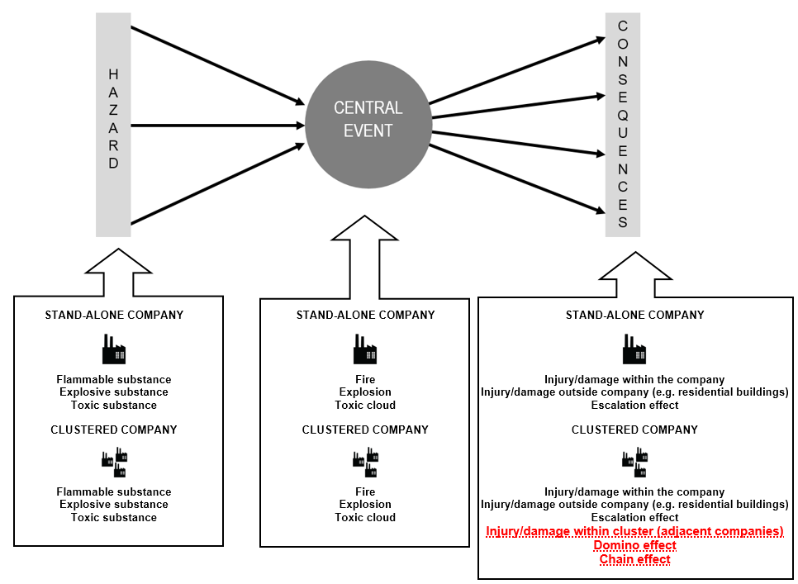
Figure 1: Worst-credible accident scenarios in (petro)chemical clusters and stand-alone companies
For both clusters and stand-alone (petro)chemical companies, worst-credible central events are fire, explosion, or toxic releases. The hazards preceding these central events are – in both clusters and stand-alone (petro)chemical companies – the presence of flammable, explosive, or toxic chemicals (ILO, 1988, Khan, 2001, Cozzani et al., 2007, Reniers, 2009, Salzano et al., 2012). Important differences are present at the right-hand side of the bow-tie, i.e. at the level of consequences. In both clustered and non-clustered companies, following consequences can be identified: injuries/damage within the own company, injuries of residents and damage at their buildings, and escalation effects where an accident scenario in one company leads to another accident scenario in the same company. In a clustered company, additional possible consequences can be identified:
- Injury/damage in the adjacent companies being part of the cluster: for instance, a toxic release in one company can lead to injury of employees of an adjacent company, or an explosion in one company can lead to damage of an adjacent company
- Domino effects: a domino effect is an accident scenario in one company leading to another accident scenario in another company. A domino effect can only occur in clustered companies (Abdolhamidzadeh et al., 2011, Darba et al., 2010, Swuste et al., 2019). This is in contrast to an escalation effect, which is an accident scenario in one company that leads to another accident scenario in the same company. Escalation effects can occur in both stand-alone companies, as in companies being part of a cluster.
- Chain effects on the level of shared utilities and/or shared streams of products: in a cluster, several companies can be intertwined. Adjacent companies can make use of the same utilities such as electricity, water or steam. Also, adjacent companies can make use of each other streams of products. This dependency can initiate chain effects: when one company experiences problems with their processes, other companies relying on these processes can also experience problems, and can eventually lead to a shut-down of multiple companies. The same applies for shared utilities, where problems can lead to the shut-down of multiple companies. Chain effects do not always lead to negative safety consequences. The speed with which a company can or must shut-down plays an important role in possible negative safety consequences. Also, the shut-down and start-up of (petro)chemical companies always leads to higher safety risks.
    - Influencing safety parameters
In the next step, parameters influencing these worst-credible accident scenarios were identified and compared. By ‘influencing’ is meant to what extent an unwanted central event (fire, explosion, toxic release) can be prevented and to what extent negative consequences can be mitigated when a central event does occur.
3.2.1 Cooperation and knowledge sharing
Cooperation and knowledge sharing can lead to a higher quality and professionalism of safety measures. There are several factors that stimulate cooperation within (petro)chemical companies. The geographical proximity makes it often easier for clustered companies to cooperate compared to companies without neighbouring companies. That is why the latter group should be additionally encouraged to form partnerships. Also, within clusters, so-called ‘trusted communities’ are often easier to accomplish due to the geographical proximity. In addition, ‘peer pressure’ where several companies encourage and control each other to achieve certain safety standards, is more easily established within clusters. After all, the decisions of one company could affect the safety of other companies within the same cluster.
Several factors within clusters could also inhibit cooperation. Especially when the dependency and intertwines between companies is limited, possible safety profit due to cooperation could not always be clear. Also sharing the costs for collective cluster initiatives could be difficult, definitely when some companies profit more from the initiative than other companies. Cooperation within clusters could also lead to a loss of autonomy of individual companies, or to conflicting business operations (definitely when the business operations are imposed from the mother company). Partnerships could also lead to difficulties in realising changes, and can cause delays in the decision-making processes. These possible inhibiting factors should be taken into account when stimulating companies to increase their cooperation and knowledge sharing.
Specific characteristics of a cluster could lead to a more difficult establishment of cooperation and knowledge sharing, such as:
- Cluster not originating from one company
- Clusters where the different companies are to a lesser extent connected and interdependent
- Clusters not located within a clearly demarcated area, in particular clusters not surrounded by a fence, and clusters where the geographical dispersion is larger
- Clusters with companies with large differences in processes or used chemicals; the possible safety profit could be less clear
- Clusters with companies with large similarities in processes or used chemicals; the companies could see each other as possible competitors
- Clusters with companies wanting to keep full autonomy, for instance under the influence of the mother company
There are additional points of attention regarding cooperation within clusters. Clear agreements regarding shared responsibilities should be made to avoid ambiguity and to make sure that no responsibilities are abdicated. Furthermore, it is not always possible to oblige companies to participate in a partnership. The non-participation or partial participation of cluster companies in joint initiatives could however lead to an increased complexity or (safety) problems. An overarching cluster-body can contribute to secure the responsibilities of all companies being part of a cluster. Finally, not only cooperation within clusters, but also between clusters is important to allow a critical reflection from outside the cluster.
3.2.2 Exchanging information on accident scenarios
This influencing safety parameter is mostly relevant for adjacent companies, or in other words, companies that can experience direct effects or consequences from each other’s accident scenarios. In the Seveso legislation, companies with a domino-designation are obliged to exchange information on possible accident scenarios. The specific implementation of the Seveso legislation has important practical implications. In the Seveso legislation, the term ‘establishment’ is used. It could be that different companies – with all a different business operation and safety management system – are part of the same establishment. However, a domino-designation is only possible between different establishments, and not between different companies of the same establishment. When there is no domino-designation, there is no obligation to exchange information on accident scenarios. There are however arguments to stimulate information exchange between adjacent companies without domino-designation:
- Also without domino-designation, Seveso companies can encounter direct effects or consequences from each other’s accident scenarios
- Direct effects or consequences from accident scenarios can also take place between adjacent (petro)chemical companies without a Seveso status
The results show that there is limited knowledge on accident scenarios from adjacent companies, even when there is a domino-designation. In the latter, the information exchange is mostly on paper and superficial. Also, it could be questioned if solely exchanging information on accident scenarios is sufficient. Actual cooperation, for instance a mutual risk analysis, could raise the safety level of adjacent companies to a higher level.
3.2.3 Influencing safety parameters at the left-hand side of the bow-tie
The results show that joint cluster initiatives are mostly situated at the right-hand side of the bow-tie, so after the central event has occurred: joint fire department, joint emergency plan, mutual alarm in case of incidents, agreements on sharing shelters,… These are, in other words, reactive measures. Joint initiatives at the left-hand side of the bow-tie, the proactive measures, remain too limited:
- Exchanging information is mostly incident-driven. At the front of the bow-tie, i.e. knowledge on each other’s processes, risks, accident scenarios, this information exchange is more limited.
- Possible accident scenarios are compiled by individual companies. When compiling these scenarios, little or no attention is paid to hazards, possible central events and possible consequences originating from adjacent companies. Some of the possible accident scenarios are consequently not taken into account, and no measures on preventing or mitigating these scenarios are taken.
- Risk analysis and threat analysis are not performed jointly, for instance with mixed teams from multiple companies.
- Safety audits are performed internally. Mutual audits between companies could create an added value.
- Cooperation regarding inspection and maintenance is rather limited.
- Regarding domino effects, measures are mostly situated to mitigate domino effects. Few measures are taken to prevent domino effects.
Not only are joint cluster initiatives mostly reactive, and to a lesser extent proactive, they are also mostly situated at an operational level. Cooperation on a strategic and tactical level is limited. However, a proactive, strategic and tactical focus is as least important as a reactive and operational focus.
3.2.4 Compliance with laws and regulations
Many laws and regulations are composed with the aim of improving the safety from organisations. In that sense, laws and regulations can act as an influencing safety parameter within clustered and stand-alone companies. However, the implementation of laws and regulations does not always lead to an actual or optimal safety improvement:
- Thresholds for Seveso companies: Seveso companies are obliged to take extra safety measures due to their potential for severe accidents with chemical substances. Companies falling just below the Seveso-threshold, are not obliged to take these extra safety measures. These so-called risk-relevant companies also have the potential for severe accidents with chemical substances, and have to follow other safety regulations. However, safety measures to prevent or mitigate possible domino effects are not legally enforceable for companies just below the Seveso-threshold. The same applies for companies of which their Seveso status expires because of the outsourcing of certain activities to adjacent companies.
- Inspection and enforcement and their focus on individual companies: many provinces in The Netherlands have designated the clustering of activities with a potential for severe accidents as a provincial interest. In this cluster policy, certain areas are foreseen for the establishment of heavy industry and high-risk companies. This cluster policy aims at increasing the external safety, where all high-risk companies are located in one area, and where the rest of the (residential) environment is relieved on this matter. It should be noted that this cluster policy is mainly focused at external safety, where the safety outside the cluster is increased, but not necessarily the safety within the cluster (where also often non-Seveso companies are located). An important paradox is noticed. As a government, there is chosen to cluster high-risk companies and concentrate the risk. After establishing these clusters, the cluster-approach is completely abandoned: during inspection and enforcement, there is only focused on individual companies, and not on companies as being part of a cluster.
It can be concluded that complying with laws and regulations can act as a parameter to influence accident scenarios, but only if important shortcomings are being acknowledged and overcome.
3.2.5 Measures for integrated companies
As mentioned above, there are clusters where companies are intertwined by means of shared utilities or product streams. When different companies are integrated with each other, it is important that extra safety measures are taken. Clear agreements should be made on measures to be taken when shared systems fail, for instance on the order of shutting down companies.
When companies are designed with an integration in mind, interfaces are most of the times clearly mapped, and failure analyses are present. This could be different when a company decides to outsource an entire installation or a part of an installation to a different adjacent company. These companies are not designed with this integration in mind, and therefore extra safety measures are needed. Clear agreements should be made on responsibilities regarding for instance maintenance of specific parts.
  - Conclusions
In this study, important differences regarding safety, and more specifically regarding worst-credible accident scenarios, between (petro)chemical clusters and stand-alone companies were identified. Important differences are present at the right-hand side of the bow-tie, i.e. at the level of the consequences. In both clustered and non-clustered companies, following consequences can be identified: injuries/damage within the own company, injuries of residents and damage at their buildings, and escalation effects where an accident scenario in one company leads to another accident scenario in the same company. In a clustered company, additional possible consequences can be identified: injury/damage in the adjacent companies being part of the cluster, domino-effects where an accident scenario in one company leads to another accident scenario in another company, and chain effects on the level of shared utilities and/or shared product streams.
Subsequently, parameters influencing these worst-credible accident scenarios, both in clustered companies and in stand-alone companies are identified. The most important parameters are: cooperation and knowledge sharing, exchanging information on accident scenarios, safety parameters at the left-hand side of the bow-tie, compliance with laws and regulations, and measures for integrated companies. Insight into these influencing parameters can lead to targeted initiatives to improve safety in both clusters and stand-alone companies.
Several recommendations are formulated. Some of the recommendations focus specifically at clusters, some specifically at stand-alone companies, and some at both clusters and stand-alone companies.
- Stimulating cooperation and sharing knowledge in clusters: in clusters, safety profit is possible when the different companies do not operate as stand-alone companies. However, many factors can influence this cooperation and knowledge sharing. Extra incentives to establish or improve cooperation and knowledge sharing could be needed for specific types of clusters, such as clusters not originating from one company or clusters with a larger geographical dispersion. Different characteristics of clusters will require other incentives.
- Regarding the cooperation and sharing knowledge in chemical clusters, ‘openness is closedness’ is very important. When ‘trusted communities’ are established, transparency between companies can be increased, without the negative side-effect that this transparency can be misused in the context of security.
- Stimulating cooperation and sharing knowledge between clusters. A tunnel vision within a cluster can be prevented by cooperating with companies from outside the own cluster.
- Stimulating cooperation and sharing knowledge between non-clustered companies: due to the geographical proximity of companies within a cluster, partnerships are often easier to establish compared to stand-alone companies. That is precisely why the latter group should additionally be encouraged to form partnerships with other companies.
- Stimulating and improving information exchange on accident scenarios: this exchanging of information should be stimulated and improved between adjacent (petro)chemical companies, regardless whether there is a domino-designation based on the Seveso legislation.
- To a more proactive and strategic cooperation between clusters: current information exchange is mainly incident-driven, and joint initiatives mostly focus on mitigation, rather than focussing on proactive measures to prevent central events. A more proactive cooperation on a strategic and tactical level should be stimulated. For instance, joint risk analysis, mutual safety audits, and cooperation regarding inspection and maintenance.
- An overarching cluster-body: a central management of different companies geographically located close to each other could overcome some of the challenges deriving from a cluster. An overarching cluster-body could guard that all decision and executive mandates are fixed, and that responsibilities are clear to all parties.
- A cluster policy should include more than only spatial planning and external safety: also after the establishment of clusters, the cluster-approach should be maintained. Companies being part of a cluster should not be treated as individual companies, but as companies being part of a cluster (for instance when inspections are performed). It should be noted that current law and regulation is not adjusted to this approach.
- Integrated plants falling under the management of different companies require an adjusted approach to optimise safety: when different companies are integrated with each other, it is important that extra safety measures are taken and that clear agreements are made.
Acknowledgments
This study is subsidised by the Dutch Ministry of Infrastructure and Water Management.
References
Abdolhamidzadeh, B., Abbasi, T., Rashtchian, D., Abbasi, S., 2011. Domino effect in process-industry accidents. An inventory of past events and identification of some patterns. Journal of Loss Prevention in the Process Industries 24, 575-593.
Cozzani, V., Tugnoli, A., Salzano, E., 2007. Prevention of domino effects: From active and passive strategies to inherent safer design. Journal of Hazardous Materials A139: 209-219.
Darbra, R., Palacios, A., Casal, J., 2010. Domino effects in chemical accidents: main features and accident sequences. Journal of Hazardous Materials 183, 565-573.
Directive 2012/18/EU of the European Parliament and of the Council of 4 July 2012 on the control of major-accident hazards involving dangerous substances.
International Labour Office, 1988. Major Hazard Control – A practical manual. International Labour Office, Geneva.
Khan, F., 2001. Use maximum-credible accident scenarios for realistic and reliable risk assessment. CEP Magazine November 2001: 56-64.
Reniers G., 2009. Multi-Plant Safety and Security Management in the Chemical and Process Industries, Wiley-VCH, Germany.
Salzano, E., Cozzani, V., 2012. Introducing external hazard factors in quantitative risk analysis. Revista de Ingeniería, Universidad de los Andes. Bogotá D.C., p. 50-56.
Swuste P., Theunissen J., Schmitz P., Reniers G., Blokland P., 2016. Process safety indicators, a review of literature, Journal of Loss Prevention in the Process Industries 40, 162-173.
Swuste P., van Nunen K., Reniers G., Khakzad N., 2019. Domino-effects in chemical factories and clusters: An historical perspective and discussion, Process Safety and Environmental Protection 124, 18-30.
van Nunen K., Swuste P., Reniers G., Paltrinieri N., Aneziris O., Ponnet K., 2018. Improving pallet mover safety in the manufacturing industry: A bow-tie analysis of accident scenarios. Materials 11, 1955, doi:10.3390/ma11101955

