|  |  |
| --- | --- |
| cetlogo ***CHEMICAL ENGINEERING TRANSACTIONS***  ***VOL. 82, 2020*** | A publication of  aidiclogo_grande |
| The Italian Association  of Chemical Engineering  Online at www.cetjournal.it |
| Guest Editors: Bruno Fabiano, Valerio Cozzani, Genserik Reniers  Copyright © 2020, AIDIC Servizi S.r.l. **ISBN** 978-88-95608-80-8; **ISSN** 2283-9216 | |

Miniaturization and Optimization of the Standard Spectrophotometric Analysis for Autonomous, Continuous and On-site Heavy Metal Detection in Water

Matteo Manachino\*, Monica Periolatto, Felice Catania, Luciano Scaltrito, Fabrizio Pirri, Sergio Ferrero

Politecnico di Torino – DISAT, C.so Duca degli Abruzzi, 24 10129 Torino (Italy)

matteo.manchino@polito.it

Water environmental monitoring is an important key to control both human life and environment health. When water quality is poor, it affects not only aquatic life but the surrounding ecosystem as well. The greatest limitation of detection devices, today on the market, is that they are limited to the measurement phase, burdening the operator of the previous sample treatment.

The development of a threshold monitoring device, designed for real time water environmental monitoring, was the aim of this study. The focus was on the design of an autonomous system for detection of dissolved heavy metals in water by spectrophotometric analysis. The ground-breaking idea is the implementation of a system inspired to the latest innovative techniques in the field of the microfluidic analysis, based on Lab-on-Chip concept. Such a choice is due to the unique advantages in terms of reduction of sample and reagents volumes, energy budget and analysis times, besides the possible multi-element analysis on the same sample.

* 1. Introduction

Water quality is the basis of all the economic and social systems. The pollution of marine, river and all surface waters is impacting worldwide, and has reached an important resonance in the last few decades. (Wang et al., 2017) The disturbance of ecosystems mainly affects flora and fauna, altering the life of many organisms and leading to the extinction of others. It is clear that these aspects have a striking impact on the life of the human being and on the large-scale economy. Surface water, ground water and drinkable water are currently monitored in all countries on a very large scale, driving both economic and political critical choices (Beck et al., 2010). Serious global health concerns are in particular due to the build-up of heavy metals and metalloids in soils and waters, as these metals and metalloids cannot be degraded into non-toxic forms but persist in the ecosystem. Due to these reasons, there is an interest in the development of specific analytical procedures to measure metal ions in water samples.

The aim of this study was the optimization of the standard detection method for metal ions, based on spectrophotometry, to be suitable for miniaturized and portable devices, for on site, real time monitoring systems. Chromium (VI), Zinc, Copper and Nickel were considered as first target pollutants.The permissible limits of these heavy metals in water, as recommended by WHO International Standards, were considered for the test. In detail: 0.05 ppm for Cr(VI), 5 ppm for Zn, 1.3 ppm for Cu and 0.1 ppm for Ni.Main process parameters were individually optimized, to be suitable for a miniaturized and portable device, for real time monitoring system, starting from the standard methods reported in literature. The optimized values were merged to test any possible mutual effects. Test were then moved on a bench prototype, to confirm laboratory results and finally the prototype device was embedded in a portable case for testing and validation in its final asset.

Among a previous research (Periolatto et al., 2019), preliminary test on the field were carried out in Mediterranean sea, near Genova commercial port (Italy), on a similar device mounted on an AUV, with wireless control and data transfer, obtaining promising results in terms of sample managing and online collection of results. Similar test are planned for the portable device and analogous results are expected.

* 1. Materials and Methods

The research work reports results related to the fabrication of a microfluidic-based prototype device, aimed to be embedded in a portable carrying case, detecting continuously, in real time, the presence and concentration of metal ions in water.

The method is based on the spectrophotometric analysis of the samples, added with proper ligands making different colored complexes, for determination of the investigated metal ions. These complexes can be determined by ultraviolet and visible (UV/Vis) spectrophotometer, detecting their absorbance at different wavelengths, and in particular at the peak of absorbance (λ max).

* + 1. Laboratory test

A standard method was retrieved from literature for each metal investigated, namely Chromium (VI), Zinc, Copper and Nickel.

1,5 Diphenylcarbazide (DFC) method is normally used for determining hexavalent chromium in drinking and surface waters, domestic and industrial wastes, in the concentration range from 0.1 mg/L to 1.0 mg/L of Cr(VI) (Pesavento et al., 2009) It is based on the reduction, in strong acid solution, of Cr(VI) to Cr(III) by reaction with 1.5 diphenylcarbazide oxidized to 1.5 diphenylcarbazone. 1.5 diphenylcarbazone yields a characteristic reddish-purple color, with an absorption maximum at about 540 nm, proportional to Cr(VI) concentration according the well-known Lambert & Beer law.

Zincon standard method, as reported in literature, was indeed considered as reference for detection of Zinc, Copper and Nickel at the recommended conditions. It mainly means the pH control by buffering and addition of suitable amounts of the required reactants (Fries and Getrost, 1975). Each metal ion is complexed by Zincon in a different way, giving rise of characteristic adsorption peaks, at different wavelengths on the visible spectrum, between 600 and 650nm. (Kocyla et al., 2017)

Starting from it, the parameters of interest for the following process miniaturization and automation were optimized, at laboratory scale, by exhaustiveinvestigations on the influence of each measurement parameter on the measurement itself.

Laboratory test were carried out on heavy metal solutions with concentration of interest, that is between 10 ppm and 5 ppb, prepared by proper dilution with distilled water of standard 1000 ppm solutions of each ion (Sigma Aldrich).A 35g/L sodium chloride solution, miming the Mediterranean Sea salinity, was also prepared and used for some test.

Zincon sodium salt and 1,5 Diphenylcarbazide were both purchased by Sigma Aldrich while other laboratory grade reagents were sulphuric acid 98%, sodium hydroxide, acetone, methanol, ethanol and standard buffer solutions, all by Sigma Aldrich.

Many parameters of interest for method optimization, according to the restrictions imposed by miniaturization, were investigated. First the measure linearity considering a wavelength other than the absorbance peak of the metal complex. In fact, a single wavelength emitting laser diode was chosen for the prototype, because of its energy-efficiency, its low price and its portability, but not all the wavelength are available as laser source. Then rinsing of cuvettes and tubes, between following test, was considered, in order to highlight its effect on consecutive measures of samples with different metal concentration and to optimize the automation of the rinse phase in automatic measurement cycle. The amount of reagents in the sample, to assess the dose tolerance for dosing phases during the automatic measurement cycle, and the influence of rest time and mixing on color development are other parameters of interest. Finally, solvents for reagents, taking in account both the complete and rapid solute dissolution and the compatibility with plastic tubes and components on the final prototype, aging and stability over time ofreagents and their solutions.

The influence of the variation of each parameter was evaluated considering the linearity of the calibration curve or the deviation in results obtained on the same sample: if R2was higher than 0.9 and the deviation was lower than 5%, the effect was considered negligible, considering the human error in the preparation of samples at laboratory scale. Narrow acceptable limits were assumed for test on the automatic prototype.

The limit of detectable concentrations for a fixed configuration were investigated, even with salted water to simulate the sea water samples. Moreover, a preliminary evaluation of accuracy and sensitivity of the measurement by the optimized method was carried out, by statistical evaluations on 10 samples for each metal concentration, analysed by the optimized method. Standard deviation and CV were evaluated both for sample and population.

* + 1. Portable prototype

The optimized methodsfor Cr(IV) and Zn were moved and tested on a bench prototype. It was composed of an automatic water sampler and an optical analyzer, both designed and built at Politecnico di Torino.

For Cr(VI) detection, the optical analyzer was composed of a PL520 laser source @520 nm, collimated with an ACL 12708U aspherical lens, a multichambered cuvette and a silicon photodiode BPW21R as detector.

For Zn, the bench prototype consisted of a TO Can laser diode emitting at 638 nm, with an output optical power (CW) of 40 mW, collimated through an aspherical lens.

The optical power was transduced by a silicon photodiode. A proprietary electronic driver was built to drive laser diode current, controlling the laser source, and to read the photodiode detector. A microfluid system, consisting of glass syringes, micro pumps and degassing system, allows to acquire the necessary quantity of water sample, filtering the sample through cascade of filters up to nanoporosity, possibly dilute or concentrate the sample and mix it with any reagents. Sampling and mixing operations are exploited through automatic syringe systems while bubble traps are set for a clear measurement. (Figure 1)

The system, obtained by the integration of the optical, microfluidic and electronical devices, was able to completely automate the sample preparation phase and, using the lab-on-chip technology, greatly minimize the time and cost of sample preparation.

The Cr(VI) detection system was finally embedded in a portable carrying case, whose dimensions are 450mm width, 360mm length and 175mm height. (Figure 2) It was validated and used for field tests. High pressure draft valve (100 bar),for submarine measurements, and filter pack can also be integrated.

Figure 1: Final miniaturized bench prototype. a) Layout designed by Solidworks, b) Final prototype manufactured. 1 - Sample and reagents dosing, 2 - Measuring chambers, 3 - Mixing and rinsing chamber

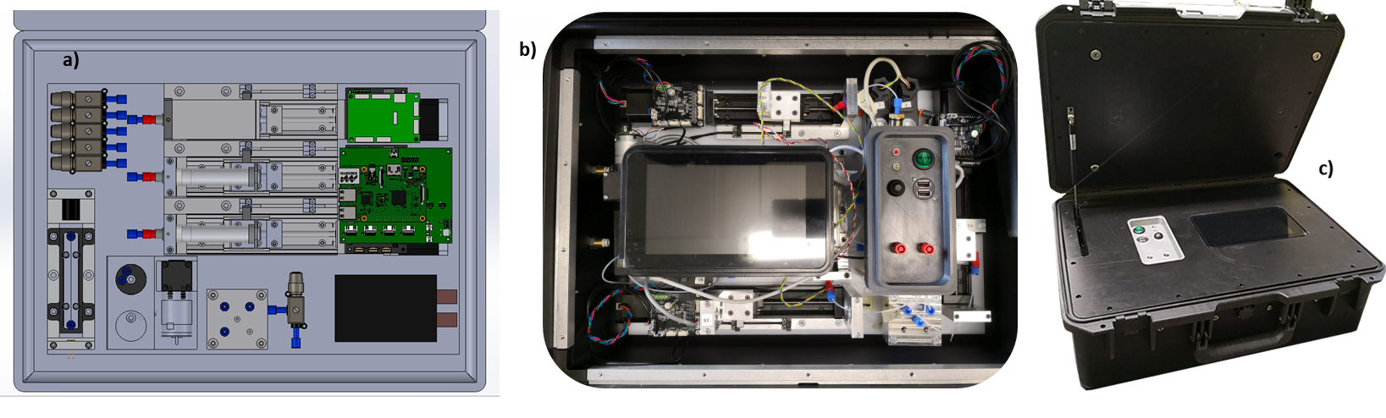

Figure 2: Portable device for Cr (VI) detection. a) Inside layout designed by Solidworks, b) Embedding in the portable carrying case, c) Final portable case.

* 1. Results and discussion
     1. Process optimization

Good results were obtained by the laboratory test for process optimization.

For example, on Cr(VI), with respect to the standard method, acetone was replaced with methanol as DFC solvent, less aggressive toward plastic components and tubes. The sulphuricacid dilution was increased from 1:1 volumes to 1:30 and reagents amounts limited; mixing and rest times were reduced and the considered wavelength for absorbance was moved from the peak (540 nm) to 520 nm, considering the cost and availability of the laser sources. A good agreement of the calibration curve with Lambert & Beer law was obtained for the optimized method in the considered Cr(VI) concentration range, that is 0.1 -1 ppm. (Figure 3a)

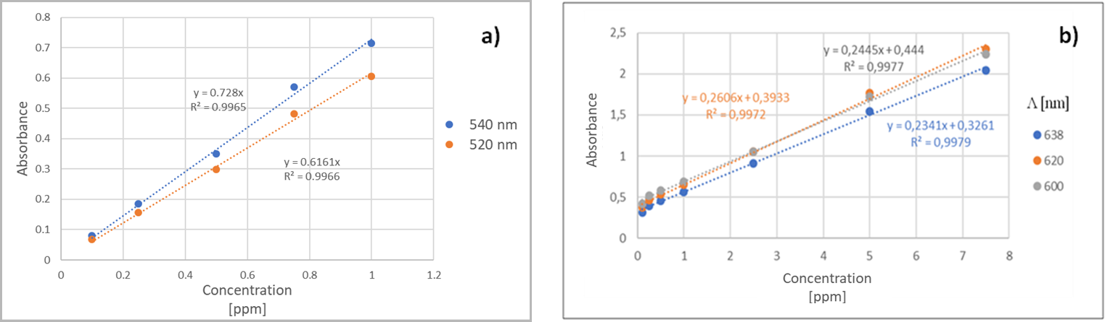

Figure 3:Calibration curves with optimized parameters. a) Cr (VI) by DFC, b) Zn by Zincon.

Main process parameters were optimized starting from the standard methods reported in literature also for Zn: NaOH concentrated solution (pH 12-13) was replaced with a pH 8.5 buffer, less aggressive as Zincon solvent; the reagents amounts were limited; the required 20 minutes rest time was skipped and the considered wavelength for absorbance was moved from the peak to 638 nm. A good agreement of the calibration curve with Lambert & Beer law was obtained in a wide Zn(II) concentration range, that is 0.1 -10 ppm, expandable to 20 ppb increasing the cuvette length and related optical path. (Figure 3b)

Same tests were carried out also for Cu and Ni; results of the laboratory tests are summarized in Table 1 in terms of optimized recipes, linearity range, meaning at least R2>0.99 for the calibration curve, and wavelength considered for absorbance.

One of the main results, functional to automation, was undoubtedly the strong process simplification. As example, the standard and optimized methods for spectrophotometric Zinc determination are reported in Figure 4. A multi-reagents and multi-fluxes, time consuming process, needing pH controls at any step, was simplified in a single step fast process, keeping unvaried the reliability and precision of the measurements.

Table 1: Results of process optimization on 4 metal ions.

|  |  |  |  |  |
| --- | --- | --- | --- | --- |
|  | Chrome | Zinc | Nickel | Copper |
| Recipe | 50mL of sample+0.5mL H2SO4 (1:30)+ 1mL of DFC dissolved in Methanol | 20mL of sample+3mL of Zincon dissolved in buffer at pH 8.5 | 20mL of sample+10mL of a commercial buffer at pH4 +3mL of Zincon solution | 5ml of sample +5ml of Zincon solution at pH 9.5 |
| Linearity | 10ppm -5 ppb | 10-0.1 ppm | 10-0.1 ppm | 10-0.1 ppm |
| Wavelength | 520 nm | 638 nm | 600 nm | 665 nm |

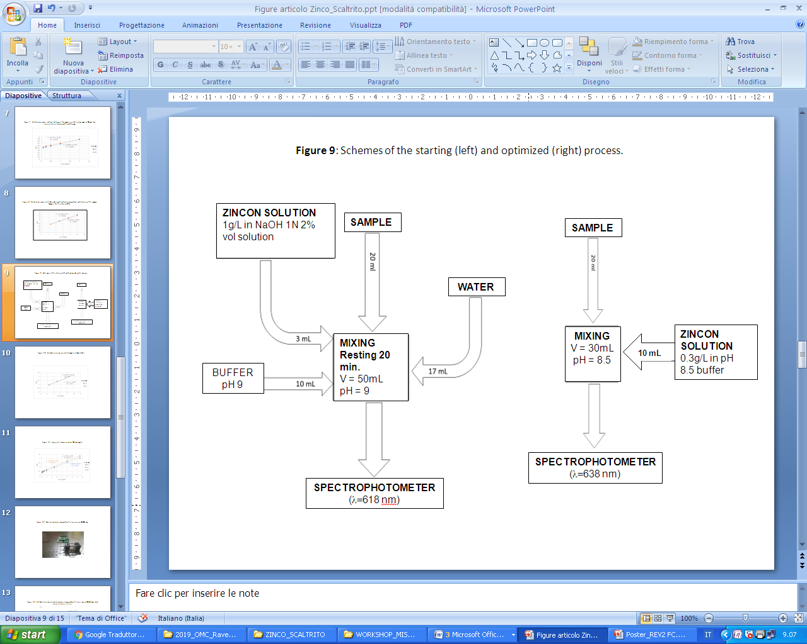

Figure 4: Schemes of the starting (left) and optimized (right) process for Zn determination

* + 1. Statistics

A statistical evaluation was carried out on repeated measurements, on the same sample or on different samples with same nominal concentration, to investigate the measurement error. Two series of experiments were planned: first, measurements were performed on the same sample 10 times, in this way errors can be only ascribable to the instrument, or accidental cuvette contamination; second, 10 samples for each considered concentration were prepared, analysed separately and compared. In the second case, even the tolerance due to the human operator in preparing the samples affects the measurements, enhancing the error. Results were collected and statistically evaluated focusing on the mean value, variance, standard deviation, variation coefficient CV, reproducibility error (Er) and uncertainty error (Ir).

Considering Zn analysis, the second test showed measurements more affected by errors, as expected. Anyway, the results can be widely accepted since the CV% was lower than 2% in almostall cases. Only for samples with the lower zinc concentration, that is 0.1 ppm, the CV% increases to 3%, but it was expected due to the high precision required in the dilution process to obtain such low concentrations. Anyway, a CV% lower than 5% can be considered satisfactory, so even in this case the limit was respected.

Better results were obtained in the first case: the higher CV% was just 0.77% and very low values of variance were found.

* + 1. Test on prototype

The calibration curves were finally determined on the bench asset. Results of experiments, by now carried out for Cr(VI) (Figure 5a) and Zn, gave evidence of the goodness of the method: very low detection limits, till 5 ppb for Cr(VI), were reached with strong simplification of the process. Moreover, the R2 of the calibration curves were still near to 1, confirming the accuracy and precision of the measurements.

In detail, for Cr(VI), first the linearity in the range 0.1 - 1 ppm was tested and confirmed with an optical path of 10 mm. Then the optical path was increased to 40 mm and the lower limit of detection, reachable by these conditions, was investigated. A concentration of 5 ppb was evaluated as lower detectable limit, with R2=0.986 for the linear approximation between 0.1 ppm and 5 ppb.For our purpose this value can be considered enough, corresponding to the permitted limit for Cr(VI) concentration in water, but it can be supposed that a further increase of the optical path can allow to detect even lower Cr (VI) concentrations, maybe properly arranging the laser intensity.

Considering the upper limit of detection, it can be concluded that a Cr(VI) concentration higher than 1 ppm, detected with an optical path of 10 mm, gives rise of absorbance values higher than 1 a.u. and out of the validity range of Lambert & Beer law. A Cr(VI) concentration of 1 ppm is well over the allowed limit, so the method is good for our purpose. Anyway, if the exact value were required for concentrated samples, they can be diluted until the absorbance falls in the required range; the dilution ratio will be taken in account to evaluate the real concentration.

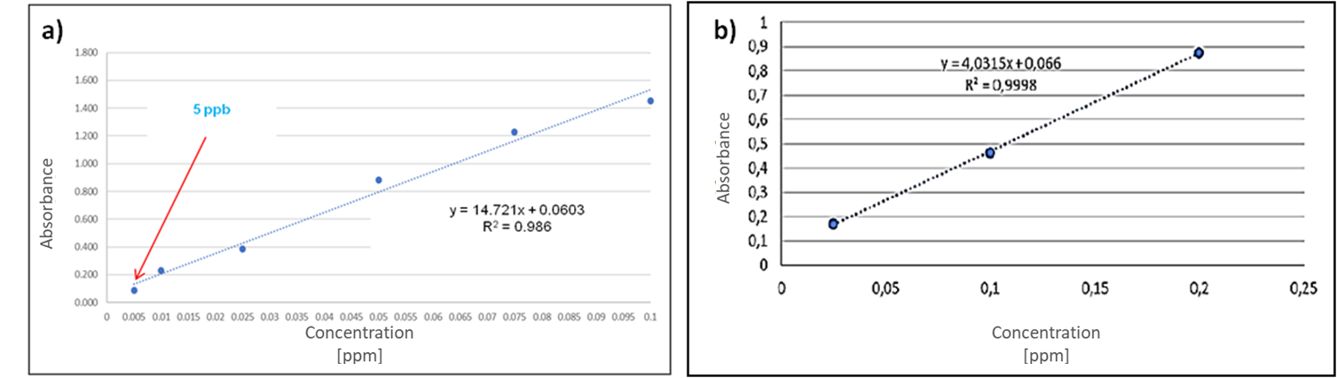

Figure 5: Calibration curves for Cr(VI) by a) bench prototype, o.p = 40 mm, b) portable prototype, o.p.=100mm

On bench prototype, the influence of salted water, rather than soft water, and of the presence of metal ions other than the detected one was investigated.

Salt does not affect the detection of any considered metal ion; it just slows down the Cr(VI) complexation by DFC, anyway the time required for the sample analysis is well enough for complete color development.

Chrome detection is neither affected by the presence of other metal ions. Zn, Cu and Ni were tested as contaminants in increasing concentrations, till 1ppm. In all cases, the evaluated concentration was in full accordance with the real one, due to the high selectivity of DFC toward Cr.

For Zn it was the same, considering Cr and Ni contamination, while Cu gave rise of some deviation from the expected result, if the Cu concentration is higher than 0.25 ppm. Anyway, the measure error was lower than 5% in all cases, so it could be considered negligible. Such influence is probably due to the measurement conditions by Zincon, similar for Cu and Zn mainly in terms of pH.

Finally, complete measurements were simulated by the final portable device, with samples showing known Cr (VI) concentrations ranging between 0.01-0.3 ppm, to verify accuracy and precision of the measurement system. For each concentration, several measurement cycles were performed, in order to obtain statistically valid data. The stability of the blank sample measurement was first investigated, avoiding the dosing and mixing phase but focusing on sensitivity of the optical and degassing systems. The real effectiveness of the dosage and mixing routine and the electro-mechanical components involved were further tested investigating the quantification of the colorimetric measurement by absorbance, a dimensionless quantity index of the optical power absorbed, as a function of the optical power.

The measurement was quite sensitive to the different temperature of the diode and to the different color of the solution with different concentrations, but the repeated measurement of the blank immediately before the colorimetric measurement, drastically decreased occurring errors. Moreover, only sporadic outlier values were obtained, indices of an error in mixing, but easily identifiable and replaceable with subsequent measurements. By investigating the linearity of experimental data, it is therefore possible to evaluate the real goodness of the system. Calibration curves showed an excellent linearity, thus going to definitively validate the automatic monitoring system built in the measurement range 0.010-0.300 ppm. (Figure 5b)

The average concentration values measured by the system for each set of tests, were finally compared to the real values of the concentrations of the samples to confirm the precision of the automatic system. Excellent features were confirmed by the portable asset, with a measurement resolution and minimum threshold of 5 ppb, for metal ions concentrations till 100 ppb and a standard deviation of 0.64 ppb.

* 1. Conclusions

Proper standard detection methods, based on spectrophotometry, were chosen for the target heavy metals water pollutants. A strong simplification of the recommended operative processes, aimed to miniaturization for a portable device, was carried out at laboratory scale. Methods were simplified and fastened for the four metal ions, without loss of precision or sensitivity. Moreover, for Cr(VI) the method was implemented on the portable device, designed and manufactured according the previous laboratory results. The miniaturized laboratory has been successfully validated to work on-site in a completely autonomous way, that is without the presence of any operator, performing the normal measurement operations that are currently performed in the laboratory, but on-field. Future studies will concern the implementation of a greater number of methods in the same payload. Furthermore, the measurement cycle will be optimized, in order to minimize the cycle time, reduce consumption and increase the autonomy of the device and the number of possible measures, without the intervention of the operator.

Acknowledgements

This paper has been possible thanks to the sponsorship of the Italian Ministry of Economic Development's, General Directorate General for Safety - National Mining, Office for Hydrocarbons and Georesources.

Authors acknowledge Microla Optoelectronics S.r.l. (Chivasso, Italy) and Chemifin S.r.l. (Brescia, Italy)for the technical support and the interest on field applications of the study.

References

Beck L., Bernauer T. and Kalbhenn A., 2010, Environmental, political, and economic determinants of water quality monitoring in Europe, Water Resour. Res*.*, 46 (11), 1–10.

Fries J., Getrost H., 1975, OrganischeReagenzien fur die Spurenanalyse, E. Merk, Darmstadt, Deutschland.

Kocyla A., Pomorsky A., Krezel A., 2017, Molar absorption coefficients and stability constants of Zincon metal complexes for determination of metal ions and bioinorganic applications, Journal of Inorganic Biochemistry, 176, 53-65.

Periolatto M., Catania F., Scaltrito L., Pirri C., Cocuzza M., Ferrero S., 2019, Continuous, on Site Spectrophotometric Determination of Zinc ions in Water Laboratory test preliminary to microfluidic device prototyping, Proceedings of Eighth International Conference on Advances in Bio-Informatics, Bio-Technology and Environmental Engineering ABBE, 16-22 DOI: 10.15224/978-1-63248-167-2-03

Pesavento M., Alberti G., Biesuz R., 2009, Analytical methods for determination of free metal ion concentration, labile species fraction and metal complexation capacity of environmental waters: A review, Analytica Chimica Acta, 631 (2), 129-141.

Wang X., Yang F., Chen X., and Yang S., 2017, Environmental Chemistry of Toxic Heavy Metals Hg-As in the Jialing River, Chemical Engineering Transactions, 59, 883-888.