CHEMICAL ENGINEERING TRANSACTIONS  VOL. 82, 2020 | A publication of
The Italian Association
of Chemical Engineering
Online at www.cetjournal.it
Guest Editors: Bruno Fabiano, Valerio Cozzani, Genserik Reniers
Copyright © 2020, AIDIC Servizi S.r.l.
ISBN 978-88-95608-80-8; ISSN 2283-9216

Pre-Startup Safety Review Performance and Close-Out Management for a New Licensed Petrochemical Plant
Federica Di Vito
Design HSE Manager, Tecnimont SpA, via De Castillia 6A, 20124 Milano, Italy
f.divito@tecnimont.it
During the development of a licensed petrochemical industrial plant project, the identification, review and proper addressing of hazards is carried out by the different project’s stakeholders (Licensor, EPCC Contractor, Owner, etc.) since the early phases of feasibility study and basic engineering, up to detail design, procurement, construction and commissioning phases.
This results in multiple layers of HSE requirements whose proper and effective implementation needs to be checked before commencing operations, in order to prevent adverse HSE consequences that could affect other business aspects and success of the project.
A formal process to ensure that plants and facilities conform to HSE requirements, that relevant safety, operating, maintenance and emergency procedures are in place and that all process hazard analyses recommendations have been implemented, is the Pre-Startup Safety Review, or PSSR.
The PSSR shall be performed at site by a multidisciplinary team as close as possible, but prior to the mechanical completion, when fire protection systems, fire water network, fire and gas detection systems and emergency blow down systems are in place.
The PSSR team shall evaluate the overall review results and recommend whether the concerned unit/system is ready and safe to start-up.
This paper illustrates how different sessions of Pre-Startup Safety Review were performed and managed to close-out on a new petrochemical plant, to demonstrate that the facilities were ready and safe prior to the introduction of any hazardous materials.
  - Introduction
In March 2005, the BP Texas City refinery suffered a major disaster that killed 15 and injured 180 others. BP hadn’t properly conducted safety critical checks. The CSB investigators found an inoperative pressure control valve, a defective high-level alarm and an uncalibrated sight-glass level transmitter as well as portable trailers with non-essential personnel located too close to the process (CSB, 2007), Properly performed PSSRs would have prevented this event (Broadribb M.P., Flynn S.A., 2009).
Effectively conducted PSSRs can prevent incidents and the resultant harm to personnel, equipment damage and loss of production and profits. PSSR is also a critical element of the process safety management (PSM) program mandated by the United States Occupational Safety and Health Administration (OSHA), which defines the need for a PSSR in 29 CFR (Code of Federal Regulations) 1910.119(i). According to OSHA, the ultimate responsibility lies with plant or facility management to ensure a PSSR is properly conducted before a covered process is started (Wincek, 2018).
The goal of the Pre-Startup Safety Review (PSSR) process is to provide a coherent, systematic, and as simple a strategy as possible to implement, in order to ensure that all prior identified hazards, loss exposures and other potential unidentified hazards associated with plant start-up and operation have been addressed to close-out before start-up.
According to the contractual requirements and to construction progress it may be decided to cover the PSSR in a single session or in two or even more sessions (Marucco D., 2015).
  - Project Overview
Tecnimont S.p.A., international leader in the field of petrochemical plant engineering, in joint venture with a Chinese contractor, was appointed by the national oil & gas company as EPCC contractor of a 400,000 tons per year High Density Polyethylene (HDPE) licensed plant in Malaysia.
The HDPE Plant was a fundamental component of the overall 27 billion USD investment made for a world scale integrated refinery and petrochemicals complex, which covered an area of 80 km² and included:
- Refinery with 300,000 barrels per day capacity
- Naphtha Steam Cracker
- Petrochemical Derivatives Units
- Cogeneration Plant
- LNG Regasification Terminal
- Deep Water Terminal
- utilities, off site and jetty installations.
The complex was designed to meet both domestic and Asia’s energy and chemicals demand, yielding an estimated annual production capacity of 3.6 million tons of petrochemical products.

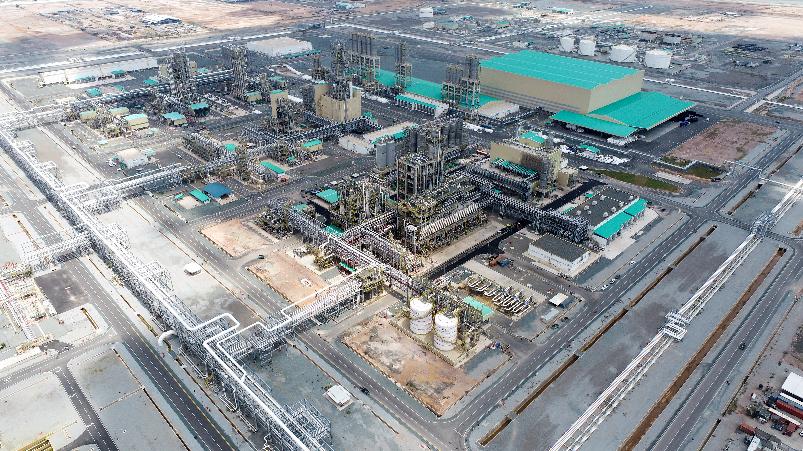
Figure 1: HDPE Plant aerial view

The Pre-Startup Safety Review (PSSR) process for the HDPE Plant started in the second quarter of 2019, after the achievement of 80% mechanical completion and continued up to the end of the year, when the Ready for Start-Up (RFSU) certificate for Hydrocarbon-In was released.
  - Pre-Startup Safety Review Process
In compliance with contractual requirements, two different PSSR Reviews were performed in series, both managed by multidisciplinary Review Teams: the first one involved Licensor’s representatives and Contractor’s representatives, while the second one involved Owner’s representatives and Contractor’s representatives.
The reviews were covered in three sessions each, focused on the three macro-areas identified based on the planned start-up sequence of the different process units:
- Hexane Storage and Hexane Distillation Section
- Extrusion and Dry-end Section
- Polymerization and Polymer Drying Section
Table 1 summarizes the split of Plant’s units by PSSR and the three macro areas superimposed to the Plant’s plot plan are shown in Figure 2.
Table 1: PSSR sessions
PSSR Session | Macro-area | Units involved
1 | Hexane Storage and Hexane | Battery limit
 | Distillation Section | Hexane Unloading
 |  | Hexane Storage Tanks
 |  | Steam System
 |  | Wastewater basin
 |  | Substation & Field Auxiliary Room
2 | Extrusion and Dry-end Section | Extruder Natural
 |  | Extruder Black
 |  | Intermediate Silos
 |  | Blending Silos
3 | Polymerization Section | Jacket Water
 |  | Reactors and Outercoolers
 |  | Polymer Drying
 |  | TEAL unloading
 |  | TEAL Transfer

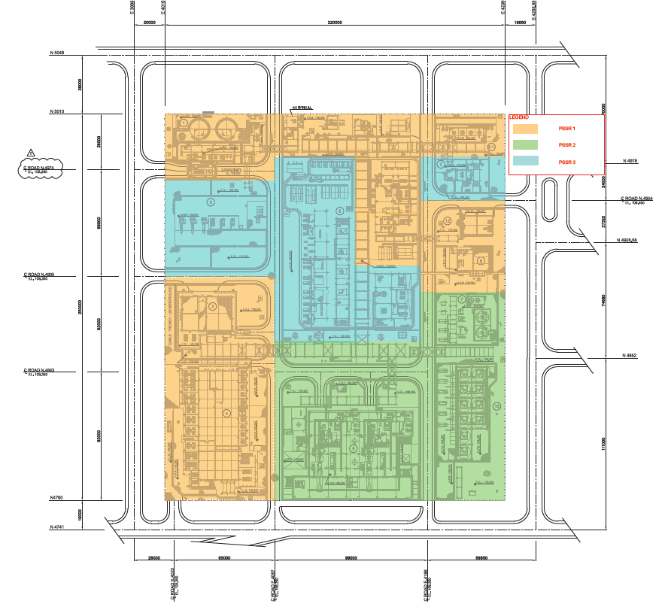
Figure 2: PSSR macro areas

    - Pre-Startup Safety Review Teams and Guidelines
The Licensor’s PSSR was conducted by a Review Team including HSE, Design and Operation Specialists from both Contractor and Licensor, led by Licensor’s Process Safety Manager. Licensor’s General HSE Design Criteria and Criteria pertaining to the specific licensed HDPE technology were the reference guidelines according to which the Plant was designed and built, and Licensor’s Pre-Startup Safety Review Sessions were conducted.
The Owner’s PSSR was performed by a Review Team including HSE, Design and Operation Specialists from both Contractor and Owner, led by Owner’s Central Directorate Operations Manager. A multidisciplinary PSSR checklists, shown in Figure 3, was developed by Owner, to help in guiding the discussions and focus the review effort in ensuring all process safety considerations were completed so that units being reviewed were ready for the start-up.
Each subject was covered by the Review Team through the assigned Specialist, according to experience and competences. Assistance to the Review Team was ensured by the Site personnel.
As a helpful support to the Review, the latest revision of: active and passive fire protection philosophies and layouts, Fire and Gas philosophy and layouts, Hazardous Area Classification philosophy and layouts, Quantitative Risk Assessment, P&IDs, Management of Change log, risk assessments action items close-out final documentation of other disciplines involved, e.g. Process, Civil, Instrumentation/Telecommunication, Electrical, etc., were made available.
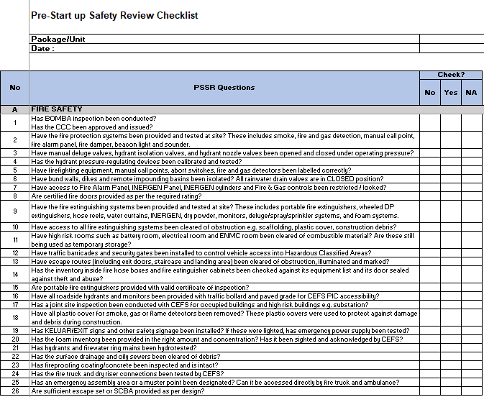
Figure 3: Owner’s PSSR sample checklist
    - PSSR Execution
The PSSR sessions started with a tabletop discussion, aimed at the clear identification of session’s scope, the review of related design documents and the planning of site visit. The site visit focused on actual implementation at site of items discussed tabletop and on verification of physical readiness of the units in terms of, but not limited to:
- availability and adequateness of escape routes throughout the Plant
- review of fire protection and fire detection systems installation
- review of safety equipment installation i.e., safety showers, eye washes, first aid boxes, escape packs, self-breathing apparatus, fire suits etc.
- check of other critical installations, such as process safety devices discharging to atmosphere, sampling points, air intakes, Public Address General Alarm system, etc.
- check of housekeeping
For each item the Review Team determined implementation adequateness to allow the unit to be safely started-up.
    - PSSR Findings, Tracking and Close-out
When substandard conditions were identified during the PSSR, the Review Teams proposed corrective actions, called recommendations, to be properly addressed to ensure that all potential hazards were eliminated.
For each session, reports were prepared by the Review Team Leader and issued with the photographic evidence reference of the items not in compliance with guidelines i.e., findings, and the indication of the recommendations to be applied. All PSSR recommendations were categorized based on Severity as per Risk Assessment Matrix (RAM) in Figure 4.
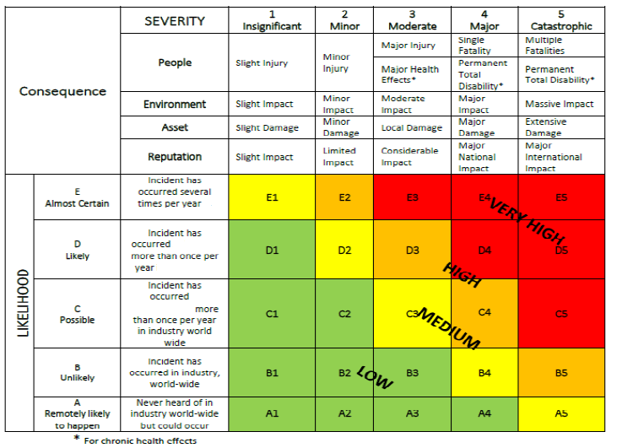
Figure 4: Risk Assessment Matrix

Recommendations were prioritized by assigning risk ranking in accordance to the following criteria:
- all PSSR recommendations under Severity Rating 3, 4 or 5 were categorized as PS1 i.e., to be closed before start-up
- all PSSR recommendations under Severity Rating 1 or 2 were categorized as PS2 i.e., to be closed after start- up.
After the two PSSR Reviews were completed, a total of 832 recommendations were identified for the HDPE Plant, categorized as shown in Table 2 and Table 3:
Table 2: Licensor’s PSSR recommendations summary
PSSR | Number of recommendations PS1 | Number of recommendations PS2
Licensor’s Session 1 | 23 | -
Licensor’s Session 2 | 26 | -
Licensor’s Session 3 | 35 | 10

Table 3: Owner’s PSSR recommendations summary
PSSR | Number of recommendations PS1 | Number of recommendations PS2
Owner’s Session 1 | 189 | 58
Owner’s Session 2 | 144 | 42
Owner’s Session 3 | 228 | 77

All PSSR recommendations were tracked and monitored internally through Contractor’s mechanical completion database management system, using the existing punch-list template, and through a dedicated register (refer Figure 5) reporting PSSR findings – “Requirement “ column – and related close-out action – “Agreed Resolution” column. Status of all PSSR recommendations, PS1 and PS2, was updated on weekly basis. Licensor and Owner respectively confirmed closure of recommendations upon provision of relevant evidence.
The PSSR was officially closed out once all findings were closed out through specific agreed resolution.

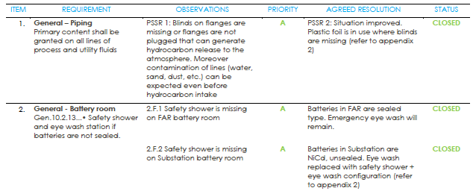
Figure 5: Sample close-out register from Licensor’s PSSR
  - Conclusions
The Pre-Startup Safety Reviews carried out for the HDPE licensed Plant allowed for the proper identification of gaps between the various HSE requirement acknowledged during the development of the Project and their effective implementation before commencing operations. After the two PSSR Reviews were completed, a total of 832 recommendations were identified for the HDPE Plant and the performance and close-out of the PSSRs required the effort of the overall Project’s Team, including Engineering Specialists, Site personnel, Project Management and Site Management from Contractor’s, Licensor’s and Owner’s side.
The HDPE Plant RFSU certificate for Hydrocarbon-In was achieved once all PS1 were closed-out and the Hydrocarbon-In was safely performed with no incidents and no equipment damage on 31st December 2019.
References
Broadribb M.P., Flynn S.A., 2009, 4 years on from Texas City, Hazards XXI, IChemE Symposium Series No. 155, Sunbury-on-Thames, UK.
Marucco D., 2015, Pre- Startup Safety Review (PSSR), Tecnimont Work Instruction, Milan, Italy.
U.S. Chemical Safety and Hazard Investigation Board, 2007, Final Investigation Report no. 2005-04-i-tx Refinery Explosion and Fire, BP, Texas city, Texas.
Wincek J.C., 2018, Perform A Proper Pre-Startup Safety Review — 5 Steps, Chemical Processing, <www.chemicalprocessing.com/articles/2018/perform-a-proper-pre-startup-safety-review-5-steps> accessed 20.03.2020.

