|  |  |
| --- | --- |
| cetlogo ***CHEMICAL ENGINEERING TRANSACTIONS***  ***VOL. 82, 2020*** | A publication of  aidiclogo_grande |
| The Italian Association  of Chemical Engineering  Online at www.cetjournal.it |
| Guest Editors: Bruno Fabiano, Valerio Cozzani, Genserik Reniers  Copyright © 2020, AIDIC Servizi S.r.l. **ISBN** 978-88-95608-80-8; **ISSN** 2283-9216 | |

Simulation of Full-Bore Tube Rupture in Shell&Tube Heat Exchanger

Luigi Raimondi

luigi.raimondi@xpsimworld.com

Shell & Tube heat exchanger is the most often used equipment for heat transfer between fluids in chemical plants, refineries, power generation stations and many other industries. The fluid cooled and the fluid heated are often operated at very different pressures: in this case design standards require an analysis to verify the maximum pressure surge that could be generated by an accidental fluid leak from the high-pressure side of the heat-exchanger into the other. The analysis of such accident is very complex due to a number of interacting phenomena such as vapor-liquid equilibrium, large enthalpy effects, large changes of fluid density and the formation two-phases (vapor and liquid) fluid flows. With reference to a real project case, this article presents the simulation of the pressure increase due to the full-bore rupture of a tube. This evaluation is required to assess if a rupture disk must be installed on the shell side to protect both the equipment and the operating personnel. The analysis is performed using a state-of-the-art dynamic simulation tool.

* 1. Introduction

Shell & Tube heat-exchangers are widely used to exchange heat between fluids in chemical plants, refineries, power generation industries and fluid-transportation stations. Often the fluid cooled and the fluid heated are operated at high pressure difference: in this case, design rules require a dynamic analysis to verify the maximum pressure surge that could be reached in the case of a fluid leak from one side of the heat-exchanger into the other side. In many cases, water is used as the cooling fluid either as liquid or as vapor generated by steam-boilers. When liquid water is used for cooling, it is provided by the integrated cooling-water system at a normal pressure of about 10 bar. If the pressure difference between the fluids is high it is a common procedure to have the high-pressure fluid in the tubes (HP side) and the low-pressure fluid (LP side) in the shell. With this configuration, the major risk is the sudden rupture of a tube with a following rapid discharge of the process fluid into the liquid water flowing in the shell. To prevent damages to the equipment and the working people, the shell can be protected by a pressure safety device, usually a rupture disk. In this occurrence, the consequence analysis must also consider the effects on the surrounding piping system. When the leaked fluid is gas, the fluid velocity may reach critical conditions and become equal to the sound velocity. To analyse the accident and possible consequences, rupture cases are today simulated using dynamic simulation software which must include up-to-date thermodynamic methods for the evaluation of physical properties (e.g. cubic equations of state), vapor-liquid equilibria and fluid flows at sonic conditions. If the leaked fluid is gas, two-phase flow is generated, and this phenomenon adds more complications in the simulation of the consequences since two-phase flow models are required; all these aspects are analysed and discussed.

It should be remarked that articles about this type of incidents are almost never discussed in academic studies but only in practical engineering magazines such as (Cassata et al.,1998) and (Ewan et al., 2000).

This article presents, for a real project case, the assessment of the pressure increase due to the full-bore rupture of a tube, with the aim to install, or not, a rupture-disk. When the rupture disk needs, the design engineer must verify that its size provides an outlet flow area will be sufficient to protect the equipment and the nearby cooling-water circuit, limiting the pressure increase to a value lower than the shell design pressure. All the computer simulations, steady-state and dynamic, presented in this study are performed using the proprietary Xpsim (eXtended Process SIMulator) simulation software tool. A heat-exchanger is analysed to find the consequences of a tube rupture followed by the discharge of the high-pressure gas from the tubes into the low-pressure shell side with a sharp surge of its pressure. A simplified schema of a shell and tube heat exchanger is presented in Figure 1. The gas (red) and the water (blue) flow in counter-current with the water path constrained to zigzag by the internal baffle separators. To perform a complete engineering analysis, the simulation must also consider part of the piping system upstream and downstream the heat-exchanger, since pressure waves travelling at the speed of sound are a key-factor in the generation of the pressure surge. Section “4.4.14 Heat Transfer Equipment Failure” of the API 521 recommended procedure discusses the event considered in this study. We may quote the initial presentation of this subject “Heat exchangers and similar vessels may require protection with a relieving device of sufficient capacity to avoid overpressure in case of an internal failure. This statement defines a broad problem but also presents the following specific problems: a) type and extent of internal failure that can be anticipated, b) determination of the required relieving rate if overpressure of the low-pressure side of the exchanger and/or connected equipment occurs as a result of the postulated failure, c) selection of a relieving device that reacts fast enough to prevent the overpressure, d) selection of the proper location for the device so that it senses the overpressure in time to react to it.”

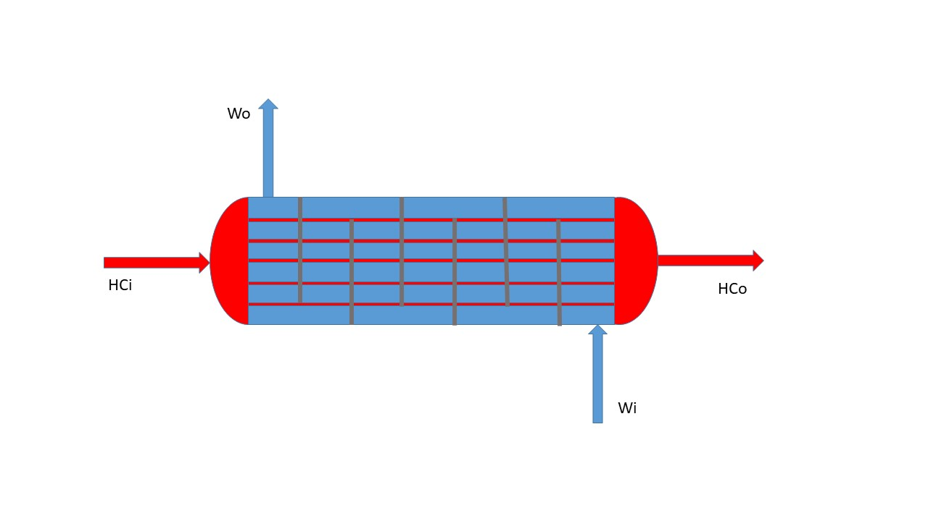

Figure 1: Shell & Tube heat exchanger schema: hot gas (red) and cooling water (blue)

* 1. Methods and Material

The analysis of the event requires the availability of simulation software code capable to treat a number of important and complex phenomena as:

1. Vapor-liquid equilibrium, to take into account condensation of hydrocarbon fractions of the gas when mixed with the cold water. Usually cubic equations of state are used such as the Peng-Robinson model (Peng and Robinson, 1976) or the Soave-Redlich-Kwong (Soave, 1972);
2. Thermodynamic properties of fluids (enthalpy, entropy and density) at high pressures. In this study the Lee-Kesler model (Lee and Kesler, 1975) is used. The properties of water are calculated on the bases of standard steam and water properties tables (Springer, 1969);
3. Calculation of transport properties
4. Fluid discharge at sonic condition. The model used is based on the maximum flow rate which satisfies the sonic condition and the enthalpy balance (Raimondi, 2007);
5. Modelling of vapor-liquid mixed phase flow. The modelling of transient two-phase flow requires the integration of the Navier-Stokes equations in a two-fluid model framework. Literature published on this subject is enormous, but few approaches are available for direct application in fields of industrial relevance. Important reference books are those of Ishii and Hibiki (2006) on thermo-fluid dynamics and of Ferziger and Peric (2002) on numerical solutions. The physical and mathematical methods used in Xpsim have been recently developed and validated in the study of fast depressurizations (Raimondi, 2014 and 2017) of pipelines. In these cases where pressure surges are involved, the liquid cannot be considered incompressible; therefore so the compressibility of water must be considered, in order to simulate the sonic pressure waves.

This is a partial list of the thermodynamic phenomena involved in the simulation of the event, so it is impossible to presents all the mathematical equations and model details in this study. The process fluid is a gas-condensate produced by an offshore reservoir with a small fraction of formation water; the complete fluid composition is shown in Table 1, where components from C6\* to C10+ are petroleum fractions. The operating and design parameters of the heat-exchanger and some mechanical data are specified in Table 2.

Table 1: Gas condensate composition

|  |  |  |  |  |  |
| --- | --- | --- | --- | --- | --- |
| No | Component | Mole per cent | No | Component | Mole per cent |
| 1 | Nitrogen | 0.588 | 14 | m-Cyclohexane | 0.008 |
| 2 | Carbon dioxide | 0.348 | 15 | Toluene | 0.001 |
| 3 | Methane | 94.347 | 15 | n-Octane | 0.001 |
| 4 | Ethane | 3.232 | 17 | e-Benzene | 0.000 |
| 5 | Propane | 0.850 | 18 | m-Xylene | 0.000 |
| 6 | i-Butane | 0.216 | 19 | n-Nonane | 0.000 |
| 7 | n-Butane | 0.194 | 20 | C6\* | 0.016 |
| 8 | i-Pentane | 0.085 | 21 | C7\* | 0.011 |
| 9 | n-Pentane | 0.056 | 22 | C8\* | 0.003 |
| 10 | n-Hexane | 0.026 | 23 | C9\* | 0.001 |
| 11 | Benzene | 0.001 | 24 | C10+\* | 0.000 |
| 12 | Cyclohexane | 0.010 | 25 | Water | 0.002 |
| 13 | n-Heptane | 0.005 |  |  |  |

Table 2: Operating conditions and mechanical data.

|  |  |  |  |
| --- | --- | --- | --- |
| Fluid | Side | Tubes(gas) | Shell(water) |
| Flow rate | kg/h | 714500 | 914500 |
| Flow rate per tube | kg/h | 420.3 |  |
| Inlet pressure | bar | 126.9 | 13 |
| Inlet temperature | °C | 83.6 | 20 |
| Outlet temperature | °C | 30.0 | 50 |
| Length | mm | 14300 | 13420 |
| No of tubes |  | 1700 |  |
| Outside tube diameter | mm | 15.88 |  |
| Wall thickness | mm | 1.81 | 20 |

The first calculation step is a rigorous calculation of the gas flowing from the tube into the shell side filled by water. The results obtained are presented in Figure 2 where it is possible to verify that the gas, because of the high pressure ratio, is discharged at critical at sonic condition (70.9 bar) with a velocity of 391 m/s. The calculated flow rate of 18157 kg/h is to be doubled to take into account that the gas flows from the two sides of the ruptured tube. With the discharge coefficients defined by API 521, the total gas flowrate used in the dynamic simulation is set at 29000 kg/h.

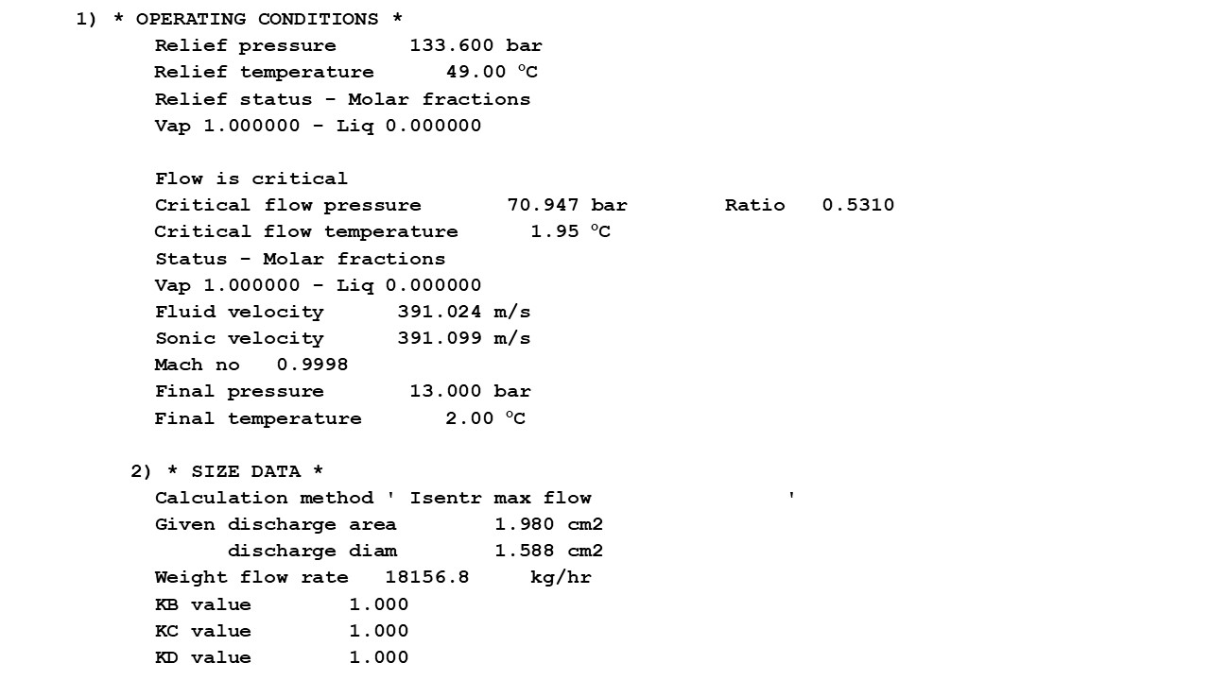

Figure 2: Calculation results of the discharge flow from pipe rupture.

* 1. Dynamic Simulation

The conceptual P&I (Process and Instrument) diagram used by the dynamic simulator is shown in Figure 3. The schema used for dynamic simulation is based on a linearization of the shell side as an equivalent pipeline: the shell volume filled by water and the flowing area are used for the definition of the total length and equivalent diameter. The pipeline diameter is set equal to 0.67 m and the length to 25.3 m. The water flows into the pipeline (i.e. heat-exchanger shell) through the (L1, CV1, L2) elements and exits the shell through the (VO1, CV2, VO2) elements. The gas leaking into the heat-exchanger shell is simulated as a second feed into the pipeline at the point of rupture through the (LH1, CVH, LH2) elements. In this case the tube rupture is set at the outlet tube sheet, that is very close to the cooling water inlet nozzle. At the initial conditions the leak is set to zero by the closed valve CVH which will open at the instant of pipe rupture. The valve flow coefficient Cv is pre-calculated to reproduce the sonic flow rate generated by the tube rupture as presented in Figure 2. The full bore rupture event is considered complete in an interval of 3 milliseconds. The dynamic simulation is performed along a time interval of 5 seconds with the tube rupture instant set at 1 second. The numerical integration is initialized with a time step of 0.0001 s, the higher limit set at 0.001 s, and the lower at 0.00001 s.

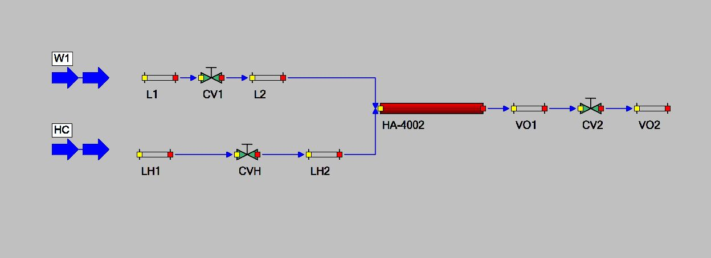

Figure 3. P&I schema for dynamic simulation

As required by API 521, the surrounding piping systems is considered in the simulation: this directs attention to the importance of a reliable specification of the appropriate boundary conditions at the beginning of the upstream and the end of the downstream piping systems. All the calculated variables, as shown in the following graphs, are collected every 0.001 s time interval. The details of the effects of the rupture onto the flowing fluids are captured efficiently, are presented on the following figures and discussed. The following figures present only a small selection of the relevant engineering values, captured by the dynamic simulation, in a time window from 0.8 s to 2.8 s. The results presented by Figure 4 are the inlet and outlet water flows at the two shell sides. At the moment of the tube rupture the immediate pressure increase stops the inlet water flow and pushes the water in the shell to the outlet side. The outlet water flowrate reaches a peak value of about 1,700,000 kg/h. Figure 5 shows how the pressure inside the heat-exchanger shell changes immediately after the tube rupture. Pressure values are collected at 3 points: 1 m after the pipe rupture, at the middle of shell, and near the water exit point. From this graph the engineer can obtain the peak pressure value and decide, on the basis of the design pressure of the heat-exchanger, if the installation of a rupture disk must be considered and included in the mechanical design of the heat exchanger. With a complete and efficient dynamic simulator the engineer can also analyze many boundary conditions of the water cooling circuit which may greatly affect the calculation of the maximum pressure reached during the incident. Concerning water velocity, in normal operating conditions, at the flow rate of 914,500 kg/h, the average crossing the tube bundle is 0.62 m/s. Under discharge conditions, at the flow rate of 1,500,000 kg/h, the water velocity becomes 1.2 m/s. Of course, this procedure is affected by the uncertainty about the cooling water return system configuration and operating conditions downstream of the exchanger

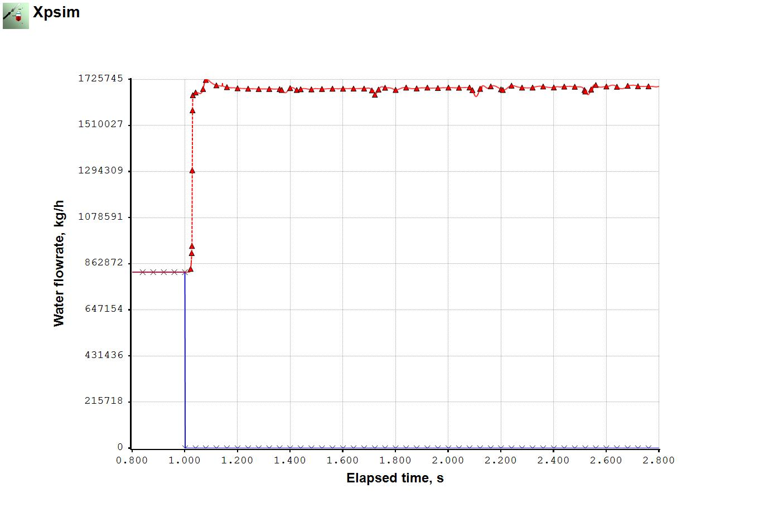

Figure 4: Inlet (×) and outlet (∆) cooling water flow flowrate

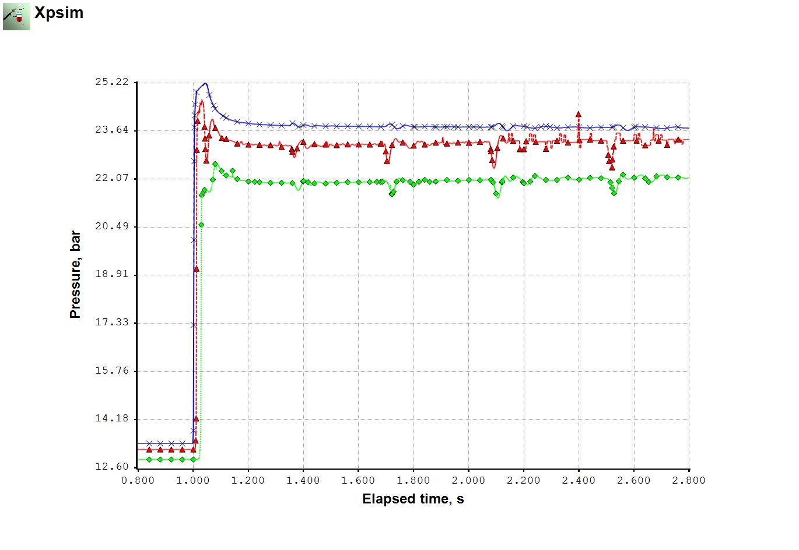

Figure 5: Calculated pressures in the shell at water flow points, inlet (**×**), middle (**∆**) and outlet (**◊**) points

Figure 6 shows the change of the liquid volume fraction in the heat exchanger shell and the fluid velocity. The values are measured at a distance of 1 m after the tube rupture.

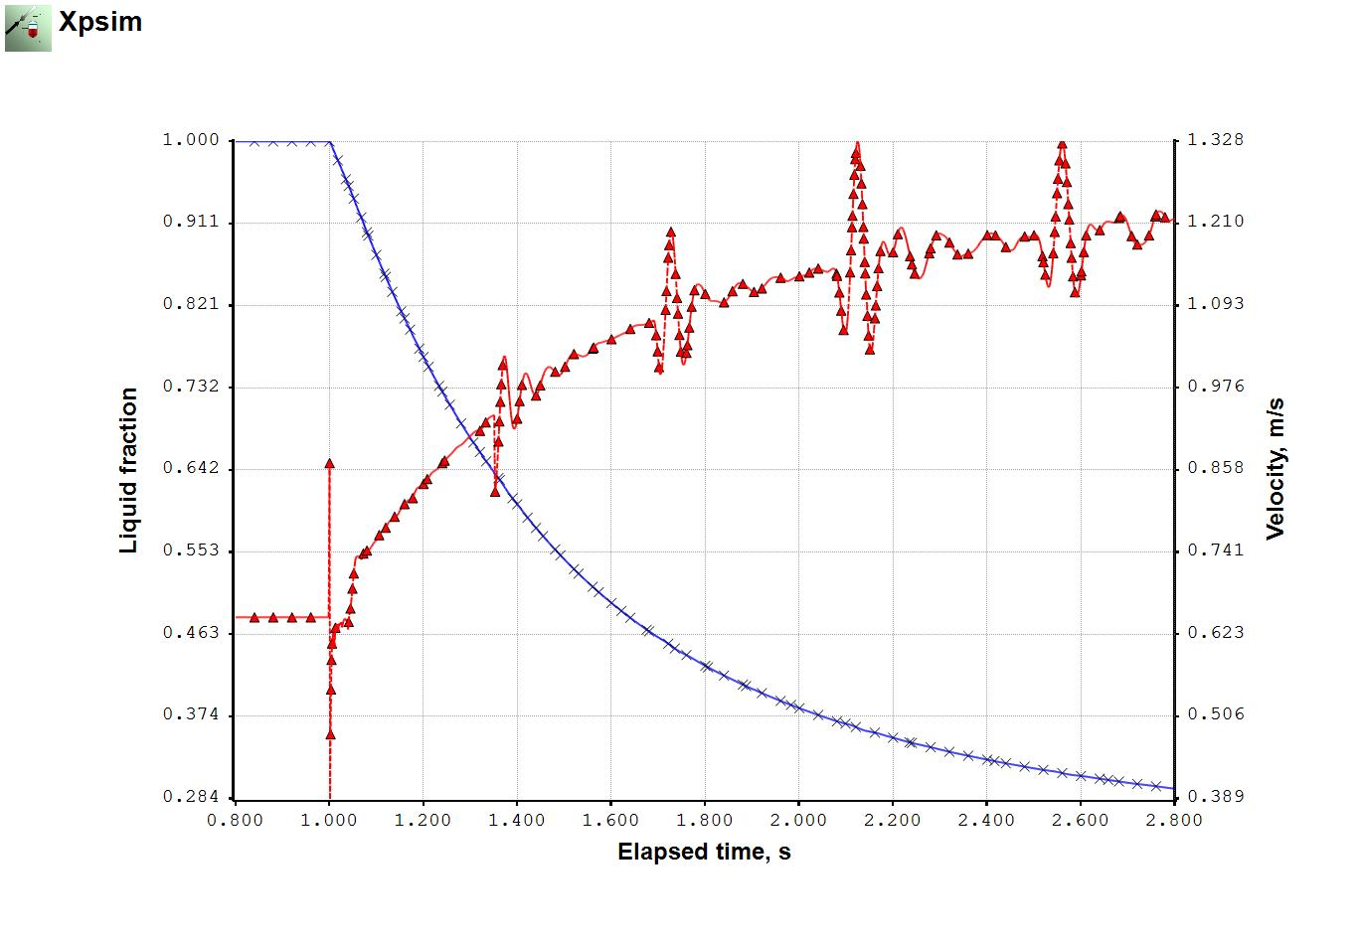

Figure 6: Liquid volume fraction (**×**) and fluid velocity (**∆**) at 1 m after tube rupture

* 1. Conclusions

In this study we have presented an engineering analysis procedure used to obtain data about an accident event which can occur in heat-exchanger equipment. Many details are considered in the dynamic analysis of the event.The analysis of this case shows that the highest pressure on the shell reaches a value of 25.2 bar and being this value slightly below the design pressure no safety disk would be required. This value is dependent on the back pressure established by cooling water circuit. The calculation presented was made assuming 9.5 bar and a sensitivity analysis showed that a rise of this value by 0.5 bar to 10 bar generates a peak pressure around 30 bar which is higher than the design project.

References

American Petroleum Institute, Pressure-relieving and Depressuring Systems, API STANDARD 521, SIXTH EDITION, JANUARY 2014

Cassata J.R., Feng Z.J, Dasgupta S., Samways R., 1998, Prevent overpressure failures on heat exchangers, Hydrocarbon Proc., Nov, 123.

Ewan B.C.R., Moatamedi M., 2000, Design aspects of Chemical Plants exposed to Transient Pressure Loads, Trans IChemE, 78, Part A, September, 866-870

Ferziger J.H, Peric M., 2002, Computational Methods for Fluid Dynamics, 3rd Edition, Springer

Ishii M., Hibiki T., 2006, Thermo-Fluid Dynamics of Two-Phase Flow, Springer, Berlin

Lee B.I., Kesler M.G., 1975, A generalized thermodynamic correlation based on three-parameter corresponding states, AIChE J. 21 (3)

Peng, D. Y.; Robinson, D. B., 1976, A new two-constant equation of state, Ind. Eng. Chem. Fundam., 15, 59−64.

Properties of Water and Steam in SI-Units, Springer Verlag, 1969

Raimondi L., 2007, Rigorous Calculation of Critical Flow Conditions for Pressure Safety Devices, Process Safety and Environmental Protection, vol. 85, issue 4, p. 277-288

Raimondi L., 2014, Full Compositional Simulation of Two-Phase Flows, MFIP13, Multiphase Flow in Industrial Plants.

Raimondi L., 2017, Compositional Simulation of Two-Phase Flows for Pipeline Depressurization, SPE Journal, 22, 4

Soave G., 1972, Equilibrium constants from a modified Redlich-Kwong equation of state, Chem.Eng.Sci. 27, 1197-1203

XPSIM (eXtended Process SIMulation), General Information, Version 3.00, [www.xpsimworld.com](http://www.xpsimworld.com), 2018.