CHEMICAL ENGINEERING TRANSACTIONS  VOL. 82, 2020 | A publication of
The Italian Association
of Chemical Engineering
Online at www.cetjournal.it
Guest Editors: Bruno Fabiano, Valerio Cozzani, Genserik Reniers
Copyright © 2020, AIDIC Servizi S.r.l.
ISBN 978-88-95608-80-8; ISSN 2283-9216

Thermal Decomposition of Sugars as an Eco-friendly and Inherent Safe Process for Carbon Nanoparticles Production
Andrea Pietro Reverberi^{a,}*, Marco Voccianteª, Marco Salerno^{b}, Simone Lauciello^{c}, Bruno Fabiano^{d}
ªDCCI – Department of Chemistry and Industrial Chemistry, Genova University, via Dodecaneso 31, 16146 Genova, Italy
^{b}Nanophysics Department, Istituto Italiano di Tecnologia, via Morego 30, 16163 Genova, Italy
^{c}Nanochemistry Department, Istituto Italiano di Tecnologia, via Morego 30, 16163 Genova, Italy
^{d}DICCA – Department of Civil, Chemical and Environmental Engineering, Polytechnic School, Genova University, via Opera
Pia 15, 16145 Genova, Italy
reverb@dichep.unige.it
A synthesis of carbon nanoparticles from hydrothermal dissociation of sugars of different composition is proposed in the present experimental study. The process has been carried out in a stirred batch reactor at a fixed temperature, using precursors dissolved in aqueous solvent in the presence of NaOH. The use of surface passivation agents has been avoided in order to test how the competing kinetics of chemical reaction and of particle agglomeration may condition the properties of the final product.
The carbon nanoparticles have been characterized in diameter by dynamic light scattering. It has been shown that the molecular structure of the precursor and the selected residence time have a basic role in determining the probability distribution function of the as-made nanoparticles diameters. When fructose and lactose are adopted as precursors, the process of sugar decomposition is active even at room temperature owing to the action of NaOH. The present method, thanks to its easy reproducibility and to the absence of noxious releases as a by product, may represent a first step towards a cost-effective and environmentally sound technique for the synthesis of carbon nanoparticles at a larger scale. Finally, such aspects are discussed and some applications of practical relevance are proposed.
  - Introduction
The synthesis of organic and inorganic nanomaterials can be considered as one of the more challenging aspects in modern manufacturing industry (Reverberi et al., 2016). Examples concern the production of sensors utilized for safety sensor systems (Fabiano et al, 2015), the fabrication of polymer composites with ferroelectric properties (Pascariu et al., 2013), the synthesis of smart materials for biomedical applications (Toccafondi et al., 2015) and for environment decontamination (Vocciante et al., 2019). Physical and chemical methods are the two most important techniques to be adopted in current manufacturing of nanoparticles (NPs). Very often, the former rely upon complex and costly apparatuses affecting the production costs, but they offer the advantage of a satisfactory process control in terms of average sizes and particle diameter dispersion. Carbon nanodots (CDs), a subset of carbon NPs having diameters <10 nm, are in the hotspot for their surprising properties that make them a first choice material in a wide variety of applications concerning environmental remediation and decontamination. According to a further classification (Cayuela et al., 2016), CDs exhibiting a crystalline state and the presence of quantum confinement are named carbon quantum dots (CQDs). In their comprehensive review paper, Li et al. (2020) analysed the uses of several carbonaceous sorbents at different length scales and observed that the carbon surface affinity with pollutants is essentially related to the electronic surface configuration of the sorbent, having π electrons of sp² hybridized double-bonded carbon atoms and also having surface heteroatoms like O and N, supplying electron pairs to the adsorbed molecules. It is generally believed that electron pair donors like oxygen of carbonyl groups and nitrogen of amine groups may explain the capture of cations present in liquid medium, and this aspect has been successfully exploited for the abatement of toxic elements like Pb²⁺, Cd²⁺, Hg²⁺ and even radionuclides operated by CQDs (Rani et al., 2020). This mechanism of capture is generally strongly conditioned and even inhibited by the pH of solution, owing to a protonation of the active sites getting inactive towards adsorption of target cations. The unique properties of CDs in optoelectronics opened a wide scenario of applications in electroluminescence as visible light emitters, in photocatalysis (Sharma et al., 2018) and in sensor technology. A satisfactory explanation of correlations between surface chemistry of CDs and their optical properties is still controversial. Beside the classical approach concerning the well-known process of electron-hole recombination at the origin of CDs photoluminescence, some authors agree in ascribing this phenomenon to the presence of fluorescent molecules at the surface of CDs (Das et al., 2014). A detailed discussion concerning the origin of light emission of CDs can be found in a review paper of Goryacheva et al. (2017), who investigated several different mechanisms of CDs luminescence, including the basic role of surface defects. A considerable rise in photoemission by excitation with UV light has been observed in N-doped and S-doped CDs (Hu et al., 2014), with a greater attention of the scientific community on the former type of functionalization. Chen et al. (2019) carried out a very exhaustive study concerning functionalization of CDs in order to improve their optical properties, where both metallic and non-metallic dopants were considered. Other authors pointed out that the intensity of photon emission may be strongly affected by the composition of the solvent embedding nanodots owing to effects related to solvation and to polarity of the solvent itself (Sciortino et al, 2018). The advantages offered by CDs with respect to conventional inorganic semiconductors rely upon their biocompatibility, low toxicity and the possibility of exploiting a specific surface functionalization not only for optical purposes, but also to improve their dispersibility in polar and aqueous solvents. For these reasons, such NPs have shown promising uses in medicine as anticancer therapy, in bioimaging for diagnostic purposes and in drug delivery. Citotoxicity tests, based on repeated administration of CDs by intravenous route in mammalians did not show significant side effects on target organs (Ostadhossein and Pan, 2017).
In a different context, agriculture benefitted from the use of CDs, owing to their positive effects on plant growth and germination. In fact, the process of photosynthesis was stimulated by luminescent CDs, acting as electron carriers in biochemical reactions occurring in chloroplasts (Shojaei et al., 2019).
Chemical methods for CDs synthesis rely upon many techniques, which are customarily divided in bottom-up and top-down processes, as indicated in Figure 1(a). The former comprise a wide variety of techniques which are more numerous than the latter, a feature generally characterizing the production of other species of NPs, such as inorganic NPs. In case of metal NPs (Reverberi et al., 2017), top-down methods like etching are often problematic, owing to an intrinsic difficulty in controlling the size of the nano-phase, whose diameter distribution function is generally large. However, a different situation occurs in case of CDs synthesis, where the drawbacks typical of top-down methods are overcome by their advantage in homogeneity of NPs, which keep the structural characteristics of the starting bulk material (Sciortino et al., 2018). A common aspect for almost all bottom-up methods for carbon NPs production is the role of temperature (Dzhardimalieva and Uflyand, 2018), acting both directly on the precursor in hydrothermal, solvothermal, pyrolysis (Chiarioni et al., 2006) and combustion methods, and indirectly, as in laser and ultrasound synthesis. Alcohols, polyalcohols, carboxylic acids, aminoacids and amines have been largely used as carbon source, but the recent stringent constraints in term of environment protection and sustainability shifted the choice towards precursors of natural origin. Sharma et al. (2017) proposed an exhaustive survey concerning many different species of green precursors, namely materials of vegetal and animal origin, common beverages, bakery products and even industrial wastes, like waste paper and food waste, including waste frying oil.
Caramelization of sugars is a challenging thermal process in bottom-up CDs synthesis, owing to the limited formation of toxic by-products together with a high yield in photoemission and stability of the as-produced carbon NPs. Glucose and sucrose are mostly used as precursors in thermolysis; the process is generally carried out in autoclave at temperatures ranging from 100°C to 200°C in aqueous or organic solvents, to ensure fast kinetics of decomposition. In most cases, the dimension of the carbon NPs are sufficiently small to be classified as CDs. In this paper, a process of sugar hydrothermal dissociation using a batch reactor with reflux of the solvent is proposed. Four different carbohydrates have been used to test the suitability of different precursors for the synthesis of carbon NPs. The process has been carried out at temperature never exceeding 100°C in presence of dissolved NaOH, to investigate the possibility of obtaining carbon NPs in milder conditions with respect to standard hydrothermal processes. In this regard, the novel process well fulfils with the ongoing trend towards cleaner, environmentally-friendly and inherent safer production processes (e.g. Primerano et al., 2016), by properly addressing the “attenuation” and “substitution” guidewords (Fabiano et al., 2019), thus minimizing the need of protective and mitigating safety barriers.
The remainder of this paper is organized as follows. In section 2, we describe the experimental setup and the relevant operative conditions. In section 3, the results are presented and the sizes of as-prepared CDs are characterized and discussed according to the different choices of precursors. In section 4, the conclusions are drawn and the direction for future works is traced.
  - Materials and Methods
    - Experimental setup
Lactose (C₁₂H₂₂O₁₁, 99%, La Farmochimica, Genova, Italy), fructose (C₆H₁₂O₆, 99%, La Farmochimica, Genova, Italy), mannitol (C₆H₁₄O₆, >98%, Sigma Aldrich, Milano, Italy), erythritol (C₄H₁₀O₄, 99%, Sigma-Aldrich, Milano, Italy), sodium hydroxide (NaOH, >99%, Carlo Erba, Milano, Italy) were of analytical grade.
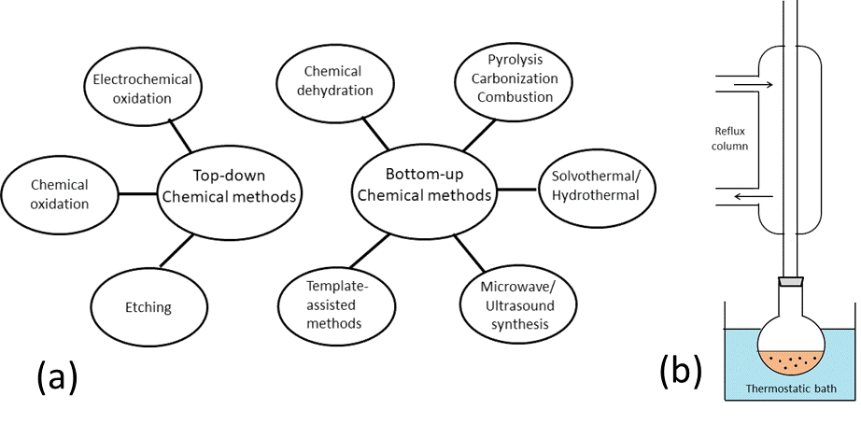
In all experimental samples, 0.3 g of precursor was dissolved in 4.5 g of distilled water, previously purged with nitrogen to remove the presence of oxygen. In each solution of sugar, 0.1 g of NaOH have been added and the mix has been put in a flask kept at constant temperature by immersion in a thermostatic bath for a prefixed time, as shown in Figure 1(b). The flask is equipped with a reflux column, cooled with a constant stream of water at room temperature, in order to ensure a fixed concentration of carbon precursor and NaOH during the experiment. The hold-up is continuously kept in vigorous agitation by a stirring bar to attain a homogeneous temperature distribution inside the vessel.
Figure 1: (a): Conceptual scheme of different types of chemical methods for carbon NPs synthesis. (b): simplified layout of the experimental laboratory equipment.
    - Analytical methods
CDs have been characterized in diameters by dynamic light scattering using a Zetasizer Nano ZS (Malvern Instruments, Malvern, UK). We used disposable polystyrene cuvettes of standard size (3.5 mL total, filled in with 1.3 mL solution). For each solution, we carried out at least six measurements of five runs each. In case of some deviating measurements, we considered only the dominating results, in the ratio of at least 67% of the total number. The results are presented as the size distribution by NPs number, which is the actual quantity of practical interest.
  - Results and Discussion
In the first experimental essays, aqueous solutions of mannitol and erythritol in the presence of NaOH were tested for decomposition at 100 °C for one hour. No appreciable change in color, which is a typical visual sign of ongoing caramelization kinetics for C NPs synthesis, was noticed. For this reason, these precursors were excluded from further experimental tests, which were focused only on fructose and lactose. The thermolysis of these compounds was carried out at 50 °C for two different reaction times.
In Figure 2, the probability distribution function of particle diameters have been plotted for four different cases, namely for fructose and lactose dissociation for two different reaction times of 10 and 30 minutes. In all samples, an appreciable change of color during time was observed, starting from a clear yellow to a dark orange-red for longer times. At equal short reaction times, the samples containing fructose show a darker coloration than those containing lactose, but these differences tend to disappear at longer reaction times. This trend can be ascribed to the combined effects of caramelization and aggregation kinetics, with different reciprocal weights depending on the specific precursor. The upper-left plot, which refers to fructose at short reaction time, indicates the formation of very small carbon NPs, having average diameter of 1.7 nm, so that they can be considered as carbon nanodots. As expected, the corresponding upper-right plot depicts a curve indicating greater average diameters of about 38 nm. This trend can be explained recalling that, in the present experiments, no surfactants or capping agents for NPs stabilization (Grytsenko et al., 2019) have been employed. As a consequence, at least as far as fructose is concerned, the longer the reaction time at the same temperature, the higher is the number of aggregation events leading to larger diameters. In lower-left panel, the curve corresponding to lactose dissociation for short times is reported. The trend is somewhat different from the one of fructose at short times, with formation of larger NPs having average diameter of 68 nm even at the beginning of the caramelization process. The lower-right plot depicts a situation essentially similar to the one corresponding to short times, with average diameter of 105 nm, suggesting the attainment of a regime where aggregation dominates the global scenario. In the present experimental campaign, the use of surface passivation agents has been intentionally avoided to check, at least qualitatively, the combined effects of time and temperature during the carbonization process. On the other side, when lactose is used, the concomitant use of a surface passivation agent was proven to be particularly beneficial to slow down the aggregation, as in the case-study reported by Zhang et al. (2013), who synthesized fluorescent carbon NPs at 100 °C in a reflux reactor for 24 h using tris(hydroxymethyl) amino-methane (Tris) as surface passivation agent. They obtained stable CD of very small dimensions, with high quantum yield in fluorescence up to 12.5%. In the present experimental study, the presence of NaOH as basifier made it possible to start a caramelization process at a particularly low temperature, but there are similar cases where variations of pH proved to be beneficial for the dissociation of precursors with formation of carbon NPs (Wang el al., 2017). Incidentally, lactose has been object of analogous investigations by López et al., (2015), who carried out its thermal dissociation by microwave heating at 160 °C in acid medium, obtaining CDs of 10 nm as average diameter. Interestingly, this result was attained without using additives for surface passivation, limiting the dissociation time at 15 minutes only. Studies concerning carbon NPs chemical synthesis carried out at
T<100 °C are uncommon in literature. In the present case, the dissociation of sugars proceeds even
at T<50 °C, as clearly observable in Figure 3, where the samples pertaining to fructose and lactose, after addition of NaOH, have been photographed at sequential time steps at room temperature to have a direct visualization of the chromatic changes related to the kinetics of caramelization.

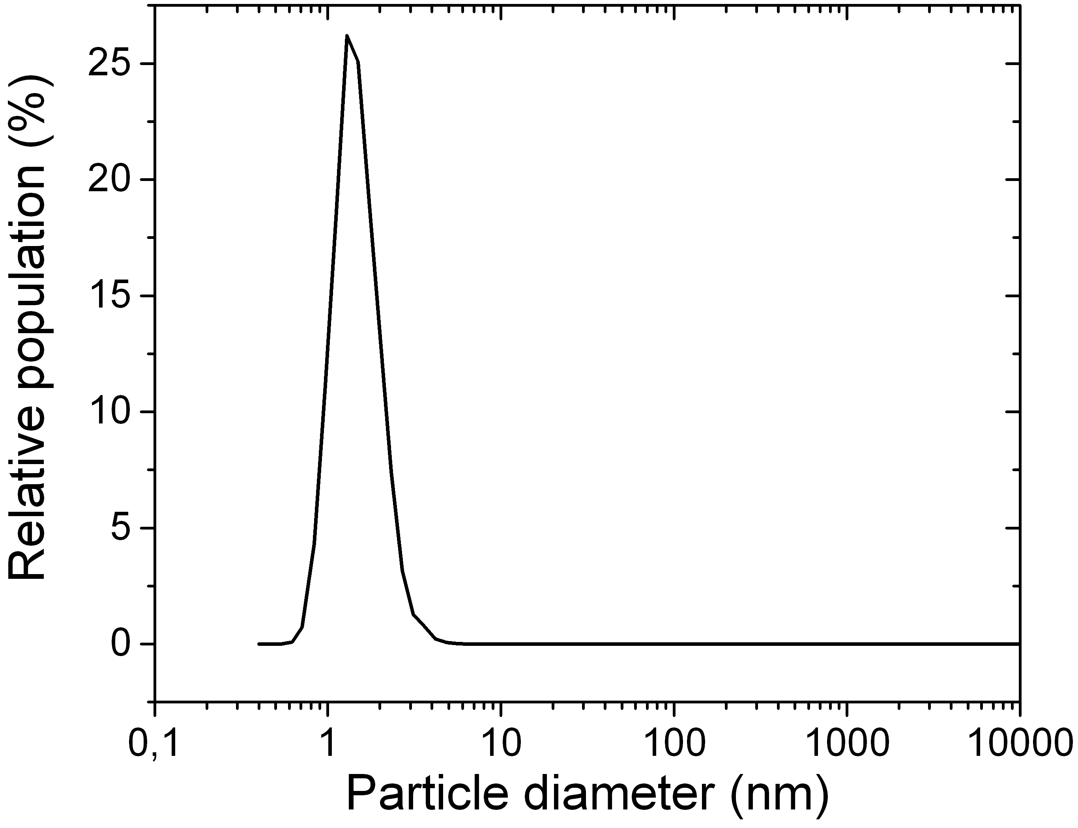
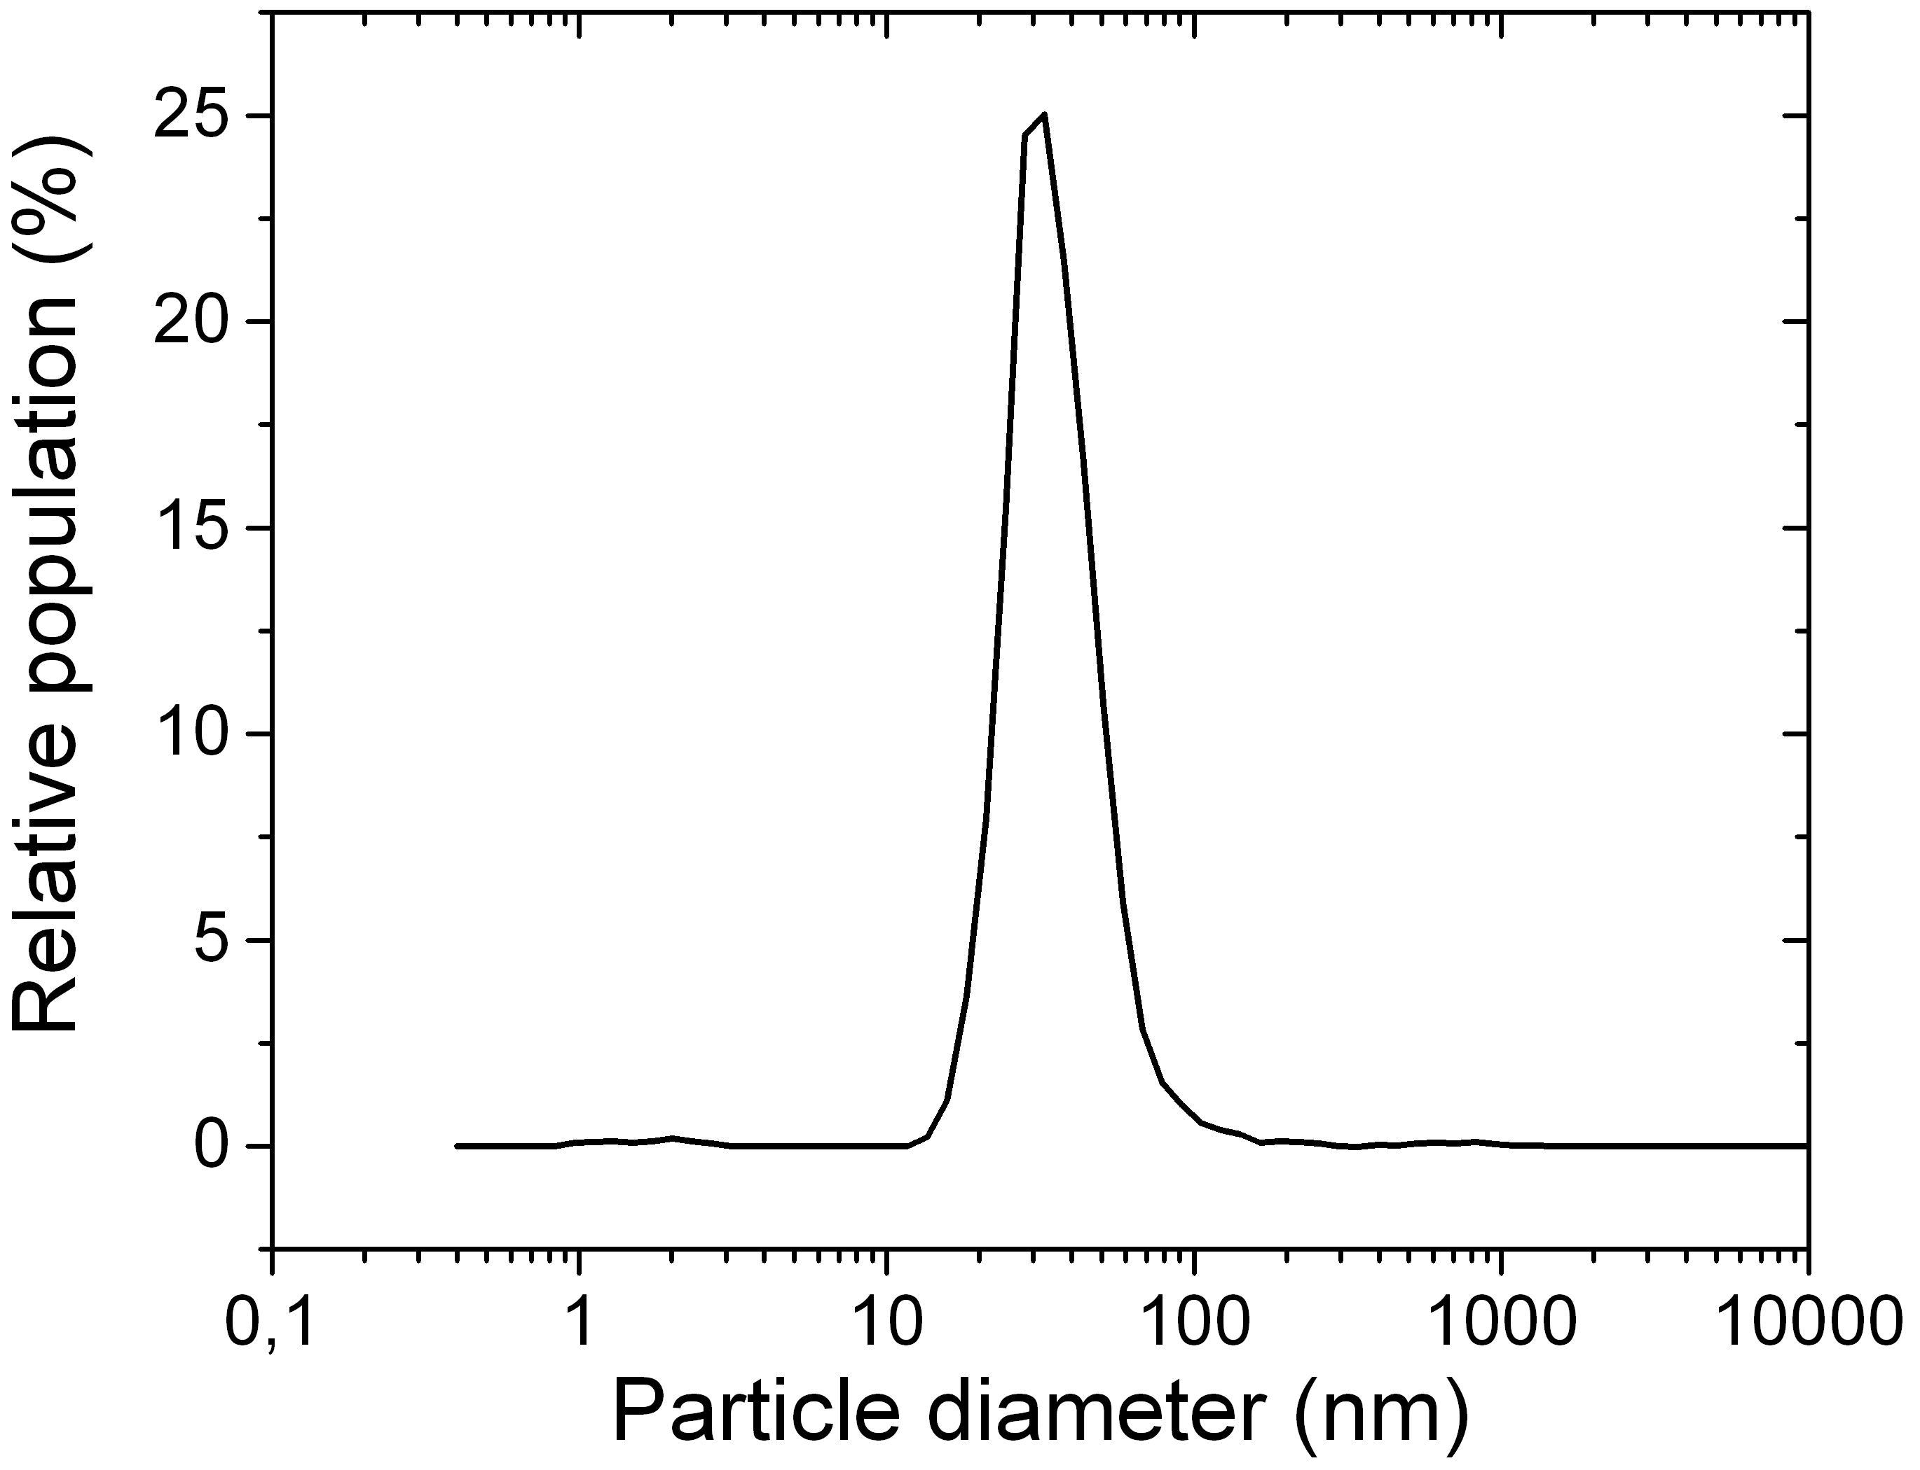
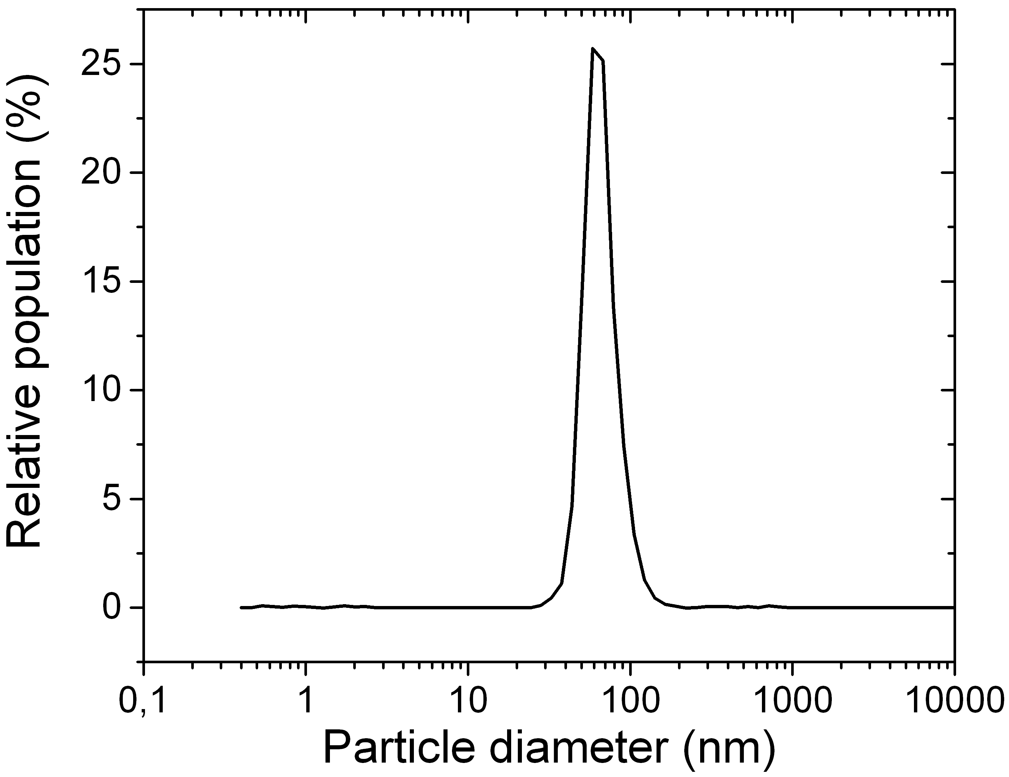
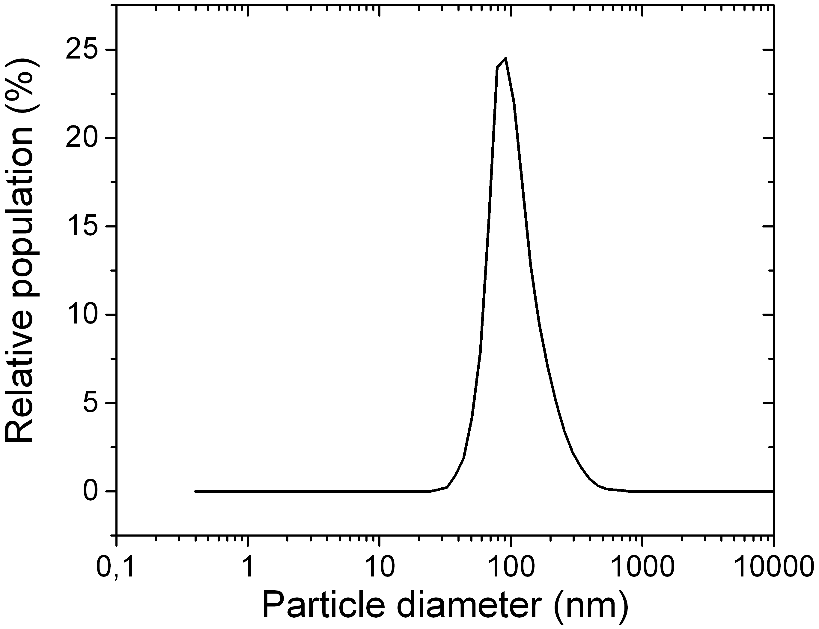
a
b
c
d

Figure 2: Particle size distributions obtained by DLS for the four combinations of fructose (upper row) and lactose (lower row) at short (left column) and long (right column) reaction time: a) fructose, 10 min; b) fructose, 30 min; c) lactose, 10 min; d) lactose, 30 min.
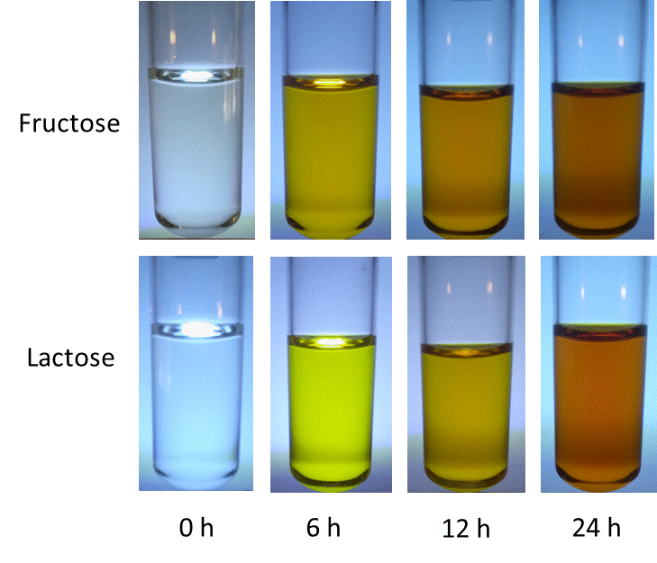
Figure 3: Upper row: from left to right, images of fructose decomposition at room temperature after several reaction times, namely t = 0h, 6h, 12h, 24h. Lower row: from left to right, images of lactose decomposition at room temperature, after the same reaction times listed above.

In this context, the present work has some aspects in common with the study of Mitra et al. (2013), who obtained CQDs at room temperature from polyethylene glycol (PEG-200) in a single-pot process.
  - Conclusions
A technique of carbon NPs synthesis at low temperature using lactose and fructose as precursors has been proposed, without the addition of capping agents or surface passivation reagents. The method benefits from the presence of NaOH as basifier, by which carbon NPs of small dimensions have been obtained at mild operating conditions. On the opposite, carbohydrates like mannitol and erythritol showed a negligible kinetics of dissociation even at higher temperatures (T=100 °C), and a relative insensitivity to the presence of NaOH. For these reasons, they did not prove to be suitable for such a technique.
With respect to other standard processes for carbon NPs synthesis from sugars, the method here proposed may offer the following advantages:
- The present hydrothermal process in aqueous solvent at T=50 °C may reduce considerably the fixed costs of operations, thus requiring simple and economical apparatuses. The running cost in terms of reagents and utilities is likewise limited.
- Neither hazardous emissions, nor toxic by-products or intermediate can result by the synthesis process, contrarily to conventional thermolysis routes carried out at higher temperature.
- The process does not require special protective or mitigating safety layers including added-on technical measures, owing to its inherent safety and “green” characteristics.
The present technique may be used as a starting point to synthesize functionalized carbon NPs for a variety of applications, including photocatalysis and optoelectronics. In further investigations, the effect of surface passivation agents will be tested, possibly having high efficiency combined with low environmental impact and easiness of removal.
Acknowledgments
It is a pleasure to thank Mr. Federico D’Onofrio who offered a basic technical support for the paper realization.
References
Cayuela A., Soriano M.L., Carrillo-Carrión C., Valcárcel M., 2016, Semiconductor and carbon-based fluorescent nanodots: the need for consistency, Chemical Communications 52, 1311-1326.
Chen B.B., Liu M.L., Li C.M., Huang C.Z., 2019, Fluorescent carbon dots functionalization, Advances in Colloid and Interface Science 270, 165-190.
Chiarioni A., Reverberi A.P., Fabiano B., Dovì V.G., 2006, An improved model of an ASR pyrolysis reactor for energy recovery, Energy 31, 2460-2468.
Das S.K., Liu Y., Yeom S., Kim D.Y., Richards C.I., 2014, Single-particle fluorescence intensity fluctuations of carbon nanodots, Nano Letters 14, 620-625.
Dzhardimalieva G.I., Uflyand I.E., 2018, Thermal transformations of polymeric metal chelates and their precursors in nanocomposites formation, Springer Series in Materials Science 257, 899-1007.
Fabiano B., Pistritto F., Reverberi A., Palazzi E., 2015, Ethylene-air mixtures under flowing conditions: A model-based approach to explosion conditions, Clean Technologies and Environmental Policy 17, 1261-1270.
Fabiano B., Reverberi A.P., Varbanov P.S., 2019, Safety opportunities for the synthesis of metal nanoparticles and short-cut approach to workplace risk evaluation, Journal of Cleaner Production, 209, 297-308.
Goryacheva I.Yu., Sapelkin A.V., Sukhorukov G.B., 2017, Carbon nanodots: Mechanisms of photoluminescence and principles of application, Trends in Analytical Chemistry 90, 27-37.
Grytsenko O., Gajdoš I., Spišák E., Krasinskyi V., Suberlyak O., 2019, Novel Ni/pHEMA-gr-PVP composites obtained by polymerization with simultaneous metal deposition: Structure and properties, Materials 12, Article number 1956.
Hu Y., Yang J., Tian J., Jia L., Yu J-S., 2014, Waste frying oil as a precursor for one-step synthesis of sulfur-doped carbon dots with pH-sensitive photoluminescence, Carbon 77, 775-782.
Li F., Chen J., Hu X., He F., Bean E., Tsang D.C.W, Ok Y.S., Gao B., 2020, Applications of carbonaceous adsorbents in the remediation of polycyclic aromatic hydrocarbon-contaminated sediments: A review, Journal of Cleaner Production 255, 120263.
López C., Zougagh M., Algarra M., Rodríguez-Castellón E., Campos B.B., Estéves da Silva J.C.G., Jiménez-Jiménez J., Ríos A., 2015, Microwave-assisted synthesis of carbon dots and its potential as analysis of four heterocyclic aromatic amines, Talanta 132, 845–850.
Mitra S., Chandra S., Pathan S.H., Sikdar N., Pramanik P., Goswami A., 2013, Room temperature and solvothermal green synthesis of self-passivated carbon quantum dots, RSC Advances 3, 3189-3193.
Ostadhossein F., Pan D., 2017, Functional carbon nanodots for multiscale imaging and therapy, Wiley Interdisciplinary Reviews: Nanomedicine and Nanobiotechnology 9, e1436.
Pascariu V., Avadanei O., Gasner P., Stoica I., Reverberi A.P., Mitoseriu, L., 2013, Preparation and characterization of PbTiO3-epoxy resin compositionally graded thick films, Phase Transitions, 86, 715-725.
Primerano P., Milazzo M.F., Risitano F., Matarazzo F., 2016, A sustainable improvement of the
tetrabromoethylcyclohexane synthesis using Amino ILs as catalysts in water. A facile and environmentally friendly procedure, J. of Chemical Technology and Biotechnology 91, 1274-1279.
Rani U.A., Ng L.Y., Ng C.Y., Mahmoudi E., 2020, A review of carbon quantum dots and their applications in wastewater treatment, Advances in Colloid and Interface Science 278, 102124.
Reverberi A.P., Vocciante M, Lunghi E., Pietrelli L., Fabiano B., 2017, New trends in the synthesis of nanoparticles by green methods, Chemical Engineering Transactions 61, 667-672.
Reverberi A.P., Salerno M., Lauciello S., Fabiano B., 2016, Synthesis of copper nanoparticles in ethylene glycol by chemical reduction with vanadium (+2) salts, Materials 9, Article number 809.
Sciortino A., Cannizzo A., Messina F., 2018, Carbon nanodots: A review-From the current understanding of the fundamental photophysics to the full control of the optical response, Journal of Carbon Research 4, 67.
Sharma S., Umar A., Sood S., Mehta S.K., Kansal S.K., 2018, Photoluminescent C-dots: An overview on the recent development in the synthesis, physiochemical properties and potential applications, Journal of Alloy and Compounds 748, 818-853.
Sharma V., Tiwari P., Mobin S.M., 2017, Sustainable carbon-dots: recent advances in green carbon dots for sensing and bioimaging, Journal of Materials Chemistry B 5, 8904-8924.
Shojaei T.R., Salleh M.A.M., Tabatabaei M., Mobli H., Aghbashlo M., Rashid S.A., Tan T., 2019, Applications of nanotechnology and carbon nanoparticles in agriculture, Chapter In: S.A. Rashid, R.N.I.R. Othman, M.Z. Hussein (Eds.), Synthesis, Technology and Applications of Carbon Nanomaterials, Elsevier, Netherlands, 247-277.
Toccafondi C., Dante S., Reverberi A.P., Salerno, M., 2015, Biomedical applications of anodic porous alumina, Current Nanoscience, 11, 572-580.
Vocciante M., Finocchi A., D'Auris A.F., Conte A., Tonziello J., Pola A., Reverberi A.P., 2019, Enhanced oil spill remediation by adsorption with interlinked multilayered graphene, Materials 12, Article number 2231.
Wang Y-Q., Xue Y-N., Li S-R., Zhang X-H., Fei H-X., Wu X-G., Sang S-B., Li X-N., Wei M., Chen W-Y., 2017, Nanocomposite carbon dots/PAM fluorescent hydrogels and their mechanical properties, Journal of Polymer Research 24, 224
Zhang Y-Y., Wu M., Wang Y-Q., He X-W., Li W-L., Feng X-Z., 2013, A new hydrothermal refluxing route to strong fluorescent carbon dots and its application as fluorescent imaging agent, Talanta 117, 196-202.

