|  |  |
| --- | --- |
| cetlogo ***CHEMICAL ENGINEERING TRANSACTIONS***  ***VOL. 82, 2020*** | A publication of  aidiclogo_grande |
| The Italian Association  of Chemical Engineering  Online at www.cetjournal.it |
| Guest Editors: Bruno Fabiano, Valerio Cozzani, Genserik Reniers  Copyright © 2020, AIDIC Servizi S.r.l. **ISBN** 978-88-95608-80-8; **ISSN** 2283-9216 | |

Analysis of the Operational Risk of the Process Pasteurization and Mixing in a Dairy Processing Plant, Using the HAZOP Methodology

Angie Montaño, Yeferson Torres, Eddy Herrera, Johan Rincon, Pablo Velasquez, Angelica Santis\*

Universidad Cooperativa de Colombia, Avenida Caracas 37-63, Bogota

angelica.santisn@ucc.edu.co

The realization of PHA (Process Hazard Analysis) as an evaluation of all those elements that are part of management programs for safety in industrial processes that can generate an impact on the profitability of the company, is a matter to highlight. Given the above, industries need to identify the variations that occur concerning normal parameters in the process. During the development of the study, operational risks are analysed in the process of a dairy plant, located in Cundinamarca, Colombia. For this analysis, the HAZOP methodology is used, which will allow the identification of hazards, operability study, and mitigation of the risks related to the investigated process. For the analysis, the pasteurization and mixing stage as the subsystem was determined. In this operational stage, the node to study was the reactor. The different diagrams of the node for the analysis were established. The specifications at the equipment and instrumentation level were used. Previous information, plus the contributions regarding the operation of the plant by staff, the inputs are compiled for the development of the mentioned methodology. Once the deviations in the studied node were identified, the possible origins and effects of each deviation were determined. The measures and corrective actions necessary for improvements in the production process were proposed.

* 1. Introduction

For a manufacturing company, it is essential to keep control of each process in order to keep the profitability rates stable and the mitigation most significant possible number of operational risks. In the case of dairy companies, considering that their products categorized as high risk to public health, these controls must be more exhaustive to ensure the total quality of the products to the customer. One of the most critical processes in the industry is milk safety before it converts into a finished product, microbial safety must ensure to increase milk life; therefore, the pasteurization is the heat treatment for used to guarantee the milk safety in this industry. (Aouanouk, et al., 2018). With the main to ensure the continuous improvement of the company and the supervision of the procedure of pasteurization of the milk, it is necessary to implement the risk analysis process commonly known as PHA. For the realization of the PHA, there are different methodologies, among the most recognized and implemented is the technical what-if checklist, the analysis of the failure tree (FTA), modal analysis of failures and effects (FMEA), analysis of cause and consequence (CCA), analysis of event tree (ETA), preliminary analysis of risks (APR) and the functional analysis of operability (HAZOP) (Kunte and Sakthivel, 2016). The analysis mentioned above is functional; however, it is of vital importance to understand the resources available to be able to run it, the scope that it wants to give to the possible outcomes, the complexity, and stage of development of the facilities, among other factors. For this study, was chosen as methodology the HAZOP because of its easy application and contribution in the processes of the dairy industry, this analysis is based on the standard IEC 61882:2016 (IEC, 2016).

The technique HAZOP focuses on identifying and analysing the risks and also in the methodical and systematic tracking of the operational deviation. Besides, this analysis achieves to determine the different stages that can affect the employees, environment, infrastructure, inputs, machinery, production, and other factors. In the same way, it is establishing the principal components that cause risks as the process distribution, the equipment, the design, human actions, lack of preventive methods, external methods, for these reasons is necessary to count on teams of experts that known and understand the process with the different risks in functioning. Later is analysed the probability and severity when the problem happens and then to pose a sequence of recommendations and suggestions that mitigate the damages and dangerous situations. Additionally, this technology is of human reasoning, and for this reason, there is not a success or exact solution, it depends on the knowledge and experience of human resource who applies the methods (Freedman, 2003). Therefore, in this case, is showed as an example of a dairy factory located in Colombia, where the control of operational parameters is not constant, only the factory realizes an initial inspection and other of the tentative way in the course of the process of pasteurization the milk. Different variables condition this process of integrating into all systems, and it requires a combination of time-temperature that achieves adequate heat treatment from microbiological and organoleptic perception milk suitable for its final treatment. (Gonzalez, 2013). As a result, with the methodology HAZOP, the factory can determine the operational risks for establishing preventive measures but also to realize a cost budget of the process and its failures. Finally, it concludes that this technique applies in any company and process with positive results in the identification of the deviation of the variable and the operational parameters of the process that carry in risk situations and difficulties in operation.

* 1. Material and methods

The analysis of operational risk performs at a plant of dairy, located in the municipality of Subachoque, department of Cundinamarca, Colombia. The method employed for the analysis, as mentioned previously, it was the HAZOP. It determinate as the principal subsystem for the analysis, the stage of pasteurization, and mixing. In this operational phase, the node-to-study was the reactor. The description of the process makes using a diagram P&ID shown in Figure 1.

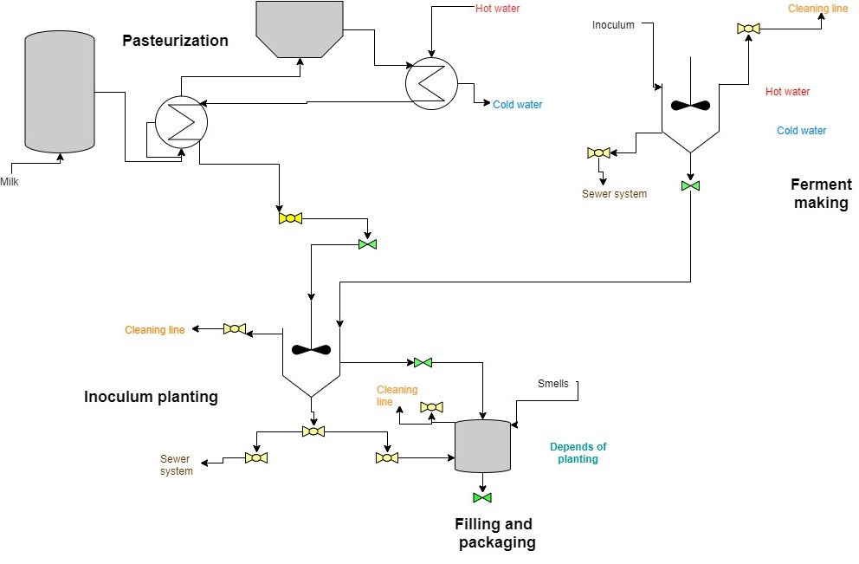

Figure 1: P&ID Process Pasteurization and Mixing

The identification process of deviations and possible causes are made considering parameters such as the pressure, temperature, flow, among others. A matrix with further improvements to the model proposed by Marhavilas et al., 2019, was created.

* 1. Results and discussion

Table 1 shows the risk matrix produced, considering the parameters for severity (S) and probability (L), and in Table 2, the parameters that define the probabilities of events where failures occur are presented.

Table 1: Risk matrix

|  |  |  |  |  |  |  |  |  |  |  |  |  |  |
| --- | --- | --- | --- | --- | --- | --- | --- | --- | --- | --- | --- | --- | --- |
| **Ranking** | **Severity(S)** | |  | | **Consequences** | | **Likelihood(L)** | | | | | | |
|  |  | **Environmental damage** | | **Clients - Business Economics** | | **Personnel injury** | | **1** | 2 | 3 | 4 | **5** |
| **5** | Catastrophic/ Fatal | Multiple environments affected | | Loss of market share. > 10 million | | Single fatality or multiple fatalities. Permanent disability | | **M** | **M** | **H** | **H** | **VH** |
| **4** | Severe/ Serious | Major localized effect | | Loss of sensitive or priority market customers. > 1 Million and <= 10 Million | | Fracture, hospitalisation >24 hrs, incapacitation >4 weeks | | **L** | **M** | **M** | **H** | **H** |
| **3** | Major | Localized effect | | Shortages and / or loss of customers. > 100,000 and <= 1 million. | | Strain/twist, sprain/ cramp/ dislocation, incapacitation >= 3 days | | **N** | **L** | **M** | **M** | **H** |
| **2** | Small/Minor | Minor effect | | Complaints and / or Claims. > 10,000 and <= 100,000 | | Minor injury (without disability), basic first-aid need, no-hospitalization | | **N** | **N** | **L** | **M** | **M** |
| **1** | Trivial/Only Minor | Slight | | Specification non-compliance fixed. <10,000 | | Minor injury, discomfort, slight bruising, self-help recovery | | **N** | **N** | **N** | **L** | **L** |
| **0** | No impact | No effect | | None | | No injury | | **N** | **N** | **N** | **N** | **N** |

Risk (R): \* VH:"Very High"; H:" High"; M:" Medium"; L:" Low"; N:" None"

Table 2: Likelihood parameters definition]

|  |  |
| --- | --- |
| Code | Definition |
| 1 | Remote (almost never). It has not happened in the industry. Once per 100 years |
| 2 | Unlikely (occurs rarely). It has happened in the industry (once per 25 years) |
| 3 | Possible (could occur, but uncommon). It has happened in the last 10 years |
| 4 | Likely (recurrent but not frequent): once per year. Probable occurrence in a period between 1 and 5 years |
| 5 | Very likely (occurs frequently). It can occur throughout the year. Several times a year (once per month) |

Based on the risk matrix developed, we identified the main perturbations and deviations that have the process. There we found that the main risks are relational with systems of flow, temperature, agitation, and lack of maintenance programs. Set out the consequences that can generate each risk, and the most critical were related to shutdowns of the process, fire, and explosions, which would imply much harm to the personal as economic the evaluation of the previously mentioned evidence in table 3. Besides, inside the table are set out the possible recommendations or solutions to mitigate the risks mentioned.

*Table 3: Evaluation of the risk of the node (continue)*

|  |  |  |  |  |  |  |  |  |
| --- | --- | --- | --- | --- | --- | --- | --- | --- |
| Parameter | Deviation | Posible Cause | Consequences | Safeguards | Risk Matrix | | | Recommendations |
|  |  |  |  |  | S | L | R |  |
| Flow | Low Flow | The flow is varied, where it is necessary that the retention time is 18 - 20 sec evenly | The reduction of microorganisms and bacteria is not achieved due to the effect of the pasteurization temperature. Delay in the process. | Regulate the flow. Process the milk again. | 3 | 3 | M | Have a follow up maintenance program |
|  | Reverse flow | Blockage / Breakage of check valves | Blockage / Breakage of check valves | Change of periodic check valves and preventive inspections to avoid production stoppage | 4 | 3 | M | Generate a change of valves in order to minimize obstructions in the process |
| Maintenance | Less Level | Liquid inlet control valve failure, Level control probe failure | Variation of optimal operating conditions, Decrease or increase of the output flow | Routine valve checks, Regular probe calibration | 5 | 2 | M | Automate the process with electrovalves where they are controlled by the signals emitted from the probes to avoid the variation of the optimal conditions of the process. |
|  | High pipe temperatures | Uncalibrated measuring instruments | Failures in the piping system | Check in detail the operation of each part of the steam system | 4 | 2 | M | Entities trained to maintenance. have personnel experienced in the handling of the tools |
|  | Delay in mixing | Breakage in the feeder mixer. | Decreases capacity and product quality | Repair mixer and review maintenance plan | 5 | 2 | M | Purchase machinery of quality. have personnel experienced in the handling of machines and the tools. planning of maintenance programs |
|  | Pollution | Microorganisms that interact with milk due to poor cleaning of heat exchange | Loss of the final product | Standardized preventive maintenance and control programs for cleaning of heat exchanges by process operators | 5 | 3 | H | Establishing a timeline with activities and responsible people of cleaning of each area. Creating a program of preventive maintenance of each machine and its components |
|  | High / low temperature | Temperature decrease in the heat exchange due to the malfunction of the pneumatic valves | customer poisoning | Check and calibrate the pneumatic valves | 5 | 2 | M | Checking the calibration parameters frequently. Creating a preventive maintenance program, with prevalence in the critical components |
|  | No agitation | Power supply failure, Failure in the agitation system | Decreased conversion, imperfect mixture. | Routine checks of the agitation system, routine Maintenance of the agitation system, Installation of an emergency generator for power failure. | 5 | 3 | H | Having at least two sources of electric power generation for an emergency. Creating a program with preventive and corrective activities that permit an assertive reaction in an emergency |
|  | No flow of milk | Compressor failure / obstruction, valves closed, pipe leak | It paralyzes the production process. Production costs increase | Review periodic state of the flow of the milk and the ducts to prevent breakdowns, obstructions and leakage of pipelines. | 5 | 3 | H | Implement a comprehensive valve system to prevent breakdowns, obstructions, and periodically carry out preventive maintenance. |
|  | Reverse flow | Pump failure | Production stopped | Constant revision of pumps | 5 | 3 | H | Perform pump maintenance, in addition to maintaining flow and process control |
|  | Agitation | Loss of control of the speed of rotation of the motor by voltage failure and system of electrical energy | Movement of the propellers of the agitator uncontrolled | Preventive maintenance, review periodic networks electrical plant | 5 | 4 | H | Periodic change of the tension pulleys. To Acquire an electric power plant |
| Temperature | Thermal inactivation | General pasteurizer failures | High microbial load in the final product | Safety integrity level mass flow control | 5 | 4 | H | Controlling the time and temperature and to implement a system of random sampling with microbiological tests that guarantee the quality levels in the pasteurization process. |
|  | Heat transfer | The deviation of 5 °C with respect to the water outlet of the unit hot water | Greater resistance to heat transfer in the heat exchanger due to fouling in the equipment. Delay in the process. | Requires cleaning by qualified personnel and quality inputs. | 5 | 2 | M | Planned maintenance programs are optimal to the periodicity of the process |
|  | Low and high temperature | The lack of standardization and control of the pasteurization process. In which a temperature must be managed of 70 to 75 °C for a period of 10 to 15 seconds. | The permanence of agents pathogens in the final product for the short period of time of exposure of the milk to the temperature, The loss characteristics of the milk as nutrients or vitamins for a long time of temperature | Control the process by means of instruments such as termometers and timers. Implementation of a control that opens an air valve triple that switches when the product has reached the temperature of pasteurization | 5 | 3 | H | Implement a system of indirect heat. Controlling and document the parameters like time and ranks of maximum and minimum temperature in the thermal process with traceability records |
|  | No heat extraction from reactors | Inefficient design of reactors that increase the risk of explosion | Explosion accidents | Increased monitoring of component status, replacement of critical components with higher reliability components, Improving reactor power Installation of protective walls | 5 | 3 | H | Maintain a follow-up maintenance programs. have experienced staff in the training and handling of machinery. |
|  | Cooling system failure | Cooling system failures | Fires, explosions | Reaction leak identification software based on energy balance | 5 | 3 | H | Periodic verification of the functioning machines through control charts |
|  | Critical temperature threshold | Emergency discharge system malfunction | Fires, explosions | Risk prediction analysis | 5 | 5 | VH | Creating an emergency protocol with corrective measures |
| Transfer | Transfer of heat | Insufficient inhibition of the microbial load due to improper heat treatment | Intoxication of customers, and total loss of the product | Implement a system of recirculation of the milk to increase inhibition of the microbial load | 5 | 1 | M | Standardize and document the parameters like time and ranks of maximum and minimum temperature in the thermal process. Delegating responsible people in the control of critical parameters |

* 1. Conclusions

The use of HAZOP allows us to conclude that the method is appropriate when identifying the existence of risks within the mixing and pasteurization process. The identification of faults in the systems that generate alterations and lack of precision, especially in the operational parameters (temperature and pressure), warns of the need for measures such as detailed inspections and maintenance. Also, it allows the recognition of the repercussions that could be had, such as the deterioration and performance of the machinery, safety risks to employees, and the quality of the final product, which could influence consumer satisfaction and well-being. It is noteworthy that many of the risks can mitigate through operational controls such as the anticipation of failures of each machine based on evaluation tools such as the documentation of maintenance activities, generation of schedules with functions aimed at responsible persons, statistical sampling methods that allow evaluating consequences and preventive and corrective measures at different stages. In conclusion, the technique allows the increase in safety levels within a process in which it is crucial that the milk meets the appropriate microbiological parameters, avoiding situations where the health of consumers can be affected.

References

Aouanouk, A., Absi, A., Mouheb, A., Tounsi, Z., 2018, Milk Heat Treatments: Temperature Effect on Fouling, Chemical Engineering Transactions, Vol 71, 1267–1272.

Gonzalez, S.M., 2013, UF1281: Preparation of Milk for Consumption, ProQuest Ebook Central, Madrid, IC Editorial.

IEC, 2016, IEC 61882 Hazard and Operability Studies(HAZOP Studies)‐Application Guide, Edition 2.0.

Kunte, V.A., Sakthivel, S., 2016, Useful Tips for a Successful HAZOP Study, Hydrocarbon Processing, 51–57.

Freedman, P., 2003, HAZOP as a risk analysis methodology, Petrotecnia, Buenos aires, 60-64.

Marhavilas, P.K., Filippidis, M., Koulinas, G.K., Koulouriotis, D.E., 2019, The integration of HAZOP study with risk-matrix and the analytical-hierarchy process for identifying critical control-points and prioritizing risks in industry – A case study, Journal of Loss Prevention in the Process Industries, Vol 62, 1–16.