|  |  |
| --- | --- |
| cetlogo ***CHEMICAL ENGINEERING TRANSACTIONS***  ***VOL. 82, 2020*** | A publication of  aidiclogo_grande |
| The Italian Association  of Chemical Engineering  Online at www.cetjournal.it |
| Guest Editors: Bruno Fabiano, Valerio Cozzani, Genserik Reniers  Copyright © 2020, AIDIC Servizi S.r.l. **ISBN** 978-88-95608-80-8; **ISSN** 2283-9216 | |

Hydrogen Refueling Stations: Prevention and Scenario Management. Large Scale Experimental Investigation of Hydrogen Jet-Fires

Chiara Vianelloa, Mattia Carbonia, Michele Mazzarob, Paolo Mocellina, Francesco Piloc, Gianmaria Pioe, Paola Russod, Ernesto Salzanoe,\*

aDipartimento di Ingegneria Industriale, Università degli Studi di Padova. Via Marzolo 9, 35131 Padova, Italia.

bCorpo Nazionale dei Vigili del Fuoco Direzione Centrale Prevenzione Sicurezza Tecnica. Largo S. Barbara 2, Roma, Italia.

cCorpo Nazionale dei Vigili del Fuoco Comando Venezia. Via Motorizzazione 7, 37100, Venezia, Italia.

dUniversità degli Studi di Roma La Sapienza.

e Dipartimento di Ingegneria Civile, Chimica, Ambientale e dei Materiali, Università di Bologna. Via Terracini 28, Bologna

40131, Italia.

ernesto.salzano@unibo.it

Hydrogen is becoming an attractive alternative for energy storage and transportation, because of the elevated energy content per unit of mass and possibility to have zero carbon-emission vehicles. For these reasons, hydrogen's share in global market is expected to grow substantially in the coming years. Today, hydrogen-fueled buses and cars are already available, and several refueling stations are operating in different countries around the world. A key role of the deployment of hydrogen fueled-vehicles is the presence of a widespread network of refueling stations, especially close to residential and industrial areas. This fact poses attention to the safety aspects related to hydrogen, with particular interest to its high flammability that can lead to catastrophic consequences for personnel and equipment. As a matter of fact, hydrogen is a comparatively less hazardous fuel compared to conventional fuels such as gasoline and diesel. Hydrogen infrastructures are characterized by operating pressure up to 1000 bar that, in case of an unintended loss of containments, may produce a highly under expanded turbulent jet. If ignited, this hydrogen jet may give rise to very severe scenarios, mainly related to high temperatures and the oriented flows. As recently suggested by Moradi and Groth (Moradi and Groth, 2019), there is a lack of experimental and on-site data for almost all of the storage and delivery technologies relevant to the hydrogen infrastructures. Experimental data is vital to support model validation, especially in the case of the very peculiar combustion process of hydrogen. In this way, a real-scale experimental campaign is proposed to investigate the main characteristic of the hydrogen jet fire resulting from its rapid fired depressurizations. The focus of the experimental campaign is the evaluation of safety distance for person and device (i.e. pressurized tanks) in order to avoid critical conditions and domino effects in refueling station. Different initial conditions, i.e., storage pressures, are exploited, and the resulting jet across specified orifice are investigated. More specifically, temperatures at various locations are measured through an arrangement of thermocouples. Values up to 1200 °C were obtained in the core of the jet. Moreover, it was found that the recorded temperatures, especially those at the outer portion of the jet, are very sensitive to the initial conditions.

* 1. Introduction

The development of the hydrogen economy that has characterized the last years is in the public eyes. Elevated environmental sustainability, flexibility in terms of production sources, and potential markets can be considered as some of the main driving forces of this trend. Indeed, hydrogen is already used as an energy carrier in motorized vehicles, for heating and cooling purposes and, also for storing excess generated electricity (Moradi and Groth, 2019). The peculiar physical and chemical properties of this species have required the development of tailor-made solutions addressing combustor, storage, and transportation systems related issues, indeed, lower density by volume characterizes hydrogen in comparison to fossil fuels (White et al., 2006). The combustion issue has promoted the development of detailed kinetic mechanisms and empirical correlations, assessing the overall reactivity under several conditions (Salzano et al., 2018). The storage issue has been traditionally addressed by implementing compressed gas solutions (Cirrone et al., 2018) or more recently by studying technological alternatives based on cryogenic liquefaction (Brunner and Kircher, 2016). Both alternatives have posed serious safety concerns because of the elevated ignitability, reactivity, and exothermicity of hydrogen/air mixtures regardless of the initial conditions and compositions (Liu and Zhang, 2014). Either theoretical or experimental approaches have been adopted to gain more insights on this subject (Bragin and Molkov, 2010). Considering the nature of the compressed systems, jet fires are of primary interest (Lees, 1996). In this sense, the majority of experimental studies include laboratory-scale tests for subsonic jet-flame burning hydrocarbons, but data for larger-scale sonic jet-flames are less available (Schefer et al., 2007). The computational fluid dynamic approach has been largely used for the characterization of accidental release from a pressurized vessel, as well (Xiao et al., 2018). Besides, empirical correlations estimating the mass flow rate ($w_{c}$) and other fundamental quantities have been developed and commonly implemented for the sake of consequence analysis. Jets with a high-pressure ratio are classified as under-expanded (Hess et al., 1973). In the reservoir, the gas is assumed to be stagnant, whereas the expansion is assumed to undertake an adiabatic transformation. Estimation of several properties is required for the sake of system characterization. To this aim, some of them can be estimated as follows:

$P_{e}=P_{0}∙ {\left(\frac{2}{γ+1}\right)}^{\frac{γ}{γ-1}}$ (1)

$T_{e}=T_{0}∙ \left(\frac{2}{γ+1}\right)$ (2)

$ρ_{e}=ρ_{0}∙ {\left(\frac{2}{γ+1}\right)}^{\frac{γ}{γ-1}}$ (3)

$u_{e}=\sqrt{\left(\frac{2∙γ}{γ+1}∙R∙T_{0}\right)}$ (4)

$w_{c}=ρ_{e}∙A∙u_{e}$ (5)

where $γ$, *P* (Pa), *T* (K), *u* (m/s), and (kg/m3) are the specific heat ratio, pressure, temperature, gaseous velocity flowing through an orifice having a surface *A* (m2), and density, respectively, and the subscripts 0 and *e* stand for reservoirs and outlet conditions. The term $w_{c}$ (kg/s) is then the mass flow rate. As mentioned before, the velocity is assumed to be zero ( $u_{0}=0)$ in the reservoirs. It should be noted that the Joule-Thomson effect was not taken into consideration. The obtained awareness on the phenomena occurring during this type of scenario for compressed hydrogen and the economic convenience in handling of high-density gas have pushed toward the implementation of higher storage pressures. However, a dearth of experimental data on large scale tackling this issue at extreme conditions can be highlighted in the current literature. In this light, additional experimental studies before large scale commercialization are essential to test the validity of the abovementioned correlations and procedures under conditions not considered, so far. For these reasons, a horizontal hydrogen jet flame deriving from a release commonly deriving from tank operating at pressures within the range 240-450 bar has been experimentally investigated in this work. The free hydrogen jets have been ignited, and the resulting thermal loads distribution with respect to the distance from the releasing point has been studied.

The length of the jet flame $LF$ has been extensively reported in the open literature also for hydrogen. Molkov et al. (2013) have developed two simple correlations, one validated for subsonic, sonic, and supersonic hydrogen jet flames line (Eq.6), and one representing the upper limiting curve for conservative estimation (Eq.7):

$LF=76∙{\left(w_{c}∙D\right)}^{0.347}$ (6)

${LF}_{max}=116∙{\left(w_{c}∙D\right)}^{0.347}$ (7)

where D is the diameter of the exit orifice expressed in m. These equations will be adopted in the next sections. The value of $LF$ is essential for the quantification of the consequences of the safety distances from the release point to apply in a hydrogen storage facility. Proust et al. (2011) used a video reduction technique to determine the flame length, and they reported that the flame length increases with the pressure up to 300 bar and never exceeds 7 m. Furthermore, they reported LF values of approximately 5.5 m and 5.0 m for pressures of 450 bar and 240 bar, respectively. Even though jet fires are often smaller than other types of fire, it is stated by Casal et al. (2012) that in 50% of the jet fires accident reported in the literature, an additional event with severe effects also occurred. Starting from these considerations, Molkov and Saffers (2013) have proposed a temperature-based criterion for the definition of safety distance based on the flame temperature of 309 °C, which is expected as third-degree burns for a 20 s duration (“death” limit). Using the measured axial temperature of hydrogen flame as a function of distance from the nozzle, x, it is then possible to derive the stand-off distances.

* 1. Experimental set-up

The tests were carried out at the Trentino Training center located in Rovereto, Italy. The high-pressure hydrogen storage was composed of a trailer consisting of sixteen high-pressure storage bottles with a volume of 50 L each, at the nominal pressure of 450 bar, and a hydrogen purity of 99.999%vol (Figure 1, left). The hydrogen release was provided by a 15 m long pipe with a constant internal diameter of 7 mm connected to a 3 mm orifice nozzle. The wind was measured at a height of 3 m by a mobile weather station. The prevailing wind direction was coincident with the direction of the jet (i.e., north) for the entire duration of the experiment. It was released horizontally 1 m above the ground and ignited by a methane-based burner (Figure 1, right). Two tests were conducted, the first at the initial pressure of 450 bar and the second at the initial pressure of 240 bar. The main test conditions are reported in Table 1.

*Table 1: Main test conditions.*

|  |  |  |  |  |  |  |  |
| --- | --- | --- | --- | --- | --- | --- | --- |
| Test | Orifice diameter (mm) | Initial reservoir pressure (bar) | Final reservoir pressure (bar) | Release duration (s) | Ambient temperature (°C) | Wind velocity (m/s) | Wind direction |
| Test 1 | 3 | 450 | 380 | 15 | 15 | 2 | North |
| Test 2 | 3 | 240 | 220 | 15 | 18 | 1 | North |

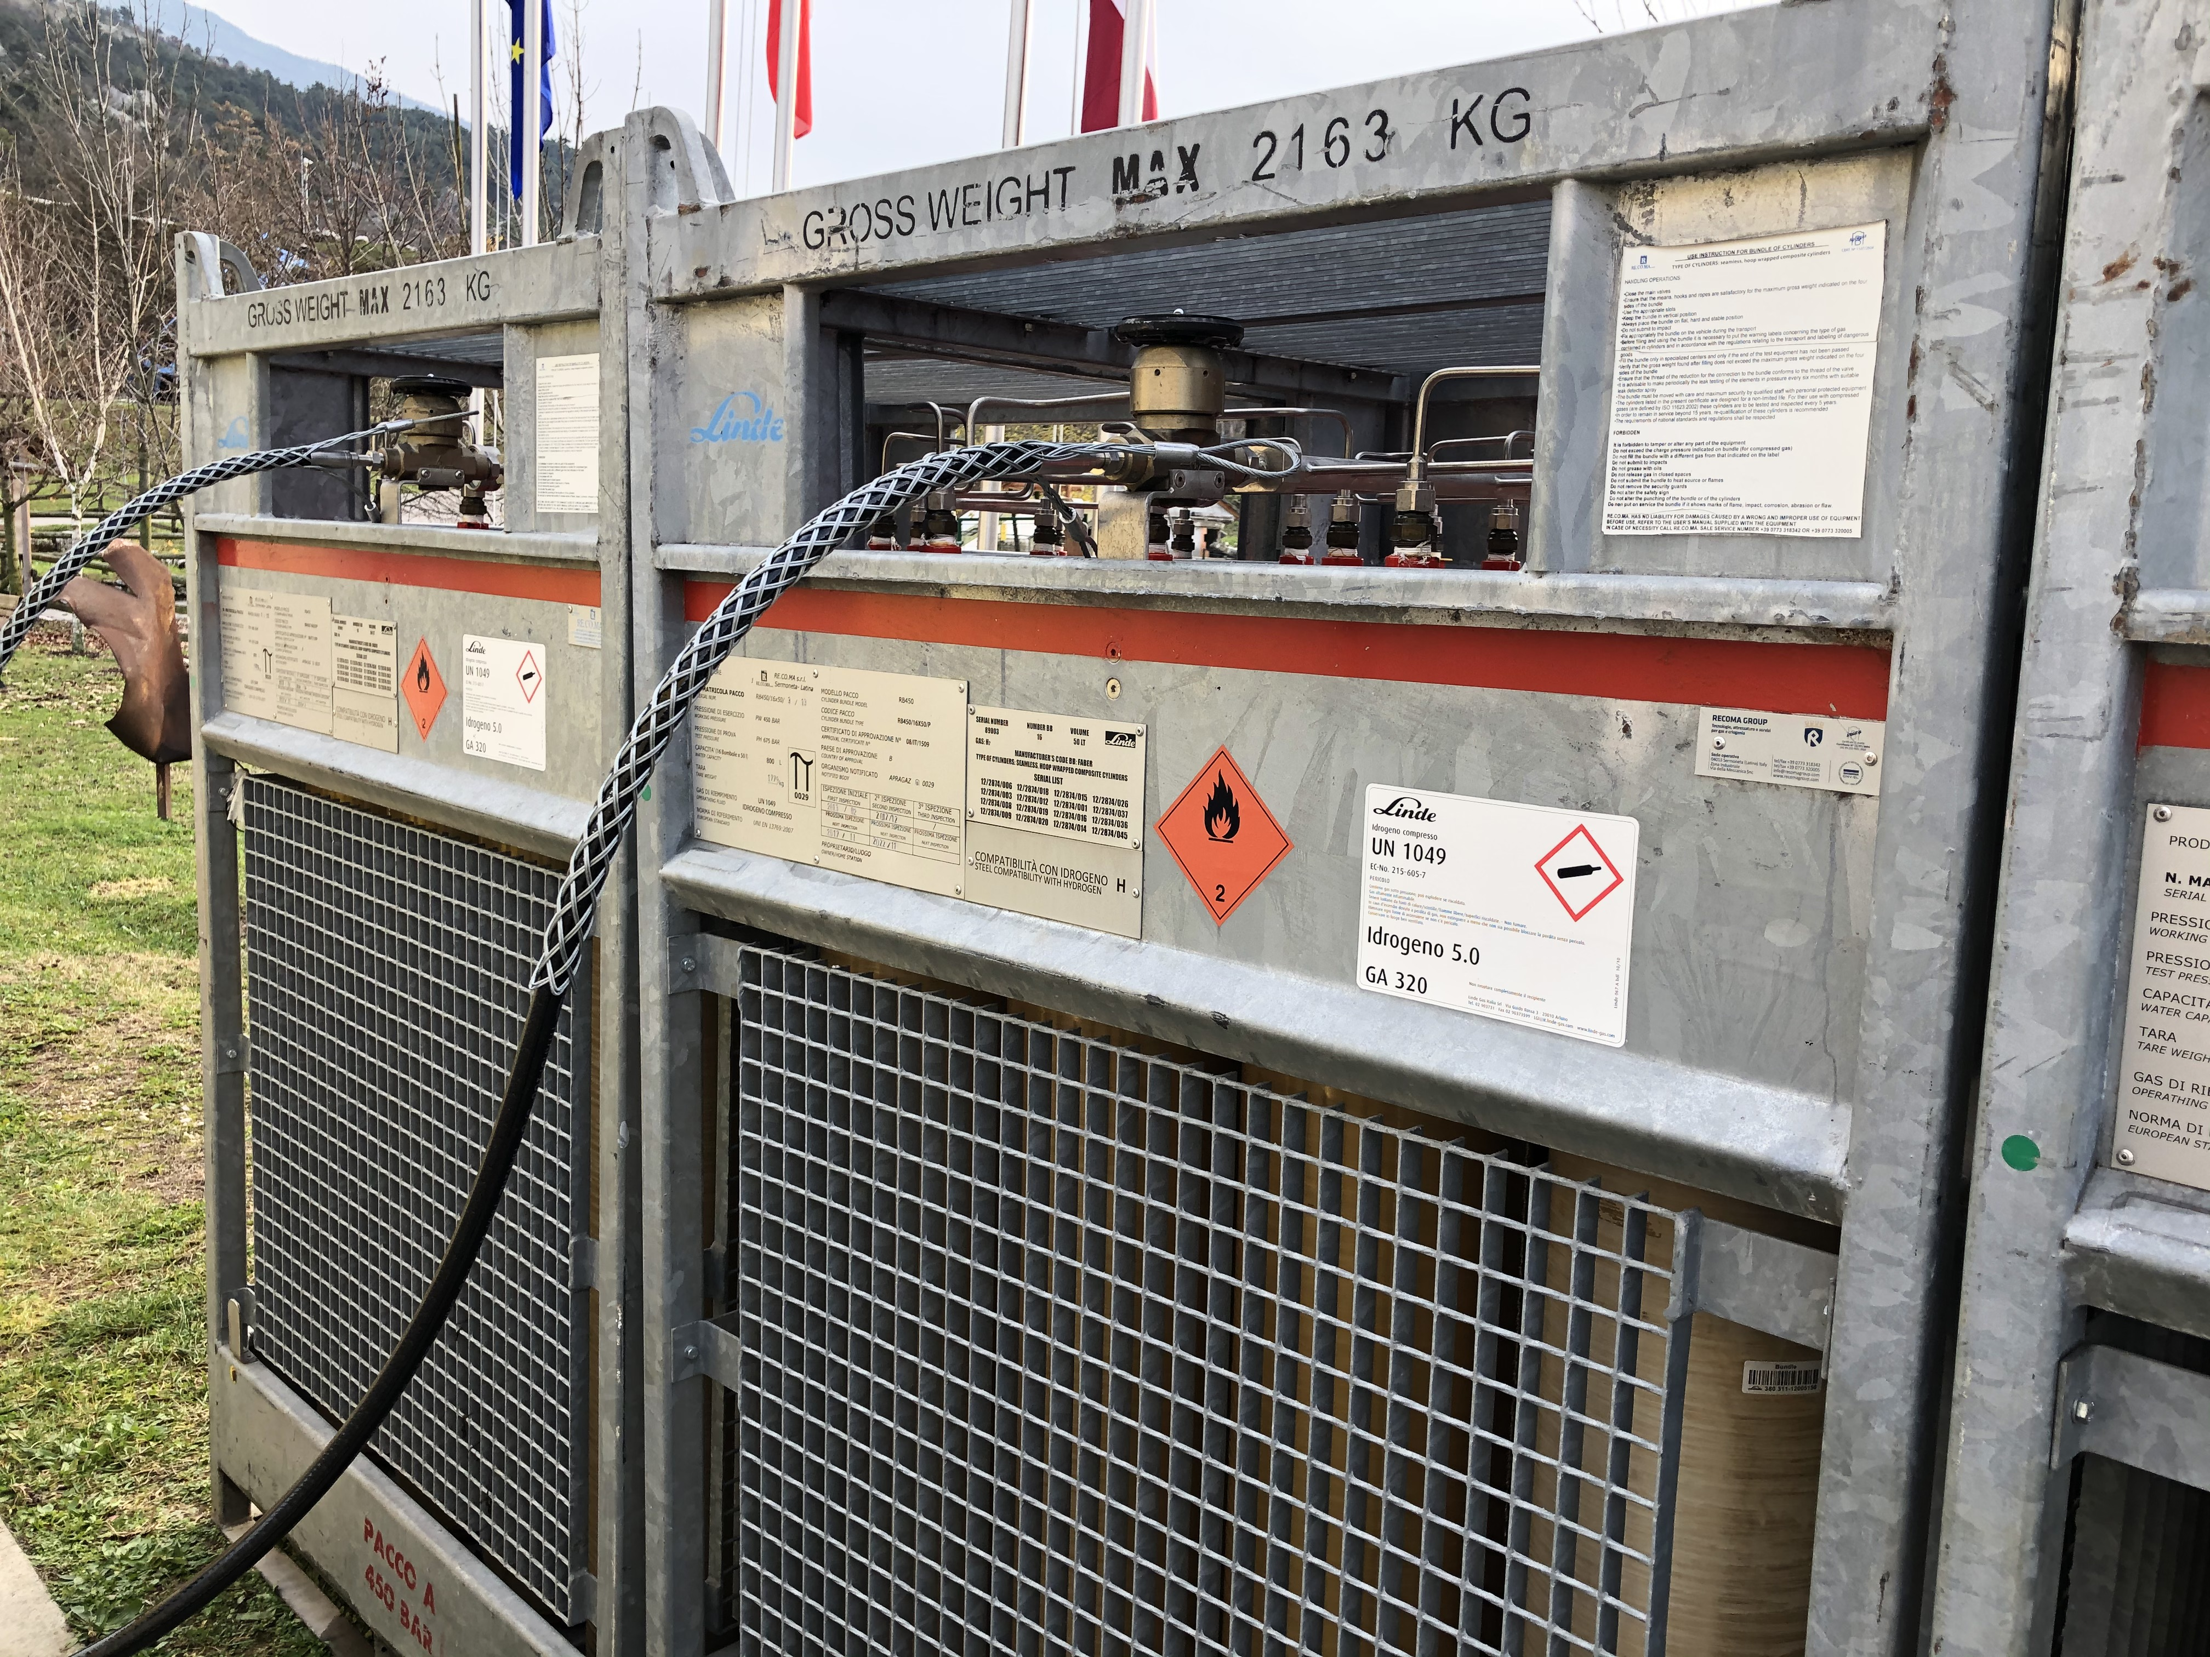 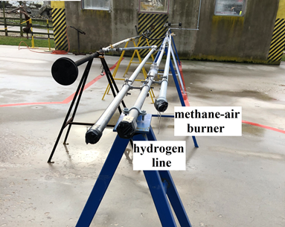

Figure 1: Storage facility (left) and hydrogen release line and methane-air burner (right).

The temperature field was measured with an arrangement of sixteen type-K thermocouples characterized by a wide range of temperatures detectable, an accuracy of $±$ 2.5 K and, a data acquisition rate of 30 samples per second. The position of each thermocouple is reported in Figure 2.

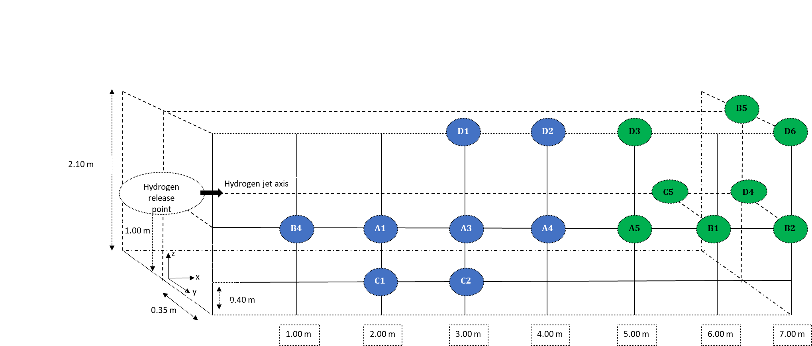

*Figure 2: Arrangement of the sixteen type-K thermocouples.*

Visible and infrared (IR) digital images of the flame were recorded to characterize the flame structure. They were obtained using a FLIR T1010 thermal imaging camera, and the images were stored at 30 Hz video frame rate. The IR images are useful to identify high temperatures regions of the flame since IR emission results primarily from vibrationally excited H2O molecules emitted in high-temperature combustion processes as products (Schefer et al., 2006). These aspects will be analyzed in future works.

* 1. Results and discussions

Figure 3 shows the temperatures registered by the thermocouples for Test 1. Similar trends are produced by Test 2 at a lower pressure (Figure 4).

 a) b)

Figure 3: Temperature (°C) with respect to space and time for Test 1 (initial pressure 450 bar). Figure 3a refers to the first eight thermocouples, closer to the hydrogen release point, while Figure 3b to the more distant ones.

 a) b)

*Figure 4: Temperature (°C) with respect to space and time for Test 2 (initial pressure 240 bar).* *Figure 4a refers to the first 8 thermocouples, closer to the hydrogen release point, while Figure 4b to the more distant ones*

As it can be observed in Figure 3a, the temperature inside the plume can be as high as 1200 °C (i.e., 1220°C), as registered by thermocouples A3 and A4. Slightly higher temperatures (i.e., 1400°C) are reported by Proust et al. (2011), for 2 and 3 mm leakage diameter. This difference can be due to the higher initial hydrogen reservoir pressure (from 900 bar down). Moreover, an intermediate temperature (i.e., 1300°C) is reported by Hansen (2019). For both tests (Figure 3a and 4a), an initial temperature rise is followed by a profile stabilization at a maximum temperature when focusing on the axial measuring points. Trends are similar for tests at 450 (Test 1), and 240 bar (Test 2), and maximum axial temperatures are higher than 800°C. No stabilized temperature profiles are observed for external and distant thermocouples in Test 1. Within the experimental trial, only for Test 2 al lower pressure, the distant profiles are stationary. Overall, higher temperatures are measured in Test 1 that is characterized by larger initial discharge pressure.

The main differences between Test 1 and Test 2 are registered in the other more distant thermocouples (Figure 3b and Figure 4b). For Test 1, at 6 m from the release point, the flame behaves under buoyancy, and it lifts, as demonstrated by the elevated temperatures registered at the height of 2.10 m by thermocouples B5 and D6. Using the model reported above (Eqs.1-5), the following quantities can be estimated (Table 2).

*Table 2: Hydrogen jet conditions derived from Eqs. 1-5.*

|  |  |  |  |  |  |  |  |
| --- | --- | --- | --- | --- | --- | --- | --- |
| Test | $P_{e}$ (bar) | (°C) | (kg/m3) | (m/s) | (m2) | (kg/s) | (kW) |
| Test 1 | 236.97 | -34.02 | 15.21 | 1183.90 | 7.1 x 10-6 | 0.127 | 15265 |
| Test 2 | 115.85 | -31.53 | 8.32 | 1190.05 | 7.1 x 10-6 | 0.070 | 8396 |

$∆h_{c}=119.962 kJ/kg$\* for hydrogen heat of combustion (Turns, 2012).

The calculated mass flow rates are in line with those measured by Proust et al. (2011). These values allow for an estimation of the heat produces by the hydrogen jet fires. Starting from these evaluations, the safety parameters can be obtained (Table 3).

*Table 3: Safety distance for third-degree burns. The values are calculated by considering a temperature limit of 309 °C and 20 s for the time of exposure.*

|  |  |  |  |
| --- | --- | --- | --- |
| Test | Flame length, LF (m) | Separation distance, x (m) | x/LF |
| Test 1 | 5.5 | 9 | 1.6 |
| Test 2 | 5.0 | 7 | 1.4 |

The safety distance can be compared with the jet flame length calculated by Eq. 6 and Eq. 7, as reported in Figure 5. Both Test 1 and Test 2 flame lengths are included within the two trends proposed by Molkov and Saffers (2013). They are slightly higher than the blue, which represents the best fit line of several experimental data reported in the cited literature, however surely within the uncertainties there reported.

On the other hand, the values of $w_{c}$ can be inversely evaluated by using the Eq. 6 and the experimental LF values. In this way, they are respectively 0.172 kg/s and 0.130 kg/s, which are relatively higher than 0.127 kg/s and 0.070 kg/s here calculated. This discrepancy is possibly related to the experimental uncertainties, to the non-ideality of the hydrogen release, and the concept of the limit temperature for the jet flame boundary.

Project Path: C:\Users\carbmat91702\OneDrive - Università degli Studi di Padova\ONEDRIVE\DOTTORATO PADOVA\IDROGENO\Prove 15032019\Cisap\double-X_ver.2_ CISAP.opju
PE Folder: 
Short Name: Graph1A

*Figure 5: Flame length with respect to the mass flow rate.*

* 1. Conclusions

This work presents an experimental investigation on high-pressure hydrogen release from a horizontal pipeline. The temperature distribution was evaluated by means of conveniently allocated thermocouples and visible and infrared digital techniques. Obtained results were compared with data published in the literature, and empirical correlations developed to characterize the accidental release of hydrogen from lower pressure systems. The agreement between the different data sources confirms the validity of the adopted approaches at higher pressure, as well. This conclusion represents an essential step for the evaluation of domino-related risks in hydrogen refueling stations. For future tests, the use of the optical technique as large-scale background oriented Schlieren could be of great assistance to characterized hydrogen flame. Furthermore, the addition of a flowmeter to the experimental set-up could be very useful to identify the hydrogen mass flow rate at the exit of the nozzle.

References

Bragin M.V. and Molkov V., 2010, Physics of spontaneous ignition of high-pressure hydrogen release and transition to jet fire, Int. J. Hydrogen Energy, 36, 2589–2596.

Brunner T. and Kircher O., 2016, Cryo-Compressed Hydrogen Storage, Hydrog. Sci. Eng. Mater. Process. Syst. Technol., 2, 711–732.

Casal J., M. G. Mares, M. Muñoz, A. Palacios, 2012, Jet Fires: a “Minor” Fire Hazard?, Chemical Engineering Transactions, 26, 13-20.

Cirrone D.M.C., Makarov D., and Molkov V., 2018, Simulation of thermal hazards from hydrogen under-expanded jet fire, Int. J. Hydrogen Energy, 2–8.

Hansen O.R., 2019, Hydrogen Infrastructure - Efficient risk assessment and design optimization approach, Chemical Engineering Transactions, 77, 19-24.

Hess K, Leuckel W, Stoeckel A, 1973, Ausbildung von Explosiblen Gaswolken bei Uberdachentspannung und MaBnahmen zu deren Vermeidung, Chem. Ing. Tech, 45, 5323-5329.

Lees F. P., 1996, Loss Prevention in the Process Industries Hazard Identification, Assessment and Control, Butterworth-Heinemann.

Liu X. and Zhang Q., 2014, Influence of initial pressure and temperature on flammability limits of hydrogen-air, Int. J. Hydrogen Energy. 39, 6774–6782.

Molkov V. and Saffers J. B., 2013, Hydrogen jet flames, Int. J. Hydrogen Energy, 38, 8141–8158.

Moradi R. and Groth K. M., 2019, Hydrogen storage and delivery: Review of the state of the art technologies and risk and reliability analysis, Int. J. Hydrogen Energy, 44, 12254–12269.

Proust C., Jamois D., and Studer E., 2011, High pressure hydrogen fires, Int. J. Hydrogen Energy, 36, 2367–2373.

Salzano E., Pio G., Ricca A., and Palma V., 2018, The effect of a hydrogen addition to the premixed flame structure of light alkanes, Fuel, 234, 1064–1070.

Schefer R. W., Houf W. G., Bourne B., and Colton J., 2006, Spatial and radiative properties of an open-flame hydrogen plume, Int. J. Hydrogen Energy, 31, 1332–1340.

Schefer R. W., Houf W. G, Williams T. C., Bourne B., and Colton J., 2007, Characterization of high-pressure, underexpanded hydrogen-jet flames, Int. J. Hydrogen Energy, 32, 2081–2093.

Turns S. R., 2012, An introduction to combustion, McGraw-Hill.

White C. M., Steeper R. R., and Lutz A. E., 2006, The hydrogen-fueled internal combustion engine: a technical review, Int. J. Hydrogen Energy, 31, 1292–1305.

Xiao J., Kuznetsov M., and Travis J. R., 2018, Experimental and numerical investigations of hydrogen jet fire in a vented compartment, Int. J. Hydrogen Energy, 43, 10167–10184.