CHEMICAL ENGINEERING TRANSACTIONS  VOL. 82, 2020 | A publication of
The Italian Association
of Chemical Engineering
Online at www.cetjournal.it
Guest Editors: Bruno Fabiano, Valerio Cozzani, Genserik Reniers
Copyright © 2020, AIDIC Servizi S.r.l.
ISBN 978-88-95608-80-8; ISSN 2283-9216

Conformity Assessment of Pressure Equipment during Coronavirus Disease Emergency: Risks and Opportunities
Francesco Giacobbe^{a*}, Elisabetta Bempoorad^{b}
ªCertification, Control and Research Territorial Operational Unit, National Institute for Insurance against Accidents at Work,Via G. Garibaldi Is. VI, Cortina del Porto 122/A, Messina (Sicily), Italy
^{b}Notified Body 0100, Department for Technological Innovations, Safety of Plants, Products and Anthropic Settlements, National Institute for Insurance against Accidents at Work, Via Roberto Ferruzzi 38-40, Rome, Italy.
f.giacobbe@inail.it
Coronavirus disease 2019 (COVID-19) health concern and travel restrictions have significantly affected conformity assessment activities in the scope of the 2014/68/UE directive (PED). Certification Bodies can anyway introduce alternative arrangements to conduct assessments e.g. remotely by using information and communication technologies (ICT). To this end, according to the International Accreditation Forum documents a feasibility analysis is required. The analysis must demonstrate the remote assessment could assure the same effectiveness of an on-site visit, otherwise it is not allowed.
The present work illustrates the result of the feasibility analysis carried out by the Notified Body (NB) INAIL 0100 and the operative instruction it is implementing in its Quality System (QS) compliant with ISO 17065 standard, to define the operating mode for each phase of the “smart” conformity assessment, the documental examination and the final product inspection and testing.
The feasibility analysis was focused on the availability of ICT and the necessary infrastructure to support their use both by the NB and the manufacturer, as like as the possibility to assure security and confidentiality of electronic or electronically-transmitted information. These issues have led to the definition of minimum requirements to assure operation during the remote assessment.
Another important issue faced by the NB in the analysis has been the identification of qualification criteria for determining when it is appropriate to perform an assessment remotely.
Furthermore the analysis of risks and opportunities that may impact audit/assessment effectiveness for each use of ICT under the same conditions, highlighted a limited impact of the selected ICTs, with a risk level maintained on the same level of the “in presence” visits.
This innovative solution has allowed to keep the NB in operation during the COVID-19 emergency while maintaining efficiency and safety, and provided also new opportunities of better timing and inclusion of personnel that may not be easily accessible.
  - Introduction
The recent outbreak of coronavirus disease 2019 (COVID-19) has resulted in a health emergency and led to safety concerns and travel restrictions, affecting significantly conformity assessment activities in the scope of the 2014/68/UE directive (PED).
    - Conformity assessment of Pressure Equipment
The directive 2014/68/EU or Pressure Equipment Directive (PED) directive applies to the design, manufacture and conformity assessment of stationary pressure equipment and assemblies with a maximum allowable pressure greater than 0.5 bar.
The manufacturer shall carry out the relevant conformity assessment procedure to demonstrate whether the Essential Safety Requirements (ESRs) of the directive, covering design (Faidy, 2005), manufacture and testing have been fulfilled. The conformity assessment procedure (Darlastona & Wintleb, 2007) shall be determined by the category of classification of the equipment according to an ascending level of hazard, 4 different categories differentiated by their growing risk, depending on the type of equipment concerned, the state and the group of the intended fluid contents, the maximum allowable pressure (PS) and the volume or, for piping, the nominal size (DN). The Directive is based on the positive aspects resulting from an efficient integration of safety and quality requirements (Labodová, 2004) through a systemic approach taking into account the analysis of the risk assessment.
Whatever the conformity assessment procedure used, the various aspects of the design must take into account both the characteristics of the materials and the manufacturing processes (Edwards, 2005), in addition, assessments that include inspections and final tests are required (see in point 3.2 of Annex I of PED), according to the ESR as provided for in the New Approach Directives (Playle, 2010).
In addition, for the series production of pressure equipment or assemblies in categories II, III and IV, the manufacturer can choose quality assurance procedures (Cory, 2005) which require quality assurance of the production process (Zeman, 1998), inspection and final tests of the equipment (Ulewicz, 2019) as well as the design. In these cases the NB shall carry out an initial certification audit to assess the conformity of the manufacturer’s quality system including an inspection visit to the manufacturer’s premises and then periodic or surveillance audits to make sure that the manufacturer maintains and applies the QS. According to art. 14 of PED, in the framework of quality assurance procedures (Giacobbe, 2016) for pressure equipment in categories III and IV the NB shall carry out at least two visits during the first year of manufacturing and determine the frequency of subsequent visits on the basis of the following criteria:
- the category of the pressure equipment,
- the results of previous surveillance visits,
- the need to follow up corrective actions,
- special conditions linked to the approval of the system, where applicable,
- significant changes in manufacturing organisation, policy or techniques.
The Manufacturers for the respect of the ESR can also take into account the contribution of the implementation in the company of any other management systems. The integrated implementation of quality and safety management systems is certainly positive (Mancuso et al., 2014).
    - Alternative arrangements to conduct assessment in extraordinary circumstances
An extraordinary event or circumstances beyond human control such as Covid-19 pandemic leading to safety concerns and travel restrictions may temporarily prevent a NB from carrying out planned on-site assessment activities. Certification Bodies, to ensure the health and safety of their staff, as well as to keep manufacturers in the condition to continue their activities while assuring full compliance with the PED, can introduce alternative arrangements to conduct assessments,
Firstly the NB should assess the risks of continuing certification and establish a documented policy and process, outlining the steps it will take, after having gathered the necessary information from the certified manufacturers who is also affected by the pandemic and could not be able to function normally. If the risk of continuing certification is low, and based on the collected information the NB may need to consider alternative short-term methods of assessment to verify continuing system effectiveness for the organization. In this consideration the NB has to keep in mind some limitations for adjusting the timing of surveillance or recertification audit and to justify, document and make available all deviations from the established certification program to Accredition Body upon request (IAF, 2011).
The Standard EN ISO 19011 (Guidelines for auditing management systems) provides remote auditing techniques via interactive communication means such as web-based collaboration, web meetings, teleconferences and/or electronic observation of the work performed via remote guide, exploiting the potential offered by Internet connecting people by appropriate multimedia application, without any distance limit.
    - Requirements for remote conformity assessment
According to the interpretation of IAF documents by the Italian Accreditation Body (Accredia) for regulated areas such as PED certification, to conduct a remote assessment a preliminarily feasibility analysis is required. The analysis must demonstrate the remote assessment could assure the same effectiveness, that is the same level of confidence, of an on-site visit, otherwise the remote audit is not allowed.
Other mandatory requirements are (IAF, 2018):
- a mutual agreement upon the use of ICT for assessment purposes by the manufacturer and the NB in accordance with information security and data protection measures and regulations;
- identification and documentation of the risks and opportunities that may impact assessment effectiveness for each use of ICT under the same conditions, including the selection of the technologies, and how they are managed and the extent to which ICT will be used for assessment purposes;
- a check that the manufacturer and the NB have the necessary infrastructure, resources, competency and ability to support the use of the ICT proposed, allowing to achieve the desired results of the assessment;
- identification in the audit plan of remote activities, considering time spent as contributing to the total duration of management systems audits and referring to the normative reference for additional requirements which may impact the application of ICT;
- indication in the final reports and related records of the extent to which ICT has been used in carrying out the assessment and the effectiveness of ICT in achieving the assessment objectives.
  - Feasibility analysis of remote conformity assessment
In order to carry out the remote conformity assessment, an appropriate feasibility analysis must be carried out in advance, as well as a risk analysis that examines potential critical issues regarding impartiality, independence and conflict of interest. The INAIL 0100 NB to apply this particular method has prepared a documented procedure in which it describes the succession of the different phases and the criteria to verify the feasibility of the activities as they are equally effective with the use of alternative information technologies. The analysis concerns both the documentary examination and the verification at the production plant.
For the documental examination, the technician in charge is allowed to log into the digital archive of the documents that the manufacturer has processed. The technician remotely examines the documentation (e.g. drawings, stability calculations, ESR evaluation, etc.) and requests additions if necessary. If the Manufacturer adopts quality modules in addition to the technical documentation, the documentation of the QS adopted must also be examined (Giacobbe et al., 2020).
For product verification activities it is initially required to define the necessary resources, i.e. personnel skills and technological requirements of software and hardware devices. The technical staff, in addition to the already provided skills and technical experience on pressure equipment must have mastery of ICT devices such as smartphones. These devices must guarantee both audio/video shooting with HD resolution and data transmission over the Internet. Broadband transmission (eg. 4G) must therefore be used to ensure fast playback.
A feasibility review must be carried out and recorded for each individual order. This includes checking compliance with the requirements for the CE marking without altering the specifications required by the PED Directive. It is important to verify that the specific conditions of the order do not alter the accreditation requirements. In this case the NB must provide its Accreditation Body with the information necessary to evaluate the requirement to be managed by derogation.
In figure 1 the logical flow adopted is represented in the form of a flow chart.
  - Qualification criteria for remote assessment appropriateness
An important issue faced by the NB in the analysis of risk and opportunities, as described above, has been the identification of principles and criteria for determining when it is appropriate to perform an assessment remotely. The issue is strongly related to the availbility of the necessary infrastructure, resources, competency, ability and also aptitude by both the manufacturer and the NB to carry on the planned activities by ICT. The availability was firstly checked for the ON, orientating the choice of ICT towards the ones resulting easier and already known among those suitable and selecting some members of the technical staff with evidence of competency, ability and aptitude to use the chosen ICT. Aside from its ordinary activity, the selected members of technical staff are also leading experimental test with a new and innovative platform of virtual and/or augmented reality.
Then the criteria were identified to qualify the manufacturer for remote assessment.
The identified criteria are (IAF, 2015):
- the type of remote assessment required, considering that new certification has been a priori excluded, renewal and extension of the scope of a PED module has been taken into account subject to restrictions, while surveillance, follow-up, partial assessment which could not be completed on-site, investigations, transfer of company name resulted viable;
- the manufacturer being in operation;
- the availability of a list of activities, areas, information and personnel to be involved in the remote assessment;
- the capability and aptitude of the operators in the chosen medium/forum of the remote assessment;
- a working environment adequate to the behavioural rules foreseen in case of emergency;
- the availability of at least:
  - the first one, under the inspector's/auditor commands, records at short range (min 20cm and max 2 meters) the equipment's particulars. the second one records at long range (min 3 meters and max 10 metres) all the situation (the first operator and the equipements);
  - an efficient audio-video streaming connection and data transmission (e.g. 4G, Hot Spot, Wi-Fi);
  - two electronic devices with a camera able to transfer images/movies by a remote platform;
- the manufacturer permits to shoot its equipment and products.

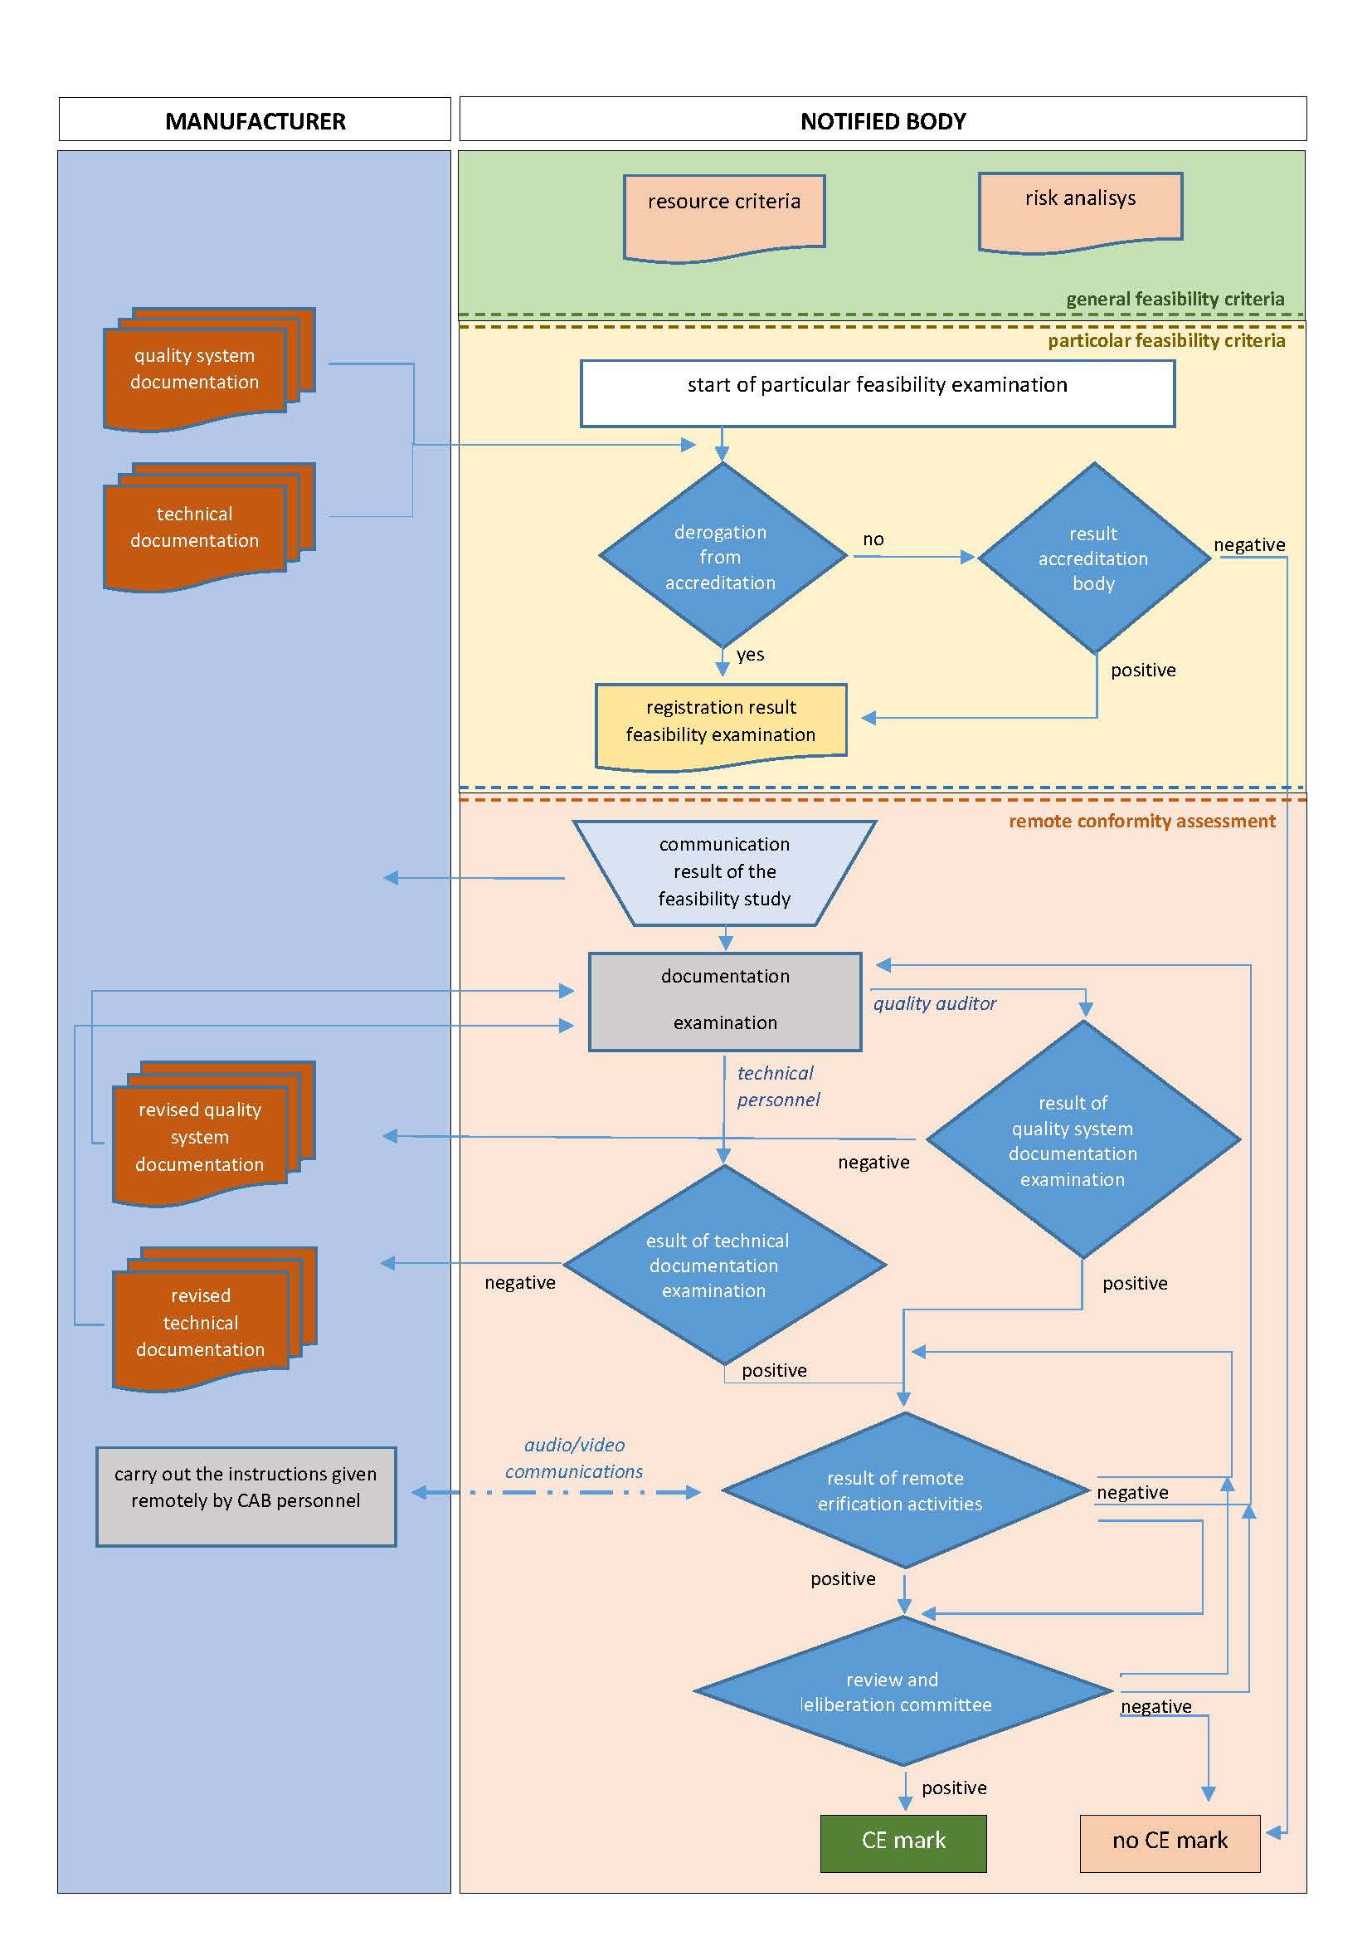
Figure 1: Flow chart for remote conformity assessment (procedure defined and used by INAIL 0100)
  - Operative criteria implemented in the NB quality system
The first step is to plan the audit, deciding the inspector of the team audit, the date, the activities, areas, document to verify and personnel to interview.
The remote audit plan is more detailed if compared with the one used for ordinary on-site audit and report a statement about the opportunity to consider some flexibility relating to additional time related to the use of ICT. The plan shall be notified to the manufacturer at least one week before the audit.
The NB decided that, if possible, the inspector/auditor(s) shall be the same who conducted the last on-site inspection/audit (last auditors) and if it’s not possible, the new inspector/auditor shall at least deal in advance with the last one.
The auditors, as like as the operators of the manufacturer company, shall be confident with the chosen medium for the remote assessment and preferably have the ability to interpret body language, to perceive eventual criticality.
The inspection/audit shall be preceded by a test to assure the operation of all devices, connections and document sharing.
In case of quality module, where the audit plan was modified to adapt to eventual limitation related to the use of ICT or to pandemic safety issues, e.g. putting off the closure of non conformities, the remote audit shall be mandatorily followed up by an on-site audit by the same auditors as soon as the Covid-19 emergency ends.
Collecting data and measures remotely on equipment, by electronic means, could be less credible than making it directly on site. The preliminary identification of all equipment used to monitor the environment and collect data during the inspection/audit, along with the relevant calibration certificate and records should be requested. A second camera for wide angle shots could be useful for more credibility. Observing the shot environment is important during the audit to also notice any physical signs of the QS implementation.
  - Conclusions
Using information and communication technologies could represent the only alternative when conformity assessment activities to certify pressure equipment cannot be performed physically e.g. during extraordinary event or circumstances beyond human control such as Covid-19 pandemic. Where correctly planned and managed the use of ICT could allow to optimize assessment effectiveness and efficiency while maintaining the integrity of the same process. For the Italian public NB ON 0100 this alternative method for audit/inspection resulted feasible, for surveillance, follow-up, partial assessment which could not be completed on-site, investigations and transfer of company name, and only with some exception for recertification and extension of the scope. The selected requirements to make a remote audit feasible and appropriate have implied a very limited impact on the effectiveness of the assessment, with a risk level maintained on the same level of the “in presence”.
In the future the procedure shall be developed to consider ICT fast evolution, e.g. by means of virtual and/or augmented reality, to improve the effectiveness and confidence of the remote assessment.
References
Cory W., 2005, Quality assurance, inspection and performance certification, Fans and Ventilation, A Practical Guide, 265-280.
Darlastona J., Wintleb J., 2007, Safety factors in the design and use of pressure equipment, Engineering Failure Analysis, Volume 14, Issue 3, 471-480.
Directive PED, 2014/68/EU of the European Parliament and of the Council of 15 May 2014 on the harmonisation of the laws of the Member States relating to the making available on the market of pressure equipment.
Edwards K.L., 2005, A risk-based approach to manufacturing process control: use in autoclave moulded composite sandwich panels, Materials & Design, Volume 26, Issue 8, 690-699-
EN ISO 17065, 2012, Conformity assessment — Requirements for bodies certifying products, processes and services.
EN ISO 19011, 2018, Guidelines for auditing management systems.
Faidy C., 2005, EPR Codes and Standards for Pressure Equipments, Proceedings of 18th International Association for Structural Mechanics in Reactor (IASMiRT), Beijing, China, 1141-1149.
Giacobbe F., 2016, La nuova Direttiva PED 2014/68/UE. Interazioni tra requisiti essenziali di sicurezza e sistema qualità, Proceedings of the “Sicurezza e affidabilità delle attrezzature a pressione” (SAFAP), ISBN 978-88-7484-520-0, Milan, Italy.
Giacobbe F., Bemporad E., Pera F., 2020, Conformity assessment procedures of the directive 2014/68/UE (PED) and implementation of the quality management system ISO 9001, Proceedings of the 30th European Safety and Reliability Conference and the 15th Probabilistic Safety Assessment and Management Conference, ISBN: 981-973-0000-00-0, Venice, Italy.
IAF ID03, 2011, Management of Extraordinary Events or Circumstances Affecting ABs, CABs and Certified Organizations, <iaf.nu/upFiles/IAFID32011_Management_of_Extraordinary_Events_or_Circumstances.pdf> accessed 8 November 2011.
IAF ID12, 2015, Principles on Remote Assessment, <iaf.nu/upFiles/IAFID12PrinciplesRemoteAssessment22122015.pdf> accessed 23.12.2015.
IAF MD04, 2018, Use of Information and Communication Technology (ICT) for Auditing/Assessment Purposes, <iaf.nu/upFiles/IAF%20MD4%20Issue%202%2003072018.pdf> accessed 04 July 2018.
Labodová A., 2004, Implementing integrated management systems using a risk analysis based approach, Journal of Cleaner Production, Volume 12, Issue 6, 571-580.
Mancuso V., Giacobbe F., Faranda F., Diaco T., 2014, Integrated safety, health and environmental management system. Case study of power plant, Proceedings of the Chemical Engineering Transactions vol.36, ISBN 978-88-95608-27-3, ISSN 2283-9216, DOI 10.3303/CET14.
Playle M., 2010, CE Marking – the Essential Requirements, Advances in Systems Safety, pp 251-271, Springer.
Ulewicz R., Nový F., 2019, Quality management systems in special processes, Transportation Research Procedia, Volume 40, 113-118.
Zeman J. L., 1998, The role of quality systems in the Pressure Equipment Directive, Technology, Law and Insurance, Volume 3, Issue 3, 183-189.

