CHEMICAL ENGINEERING TRANSACTIONS  VOL. 82, 2020 | A publication of
The Italian Association
of Chemical Engineering
Online at www.cetjournal.it
Guest Editors: Bruno Fabiano, Valerio Cozzani, Genserik Reniers
Copyright © 2020, AIDIC Servizi S.r.l.
ISBN 978-88-95608-80-8; ISSN 2283-9216

Predictive Indication of Performance Failure in Electricity Critical Infrastructure Elements
Alena Splichalova*, David Patrman, Nikol Kotalova
VSB - Technical University of Ostrava, Faculty of Safety Engineering, Lumirova 630/13, 700 30 Ostrava, Czech Republic
alena.splichalova@vsb.cz
Infrastructures which are central to the functioning of the state and irreplaceable or difficult to replace are referred to as a critical infrastructure system. As threats and the intensity of these threats rise, elements of critical infrastructure system are increasingly exposed to disruptive events. In order to maintain the operability and continuity of these elements, protecting them is crucial. Protecting infrastructure elements which are highly interdependent and impact the functioning of dependent infrastructures is especially important. In this respect, the electricity infrastructure can be considered uniquely critical. For this reason, maintaining a high level of protection for elements of this type of infrastructure is necessary, especially through pre-emptive measures to prevent disruptive events. Following from this observation, the paper presents a proposed procedure for predictive indication of the failure of elements in electricity critical infrastructure.
  - Introduction
Electricity is a core sector of European critical infrastructure (Council Directive, 2008). Its interdependence with and effect on secondary sectors is very high. The entire electricity critical infrastructure system is crucial for the functioning of dependent critical infrastructure elements (PPD-21, 2013). Disruption or failure of this sector would have far-reaching consequences for the security and economy of the state and basic human needs (Rehak et al., 2019; Vichova and Hromada, 2019). Protecting the critical infrastructure of the electricity industry is therefore necessary, not only from the impact of disruptive events already in progress, but especially during the prevention phase, when prompt indication of failure of performance of these elements is necessary. An element’s performance is affected by both positive and negative factors. A key and positive factor affecting the stability of an element’s performance is resilience. This factor is determined by the robustness (i.e. absorption capacity), recoverability and adaptability of the element (NIAC, 2009; Rehak et al., 2018). A high level of robustness, especially, allows a system to absorb and to a degree mitigate the adverse effects of disruptive events without compromising the element’s performance. However, if the disruptive event intensifies to a point when absorption capacity is exhausted, the system can no longer withstand the disruptive event, and consequently, the performance of the element fails.
The use of infrastructure indicators is examined in a number of publications. For example, the usability of performance indicators in logistics infrastructure (Foltin et al., 2018), vulnerability indicators in energy systems (e.g. Hofmann et al., 2012; Hiete and Merz, 2009), indication of energy security (e.g. Lösche et al., 2010; Kruyt et al., 2009) and measurement of resilience using indicators (e.g. Prior and Hagmann, 2012; Petit et al., 2013; Rehak et al., 2017). However, the indicators in the above areas are too specific and do not provide a suitably comprehensive overview of indicating performance failures. The present paper therefore investigates the indication of performance failure in the electricity sector. This indication process is based on categorizing threat intensity in order to determine the boundary parameters for indicating the onset of a disruptive event which may cause an element to fail.

  - Electricity critical infrastructure
Critical infrastructure means an asset, system or part thereof located in Member States which is essential for the maintenance of vital societal functions, health, safety, security, economic or social well-being of people, and the disruption or destruction of which would have a significant impact in a Member State as a result of the failure to maintain those functions (Council Directive, 2008).
A critical infrastructure system can be categorized according to its specific functions into two areas, namely technical and socio-economic infrastructure (Rehak et al., 2016). These areas are considerably interdependent. All socio-economic sectors require the unrestricted availability of commodities for technical infrastructure, which is fully dependent on socio-economic infrastructure during a crisis (Rehak et al., 2020). However, both areas show a high dependence on the electricity sector, which is therefore rightly referred to as uniquely critical (PPD-21, 2013). Electricity critical infrastructure is a highly complex system involving the generation, transmission and distribution of electricity. The most important element of critical infrastructure for electricity generation according to Act (2000) are plants with a total electrical output of at least 500 MW, plants providing ancillary services with a total electrical output of at least 100 MW, electricity, power lines for distribution and to supply the power plant’s own power, and the technical control rooms of electricity producers. The most important elements of critical infrastructure for electricity transmission according to Act (2000) are transmission system lines of at least 110 kV, transmission system stations of at least 110 kV, and the transmission system operator’s technical control rooms. The most important elements of critical infrastructure for electricity distribution according to Act (2000) are the distribution system and 110 kV lines (110/10 kV, 110/22 kV and 110/35 kV type stations and associated lines, according to their strategic importance in the distribution system), and the technical control rooms of the distribution system operator.
  - Factors affecting the performance of electricity elements
The capacity of the electricity system is determined by the performance produced by individual production units connected to the electricity system. This performance level is expressed in watts (W), kilowatts (kW) or megawatts (MW). In the Czech Republic, for example, capacity is mostly covered by thermal power plants (approx. 50%), followed by nuclear power plants (approx. 20%), solar, steam-gas, water, pumped, combustion and wind power plants. This performance is then transported through the transmission and distribution system. Each element of these networks has a performance limited to the range 35–800 kV.

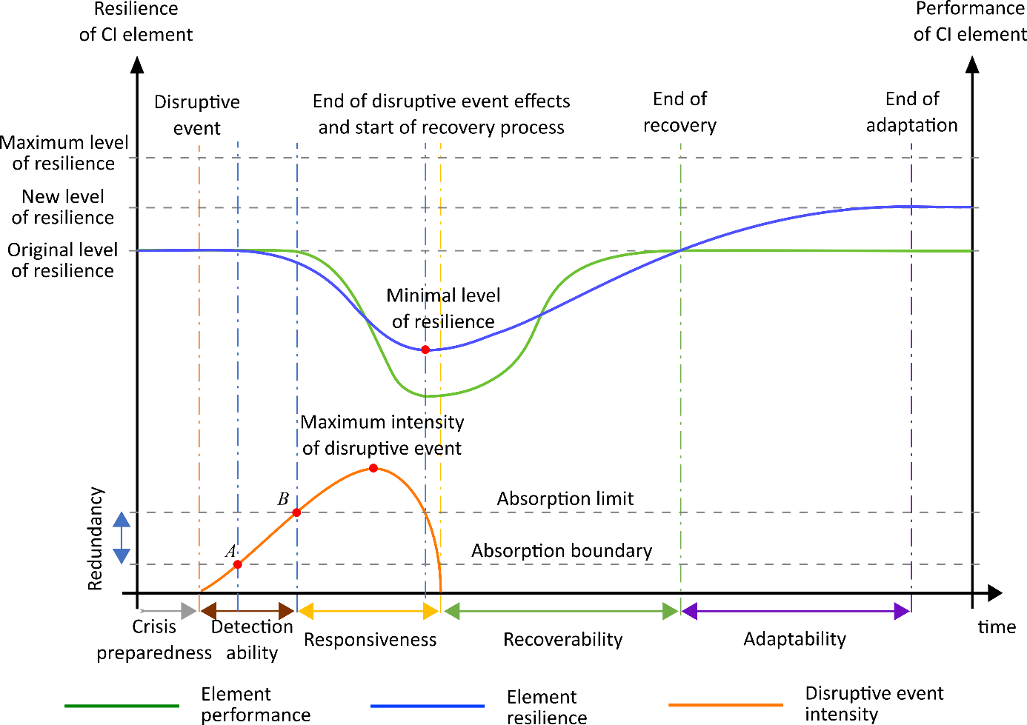
Figure 1: Graphical representation of the relationship between element performance, element resilience, and intensity of a disruptive event (Rehak et al., 2018)
The performance of these elements depends on many factors. At the first, there are the factors determine performance which relates mainly to the production process. At the second, there is factors limit performance, especially in current technology, or even influence performance. These factors can be external or internal threats (i.e. adversely influencing factor) or element resilience (i.e. positively influencing factor). The greater the threat and the lower the element’s resilience, the higher the likelihood of the occurrence of a disruptive event and its severity (i.e. risk), which will have an adverse impact on the performance of critical energy infrastructure elements. The relationship between element performance, element resilience, and disruptive event intensity is presented in Figure 1.
When an element begins to experience a disruptive event, the absorption capacity of the element is spread over two phases. In the first phase, the system is able to absorb the impact of a disruptive event without involving redundant capacity, up to the element's ability to fully absorb the impact of the disruptive event (point A, Figure 1). In the second phase of absorption, the redundant capacity available to the element is already involved, and the element can still provide the full performance required. At this stage, there is still room to detect the disruptive event and respond to its course. (Rehak et al., 2018).
Only when the element’s redundant capacity is depleted, i.e. the element's ability to absorb the impact of a disruptive event (point B, Figure 1), do the adverse effects of the event begin to manifest as a decline in functionality. The nature of the decline is determined by the element’s ability to defend itself against the event. If this ability exists, the reduction in performance provided by the element may be gradual, but if the intensity of the adverse event overcomes this ability, the reduction in performance is usually steep or even instantaneous. (Rehak et al., 2018).
  - Defining the performance failure indication process
It is clear from the foregoing that elements of electrical critical infrastructure are exposed to the risk of threats which may result in disruptive events (Rehak et al., 2019) leading to the disruption or failure of the performance of these elements. In this context, the optimal method of protecting these elements would be implementing preventive measures against the occurrence of adverse events (Stoller et al., 2018; Lukas and Necesal, 2011). Following from this conclusion, a procedure to predict and indicate the failure of performance of elements in electricity critical infrastructure is proposed in the present paper. This procedure includes interrelated and logically sequential steps (see Figure 2) and offers a clear guide for indication.
The indication procedure consists of three phases. In the first phase, the indicated area is delimited: critical infrastructure system >> energy sector (Council Directive, 2008) >> electricity subsector (PPD-21, 2013) >> distribution system (GD, 2010). In this phase, elements for which potential causes of their performance failure are further indicated can be selected.
In the second phase evaluation of the procedure, the elements are assessed, with attention given to identification, analysis and evaluation. Elements are selected using multicriterial analysis (Figueira et al., 2005) by comparing individual element types, strategic importance, element substitutability, security, location, etc. Elements are subsequently subjected to a functional analysis (Kantorovich and Akilov, 1982) in order to identify, define and describe the individual functions that are crucial for their operation. The final step of the second phase is assessing the resilience of the elements. The resulting level defines the ability of an element to absorb the effects of a disruptive event and subsequently restore its performance and adapt to this type of disruptive event (NIAC, 2009). An element’s resilience level is the starting point for selecting indicators and indicator parameter values. The CIERA method should be used to determine the level of resilience (Rehak et al., 2019).
The third phase of the procedure is the indication process itself. The initial step is to identify indicators, i.e. indicators signalling a potential threat to the function of an element of electricity critical infrastructure. In this context, these indicators are individual threats. These threats can be identified with a Fault Tree Analysis (IEC, 2006). Indicator parameters can be subsequently identified by analysing the identified threats. The character and level of the threat determine the creation of parameters which indicate disruption of the performance of an element. The final step is setting the limits of indication parameters for each threat. These limits are variable, and their levels are derived from the resilience level of the evaluated element. The higher the resilience, the higher this threshold. Exceeding this threshold already indicates an insufficient level of resilience and subsequent disruption or failure of the performance of the critical infrastructure element.

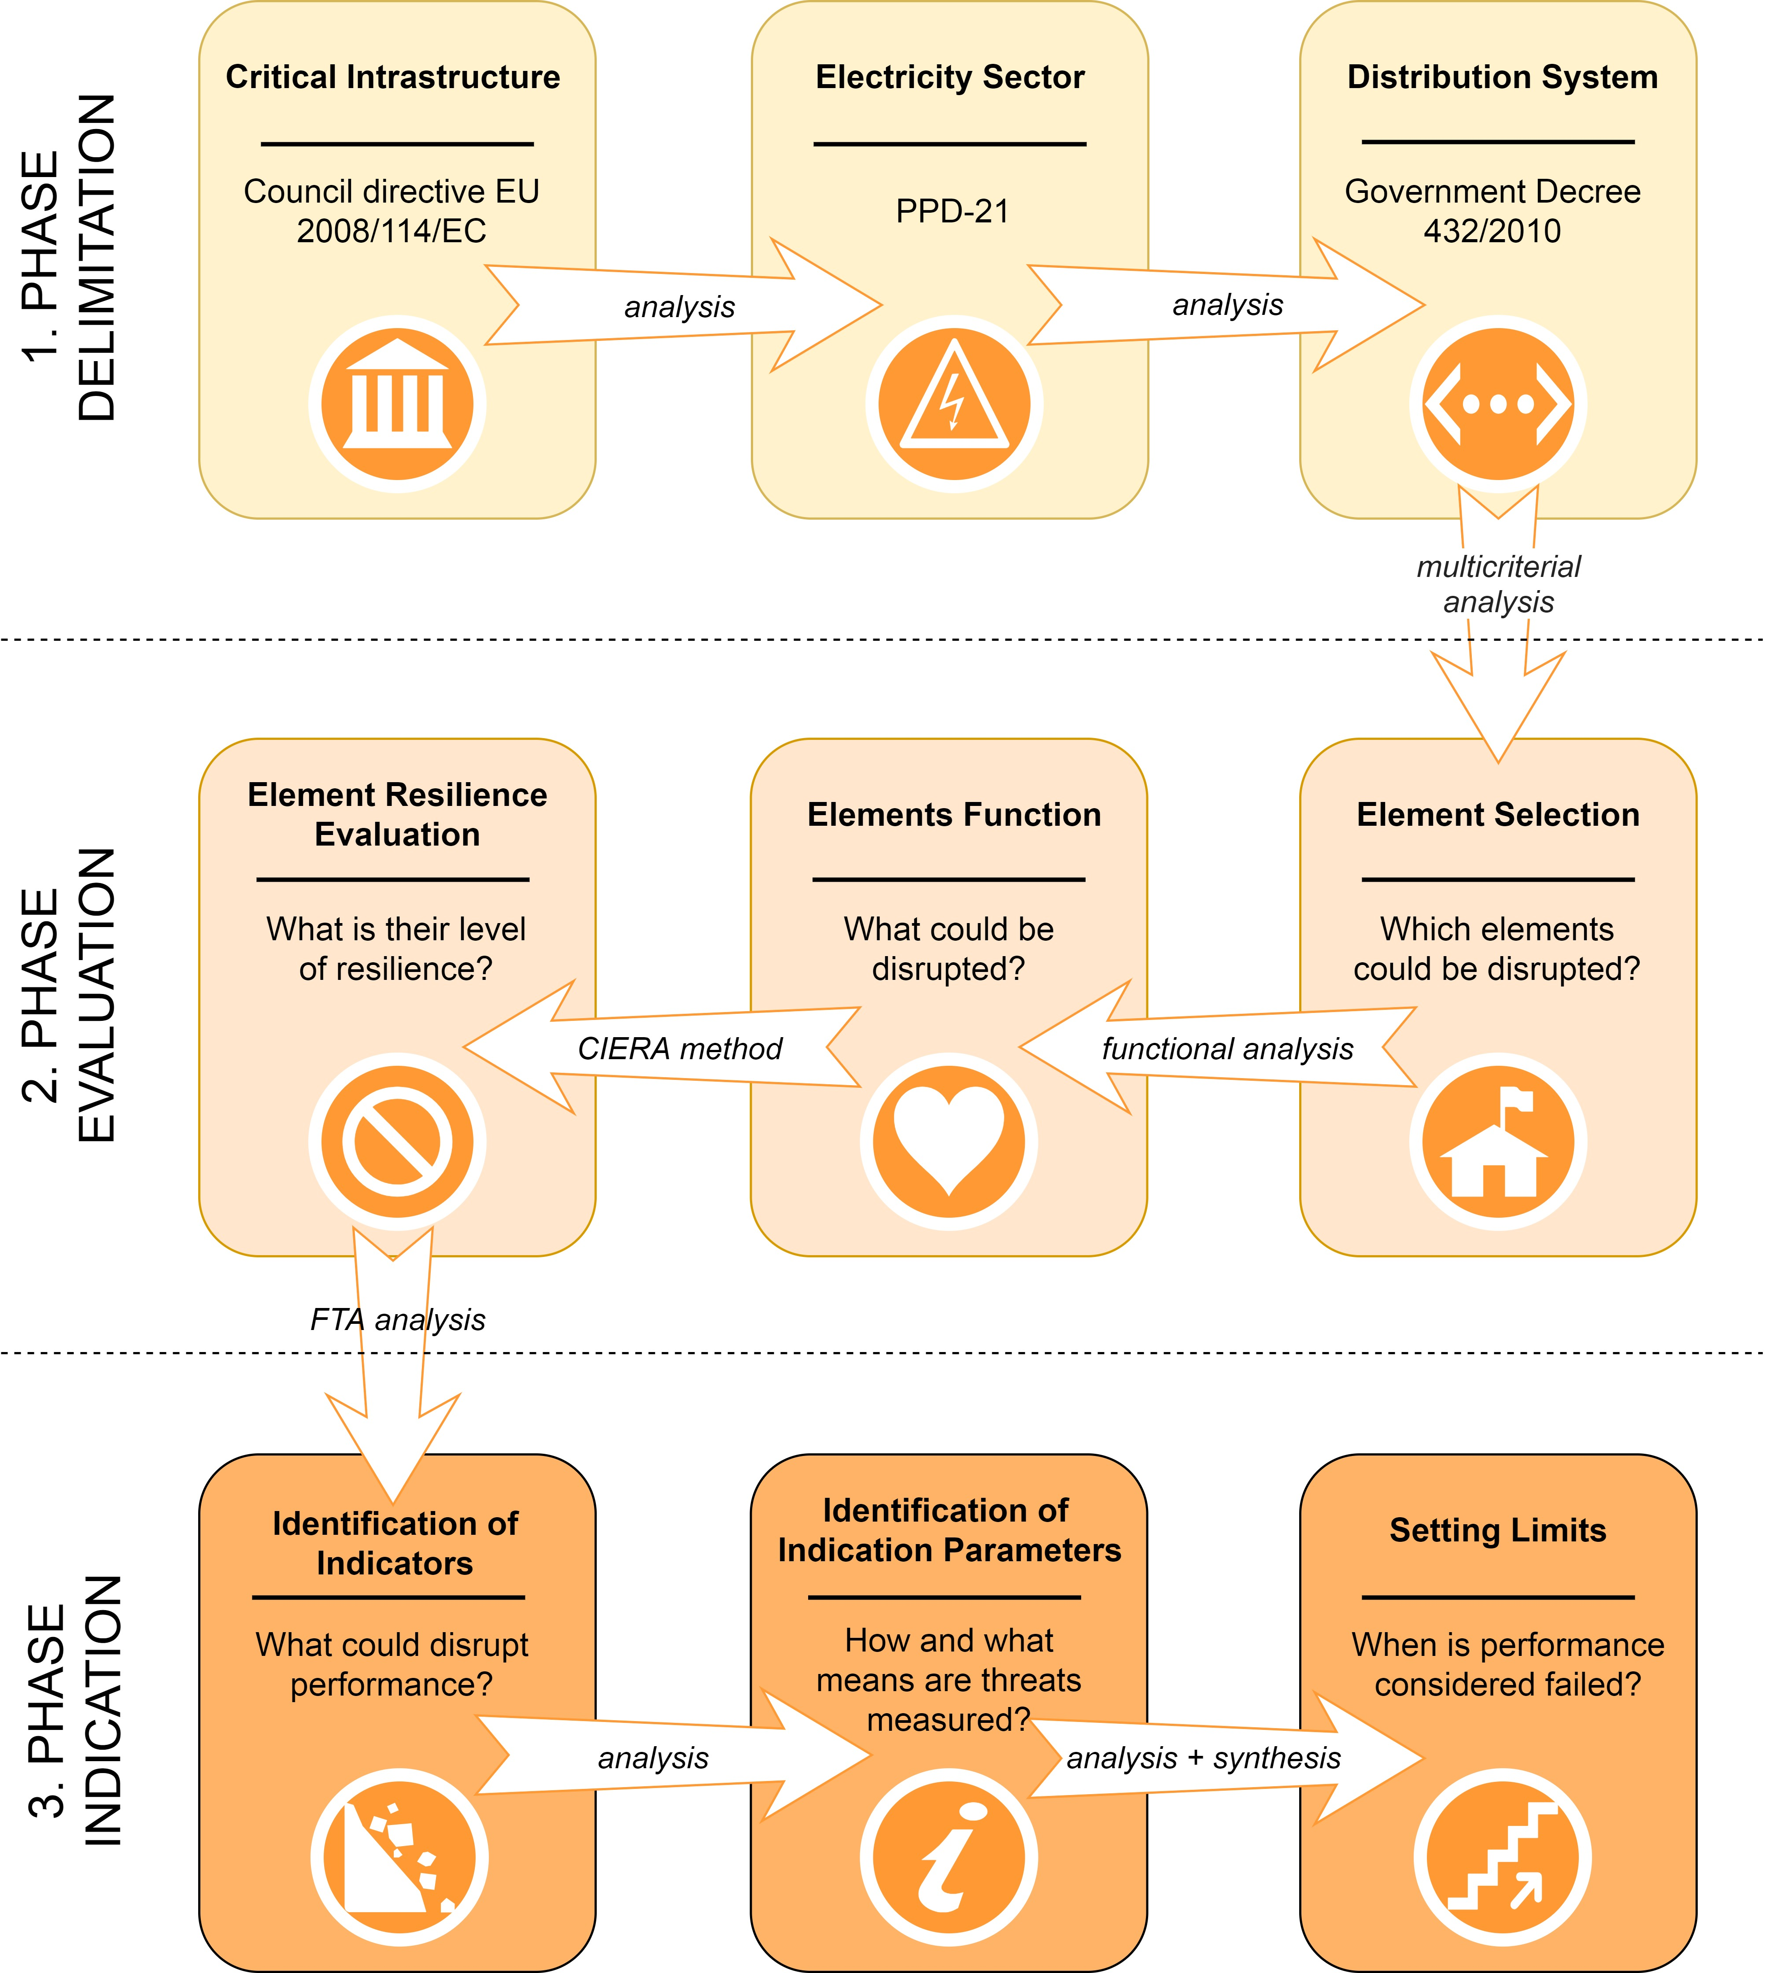
Figure 2: Predictive indication of performance failure in electricity critical infrastructure elements
  - Case study
As the first phase of the power failure indication procedure a node element of the critical infrastructure of the power supply network located at the interface of the transmission and distribution system was selected for the case study. The element in question is an electrical substation selected using multi-criteria analysis (Figueira et al., 2005). Its key function is to ensure transforming voltage to the required tension level and is therefore considered a strategic and irreplaceable element of the power supply system. Using the CIERA method (Rehak et al., 2019) the level of resilience against threats of a process-technological nature was set at 76.4% for this element, which indicates an acceptable level of resilience.
The third phase included application of the fault tree analysis (IEC, 2006) through which indicators were identified, i.e. specific threats of a process-technological nature, which have the greatest potential to disrupt resilience and cause failure of the element’s performance. The results of the analysis show that the most dangerous threat are electric shocks causing overloading of the electricity substation and subsequently of the lines, which can lead to the collapse of the entire system. These shocks of varying voltage and magnitude are caused by overflows from the electricity transmission system of other states and are difficult to predict. Based on their scope and character, they are divided into small, medium and large scale overflows. By determining the level of resilience and subsequent comparison with the indication parameters (i.e. the extent and nature of the threat), a limit can be determined. The absorption capacity of resilience is exhausted at this limit and the key functions of the element fail. Based on the performed analysis the limit was set only at the large-scale overflow level. This means that small to medium power fluctuations should be absorbed by the element under investigation without any disruption of its performance.
  - Conclusions
The electricity sector is currently a key energy source for maintaining basic human needs. Disruption of the continuity of electricity supply would have a major impact not only on the health and lives of people, national security, the economy and society, but also on the elements of dependent subsectors of other critical infrastructures. Analysis of electricity systems demonstrates its importance in other technological and socio-economic systems. Ensuring reliable and secure electricity supply is a national priority, and any threat to these infrastructures is incompatible with the requirements and needs of the population at the time.
In this context, it can be concluded that predictive indication of the failure of performance of elements in electricity critical infrastructure is a highly effective preventive measure. Through the early indication of threats, the occurrence of disruptive events can be prevented. From the results of predictive indication, adequate and effective security measures can be promptly applied in order to prepare for potential threats. The proposed procedure can be especially applied by critical infrastructure entities and coordinators of individual sectors of the critical infrastructure system.
Acknowledgments
This research was supported by the Ministry of the Interior of the Czech Republic under Project VI20192022151 "CIRFI 2019: Indication of critical infrastructure resilience failure" and by the VSB – Technical University of Ostrava under Project SP2020/40 "Research on approaches and methods of strengthening the resilience of critical infrastructure elements in the electricity sub-sector".
References
Act 240 of 28 June 2000 on the Crisis Management (Czech Republic).
Council Directive 2008/114/EC of 8 December 2008 on the identification and designation of European critical infrastructures and the assessment of the need to improve their protection.
Figueira J., Greco S., Ehrgott M., (Eds.), 2005, Multiple Criteria Decision Analysis: State of the Art Surveys, International Series in Operations Research & Management Science, 78, DOI: 10.1007/b100605
Foltin P., Brunclik M., Ondryhal V., Vogal L., 2018, Usability of Performance Indicators of Logistics Infrastructure Availability in Supply Chain Designing, In: 18th International Scientific Conference on Business Logistics in Modern Management, Osijek, Croatia, 157-170.
GD, 2010, Government Decree 432/2010 of 22 December 2010 on criteria for determination of the critical infrastructure element (Czech Republic).
Hiete M., Merz M., 2009, An Indicator Framework to Assess the Vulnerability of Industrial Sectors against Indirect Disaster Losses, In: 6th International Conference on Information Systems for Crisis Response and Management (ISCRAM 2009), Gothenburg, Sweden.
Hofmanna M., Kjøllea G.H., Gjerde O., 2012, Development of Indicators to Monitor Vulnerabilities in Power Systems, In: Presented at the PSAM 11 and ESREL 2012 Conference on Probabilistic Safety Assessment, Helsinki, Finland.
IEC 61025, 2006, Fault Tree Analysis (FTA), International Electrotechnical Commission, Geneva, Switzerland.
Kantorovich L.V., and Akilov, G.P., 1982, Functional Analysis, Elsevier, Amsterdam, Netherlands, DOI: 10.1016/C2013-0-03044-7
Kruyt B., Vuuren D.P., Vries H.J.M., Groenenberg H., 2009, Indicators for Energy Security, Energy policy, 37(6), 2166-2181, DOI: 10.1016/j.enpol.2009.02.006
Löschel A., Moslener U., Rübbelke T.G.D., 2010, Indicators of Energy Security in Industrialised Countries, Energy Policy, 38(4), 1665-1671, DOI: 10.1016/j.enpol.2009.03.061
Lukas L., Necesal L., 2011, Measures for critical infrastructure protection, International Journal of Mathematical Models and Methods in Applied Sciences, 5(7), 1249-1256.
NIAC (National Infrastructure Advisory Council), 2009, Critical Infrastructure Resilience Final Report and Recommendations, The Department of Homeland Security, Washington, DC.
Petit F., Bassett G., Black R., Buehring W., Collins M., Dickinson D., Fisher R., Haffenden R., Huttenga A., Klett M., Phillips J., Thomas M., Veselka S., Wallace K., Whitfield R., Peerenboom J., 2012, Resilience Measurement Index: An Indicator of Critical Infrastructure Resilience, Argonne National Laboratory, Chicago, IL.
PPD-21, 2013, Presidential Policy Directive -- Critical Infrastructure Security and Resilience, The White House, Washington, DC.
Prior T., Hagmann J., 2013, SKI Focus Report 8: Measuring Resilience, Eidgenössische Technische Hochschule Zürich, Zurich, Switzerland.
Rehak D., Markuci J., Hromada M., Barcova K., 2016, Quantitative Evaluation of the Synergistic Effects of Failures in a Critical Infrastructure System, International Journal of Critical Infrastructure Protection, 14, 3-17, DOI: 10.1016/j.ijcip.2016.06.002
Rehak D., Hromada M., Ristvej J., 2017, Indication of Critical Infrastructure Resilience Failure, In: European Safety and Reliability Conference (ESREL), Portorož, Slovenia, DOI: 10.1201/9781315210469-124
Rehak D., Senovsky P., Slivkova S., 2018, Resilience of Critical Infrastructure Elements and its Main Factors, Systems, 6(2), Article 21, DOI: 10.3390/systems6020021
Rehak D., Senovsky P., Hromada M., Lovecek T., 2019, Complex Approach to Assessing Resilience of Critical Infrastructure Elements, International Journal of Critical Infrastructure Protection, 25, 125-138, DOI: 10.1016/j.ijcip.2019.03.003
Rehak D., Hromada M., Lovecek T., 2020, Personnel Threats in an Electric Power Critical Infrastructure Sector and Their Impacts on Dependent Sectors, Safety Science, 127, Article 104698, DOI: 10.1016/j.ssci.2020.104698
Stoller J., Dvorak P., Turo T., Zezulova E., 2018, Basic Principles of Critical Infrastructure Protection, In: Proceedings of the 22nd International Scientific Conference “Transport Means 2018”, Kaunas, Lithuania, 267-271.
Vichova K., Hromada M., 2019, Power outage in the hospitals, In: International Conference on Intelligent Medicine and Image Processing (IMIP 2019), Bali, Indonesia, 15-20, DOI: 10.1145/3332340.3332345

