CHEMICAL ENGINEERING TRANSACTIONS  VOL. 82, 2020 | A publication of
The Italian Association
of Chemical Engineering
Online at www.cetjournal.it
Guest Editors: Bruno Fabiano, Valerio Cozzani, Genserik Reniers
Copyright © 2020, AIDIC Servizi S.r.l.
ISBN 978-88-95608-80-8; ISSN 2283-9216

Ground Interaction on High-Pressure Jets: Effect on Different Substances
Cristian Colombini^{a,b}, Luca Carliniª, Renato Rotaª, Valentina Busini^{a,*}
ª Politecnico di Milano - Department of Chemistry, Materials and Chemical Engineering “Giulio Natta”, Via Mancinelli 7, 20131, Milano, Italy
^{b} Presently at RINA Consulting S.p.A. – EOGRS Group, Via Cecchi 6, 16129, Genova, Italy
valentina.busini@polimi.it
Due to the severity of their consequences, accidental high-pressure flammable gas releases are relevant hazards in the process safety. In the recent decades, several are the efforts spent on the study of high-pressure jets in open field (i.e., free jets). In particular, easy-to-use mathematical models have been developed. These, by hand calculations, allow to quickly assess various physical variables that are of paramount importance in safety evaluations.
However, it is easily as possible that, in a realistic accidental scenario, the unwanted leak may involve either the ground or an equipment placed in its vicinity. As demonstrated by recent works, when a jet interacts with an obstacle, its behavior can significantly change. Hence, in the safety assessment of this situation, the mathematical models derived for the free jet scenario can lead to incorrect predictions. Focusing on the scenario of an accidental high-pressure unignited flammable jet, this work shows how the proximity to the ground can influence the lower flammability limit cloud extent of different substances. Varying the height above the ground of the source term, the effect of the ground was systematically studied through a Computational Fluid Dynamics analysis considering high-pressure unignited methane, propane and hydrogen jets. The main achievement is the demonstration that releases of compounds with similar or larger molecular weight than that of air are similarly affected by the ground while, releases of compounds lighter than air interact with the ground in a sensibly different way.
  - Introduction
A large part of industrial compounds is normally handled in gaseous form at high-pressure conditions. Among the safety implications to be considered, accidental high-pressure releases are relevant hazards in the process safety (Liao et al., 2018). In the case that a flammable substance is involved, if immediate or delayed ignition occurs, the consequences can be relevant: as reported by Casal et al. (2012), a jet or flash fire (whose hazardous distance can be roughly estimated as the maximum distance reached by Lower Flammability Limit (LFL) concentration value) can be intended as a major accident initiator.
Among the works available in literature focusing on such a critical scenario, in the recent decades several have been the efforts spent on the study of high-pressure releases as free jets (intended as a release occurring in an unconfined environment). Thanks to these works, as reported by Franquet et al. (2015), nowadays the overall structure of a high-pressure jet is very well known. In particular, a result of such a deep gathered comprehension has been the development of easy-to-use mathematical models that, by hand calculations, allow the quick estimation of various important physical variables characterizing the free jet. Therefore, for this kind of process safety issue, the risk analysis can be performed exploiting practical tools.
However, it is easily as possible that, in a more realistic situation (with respect to the free jet one), the accidental leak may involve either the ground or an equipment placed in its vicinity. It is in this more lifelike problem that, troubles using the aforementioned tools start to rise: as will be shown in this work (and in accordance with the literature (Colombini and Busini, 2019), when a jet interacts with an obstacle, its behavior significantly changes. Hence, to describe this accidental scenario, the useful mathematical models derived for the free jet situation fail, leading to incorrect predictions (Pontiggia et al., 2014).
Therefore, to properly simulate this kind of accidental scenario, only a Computational Fluid Dynamics (CFD) analysis can be feasible and reliable. This because CFD models are the only numerical tool able to account for the influence of obstacles or, more in general, of a complex geometry on the jet release (Batt et al., 2016). However, shortcomings are present: the computational demand and the required user knowledge limit the CFD use in the daily risk assessment and consequences analysis activities (Zuliani et al., 2016).
The ground can be counted among the industrial obstacles. The main reason is that its effect on the jet development is the increase of the damage area involved (Hall et al., 2017). With regards to this accidental scenario, in the past some works have been carried out. In particular, flat surface influence, which can be either horizontally or vertically oriented, has been analyzed varying some scenario parameters (such as source-surface distance, upstream pressure, orifice diameter) both numerically (Benard et al., 2007; Hourri et al., 2009; Angers et al., 2011; Benard et al., 2016) and experimentally (Desilets et al., 2009; Hall et al., 2017).
However, none of these literature works investigated what happens if different substances are involved.
In the present work, the ground influence was investigated in terms of how the flammable area extent of a high-pressure jet is enlarged (in terms of Maximum axially-oriented Extent (ME) of the LFL cloud) varying the height of the source above the ground.
In particular, the aim was to compare how three widely used flammable substances (namely methane, propane and hydrogen) behave when their release is modified by the ground presence. All the three were considered at their typical handling conditions. For methane and propane, the numerical outcomes were computed by using the developed CFD model, while, for the hydrogen case, data were taken from the work of Benard et al. (2016).
As stated, the aim is to compare how the ground affects high-pressure jets of three different substances.
However, perform such a comparison highlighting only the effect of considering different substances is not as immediate as it seems. In fact, other aspects change when changing the substance:
- considering the correspondent LFL value means different observed concentrations
- considering typical handling conditions means different source pressures
Therefore, to fruitfully show which is the dependency of the ME upon only the substance change, it was needed to define a proper space that allowed to offset both the different concentrations observed, and the different source pressures considered.
  - Materials and methods
For all the three fluids considered in the present work, an upstream pressure greater than the critical threshold to achieve chocked conditions is noticed (Cameron and Raman, 2005). In this case, supercritical releases are expected to occur. By the numerical point of view, this implies a computationally expensive problem to face. The reason lies in the need of simulating complex phenomena such as shock waves formation and Mach disk establishment downstream to the jet orifice (Franquet et al., 2015). Since in the present work the far field zone of the jet is of primary interest, a way to overcome the aforementioned phenomena simulation is to model them exploiting well established analytical correlations (Tolias et al., 2019). Named as Equivalent Diameter Models (EDM), among the various approaches to model the jet source term available in literature, the widely adopted model of Birch et al. (1984) was chosen.
Given the outdoor location of the accidental scenario investigated, particular attention was paid to model realistic wind conditions. To consider the atmospheric conditions of an open field scenario, a velocity profile in accordance with the atmospheric class 5D of the Pasquill’s categories was supplied to the solver through a User Defined Function (UDF) (Pontiggia et al., 2014).
To perform the CFD analysis, Ansys Workbench (release 19.1) was used and, Fluent was deployed to numerically solve the flow governing equations.
By the numerical resolution point of view, to obtain a good quality representation of the flow field as well as a time-saving tool, the Reynolds’s Average of the governing equations (i.e, the RANS approach) was used. To avoid the need of resolve the boundary layer of the ground, among the possible turbulence models available, the k-ω SST was chosen.
  - Results and discussion
Guessing a spill from a storage tank (or a pipeline), for all the three substances released, the leakage was considered to be constant in time (i.e., steady state condition). Details of the actual source term (namely, stagnation pressure (p), temperature (T) and actual orifice diameter (d)) together with the correspondent equivalent conditions computed with the Birch et al. (1984) EDM (namely, mass flow rate ($\dot{m}$), total temperature (T_{TOT}) and equivalent source diameter (d_{EQ})) are reported in Table 1. The ground was modeled as an adiabatic wall surface, with a roughness height equal to 0.01 m, simulating a concrete forecourt. While, as described in Section 2, the wind inlet and the lateral and top boundaries were set according to the aim of providing realistic wind conditions. An environmental temperature equal to 300 K was considered. For the simulations carried out in the present work, Table 2 reports how the boundary conditions were set.
Computational domain dimensions were properly sized in order to avoid any interference with the boundaries but, at the same time, avoiding a useless waste of computational resources. To this aim, the work of Hourri et al. (2009) was taken as reference. A rectangular box of 90x10x10 m was built for each of the simulations performed. Notice that, a vertical planar symmetry in correspondence of the jet axis was used. For what concerns the fluid volume discretization, a full unstructured tetrahedral grid was made. Ranging between 7.3 and 7.8 million of elements, the prescribed quality criteria were always fulfilled. Moreover, also the grid independence of the results was positively achieved.
Table 1: Actual and equivalent source term characteristics for the methane and the propane releases.
Characteristic | Methane  (Colombini et al., 2020) | Propane  (this work) | Hydrogen  (Benard et al., 2016)
p [bar] | 65 | 8 | 101
T [K] | 278 | 278 | 293
d [m] | 0.0254 | 0.0254 | 0.00635
$\dot{m}$ [kg/s] | 5.18 | 0.9548 | 0.1987
T_{TOT} [K] | 343 | 318 | Not reported
d_{EQ} [m] | 0.1458 | 0.0518 | Not reported
Table 2: Boundary conditions used in all the simulation.
Boundary | Type
Ground | Wall
Jet inlet | Mass flow inlet
Symmetry | Symmetry
Lateral boundary | Velocity inlet
Top boundary | Velocity inlet
Wind inlet | Velocity inlet
Wind outlet | Pressure outlet
Nozzle | Wall

To investigate the influence that the ground has on the jet behavior, the height of the source above the ground (h) was systematically varied. Figure 1 shows, qualitatively, the effect that this parameter variation has on the jet development of both methane and propane releases. Same figure can be found in the work of Benard et al. (2016) about the hydrogen one. While, quantitatively, Figure 2 shows how the ME of each of the LFL clouds varies as a function of h.
For all the three compounds, it is noticeable that: i) there is an h threshold value (h*) after that the ground does not influence anymore the jets; such value changes based on the considered compound. ii) When h<h*, the ground influence increase ME. These results are in accordance with the physics that characterizes the jet development (i.e., the Coanda effect (Miozzi et al., 2010)).
Then, to effectively show which is the dependency of the ME upon only the substance change, it was needed to define a proper space that allowed to offset both the different LFL concentrations observed, and the different source pressures considered. To offset the stagnation pressure effect, for each data set, the y axis was normalized by dividing for the correspondent ME of the free jet (ME_{FJ}), while, the x axis was divided by the correspondent equivalent source diameter (d_{EQ}); this normalization works because both the ME_{FJ} and the d_{EQ} depend on the pressure (Colombini et al., 2020). To offset the effect of the observed concentration level, only the x axis required a further manipulation since both ME and ME_{FJ} already depend on the concentration considered. In particular, the ratio c_{i}/c_{RIF,} where c_{i} is the LFL concentration value of each substance and c_{RIF} a reference concentration arbitrarily chosen (in this case, the methane LFL), was used to perform the scaling. In Figure 3, the layout of the results appears to be very similar to the one seen in the dimensional space (Figure 2). From this plot, it is possible to remark that different substances are differently influenced by the ground.

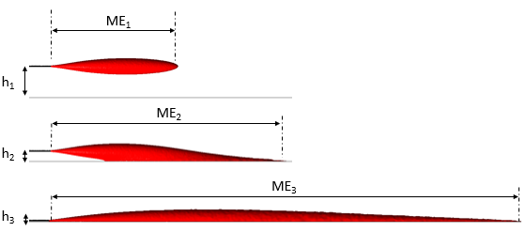
(a)
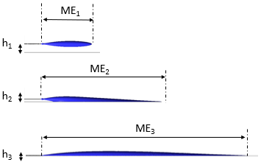
(b)
Figure 1: Effect of the h variation on the (a) methane and (b) propane LFL clouds.
However, when considering substances heavier than, or similar to, air (it is the case for propane and methane) the behavior of the jet (and thus the ground influence) appears to be way less different than that of considering a much lighter one (i.e., hydrogen). In particular, the heavier the gas is, the steeper the curve is. This leads to remark that the ground affects much more high momentum releases of heavy compounds. The reason can be explained by the different buoyancy effect: hydrogen jets driving up, while methane and propane jets stay parallel to the ground (and thus resulting much more affected by it). Meaning that the high momentum of the flow prevails on the buoyancy effects, this also justifies why methane and propane ME increases up to 4 times with respect to ME_{FJ} while hydrogen ME of only 1.5.
Contrarily to what seen for the ground influence, Figure 3 shows that the dimensionless h* value, about 13, is practically shared by all three compounds.
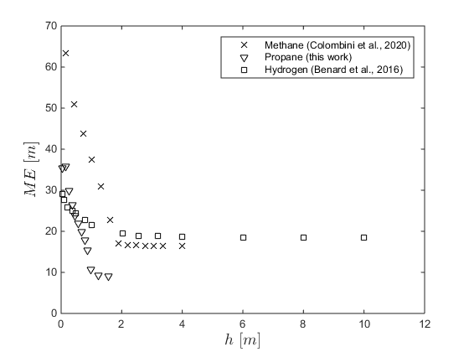
Figure 2: ME over h for the three considered substances, where LFL_{Methane} = 5, LFL_{Propane} = 2.1, LFL_{Hydrogen} = 4 expressed in % of vol_{SUB}/vol_{AIR}.
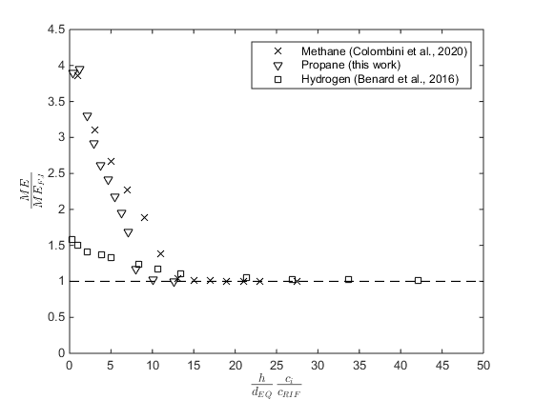
Figure 3: Dimensionless space defined to offset both different stagnation pressures and different concentrations.
  - Conclusions
In this work, the scenario of a high-pressure jet parallel to the ground, and interacting with it, was investigated. Varying the height of the source above the ground, the influence that such kind of obstacle has on the jet was analysed for three widely used process substances, namely methane, propane and hydrogen.
With regards to the preliminary results shown, it is possible to conclude that:
- the dimensionless space defined appears to be adequate to provide a direct comparison among results obtained when considering different storage conditions as well as different concentrations observed;
- both qualitatively and quantitatively, the ground influence appears to be similar when considering high-pressure jets of compounds heavier than, or similar to, air;
- both qualitatively and quantitatively, the ground influence appears to be different when considering a released compound much lighter than air;
- by order of magnitude, the dimensionless height that defines when the ground effect starts, it appears to be comparable for all the three compounds.
Broadly speaking, the ground effect is to increase the damage area. The results of the present work indicate that for compounds heavier than, or similar to, air a larger increase of the hazardous distance should be expected with respect to the case of considering lighter compounds.
References
Angers B., Hourri A., Bénard, P., Tchouvelev A., 2011, Numerical Investigation of a Vertical Surface on the Flammable Extent of Hydrogen and Methane Vertical Jets, International Journal of Hydrogen Energy, 36(3), 2567-72.
Batt R., Gant S., Lacome J., Truchot B., 2016, Modelling of Stably-Stratified Atmospheric Boundary Layers with Commercial CFD Software for use in Risk Assessment, Chemical Engineering Transactions, 48, 61-66 DOI:10.3303/CET1648011.
Bénard P., Tchouvelev A.V., Hourri A., Chen Z., Angers B., 2007, High Pressure Hydrogen Jets in the Presence of a Surface, Proceedings of the International Conference on Hydrogen Safety, 11–13 September, San Sebastain, Spain.
Bénard P., Hourri A., Angers B., Tchouvelev A., 2016, Adjacent Surface Effect on the Flammable Cloud of Hydrogen and Methane Jets: Numerical Investigation and Engineering Correlations, International Journal of Hydrogen Energy, 41, 18654-662.
Birch A.D., Brown D.R., Dodson M.G., Swaffield F., 1984, The Structure and Concentration Decay of High- Pressure Jets of Natural Gas, Combustion Science and Technology, 36, 249-261.
Cameron, I., Raman, R., 2005. Process System Risk Management, first ed. Elsevier Amsterdam., The Netherlands.
Casal, J., Gómez-Mares, M., Muñoz, M., Palacios, A., 2012, Jet fires: A ‘minor’ fire hazard? Chem. Eng. Trans. 26, 13–20. DOI: 10.3303/CET1226003.
Colombini, C., Busini, V., 2019, Obstacle Influence on High-Pressure Jets based on Computational Fluid Dynamics Simulations. Chemical Engineering Transactions, 77, 811–816. https://doi.org/10.3303/CET1977136.
Colombini, C., Martani, A., Rota, R., Busini, V., 2020, Ground Influence on High-Pressure Methane Jets: Practical Tools for Risk Assessment, Journal of Loss Prevention in the Process Industries, submitted.
Desilets, S., Cote, S., Nadau, G., Benard, P., Tchouvelev, A., 2009, Experimental results and comparison with simulated data of a low pressure hydrogen, proceedings of the 3rd International Conference on Hydrogen Safety, 16-18 September, Ajaccio, Corsica.
Franquet, E., Perrier, V., Gibout, S., Bruel, P., 2015, Free underexpanded jets in a quiescent medium: A review. Prog. Aerosp. Sci. 77, 25–53. DOI: 10.1016/j.paerosci.2015.06.006.
Hall J.E., Hooker P., O'Sullivan L., Angers B., Hourri A., Bernard P., 2017, Flammability Profiles Associated with High-Pressure Hydrogen Jets Released in Close Proximity to Surfaces, international journal of hydrogen energy, 42, 7413-21.
Hourri A., Angers B., Bénard P., 2009, Surface Effects on Flammable Extent of Hydrogen and Methane Jets, International Journal of Hydrogen Energy, 34, 1569-1577.
Liao, N., Huang, K., Chen, L., Wang, Z, Wu, J., Zhang, F., 2018, Numerical simulation of gas dispersion during cold venting of natural gas pipelines. Adv. Mech. Eng. 10, 1–14. DOI: 10.1177/1687814018755244.
Miozzi, M., Lalli, F., Romano, G.P., 2010, Experimental investigation of a free-surface turbulent jet with Coanda effect. Exp. Fluids 49, 341–353. DOI: 10.1007/s00348-010-0885-1.
Pontiggia M., Busini V., Ronzoni M., Uguccioni G., Rota R., 2014, Effect of Large Obstacles on High Momentum Jets Dispersion, Chemical Engineering Transactions, 36, 523-528 DOI: 10.3303/CET1436088.
Tolias, I. C., Giannissi, S.G., Venetsanos, A.G., Keenan, J., Shentsov, V., Makarov, D., Coldrick, S., Kotchourko, A., Ren, K., Jedicke, O., Melideo, D., Baraldi, D., Slater, S., Duclos, A., Verbecke, F., Molkov, V., 2019, Best practice guidelines in numerical simulations and CFD benchmarking for hydrogen safety applications. Int. J. Hydrogen Energy 44, 9050–9062. DOI: 10.1016/j.ijhydene.2018.06.005.
Zuliani C., De Lorenzi C., Ditali S., 2016, Application of CFD Simulation to Safety Problems – Challenges and Experience Including a Comparative Analysis of Hot Plume Dispersion from a Ground Flare, Chemical Engineering Transactions, 53, 79-84. DOI: 10.3303/CET1653014.

