CHEMICAL ENGINEERING TRANSACTIONS  VOL. 82, 2020 | A publication of
The Italian Association
of Chemical Engineering
Online at www.cetjournal.it
Guest Editors: Bruno Fabiano, Valerio Cozzani, Genserik Reniers
Copyright © 2020, AIDIC Servizi S.r.l.
ISBN 978-88-95608-80-8; ISSN 2283-9216

Extraction and Transport of Methylene Blue Dye through a Plasticized Liquid Membrane containing Trioctyl Phosphine Oxide (TOPO) as the Carrier: Parametric Study
Nadjet Taoualitª*, Khalida Boutemak^{b}, Nabila Bensaciaª, Soumia Chemlalª, Soumia Irririª, Djamal-Eddine Hadj-Boussaadª
ªLaboratoire des Applications Énergétiques de l’Hydrogène. Université de Blida1, Route de Soumaa, Blida, Algeria
^{b}Laboratoire d’Analyse Fonctionnelle des Procédés Chimiques. Université de Blida1, Route de Soumaa, Blida, Algeria
ntaoualit@hotmail.fr
Extraction and transport of Methylene Blue dye (MB) from synthetic waste water were investigated in this work, using a plasticized polymeric membrane (PPM) composed of the base polymer (PVC), the carrier trioctyl Phosphine Oxide (TOPO) and the plasticizer dioctyl phthalate (DOP). MB species extraction and transfer conditions from feed phase to the strip one through PVC/TOPO/DOP, were optimized (carrier mass, H₂SO₄ concentration in the strip solution...). The membrane was characterized by using SEM techniques.
Obtained results establish that PPM technique is suitable for discoloration of wastewater.
  - Introduction
Pollution from industrial wastewater has become a serious problem for many countries (Kümmerer, 2007). Some of the important pollutants are dyes which, once dissolved in water, will sometimes be difficult to treat, because they have a synthetic origin and a complex molecular structure which makes them more stable and difficult to be biodegraded (Forgacs et al., 2004) therefore they can constitute risk factors for human health and nuisance for environment (Rai et al., 2005).
Nowadays, there are more than 100,000 dyes belonging to various chemical classes with an annual production of 7x10⁵ tonnes (Yalkowski et al., 2010). Methylene blue, is the most common cationic (basic) dye used in dyeing cotton, wood and silk. Its inhalation can give rise to breathing difficulties and its ingestion by the mouth produces a burning sensation, causes nausea, vomiting, perspiration and profuse cold sweats (Djenouhat et al., 2018). It can cause eye burns that cause permanent injury to the eyes of humans and animals.
Different techniques have been applied for the treatment of industrial effluents containing dyes, such as biological reactions (Rai et al., 2005) and physicochemical processes, as adsorption (Boutemak et al., 2019) including the work of Rubio (2018) who used Cassava Bark residue (CBR) as adsorbent materials to remove methylene blue from aqueous solution and that of Kang (2020) who used a biomaterial prepared from Escherichia coli biomass, coagulation/flocculation (Bouyakoub et al., 2010), electrochemical oxidation (Dutta et al., 2001), nanofiltration, precipitation (Ben Mansour et al., 2011) and membrane separation processes such as liquid membranes (Hilmi et al., 2018) which have been used for the removal of organic and metallic pollutants from aqueous solutions, have shown great potential, especially in cases where solute concentrations are relatively low and other techniques cannot be applied effectively (Taoualit et al., 2016).
The extraction of chemical species in the liquid membrane system can be facilitated by a transporter (a carrier). In such transport, an ion exchange reagent or complexing agent (solvating agent) is incorporated into the membrane phase to transport the diffusing species from the feed phase through the membrane to the reception phase.
In this work, plasticized liquid membranes PPM is applied to study the extraction, recovery and transport of the Methylene Blue (MB) dye present in synthetic aqueous solutions. PPM is composed of i) polyvinyl chloride (PVC) as base polymer that provides mechanical strength, ii) trioctylphosphine oxide (TOPO) as carrier (solvating extractant, Figure1) which is responsible for the chemical species extraction and transport through PPM, iii) and dioctyl phthalate (DOP) as plasticizer which provides elasticity to the membrane (Benosmane et al., 2016) and increases the solubility of the extracted species in the membrane liquid phase (Nghiem et al., 2006).
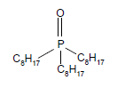
Figure 1: Structure of the organophosphorus carrier TOPO
  - Materials and Methods
    - Preparation of the plasticized liquid membrane PPM
PPM membranes were developed according to the protocol of Sugiura et al. (Sugiura, 1993; Sugiura et al., 1989) described by White et al. (Small, 1963).
In the present work, the used membrane was prepared from 1g of PVC dissolved in 30mL of tetrahydrofuran THF (99.9 % purchased from Carlo Erba Reagents), 0.1g of TOPO (97%, purchased from Fluka) and 1mL of DOP (99.5%, purchased from Yucheng Jinhe Industrial). The samples of obtained film were cut for duplication experiments. Aqueous solutions of MB were prepared by dissolving the corresponding reagent (dark blue crystals purchased from Merck Eurolab S.A) in bidistilled water. The chemical structure of MB or methylthioninium chloride is shown in Figure 2a.
    - Experimental device for Methylene Blue transport
The extraction and transport experiments were carried out in a two-compartment Teflon cell with a volume of 50 ml, respectively the source solution of $400 mg.L^{-1}$$25 ppm$ of MB at pH solution of 2 and receiving phase containing a solution of H₂SO₄ 0.05 M. The two compartments are separated by the membrane PVC/TOPO/DOP as shown in Figure 2b. Both the source and the receiving aqueous phases were stirred at 600 rpm. The active surface of PPM was S = 8.04 cm² and the thickness was e = 250-300 μm.

(a) (b)
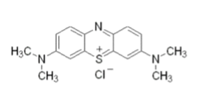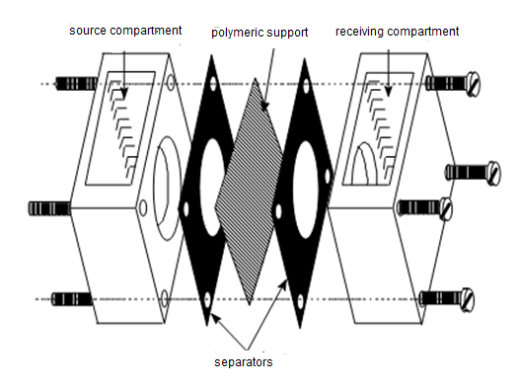
Figure 2 : (a) Chemical structure of MB : C₁₆H₁₈ClN₃S (b) Experimental device of transport cell
Flux transport of MB species through PPM are determined by following the concentration variation of MB as function of time in both, source and receiving compartments, by removing successive samples of 0.5 mL in each compartment at defined time intervals, to be analyzed by spectrophotometry at 665 nm using a Shimadzu UV-1700 pharma spectrophotometer. The mass flux can be calculated using equation (1), (Arous et al., 2011), where J is the flux of the transported MB, V_{R} is the receiving phase volume, ΔC is the concentration variation of complexes species in the receiving phase, corresponding to time interval Δt (Yang et al., 2015):
$J=\frac{V_{R}. ∆C}{∆t . S}$ | (1)
Permeation coefficients P (Taoualit et al., 2016) were calculated by:
$\ln{\frac{C_{ini}}{C_{t}}}=P\frac{S.t}{V_{A}}$ | (2)
The flux can be calculated according to:
$J=P. C_{ini}$ | (3)
The permeability is therefore determined by the slope of the curve:
$\ln{\frac{C_{ini}}{C_{t}}}=f (t)$ | (4)
Where $C_{t}$ and $C_{ini}$ are respectively the concentration of MB in the feed phase at given time and at the beginning of reaction, $V_{A}$ is the feed solution volume and t is the process time. The extraction percentage of MB is calculated using the balance of the masses.
  - Results and Discussion

    - Effect of H₂SO₄ concentration in the strip solution

In order to avoid the accumulation of the MB-TOPO species in the membrane phase, reception solution must be used to facilitate the decomplexation and the release of MB species from the membrane phase at the second interface. In order to obtain the appropriate reception solution, two types of solutions were chosen; the sulphuric acid H₂SO₄ and water.
Obtained results show that H₂SO₄ solution is more effective than H₂O in improving the MB transport through PVC/TOPO/DOP which can be explained by the favoured decomplexions at the second interface (II) between membrane and aqueous phase (II) in the presence of H₂SO₄ (Figure 3a). Extraction and permeation of MB are higher, the extraction yields approach to 100 % (Figure 3b), those of diffusion do not exceed 1.03% (Figure 3c) and the diffusion coefficient about $7.82 x {10}^{-4} cm^{2}.s^{-1}$. Therefore, sulphuric acid solution was chosen as the strip one for the rest of this work. Experimental results illustrated on Figure 3a show that the increase in the concentration of H₂SO₄ favours the increase of the MB permeability coefficient that becomes quasi-constant in the chosen range of H₂SO₄ concentration from 0 to 1.5M. A maximum permeability coefficient of $0.64 m.s^{-1}$ is observed at [H₂SO₄] = 0.05 M, which has therefore been chosen as optimal for the rest of this work.
    - Influence of the mass of the carrier
The mass range of the carrier TOPO is: 0.01, 0.02, 0.05, 0.1, 0.2, 0.3 and 0.5g. The coefficient of permeability increases until reaching a constant value slightly higher than $0.6 m.s^{-1}$and a plateau is observed (Figure 3d). This result is probably explained by the maximization due to the saturation by the complexes formed and accumulated at the membrane interface, increasing the retention of the separation component on the entry side. Thus the coefficient of permeability is maintained at a constant value from 0.02 g of TOPO. Another reason is possible: it is a possible dimerization of TOPO at high concentrations in organic phase, which could make complexation of MB by TOPO at the first interface difficult (Kim et al., 2001). A mass of 0.02 g of TOPO is then maintained as the optimal value for the rest of the work.
    - Thermodynamic study of MB extraction-complexation by TOPO
Thermodynamic parameters of MB extraction and complexation by TOPO such as Gibbs free energy ΔG, enthalpy ΔH and entropy ΔS have been calculated using the following equations:
$ΔG = ΔH – TΔS$ | (5)
$ΔG =-RT Ln K_{eq}$ | (6)
According to the following equilibrium (Taoualit et al., 2016):
$MB+ TOPO ↔ \overline{MBTOPO}$ | (7)
Taking into account the equation:
$Ln K_{eq}=-\frac{ΔH}{R.T}+ \frac{ΔS}{R}$ | (8)
$∆H$ and $∆S$ values have been determined from the slope and the original value of the line $Ln K_{eq}=f (\frac{1}{T})$ and the values of $K_{eq}$ have been calculated from the equation 9. Table 1 groups the obtained results.
$K_{eq}=\frac{\overline{[BMTOPO}]}{\left[BM\right]x[TOPO]}= \frac{D}{[TOPO]}$ | (9)
Table 1: Thermodynamic values of MB extraction by the PPM: PVC/TOPO/DOP
Temperature (K) | 292.60 | 303.00 | 313.00
$$∆H (kJ.{mol}^{-1} )$$ | -15.750 | -15.750 | -15.750
$$∆S (J. {mol}^{-1}.K^{-1} )$$ | 74.780 | 74.780 | 74.780
$$∆G (kJ.{mol}^{-1} )$$ | -21.864 | -22.642 | -23.390

Negative values of ∆H and ∆G and the positive values of ∆S indicate the exothermic and the spontaneous nature of MB complexation (extraction) by TOPO.

Figure 3: (a) Influence of H₂SO₄ concentration on MB permeability, (b)MB concentration in phase (I), (c) MB concentration in phase (II), (d) Influence of TOPO mass on MB permeability, T=20 °C, pH = 2, [MB]_{init} = 25 ppm
  - Characterization of PPM by SEM technique
The images (a, b and c) of Figure 5, show clearly that the addition of the carrier TOPO confer to the membrane a porous appearance with many regular micro-pores or craters of different sizes that have been formed on the PPM surface due to the rapid evaporation of the THF solvent (Witt et al., 2018), comparing to the surface of PVC alone which is uniform and dense without porosity (Kebiche-Senhadji et al., 2008). The difference in pore size is related to the difference in the driving force for phase separation (Rajendran et al., 2008). Apparition of substances, probably, type of (MB TOPO) formed on the membrane surface filling an important number of pores, is shown on the SEM image of PPM loaded with MB (Figure 5d). There are some impurities due to the bad dissolution (distribution) of the extractant TOPO in the matrix, probably.
(a) (b)
(c) (d)
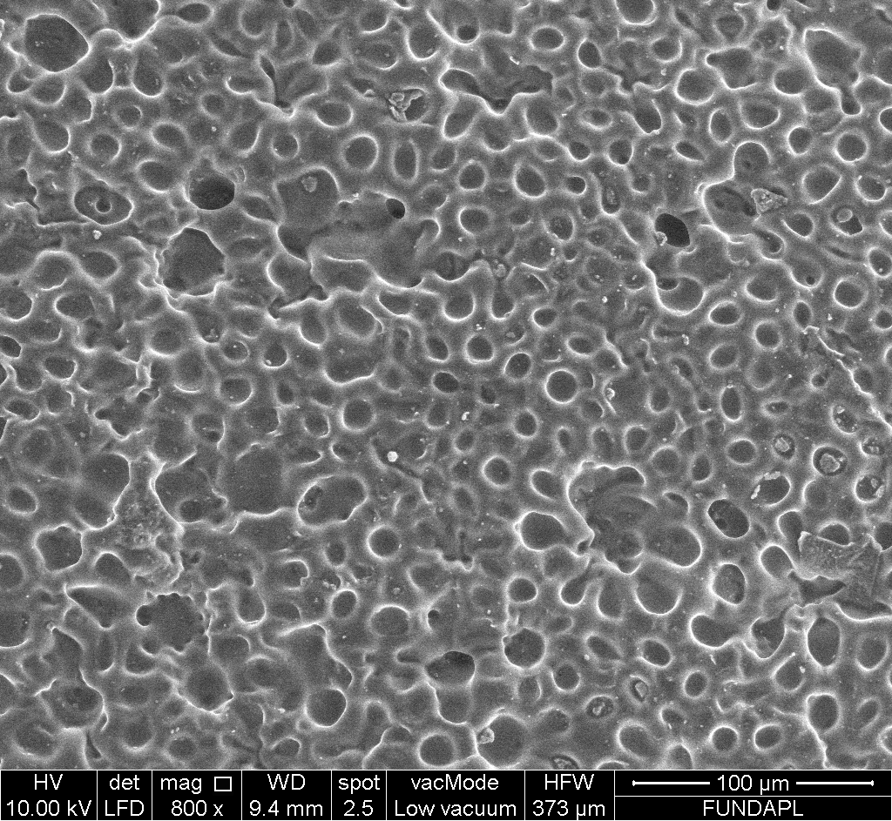
Figure 5: Membranes SEM images: (a) PVC/DOP, (b)micro-pore, (c)PVC/TOPO/DOP, (d)PVC/TOPO/DOP/ MB
  - Conclusions
Systematic parametric study of Methylene Blue transport from an aqueous feed solution through a plasticized liquid membrane (PPM) to a receiving solution of H₂SO₄ was carried out in order to optimize the operating conditions, such as the quantity of the carrier (extractant), composition of the strip aqueous phase as well as its H₂SO₄ concentration. Permeability experiments indicate that almost 100 % of a synthetic solution of 25 ppm of MB can be efficiently complexed with a permeability coefficient of 0.60 m.s⁻¹ during few minutes using 0.02 g of TOPO and 0.05 M of H₂SO₄$\left[NaOH\right]=0.4 mol.L^{-1}$ in the strip solution. $\left[TOPO\right]=0.05 mol.L^{-1}$Against only about 1.03% of MB who crossed PPM to the second compartment. The extraction-complexation of MB by TOPO is exothermic and spontaneous in aqueous solution. The diffusion coefficient is $7.82 x {10}^{-4} cm^{2}.s^{-1}$. SEM images show that the addition of the carrier creates inside the membrane a certain type of paths which facilitates the transport of complexes by diffusion. PPM technique is suitable for discoloration of wastewater. It is to consider to test this type of membrane also to treat other types of wastewater such as those of surface treatment workshops, olive oil mills, leachates, for desalination, etc., in order to protect the environment and recover the considered species.
References
Arous O., Saad Saoud F., Amara M., Kerdjoudj H., 2011, Efficient Facilitated Transport of Lead and Cadmium across a Plasticized Triacetate Membrane mediated by D₂EHPA and TOPO, Materials Sciences and Applications, 2, 615-623. doi: 10.4236/msa.2011.26083
Ben Mansour H., Boughzala O., Dridi D., Barillier D., Chekir-Ghedira L., Mosrati R., 2011, les Colorants Textiles Sources de Contamination de l’Eau : Criblage de la Toxicité et des Méthodes de Traitement, Revue des Sciences de l'Eau, 24, N°3, 209-238, doi :10.7202/1006453ar
Benosmane N., Boutemeur B., Hamdi S. M., Hamdi M., 2016, The Removal of Phenol from Synthetic Wastewater using Calix [4] Resorcinarene Derivative Based Polymer Inclusion Membrane, Algerian Journal of Environmental Science and Technology, 2 (2), 26-33.
Boutemak K., Taoualit N., Cheknane B., Laslouni O., Djeddou S., Medaoud K., Mazouni I., Aoudj S., 2019, Equilibirum, Kinetic and Thermodynamic Study of Green Malachite and Rhodamine-b Dyes Sorption on Olive Pomace, Chemical Engineering Transactions, 73, 277-282, doi :10.3303/CET1973047
Bouyakoub A. Z., Kacha S., Ouhib R., Bellebia S., Lartiges B., 2010, Traitement Combiné d’un Effluent Textile contenant des Colorants des Réactifs par Coagulation-Floculation et Elecrtroflotation, Revue des Sciences de l'Eau 23, 89-103.
Djenouhat M., Bendebane F., Bahloul L., Samar M.E.H., Ismail F., 2018, Optimization of methylene blue removal by stable emulsified liquid membrane using Plackett–Burman and Box–Behnken designs of experiments, Royal Society Open Science 5 (2): 171220, doi.org/10.1098/rsos.171220
Dutta K., Mukhopadhyaya S., Bhattacharjee S., Chaudhuri B., 2001, Chemical Oxidation of Methylene Blue using a Fenton-Like Reaction, Journal of Hazardous Materials B 84, 57– 71.
Forgacs E., Cserhati T., Oros G., 2004, Removal of Synthetic Dyes from Wastewaters: a review. Environment International 30 (7), 953–971. doi:10.1016/j.envint.2004.02.001
Hilmi Abdul Rahman, Norasikin Othman, Muhammad Bukhari Rosly, Raja Norimie Raja Sulaiman, Norela Jusoh, Norul Fatiha Mohamed Noah, 2018, Synergistic Extractant for Extraction of Remazol Orange 3R in Liquid Membrane Formulation, Malaysian Journal of Analytical Sciences, Vol 22 N° 4, 626-632, doi.org/10.17576/mjas-2018-2204-08
Kang S.B., Wang Z., Won S.W., 2020, Adsorption Characteristics of Methylene Blue on PAA-PSBF Adsorbent, Chemical Engineering Transactions, 78, 205-210.
Kebiche Senhadji, O., Sahi, S., Kahloul, N., Tingry, S., Benamor, M., Sera, P., 2008, Extraction du Cr (VI) par Membrane Polymère à Inclusion, Sciences et Technologie A, Volume B, N° 27, 43-50.
Kim J.S., Kim S.K., Cho M.H., Lee S.H., Kim J.Y., Kwon S.G., Lee E.H., 2001, Permeation of Silver Ion through Polymeric CTA Membrane containing Acyclic Polyether Bearing Amide and Amine End-Group, Bulletin of the Korean Chemical Society, 22 (10), 1076-1080.
Kümmerer K., 2007, Sustainable from the Very Beginning: Rational Design of Molecules by Life Cycle Engineering as an Important Approach for Green Pharmacy and Green Chemistry, Green Chemistry 9, 899–907.
Nghiem L. D., Morname P., Potter J. M., Perera Cattrall R. W., Kolev S. D., 2006, Extraction and Transport of Metal Ions and Small Organic Compounds using Polymer Inclusion Membranes (PIMs), Journal of Membrane Science, 218, 7-41, doi:10.1016/j.memsci.2006.03.035
Rai H.S., Bhattacharyya M.S., Singh J., Bansal T.K., Vats P., Banerjee U.C., 2005, Removal of Dyes from the Effluent of Textile and Dyestuff Manufacturing Industry: a review of Emerging Techniques with Reference to Biological Treatment. Critical Reviews in Environmental Science and Technology, 35, 219–238.
Rajendran S., Ramesh Prabhu M., Usha Rani M., 2008, Characterization of PVC/PEMA Based Polymer Blend Electrolytes, International Journal of Electrochemical Science, 3, 282 – 290.
Rubio A., Zanette Da Silva I., Gasparotto F., Paccola E., Silva C., Ueda Yamaguchi N., Emanuelli Picada I., Bergamasco R., 2018, Removal of Methylene Blue Using Cassava Bark Residue, Chemical Engineering Transactions, 65, 751-756.
Small H., 1963, Solvent Extraction Process for the Recovery of Uranium and Rare Earth Metals Aqueous Solution, The Dow Chemical Company, U.S Patent, 3, 102, 782.
Sugiura M., 1993, Effect of Quaternary Ammonium Salts on Carrier-Mediated Transport of Lanthanide Ions Through Cellulose Triacetate Membrane, Separation and Purification Technology, 28, 1153-1463, doi : 10.1080/01496399308018050
Sugiura M., Kikkawa M, Urita S., 1989, Carrier-mediated transport of rare earth ions through cellulose triacetate membranes. Journal of Membrane Science, 42 (1-2), 47-55, doi:10.1016/S0376-7388(00)82364-9
Taoualit N., Azzazi F.Z., Benkadi N.E., Hadj-Boussaad D.E., 2016, Extraction and Transport of Humic Acid using Supported Liquid-Membrane Containing Trioctyl Phosphine Oxide (TOPO) as the Carrier, Acta Physica Polonica A, 129 (1), 115-121, doi: 10.12693/APhysPolA.130.115
Witt K., Radzyminska-Lenarcik E., Kosciuszko A., Gierszewska M., Ziuziakowsk K., 2018, The Influence of the Morphology and Mechanical Properties of Polymer Inclusion Membranes (PIMs) on Zinc Ion Separation from Aqueous Solutions, Polymers, 10(2), 134, doi: 10.3390/polym10020134
Yalkowski SH., He Y., Jain P., 2010, Handbook of aqueous solubility data, 2nd Edn; CRC Press, Boca Raton.
Yang X., Duan H., Shi D., Yang R., Wang S., Guo H., 2015, Facilitated Transport of Phenol through Supported Liquid Membrane containing bis (2-Ethylhexyl) Sulfoxide (BESO) as the Carrier, Chemical Engineering and Processing, 93, 79-86, doi : 10.1016/j.cep.2015.05.003

