CHEMICAL ENGINEERING TRANSACTIONS  VOL. 82, 2020 | A publication of
The Italian Association
of Chemical Engineering
Online at www.cetjournal.it
Guest Editors: Bruno Fabiano, Valerio Cozzani, Genserik Reniers
Copyright © 2020, AIDIC Servizi S.r.l.
ISBN 978-88-95608-80-8; ISSN 2283-9216

Study of Oxidative Torrefaction Process of Sunflower Husks
Rafail L. Isemin*, Dmitriy V. Klimov, Aleksandr V. Mikhalev, Natalia S. Muratova, Artemiy V. Nebyvaev
Tambov State Technical University, Michurinskaya street, 112, I, Tambov, 392032, Russia,
penergy@list.ru
The problem of using sunflower husk, which Russia produces annually about 3.6 million tons, as a fuel for communal and industrial boiler houses, is considered. It is shown that the fuel characteristics of husks can be significantly improved as a result of its oxidative torrefaction in a fluidized bed in a flue gas medium with a low oxygen content. The kinetics of oxidative torrefaction process of husks was studied; it was found that the torrefaction process is accompanied by exothermic reactions, but this process can be controlled due to the intense heat exchange processes in the fluidized bed.
  - Introduction
Horticulture waste can be considered as a significant and annually updated source of biofuel. For example, in Russia the production of sunflower seeds is one of the main elements of the agro-industrial complex. In 2019 21.2 million tons of oilseeds were harvested in Russia, where 14.6 million tons were sunflower seed crops (ROSNG, 2019). The husk formed during the sunflower seeds processing can be considered as biofuel, since it has a combustion heat of 13–17.5 MJ/kg, humidity of 9.1–11.6 %, ash content of 1.7–3.8 % and it contains 70.4–77.1 % of volatiles (Poznayka, 2017). Approximately 3.6 million tons of such biofuel were produced in Russia in 2019 (TK Solutions, 2020). In Russia sunflower husk is applied as fuel in plants for the production of sunflower oil. The burning of husks is carried out in a low-temperature vortex, which allows minimizing the amount of work when transferring boilers, operating on coal or fuel oil, to husks burning (Puzyrev, Shchurenko, 1998) (Puzyrev et al., 1999). However, the physicochemical characteristics of sunflower husks do not allow it to be efficiently burned in boilers equipped with furnaces with a low-temperature vortex. The husk burning processes do not end in the furnace; husk particles are carried out of the furnace and continue to burn in the inflow chimneys because of the high windage. As a result, the temperature of the gases in the inflow chimneys exceeds the established limits and the husk ash particles become hot, which leads to a rapid increase in ash sediments on the convective heating surfaces of the boiler. Due to the rapid growth of ash sediments, the boiler capacity during the sunflower husks burning drops by 40–50 % of the nominal value.
According to the experience of Millerovo branch of ASTON JSC (Millerovo, Rostov region, Russia), one of the largest plants for the production of sunflower oil, which processes 1200 tons of sunflower seeds per day, the husk should be pressed into pellets for the effective burning. This will not only reduce the entrainment of unburned husk particles from the boiler furnace and reduce the growth rate of ash sediment on convective heating surfaces, but also use these pellets as fuel not only at plants that process sunflower seeds, but also at other boiler houses, including those remote from sunflower seeds processing places.
However, the pellets from sunflower husks, like pellets from other types of biomass, are hygroscopic and quickly destroyed by even slight contact with water, which increases the cost of storage and transportation of pellets (Graham et al., 2016).
Heat treatment of biomass, including sunflower husk, before pelletizing at a temperature of 200–320 °C in oxygen-free medium (torrefaction) can significantly improve the fuel properties of biomass, increase its calorific value, reduce hygroscopicity and make biomass more suitable for combustion and gasification (van der Stelt et al., 2011).
However, torrefaction is an energy-intensive process, especially when using an inert gas as nitrogen. The torrefaction process can also be carried out in a gaseous medium containing a small amount of oxygen. This process is called oxidative torrefaction. In order to carry out the oxidative torrefaction process, flue gases leaving the boilers can be used (Mei et al., 2015). In this case, the oxygen concentration can reach 6–14 vol. % (Uemura et al. 2017). It is noted (Wang et al., 2018) that the necessary time and duration of the process are reduced during the oxidative torrefaction.
The heat capacity of the flue gases is very low and they obviously cannot be considered as the main heat carrier in the process of torrefaction. So, it is necessary to use a different heat source, for example, it is possible to place the heat exchange surfaces in the torrefaction reactor, through which the heat from a high-temperature liquid heat transfer to heat-treating biomass. It should also be in mind that in the presence of oxygen in the heated biomass bed the exothermic processes will develop, for the regulation of which it will be necessary to remove effectively the excess heat from the biomass bed. Therefore, it would be correct to carry out the torrefaction process in a fluidized bed, the use of which ensures intensive heat exchange of particles of the biomass layer with heat exchange surfaces located in the bed. In this case, the excess heat will be quickly removed to the high-temperature coolant and the possibility of ignition of the biomass will be excluded. Based on our own research experience in the area of torrefaction of various biowaste (Isemin et al., 2018), including in a fluidized bed (Isemin et al., 2019), and drawing on the experience of designing plants for heat treatment of biomass in a fluidized bed (Isemin et al., 2016) we chose a fluidized bed oxidative torrefaction method for biowaste processing.
Unfortunately, there are only a few studies of the process of oxidative torrefaction in a fluidized bed (Wang et al., 2018). The purpose of this work is to fulfill the knowledge gap in this area and study the kinetics of the oxidative torrefaction process in a fluidized bed.
  - Experimental set-up
In order to study the oxidative torrefaction process, an experimental set-up was created, the scheme of which is shown in Figure 1. The experimental set-up consists of fluidized bed reactor 1, electric boiler 2, smoke exhauster 3, heat exchanger 4, cooling water storage tank 5, cyclone 6, gas analyzer 7. The fluidized bed reactor 1 have a jacket into which a liquid high-temperature heat carrier is supplied, heated in an electric boiler 2. Reactor 1 is made of a steel pipe with a diameter of 108 mm and a height of 2000 mm. The reactor 1 is equipped with a node for introducing a portion of the biomass (the node is located in the upper part of the reactor 1) and a node for the heat-treated biomass output from the reactor 1 (the output node is located in the lower part of the reactor 1).
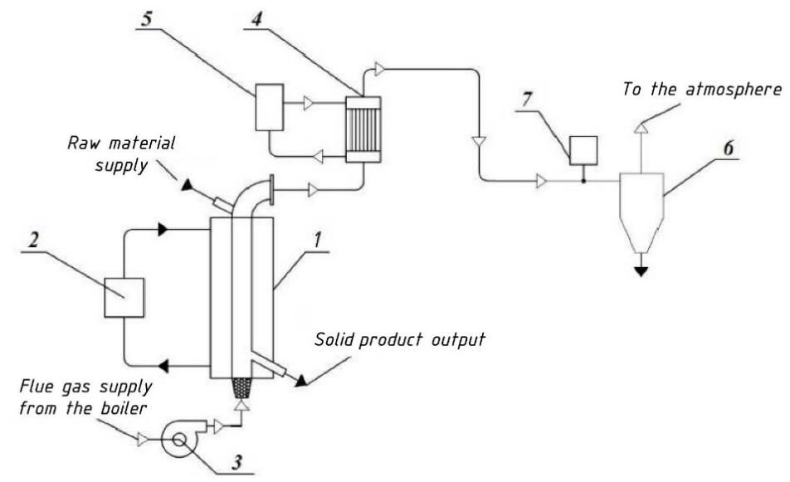
Figure 1: Scheme of experimental set-up for studying the oxidative torrefaction process of sunflower husks. 1-fluidized bed reactor, 2-electric boiler, 3-smoke exhauster, 4-heat exchanger, 5-storage tank, 6-mechanical cleaning in cyclone, 7-gas analyzer
The fluidized bed in the experimental reactor is formed by crushed particles of biomass itself. The biomass layer in the reactor 1 is converted into a fluidized state by the flue gases, which are fed to the lower part of the reactor 1 by means of a smoke exhauster 3 from a boiler (not shown in the diagram), where the pellets from sunflower husk are burned.
The gases leaving the reactor 1 contain condensing and non-condensing gaseous products of biomass torrefaction. These gases are cooled in the heat exchanger 4 by water circulating by means of a pump (not shown in the diagram) between the heat exchanger 4 and the water storage tank 5. The formed condensate is removed from the system. Then non-condensable gaseous products of torrefaction go through the mechanical cleaning in cyclone 6 and are released into the atmosphere.
Before the experiments began, the set-up was purged with flue gases, which were cooled in the heat exchanger 4, and after removal of moisture from the gases, they were introduced to chemical analysis for the contents of О₂, СО, СО₂, and SO_{x} using a gas analyzer of SWG 300.
The torrefaction process of chopped sunflower husk was studied, because the sunflower husk was not fluidized in the initial state. These particles of crushed husk had the following fractional composition (Table 1).
Table 1: Fractional composition of crushed husk
˃ 5 mm | 2 – 5 mm | 1 – 2 mm | 0.4 – 1.0 mm | 0.2 – 0.4 mm | 0.09 – 0.2 mm
0.02 % | 6.48 % | 30.84 % | 50.54 % | 9.72 % | 2.4 %

The true density of husk particles was 520 kg/m³. The minimum fluidization velocity of husk particles was 0.3 m/s. The working gas velocity at the inlet to the reactor was 0.45 m/s.
The mass of crushed particles of sunflower husk before and after torrefaction was determined using Acom JW-1 laboratory balance. Husk moisture was determined by Ohaus MB45 moisture analyzer.
Ash content and volatility were determined using thermogravimetric analysis (TGA) using NETSCH STA 409 PC/PG thermal analyzer. The samples were dried to a relative humidity of 0.1 % before the ash content determination, volatile content and elemental content.
The elemental content of husks before and after heat treatment (content of C, H, N, S) was determined on Elementar vario MACRO cube elemental analyzer. The oxygen content (O, wt.%) on a dry state was calculated based on the material balance:

O=100-(C+H+N+AA), | (1)

where C, H, N, S, 𝐴𝐴 – the content in the sample of carbon, hydrogen, nitrogen, sulfur and ash content of raw materials, expressed in wt.%. calculated on the dry state.
The higher calorific value of the husk before and after treatment was determined using BKS-2X calorimeter.
During the experiment, a portion of biomass in the amount of 1270 g was periodically loaded into the reactor 1. The height of the fixed bed of husk particles in the reactor 1 was 800 mm. The temperature of the high-temperature coolant supplied to the reactor’s jacket 1 was 250 °C. The temperature of the flue gases supplied to the reactor 1 was 200 – 225 ºС. During the experiments, the temperature of the fluidized bed and the pressure drop in the fluidized bed were continuously measured taking into account the resistance of the gas distribution grid (the measurement was carried out using “Testo 521” differential micromanometer).
After cooling the gaseous products of torrefaction and removing the condensing fraction, the content of carbon monoxide, carbon dioxide and sulfur dioxide in non-condensable gaseous products of torrefaction was continuously measured.
During the torrefaction process, the samples of biomass weighing 50 g, which were placed in a hermetically sealed container for subsequent analysis, were taken from the reactor after 5, 10, and 20 minutes.
  - Experiment results
Figure 2a shows the content of oxygen, carbon dioxide and carbon monoxide in the flue gases behind the boiler, i.e. in those gases that are used to fluidize a bed of crushed husks of sunflower.
As can be seen from Figure 2a, the flue gases at the entrance to the husk fluidized bed contain an average of 2.5 % oxygen, 16.5 % carbon dioxide and 10,000 ppm/m³ carbon monoxide. In the considered temperature range (up to 400 °C), carbon dioxide does not interact with carbon, and therefore the presence of CO₂ in flue gases should not have an effect on the intensity of the torrefaction process.
Figure 2b shows the change in the temperature of the husk fluidized bed in the process of torrefaction. As can be seen from Figure 2b, at the start of torrefaction the temperature begins to increase from 200 ºС (the temperature of the flue gases at the inlet of the fluidized bed) to 325 – 350 ºС. Moreover, the bed’s temperature 325 ºС is reached approximately 5 minutes after the start of the torrefaction experiment. It can be assumed that during these 5 minutes, husks are dried, and the torrefaction process itself already begins from the fifth minute.
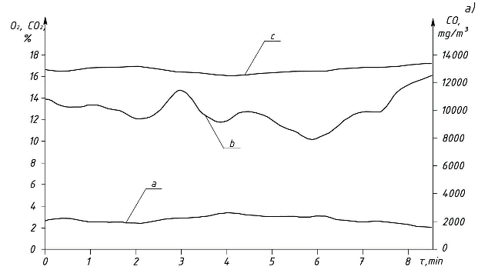 | 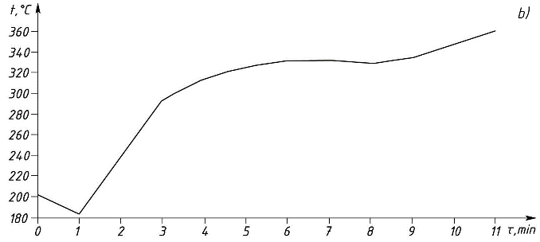
Figure 2: a) Content of flue gases at the entrance to fluidized bed of sunflower husks (a - oxygen content, b - carbon monoxide content, c - carbon dioxide content), b) Change in temperature of husk fluidized bed in torrefaction process
The temperature rise in the fluidized bed from 200 to 325 ºС, and then to 350 ºС can be explained by exothermic reactions occurring in the husk fluidized bed. Interestingly, the temperature of the fluidized bed does not change in the interval between 5 and 9 minutes from the beginning of the process. It can be assumed that during this period of time the thermal energy, supplied to the husk fluidized bed and released from the husk during exothermic reactions, is spent on the release of volatile substances from biomass. The husk gasification process begins from 9th minute, which is suppressed by heat removal to a high-temperature coolant washing the walls of the reactor.
The fact, that in the first five minutes after loading the husk into the reactor the drying process of husk starts, is confirmed by the change in time of the pressure drop in the system of the husk fluidized bed + gas distribution grill (Figure 3a).
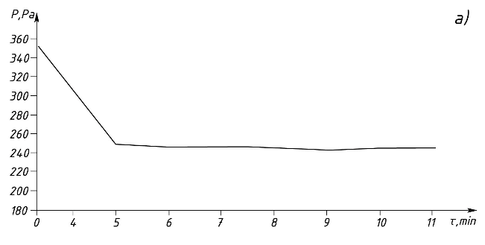 | 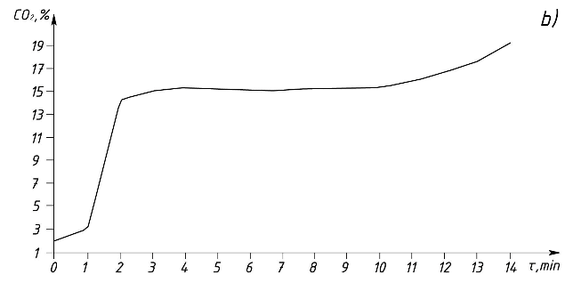
Figure 3: a) Change in pressure drop in fluidized bed + gas distribution system during torrefaction of sunflower husks, b) Change in carbon dioxide concentration in non-condensable gaseous products at torrefaction process of sunflower husks in a fluidized bed
As can be seen from Figure 3a, in the first 5 minutes from the start of the torrefaction process, the pressure fall in the fluidized bed + gas distribution system decreases by about 30 %. This is obviously connected, as noted above, with the removal of moisture of the volatile substances, as well as with the removal of very small particles of husk from fluidized bed. Then the pressure drop does not change, i.e. during oxidative torrefaction in a fluidized bed the main weight loss of the sample is observed in the first five minutes of the process.
With the start of the torrefaction process during cooling of gaseous products, the condensation of moisture released from the husk at the first stage of the process occurs. This moisture absorbs part of the carbon dioxide contained in the flue gas, resulting in a sharp decrease in the concentration of carbon dioxide in non-condensable gaseous products of torrefaction (Figure 3b). Then, approximately 3 minutes after the start of the process, the concentration of carbon dioxide reaches its initial values ​​and then does not change until 10 minutes, when this concentration begins to increase due to the start of husk gasification.
The fact that from about 10th minute from the start of oxidative torrefaction process of sunflower husk in a fluidized bed, the process of gasification begins is confirmed by a sharp increase in the carbon monoxide concentration in non-condensable gaseous products of torrefaction (Figure 4a).
Up to this point, the concentration of CO in these gases was approximately the same as in the flue gas supplied to the fluidized bed reactor (Figure 2a).
The husk gasification process is accompanied by a sharp increase in the sulfur dioxide concentration in non-condensable gaseous products of torrefaction, and the increase in the sulfur dioxide concentration also begins from about tenth minute from the start of the process (Figure 4b).
Thus, it can be stated that the process of sunflower husks torrefaction in a fluidized bed in the exhaust flue gas environment takes about ten minutes, where the medium should not exceed 10 minutes, because from the tenth minute, intense husk gasification begins.
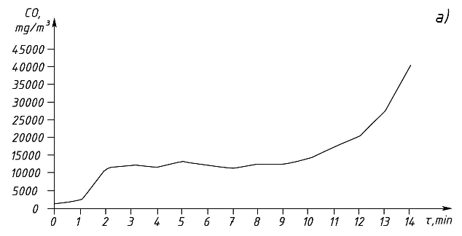 | 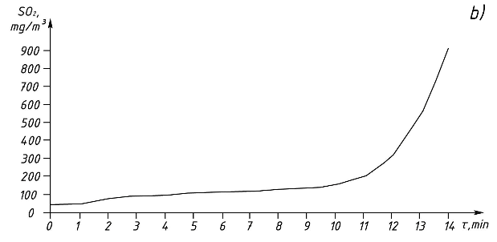
Figure 4: a) Change in carbon monoxide concentration in non-condensable gaseous products during sunflower husk torrefaction in fluidized bed, b) Change of sulfur dioxide concentration in non-condensable gaseous products during sunflower husks torrefaction process in fluidized bed
Table 2 presents the results of chemical analysis of husk (initial husk, husk after torrefaction for 2.5 minutes, husk after torrefaction for 5 minutes, husk after torrefaction for 10 minutes).
Table 2: Results of chemical analysis of husk particles before and after oxidative torrefaction in fluidized bed
Indicator | Unit of measurement | Initial sunflower husk | Husk after torrefaction for 2.5 min. | Husk after torrefaction for 5 min | Husk after torrefaction for 10 min.
Humidity | % | 10.6 | 9.29 | 3.2 | 2.7
Ash content  (at 550 °C) | % | 3.7 | 4.9 | 6.1 | 6.8
Lowest calorific value | MJ/kg | 16.0 | 18.35 | 20.7 | 21.2
Volatile Content | % | 75.6 | 65.2 | 54.8 | 49.9
C | % | 51.3 | 55.6 | 59.9 | 62.0
H | % | 6.3 | 5.65 | 5.0 | 4.86
N | % | 0.92 | 1.0 | 1.09 | 1.12
As follows from Table 2, with time increase of husks in the torrefaction reactor from 5 to 10 minutes, the insignificant changes in the husk characteristics occur in comparison with those changes that took place during the first five minutes of the torrefaction process. So, time increasing of husks in a torrefaction reactor over 10 minutes does not make sense.
  - Conclusion
The oxidative torrefaction study method used in this work allowed us to determine two main stages of the torrefaction process and the limits of its duration. In relation to the process of torrefaction of sunflower husk in a fluidized bed in the flue gases medium containing a small amount of oxygen, it was found that the oxidative torrefaction is accompanied by exothermic reactions in the heated biomass, which can obviously be controlled only by intensive removal of excess heat from the reaction zone, due to the fluidization technology application. It is planned to apply such torrefaction technology for heat treatment of other types of biomass (chicken manure, sawdust, etc.).
Acknowledgments
The work was financially supported by the Ministry of Education and Science of Russia (Agreement № 074 -11 – 2018 – 018 of May 29, 2018).
References
Chen W.-H., Lu K.-M., Lee W.-J., Liu S.-H., Lin T.-C., 2014, Non-oxidative and oxidative torrefaction characterization and SEM observations of fibrous and ligneous biomass, Applied Energy, 114, 104–113.
Graham S., Ogunfayo I., Hall M.R., Snape C., Quick W., Weatherstone S., Eastwick C., 2016, Changes in mechanical properties of wood pellets during artificial degradation in a laboratory environment, Fuel Processing Technology, 148, 395–402.
Isemin R., Klimov D., Larina O., Mikhalev A., Zaitchenko V., 2018, Integrated waste treatment system combining biogas technology and pyrolysis, Chemical Engineering Transactions, 67, 505–510.
Isemin R., Mikhalev A., Muratova N., Kogh-Tatarenko V., Teplitskii Y., Grebenkov A., Pitsukha E. 2019, Low-temperature pyrolysis of poultry litter for biofuel production, Chemical Engineering Transactions, 75, pp. 103–108.
Isemin R., Klimov D., Mikhalev A., Milovanov O., Muratova N., Zaichenko V., 2016, Fluidized bed straw pellets combustion with minimal emissions of carbon monoxide, Chemical Engineering Transactions, 53, 13–18.
Mei Y., Liu R., Yang Q., Yang H., Shao J., Draper C., Zhang S., 2015, Torrefaction of cedarwood in a pilot scale rotary kiln and the influence of industrial flue gas, Bioresource Technology, 177, 355–360.
Poznayka, 2017, Lecture 12, Characteristics of waste of oil production, <poznayka.org/s80006t1.html> accessed 27.03.2020.
Puzyrev E.M., Shchurenko V.P., 1998, Cyclone furnace. The patent of the Russian Federation №2105239, 20.02.1998.
Puzyrev, E.M., Shchurenko, V.P., 1999, Sharapov, M.A., Device for burning solid fuel. Patent of the Russian Federation No. 2126113, 10.02.1999.
ROSNG, 2019, <rosng.ru/post/v-rossii-sobrali-rekordnyy-urozhay-maslichnyh> accessed 27.03.2020.
van der Stelt, M.J.C., Gerhauser, H., Kiel, J.H.A., Ptasinski, K.J., 2011, Biomass upgrading by torrefaction for the production of biofuels: A review, Biomass and Bioenergy, Vol. 35, Issue 9, 3748–3762.
TK Solutions, 2020, Marketing research of the sunflower oil market for 2016-2020. Forecast for 2020-2024, Moscow, Russia.
Wang C., Peng J., Li H., Bi H.T., Legros R., Lim C.J., 2013, Oxidative torrefaction of biomass residues and densification of torrefied sawdust to pellets, Bioresource Technology, Vol 127, 318–325.
Wang Z., Li H., Lim C.J., Grace J.R., 2018, Oxidative torrefaction of spruce-pine-fir sawdust in a slot-rectangular spouted bed reactor, Energy Conversion and Management, Vol 174, 276–287.

