|  |  |
| --- | --- |
| cetlogo ***CHEMICAL ENGINEERING TRANSACTIONS***  ***VOL. 82, 2020*** | A publication of  aidiclogo_grande |
| The Italian Association  of Chemical Engineering  Online at www.cetjournal.it |
| Guest Editors: Bruno Fabiano, Valerio Cozzani, Genserik Reniers  Copyright © 2020, AIDIC Servizi S.r.l. **ISBN** 978-88-95608-80-8; **ISSN** 2283-9216 | |

Multifactor Geochemical Modeling Of Biodegradable Subsurface Hydrocarbon Contamination

Valery P. Meshalkina, Sergey V. Ostakhb, Violetta S. Kusheevab\*

aD.Mendeleev University of Chemical Technology of Russia, 125047, Russian Federation, Moscow, Miusskaya Square, 9

bNational University of Oil and Gas «Gubkin University», 119991, Russian Federation, Moscow, Leninsky Prospekt, 65

v\_kusheeva@mail.ru

Accidents at oil pipelines, leaks from underground or buried tanks and pipelines, unloading and loading operations on oil loading racks, and other dumping loads are the most dangerous sources of subsurface hydrocarbon pollution. Vertical infiltration of oil and oil products leads to the formation of technogenic deposits and abnormal geochemical zones.

The various microbiological conditions of contaminated soils and lands determine the direction of multi-stage reactions of hydrocarbon transformation and complicate the process of identifying the corresponding geochemical anomalies and the source of its formation.

The aim of this work is to use geochemical modeling approaches to identify and eliminate subsurface oil pollution based on a single automated network of observation and injection wells with forced circulation of suspended mixture of microorganisms.

The total soil microbiological activity, characterized by a gradient in the zone of hydrocarbon contamination distribution and described by the Monod equation, was chosen as a quantitative bioindicator for assessment the degree of contamination. In this case, the data of the model experiment on the biological treatment of the hydrocarbon contamination zone were used to correct the proposed dependencies.

Activated oil destructing microorganisms contribute to the decomposition of hydrocarbon pollution as part of suspended mixture, therefore, their quantity will correlate with the concentration of the pollutant in the medium and can be used for its approximate estimation.

The results of multifactor geochemical modeling using the data of a full-scale experiment allow not only to develop a comprehensive knowledge system about the nature of the subsurface hydrocarbon pollution distribution, but also to adapt the measures for identifying and eliminating this pollution having regard to the areas with the greatest degree of disturbance.

* 1. Introduction

At present, the poorly studied processes of migration and transformation of hydrocarbon pollution in the geological environment not only endanger the ecological balance of natural objects, but also offset any beneficial effect of environmental protection measures, that are often of an undirected and nominal nature (Petangeli Papini, Ostakh, Kusheeva, 2018).

Hydrocarbon contamination of the geological environment is a priority environmental problem for many regions and countries. This problem concerns not only oil production regions: geological pollution is observed almost everywhere, especially clearly manifested in areas of the lithosphere affected by the oil production, storage, transportation and processing of oil and oil products.

Such environmental impact can initiate irreversible changes or destruction of landscapes, and also lead to pollution and degradation of adjacent environmental components, such as surface water-bodies, soils and the atmosphere. The semantic network of the considered technogenic (artificial) ecological anomalies formation make allowance for their diversity in size, form of localization and internal structure (Figure 1). The presented network has a complex and complicated nature.

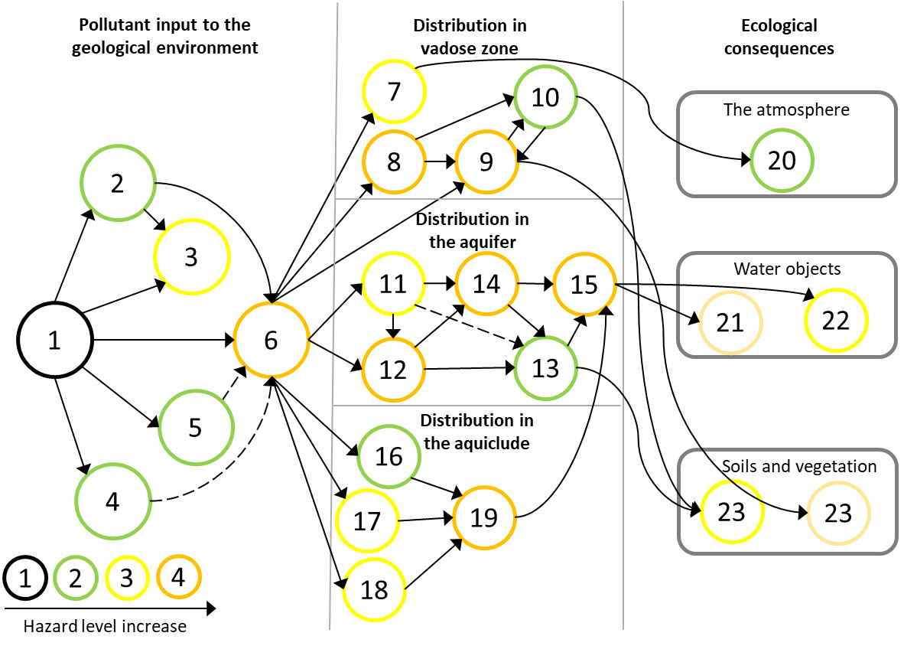

Figure 1: Semantic network of processes and phenomena caused by pollution of the geological environment: 1 - hydrocarbon pollution (primary source): accidents, leaks, oily emissions; 2 - pollution of the soil surface and vegetation; 3 - pollution of the deep soil layers; 4 - pollution of a water body; 5 - air emissions; 6 - pollution of the geological environment; 7 - evaporation in soil air; 8 - sorption on soil particles; 9 - dissolution in ground moisture; 10 - biodegradation; 11 - emulsifying in groundwater; 12 - dissolution in groundwater; 13 - biochemical transformations; 14 - advective transfer; 15 - pollutant plume formation; 16 - sorption on particles of low permeable silts; 17 - diffusion and capillary percolation; 18 - adhesion of high viscosity oil products; 19 - back diffusion; 20 - secondary pollution of the atmosphere; 21 - oil seepage in watercourse and water bodies; 22 – pollutant accumulation in bottom sediments; 23 - adaptation of soil biogeocenosis up to extermination; 24 - land degradation up to complete loss of fertility.

Oil-containing technogenic flows with melt and atmospheric waters fall into local soils, creating specific technogenic geochemical anomalies. The acuteness of the problem requires the search for new solutions that would allow to carry out the most efficient remediation of the contaminated geological environment and decrease the burden of deposited oil-containing wastes on the adjacent components of environmental systems.

* 1. Research objectives

By now the basic ideas about the physical mechanisms of mass transfer in groundwater have been developed (Shengqi et al., 2020). According to them, the migration of components is based on their convective transport (taking into account the mechanism of gravitational differentiation) and diffusion-dispersive spreading, which are superimposed on the physicochemical processes of pollutant transformation in underground solutions and its interaction with rocks (Mironenko, Rumynin, 2002).

Hydrocarbon contamination (hereinafter - HC contamination) is slightly-soluble in groundwater and therefore forms a separate phase (Riccardi et al., 2008). It makes the behaviour of HC pollutants difficult to forecast, especially in the aeration zone, where two mobile phases, liquid and gaseous, initially exist.

Phenomenological dependencies, including those studied by indicator testing methods (Agaoglu, Scheytt, Copty, 2016), for example, are now widely used to consider the behavior of two immiscible liquids.

The basis of experimental studies involving indicator testing is the launch of chemical and biological indicators into aquifers, followed by monitoring of their migration (Jin et al., 1995). Implemented indicator testing can be aimed at determining parameters reflecting the migration of HC contamination (mainly from surface primary technogenic sources) in the field of injection and pumping wells. The aim of this work is to study the possibilities of multifactor geochemical modeling of biodegradable hydrocarbon contamination of the geological environment to justify alternative technological solutions for remediation and minimisation of ecological consequences and evaluate its environmental and economic efficiency.

* 1. Justification of indicator selection and description of its dynamic during experiment

For the early preventing of geological environment contamination, as well as for assessing the dynamics of oil-containing technogenic flows, it is relevant to determine stable informative geo-indication parameters.

Experimental studies should be carried out with indicators that are sufficiently inert and stable in natural waters, can be easily determined (preferably in the field) by analytical chemistry and bioindication methods, and have little effect on the filtration properties of rocks.

At the same time, the choice of indicators is determined by their ability to identify and emphasize certain features of the physical processes of in-situ mass transfer during testing of heterogeneous media.

Electrolytes are not applicable for the performance targets, because they are water soluble, therefore, do not form a separate phase and cannot characterize the spread of oil fluid in the geological environment.

The main advantage of using organic colourants (fluorescein, uranium) is the simplicity of visual and instrumental registration, while downhole colorimetry of solutions using special immersion probes with high sensitivity of determination is also possible (Luciano, Viotti, Petrangeli Papini, 2010). At the same time, the organic nature of the colouring substances affects the peculiarities of their physicochemical interaction with rocks - they can be sorbed in a varying degree, and the intensity and kinetics of sorption are difficult to predict in advance. Despite all this, testing with organic colouring indicators is very effective, at least in the steps leading up to the main experiment.

In the case of experiments in heterogeneous media with low permeable zones (Tatti et al., 2018), it is necessary to use rather sophisticated method of indication that do not shift substantially specified or measured conditions at the boundaries of the researched zones: the time of the sample volume accumulation should be much less than the total time of registration of the calculated part of the experimental curve.

Therefore, in particular, it may seem appropriate to use indirect methods for continuously monitoring the dynamics of pollution and its distribution in the geological environment.

The oil-oxidizing activity of the microbial consortium is an indirect indicator of the studied hydrocarbon fluid presence in the researched field of the geological environment.

The research microbial consortium is a suspension containing living cells of hydrocarbon-oxidizing microorganisms. At the same time, their number can be used as a quantitative factor for assessing the degree of environmental contamination. In the course of pollutants biodegradation, this factor allows to assess the intensity, stage and nature of these processes.

A microbial cell oxidizes hydrocarbon contamination, adsorbing on its surface; as a result, the oil-oxidizing activity of cultures depends on their ability to utilize a hydrocarbon substrate (Kusheeva, Ostakh, 2018).

The processes that affect the number of microorganisms in the environment are following (Liu et.al., 2016):

- mass transfer in the flow of infiltrating moisture;

- accumulation in the area of poorly permeable rocks;

- enhanced mass transfer during dynamic water flow in comparison with hydrostatic conditions;

- biological processes (nutrition, reproduction, dying off, oppression).

The determined weighting coefficients of bioindication parameters are applicable for estimation of integral indices respectively to the dynamics of anomalous concentrations of indicator microbial populations and the soils humus content. Consequently, the general microbiological activity of soils was selected as a quantitative indicator of biodegradable contamination of geological environment, characterized by a gradient in the zone of HC contamination.

To describe the variability in the number of microorganisms of the research consortium over time, taking into account the death of cells, the Monod equation is applicable (Lensing et al., 1994):

|  |  |
| --- | --- |
| $$\frac{∂C}{∂t}=\frac{μ∙G}{G+K_{S}}∙C-λ∙C$$ | (1) |

where  *C –* the total number of microorganisms in a unit controlled by a volume monitoring system;

$μ$*–* maximum growth rate of soil bacteria;

*G –* hydrocarbon (substrate) concentration;

$K_{S}$*–* microorganism-substrate affinity constant;

$λ$*–* cell death rate (without cell regeneration).

The total number of bacteria is described by the equation:

|  |  |
| --- | --- |
| $$C=C_{S}+C_{W}∙\frac{ε}{ρ}$$ | (2) |

where $ρ$*–* soil density;

$ε$*–* soil permeability;

$C_{W}$*–* the number of bacteria in groundwater;

$C_{S}$*–* the number of bacteria immobilized (adsorbed) on soil particles.

Taking into account the number of bacteria immobilized on soil particles the final equation for the total number of microorganisms:

|  |  |
| --- | --- |
| $$\frac{∂C}{∂t}=\frac{μ∙G}{G+K_{S}}∙C-λ∙C-\frac{ϑ}{ε_{эф}^{м}}∙\frac{∂C}{∂x}$$ | (3) |

where $ϑ$– groundwater velocity;

$ε_{ef}^{m}$– effective permeability, taking into account adsorption on soil particles;

$\frac{∂C}{∂x}$– convective transfer rate of microorganisms with infiltrating moisture.

When taking into account the total number of microorganisms, the value of hydrocarbon-oxidizing activity is taken equal to at least 50%.

* 1. Mathematical modelling

Laboratory methods for studying mass transfer are important to use as an independent tool, i.e. their results can be directly used in the creation of models and in forecast estimations, as well as auxiliary - when decoding the data of field experiments and observations.

The planned laboratory experiment was tasked with several interrelated objectives:

- determination of environmental migration parameters;

- identification of the physico-chemical nature of the pollutant conversion processes;

- assessment of parameters that control the course of interphase physical and chemical reactions necessary for predictive modelling.

The reliability of the results is largely determined by the preservation of the natural structure of the soil. If it is impossible to receive an undisturbed structure, it is necessary to pre-compact the soil under technogenic loads. A microbial consortium is a liquid activated suspension of microorganisms included in the bio-based product-oil destructor (biosuspension).

The adding of activated biosuspension as an indicator for subsequent quantitative modeling can be carried out in two ways, shown in Figure 2.

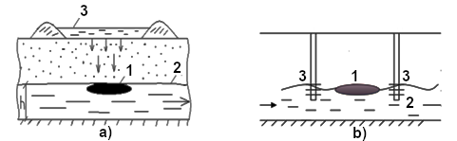

Figure 2: The scheme for adding the biosuspension into the polluted groundwater flow: a) from the soil surface with its subsequent filtration through the vadoze zone; b) injection through perforated pipes (wells): 1 - zone of oil pollution (oil lens), 2 - underground aquifer, 3 - biosuspension

In the planned experiment, biosuspension is introduced both ways: mixed with pumped-out liquid stream through the infiltration gallery and directly using the injection wells (Figure 3).

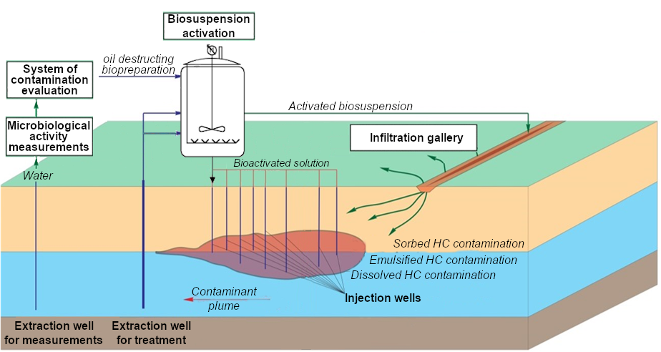

Figure 3 – The scheme of the box for a model experiment

Microorganisms of various types have different emulsifying ability and produce surfactants of various nature. In response to the presence of hydrocarbons oil-oxidizing microorganisms synthesize surfactants (Besha, et al, 2018).

The loss of oil fluid in the geological environment occurs due to biodegradation of the hydrocarbon phase of and leaching in emulsified form.

Biodegradation is described by the Monod equation (Toscano, Colarieti, Greco, 2012), while leaching is described by the convective transfer equation, and their combination describes the total loss of oil fluid:

|  |  |
| --- | --- |
| $$\frac{∂G}{∂t}=-\frac{1}{q}∙\frac{μ∙G}{G+K_{S}}∙C-\frac{ϑ∙n}{ρ}∙\frac{∂G_{e}}{∂x}$$ | (4) |

where q – a coefficient linking the number of formed cells with the degraded substrate;

$G_{e}$– concentration of emulsified HC contamination in groundwater.

It is widely thought that bacteria produce surfactants during the decomposition of hydrocarbons, i.e. some hydrocarbons are used to produce surfactants. The process of bio-surfactant synthesis is described by the equation of type Monod. The produced bio-surfactant is spent on emulsification of HC contamination. That means, the rate of the reaction is the sum of the surfactant micelle formation rate and the rate of inclusion of the HC molecule in this micelle. It suggests that the surfactant flow rate will be proportional to its concentration and the concentration of the oil product. Therefore, the final equation describing the change in the concentration of bio-surfactant:

|  |  |
| --- | --- |
| $$\frac{dS}{dt}=\frac{1}{q_{s}}∙\frac{μ∙G}{G+K_{S}}∙C-k∙G∙S$$ | (5) |

where S – bio-surfactant concentration;

$q_{s}$– coefficient linking the amount of surfactant formed with the degraded substrate;

*k* – interaction constant of surfactant and oil product.

The concentration of emulsified HC contamination in groundwater, taking into account the removal with infiltrating water, then is described:

|  |  |
| --- | --- |
| $$n∙\frac{∂G_{e}}{∂t}=\frac{1}{ρ}∙\frac{α}{q_{s}}\frac{μ∙G}{G+K_{S}}∙C-ϑ∙\frac{∂G_{e}}{∂x}$$ | (6) |

where $α$– the number of surfactant molecules forming a micelle.

The final system of equations describing the dynamic of the concentrations of bacteria, free and emulsified HC contamination in the geological environment, is obtained by a combination of equations (3), (4) and (6).

Using a mathematical model developed on the basis of this system of equations, it is possible to calculate such integral quantities as the pollution concentration in the soil and the amount emulsified to the water bodies, the number of oil-oxidizing bacteria in the medium, as well as the change in the free oil product concentration in depending on the depth, its vertical transfer and the distribution of bacteria in the soil at a given point in time. The initial conditions are the initial distribution of free and emulsified oil pollution and bacteria. The boundary condition is the concentration of bacteria in the injected biosuspension.

The constants necessary for the calculation are determined according to laboratory model experiments; available literature data can be used for an approximate estimation.

The Figure 4 shows the results of the quantitative modeling of treatment carried out by introduction of the biosuspension into the soil, contaminated with hydrocarbons with an initial average concentration of 0.005 g/g of soil. The presented graphs describe the change in the concentration of free and emulsified hydrocarbon contamination over time in the course of biodegradation and related processes of physico-chemical transformation and transfer.

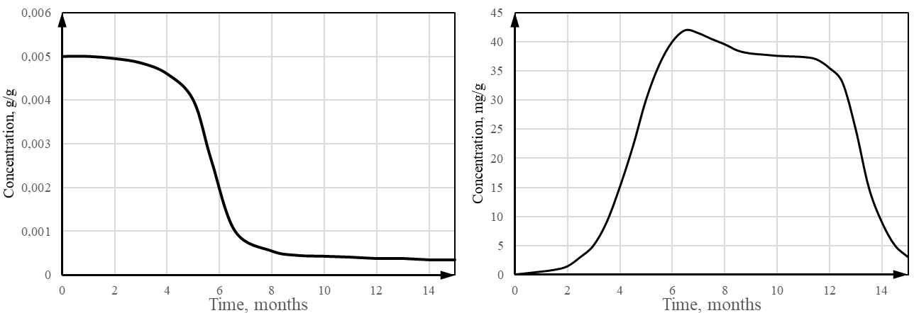

Figure 4 - Average concentration of free (left) and emulsified (right) HC contamination, calculated according to the developed geochemical model of biodegradable subsurface hydrocarbon contamination

The obtained results of quantitative modeling have sufficient convergence with the available field survey data of typical hydrocarbon contamination objects.

* 1. Conclusions

Experimental migration observations at real objects should be carried out in close interaction with laboratory experiments. Analysis and quantitative interpretation of migration processes modelling can be used to plan the further development of the observational network, long-term forecast estimations, which can be subsequently updated as information is accumulated at various stages of observation; development of water protection measures and assessment of their effectiveness.

The parameters determined by solving the theoretical equations showed good convergence with empirical data obtained in field studies of objects with hydrocarbon contamination. The results of the quantitative modeling are valuable in long-term forecast estimations.

The obtained model of microbial activity dynamics can also be considered in terms of immobilization of bacteria-oil-destructors on some medium. The implementation of such a technological approach as creating a geochemical barrier with a built-in monitoring system and active oil oxidizing effect can be optimized using data obtained from the mathematical model. Prospects and effectiveness of using this technology can also be estimated by the developed geochemical forecasting model.

References

Agaoglu B., Scheytt T., Copty N. K., 2016, Impact of NAPL architecture on interphase mass transfer: A pore network study, Advances in Water Resources, 95, 138-151.

Jin М., Delshad М., Dwarakanath V., McKinney D.C., Роре G.A., Sepehrnqri К., Tilburg С.Е., Jackson R.E., 1995, Partitioning tracer test for detection, estimation, and remediation performance assessment of subsurface nonaqueous phase liquids, International Journal of Rock Mechanics and Mining Sciences & Geomechanics Abstracts, 33, A62.

Kusheeva V.S., Ostakh S.V., 2018, Bioremediation of soil contaminated with PAH’s, Abstracts of the 72nd international youth scientific conference “Oil and Gas - 2018”, Moscow, Russian Federation.

Lensing H.J., Vogt M., Herrling B., 1994, Modeling of biologically mediated redox processes in the subsurface, Journal of Hydrology, 159, 125-143.

Liu P.C., Mailloux B.J., Wagner A., Magyar J.S., Culligan P.J., 2016, Can varying velocity conditions be one possible explanation for differences between laboratory and field observations of bacterial transport in porous media?, Advances in Water Resources, 88, 97-108.

Luciano A., Viotti P., Petrangeli Papini M., 2010, Laboratory investigation of DNAPL migration in porous media, Journal of Hazardous Materials, 176, 1006-1017.

Mironenko V.A., Rumynin V.G., 2002, Monograph, Problems of hydrogeoecology, Part 1. Theoretical study and modeling of geomigration processes, Moscow State Mining University, Moscow, Russian Federation.

Petangeli Papini M., Ostakh S.V., Kusheeva V.S., 2018, The method and principles of extraction of technogenic deposits on oil production facilities, Conference materials Geopetrol 2018. Development of hydrocarbon exploration and production technologies, 771-776.

Riccardi C., Di Filippo P., Pomata D., Incoronato F., Di Basilio M., Petrangeli Papini M., Spicaglia S., 2008, Characterization and distribution of petroleum hydrocarbons and heavy metals in groundwater from three Italian tank farms, Science of The Total Environment, 393, 50-63.

Shengqi Qi, Jian Luo, David O'Connor, Xiaoyuan Cao, Deyi Hou, 2020, Influence of groundwater table fluctuation on the non-equilibrium transport of volatile organic contaminants in the vadose zone, Journal of Hydrology, 580.

Tatti F., Petrangeli Papini M., Sappa G., Raboni M., Arjmand F., Viotti P., 2018, Contaminant back-diffusion from low-permeability layers as affected by groundwater velocity: A laboratory investigation by box model and image analysis, Science of The Total Environment, 622-623, 164-171.

Tesfaye Besha A., Bekele D. N., Naidu R., Chadalavada S., 2018, Recent advances in surfactant-enhanced In-Situ Chemical Oxidation for the remediation of non-aqueous phase liquid contaminated soils and aquifers, Environmental Technology & Innovation, 9, 303-322.

Toscano G., Colarieti M. L., Greco G., 2012, Biodegradation of aircraft deicing fluids in soil slurries, Chemical Engineering Transactions, 28, 1-6.