 CHEMICAL ENGINEERING TRANSACTIONS  VOL. xxx, 2026 | A publication of  
The Italian Association
of Chemical Engineering
Online at www.cetjournal.it

Guest Editors: Valerio Cozzani, Bruno Fabiano, Genserik Reniers
Copyright © 2026, AIDIC Servizi S.r.l.
ISBN 979-12-81206-xx-x; ISSN 2283-9216

Accident and Near Miss Management in Non-Seveso Production Sites of the Italian “Food Valley”: the Case of a Large Wine Company
Silvia Carraª, Giuseppe Vignali^{b,*}, Luigi Monicaª
ªINAIL, Dipartimento Innovazione Tecnologica e Sicurezza degli Impianti, Prodotti e Insediamenti Antropici, Via Roberto Ferruzzi, 38, 00143 Roma, Italy
^{b}Università degli Studi di Parma, Dipartimento di Ingegneria dei Sistemi e delle Tecnologie Industriali, Parco Area delle Scienze 181/A, 43124 Parma, Italy
giuseppe.vignali@unipr.it
Identification and management of near misses constitute a standard approach for supporting safety management systems in high-risk Italian industrial plants subject to Seveso Directive. Accidents, quasi-accidents and injuries have always to be registered and recorded; moreover, this aspect is typically subjected to the control action of the surveillance bodies. Nonetheless, in recent years both the scientific literature and the national entities responsible for defending safety at the workplace have highlighted that even industrial contexts considered to be at lower risk, such as the manufacturing industry, can take great advantage in terms of accident prevention if they are able to focus on the identification of near misses.
This work aims to analyse the specific sector of the food industry, starting from the results of a questionnaire concerning accidents and near misses, to which numerous food companies in Emilia-Romagna (the so-called “Food Valley” in Northern Italy) were subjected. Then, the case of a large local winery is investigated, to validate and to deepen the conclusions drawn from the survey. The occurred unwanted events are analysed and discussed. The obtained results are expected to contribute to show the meaning and the importance that the expression “near miss” acquires even in contexts other than the Seveso sites. At the same time, it has been possible to identify different specific phases of the entire wine production process in which unwanted events mainly occur.
  - Introduction
The recording and analysis of near misses and accidents is an established practice in all high-risk Italian facilities commonly referred to as “Seveso sites” (e.g. big chemical and nuclear plants), which are subjected to Legislative Decree 105/2015 and therefore to mandatory inspections because of the presence of above-threshold quantities of dangerous substances. In such contexts, where it cannot be excluded that High-Impact Low Probability accidents may arrive, the a priori identification of conditions of initial or potential development of catastrophic events before they occur appears essential for preventive purposes. That is why even the international literature reports many studies showing methodologies for analysing quasi-accidental data coming from operative plants (Ansaldi et al., 2021), even in specific fields, e.g. steel industry (Awolusi and Marks, 2015) or specific work phases (Di Girolamo et al., 2023) through the historical analysis of such undesired events (Fabiano and Currò, 2012). Possible inconsistencies related to the decisional phase have always to be considered (Winkler et al., 2019). In some cases, the requirements in terms of completeness of the near miss reports have been also discussed (Simone et al., 2023), as well as the possibility to use smart technologies to realize an automated detection system and increase reliability (Elia et al., 2022). Nevertheless, in more recent years, attention to near misses, as potential precursors to more serious accidents, is gradually spreading to industrial sectors even not covered by major accident prevention regulations (Gnoni et al., 2022) and some companies have even declared to be equipped with a dedicated “near miss management model”, in accordance with current scientific international trends (Baldissone et al., 2019). Many non-Seveso companies have begun to put in place specific procedures dedicated to identification and managing of near miss, driven by the intuition of a possible advantage in terms of injuries or damages prevention and supported by the latest scientific evidence.
In the very recent past, Law 29 December 2025, n. 198 (converting Decree 31 October 2025, n. 159 “Urgent measures to safeguard health and safety in the workplace and in the field of civil protection”) has made the reporting, analysis and tracking of near misses mandatory in Italy even for non-Seveso companies with more than 15 employees, giving definitive confirmation of the necessity to give priority to the analysis of quasi-accidents in a wider range of industrial contexts. The Italian Workers’ Compensation Authority, embodied in the National Institute for Insurance against Accidents at Work (INAIL), is already proposing a specific web platform to support all companies in applicating a correct methodology to analyse near misses (INAIL, 2025). Even international scientific literature has started to deal with near misses in contexts with a limited level of risk, as in case of manufacturing industry (Pickup et al, 2020; Van Derlyke et al., 2022).
In this scenario, the present research addresses the specific context of the food industry, which is one of the key sectors in the economy of the Emilia-Romagna region (located in Northern Italy in the Po Valley) and, more generally, of Italy's so-called “Food Valley”. Although accidents do not reach the same numbers as in other sectors (e.g. constructions) nor the same severity in terms of possible consequences as in Seveso plants, they should not be overlooked. There are particular risk factors, such as in the case of companies which use seasonal workers for specific activities (e.g. tomato harvesting): in Summer the number of employees increases dramatically and they also must be trained quickly and from zero, sometimes notwithstanding a limited supervision capacity.
In the present study, after an initial analysis of the state of the sector in terms of awareness and management of accidents and near misses - carried out using a questionnaire sent to a large number of food production companies - the case-study of a single company (a large winery) is investigated, in order to verify or refute the conclusions drawn from the questionnaire results, which were reworked in aggregate form. Although the company does not fall within the Seveso domain, it presents various types of significant risks, including those related to the presence of dangerous substances for oenological treatments and to human-machine contact (e.g. during the packaging and bottling phases), therefore being a representative example of food industry hazards as described in other recent studies (INAIL, 2024). As already observed by Gajek and Michalik (2013), the fact that the Seveso threshold for quantities of hazardous fluids is not exceeded does not rule out the possibility that serious accidents occur. The company has activated specific procedures for recording, collecting and analysing accidents as well as near misses, also including actions taken to prevent them and interventions aimed at mitigating their consequences.
The results of both the questionnaire and the case-study analysis are reported and commented, to highlight the main anomalies detected (precursors of potential accidents), as well as the related possible causal factors and adopted solutions. Finally, some points for possible further study and improvement are highlighted, with the aim of contributing to diffusion and conscious use of common methodologies for near miss management and prevention in the variety of the Italian industrial contexts.
  - The questionnaire: recipients, covered topics, obtained results
The study sample was defined focusing on food and beverage production sector in the Emilia-Romagna market and using Kompass platform to identify the companies of interest (mainly through their ATECO codes). Food machinery manufacturers were excluded. A list including almost 800 companies was obtained; among them, 50 answered to the questionnaire, that was sent by email in Summer 2023.
Regarding companies that provided information on their size (30 on the total of 50), 23% of them were large companies, 26% were medium-sized companies, 35% were small enterprises and 16% were micro-enterprises. Such company dimensions were defined according to the Italian Decree 18 April 2005 “Alignment of the criteria for identifying small and medium-sized enterprises with EU regulations”, that is:

- Micro-enterprise: less than 10 employees, Financial Statement not exceeding €2 million.
- Small enterprise: less than 50 employees, Financial Statement not exceeding €10 million.
- Medium-sized company: less than 250 employees, Financial Statement not exceeding €50 million.
- Large company: more than 250 employees, Financial Statement exceeding €50 million.

A comprehensive set of sixteen questions was developed, including both open-ended questions and multiple-choice questions, organized in two main sections: the first one required general data (company location, dimension, etc.) and the second one required information about management of accidents and near misses.
Almost 40% of participants stated that a definition of “near miss” did exist within the company, but different answers were given, that is: (i) an accident/event that did not result in injury, (ii) a potentially dangerous situation that, for fortuitous reasons, did not cause damage, (iii) a precursor of an accident or (iv) something to be managed exactly as an accident. Previous studies reported that a near miss can be really defined as an accident that does not cause injury or illness but has the potential to do that [INAIL, 2025]. In addition, 38% of the companies also declared to have adopted a real Near-Miss Management System.
Near misses can be generally related to anomalies/non-conformities, that is hazardous situations that do not result in any accident/injury but are detectable in operating procedures, equipment, etc. Potentially critical situations that occurred in the last decade are shown and listed in Figure 1 for different company dimensions.
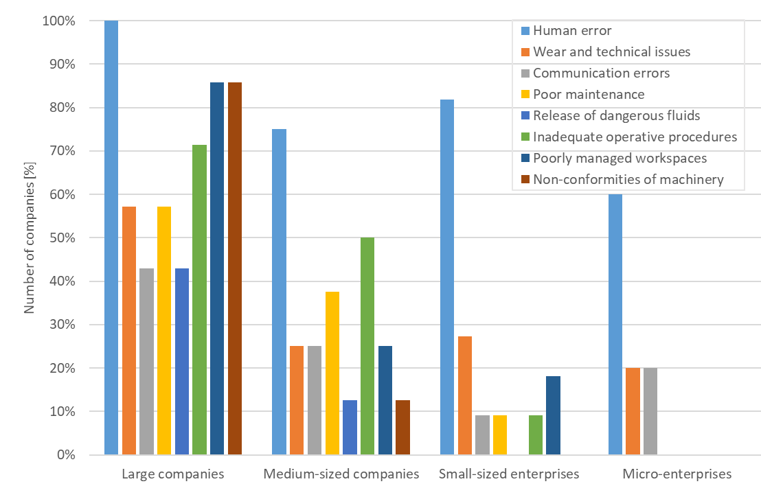
Figure 1: Distribution of observed anomalies related to near misses on companies with different dimensions
Human errors (failure to use or incorrect use of PPE, inappropriate behaviour, failure to comply with established procedures, overconfidence, misjudgement, underestimation of risk, incorrect setting of process parameters, lack of attention) are the most observed for each company dimension. The human factor appears to be very significant for safety, as generally observed even in other industrial fields, since it significantly influences reliability (Di Nardo and Murino, 2021).
Large companies seem to recognize a broader spectrum of anomalies; this number decreases when the company dimension decreases, down to the case of micro-enterprises, which only present human errors, critical components with excessive wear/damage or breakage/malfunctions of machinery (technical problems) and communication errors between operators or between the various management levels of the company. In large and medium-sized companies, non-compliances of machinery and equipment with the various Product Directives (e.g. Machinery Directive) are also shown. Other observable anomalies are maintenance (ineffective or incorrectly scheduled), operating procedures (incomplete or inefficiently planned), release of hazardous fluids in the workplace and inappropriate management of workspaces (storage of materials in unsuitable places, excessive disorder in workstations). Such situations were reported through checklists (18% of cases), voluntary employees reports (62%), supervision and monitoring (48%) and regular meetings (20%).
The actions taken by companies after accidents (or near misses) are shown in Table 1, together with the perceived main effects of an accident. When participants were asked to define an accident, most of them declared to perceive it exclusively as an event that causes injuries, but (mainly in large companies) even technical damages to plants and equipment have been cited.
The prevailing action taken is education with training, confirming the significant role of human error in the occurrence of undesirable events. Then, changes to operating procedures (including safety procedures and internal communication procedures) highlight a commitment to adopt organisational changes. Technical problems are generally addressed through changes to maintenance procedures and design work on systems/machines and their components. Changes to workers supervision/monitoring methods and rearrangement of workspaces/layout are finally chosen as adoptable solutions in a limited number of cases.
Table 1: Perceived characteristics of an accident in companies (percentage of total) and actions taken
Main effects of an accident |  |  | Actions to be taken after an accident
Injuries | Economic damages | Technical  damages | Changes to operative procedures | Changes to maintenance | Machine redesign | Training | Changes to monitoring | Spaces reassett
92% | 14% | 24% | 34% | 10% | 12% | 58% | 16% | 10%
  - A case-study: accident and near miss management in a large Italian winery
The analysed company operates in the wine and oenology sector and owns two main wineries - where different types and varieties of wine are produced - as well as seven other production sites where grapes are initially processed and must and wine are subsequently produced. A detailed internal procedure is dedicated to first aid and to the recording and analysis of accidents and near misses. A near miss is there defined as any event that, under different circumstances, could have caused harm to people but, only due to favourable and/or random conditions, did not produce such effects. It is therefore an event that has the potential to cause personal injury (physical and/or psychological damage). Any accident, incident and/or near-miss, discovered by anyone, must be promptly reported to the department manager. A specific accident or near-miss analysis report has to be completed. Subsequently, an analysis of the incident will be carried out (through collection of information and testimonies, which help in establishing the dynamics of the event) and, if necessary, improvement actions will be implemented to prevent the recurrence of the accident. The reports drawn up during the calendar year are reviewed to evaluate the actions taken and any further ideas for improvement.
The company reported that there have been 18 events (accidents or near misses) in the period 2020-2025. Detailed information was recorded for each of these events, including an analysis of possible causes and the sequence of corrective actions taken. Several managers typologies (e.g. Maintenance Manager, Logistics Manager, Oenologist, Warehouse Manager) can be involved in the reporting and analysis process, due to the complexity of the company, which include several departments and activity typologies. In particular, a storage area can host raw materials and finished products, while a wine cellar includes bulk wine, finishing, production and rectification of concentrated musts. The bottling and packaging lines consist of a series of machines connected by conveyor belts on which the individual containers travel, undergoing specific technological processes aimed at creating and completing the finished container containing the wine. The most significant machines, for the purposes of the activities carried out, are therefore those dedicated to filling the containers, positioning the caps and labelling, as well as those that palletise the cartons containing the various types of filled containers (bottles, cartons, jugs, bag-in-boxes, kegs and cans). The maintenance department provides initial internal assistance for any malfunctions affecting company tools and equipment, as well as coordinating any interventions by external technicians and personnel who carry out specialised work on specific machinery and systems.
Figure 2 shows in a pie chart the percentages of undesirable events that occurred in each of the main company departments in the considered period. It should be noted that in some cases, where the operator had actually come into contact with dangerous parts or toxic substances, the company chose to classify the event as a near miss (rather than an actual accident) if the physical consequences were ultimately negligible. Next to the pie chart, the black boxes show the main issues that could represent near misses, as identified in the different sectors mentioned above. The red boxes list the possible causes for each issue, as identified by the company's analysis.
It appears clear that the warehouse department is where most events generally occur. In this department (but also in other ones) there have been collisions between forklifts and operators on foot (risk of injuries) and/or pallets (risk of damage to goods). In these cases, responsibility has been often attributed to the forklift operators if incorrect manoeuvres were performed, but also to poor space management if safe routes were obstructed by materials due to an already full warehouse. Moreover, if mechanical defects are identified in forklifts, maintenance is required. It can be also observed that – during bottling and packaging - operators may be subjected to accidents or near misses when working close to the machines (palletizers, fillers, etc.) if they are entangled or come into contact with moving parts. These types of events are widely documented in the food machinery sector in the context of machinery market surveillance (INAIL, 2021), since sometimes they can be caused by non-conformities of the machine itself. However, in this case the company mainly identifies the unpredictable misconduct of operators as the main cause of accidents.
There is also the possibility that hazardous substances are released (a circumstance that represents a classical near miss in other plants, that is the Seveso ones), especially in the wine cellar area. The incoming wines are stored in vats and tanks where the product is kept until the processing stage. These wine vats are subject to cleaning, which may include washing and sanitising using specific chlorine-alkaline products used in appropriate dilutions and distributed by automatic washing systems. Access to the wine vats is normally prohibited. In cases where it is necessary to work in these confined spaces, a specific company procedure is in place. In the must concentration and rectification department, there are also three tanks containing sulphuric acid, hydrochloric acid and caustic soda, protected by special containment tanks. These products, which have concentrations ranging from 35% to 50%, are used to wash the rectification plant. The presence of concentrated acids and bases is managed for loading and unloading activities with specific operating instructions.
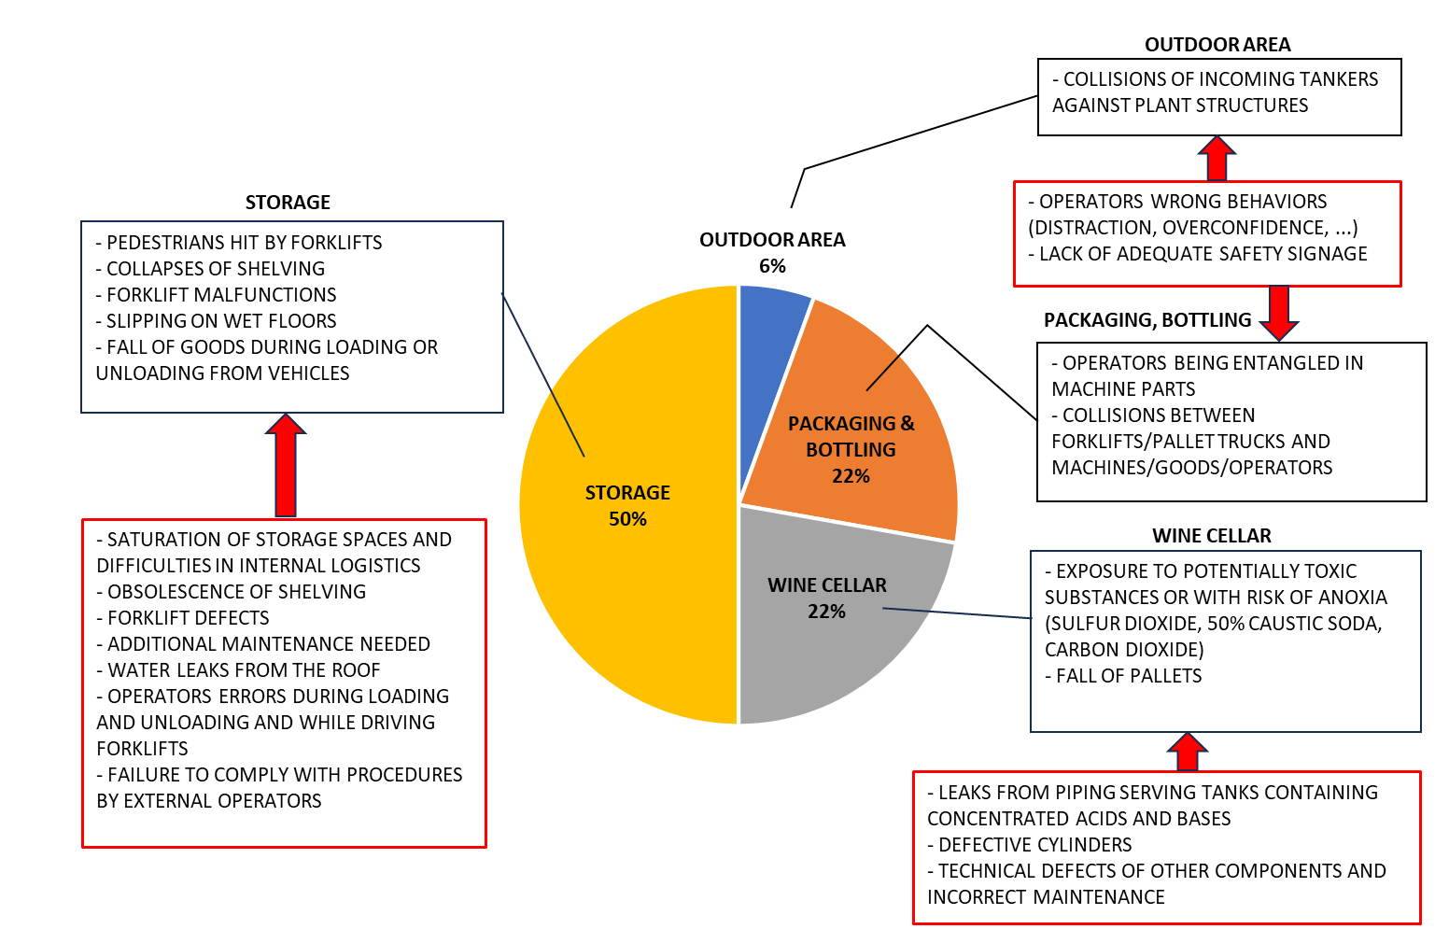
Figure 2: Occurred unwanted events in different departments of the company (percentage of total). The main problems observed and their possible causes (as hypothesized by the company) are listed on the sides, in black and red boxes respectively.
Consequently, various types of corrective actions are applied in order to manage each event and try to prevent it from happening again. Sometimes such interventions involve operational (or maintenance) procedures, when they need to be modified, updated or enhanced. In other cases, if human error plays a central role (almost 55% of cases), training and awareness-raising activities for workers are preferred. Technical interventions are also necessary to close leaks from piping, while falls of goods or pallets can be avoided by checking the stability of structures (e.g., shelving) and replacing them if they are excessively old. In relation to the proper management of spaces, it was sometimes decided to increase signage and, where necessary, install additional protective barriers. It should be finally noted that in some cases, even operators from external companies are involved (e.g., tanker drivers or maintenance workers). It is therefore necessary to coordinate with their employers to ensure that appropriate information and instructions are provided for their safe access to the site and that all internal procedures are followed.
The company finally observed that focusing on near misses has led to an improvement in safety culture (reporting incidents has become part of the company’s routine), a general improvement in the management of the company’s response to critical situations and a reduction in near misses (even more evident given the increase in the workforce, which has grown from 260 to approximately 490 employees over the last two years).
  - Conclusions
The proposed questionnaire highlighted how the importance of recognizing and managing near misses is no longer an unknown concept in the Italian food industry, although this awareness is more evident in larger companies. There is a need to define more clearly the distinction between near misses and accidents, to standardize approaches without ambiguities. Human error appears as the main component causing unwanted events, regardless of company size, but many other typologies of anomalies have been also identified.
The analysis of the specific case of a winery has clearly confirmed such variety of near misses that can occur, given the extreme diversification of activities and risks in the departments of the company. The storage phase appears to be the most affected by undesirable events or anomalies; this suggests that similar problems may also arise in many other types of industrial fields, whereas storing components or products is a fundamental requirement. The wine cellar also presents risks in relation to possible leakage of hazardous chemicals used in wine processing or in cleaning. This confirms that, even in non-Seveso sites, accidents with severe consequences can occur. Such diversification requires wide-ranging interventions and complex choices. The investigated company has reported that the assessment of near misses has brought tangible benefits to the safety of its workplaces.
Although non-compliance of machinery and equipment appears among the anomalies observed in large and medium-sized enterprises in the Food Valley, in the analyzed winery near misses in packaging and bottling departments were generally attributed to human error. Future studies could investigate further the effective role that possible non-conformities of machinery can have in the occurrence of accidents and near misses.
Finally, it must be emphasized the importance of implementing common guidelines at the national level dealing with management of near misses, according to the path already taken by new Decree 159/2025.
Acknowledgments
The authors are very grateful to Terre Cevico Soc. Coop. Agricola for sharing data, procedures and operational experiences. Engineering student Yassine Bounafa is also thanked for participating in the questionnaire design and reworking.
References
Ansaldi S.M., Agnello P., Pirone A., Vallerotonda M.R., 2021, Near miss archive: a challenge to share knowledge among inspectors and improve Seveso inspections, Sustainability, 13, article number 8456.
Awolusi I., Marks E., 2015, Near miss reporting to enhance safety in the steel industry, Iron and Steel Technology, 12(10), 62–68.
Baldissone G., Comberti L., Bosca S., Murè S., 2019, The analysis and management of unsafe acts and unsafe conditions. Data collection and analysis, Safety Science, 119, 240-251.
Di Girolamo C., Carra S., Monica L., Tonti A., 2023, Risks in loading and unloading LPG at storage sites: analysis of a set of quasi-accidental events, Chemical Engineering Transactions, 99, 343–348.
Di Nardo M., Murino T., 2021, The system dynamics in the human reliability analysis through cognitive reliability and error analysis method: a case study of an LPG company, International Review of Civil Engineering, 12(2), 56–68.
Elia V., Gnoni M.G., Tornese F., Guglielmi A., Pellicci M., De Merich D., Campo G., 2022, Applications of smart technologies for automatic near miss detection in the industrial safety, Procedia Computer Science, 200, 1282–1287.
Fabiano B., Currò F., 2012, From a survey on accidents in the downstream oil industry to the development of a detailed near-miss reporting system, Process Safety and Environmental Protection, 90, 357–367.
Gajek A., Michalik J.S., 2013, Major accident hazard posed by non-Seveso establishments in Poland and management in the area of their control, Chemical Engineering Transactions, 31, 169–174.
Gnoni M.G., Tornese F., Guglielmi A., Pellicci M., Campo G., De Merich D., 2022, Near miss management systems in the industrial sector: a literature review, Safety Science, 150, article number 105704.
INAIL, 2021, The technical assessment for the safety of food machinery, Tipolitografia Inail - Milano, Italy (in Italian).
INAIL, 2024, Supporting companies in reporting and analysing near misses: a proposal for a technical and organizational model, Tipolitografia Inail - Milano, Italy (in Italian).
INAIL, 2025, CONDIVIDO: an integrated approach in collaborative networks for the development of knowledge about near misses, Tipolitografia Inail – Milano, Italy (in Italian).
Pickup S., Paton K., Hayes C., Morrison B., 2020, A day in the life of frontline manufacturing personnel: a diary-based safety study, 132, article number 104992.
Simone F., Ansaldi S.M., Agnello P., Di Gravio G., Patriarca R., 2023, Knowledge in graphs: investigating the completeness of industrial near miss reports, Safety Science, 168, article number 106305.
Van Derlyke P., Marìn L.S., Zreiqat M., 2022, Discrepancies between implementation and perceived effectiveness of leading safety indicators in the US dairy product manufacturing industry, Safety and Health at Work, 13, 343-349.
Winkler M., Perlman Y., Westreich S., 2019, Reporting near-miss safety events: impacts and decision-making analysis, Safety Science, 117, 365-374.

