 CHEMICAL ENGINEERING TRANSACTIONS  VOL. xxx, 2026 | A publication of  
The Italian Association
of Chemical Engineering
Online at www.cetjournal.it

Guest Editors: Valerio Cozzani, Bruno Fabiano, Genserik Reniers
Copyright © 2026, AIDIC Servizi S.r.l.
ISBN 979-12-81206-xx-x; ISSN 2283-9216

MEMBRANE PREPARATION WITH NON-TOXIC SOLVENTS FOR MEMBRANE DISTALLATION PROCESS
Mirko Frappa, Francesca Macedonio*, Francesco Galiano*, Alberto Figoli
National Research Council of Italy-Institute on Membrane Technology “Enrico Drioli”- (CNR-ITM), Via P. Bucci 17/c, 87036 Rende (CS), Italy]
*f.macedonio@itm.cnr.it; f.galiano@itm.cnr.it;
Within the MEloDIZER project, aimed at optimizing and advancing membrane distillation (MD) technology, PVDF-based membranes were fabricated using non-toxic solvents such as N-butylpyrrolidone (commercially known as Tamisolve), in both hollow-fiber and flat-sheet configurations. MEloDIZER is a Horizon Europe initiative focused on bridging the gap between laboratory-scale MD research and large-scale implementation through system design optimization, identification of the most effective membranes, and integration of renewable energy sources to improve efficiency in industrial, domestic, and community settings. The performance of the prepared membranes was evaluated in direct-contact membrane distillation (DCMD) using saline feed solutions. In MD, the membranes exhibited good transmembrane flux and an almost complete salt rejection (≈100%). The membranes were therefore also tested using a synthetic solution with higher salinity and in the presence of humic acid, consistently showing stable flux without wetting for 30 hours and a slight decrease in salt rejection to 99.8%, particularly under applied pressure.
These results highlight the strong potential of the MEloDIZER project for the development of high-performance membranes for MD, representing a key milestone toward large-scale implementation.
  - Introduction

The extensive use of hazardous solvents in the chemical industry raises critical issues related to environmental sustainability and occupational safety. As the adoption of green chemistry principles becomes increasingly important, significant efforts are being focused on the development and implementation of safer solvent systems to replace conventional harmful chemicals (Figoli et al. 2014). Most industrial solvents are derived from fossil resources and are known to cause adverse health effects, including long-term organ toxicity when exposure occurs at high concentrations or over extended periods (Zou et al. 2021).
Solvents are a fundamental component in membrane-based separation technologies, as they directly govern the kinetics of phase inversion and, consequently, the morphology, porosity, and performance of the resulting membranes. Although membrane processes are intrinsically more energy-efficient than conventional separation techniques such as thermal distillation or evaporation, the sustainability of membrane fabrication itself remains strongly dependent on the choice of solvent (Drioli and Curcio 2007). This aspect is particularly relevant for membranes intended for water-related applications, including desalination and the treatment of industrial and municipal wastewaters, where environmental compatibility is a key requirement. Among polymeric materials, poly(vinylidene fluoride) (PVDF) has emerged as one of the most suitable candidates for membrane distillation applications due to its high chemical resistance, thermal stability and good mechanical robustness under demanding operating conditions. Compared to other typical polymers used for membrane preparation, PVDF offers a more balanced compromise between cost, performance, and processability (Cheng et al. 2022). PVDF can instead be processed by standard techniques such as NIPS or TIPS and can be readily functionalized to enhance hydrophobicity or antifouling properties (Khan et al. 2025). Despite these advantages, the production of PVDF membranes still largely relies on conventional aprotic solvents such as NMP and DMF, which are associated with significant environmental and health hazards and are progressively being restricted by regulatory frameworks (Tomietto et al. 2022). his has driven growing interest in the identification of safer solvent systems, including TEP, DMI, Rhodiasolv® PolarClean, and Cyrene™. Among these alternatives, Tamisolve® NxG (N-butylpyrrolidone) stands out due to its non-toxic profile, high boiling point, water miscibility, and solubility parameters closely matching those of PVDF and traditional solvents, enabling the preparation of stable and homogeneous polymer solutions (Marino et al. 2017). Its potential has already been validated for the fabrication of PVDF flat-sheet membranes for membrane distillation, yielding high permeate fluxes and salt rejection values exceeding 99.9% under mild operating conditions (Saïdi et al. 2021).
Building on these findings, the present work reports the first successful fabrication of PVDF hollow fiber membranes using Tamisolve® NxG as a green solvent. The membranes were specifically developed for direct-contact membrane distillation (DCMD), a configuration that exploits a temperature-driven vapor pressure gradient across a hydrophobic membrane to achieve high salt rejection using low-grade thermal energy sources (Capizzano et al. 2021). The study focuses on the membrane preparation by using Tamisolve® NxG as non-toxic solvent, analyzing membrane morphology and physicochemical properties, and assessing DCMD performance under different operating conditions. Specifically, the membranes may be suitable for various water treatment applications, including seawater desalination for drinking water production, industrial wastewater treatment and reuse, and purification of saline effluents prior to discharge into natural bodies of water.
  - Materials
The following paragraph outlines the basis for the membrane preparation, characterization and testing in membrane distillation and crystallization.

2.1. Materials
Two types of PVDF polymer (SOLEF® 1015; Kynar 150G) supplied by Solvay Specialty Polymers and Arkema were used for the membrane preparation in hollow fiber and flat-sheet configuration respectively. Tamisolve® NxG was kindly provided by Taminco and used as solvent. Polyvinylpyrrolidone (PVP, Luviskol K17; Mw = 10 kg/mol) and Polyethylene glycol (PEG; Mw = 400 Da) were purchased by BASF (Ludwigshafen, Germany) and Sigma Aldrich (Milan, Italy), respectively and used as additives in the membrane preparation. Sodium chloride (NaCl) was acquired by Carlo Erba, Italy for the preparation of salt solution. 2-propanol were purchased by Sigma Aldrich. The coagulation bath for membrane preparation was bi-distilled water at 15 °C.

2.2. Preparation of PVDF membranes
PVDF membranes were fabricated by phase inversion technique. In particular, non-induced phase separation (NIPS) technique was considered for the fabrication of both configurations. Polyvinylpyrrolidone (PVP) K17 and polyethylene glycol (PEG) 400 were used as pore-forming additives at different concentrations. Table 1 reports the compositions used for the membrane preparation.
Table 1. PVDF-based membranes composition
PVDF | Configuration | PVDF (wt.%) | K17 (wt.%) | P400 (wt.%) | TAMISOLVE NXG (wt.%)
1015 | Hollow FIber (HF) | 16 | 13 | 10 | 61
150G | Flat Sheet (FS) | 15 | 10 | 10 | 65

In the case of the hollow fiber membranes, they were prepared using a batch extruder. Measured amounts of polymer, additive, and solvent were fed into the vessel, heated to 95 °C, and then mixed for 2 h. The homogeneous polymer solution was fed into a spinneret via a gear pump under nitrogen atmosphere. The elevated bore fluid temperature (50 °C) helped to moderate the solvent–non-solvent exchange rate at the inner surface, promoting the formation of a homogeneous lumen structure and reducing the risk of defects. The selected dope solution flow rate (approximately 10 g min⁻¹) ensured a continuous and stable extrusion, while the bore fluid flow rate, allowed fine control over the inner diameter and internal morphology of the fibers. The hollow fiber was extruded from the spinneret into a water bath maintained at room temperature to induce phase separation and solidify the hollow fibers membrane. The distance between the spinneret and the water bath (air gap) was 23 cm. The solidified membrane was wound by a winder. The best results with a suitable structure for membrane distillation application was achieved with the pure water used as bore fluid while flow at 8.7 mL min⁻¹.
For what concern the flat-sheet membrane preparation, PVDF powder was added under mechanical stirring at 80 °C to Tamisolve together with the various additives, as reported in Table 1. After solubilization of the polymer and of the additives, the solution was left to degas for at least one hour. The solution was, then, uniformly cast on a glass plate by using a casting knife set at a thickness of 250 μm. The cast film was successively coagulated by immersion in a water coagulation bath in order to promote the precipitation of the polymer through solid-liquid demixing and to allow the formation of the porous membrane. The obtained membranes were then washed in milli-Q 136 water, air-dried at room temperature overnight, and finally at 30 °C for 1 hour in an oven before being used.

2.3. Membrane characterizations

Membrane characterization was carried out in terms of morphology, surface hydrophobicity and mechanical properties. The surface and cross-sectional morphologies of the membranes were examined by scanning electron microscopy (SEM). For cross-sectional analysis, they were cryo-fractured in liquid nitrogen and sputter-coated with a thin gold layer prior to observation.
Surface hydrophobicity was assessed through static water contact angle measurements. Deionized water droplets were deposited on the outer surface of the membranes, and contact angles were determined using a circular baseline method. The reported values correspond to the average of six measurements taken at different positions on each membrane.
Mechanical properties were investigated by tensile tests, from which stress, strain, and Young’s modulus were determined based on the initial linear region of the stress–strain curves.

2.4. Membrane distillation tests
The PVDF membranes were tested in DCMD, with the feed flowing at the shell side and bi-distilled water at the permeate side. The schematic setups used for DCMD tests is shown in Figure 2.
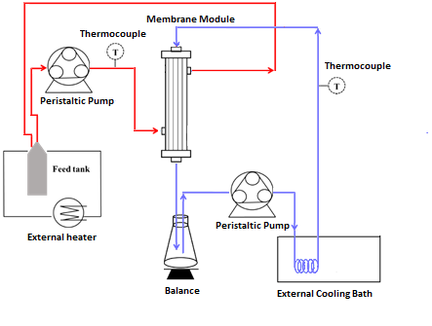
Figure 2 Schematic representation of setup used in DCMD.
Each test was 6 h long and the performance of MD tests is reported in terms of rejection (R%) and transmembrane flux. Distilled water and NaCl aqueous solutions at different concentrations were used as feed streams, including 0.6 M NaCl, 0.6 M NaCl with 1 ppm humic acid (HA), and 1.1 M NaCl. Distilled water was used as permeate stream. The feed temperature was varied between 42 and 56 °C, while the permeate temperature was maintained at 9 °C. The feed and permeate flow rates were fixed at 15 and 6 L h⁻¹, respectively.
  - Results
In the following section the results obtained on the preparation, characterization and testing in MD is reported and discussed.

3.1. Characterization
SEM pictures of the cross-section of the hollow fibers are reported in Fig. 1. The cross-sections revealed the sponge-like structure of the membrane with some macrovoids on the internal surfaces. The obtained structures are related to the mechanisms of the coagulation process. During the hollow-fiber coagulation, the bore fluid causes the polymer precipitation and formation of the inner surface; the formation of the outer surface starts during fiber falling along the air gap and ends in the coagulation bath. The composition of both coagulation media (internal and external), the air gap, the possible presence of hydrophilic additives and the temperature are all affecting fiber’s final structure, since they influence the solvent/non-solvent exchange velocity, which is the main variable during the hollow-fiber coagulation.

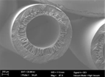
Figure 1 SEM micrographs collected on the cross section, of the PVDF hollow-fibers (TAM)
The main characteristics of the prepared membranes are reported in Table 4. The PVDF-based membranes exhibit high water contact angles, approximately 117° for hollow fiber and 125° for flat sheet, indicating a hydrophobic surface suitable for membrane-contactor processes. The flat sheet Kynar membrane displays higher contact angles, confirming its stronger intrinsic hydrophobic character compared to the hollow fiber membrane. Porosity values vary significantly among the configurations, spanning from 79.0% for (FS) to 84.26% (HF). HF exhibits the highest porosity, which is typically associated with enhanced permeability but may compromise mechanical strength. The flat sheet Kynar membranes present intermediate to high porosity, comparable to hollow fiber samples. The mechanical behavior of the hollow fiber membranes reflects a trade-off between stiffness and flexibility. Hollow fiber, characterized by the highest porosity, exhibits the lowest modulus, supporting the inverse relationship between porosity and mechanical rigidity. Elongation at break for hollow fiber membranes is relatively high (113.47%), indicating good ductility and suitability for applications requiring mechanical deformation resistance. In contrast, the flat sheet Kynar membranes show significantly lower elongation at break (≈34%), suggesting a more brittle mechanical response despite comparable Young’s modulus values.
Table 4. Main characteristics of the membrane prepared with Tamisolve® NxG
Code | Contact Angle (°) | Thickness (µm) | LEP (bar) | Pore Size Distribution (µm) | Porosity (%) | Young Module (Mpa) | Elongation at Break (%)
HF PVDF | 117.9 ± 7.0 | 241.0 ± 9.1 |  | 0.2 | 84.3 ± 1.2 | 23.3 ± 4.0 | 113.5 ± 1.6
FS PVDF | 124.9 ± 1.2 | 141.5 ± 4.5 | 1.5 | 0.3 | 79.0 ± 0.5 | 65.1 ± 3.6 | 33.8 ± 4.5

3.2 Membrane distillation tests

The PVDF hollow-fibers and the flat-sheet membranes prepared using Tamisolve® NxG as solvent were tested in membrane distillation utilizing the different feed solutions and operative conditions as described before.
Figure 2 shows the average normalized flux for PVDF flat-sheet (blue bars) and hollow fiber (red bars) membranes fabricated with Tamisolve® NxG under sequential feed conditions, including pure water, saline solutions at different concentrations, and saline feeds containing humic acid, and the corresponding feed temperatures. The bars represent the flux normalized with respect thickness, while the continuous line indicates the feed temperature associated with each operating condition. The comparison clearly highlights the influence of feed composition, and operating temperature on DCMD performance. Under pure water conditions and moderate salinity (0.6 M NaCl), the flat-sheet membrane exhibits slightly higher average fluxes, typically in the range of 10 L/m²*h, reflecting its lower intrinsic mass transfer resistance due to the thinnest effective membrane structure and higher pore size. In contrast, the hollow fiber membrane shows lower normalized flux, generally between 1 and 2 L /m²*h under similar conditions.
The presence of humic acid (0.6 M NaCl + 1 ppm HA) results in a noticeable reduction in permeate flux for both membrane configurations, even in experiments lasting only 6 hours, highlighting the influence of organic compounds on mass transfer across the membrane. This effect is more pronounced for the flat-sheet membrane in absolute terms, due to its initially higher flux, but follows the same qualitative trend for the hollow fiber membrane.

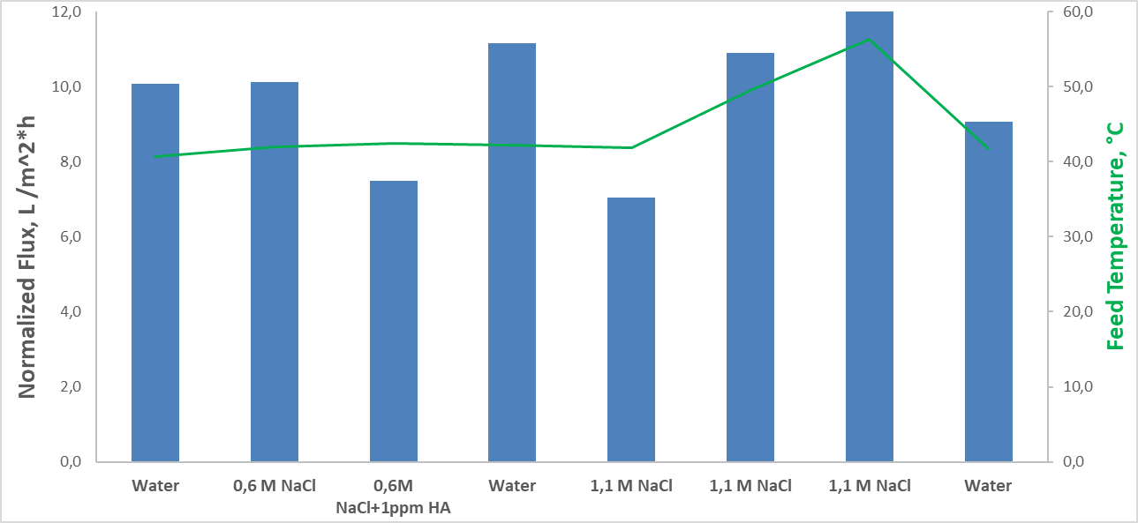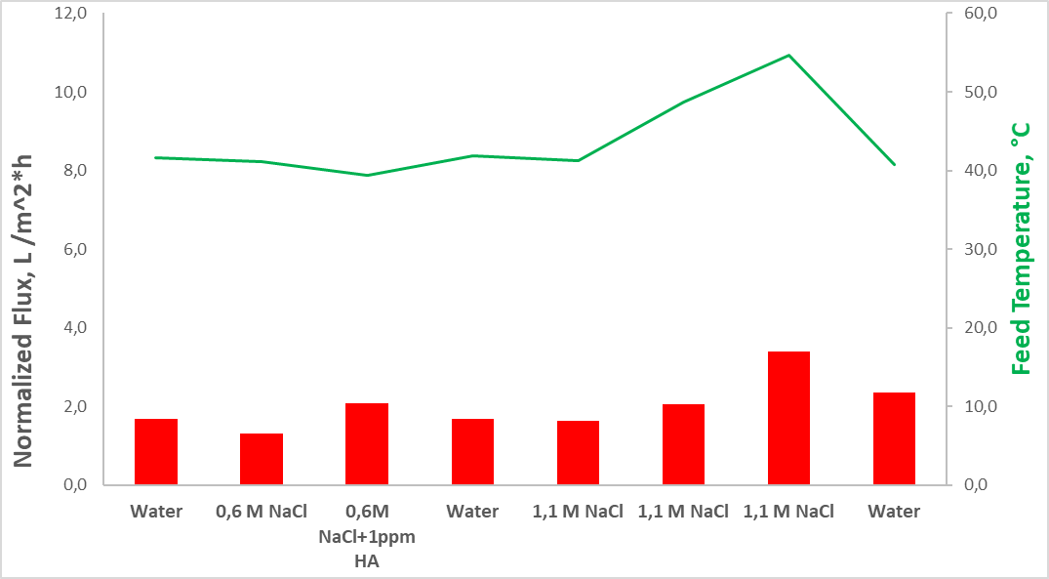
Figure 2 Normalized Flux of flat-sheet (blue bar) and hollow fiber (red bar) with diverse feed solution.
At higher salinity (1.1 M NaCl), the average flux decreases at comparable feed temperatures, reflecting the combined effects of increased osmotic resistance and reduced vapor pressure. However, a clear enhancement in flux is observed as the feed temperature increases, with the highest average flux values measured at T_{feed} close to 56 °C. This trend confirms the dominant role of temperature as it is the driving force in DCMD, capable of partially compensating for the negative effects of salinity and fouling. When the feed is switched back to pure water at the end of the test sequence, the average flux returns to values close to those measured initially, demonstrating the reversible nature of the observed flux decline.

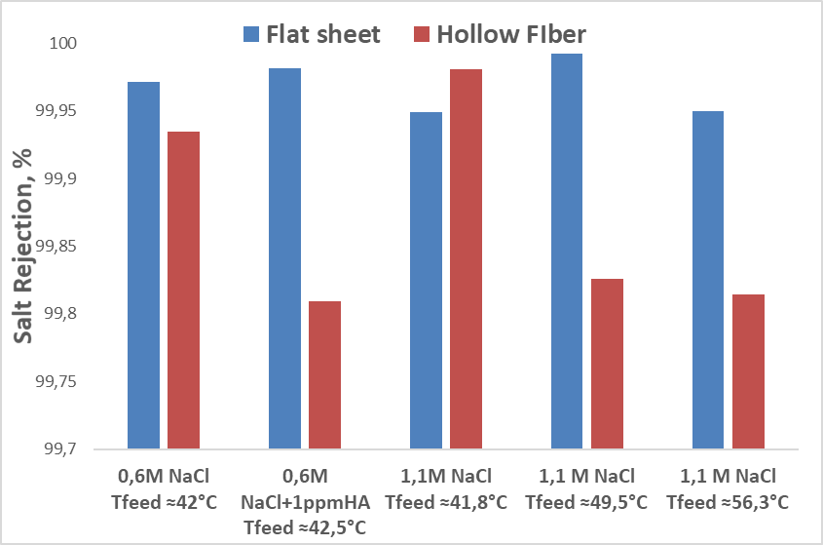
Figure 3 Salt Rejection with diverse feed solution
Figure 3 reports the corresponding salt rejection values under selected operating conditions. Regardless of feed salinity, temperature, and the presence of humic acid, both membranes maintain very high salt rejection, always above 99.8% and in most cases exceeding 99.9%. A slight decrease in rejection is observed at higher temperatures and in the presence of humic acid, particularly for the hollow fiber membrane, likely due to enhanced solute diffusion or marginal pore wetting phenomena. Nevertheless, these effects remain limited and do not compromise the overall separation efficiency, confirming the suitability of the membranes for stable membrane distillation operation under demanding conditions.
- Conclusions
This study demonstrated the successful fabrication of PVDF membranes for membrane distillation using the non-toxic solvent Tamisolve® NxG, confirming its suitability as a sustainable alternative to conventional hazardous solvents. PVDF membranes were successfully fabricated using the non-toxic solvent Tamisolve® NxG and evaluated in direct-contact membrane distillation under a wide range of operating conditions, including different feed salinities, temperatures, and the presence of organic foulants. The results confirm that the use of a green solvent does not compromise membrane performance and allows the production of membranes suitable for MD applications. DCMD experiments showed that permeate flux is strongly affected by feed composition and temperature. A decrease in flux was consistently observed when switching from pure water to saline solutions, and a further reduction occurred in the presence of humic acid, confirming the combined influence of vapor pressure depression and organic compounds on mass transfer. Nevertheless, increasing the feed temperature effectively enhanced permeate flux under all tested conditions, demonstrating that the thermal driving force remains the dominant parameter controlling MD performance. In any case, salt rejection remained consistently very high throughout all experiments (over 99.8%), confirming both the integrity and the hydrophobic character of the membranes at least in the tests conducted (each membrane was tested for 48 hours under different operating conditions. In conclusion, the results confirm that Tamisolve® NxG enables the sustainable production of high-performance PVDF membranes in both hollow fiber and flat-sheet configurations, supporting the development of efficient and environmentally friendly membrane distillation membranes in line with the objectives of the MEloDIZER project.
Acknowledgments
Funded by the European Union (Grant Agreement #101091915, MEloDIZER, HORIZON-CL4-2022-RESILIENCE-01). Views and opinions expressed are however those of the author(s) only and do not necessarily reflect those of the European Union or the European Health and Digital Executive Agency (HADEA). Neither the European Union nor the granting authority can be held responsible for them.
References
Capizzano, Stefano, Mirko Frappa, Francesca Macedonio, and Enrico Drioli. 2021. “A Review on Membrane Distillation in Process Engineering: Design and Exergy Equations, Materials and Wetting Problems.” Frontiers of Chemical Science and Engineering. doi:10.1007/s11705-021-2105-3.
Cheng, Lilantian, Zixun Zhou, Lei Li, Pei Xiao, Yun Ma, Fei Liu, and Jian Li. 2022. “PVDF/MOFs Mixed Matrix Ultrafiltration Membrane for Efficient Water Treatment.” Frontiers in Chemistry 10. doi:10.3389/fchem.2022.985750.
Drioli, Enrico, and Efrem Curcio. 2007. “Membrane Engineering for Process Intensification: A Perspective.” Journal of Chemical Technology and Biotechnology. doi:10.1002/jctb.1650.
Figoli, A., T. Marino, S. Simone, E. Di Nicolò, X. M. Li, T. He, S. Tornaghi, and E. Drioli. 2014. “Towards Non-Toxic Solvents for Membrane Preparation: A Review.” Green Chemistry 16(9):4034. doi:10.1039/C4GC00613E.
Khan, Aqsa Mansoor, Francesca Russo, Francesca Macedonio, Alessandra Criscuoli, Efrem Curcio, and Alberto Figoli. 2025. “The State of the Art on PVDF Membrane Preparation for Membrane Distillation and Membrane Crystallization: Towards the Use of Non-Toxic Solvents.” Membranes 15(4):117. doi:10.3390/membranes15040117.
Marino, T., F. Russo, A. Criscuoli, and A. Figoli. 2017. “TamiSolve® NxG as Novel Solvent for Polymeric Membrane Preparation.” Journal of Membrane Science 542:418–29. doi:10.1016/j.memsci.2017.08.038.
Saïdi, Safa, Francesca Macedonio, Francesca Russo, Chiraz Hannachi, Béchir Hamrouni, Enrico Drioli, and Alberto Figoli. 2021. “Preparation and Characterization of Hydrophobic P(VDF-HFP) Flat Sheet Membranes Using Tamisolve® NxG Solvent for the Treatment of Saline Water by Direct Contact Membrane Distillation and Membrane Crystallization.” Separation and Purification Technology 275:119144. doi:10.1016/j.seppur.2021.119144.
Tomietto, Pacôme, Francesca Russo, Francesco Galiano, Patrick Loulergue, Simona Salerno, Lydie Paugam, Jean-Luc Audic, Loredana De Bartolo, and Alberto Figoli. 2022. “Sustainable Fabrication and Pervaporation Application of Bio-Based Membranes: Combining a Polyhydroxyalkanoate (PHA) as Biopolymer and CyreneTM as Green Solvent.” Journal of Membrane Science 643:120061. doi:10.1016/j.memsci.2021.120061.
Zou, Dong, Suzana P. Nunes, Ivo F. J. Vankelecom, Alberto Figoli, and Young Moo Lee. 2021. “Recent Advances in Polymer Membranes Employing Non-Toxic Solvents and Materials.” Green Chemistry 23(24):9815–43. doi:10.1039/D1GC03318B.

