 CHEMICAL ENGINEERING TRANSACTIONS  VOL. , 2026 | A publication of  
The Italian Association
of Chemical Engineering
Online at www.cetjournal.it

Guest Editors:
Copyright © 2025, AIDIC Servizi S.r.l.
ISBN 979-12-81206-XX-X; ISSN 2283-9216

A Multi-Period Model for Optimal Deployment of Cost‐Effective Risk Reduction Systems
Dominic C. Y. Foo^{a,}*, Raymond R. Tan^{b}
ªDepartment of Chemical and Environmental Engineering/ Centre of Excellence for Green Technologies, University of Nottingham Malaysia, Broga Road, 43500 Semenyih, Selangor, Malaysia
^{b}Department of Chemical Engineering, De La Salle University, 2401 Taft Avenue, 0922 Manila, Philippines
Dominic.Foo@nottingham.edu.my
Reducing safety risk is an important priority for all industrial plants. However, it can be difficult to select a risk management portfolio from a large number of options when there is a constraint on capital expenditure. In this work, a mixed-integer linear programming model is developed for the optimal deployment of risk reduction systems, taking into cost constraints and multiple time periods. Results from the solved model can then be visualized graphically via a composite curve to facilitate analysis and communication. The model is useful for industrial scenarios involving selecting risk reduction systems with capital expenditure constraints. The new method is demonstrated with a literature example, where a portfolio is determined from 13 risk reduction options across three time periods, each with its own maximum allocated budget. Two scenarios are considered with different capital expenditures for each period. The methodology itself can be readily generalized to similar applications assuming that the required input data is available.
  - Introduction
Process systems engineering (PSE), also known as computer-aided process engineering (CAPE), is the branch of chemical engineering dedicated to the development and use of computing techniques for the discipline. Mathematical programming is an important tool in PSE/CAPE for optimizing the design and operation of process plants based on various economic, environmental, and even safety aspects (Pistikopoulos and Gani, 2026). Models for improving plant safety often make use of integer decision variables to represent discrete choices. For example, Caputo et al. (2011) developed a 0-1 programming (i.e., “knapsack”) model for optimizing the mix of process safety measures based on cost, using genetic algorithm to deal with computational challenges resulting from non-linear model components. Caputo et al. (2013) also developed a multi-criterion knapsack model extension of this approach. Eslami Baladeh et al. (2019) extended this approach into a multi-objective model that was demonstrated on oil and gas facilities. More recently, Özkan et al. (2025) developed a stochastic knapsack model to consider uncertainties as well as interactions among the component safety measures. The work of Jameel Malik et al. (2025) considered safety-economic index for preliminary process design.
In addition to pure mathematical programming approaches, alternative PSE/CAPE techniques have also been developed for these problems. Antes et al. (2001) developed a methodology for the design of safety risk mitigation portfolios by selecting component measures considering cost and benefits. Ishizaka and Labib (2014) developed a hybrid framework to mitigate safety risk in process plants, using a crisis tree-based approach to analyse causality of complex events; they then proposed a mathematical programming model to determine the cost-optimal mix of mitigation measures using a new criticality index. Tan et al. (2016) then developed a graphical pinch analysis approach utilizing this criticality index. This approach is based on a versatile family of techniques with a broad range of process integration (PI) and PI-like applications (Klemeš, 2023). Yuan et al. (2015) developed a Bayesian network-based methodology to find optimal budget-constrained safety measures to mitigate dust explosion risks. Tan et al. (2022) used a P-graph causality map approach to retrospectively analyse the factors that contributed to the Union Carbide disaster in Bhopal, India. In addition to safety, PSE/CAPE tools have also been developed to the related problem of securing plants against attacks by malicious agents (Amin et al., 2022). Some of these approaches demonstrate advantages in interpretability compared to pure mathematical programming methods, enabling them to provide superior decision support to engineers. Inherently interactive procedures enhance the generation of useful and explainable engineering insights by keeping the “human in the loop” in contrast to black-box approaches (Lumbreras and Ciller, 2025). Because safety is of paramount importance in the process industries, there is still a need for better interpretable optimization approaches for planning safety risk mitigation measures.
In this work, a novel mixed-integer linear programming (MILP) model for finding optimal combinations of process safety measures is developed. The formulation is based on the automated targeting model (ATM), which was originally developed in the context of process integration for resource conservation (Foo, 2025). A recent extension applied a modified version of ATM to industrial decarbonization measures (Foo and Chew, 2025); this same approach is adapted to the current problem of optimizing a portfolio of safety measures. The rest of this paper is organized as follows. Section 2 gives the formal problem statement. Section 3 describes the model formulation and methodology. Section 4 demonstrates this approach on a literature case study (Antes et al., 2001). Section 5 gives the conclusions and discusses promising directions for future research.
  - Problem statement
The problem to be addressed in this work is formally stated as follows.
- Given a long planning horizon with various time periods t; the latter may take several month/years. In each planning period, a budget is given for the investment of risk reduction initiatives.
- Given a list of risk reduction initiatives i, each will help to reduce safety risk upon implementation. The latter may take the form of financial benefits with reduced fatality. Each initiative also has its capital investment cost. Dividing the risk reduction benefit by its capital investment yield a safety-intensity value for each initiatives i. It is assumed that all initiatives can only be implemented once throughout the planning horizon.
It is desired to pick the right risk reduction initiatives to be implemented in time period t, subject to the maximum budget available in that period.
  - Methodology
The MILP-based automated targeting model (Foo and Chew, 2025) is extended in this work for the optimal deployment of risk reduction systems k in time period t. A basic framework for the model is given in Figure 1, and has the following structure:
Intensity level: all risk reduction systems k are arranged in ascending order based on their safety-financial intensity value (${INT}_{k}$; columns 1 and 2 of Figure 1). Note that this financial intensity may take the form of risk reduction (per investment), or financial benefit gain (due to reduction of fatality). In other words, the intensity level allows one to compare different risk reduction systems – those higher in the rank perform better per capital investment. Next, the risk reduction systems with its capital investment (CAPEX_{k}) is located at the respective level (column 3).
 |  |  |  | Risk reduction cascade |  |  | Cost cascade
1 | INT₁ | CAPEX₁ |  | RR_{1,t} | CRR_{1,t} |  | COST_{1,t} | CCOST_{1,t}
2 | INT₂ | CAPEX₂ |  | RR_{2,t} | CRR_{2,t} |  | COST_{2,t} | CCOST_{2,t}
k | INT_{k} | CAPEX_{k} |  | RR_{k,t} | CRR_{k,t} |  | COST_{k,t} | CCOST_{k,t}
Figure 1: Basic framework of MILP-based automated targeting model (adopted from Foo and Chew, 2025)
Risk reduction cascade: Within each time period t, risk reduction (RR_{k,t}) at each intensity level k is calculated (column 4 of Figure 5) using Equation 1. In the latter, RR_{k,t} is the product of CAPEX_{k}, INT_{k}, and the binary variable B_{k,t} [0,1]. The latter takes a value of 1 when the risk reduction system k will be deployed in period t, and vice versa. In other words, Equation 1 allows risk reduction benefit to be materialized in period t (RR_{k,t}) if risk reduction system k will be deployed. The risk reduction cascade is then formed by adding the cumulative risk reduction (CRR_{k,t}) values downward across level k (column 5), following Equation 2.
$$\begin{matrix}{RR}_{k,t}=B_{k,t}{{CAPEX}_{k}INT}_{k} & \begin{matrix}∀k & ∀t\end{matrix}\end{matrix}$$ | (1)
$$\begin{matrix}{CRR}_{k,t}={RR}_{k,t} & k=1 & ∀t\end{matrix}$$ | (2a)
$$\begin{matrix}{CRR}_{k,t}={CRR}_{k-1,t}+{RR}_{k,t} & k≥2 & ∀t\end{matrix}$$ | (2b)
Cost cascade: When risk reduction system k is selected for deployment in interval t, its binary variable will be activated (with value of 1), which allows the calculation of the capital cost following Equation 3 (column 6 of Figure 5). The cumulative cost then determines the cost cascade within time period t (column 7) following Equation 4. Note that the model has an inherent assumption, i.e. capital investment is restricted to the time period t where it is activated (Foo and Chew, 2025). This is logical as most corporations will allocate capital expenditure for each financial year.
$$\begin{matrix}{COST}_{k,t}=B_{k,t}{CAPEX}_{k} & \begin{matrix}∀k & ∀t\end{matrix}\end{matrix}$$ | (3)
$$\begin{matrix}{CCOST}_{k,t}={COST}_{k,t} & k=1 & ∀t\end{matrix}$$ | (4a)
$$\begin{matrix}{CCOST}_{k,t}={CCOST}_{k-1,t}+{COST}_{k,t} & k≥2 & ∀t\end{matrix}$$ | (4b)
Since there is a budget limit for project implementation in each time period t (${TCOST}_{t,max}$). Hence, Equation 5 is used to determine the total expenditure in period t (${TCOST}_{t}$), which is given by the summation of capital cost of individual risk reduction system that is selected. Equation 6 then restricts that this capital cost in each period t for not exceeding its limit.
$$\begin{matrix}{TCOST}_{t}=\sum_{k}{B_{k,t}{CAPEX}_{i}} & ∀t\end{matrix}$$ | (5)
$$\begin{matrix}{TCOST}_{t}≤{TCOST}_{t,max} & ∀t\end{matrix}$$ | (6)
Besides, Equations 7 and 8 are used to ensure the risk reduction system k is only costed once.
$$\begin{matrix}\sum_{t}{B_{k,t}≤}B_{k,max} & ∀k\end{matrix}$$ | (7)
$$\begin{matrix}B_{k,max}=1 & ∀k\end{matrix}$$ | (8)
The objective of the model may be set to maximum reduction of risk, with additional constraints for different scenarios. For a MILP model, finding a global solution with a branch-and-bound search is guaranteed if one exists. Note that an added benefit is that, the risk reduction cascade may be plotted against the cost cascade (columns 5 vs. column 7 in Figure 1) to form a risk reduction composite curve, a graphical tool that can facilitate discussion among the project team members. A generic form of the risk reduction composite curve is shown in Figure 2. Note that in the latter, the risk reduction composite curve is plotted with safety benefit versus CAPEX, which takes a different form as that presented by Tan et al., (2016). The main idea is that, each segment in the composite curve represents a safety initiative, where its CAPEX is given by the horizontal distance, while the vertical distance of the segment represents its benefit. Note that safety benefit in the risk reduction composite curve (Figure 2) may take different forms, such as risk reduction, financial benefit due to fatality reduction (see Example that follows), etc. Hence, the composite curve in Figure 2 is useful to showcase total risk reduction benefit as per capital investment, with steeper slope representing safety initiative that is more cost effective (i.e. higher benefit as per CAPEX invested). For instance, project S1 in Figure 2 has higher safety benefit as compared to project S3, for the amount of CAPEX invested.

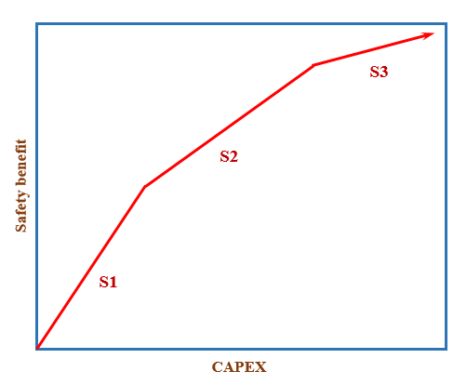
Figure 2: A generic risk reduction composite curve.
Note that this method has an important assumption, i.e. all initiatives will lead to risk reduction benefits that are quantitative in nature. In most cases, risk reduction will avoid hazard incidents where losses may be quantified from financial benefits.
In the following section, a literature example is next used to elucidate how the model is used for optimal deployment of risk reduction systems. A laptop with Core i7 and 1.80 GHz processor is used to solve the model using LINGO v16 (www.lindo.com) with negligible computing time.
  - Example
A literature example adapted from Antes et al. (2001) is used for elucidating the newly extended method. In this case, a company wishes to reduce personnel safety hazards and expected financial losses in their fired heaters through the implementation of safeguards. Apart from safety upgrades for their existing heaters, the company also looks into options to improving the design of new fired heaters. Since most safety options are expensive, it is desired to identify the most cost-effective solutions for implementation. Besides, it is assumed that CAPEX are made available across three years for the assessment of eleven projects; the latter are summarised in Table 1. As shown, every project has different annualised cost and annual benefit; dividing the former with the latter yield the benefit-cost ratio given in the last column. Note that the benefit-cost ratio is treated as the safety- intensity as described in the methodology section.
Table 1: Details of projects for example (Antes et al., 2001)
Project | Annual benefit ($/y) | Annualised cost ($/y) | Benefit-cost ratio ($/$)
P1 | 24,000 | 1,000 | 24.000
P2 | 5,300 | 700 | 7.571
P3 | 49,000 | 19,300 | 2.539
P4 | 1,500 | 700 | 2.143
P5 | 3,700 | 1,900 | 1.947
P6 | 53,000 | 32,900 | 1.611
P7 | 420 | 700 | 0.600
P8 | 14,000 | 49,900 | 0.281
P9 | 14 | 700 | 0.020
P10 | 13 | 700 | 0.019
P11 | 1 | 700 | 0.001
P12 | 8 | 27,200 | 0.0003
P13 | 0.1 | 1,600 | 0.0001

In scenario 1, it is assumed that annualised costs of 2,000, 3,000 and 5,000 $/y is made available for a consecutive of three years. Solving the model yielded the composite curves in Figure 3(a)-(c). As shown, two projects are selected for deployment in year 1, while three others for year 2, and four others for year 3. The total project cost across all years are added as 8,700 $/y, with the total benefits of 34,948 $/y.
In scenario 2, it is assumed that more fund will be made available earlier, i.e. 4,000, 3,000 and 3,000 $/y for years 1, 2 and 3, respectively. Besides, it is desired to have higher benefits for earlier years (so to benefit for later years); hence, a new constraint is added in Equation 9. Solving the model yielded the composite curves in Figure 3(d)-(f). Naturally, when higher fund is allocated to year 1, most projects are implemented here, i.e. a total of five, which is then followed by three and one projects in years 2 and 3, respectively. While the total project cost and total benefit remain identical as those in scenario 1, the total benefit of year 1 is the highest, followed by year 2.
$$\begin{matrix}{CRR}_{k,t}≤{CRR}_{k,t-1} & t≥2\end{matrix}$$ | (9)
A further analysis reveals that both scenarios have selected the same projects, i.e. 1, 2, 4, 5, 7, 9-11 and 13 for implementation, and let go the other. The main rationale is that, these projects have relatively lower annualised cost. Hence, when cost limit is set for each period t (Equation 6), the model will tend to select projects of lower capital cost. Sensitivity analysis was conducted to increase the cost limits between 5,000-10,000 $/y for each time period; however, the results remain identical. The reason is that, all four unselected projects (3, 6, 8 and 12) have annualised costs that are higher than 10,000 $/y (see Table 1).

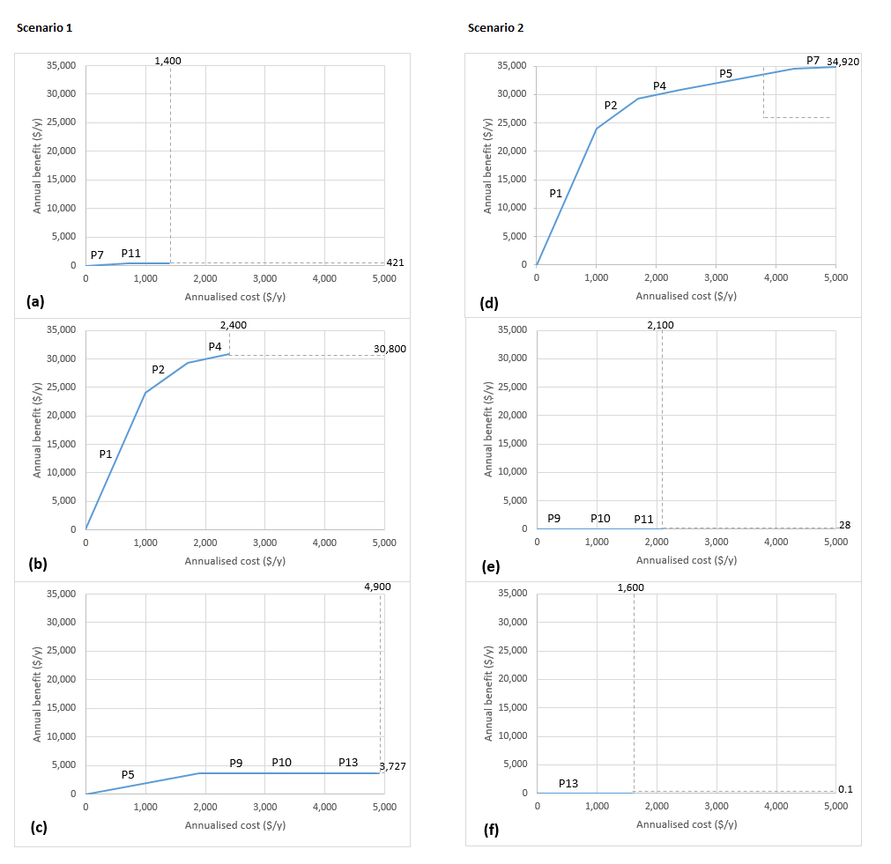
Figure 3: Risk-financial pinch diagram for scenario 1: (a) year 1; (b) year 2; (c) year 3; scenario 2: (d) year 1; (e) year 2; (f) year 3.
  - Limitations of current approach
The approach developed in this work has some limitations. First, the model assumes all initiatives will lead to risk reduction benefits can be quantified. There are however benefits that are qualitative in nature, such as public image or employee acceptability, as pointed out by Antes et al. (2001). These factors may be used for final decision making important when the benefit and/or cost of implementation of competing initiatives are close. It is assumed that the candidate techniques are mutually independent, and techno-economic uncertainties in the risk reduction techniques can result in the over under- or overestimation, of their benefits. Hence, the basic MILP model will need to be extended to account for interactions and parametric uncertainties, possibly resulting in a non-linear formulation.
  - Conclusions
A multi-period optimization model has been developed for planning risk reduction systems in process plants under budget constraints. The model is based on the ATM approach developed for PI and PI-like problems and is formulated as a MILP. A literature case study was solved to demonstrate the applicability of this technique to industrial problems. For both scenarios analysed, the model selected projects of lower cost for implementation, due to the restriction on budget constraints. The model can be generalized to other applications given the requisite cost and performance datasets. It is also simple enough to be implemented using spreadsheets if dedicated optimization software is not available. The ability of generating graphical display helps to facilitate discussion among stakeholders. Future work can refine this formulation to account for uncertainties in model parameters using stochastic programming or alternative techniques. Potential interactions among different safety measures should also be modelled. Extensions can also focus on extending this model to other PSE/CAPE problems other than reducing safety risk. For example, portfolios of measures for improving process resilience to disruptions and malicious attacks can be optimized in the same manner as the safety case study solved here.

Nomenclature
B_{k,t} – binary variables at level k in period t, [1,0]
B_{k,max} – maximum binary variables at level k [1,0]
CAPEX_{k} – capital investment at level k, $
COST_{k,t} – cost at level k in period ti, $
CCOST_{k,t} – cumulative cost at level k in period ti, $
CRR_{k,t} – cumulative risk reduction at level k in period ti, -
INT_{k} – intensity value at level k, -
RR_{k,t} – risk reduction at level k in period t, -
TCOST_{t} – total cost in period t, $
TCOST_{t,max} – total cost limit in period t, $

References
Amin, M.T., Khan, F., Halim, S.Z., Pistikopoulos, E., 2022, A holistic framework for process safety and security analysis. Computers & Chemical Engineering, 165, 107963.
Antes, M.K., Miri, M.F., Flamberg, S.A., 2001, Selection and design of cost-effective risk reduction systems, Process Safety Progress, 20, 197–203.
Caputo, A.C., Pelagagge, P.M., Salini, P., 2013, A multicriteria knapsack approach to economic optimization of industrial safety measures, Safety Science, 51, 354–360.
Caputo, A.C., Pelagagge, P.M., Palumbo, M., 2011, Economic optimization of industrial safety measures using genetic algorithms, Journal of Loss Prevention in the Process Industries, 24, 541–551.
Eslami Baladeh, A., Cheraghi, M., Khakzad, N. 2019, A multi-objective model to optimal selection of safety measures in oil and gas facilities, Process Safety and Environmental Protection, 125, 71–82.
Foo, D.C.Y., 2025. Process Integration for Resource Conservation, 2nd Ed. CRC Press, Boca Raton, USA.
Foo, D.C.Y., Chew, C.H., 2025, Optimal deployment of decarbonisation initiatives with multi-period consideration, Process Safety and Environmental Protection, 204, 108059.
Ishizaka, A., Labib, A., 2014, A hybrid and integrated approach to evaluate and prevent disasters, Journal of the Operational Research Society 65, 1475–1489.
Jameel Malik, M. A., Athar, M., Mohd Shariff, A., and Umer, A. (2025). Inherent Safety Economic Index for Route Selection in Process Design at the Preliminary Design Stage, ACS Chemical Health & Safety 32 (3), 276-287.
Klemeš, J.J. (ed.), 2023, Handbook of Process Integration (PI): Minimisation of Energy and Water Use, Waste and Emissions, 2nd Ed. Woodhead Publishing, Kidlington, UK.
Lumbreras, S., Ciller, P., 2025, Interpretable Optimization: why and how we should explain optimization models. Applied Sciences, 15, 5732.
Özkan, G., Birgören, B., Sakallı, Ü.S., 2025, A stochastic knapsack model for sustainable safety resource allocation under interdependent safety measures, Sustainability, 17, 5242.
Pistikopoulos, E.N., Gani, R., 2026, Data, models, algorithms, AI and the role of PSE – the generation next. Computers and Chemical Engineering 207, 109564.
Tan, R.R., Aziz, M.K., Ng, D.K.S., Foo, D.C.Y., Lam, H.L., 2016, Pinch analysis-based approach to industrial safety risk and environmental management. Clean Technologies and Environmental Policy 18, 2107–2117.
Tan, R.R., Aviso, K.B., Lao, A.R., Promentilla, M.A.B., 2022, Modelling vicious networks with P-graph causality maps, Clean Technologies and Environmental Policy, 24, 173–184.
Yuan, Z., Khakzad, N., Khan, K., Amyotte, P., 2015, Risk-based optimal safety measure allocation for dust explosions, Safety Science, 74, 79–92.

