 CHEMICAL ENGINEERING TRANSACTIONS  VOL. xxx, 2026 | A publication of  
The Italian Association
of Chemical Engineering
Online at www.cetjournal.it

Guest Editors: Valerio Cozzani, Bruno Fabiano, Genserik Reniers
Copyright © 2026, AIDIC Servizi S.r.l.
ISBN 979-12-81206-xx-x; ISSN 2283-9216

H2 Refuelling Station – Depressurization Event Simulation
Luigi Raimondi
Process Simulation Services srl, Via Piave 17, 20027 Rescaldina, MI, Italy
luigi.raimondi@xpsimworld.com
A hydrogen refuelling station (HRS) is one of the central items required to assure “H₂ mobility” using hydrogen-powered vehicles. The study presents an initial analysis of the system's thermodynamics and considers the filling of a user’s car tank as a partial depressurization of the main hydrogen tank. This problem was discussed in an article presented in the last edition of this conference (CISAP 11). Some of the graphs presented were questionable due to the incorrect thermodynamics used. Since the calculated temperature profile could not be reproduced, a new corrected temperature graph is presented. The second part of the study presents the depressurization of the main hydrogen storage tank to the atmosphere. The time required to depressurize, the pressure and temperature profiles, and the discharge flow rate are calculated. The case analyzed is the depressurisation event of an H70 (70 MPa) dispensing station starting from the maximum pressure of 90 MPa.
  - Introduction
According to the general opinion that climate change is due to man-made CO₂ emissions, the industry is looking for some alternatives to the traditional liquid fuels used in the transport sector. The use of hydrogen in fuel cells produces water only, which appears interesting towards the decarbonization of the transport sector. A joint effort of governments and industries is essential to guarantee the rollout of hydrogen systems in the transport sector. Therefore, along with the extensive fuel cell vehicle use, a widespread network of hydrogen refuelling stations (HRS) is required for an adequate transition towards zero-emission transport. A hydrogen refuel station is built by several sections: a) H₂ production, b) H₂ compression, and c) H₂ fuel dispenser. The industry standard for compressed hydrogen storage systems on vehicles is to operate at a nominal working pressure (NWP) of either 350 bar or 700 bar. The majority of HRS dispensers for light-duty vehicles are 700 bar systems (H70), while 350 bar dispensers (H35) are more common for refuelling heavy-duty vehicles. According to the SAE J2601 protocol, hydrogen gas is cooled down to -40 ºC to allow maximum filling capacity. This is to avoid overheating of the vehicle’s hydrogen tanks during refuelling due to the Joule-Thomson thermodynamic effect. Following this standard, the H70 light-duty hydrogen dispensers fill hydrogen gas at a maximum flow rate of 60 g/s (3.6 kg/min). Heavy-duty high-flow H35 dispensers are currently limited to a maximum flow rate of 120 g/s (7.2 kg/min), though future H70 heavy-duty dispensers may refuel up to 18 kg/min by following the SAE J2601-5 standard.
  - Hydrogen Thermodynamic Properties
One should compare the physical and chemical properties of hydrogen with those of methane, the other main gas used as fuel for self-propelled vehicles. The main properties of these two chemical compounds are reproduced in Table 1. Another important parameter is the Joule-Thomson coefficient, i.e. the temperature change when the pressure of the system is varied adiabatically, as given by Equation 1.

$μ_{JT}={\left(\frac{∂T}{∂P}\right)}_{H}$ (1)

Table 1. Hydrogen and methane thermodynamic properties
Chemical component | Hydrogen | Methane
Formula | H₂ | CH₄
Molecular weight | 2.016 | 16.043
Boiling point | 20.2 K, -252.95 °C | 111.66 K, -161.49 °C
Critical temperature | 32.9 K, -240.25 | 190.56 K, -82.59 °C
Critical pressure | 1.2858 MPa, 12.858 bar | 4.5992 MPa, 45.992 bar
Heat of combustion | -285.8 kJ/mol | -890.3 kJ/mol

In the case of hydrogen, the Joule-Thomson coefficient is negative, i.e. the temperature of the gas increases during an adiabatic depressurization, unlike what happens with most gases. Instead, the JT coefficient of methane is positive for methane at normal ambient conditions. Another characteristic value, to be considered during a depressurization, is the speed of sound, which characterizes the maximum gas velocity when ejected by a pressure safety valve. This value is higher than 1,000 m/s (1310 m/s at 27 °C) and may reach values higher than 2000 m/s at high pressures. To complete the picture of the safety problems posed by hydrogen, it is worth mentioning that hydrogen forms explosive mixtures with air in concentrations from 4% to 74%.
  - Hydrogen Refuelling Stations
HRSs are highly complex and integrated infrastructures, in which numerous modules enable: hydrogen production, storage, compression, cooling, and dispensing. The physicochemical properties of hydrogen in ambient conditions require high compression levels (up to 70 MPa) to reach driving ranges comparable with traditional vehicles. Along with the compression, elevated mass flow rates and low temperatures are needed to achieve fast refuelling and a high state of charge of the tank. To satisfy these requirements and guarantee suitable operations, performance, and safety aspects should be carefully considered. The aim is to perform a refueling process that satisfies the customers’ needs without compromising safety. Concerning the technical performance, further technology advancements are necessary: the Clean Hydrogen Partnership (2022) reports that, at present, the HRS consumption is approximately 5 kWh/kg for delivering hydrogen at 70 MPa and it should be almost halved by 2030, reaching 3 kWh/kg. Consequently, technological improvements move together with safety advancements, such as accurate consequence analyses, evaluations of human error, and ad-hoc inspection and maintenance strategies. In this way, the mean time between failures can be extended, going beyond the limitation, cited in Clean Hydrogen Partnership (2022), which requires tripling this parameter, reaching a value of 168 days by 2030. To meet this goal, simulation models are crucial tools for designing an HRS layout, sizing each component, testing the energy performance, implementing new control strategies, calculating the safety distances, and optimizing the positioning of safety barriers.

Refuelling station schema
The Process Flow Diagram schema of a hydrogen refuelling station for a dynamic simulation based on Xpsim (2025), can be represented as in Figure 1. The main hydrogen storage is the TANK vessel, while the smaller USER fuel vessel represents the car tank. There are four assemblies (i.e., the pipe, valve, and pipe sequences) included in four links designed for setting the initial pressure of the two vessels, and the hydrogen discharge from one vessel into the other. The links LKF2 and LKF6 assure the pressure and fluid content initialization at the initial simulation time. The link LK-TU (link to Tank User) provides the refilling of the USER tank with the hydrogen fluid. The analysis of the time required for refilling the tank of a user’s car was discussed in a study presented in the previous CISAP event with the title “Performance Analysis and Safety Aspects of Hydrogen Refueling Infrastructures” by Piraino et al. (2024).
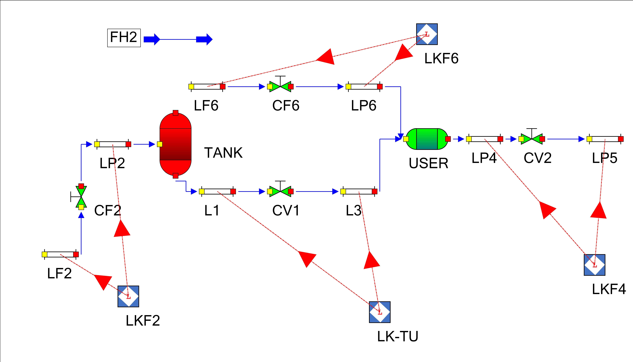
Figure 1. Process Flow Diagram for a dynamic simulation of a refuelling station
The figures presented by Piraino (2024), as published in the CET journal, are reproduced in Figure 2 and show the receiver pressure, temperature, and fuel content during the filling of the user’s tank.

Figure 2: From Piraino et al. Simulation results: (a) Supply tank pressure; (b) H₂ mass flow rate; (c) Receiver tank pressure; (d) Receiver tank temperature
It is the fourth Figure 2-d that immediately raises doubts in those accustomed to dealing with the simulation of gas depressurizations. The figure shows the temperature of the fluid in the receiving vessel increasing from 300 K to 360-370 K in a few seconds, and remaining at this level for the subsequent filling time interval. The initial temperature increment of approximately 60 K can be attributed to the hydrogen negative JT effect, but this effect should be limited to the initial depressurization period only. The general rule of thumb would suggest that the temperature rise would diminish as the pressure in the receiving vessel increases. The temperature increase of hydrogen should become lower as the pressure in the receiver tank increases. The correct temperature change of hydrogen in the receiver tank is shown in Figure 3. The gas initially discharged in the receiver tank increases its temperature owing to the JT effect, but afterwards the temperature of the gas decreases due to the compression by the new incoming gas. The receiver tank pressure and mass content are presented in Figure 4.
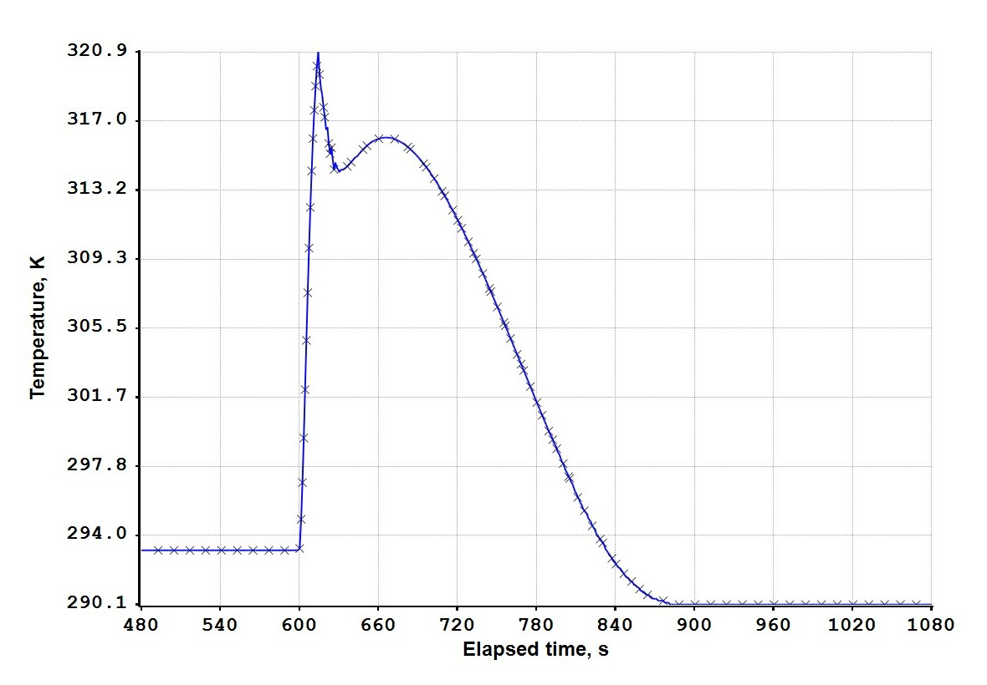 | 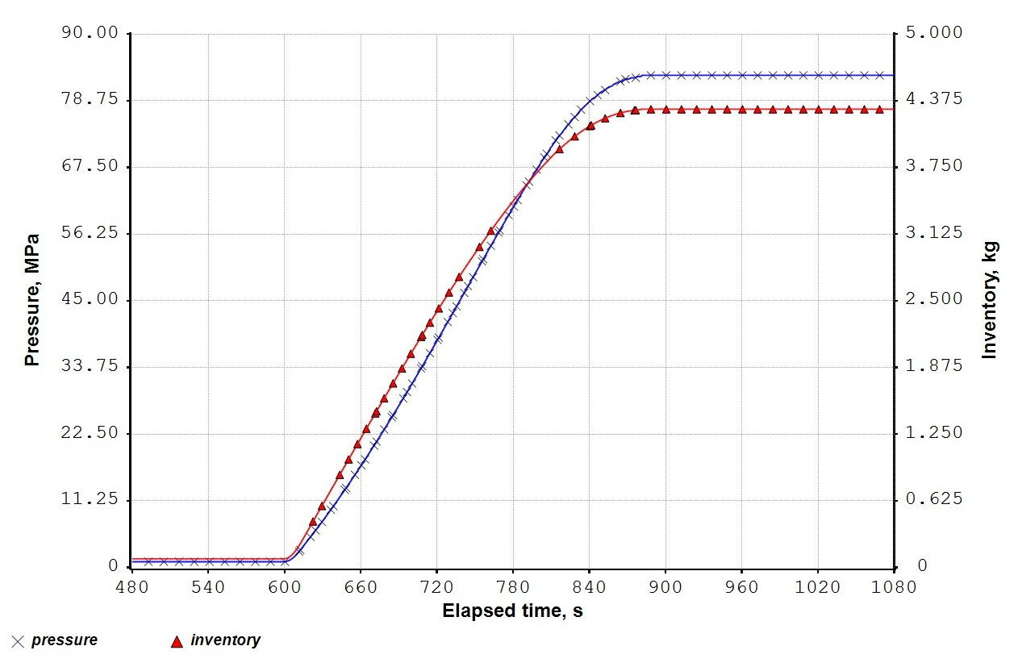
(a) | (b)
Figure 3: Receiver tank - Refilling starts after 600 seconds. (a) Temperature (X); (b) pressure (X), inventory (∆).
  - Tank Depressurization
The hydrogen generated by electrolysis at low pressure is compressed and stored at 90 MPa (900 bar). The buffer tank is assumed to have a diameter of 1 m and a length of 5 m, and the tank storage volume is around 4 m³. Depressurization could be required in case of an emergency and is performed through a pipe-valve-pipe assembly. The two pipe segments have diameters of 5 mm and are 3 m long. The control or pressure-safety valve has a Cv value equal to 0.5. The depressurization of the high-pressure buffer tank is calculated for different storage temperatures. The mass of hydrogen stored at 90 MPa depends on the temperature and is shown in Table 2. It is interesting to note that different equations of state compute different values for the initial hydrogen content. The equations of state tested are the Lee-Kesler (LK, Lee and Kesler, 1976), the GERG 2008 (GERG, Kunz and Wagner, 2012) and the Soave-Redlich-Kwong (SRK, Soave, 1972). It should be noted that the LK and SRK equations compute similar values. A much larger difference is found between their values and those calculated with the GERG-2008 equation.
Table 2. Summary of results for refuel tank depressurization
Temperature, °C | -40 | -20 | 0 | 20
Mass (LK), kg | 200.9 | 191.3 | 182.6 | 174.8
Mass (GERG), kg | 212.0 | 201.8 | 192.5 | 184.1
Mass (SRK), kg | 200.9 | 191.7 | 183.4 | 175.7
Time required, minutes | 328 | 321 | 306 | 299
Final pressure, MPa | 0.10 | 0.10 | 0.10 | 0.10
Final H2 content, kg | 0.35 | 0.32 | 0.30 | 0.28
Final Temperature, °C | 1.7 | 22.6 | 43.5 | 64.4

For all simulation cases, the depressurization is initiated 10 minutes after the beginning of the simulation. Of the many graphs generated, we present three graphs related to the depressurization of the H₂ tank from an initial temperature of 0°C. Figure 4 shows the pressure curve of the hydrogen in the tank and its mass content.The reliability of the results was already discussed in a previous study (Raimondi, 2017), where calculated results were compared with experimental data for the ‘Isle of Grain’ LPG depressurization (Richardson and Saville, 1996). An example of the depressurization of hydrogen and methane mixtures has been presented recently in this journal (Raimondi, 2024).
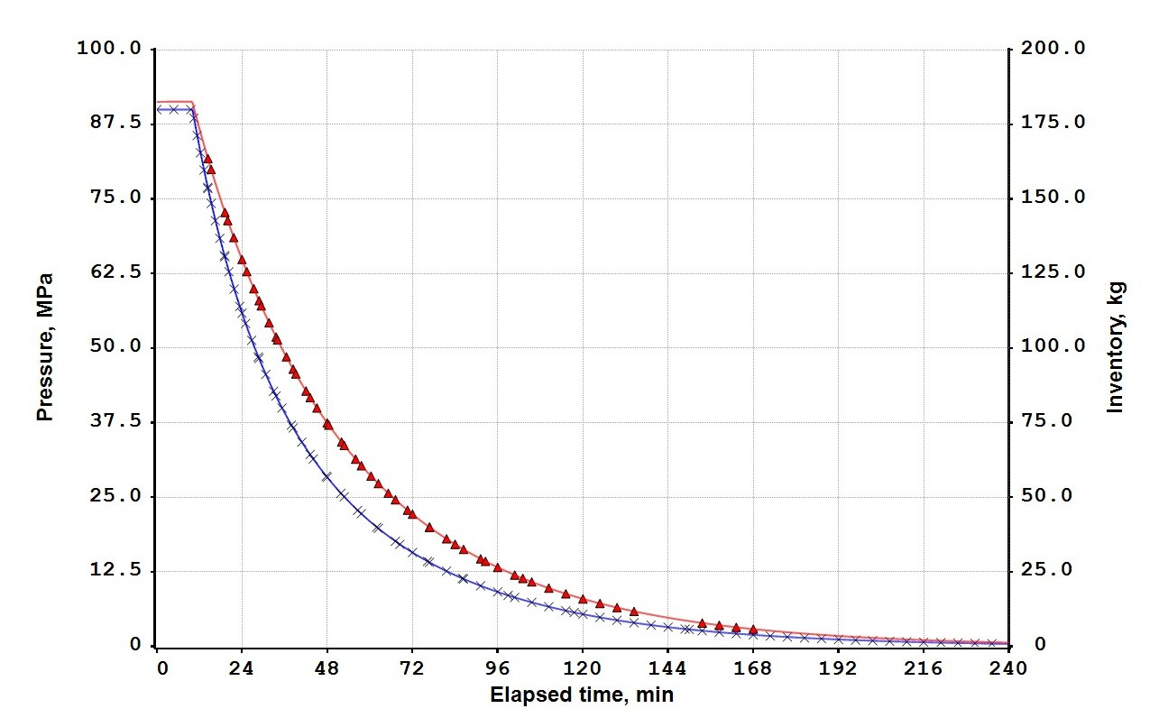
Figure 4. Tank initial temperature 0°C. Pressure (X) and inventory (∆)
Figure 5 presents the depressurization flow rate and the temperature of the hydrogen tank.
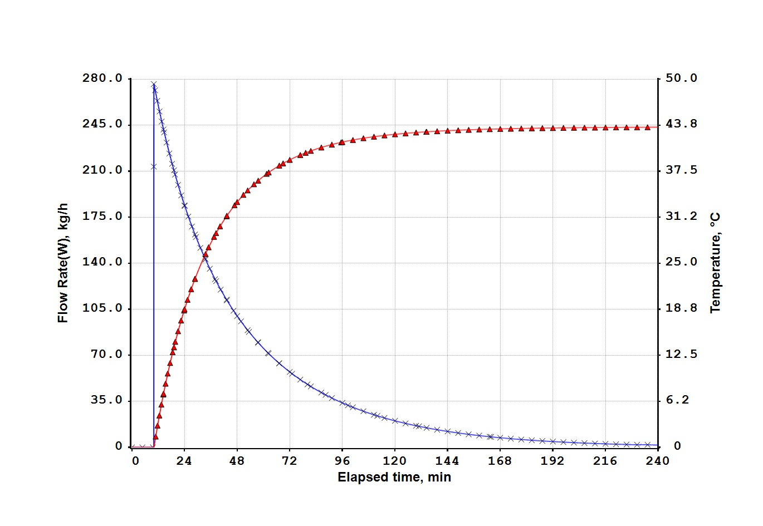
Figure 5. Tank initial temperature 0°C. Discharge flow rate (X) and temperature (∆)
The graphs in Figure 6 are of interest, as they show the gas velocities at the inlet and outlet of the two pipes involved in the depressurization.

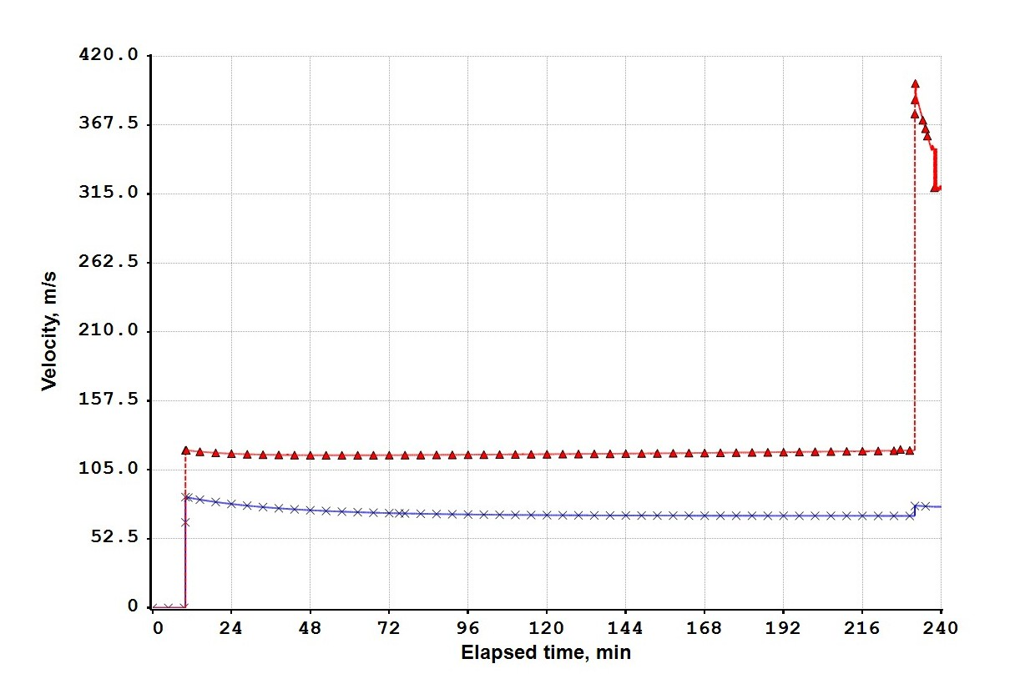
Figure 6. Tank initial temperature 0°C. H2 velocity in pipe, inlet (X), at exit (∆)
  - Conclusion
The use of a correct and validated thermodynamic framework is the fundamental basis for accurate simulation of pressure, temperature and flow effects involved in the design of HRS and the simulation of gas depressurization due to emergency events. This study presents the simulations of depressurization events in an HRS for possible emergency cases. The calculation does not present specific numerical problems, as there is no formation of a second liquid phase from the depressurised hydrogen gas. The selection of a reliable equation of state is fundamental for the calculation of the fluid mass contained in the tanks, transferred from one tank to another, or discharged into the ambient.
References
Clean Hydrogen Partnership, 2022, Clean Hydrogen JOINT UNDERTAKING – work programme 2022.
Kunz O., Wagner W., 2012, The GERG-2008 Wide-Range Equation of State for Natural Gases and Other Mixtures: An Expansion of GERG-2004, Journal of Chemical Engineering Data, 57, 3032-3091
Lee B.I., Kesler M.G., 1975, A generalized thermodynamic correlation based on three-parameter corresponding states, AIChE J., 21, 510-527.
Piraino F., Ustolin F., Campari A., Venetsanos A., Paltrinieri N., Fragiacomo P., 2024, Performance Analysis and Safety Aspects of Hydrogen Refueling Infrastructures, Chemical Engineering Transactions, 111, 403-408 DOI:10.3303/CET24111068
Raimondi L., 2017, Compositional Simulation of Two-Phase Flows for Pipeline Depressurization, SPE Journal, 22, 4, 1242-1253.
Raimondi L., 2024, Depressurization Simulation of Methane-hydrogen Mixtures in Pipelines, Chemical Engineering Transactions, 111, 481-486 DOI:10.3303/CET24111081
Richardson S.M., Saville G., 1996, Isle of Grain Pipeline Depressurization Tests, Health & Safety Executive.
Society of Automotive Engineers, 2024/2025, High-Flow protocols for medium and heavy-duty vehicles, SAE J2601-5.
Soave G., 1972, Equilibrium constants from a modified Redlich-Kwong equation of state, Chem. Eng. Sci. 27,1197-1203
XPSIM (eXtended Process SIMulator), 2025, Reference Manual, Version 3.2, Process Simulation Services, www.xpsimworld.com

