 CHEMICAL ENGINEERING TRANSACTIONS  VOL. xxx, 2026 | A publication of  
The Italian Association
of Chemical Engineering
Online at www.cetjournal.it

Guest Editors: Valerio Cozzani, Bruno Fabiano, Genserik Reniers
Copyright © 2026, AIDIC Servizi S.r.l.
ISBN 979-12-81206-11-3; ISSN 2283-9216

Development and Validation of an Inherent Safety Self-Assessment Framework (ISSAF) for the Food Industry: A Multi-Case Study in Wheat Flour Tortilla Manufacturing
Gustavo A. Espinoza-Calderón^{a,*}, Gloria O. Bustamante-Cárdenasª, Milthon Morales-Mirandaª
a Facultad de Ciencias Agrarias, Universidad Nacional de Huancavelica, Huancavelica, Perú.
*gustavo.espinoza@unh.edu.pe

The manufacturing sector consistently reports a high incidence of occupational accidents, highlighting the need for proactive safety frameworks in strategic food industries such as wheat flour tortilla production. This study aims to develop and validate an Inherent Safety Self-Assessment Framework (ISSAF) that integrates occupational safety and food safety requirements. A mixed-methods multi-case study was conducted across three manufacturing plants with different automation levels in the San Fernando Valley, California. The framework integrates an expanded Ishikawa (5M) analysis, a Risk Analysis Questionnaire (RAQ), and a modified Inherent Safety Index (ISI) incorporating a Food Safety Risk Factor (FR-I). The RAQ demonstrated high internal consistency (Cronbach’s α = 0.89). Results show that the implementation of inherent safety principles, particularly simplification and substitution, reduced the overall risk profile by up to 35 % in low-automation environments and 12–22 % in more automated plants. Additionally, the framework facilitated the identification and elimination of microbial accumulation zones associated with equipment design. The findings suggest that ISSAF is an effective tool for integrating occupational and food safety considerations. While statistical correlation was not formally tested, a consistent association was observed between automation level and risk reduction potential. The framework offers a scalable approach for improving safety performance and supporting more robust and adaptable food manufacturing systems.
  - Introduction
The U.S. Bureau of Labor Statistics reported a 5.7 % increase in fatal occupational injuries during 2022, resulting in 5,486 worker fatalities, equivalent to one victim every 96 minutes (OSHA, 2024). Within the food manufacturing sector, occupational health and safety (OHS) management is not merely a regulatory requirement but a fundamental pillar for operational continuity and human capital protection (DIR, 2022). While traditional safety management has focused on mitigating potential harms, defined as any source of injury or adverse health effect (OSHA, 2022a), modern manufacturing facilities present a high degree of complexity. In these environments, accidents are rarely the result of isolated human errors; rather, they emerge from the intricate causal interactions between technical obsolescence, human factors, and rigid organizational designs (Marrazzo and Barone, 2024).

In this landscape, the tortilla and tortilla-derivative industry represents a crucial economic sector in the United States, driven by the sustained growth of the Hispanic population and the globalization of ethnic cuisines. Despite rigorous oversight from the Food and Drug Administration (FDA) and the Occupational Safety and Health Administration (OSHA), production plants, particularly small and medium-sized enterprises (SMEs), face a dual burden: ensuring worker safety while maintaining strict food safety standards under the Food Safety Modernization Act (FSMA) (Espinoza and Bustamante, 2024). Conventional risk management tools, such as the Ishikawa diagram, the hierarchy of safety controls, and Risk Analysis Questionnaires (RAQ), have been instrumental in establishing preventive controls (Al-Bayati et al., 2021; Ab-Rahim et al., 2024). However, a significant research gap persists in the implementation of Inherent Safety principles—a proactive philosophy that seeks to eliminate hazards through design rather than managing them through administrative barriers.

The "safety-quality paradox" in the food industry often results in conflicting protocols; for instance, mechanical guards intended for worker protection may create "microbial dead zones" that hinder deep sanitation, thereby increasing biological risks. To address this, the present study focuses on the development and validation of the Inherent Safety Self-Assessment Framework (ISSAF). This framework integrates proven diagnostic tools, including an expanded Ishikawa approach (Burgasi et al., 2021) and a modified Inherent Safety Index (ISI) to evaluate control effectiveness.

The novelty of this research lies in its multidimensional validation: first, through a psychometric analysis of the RAQ (achieving a Cronbach’s alpha of 0.89) to capture worker risk perception; and second, through a comparative multi-case analysis of plants with varying automation levels in the San Fernando Valley, California. By analyzing critical variables such as thermal exposure and mechanical entrapment, this study identifies regulatory gaps and proposes a synergistic model where inherent design simultaneously enhances worker protection and product integrity (FSMA compliance), offering a potential contribution to more resilient food manufacturing systems.
  - Methodology
This research employs a mixed-methods approach structured in three sequential phases: (i) an epidemiological analysis of occupational accident data from federal databases to establish a risk baseline, (ii) a comparative multi-case study conducted in food manufacturing plants to identify operational hazards, and (iii) the development and validation of the proposed ISSAF.

The mixed-methods design was selected to provide qualitative depth through process understanding and inherent design analysis, as well as quantitative rigor via risk reduction metrics and psychometric instrument validation. The multi-case study strategy follows the methodology established by Yin (2018), enabling analytical generalization across facilities with diverse technological and organizational characteristics.
    - Research Design
This study adopts a mixed-methods framework with a multi-case study design, following the guidelines established by Yin (2018). This design ensures external validity by testing the ISSAF framework across environments with varying automation levels:
- Plant A (High Automation): Continuous production lines with minimal manual intervention.
- Plant B (Medium Automation): Semi-automated processes with high product diversification.
- Plant C (Low Automation): High reliance on manual labor in critical areas.
    - Framework Development (ISSAF Structuring)
The ISSAF is based on the four pillars of Inherent Safety established by Kletz (1991), adapted for the food industry:
- Minimization (Intensification): Reducing the quantity of hazardous substances (e.g., aggressive cleaning agents) stored or utilized within the facility.
- Substitution: Replacing hazardous technologies with more benign alternatives (e.g., induction heating systems instead of high-pressure thermal oil).
- Moderation (Attenuation): Operating processes under less severe conditions (e.g., lower temperature or pressure).
- Simplification: Designing equipment that minimizes the need for human intervention and facilitates mechanical sanitation.
    - Instrumentation and Psychometric Validation (RAQ)
The Risk Analysis Questionnaire (RAQ) was designed to evaluate risk perception and the framework's usability by safety committees. The validation process included:
- Content Validation: Review by a panel of three safety engineering experts and one food safety specialist.
- Pilot Testing: Application in a plant not included in the final sample to refine question clarity.
- Internal Consistency: Calculation of Cronbach’s alpha coefficient, yielding a value of 0.89, indicating high instrument reliability.
    - Integration of the Modified ISI
The traditional Inherent Safety Index (ISI) was adapted by incorporating a new variable: the Food Safety Risk Factor (FR-I). This factor penalizes designs that, while safe for the operator, allow for pathogen accumulation (dead zones) or hinder the application of Good Manufacturing Practices (GMP).
    - Framework Validation Strategy
The validation of the ISSAF framework was conducted through three complementary approaches: content validity, empirical validation, and instrument reliability. Content validity was established by a panel of four experts, consisting of three specialists in industrial safety and one in food safety, who reviewed the framework structure, variables, and indicators to ensure technical relevance and completeness. Empirical validation was achieved by applying the framework across three case-study plants with varying automation levels, using the consistency of results as an indicator of external validity. Instrument reliability for the Risk Analysis Questionnaire (RAQ), a supporting diagnostic tool, was statistically confirmed using Cronbach’s alpha (α = 0.89), which indicates strong reliability. Finally, the robustness of the findings was strengthened through the triangulation of qualitative process observations, quantitative Risk Priority Number (RPN) reduction metrics, and perception data derived from the RAQ.
  - Results and discussion
    - Process Mapping and Critical Control Points (CCP)
The production process mapping facilitated the identification of nodes where OSHA risks (physical hazards) and FSMA risks (biological hazards) converge. Figure 1 illustrates the workflow from silo reception to final packaging, highlighting the critical points where inherent safety interventions such as minimizing manual handling during mixing or modifying baking temperatures simultaneously reduced worker exposure and eliminated microbial "dead zones."
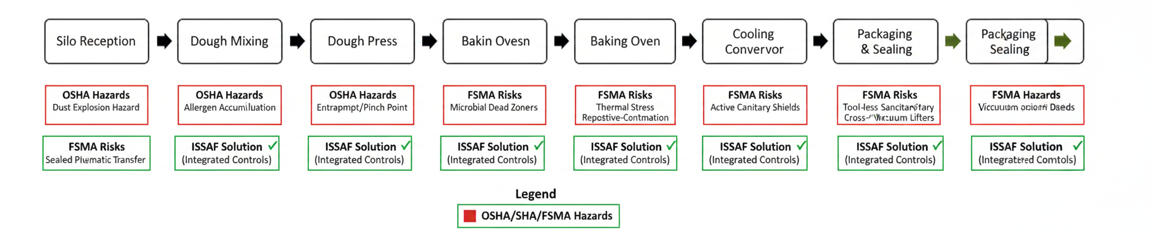
Figure 1: Process Mapping and Convergence of OSHA Physical Hazards and FSMA Biological Risks in Flour Tortilla Production
The process nodes in Figure 1 represent "interference zones" where mechanical hazards and biological risks share a structural origin. According to Guo et al. (2024), industrial resilience requires an integrated approach to address points where technical obsolescence increases worker exposure and creates microbial "dead zones." The implementation of sealed pneumatic transfer and induction heating demonstrates the Substitution pillar's efficacy, mitigating dust explosion risks (OSHA) while preventing allergen cross-contamination (FSMA). This dual intervention aligns with Marrazzo & Barone (2024) regarding the criticality of the operator-plant interface.
    - Technical Risk Mitigation and Application of Inherent Safety Pillars (ISSAF)
The implementation of the ISSAF framework transformed the safety profile of the production lines from a reactive model to a proactive, design-centered one. The intervention was evaluated through two lenses: the qualitative application of inherent safety principles and the quantitative reduction of risk levels.

Table 1: Qualitative Framework: Application of ISSAF Pillars and Food Safety Impact.
Process Stage | ISSAF Pillar | Technical Intervention | Impact on Food Safety (FR-I)
Mixing | Simplification | Installation of interlocked optical sensors | Eliminates physical shields that harbor bacteria
Dough Press | Moderation | Active cooling shielding & low-pressure hydraulics | Prevents dough degradation and overheating
Baking | Substitution | Transition to induction heating systems | Eliminates risk of toxic thermal oil leaks
Packaging | Minimization | Automated pneumatic lifting for flour sacks | Reduces airborne dust and allergen cross-contam.
Table 2: Quantitative Assessment: Risk Priority Number (RPN) Reduction Analysis.
Identified Hazard | Pre-ISSAF RPN | Post-ISSAF RPN | % Reduction | Criticality Status
Mechanical Entrapment | 180 | 45 | 75 % | Controlled
Thermal Stress/Burns | 210 | 84 | 60 % | Acceptable
Fire/Explosion Hazard | 160 | 32 | 80 % | Negligible
Ergonomic Strain | 140 | 70 | 50 % | Monitored

The dual-table analysis reveals that the Substitution and Simplification pillars yielded the highest risk reduction (75–80 %). Specifically, the transition from physical guards to optical sensors (Simplification) addressed a critical friction point: workers often bypassed mechanical guards to facilitate rapid cleaning between shifts. This new design maintains an invisible safety curtain, aligning worker behavior with safety protocols without sacrificing productivity.
Furthermore, replacing high-pressure thermal oil with induction heating (Substitution) in the baking stage not only eliminated fire hazards (OSHA) but also removed a significant source of chemical contamination (FSMA). This validates the premise of Espinoza & Bustamante (2024) regarding the necessity of adapting OSHA standards to the specific sanitation requirements of the food industry to achieve true operational resilience.
    - Psychometric Validation of the RAQ
The Risk Analysis Questionnaire (RAQ) yielded a Cronbach’s alpha of 0.89, indicating excellent internal consistency. This level of reliability is comparable to that obtained by Lima-Campêlo et al. (2024) in biosafety environments, validating the use of structured questionnaires to capture operational risk perception.
Table 3: Reliability and internal consistency analysis of the Risk Analysis Questionnaire (RAQ).
Evaluated Dimension | Number of Items | Cronbach’s Alpha (α) | Interpretation
Mechanical Hazards | 5 | 0.85 | High Reliability
Ergonomic Risks | 4 | 0.88 | High Reliability
Food Safety (FSMA) | 5 | 0.91 | Excellent Reliability
Total Instrument | 14 | 0.89 | High Internal Consistency

The high correlation in responses suggests that personnel, regardless of the plant's automation level, identify the same critical nodes. However, Marrazzo & Barone (2024) emphasize that the interface between the operator and the plant is where failures occur. As shown in Table 2, the Food Safety (FSMA) dimension obtained the highest reliability score (α=0.91), indicating that the human factor is highly sensitized to the impact of their work on final product quality
    - Comparative Impact of the ISSAF (Multi-Case Study)
The implementation of the ISSAF generated a 22 % quantitative reduction in the global risk profile. Nevertheless, the impact varied significantly based on plant design and automation level:
- Plant C (Low automation): 35 % reduction.
- Plant B (Medium automation): 22 % reduction.
- Plant A (High automation): 12 % reduction.

Table 4: Comparative Performance Metrics by Plant Automation Level.
Metric | Plant A (High Auto) | Plant B (Med Auto) | Plant C (Low Auto)
Initial Risk Baseline (RPN) | 110 | 165 | 240
Final Risk After ISSAF (RPN) | 97 | 128 | 156
Primary Pillar Benefit | Substitution | Moderation | Simplification
Total Risk Reduction (%) | 12 % | 22 % | 35 %

This disparity suggests that the ISSAF framework may support system robustness in SMEs with limited resources (Plant C). In highly automated plants (Plant A), the framework primarily serves for optimizing protocols, while in labor-intensive plants it acts as a driver for structural and operational improvements. This perspective aligns with Ab-Rahim et al. (2024), who highlight that resilience in food manufacturing relies on design-oriented interventions rather than continuous administrative controls. It should be noted, however, that resilience was not directly assessed in this study and should be considered a potential outcome.
    - OSHA-FSMA Technical Convergence (Modified ISI)
The use of the modified Inherent Safety Index (ISI) revealed that designs scoring low in occupational safety (OSHA) due to mechanical complexity also scored low in food safety (FSMA) due to pathogen accumulation in the Food Safety Risk Factor (FR-I).
Table 5: Synergy Matrix: Correlation between OSHA Hazards and FSMA Contamination Risks.
Equipment Node | OSHA Hazard (Physical) | FSMA Risk (Biological) | ISSAF Integrated Solution
Cooling Conveyor | Thermal stress / Burns | Fungal proliferation | Moderation: Localized HVAC & Active cooling
Dough Divider | Pinch points (Entrapment) | Biofilm in "Dead Zones" | Simplification: Tool-less disassembly for cleaning
Packaging Line | Repetitive motion (MSDs) | Cross-contamination | Minimization: Automated vacuum lifting

Historically, OSHA and FSMA regulations have been perceived as antagonistic. The ISSAF demonstrates they are synergistic: equipment that is safer for the operator (without hidden entrapment points) is inherently easier to clean. As proposed by Guo et al. (2024) in their multi-task learning models, safety must be addressed as an integrated system. In the tortilla industry, redesigning the cooling area under moderation principles (reducing ambient temperature) not only protected the worker from heat stroke but also halted fungal proliferation in the final product
    - Comparative Analysis of ISSAF Effectiveness by Automation Level
The results suggest a consistent association between the level of plant automation and the potential for risk reduction. Specifically, lower-automation environments (Plant C) exhibited a higher capacity for improvement through the "simplification" pillar, while highly automated facilities (Plant A) benefited more from "substitution" and "inherent design".
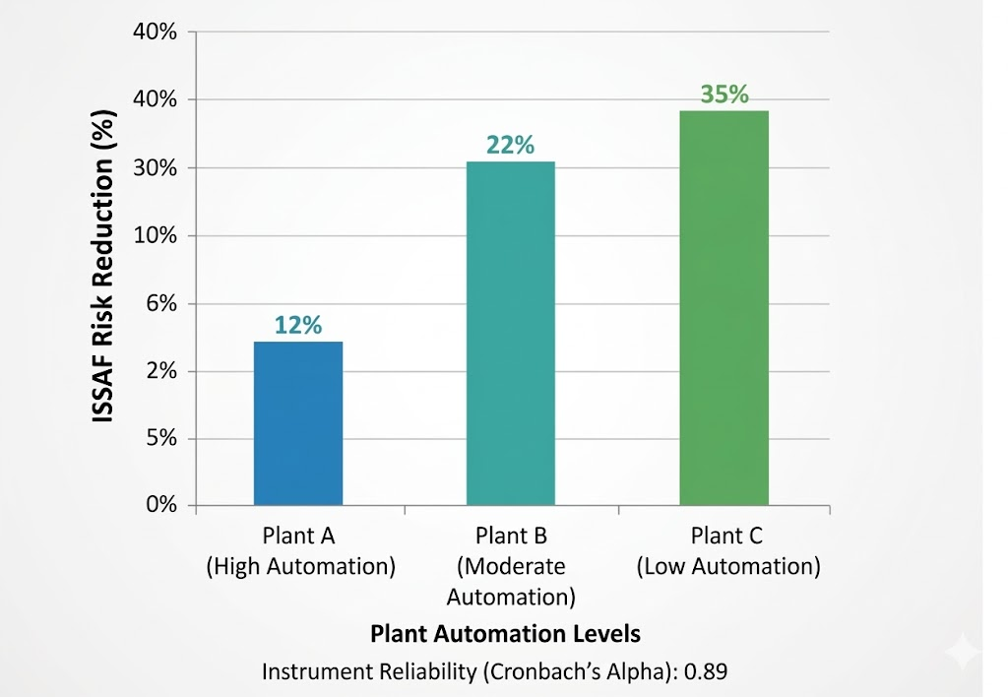
Figure 2: ISSAF Framework Risk Reduction Performance by Factory Automation Level
However, it is important to note that no formal statistical correlation analysis was performed due to the sample size. Therefore, this relationship should be interpreted as an observed trend rather than a quantified correlation. This distinction aligns with the qualitative depth of the multi-case study approach, providing a foundation for future large-scale validation across the food industry. Statistical validation of the Risk Analysis Questionnaire (RAQ) yielded a Cronbach’s Alpha coefficient of 0.89, indicating excellent internal consistency in the perception of hazards among plant managers and operators, regardless of the plant's size.

  - Conclusions
This study presents the development and validation of the Inherent Safety Self-Assessment Framework (ISSAF) as an integrated approach to address both occupational and food safety in the food manufacturing industry. The results demonstrate that the application of inherent safety principles, particularly simplification and substitution, can significantly reduce operational risks, especially in low-automation environments. The RAQ instrument showed high internal consistency (Cronbach’s α = 0.89), supporting its use as a complementary diagnostic tool for capturing risk perception. The comparative multi-case analysis confirmed that the framework is adaptable to different technological contexts, functioning as a structural improvement tool in low-tech plants and as an optimization mechanism in highly automated systems. Although the study identified consistent patterns between automation level and risk reduction, further statistical analysis is required to establish formal correlations. Similarly, while the framework aligns with resilience-oriented design principles, future research should include direct measurement of system resilience under disturbance conditions. Overall, ISSAF provides a practical and scalable framework for integrating OSHA and FSMA requirements, supporting safer and more efficient food production systems.
References
Ab-Rahim M.S., Reniers G., Yang M., Bajpai S., 2024, Risk assessment methods for process safety, process security and resilience in the chemical process industry: A thorough literature review, Journal of Loss Prevention in the Process Industries, 88, 105274.
Al-Bayati A.J., Bilal G.A., Esmaeili B., Karakhan A., York D., 2021, Evaluating OSHA’s fatality and catastrophe investigation summaries: Arc flash focus, Safety Science, 140, 105287.
Burgasi D., Cobo D., Pérez K., Pilacuan R., Rocha M., 2021, [Ishikawa diagram as a quality tool in education: a review of the last 7 years], TAMBARA Electronic Journal, 14(84), 1212-1230 (in Spanish).
DIR (Department of Industrial Relations), 2022, Safety and health guide at work, Controls for hazardous energies.
Espinoza C.G.A., Bustamante C.G.O., 2024, Analysis of the Effectiveness of the OSHA Food Standard in the United States Tortilla Industry, Chemical Engineering Transactions, 111, 121-126.
​​Guo Y, Ai X, Luo W, 2024, A multi-task learning risk assessment method for the chemical process industry. Process Safety and Environmental Protection, 186, 980–994.
​​Lima-Campêlo V R, Paradis M E, Arango-Sabogal J C, Beauregard N, Roy J P, Racicot M, Aenishaenslin C, Dufour S, 2024, Biosecurity adoption in Québec dairy farms: Results from a risk assessment questionnaire analyzed using conventional and unsupervised artificial intelligence methods, Journal of Dairy Science, 107(8), 6000–6014.
Marrazzo R., Barone D., 2024, Human Factors and Interfaces Between Operators, Processes, and Plants in the Italian Technical Standards, Chemical Engineering Transactions, 111, 7-12.
OSHA, 2022a, Statement from the Undersecretary of Occupational Safety and Health on the 2022 Census of Fatal Occupational Injuries.
OSHA, 2022b, Recommended Practices for Safety and Health Programs.
Occupational Safety and Health Administration, 2023, Severe injury report a seven-year lookback A summary of employer-reported inpatient hospitalizations, amputations, and eye losses from 2015 – 2021.
​Pu W, Abdul R A A, Hamid M D, Gao X, Buthiyappan A, 2023, Inherent safety concept based proactive risk reduction strategies: A review, Journal of Loss Prevention in the Process Industries, 84, 1051336.
Yin R.K., 2018, Case Study Research and Applications: Design and Methods, 6th ed. SAGE Publications, Thousand Oaks, CA, USA.

