 CHEMICAL ENGINEERING TRANSACTIONS  VOL. xxx, 2026 | A publication of  
The Italian Association
of Chemical Engineering
Online at www.cetjournal.it

Guest Editors: Valerio Cozzani, Bruno Fabiano, Genserik Reniers
Copyright © 2026, AIDIC Servizi S.r.l.
ISBN 979-12-81206-xx-x; ISSN 2283-9216

Lisa Hyper harness: development of IoT based tool to prevent fall from height events
Jacopo Moretti^{*1}, Lorenzo Corallo¹, Francesco Maffei¹, Angelo Spingardi¹, Enrico Sansone²
1.Saipem S.p.A., Via Luigi Russolo 5, 20138, Milano, Italy
2.R13 Technology
jacopo.moretti@saipem.com

The following paper presents the development of the Lisa Hyper Harness, an IoT‑based smart safety harness designed to prevent fall‑from‑height incidents in Oil & Gas construction sites. Since 2023, Saipem has explored available market solutions for monitoring work‑at‑height activities, but none met the company’s standards, prompting the creation of a tailored device. The system integrates a primary sensorized carabiner unit and a secondary wearable data‑collector module, enabling automatic activation when workers enter predefined high‑risk zones. Equipped with GPS, accelerometers, barometers, and Time‑of‑Flight sensors, the harness continuously evaluates operator position, fall factor, and relative height between its parts. Real‑time alarms—visual and vibrating—warn scaffolders when 100% tie‑off is not maintained, while a digital dashboard supports remote supervision and statistical analysis of safe vs. unsafe behaviors. The solution enhances both worker self‑awareness and HSE supervisors’ ability to rapidly correct unsafe acts. Early deployment aims to support behavioral analysis, improve safety culture, and ultimately reduce fall‑related incidents. The paper concludes with an update on industrialization and field‑testing, targeting full operational use at Saipem construction sites.

  - Introduction
The issues connected with Working at Height (W@H) have been widely discussed and analyzed in the field of construction sites. As of today, the W@H environment remains one of the most dangerous and widespread causes of accidents worldwide ranging from 40 % up to 60 % of the total amount of severe accidents (Hartono et al., 2024; Rey-Merchàn et al., 2021; Swart et al., 2025).
The same trend has been found in the Oil&Gas EPC, sparking many initiatives to reduce the risk of such events and prompting the IOGP to create a specific lifesaving rule to tackle it (IOGP, 2018). Starting from 2010 this rule has been applied by the major companies in the field.
Saipem, has always been on top of this issue and tried through many different initiatives to end the risk associated with W@H, striving for the very challenging objective of 0 accidents. A deep analysis of the incidents has revealed a strong connection with human performance (distractions, overconfidence, lessened supervision, etc.) which had to be reduced through new approaches and safety culture improvement. However, the company has now reached a plateau in the number of severe accidents, prompting a new approach based on a change of safety paradigm connected, amongst other initiatives, to the usage and development of new technologies.
With these scopes in mind, starting from the summer of 2023 after some severe events connected to W@H, the company has been looking on the market for something that could aid personnel at site to be fully compliant to safety rules.
The market offered many different devices, mostly coming from Korea, which had many interesting features and functionalities. However, all of them weren’t completely in line with Saipem’s internal standards. Most devices had to rely on modifying the structure of the safety hook, compromising its resistance to shock and rendering the safety certifications useless. Moreover, the optical sensors connected to these smart hooks required a great amount of energy to work and, due to the current status of battery cells, their maximum charge couldn’t even cover a single worker shift.
Considering all the limitations above, Saipem decided to embark on a development process to ensure that the final device would be fully compliant with requirements and had the desired functionalities.
After a brief search on innovation platforms and already contracted vendors, it was decided to engage Confezioni Mario De Cecco, an historic Italian PPE seller and long-time vendor of Saipem, as a 50/50 partner for the development of the device.
R13 Technology, a small start-up from L’Aquila born as a spin-off of the local university, was selected as technical partner due to their ability in developing IoT and electrical solutions in many different fields spanning from healthcare to automotive.
This combined team has been working for the last two years to create a reliable and cutting-edge device to be adopted not only in Saipem and Oil&Gas, but in every construction site. The joined effort has produced “LiSa HyperHarness”, which has already been presented to many clients and competitors from the industry gathering very positive feedback.

  - State of the art and research gap
Falls from height (FFH) remain one of the main causes of severe and fatal incidents in construction environments despite the use of personal protective equipment (PPE) and the continuous improvement of procedures and training. Recent literature highlights that traditional safety management approaches (inspections, training, communication) are often insufficient to cope with dynamic and complex site conditions, thus motivating the adoption of digital technologies capable of supporting real-time monitoring and proactive interventions (Daniel et al., 2025). In this broader context, Internet of Things (IoT) approaches are increasingly adopted to connect wearable devices, environmental sensors, and site management systems, enabling data-driven monitoring and decision-making aimed at improving safety and operational performance (Khan et al., 2024).
A specific research stream concerns “smart PPE” and wearable safety technologies, where sensing, connectivity, and analytics are integrated into conventional equipment to move from passive protection to more active risk mitigation. Recent reviews describe a transition toward sensor-enabled PPE integrated with real-time monitoring solutions, while also emphasizing persistent barriers to large-scale deployment such as user acceptance, infrastructure constraints, robustness, privacy concerns, and the need for governance and user-centered design (Adebowale and Agumba, 2026). These constraints are particularly relevant for work-at-height activities, where device usability, battery life, reliability in metallic environments, and trust in alarms are essential for day-by-day adoption on construction sites.
Within FFH prevention, multiple studies propose IoT-based systems to monitor hazardous conditions and support decision-making. For example, Rey-Merchán et al. (2022) propose and test an IoT system integrating expert knowledge (via fuzzy logic) to support prevention of FFH in multiple construction scenarios, discussing how site complexity and continuously changing layouts make automated monitoring challenging. Other approaches focus on the timely detection of falls and rapid notification to reduce consequences, using wearable sensors and IoT connectivity (Dogan and Akcamete, 2018). While these contributions are valuable, a significant portion of the literature concentrates either on post-event detection/notification or on generic monitoring concepts, with less emphasis on continuous and operationally reliable verification of “effective protection” during real work sequences (e.g., maintaining 100% tie-off during scaffolding erection and dismantling).
Another relevant direction is the use of context awareness (risk zones, access control, geofencing/virtual fences) to activate monitoring only when needed and reduce unnecessary alarms and energy consumption. Virtual fence concepts have been explored to prevent intrusions into hazardous areas using IoT paradigms and highlight that successful adoption requires integration with site procedures and organizational culture (Rey-Merchán et al., 2021). In parallel, recent work specifically addresses FFH prevention on scaffolds by combining sensing and contextual logic; for instance, Khan et al. (2022) propose a “smart safety hook” approach integrating IoT sensing and computer vision to classify safe/unsafe behavior and to reduce power consumption by switching to low-power operation when outside risk conditions. This literature supports the relevance of both hook/tie-off monitoring and context-driven operation to make solutions viable on active sites.
Finally, reliability is a central issue for any real-time safety monitoring solution. False positives can cause nuisance alarms and workflow disruptions, while false negatives can conceal truly unsafe conditions. Literature on automated safety monitoring explicitly recognizes that false alarms degrade usefulness and proposes techniques (e.g., temporal analysis) to reduce false alarms (Zaidi et al., 2024). For work-at-height protection, this reinforces the need to assess smart PPE not only by nominal functionality but also through measurable performance indicators (false positives/false negatives) that directly influence user trust, operational usability, and safety effectiveness.
The reviewed literature shows strong interest in digital and IoT-enabled construction safety, including FFH prevention, wearables, and context-aware monitoring. However, there remains a gap in field-deployable solutions that simultaneously: verify continuous tie-off effectiveness during real operations (not only “PPE worn” or “fall occurred”), preserve certification integrity by avoiding structural modifications of load-bearing connectors, and are evaluated through operational KPIs that explicitly account for both nuisance alarms and safety-critical missed detections.

  - Methods, procedures and processes
The development of LiSa Hyperharness combines technical knowledge from different fields of expertise from HSE requirements to very high-tech technology.
The device was designed to be suitable for use on construction sites, prefabrication yards, and offshore installations/vessels in the various geographical areas where Saipem operates. The main use case concerns the assembly, use, and disassembly of scaffolding. The primary professional figure intended to use the device is the scaffolder; other workers operating at height may also wear it under the above criteria. The system must also function properly in situations where scaffolding is not foreseen (e.g., work/inspection on large equipment involving work at height), provided that metallic anchoring elements such as lifelines, anchor points, etc., are present.

    - HSE Technical needs
As previously stated, this project’s base is rooted in a specific HSE need connected to the safety of workers at height.
Before starting any work at height, each worker must wear the safety harness containing the device. Any work at height activities in a setting where the worker is exposed to a possible fall of more than 1.8 m needs to have a mandatory enforcement of the harness.
The “work at height” mode needs to be activated when the device worn by the operator passes near the entrance area of the scaffolding, where a virtual gate will be installed (with the possibility to set a delay in activation after passage).
Once “work at height” mode is activated, the worker must secure at least one hook to a safe metallic anchor point (such as a certified lifeline). If this doesn’t happen, a local alarm will be triggered (via vibration and visual/audible alerts). The signal will also be sent to the team supervisor and to a dashboard available for site management. This step is to ensure that each person involved in safety management is immediately alerted in case of violation.
A virtual gate allows the activation or deactivation of “work at height” mode depending on whether the operator enters or exits a scaffolding or an elevated structure. The gates need to be put at each entrance/exit of the scaffolding. Due to the ever-changing setting of scaffolding erection, no access point must be left without a gate.
The system is designed so that the team supervisor can activate and/or deactivate the “work at height” mode through the mobile app in case of need. This feature was added to give the possibility to the supervisors to use the devices in contexts where the gates can’t be used, for example in absence of a scaffolding structure or in very complex situations. To prevent tampering, there is no way for the workers to deactivate work at height mode or the whole device.
Once all these parameters are set, the system can gather a constant flux of data coming from different workers in various situations. A dashboard/app is then used to analyze and control these data.
From an HSE and management perspective the dashboard can show a great amount of information. First of all, data regarding the status of each worker showcasing their unique identifier, their assignment to working team and supervisor and their live work status (safe, unsafe, alarm). Secondly, the technical status of the devices: battery levels, connectivity status and internet connection level.
Moreover, the dashboard can show some additional information connected to working conditions. The fall factor, a value, spanning from 0 to 2, calculated considering the relative height between the worker and the hook. Positioning (GPS) and height of the worker in case of an emergency (man down or fall from height).

    - Technological Specifications
LiSa HyperHarness is composed of a set of interconnected technological components designed to operate cohesively in demanding industrial environments. At its core, the architecture integrates the Primary Control Unit, the Secondary Control Unit, Virtual Gates, the centralized Dashboard and the Mobile App. These elements function together to detect work‑at‑height conditions, monitor operator behaviour and ensure that all safety requirements are respected throughout the duration of the activity.
The Primary Control Unit (PCU) is engineered as an electronic module embedded within a mechanically resistant enclosure that must integrate seamlessly with certified scaffolders’ hooks without altering their structural or safety properties. This unit contains sensors capable of determining the state of the connectors, distinguishing whether they are open, closed or incorrectly positioned in non‑safe resting conditions. The PCU must also identify when the worker is attached to metallic anchor points, such as certified lifelines, and must determine the fall factor by evaluating absolute height differences and distance relative to the Secondary Control Unit (SCU). Its design must remain modular and maintainable, enabling replacement or removal without compromising the integrity of the harness. The pairing procedure between the PCU and the SCU must be unique and manageable autonomously by Saipem personnel, ensuring operational flexibility and quick deployment even in remote site conditions. The general idea behind PCU’s structure and usage is to be a plug-and-play system adaptable to any type of safety hook. This feature is very important to ensure that the certification on the hook is not lost, due to modifications of the structure and integrity, and to be more sustainable in case of fault. If the electronic part breaks it can be substituted without having to waste the whole hook and parts can be easily substituted. The current status of development makes it suitable for standard safety hooks; however, a more adaptable and interchangeable structure is in the making.
The Secondary Control Unit is a wearable electronic device that accompanies the worker throughout the activity. Anchored directly to the harness, it incorporates motion‑sensing technology capable of detecting fall events and recording the dynamic parameters associated with each incident. It receives and processes the data sent by the PCUs, evaluates height differences and communicates directly with the dashboard using Wi‑Fi or 5G depending on the available connectivity. It contains a dedicated button that allows the worker to request help in case of need. The SCU is also the node responsible for managing GPS‑related functions. It must allow the configuring of GPS transmission according to three distinct modes: disabled by default, always active or active only during “work at height” mode when triggered by the gate logic. This flexibility ensures compliance with privacy considerations and operational constraints in areas where GPS use may be limited.
Virtual Gates serve as intelligent access‑control devices placed at entry and exit points of elevated structures or scaffolding. Their role is to detect the entry or exit of the operators’ devices into dangerous work at height zones. When the operator passes one of these thresholds, the system automatically enables or disables the “work at height” mode. For these gates to operate effectively, the supplier must provide robust installation procedures and ensure that the operating range can be programmed and customized through an app or a PC‑based configuration interface. Their functioning is critical to guaranteeing that the system responds accurately to transitions between safe ground‑level areas and zones that entail fall hazards. Initially, the gate was built on Bluetooth technology. However, after some field testing, it was abandoned in favor of RFID scanners, more reliable and capable of discerning a passage movement.
The Dashboard represents the centralized intelligence of the entire system. It is responsible for acquiring data from all SCUs active within the monitored environment and must be capable of managing high user concurrency, particularly in large projects where thousands of workers may be active simultaneously. The dashboard must allow the upload of site maps, the definition of gate positions and the association of multiple SCUs with specific supervisors. It must provide detailed information on connector conditions, alarms, deactivation requests and general system status while consolidating historical and real‑time data. Furthermore, it must offer analytical features enabling supervisors and management to evaluate usage statistics, compliance patterns and the distribution of work‑at‑height activities through heatmap visualizations. The system must also support reconstruction of fall‑event dynamics by aggregating data from sensors and logs. All software components must adhere to Saipem’s architectural and cybersecurity guidelines to ensure robustness, data protection and resilience against external threats.
Complementing the dashboard, the Mobile App extends monitoring and management capabilities directly to field supervisors. Through the app, supervisors can track the number of active PCU‑SCU pairs under their responsibility, verify their operational status and receive alarms related to incorrect attachments or system disconnections. The app also allows supervisors to manage the deactivation and reactivation of the “work at height” mode in real time, ensuring operational continuity in cases where rapid decisions are required on site.
All technological components must be able to operate under extreme environmental and operational conditions. Defined parameters include an operating temperature range from –40°C to +85°C, a storage temperature range between –10°C and +50°C, tolerance to 100% humidity and IP67‑level protection against dust and water. The devices must meet CE and IPC Class 2 certification standards and resist environmental shocks in accordance with MIL‑STD 810 criteria. Battery life is a critical factor: PCUs and SCUs must guarantee at least 12 hours of continuous operation, while Virtual Gates must function autonomously for a minimum duration of four days. The system must generate alarms using vibration, audible signals and intermittent visual indicators, ensuring clear perception in a variety of operational contexts.
Connectivity is a fundamental aspect of the system’s technological backbone. Communication between the PCU and SCU must rely on BLE 5.0 to ensure stable, low‑power, short‑range data exchange, while interactions between the SCU and the dashboard must use Wi‑Fi when available on the Saipem intranet or 5G where permitted. This layered communication strategy ensures that the system remains functional even in remote locations or in environments with limited mobile coverage.
Overall, the technological specifications of the Smart Safety Harness define a sophisticated and resilient system capable of integrating mechanical safety equipment with advanced electronics, connectivity and data analytics. The solution is conceived as modular, adaptable and robust, ensuring that it can be deployed across diverse operational contexts while maintaining compliance with safety, certification and cybersecurity standards.
Figure 1 shows a comprehensive diagram of the main system’s components and connections.

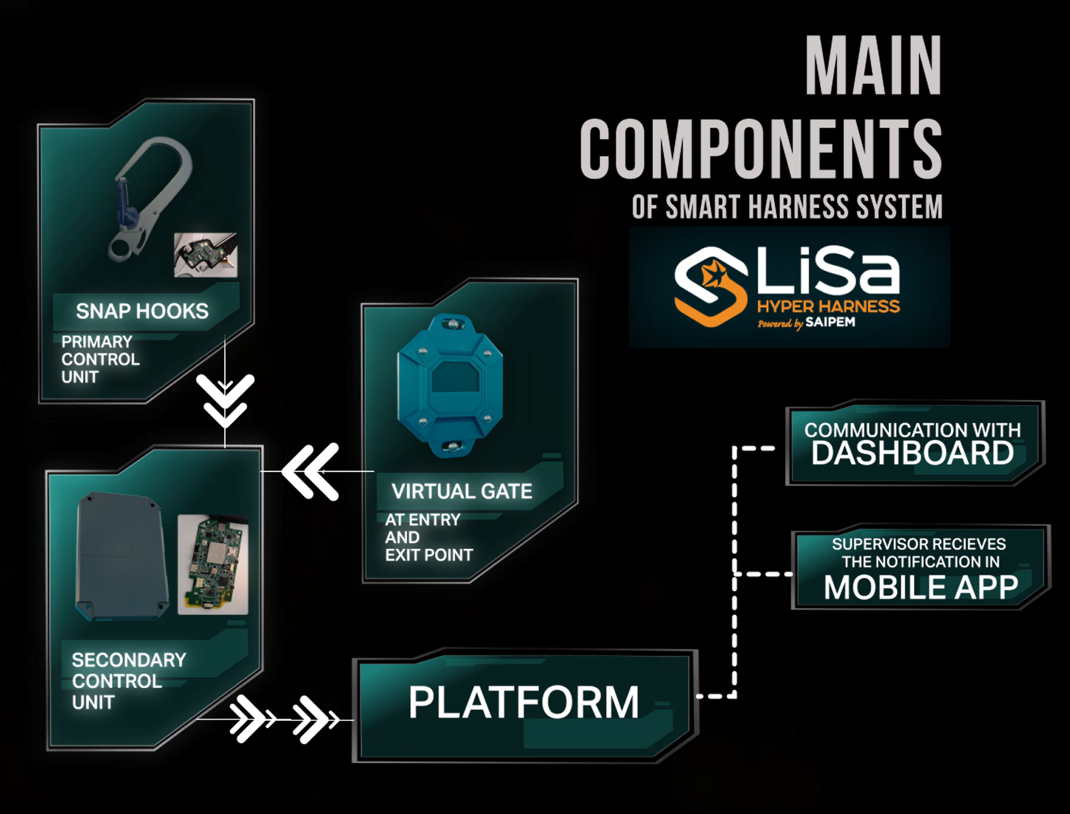

Figure 1: LiSa Hyper Harness main components. The PCU and SCU communicate via Bluetooth, while the SCU communicates via RFID with the gate and via Wi-Fi/4G/5G with the online platform.

    - Gaps with existing technologies and novelties in the development
Although several “smart hooks” and wearable IoT solutions for working-at-height monitoring are available on the market, their scope is typically limited to basic connection detection (hook open/closed) or post-event fall alarms. The development of LiSa HyperHarness addresses a more specific scientific and technical gap: the lack of a reliable, field-deployable and certification-preserving method to continuously verify the effectiveness of the tie-off (i.e., whether 100% tie-off is actually maintained in real operations) while simultaneously estimating the severity potential of a fall through real-time fall-factor and height-to-ground metrics. In other words, existing systems often capture “PPE is worn” or “a fall occurred”, while the most safety-critical window—early detection of unsafe detachment, incorrect anchoring, or degraded protection conditions before an accident—remains weakly covered, especially in harsh industrial settings where metal structures, dust, water and connectivity limitations reduce sensor reliability.
Compared with existing IoT-based fall protection systems, LiSa HyperHarness differentiates itself through both mechanical integration choices and system-level logic. First, the Primary Control Unit is designed as a plug-and-play add-on that integrates with certified connectors without modifying the hook load-bearing structure, therefore avoiding the typical trade-off between “smartness” and certification validity observed in many commercial smart-hook solutions. Second, the architecture is natively multi-node (PCU–SCU–Virtual Gates–Dashboard) and is centered on context-aware activation: the work-at-height mode is triggered by Virtual Gates (RFID-based, after Bluetooth trials), reducing unnecessary monitoring and battery drain while improving data relevance. Third, the device does not rely on a single sensing principle (e.g., optical proximity only); rather, it combines connector-state sensing with inertial/altimetric/GPS data to support: immediate local feedback to the worker (vibration/visual alerts) when tie-off is missing, and remote escalation to supervisors for rapid intervention. Finally, the platform is conceived for high concurrency and operational analytics, enabling supervision at scale (hundreds to thousands of users) rather than isolated device-level alarms.
Beyond an industrial customization effort, the project generates new insight on how digital safety wearables can be engineered and evaluated when the target outcome is behavioral prevention rather than mere incident reporting. The introduction of gate-driven context detection, real-time computation of fall-factor and height-to-ground as leading indicators of exposure, and KPI-based validation using false-positive/false-negative rates (including the explicit notion of “dangerous” false negatives) provides an evidence-oriented framework to quantify whether a smart fall-protection system is practically usable on site.

    - User Acceptance Test
Ater the development phase, a through user acceptance test has been started. The test is based on an Inspection test plan (ITP) written by different teams internal to Saipem, gathering different expertise fields. It applies to every component of the system: the Primary Control Unit, the Secondary Control Unit, the virtual gate, the supervisory dashboard and the dedicated mobile application. Its ultimate aim is to guarantee that the system is reliable, safe, and aligned with all regulatory requirements, both in routine operations and in emergency scenarios.
The tests focus on several key aspects: the general functioning of the harness and its electronics, the communication capabilities between the different components, the robustness of the system when exposed to impacts and harsh environmental conditions, the adherence to safety standards and certifications, and the correct behavior of the software interfaces, including user interaction, alarms, and data transmission. In addition, the plan includes the evaluation of all supporting documentation and safety certifications that accompany the system.
Testing begins by verifying that the Smart Safety Harness functions correctly under standard operational conditions. The operator wears the harness, activates the device and simulates entry into a work‑at‑height area by passing through a virtual gate. Once the system recognizes the scenario, it must automatically activate the correct operating mode. At least one safety hook must be properly attached to a metallic anchorage point, and when any non‑compliant condition is simulated, such as a missing attachment, the system must activate local alarms and send an immediate notification to the dashboard.
The connectivity evaluation is equally essential. The plan requires confirming that the PCU establishes a stable Bluetooth connection with the SCU, even when environmental or operational conditions vary. The SCU must be able to transmit data in real time to the dashboard through Wi‑Fi and also through 5G, ensuring reliable communication in all coverage scenarios. Any notification originating from the SCU must be received correctly by the mobile application, regardless of whether the device is connected through Wi‑Fi or cellular networks.
Environmental resistance tests validate the system’s durability. The harness is subjected to impact resistance procedures following the MIL‑STD‑810 standard. It must also continue to operate reliably within a temperature range stretching from –40°C to +85°C and must withstand exposure to humidity levels up to 100%, including direct water exposure. These tests demonstrate the endurance of the system in extreme operating environments.
A dedicated section of the plan addresses safety and regulatory compliance. These tests ensure that the Smart Safety Harness meets CE requirements and IPC Class 2 standards, and that integrating the PCU and SCU into the harness does not compromise its intrinsic safety certification. An important aspect is confirming that the system architecture prevents any accidental deactivation of the “working at height” mode, especially in scenarios where such a failure could create significant risk.
The dashboard and mobile application are then examined to verify their complete functionality. During these tests, the operator loads a site map onto the dashboard and configures virtual gates. Supervisors associate SCUs with their personnel and are able to monitor their real‑time operational status. The dashboard and app must display and manage alarms correctly, and the system must allow supervisors to deactivate and reactivate “working at height” mode when required. Additional capabilities, such as statistical analysis and the reconstruction of fall event dynamics, are also verified to ensure that the digital platform supports both operational control and post‑event evaluation.
The safety component of the plan includes fall simulations to confirm that the system detects falls accurately and triggers the necessary alarms immediately. Following the event, the SCU must record all relevant fall dynamics and transmit this information to the dashboard. Non‑compliance scenarios are simulated again to ensure that alarms activate correctly and that emergency communication mechanisms are functional. In all critical situations, the system must be capable of sending emergency signals both to the dashboard and the mobile application, ensuring rapid response from supervisors.
The testing campaign includes a predefined number of practical tests for each category. General functioning, connectivity, environmental resistance, regulatory compliance, dashboard functionalities and safety features are each validated through multiple dedicated trials to ensure comprehensive coverage
Finally, all results must be documented in detail. For each test, the documentation must describe the procedure used—which must be submitted in advance to Saipem for comments—along with the results observed, any anomalies found and the corrective actions taken. This thorough documentation ensures traceability, supports certification processes and provides a solid basis for improving future iterations of the Smart Safety Harness.
Once the tests are done, some KPIs can be derived from the collected data. These KPIs follow a precise schematic resume in Figure 2.

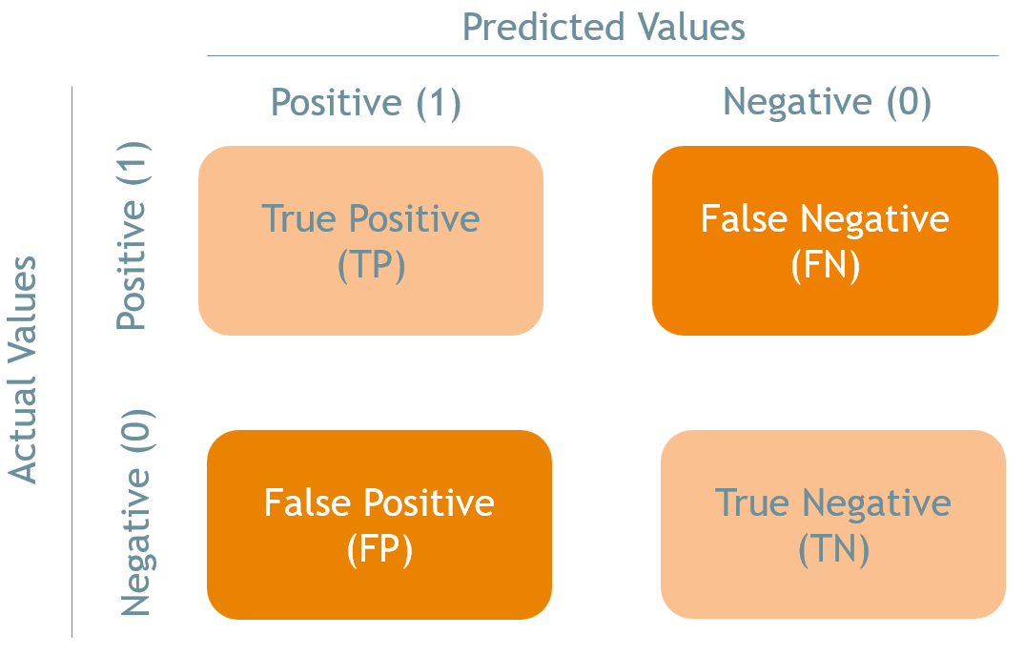
Figure 2: KPI Confusion Matrix

In the LiSa context, the systematic collection of positive and negative detection ratios—true hookings, false positives, true negatives, and false negatives—is essential to steering the system’s development toward real safety effectiveness. These metrics provide an objective measure of how reliably LiSa detects actual anchorage and detachment events during work at height, beyond nominal functionality. Minimizing false negatives is critical to avoid undetected loss of protection, while controlling false positives is necessary to prevent alarm fatigue and loss of operator trust. By monitoring these ratios across testing phases and operational scenarios, LiSa development can be guided by evidence‑based decisions on algorithm tuning, hardware refinement, and readiness for industrialization, ensuring that performance improvements translate into tangible risk reduction on site. The results will be consistent throughout the testing phase but also after to keep a constant eye on the reliability of the system through time.

  - Site Feedback and Testing
After a one year and a half developing phase, it was possible to start some field testing. As a first testing ground Karimun yard, in Indonesia, was selected. A first mission was organized with the vendor to assess issues that might have arisen using the devices in the field environment instead of the laboratory. Following this mission 20 devices have been sent to site and are currently being tested.

    - Workers’ Perception and Acceptance
From the first visit at site, it transpired that the perception of the LiSa HyperHarness among workers and site personnel reveals a technology that is viewed as highly promising but still in need of fine tuning for field use. The contributions from site HSE and Scaffolding coordinators demonstrated proactive involvement rather than explicit personal opinions, but their engagement implied a constructive and collaborative attitude at site.
Workers’ perception can be inferred from the practical issues encountered during testing and daily usage of the prototype kits. Despite the criticalities, several feedback show that demonstrations performed in the Karimun yard have been appreciated. Workers and client representatives showed interest and provided positive reactions when the harness was showcased during training and fabrication activities, confirming the system’s potential value.
Moreover, the global demonstrations organized during international events and conferences also generated strong interest and recognition for its innovative nature, with international safety leadership acknowledging that the LiSa Smart Harness represents a significant step forward in wearable safety technologies. This broader external feedback supports the idea that the harness concept is widely understood and valued, even if practical challenges persist in the field.
Taken together, these elements form a coherent narrative of how the system was first perceived on the ground. Workers recognized the potential and appreciated the innovation brought by the device, especially considering its capability to automatically monitor anchorage and enhance safety in work‑at‑height scenarios. At the same time, the slight persistence of false alarms, inconsistent powering of the units, limited robustness and connectivity issues needed some rework and improvement.

    - Technical Testing
After the first testing mission at site, many improvements have been implemented on both hardware and software. The devices have been customized to meet site requirements.
As of today, 20 HyperHarnesses are presently being tested at site as part of the final tests before industrialization. The yard HSE management plays a central role in coordinating on‑site testing, granting access to videos, supporting KPI verification and facilitating communication between the site and the technical teams. In particular, they provide access to videos used to evaluate detection performance and support the assessment of missed detections during recent trials, enabling the vendor and HSE corporate teams to extract percentages and confirm performance levels for the functioning kits.
The main points consistently raised concerned the reliability of the system in detecting real hooking events and avoiding unwanted alarms. Workers and supervisors have reported a slight rate of false positives, which disrupts workflow. This feedback was of utmost importance for KPI verification, considering that the count of false positives and false negatives is essential to evaluate the true performance of the harnesses. The system also suffered from false negatives which, although partially intentional from a technical design standpoint, still caused confusion among users who expect consistent and intuitive behavior. Additionally, connection issues with rosetta and with lifeline interfaces Is still under development due to the complex setting and basic difference with classic scaffolding tube anchorage points.
Initially, some harness kits failed to turn on entirely or required internal resets to restart, reinforcing the perception that the delivered batch must still be considered a set of prototypes rather than finalized units. However, after a couple of tuning remote sessions, and after having provided a full manual of utilization to the yard, the system started working better with many improvements all over. To set this issue completely, another vendor site visit has been organized to train the workers on usage and finetune the last characteristics.
Quantitative assessment activities carried out with the support of Management, IT and HSE site teams led to an extraction of percentages of missed detections from the videos.

  - Results
Since the release of the last version of the prototype, many on site tests have been conducted on the system, trying to identify possible flaws in both software and hardware.
Here below in Table 1 are the preliminary test’s results.
Table 1: Preliminary results on final prototypes (R: Right hook, L: Left Hook, FP: False Positive, FN: False Negative)
Kit Nr. | Notes | Iterations | R Detached | L Detached | FP | FNR | FNL | Total | Total F | False% | Dangerous false%
1 | defective | 0 | 0 | 0 | 0 | 0 | 0 | 0 | 0
2 |  | 10 | 10 | 0 | 0 | 0 | 0 | 20 | 0 | 0 | 0
3 | defective | 5 | 3 | 2 | 2 | 1 | 0 | 10 | 3 | 30 | 20
4 |  | 11 | 11 | 0 | 0 | 1 | 0 | 22 | 1 | 5 | 9
5 | defective | 0 | 0 | 0 | 0 | 0 | 0 | 0 | 0
6 |  | 8 | 5 | 3 | 3 | 0 | 0 | 16 | 3 | 19 | 0
7 | defective | 0 | 0 | 0 | 0 | 0 | 0 | 0 | 0
8 | defective | 0 | 0 | 0 | 0 | 0 | 0 | 0 | 0
9 |  | 9 | 9 | 0 | 0 | 0 | 0 | 18 | 0 | 0 | 0
10 |  | 10 | 10 | 0 | 0 | 1 | 0 | 20 | 1 | 5 | 10
11 | defective | 7 | 0 | 7 | 7 | 0 | 1 | 14 | 8 | 57
12 |  | 12 | 10 | 2 | 2 | 0 | 0 | 24 | 2 | 8 | 0
13 |  | 9 | 9 | 0 | 0 | 0 | 0 | 18 | 0 | 0 | 0
14 | defective | 8 | 0 | 8 | 8 | 0 | 0 | 16 | 8 | 50
15 |  | 14 | 9 | 5 | 4 | 1 | 0 | 28 | 5 | 18 | 7
16 |  | 10 | 10 | 0 | 0 | 0 | 0 | 20 | 0 | 0 | 0
17 |  | 14 | 9 | 5 | 4 | 0 | 1 | 28 | 5 | 18 | 7
18 | defective | 0 | 0 | 0 | 0 | 0 | 0 | 0 | 0
19 | defective | 11 | 2 | 9 | 9 | 0 | 0 | 22 | 9 | 41
20 | defective | 0 | 0 | 0 | 0 | 0 | 0 | 0 | 0

As shown in the table above, the test highlighted defective equipment in which some of the components weren’t properly working. These kits will be put aside for the next testing phase which will concentrate on the working ones (6 out of 20).
The working devices, considering that they are still final prototypes, showed good results on both False Positive and Negative rate, staying well below 20%. This consideration is especially true when looking at potentially dangerous false negatives, which occur when a worker detaches and the system can’t detect it, meaning that the worker might be exposed to dangerous falls. This value never went over 10% failure.
From a hardware point of view, the results have been in line with feedback from the first site visits and appear to be suitable for usage in harsh environments.
Taking this first testing phase as a starting benchmark, the devices were brought back to the laboratory to be modified and salvaged to ensure that the functioning parts from defective devices were recycled.
After a month, a new official phase of product testing was brought on. The results shall be found in Table 2 and 3.
Table 2: First official testing - day 1 results (R: Right hook, L: Left Hook, FP: False Positive, FN: False Negative)
Kit Name | Notes | Iterations | FPR | FPL | FNR | FNL | Total F | FP% | FN%
A |  | 100 | 0 | 0 | 0 | 2 | 2 | 0 | 2
B |  | 100 | 1 | 7 | 0 | 1 | 9 | 8 | 1
C |  | 100 | 6 | 6 | 1 | 2 | 15 | 12 | 3
D |  | 100 | 16 | 14 | 0 | 0 | 30 | 30 | 0
E |  | 100 | 7 | 8 | 3 | 3 | 21 | 15 | 6
F |  | 100 | 5 | 9 | 2 | 5 | 3 | 14 | 8
G |  | 100 | 7 | 7 | 0 | 0 | 14 | 14 | 0
H |  | 100 | 16 | 12 | 2 | 0 | 30 | 28 | 2
I | Defective | 100 | 15 | 23 | 0 | 2 | 40 | 38 | 2
L |  | 100 | 7 | 4 | 0 | 0 | 11 | 11 | 0

Table 3: First official testing - day 2 results (R: Right hook, L: Left Hook, FP: False Positive, FN: False Negative)
Kit Name | Notes | Iterations | FPR | FPL | FNR | FNL | Total F | FP% | FN%
A |  | 100 | 8 | 14 | 3 | 3 | 28 | 22 | 6
B |  | 100 | 5 | 8 | 1 | 1 | 15 | 13 | 2
C |  | 100 | 2 | 2 | 3 | 1 | 8 | 4 | 9
D |  | 100 | 3 | 1 | 0 | 1 | 5 | 4 | 1
E |  | 100 | 5 | 6 | 5 | 3 | 19 | 11 | 8
F |  | 100 | 20 | 18 | 3 | 0 | 41 | 38 | 3
G | Broken during testing | 77 | 0 | 0 | 0 | 0 | 0 | 0 | 0
H |  | 100 | 3 | 4 | 0 | 0 | 7 | 7 | 0
I | Not tested | 0 | 0 | 0 | 0 | 0 | 0 | 0 | 0
L |  | 100 | 6 | 7 | 2 | 1 | 16 | 13 | 3

The results were much more satisfying than the prototype testing, showing, on average, lower percentages of false positives and negatives. With few exceptions, the False positive rate stayed well below the 20% threshold, while in almost all devices the dangerous False negative rate stayed under 5%.
Excluding Kit G, broken during testing, and Kit I, defective, all other kits gave quite good and consistent results.
To corroborate the results, the kits were given to actual scaffolders during a simulated activity of building and dismantling a scaffold structure. Table 4 shows the results of this test.
Table 4: First official testing - scaffolding activities results (R: Right hook, L: Left Hook, FP: False Positive, FN: False Negative)
Kit Name | Notes | Iterations | FPR | FPL | FNR | FNL | Total F | FP% | FN%
B |  | 28 | 6 | 4 | 2 | 3 | 15 | 36 | 18
C |  | 13 | 2 | 1 | 0 | 1 | 4 | 23 | 8

The test showed a higher rate in both positives and negatives, while maintaining a certain degree of confidence. The scaffolders’ high dexterity connected to their experience in using the harness might have influenced the results, urging for some more fine tuning.
After another period of laboratory reworking, the devices were taken again on site for one final round of testing.
Considering the issues encountered during the first official testing, the devices were directly given to scaffolders to ensure that the testing would be brought on in the most realistic conditions. Table 5 and 6 gather the results.
Table 5: Second official testing - day 1 results (R: Right hook, L: Left Hook, FP: False Positive, FN: False Negative)
Kit Name | Notes | Iterations | FPR | FPL | FNR | FNL | Total F | FP% | FN%
D |  | 30 | 1 | 1 | 0 | 1 | 3 | 7 | 3
G |  | 30 | 2 | 3 | 0 | 0 | 5 | 17 | 0
H |  | 30 | 1 | 2 | 1 | 1 | 5 | 10 | 7
I |  | 30 | 2 | 2 | 0 | 0 | 4 | 13 | 0
M |  | 30 | 0 | 1 | 0 | 0 | 1 | 3 | 0
N |  | 30 | 1 | 2 | 0 | 1 | 4 | 10 | 3
O |  | 30 | 1 | 3 | 1 | 1 | 6 | 13 | 7
P |  | 30 | 1 | 2 | 0 | 0 | 3 | 10 | 0
Q |  | 30 | 2 | 0 | 0 | 0 | 2 | 7 | 0
S |  | 30 | 1 | 1 | 0 | 0 | 2 | 7 | 0

Table 6: Second official testing - day 2 results (R: Right hook, L: Left Hook, FP: False Positive, FN: False Negative)
Kit Name | Notes | Iterations | FPR | FPL | FNR | FNL | Total F | FP% | FN%
D |  | 100 | 11 | 7 | 12 | 11 | 41 | 18 | 23
G |  | 100 | 7 | 2 | 6 | 2 | 17 | 9 | 8
H |  | 100 | 4 | 1 | 2 | 2 | 9 | 5 | 4
I |  | 100 | 6 | 4 | 0 | 0 | 10 | 10 | 0
M |  | 100 | 4 | 1 | 3 | 4 | 12 | 5 | 7
N | Welding activities | 100 | 20 | 24 | 22 | 22 | 88 | 44 | 44
O |  | 100 | 1 | 3 | 2 | 3 | 9 | 4 | 5
P |  | 100 | 6 | 7 | 2 | 2 | 17 | 13 | 4
Q |  | 100 | 1 | 1 | 5 | 5 | 12 | 2 | 10
S |  | 100 | 7 | 3 | 6 | 5 | 21 | 10 | 11

These final days of testing show a great general improvement with False positives generally below 15% and false negatives mostly below 5%.
Kit N showed a strong deviance compared to the other devices probably due to some welding activities in the testing area. Strong welding devices greatly influence the magnetic field.

  - Conclusions

Overall, LiSa HyperHarness demonstrates the feasibility of a modular, certification-preserving smart fall-protection system that integrates context-aware activation with continuous tie-off verification and the computation of leading exposure indicators (fall factor and height-to-ground). Early field testing highlights a key engineering lesson: in metallic, scaffold-dense environments, reliability and user acceptance are dominated by the balance between sensitivity (missed detections) and nuisance alarms (false positives), implying that safety IoT devices must be designed with measurable performance targets and iterative tuning loops supported by operational data (videos, logs, dashboards) rather than being treated as static PPE add-ons.
Across the preliminary on-site campaign, a non-negligible share of kits (14/20) was identified as defective and excluded from KPI assessment; for the functioning devices (6/20), both false positives and false negatives generally remained below 20%, while safety-critical missed detections (“dangerous” false negatives occurring during actual detachment) did not exceed 10%. Following laboratory rework and the first official testing, performance improved further: with limited exceptions linked to defective or broken units, false positive rates were typically below the 20% threshold and dangerous false negatives were mostly below 5%. A subsequent scaffolding activity test, performed with experienced scaffolders, showed higher error rates than laboratory-style trials, indicating the importance of validating algorithms under realistic, high-dexterity work sequences; nevertheless, the final test round confirmed a net improvement trend, with false positives generally below 15% and false negatives mostly below 5%. Deviations observed during welding activities (kit N) also highlighted sensitivity to local electromagnetic disturbances and the need for dedicated mitigation strategies.
Taken together, these results support the use of a KPI-driven development loop as an operationally meaningful validation approach for smart PPE in harsh, scaffold-intensive environments. Further work toward industrialization will prioritize robustness to electromagnetic interference and connectivity disruptions, refinement of detection logic for edge cases (e.g., lifelines and welding areas), and a structured training and rollout model to sustain adoption and deliver measurable reductions in exposure to fall-from-height risk.
It is a shared vision between all the parties involved that the purely magnetic technology at the base of these devices has been exploited to its full potential. It would be difficult to bring down the false rates with the technology as it is now.
Therefore, future developments will focus in integrating this good base with different sensors and technologies capable of eroding the rates until they eventually reach 0%.

  - Bibliography
Adebowale O.J.; Agumba J.N.; Smart PPE and wearable technology for construction safety management: A scientometric analysis and state-of-the-art review. Archives of Environmental & Occupational Health, 2026 (online ahead of print), doi: 10.1080/19338244.2026.2655851.
Daniel E.I.; Oshodi O.S.; Nwankwo N.I.; Emuze F.A.; Chinyio E.; The Use of Digital Technologies in Construction Safety: A Systematic Review. Buildings 2025, 15(8), 1386.
Dogan O.; Akcamete A.; Detecting Falls-from-Height with Wearable Sensors and Reducing Consequences of Occupational Fall Accidents Leveraging IoT. In: Advances in Informatics and Computing in Civil and Construction Engineering, 2018, pp. 207–214.
Hartono W.; Handayani D.; Rhamadani H.C.; Analysis the Effect of Height on Work Accidents in High Rise
Building Projects E3S Web of Conferences 517, 05028 (2024).
Khan A.M.; Alrasheed K.A.; Waqar A.; Almujibah H.; Benjeddou O.; Internet of things (IoT) for safety and efficiency in construction building site operations. Scientific Reports 2024, 14, 28914.
Khan M.; Khalid R.; Anjum S.; Tran S.V.T.; Park C.; Fall prevention from scaffolding using computer vision and IoT-based monitoring. Journal of Construction Engineering and Management 2022, 148(7), 04022051.
Rey-Merchán M.C.; López-Arquillos A.; Soto-Hidalgo J.M.; Prevention of Falls from Heights in Construction Using an IoT System Based on Fuzzy Markup Language and JFML. Applied Sciences 2022, 12(12), 6057.
Rey-Merchán M.C.; Gómez-de-Gabriel J.M.; López-Arquillos A.; Fernández-Madrigal J.A.; Virtual Fence System Based on IoT Paradigm to Prevent Occupational Accidents in the Construction Sector. Int. J. Environ. Res. Public Health 2021, 18(13), 6839.
Rey-Merchán M.C.; Gómez-de-Gabriel J.M.; López-Arquillos A.; Choi, S.D. Analysis of Falls from Height Variables in Occupational Accidents. Int. J. Environ. Res. Public Health 2021,18, 13417.
Swart L; Buys T; Claassen N.; Mapping the evidence on the assessment of fitness to work at heights: a scoping review. BMJ Open 2025;15.
Zaidi S.F.A.; Yang J.; Abbas M.S.; Hussain R.; Lee D.; Park C.; Vision-Based Construction Safety Monitoring Utilizing Temporal Analysis to Reduce False Alarms. Buildings 2024, 14(6), 1878.

