 CHEMICAL ENGINEERING TRANSACTIONS  VOL. xxx, 2026 | A publication of  
The Italian Association
of Chemical Engineering
Online at www.cetjournal.it

Guest Editors: Valerio Cozzani, Bruno Fabiano, Genserik Reniers
Copyright © 2026, AIDIC Servizi S.r.l.
ISBN 979-12-81206-xx-x; ISSN 2283-9216

Proactive Environmental Risk Management: Replicable Framework for Environmental Risk Assessment during Offer Phase
Pierluigi Nunzi, Ludovica Maria Gullo*, Maria Josè Scalia
Saipem Spa, Via Luigi Russolo 5, Milano,Italy
ludovicamaria.gullo@saipem.com
In the contemporary business landscape, sustainability drivers, including climate change, stringent regulatory frameworks, and evolving stakeholder expectations, have fundamentally redefined the risk profile of the industrial sectors. Identifying risk drivers and establishing robust mitigation measures is no longer merely an operational task but a strategic necessity. This paper illustrates Saipem’s proactive approach to embedding environmental sustainability into its decision-making processes through a standardized and highly replicable methodology applied during the bid approval stage. The core of this approach is to transition environmental risk management from a reactive, project-specific monitoring activity to a high-level strategic de-risking tool.
The methodology identifies and assesses five key environmental aspects: Scope 1 and 2 greenhouse gas emissions, water withdrawal, biodiversity conservation, and waste management. It provides a structured and consistent assessment of distinct environmental risk dimensions, enabling a clear and transparent understanding of individual environmental risks to support strategic decision‑making. To ensure objectivity and global replicability, the framework integrates project-specific technical data with internationally recognized environmental databases.
  - Nomenclature
CSRD Corporate Sustainability Reporting Directive
DEFRA Department for Environment, Food and Rural Affairs (UK)
EACs Energy Attribute Certificates
EMS Environmental Management System
EMP Environmental Management Plan
EPCI Engineering, Procurement, Construction and Installation
EPI Environmental Performance Index
ESG Environmental, Social and Governance
ESIA Environmental and Social Impact Assessment
GHG Greenhouse Gas
GO Guarantees of Origin
HVO Hydrotreated Vegetable Oil
IBAT Integrated Biodiversity Assessment Tool
IEA International Energy Agency
I-RECs International Renewable Energy Certificates
KPI Key Performance Indicators
  - Introduction
Environmental risk assessment in industrial projects requires a structured and replicable methodology to ensure consistent evaluation across diverse geographical contexts and project types. This paper presents Saipem’s standardized approach applied during the bid approval stage, integrating project-specific data with internationally recognized environmental databases (Aqueduct, IBAT, Environmental Performance Index) to provide objective, quantitative, and comparable risk assessments.
Saipem’s approach to environmental risk management is further strengthened by its certified Environmental Management System (EMS), developed in alignment with international standards such as ISO 14001:2015 [1]. This framework ensures that risk assessment is rigorous, systematic, and oriented toward continuous improvement. Since 2024, this methodology has been applied to over 50 global projects, covering a broad spectrum of sectors from onshore to offshore EPCI projects, demonstrating its versatility and robustness throughout the bidding phase. This systematic evaluation acts as a bridge between commercial strategy and field operations, as the risk profiles generated can directly inform the subsequent development of Environmental Management Plans (EMP) for the projects. This ensures that mitigation commitments are transferred into the project execution stage.
By elevating environmental risk to the strategic level, Saipem ensures long-term business resilience and operational excellence. This paper demonstrates how a structured, data-driven assessment during the tender phase provides a comprehensive overview of corporate risk exposure, facilitating more precise management, and the development of efficient mitigation measures.
The methodology addresses challenges of data variability and incompleteness at the preliminary stage, balancing flexibility with standardization. It enables early identification of environmental risks and supports the development of mitigation measures and Environmental Management Plans (EMP), directly linking assessment outputs to operational planning.
  - Methodology
The methodology provides a standardized framework for assessing environmental risks relevant to a project. Each risk is evaluated using a three-level classification (low, medium, high) based on predefined criteria combining project-specific data and external datasets. Residual risk is calculated by applying standard mitigation measures and comparing inherent risk against planned interventions.
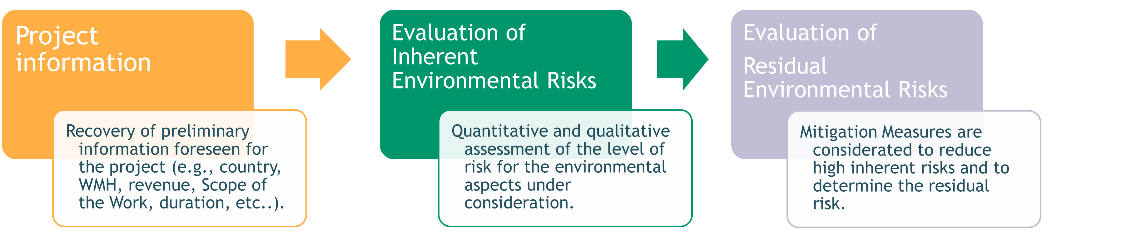
Figure 1: Environmental Risk Assessment approach
For projects outside the environmental reporting scope, the environmental risks are assigned “Not Applicable” (N/A), but the assessment is still performed to maintain traceability and ensure alignment with potential regulatory updates (e.g., CSRD). This approach ensures quantitative comparability across projects and sectors, supporting early identification of critical environmental aspects and guiding mitigation planning. The model categorizes environmental risks into four key environmental aspects: GHG emissions, water withdrawal, biodiversity conservation, and waste management.

    - Inherent risk evaluation
3.1.1 GHG Emissions Risk
GHG Emissions Risk refers to the direct (Scope 1) and indirect (Scope 2) greenhouse gas (GHG) emissions generated by project activities, which vary depending on the specific business type and operational scope. To ensure a structured and comparable assessment across different projects, annual GHG emissions are estimated as:

$$GHG_{estimation}= \frac{KPI_{BL}*V_{F}}{V_{T}}$$ | (1)
Where:
- $KPI_{BL}$ is the baseline emission intensity factor, calibrated for the specific business type, periodically updated using historical data from the last three years and, where applicable, predictive models.
- $V_{F}$ is a project financial variable (e.g., total project revenue, investment value, or operational expenditure, etc).
- $V_{T}$ is a project temporal variable (e.g., project duration in years or estimated operational lifespan, etc).
The risk is assessed by comparing estimated annual emissions against reference thresholds, set according to company scale, industry benchmarks, environmental sustainability objectives, and ESG targets.

Since many companies establish specific Scope 2 reduction targets, a detailed assessment of the GHG Scope 2 risk is essential to ensure that project planning aligns with the corporate decarbonization strategy.
GHG Emissions Scope 2 Risk is assessed based on electricity consumption and country-specific grid emission factor (EF) from IEA and DEFRA databases [2] [3].
Table 1: GHG Emissions Scope 2 Risk Classification
GHG Emissions Scope 2 Risk | EF [gCO₂/kWh] | Country energy mix
LOW | (0;100] | Mainly low-carbon sources
MEDIUM | (100;400] | Mixed energy mix
HIGH | >400 | Fossil-fuel dependent

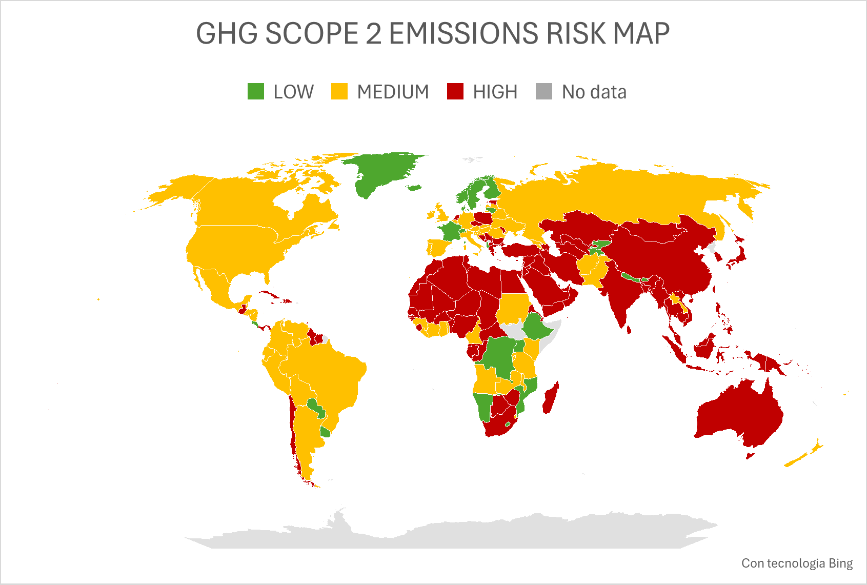 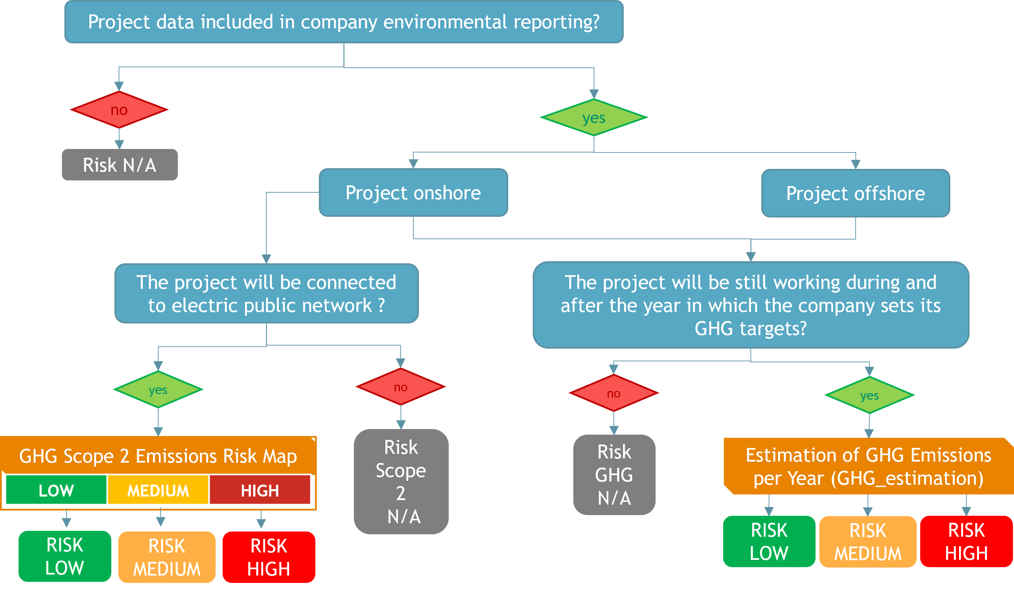Figure 2. Greenhouse gas (GHG) emissions risk assessment.
(a) Scope 2 GHG emission risk map;
(b) Project GHG (Scope 1 and 2) risk assessment flowchart.

Beyond the assessment of emissions in absolute terms at project level, a cumulative risk perspective is developed at Group level. This broader evaluation considers the aggregated impact of projected project emissions in relation to the corporate decarbonization trajectory, enabling a forward-looking understanding of overall exposure. Cumulative GHG Risk compares projected project emissions to the corporate decarbonization roadmap, supporting alignment between individual project decisions and long-term emission reduction targets.

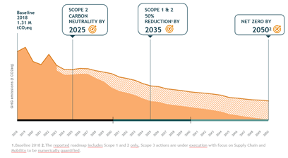
Figure 3: Saipem long-term decarbonization roadmap (issued in 2024)
The cumulative emission exposure is calculated by aggregating the existing portfolio emissions with the estimated emissions of the project under evaluation and comparing the result against the corporate decarbonization pathway. The resulting percentage represents the utilization rate of the emission capacity defined by the roadmap.
$$\%_{emission utilization}= \frac{GHG_{portfolio}+GHG_{estimation}}{GHG_{roadmap}}*100$$ | (2)
Classification thresholds allow early identification of projects requiring corrective measures.
Table 2: Cumulative GHG Emissions Risk Classification
$$GHG_{estimation}$$ | $$\%_{emission gap}$$ |  | Cumulative GHG Risk
LOW |  | ≥90% | MEDIUM
 |  | <90% | LOW
MEDIUM |  | ≥90% | HIGH
 |  | 50%-90% | MEDIUM
 |  | <50% | LOW
HIGH |  | ≥90% | HIGH
 |  | <90% | MEDIUM

3.1.2 Climate Change Mitigation Risk
This risk quantifies project exposure to climate-related regulatory and operational pressures using the Climate Change Environmental Performance Index (EPI_cc) [4]. Countries are classified based on EPI_cc scores:
Low Risk (EPI_cc < 33)
Medium Risk (33 ≤ EPI_cc < 66)
High Risk (66 ≤ EPI_cc ≤ 100).

Sector-specific weighting is applied for high-impact industries (e.g., Oil & Gas) to reflect relative exposure. The resulting score integrates country-level climate performance with project operational characteristics, enabling consistent risk comparison across projects.
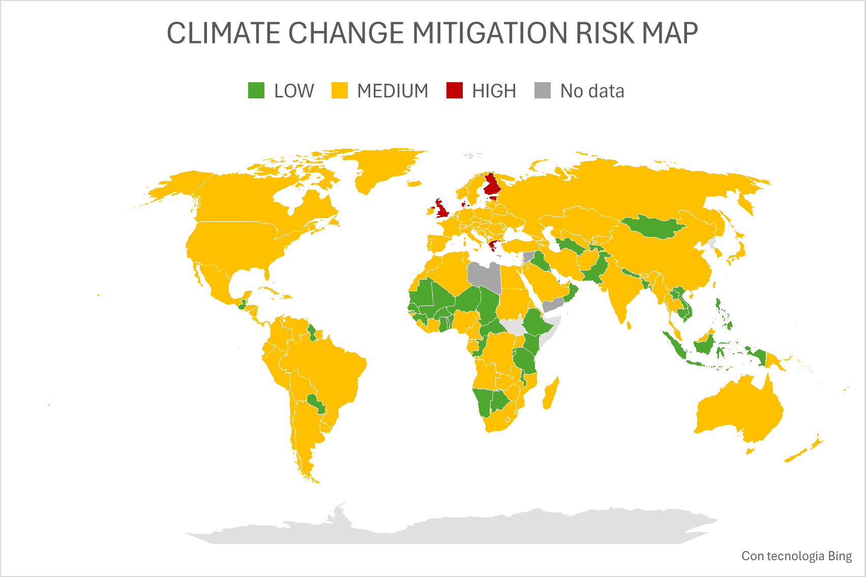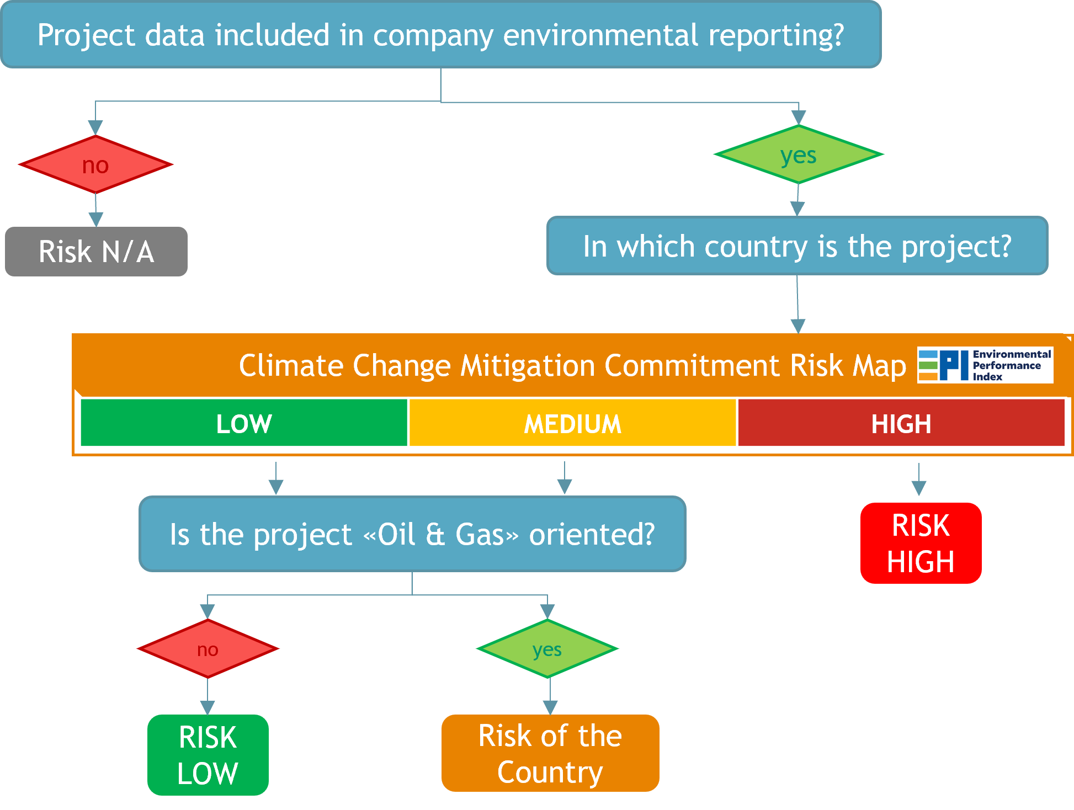
Figure 4. Climate change commitment risk assessment.
(a) Climate change commitment risk map;
(b) Climate change commitment risk assessment flowchart

3.1.3 Water Withdrawal Risk
This risk assesses potential impacts of project activities on local water resources, using project type, water demand, and country water stress as key parameters. Country water risk is obtained from the Aqueduct tool [5], and projects are classified as:
- Low Risk (Aqueduct value in the range 0–2)
- Medium Risk (Aqueduct value in the range 2–3)
- High Risk (Aqueduct value in the range 3–5).

Offshore projects generally present lower risk, except when freshwater is required (e.g., hydrotesting in stressed regions), while the use of desalination reduces the risk.

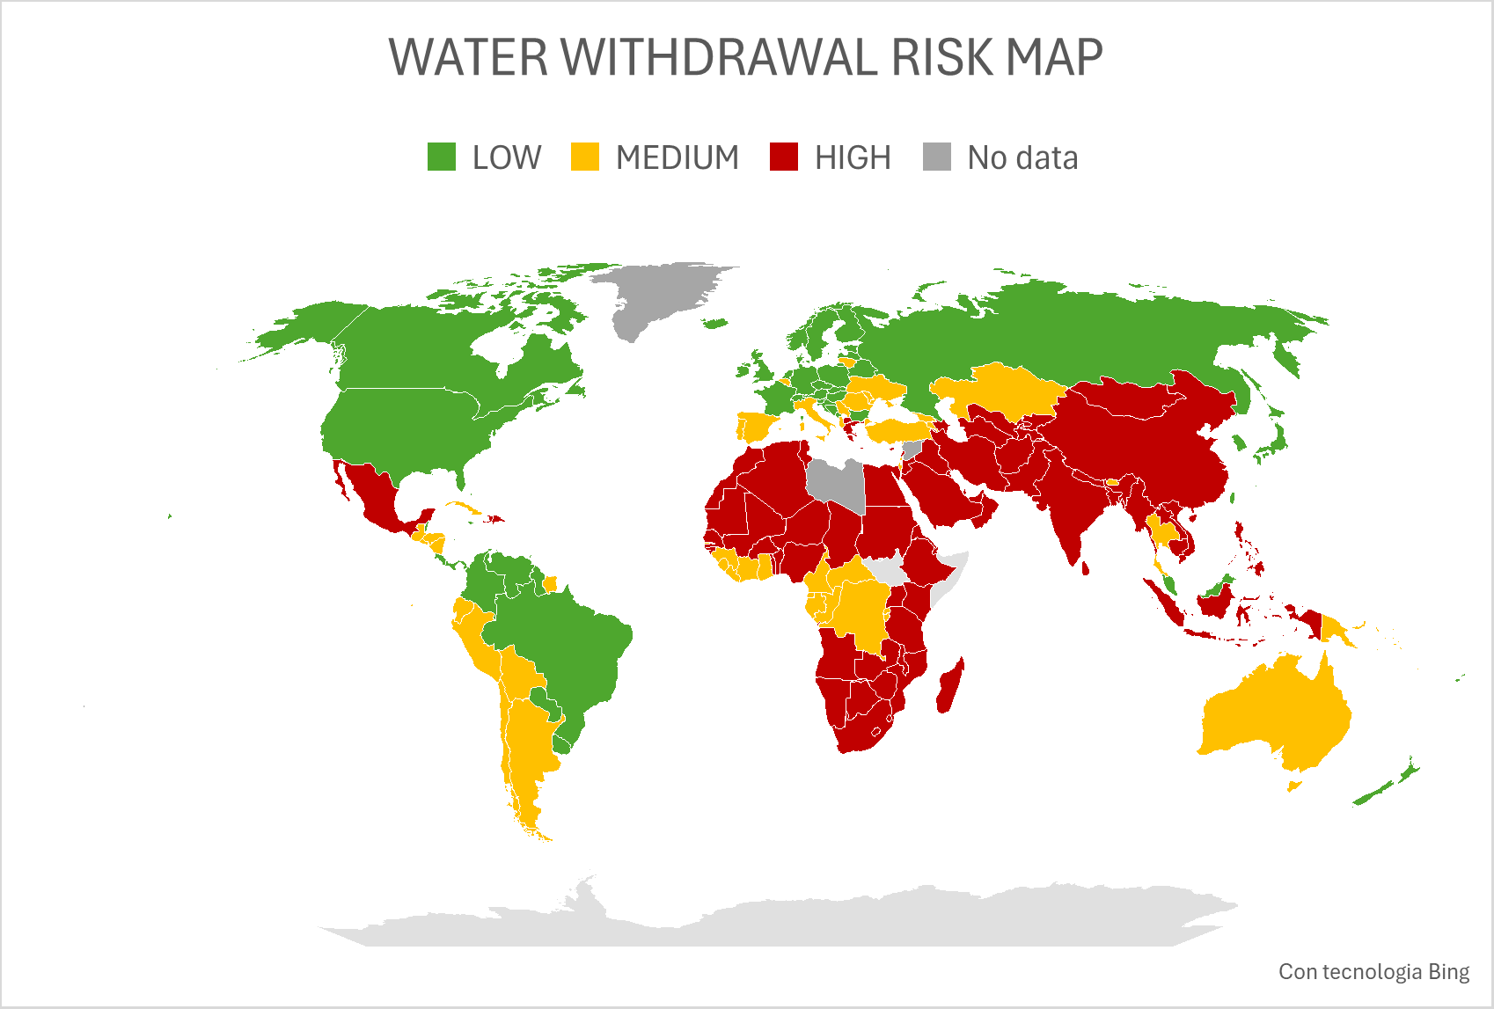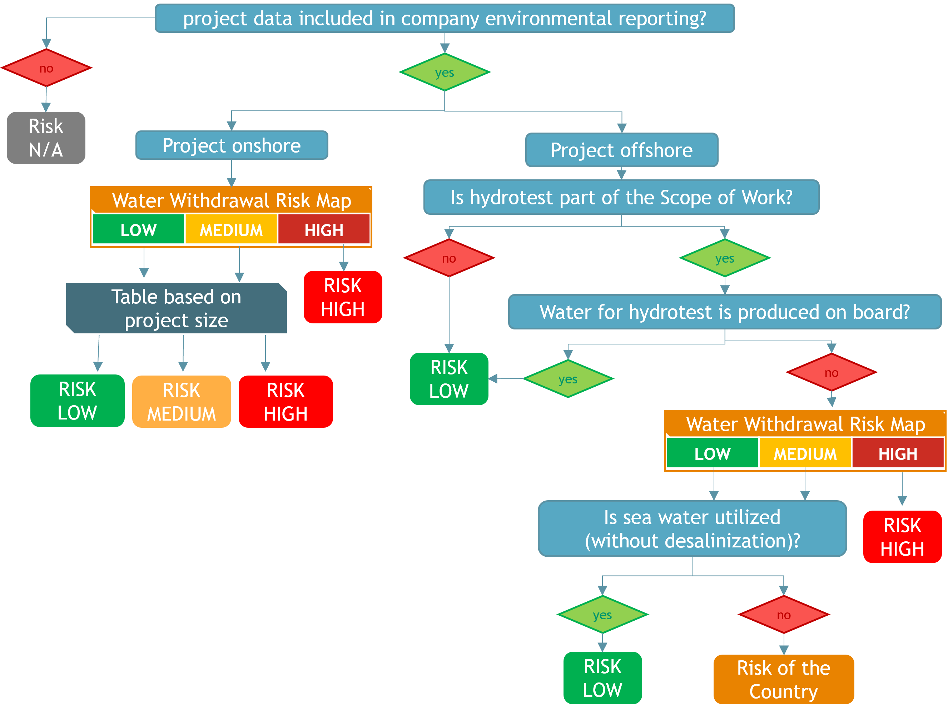
Figure 5. Water risk assessment framework.
(a) Water risk map;
(b) Water risk assessment flowchart.

3.1.4 Biodiversity Risk
This risk evaluates potential impacts on sensitive habitats, species, or ecosystems using a two-step assessment:
- Project Scope Assessment : baseline risk assigned by project type and operational characteristics. Risk baseline is assigned by project type based on experience.
- Country-Level Assessment: based on IBAT biodiversity maps [6], which quantify the share of protected or sensitive areas with the following classification:
  - For onshore projects the risk is linked to % of land in biodiversity-sensitive zones: Low Risk (0–10%), Medium Risk (10–25%), High Risk (25–100%).
  - For offshore projects the risk is linked to % of territorial waters under protection: Low Risk (0–1%), Medium Risk (1–10%), High Risk (10–100%).
  - For projects that span both onshore and offshore domains, the higher risk level between the two is conservatively applied.
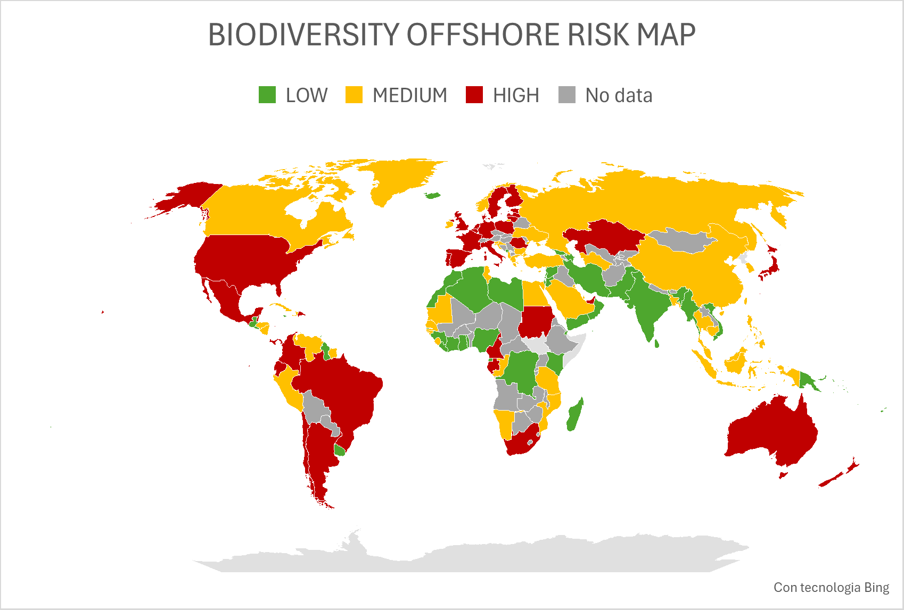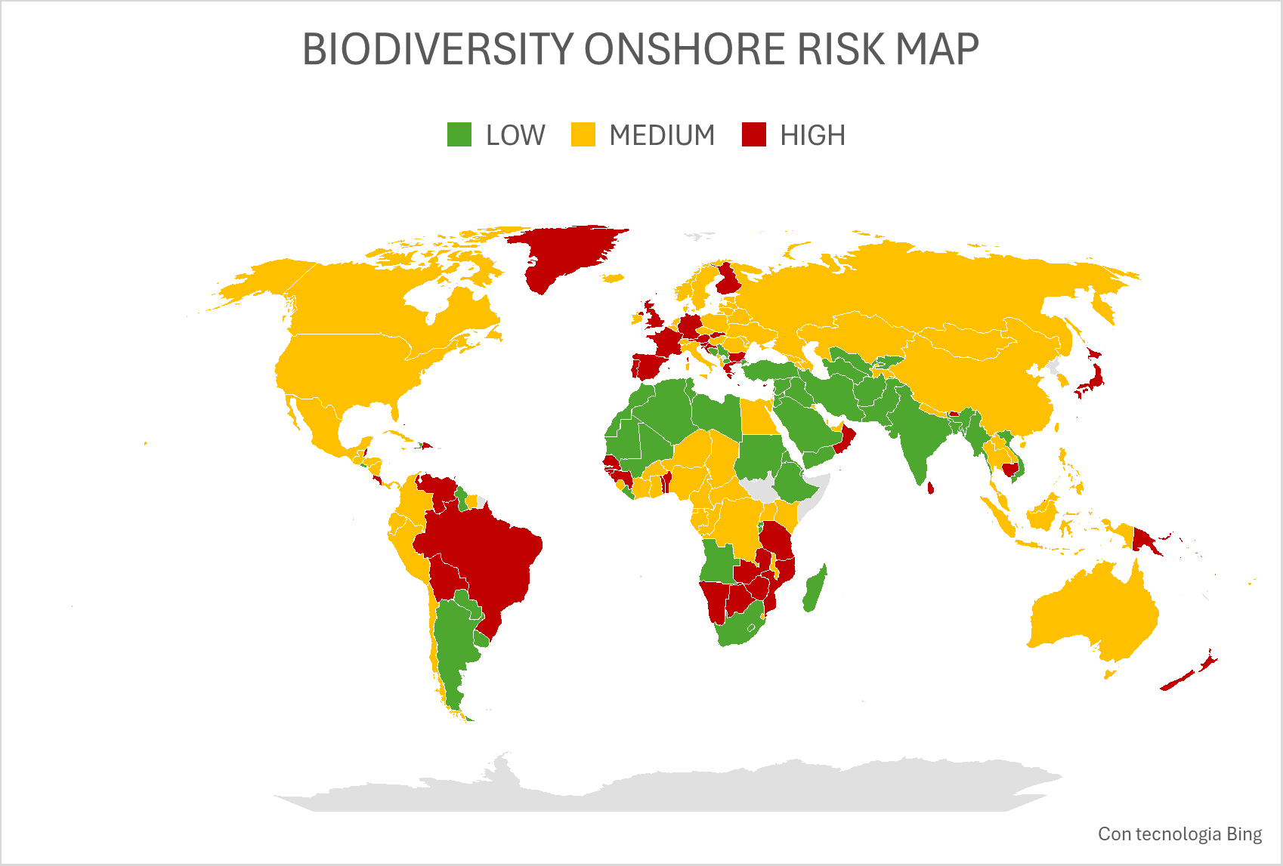
Figure 6. Biodiversity risk mapping.
(a) Offshore biodiversity risk map;
(b) Onshore biodiversity risk map.

Once both assessments are completed, the final biodiversity risk level is determined conservatively by adopting the higher of the two risk levels in line with a conservative approach. If an ESIA is available and indicates protected or sensitive areas the biodiversity conservation risk is automatically classified as “High Risk”.

3.1.5 Waste Risk
Waste risk is evaluated using project type and country-level Waste Management EPI [4]. Risk classification thresholds are:
- Low Risk (<44)
- Medium Risk (44–64)
High Risk (>64).
In reference to EPI values, the score is subject to an inversion: higher EPI scores indicate better performance in the EPI benchmark; therefore, values are inverted so that higher risk corresponds to a higher risk score, consistent with other environmental country risk indicators. As reported in the flowchart, for offshore projects the risk is based on the disposal country corresponding to the project location, while projects in high-risk countries are automatically classified as High; in medium/low-risk countries, project size or remoteness is considered.

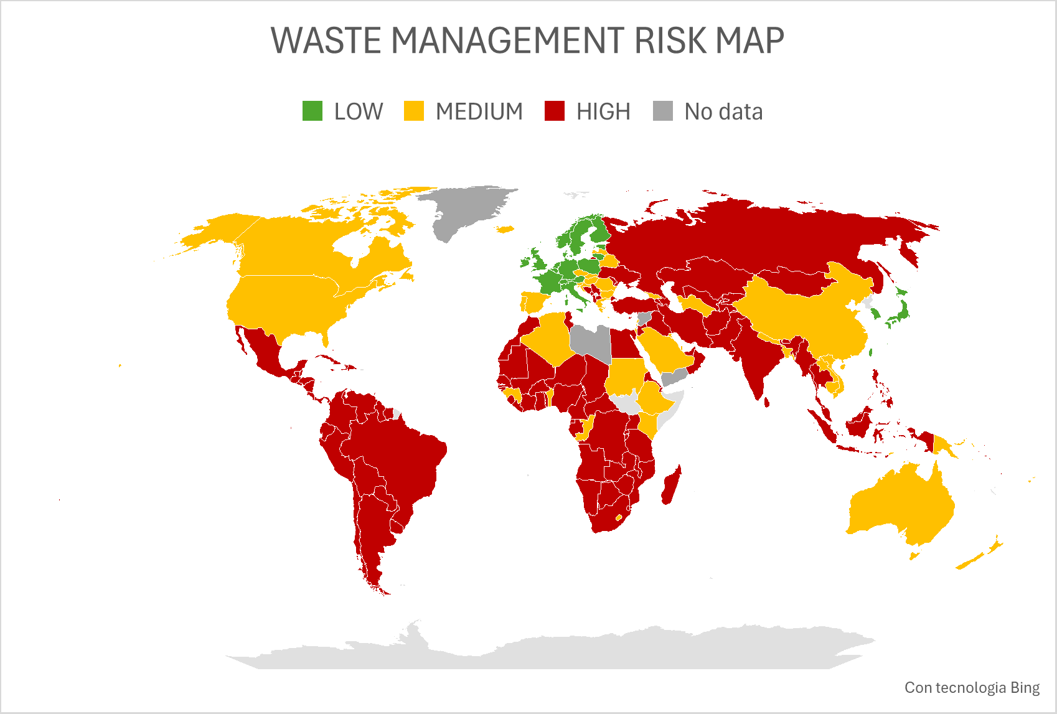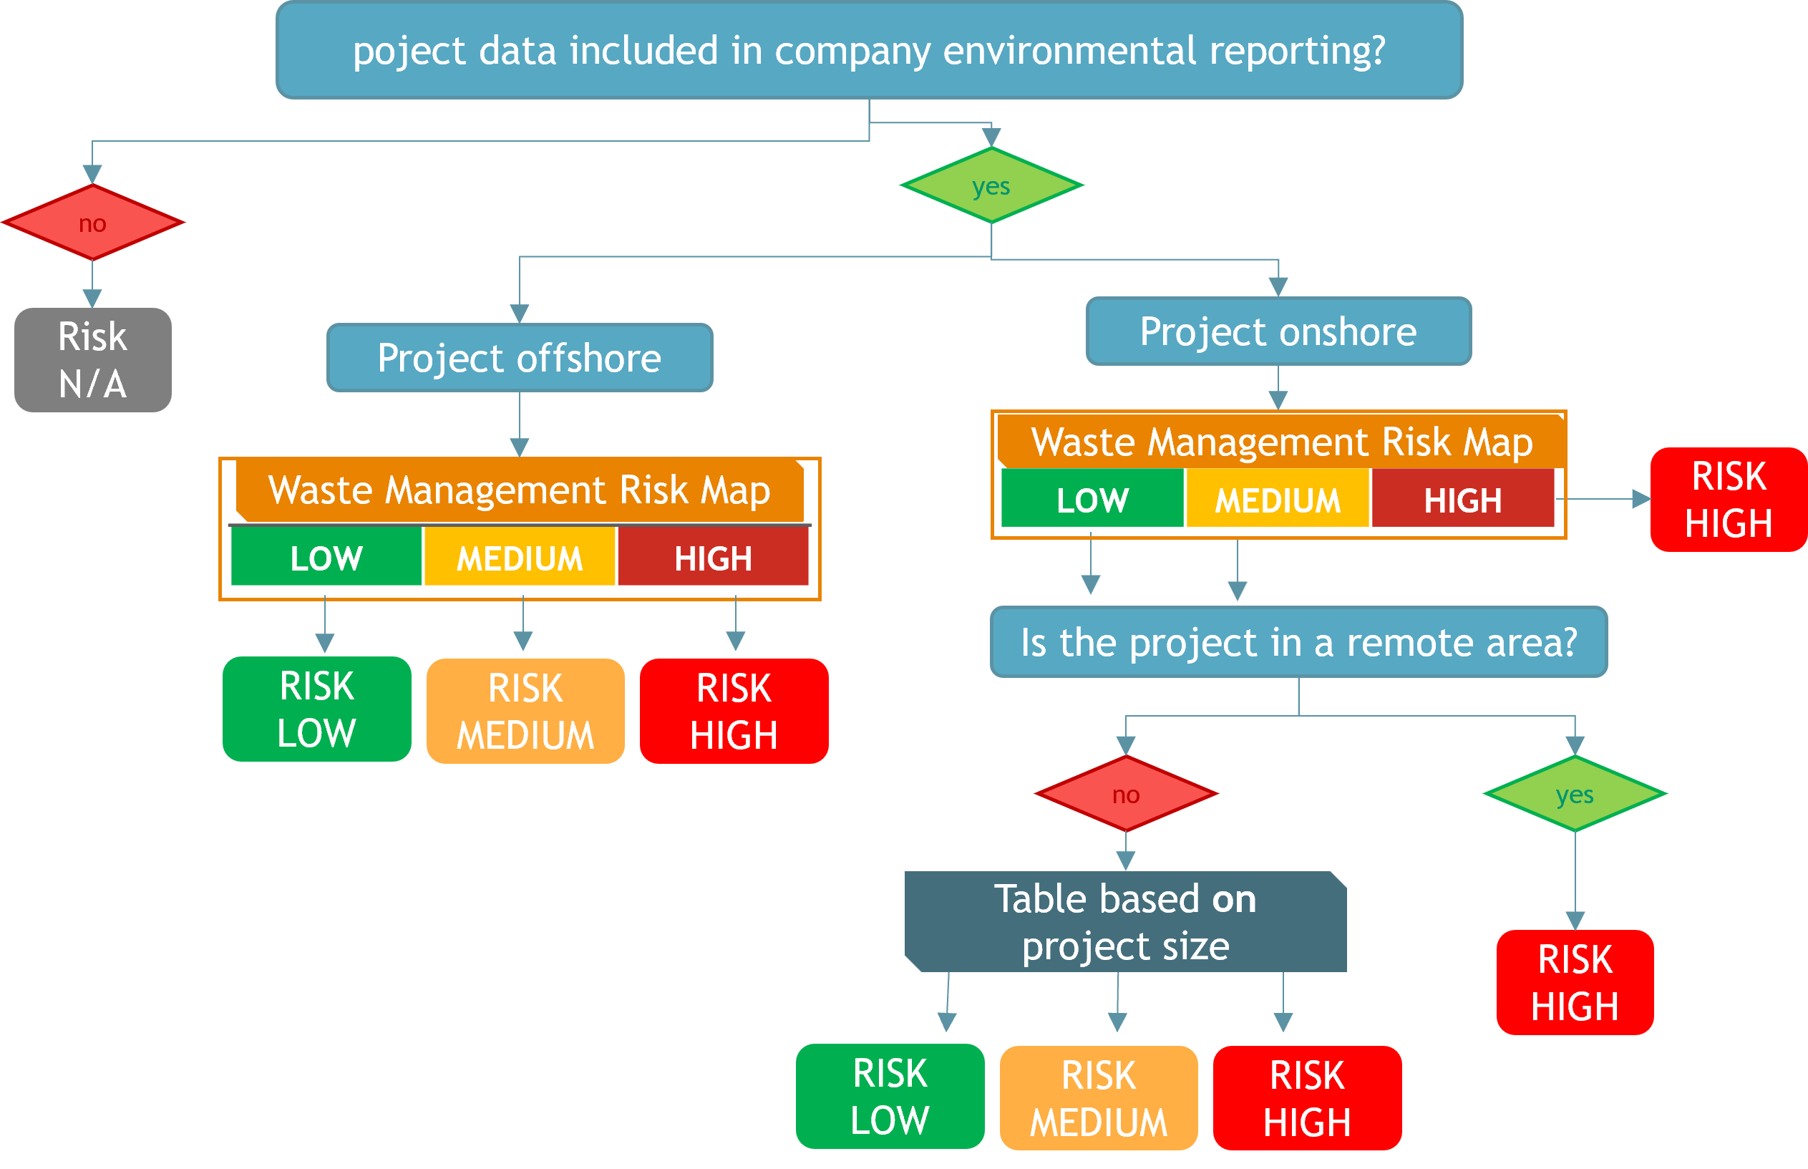
Figure 7. Waste risk assessment.
(a) Waste risk map;
(b) Waste risk assessment flowchart.

    - Residual risk evaluation
For each environmental aspect, residual risk is calculated by evaluating a set of standard mitigation measures classified as planned, not planned, or not applicable. Only applicable measures are considered in the calculation: planned measures are assigned a value of 1, not planned measures a value of 0, while not applicable measures are excluded from the denominator. If ≥65% of applicable measures are planned, the residual risk is reduced by one level from the inherent risk. Example mitigation measures by environmental aspect are provided in Table 3.
Table 3: Mitigation Measures
Risk | Mitigation Measure
GHG  Emissions  Risk  (Scope 1) | Adoption of low-carbon fuels (e.g., Hydrotreated Vegetable Oil - HVO).
GHG  Emissions  Risk  (Scope 1) | Optimization of power generation systems (e.g., efficient generators, hybrid solutions).
GHG  Emissions  Risk  (Scope 1) | Integration of on-site renewable energy (e.g., solar panels, wind turbines).
GHG  Emissions  Risk  (Scope 1) | Energy efficiency measures (e.g., high-efficiency accommodation camps)
GHG  Emissions  Risk  (Scope 1) | Adoption of low-emission vehicles and machinery.
GHG  Emissions  Risk  (Scope 1) | Other initiatives planned.
GHG  Emissions  Risk  (Scope 2) | Connection of accommodation camps and facilities to the electrical grid where feasible.  Implementation of on-site renewable energy sources.  Procurement of certified renewable energy through Energy Attribute Certificates (EACs) such as I-RECs or Guarantees of Origin.  Long-term agreements to ensure continuous supply of certified renewable energy.  Energy efficiency measures (e.g. LED lighting)  Other initiatives planned.
Water | Installation of on-site wastewater treatment systems to reduce discharge impacts.  Implementation of water reuse systems for dust suppression, irrigation, and hydro-tests.  Utilization of desalination plants for freshwater production instead of relying on groundwater or public water supplies.  Deployment of water-makers for drinking water to reduce plastic bottle consumption.  Use of water-saving devices (e.g., tap aerators, dual-flush toilets,).  Other project-specific water conservation measures.
Biodiversity | Implementation of habitat restoration initiatives.  Conservation programs for local flora and fauna.  Establishment of biodiversity monitoring programs.  Use of micro-tunneling techniques to minimize surface and ecosystem disturbances.  Avoidance of construction activities in sensitive ecological areas.  Other biodiversity protection initiatives.
Waste | Establishment of on-site waste treatment facilities.  Implementation of waste segregation and recycling programs.  Development of agreements with third parties for waste recycling to minimize landfill disposal.  Promotion of waste-to-energy initiatives.  Reusable materials and sustainable procurement policies.  Other initiatives.
Conclusion
By integrating quantitative and qualitative indicators, project-specific data, and international environmental benchmarks, the methodology enables early identification of key environmental risks before project initiation. This early-stage assessment allows for timely planning of mitigation measures, ensures consistency and comparability across diverse project types and geographical contexts, and supports the structured development of Environmental Management Plans (EMP).
Overall, the methodology provides a systematic, replicable, and proactive tool for managing environmental risks, enhancing project planning accuracy and operational readiness while ensuring alignment with global environmental standards.
References
[1] ISO 14001:2015 – Environmental Management Systems.
[2] International Energy Agency (IEA) – Emission Factor Database.
[3] UK Department for Environment, Food & Rural Affairs (DEFRA) – Emission Factors Database.
[4] Yale Center for Environmental Law & Policy (2024) – Environmental Performance Index.
[5] World Resources Institute (2023) – Aqueduct 4.0 Water Risk Indicators.
[6] Integrated Biodiversity Assessment Tool (IBAT) Database.

