 CHEMICAL ENGINEERING TRANSACTIONS  VOL. xxx, 2026 | A publication of  
The Italian Association
of Chemical Engineering
Online at www.cetjournal.it

Guest Editors: Valerio Cozzani, Bruno Fabiano, Genserik Reniers
Copyright © 2026, AIDIC Servizi S.r.l.
ISBN 979-12-81206-xx-x; ISSN 2283-9216

Psychophysiological Assessment of Acute Stress in Control Room Operators During Cyberattack Conditions
Anthony A. Adeboboye*, Chidera W. Amazu, Gabriele Baldissone, Micaela Demichela
Politecnico di Torino, Corso Duca degli Abruzzi 24, 10129, Turin, Italy
anthony.adeboboye@polito.it
Stress, from a medical perspective, is a state of mental tension or physiological and psychological strain caused by difficult situations, triggering neuroendocrine and autonomic responses aimed at maintaining homeostasis. However, individual stress responses vary significantly and can have a profound impact on both overall well-being and work outcomes. In process control rooms, different factors (e.g. management of change, faults, system design, etc.) pose a critical threat not only to system integrity but also to the human operators responsible for maintaining safety and facilitating system recovery. In the future, one of the most important critical factors for control room operators can be expected to be the presence of cyber-attacks. Such incidents impose acute psychological, cognitive, behavioural, and physiological demands on operators, potentially degrading decision-making, situational awareness, and operational efficiency. This paper examines the psychophysiological effects of acute stress experienced by control room operators during a simulated cyberattack scenario. Specifically, it investigates the psychological and physiological responses elicited under acute stress conditions and evaluates their impact on operator performance during cyber incident management. The stressor employed involves a controlled cyberattack scenario targeting operators within a simulated control room environment. Stress responses are assessed using a multimodal approach that includes objective performance measures, subjective participant reports, and physiological biomarkers such as heart rate (HR), heart rate variability (HRV), blood pressure (BP), and respiratory rate (RR). The findings aim to provide insight into stress-induced performance degradation and inform the development of effective stress assessment.

Keywords: psychophysiology, acute stress, stressor, HRV, BP, respiratory rate, cybersecurity, control room, cyberattacks.
  - Introduction
As internet use and the connectedness of systems increase, cybercrime grows right alongside it, and the psychological impact is way bigger than most people realise. A considerable amount of research has been devoted to cyberattacks in control rooms. However, little is known about the psychophysiological effects of the cyber-attacks on the control room operators and the eventual process outcome. This conceptual paper aims to explore how exposure to cyber-attacks impacts the psychological state (particularly acute stress) and physiological responses (e.g., heart rate variability, respiratory rate, heart rate, etc) of control room operators. Furthermore, the study seeks to determine how these psychophysiological changes affect decision-making, response time, error rates, and overall process performance within the control room. By analysing operator responses under controlled simulated cyber-attack conditions, the research intends to better understand the human factor vulnerabilities in cyber-physical systems.
Heart Rate (HR), Heart Rate Variability (HRV), Blood Pressure (BP), and Respiratory Rate (RR) provide an objective, multimodal window into the operator's Autonomic Nervous System (ANS) during a cyber-attack. While HR and BP serve as primary indicators of sympathetic "fight-or-flight" activation, a quantitative decrease in HRV represents the most sensitive biomarker for cognitive load and reduced psychological resilience. Monitoring the evolution of these markers from a stable baseline to a stressed state is critical for identifying biometric thresholds where acute stress begins to impair decision-making and increase error rates. By quantifying these physiological shifts, this research moves beyond subjective reporting to establish an evidence-based link between systemic cyber-threats and the human operator's functional capacity, directly supporting the "human-centric" safety requirements of the EU legislative framework.
Significantly, this conceptual paper aligns with the EU legislative framework, which mandates the protection of workers from psychosocial risks. Under the Council Directive 89/391/EEC (the "Framework Directive"), employers have a legal obligation to ensure the health and safety of workers in every aspect related to work, including the assessment and prevention of occupational stress (Council of the European Communities, 1989, Art. 3). This is further reinforced by the European Framework Agreement on Work-related Stress (2004), which identifies the need for systematic evaluation of stressors that can affect mental health and operational safety (European Social Partners, 2004). By investigating the acute stress triggered by cyber-threats, this study contributes to the development of evidence-based risk assessment protocols required by these European standards, ensuring that "security-by-design" includes the psychological resilience of the human operator.

  - Theoretical Framework
Stress, from a medical perspective, is a state of mental tension or physiological and psychological strain caused by difficult situations, triggering neuroendocrine and autonomic responses aimed at maintaining homeostasis (World Health Organisation, 2023). Stress can be further classified as chronic or acute. Chronic stress involves prolonged disruption of homeostasis and is associated with lasting behavioural changes and negative health outcomes. Chronic stress can persist even when no acute stressors are present.
Acute stress, on the other hand, is the body’s quick reaction to a sudden challenge or threat. It activates the “fight or flight” response, releasing hormones like adrenaline and cortisol that temporarily help the body react and cope. Acute stress arises from short-term external stressors such as time pressure, urgency, and concern about outcomes, and it can impair physical functioning, cognitive processes, and overall performance.
Stephenson et al. (2022) report that acute stress negatively impacts the prefrontal cortex (PFC), thereby impairing core executive functions, which are considered higher-order cognitive processes. These functions include working memory, cognitive flexibility, and inhibitory control, with inhibitory control being the most affected by psychosocial stress. Cognitive overload can further contribute to a deterioration in tactical performance, for example, during an intervention in control rooms. Such impairments are often driven by two key stressors that affect decision-making: time pressure and information overload (Phillips-Wren & Adya, 2020). Likewise, during a cyberattack, events often unfold suddenly and, in some cases, generate alarm floods, placing the response team under a state of acute stress. At such points, intense time pressure (from the urgency to stop any form of cyber-attack) heightens stress, potentially impairing judgment and response quality. This can be further understood with Lazarus and Folkman’s Psychological Stress and Coping theory (Lazarus and Folkman, 1984). The theory clarifies that stress is a relationship between humans and their environment. Essentially, the individual’s appraisal of what is happening in the event of an attack, and external factors like available time or the number of alarms, can increase the demand posed and result in increased stress levels.
For control room operators, in such cyber-attack scenarios, these stressors can significantly complicate the operators’ situational awareness and decision-making capability to stabilise a plant process or keep it in a safe state, thereby resulting in potentially catastrophic consequences. Beyond the impact of situational awareness and decision making, the operators’ overall physiology is in question. The human body, and as such, the operators’, respond to acute stress in various ways, with different organs exhibiting distinct physiological reactions. The image in Figure 1 illustrates these diverse physiological responses as applicable to the control room operator during an attack scenario.

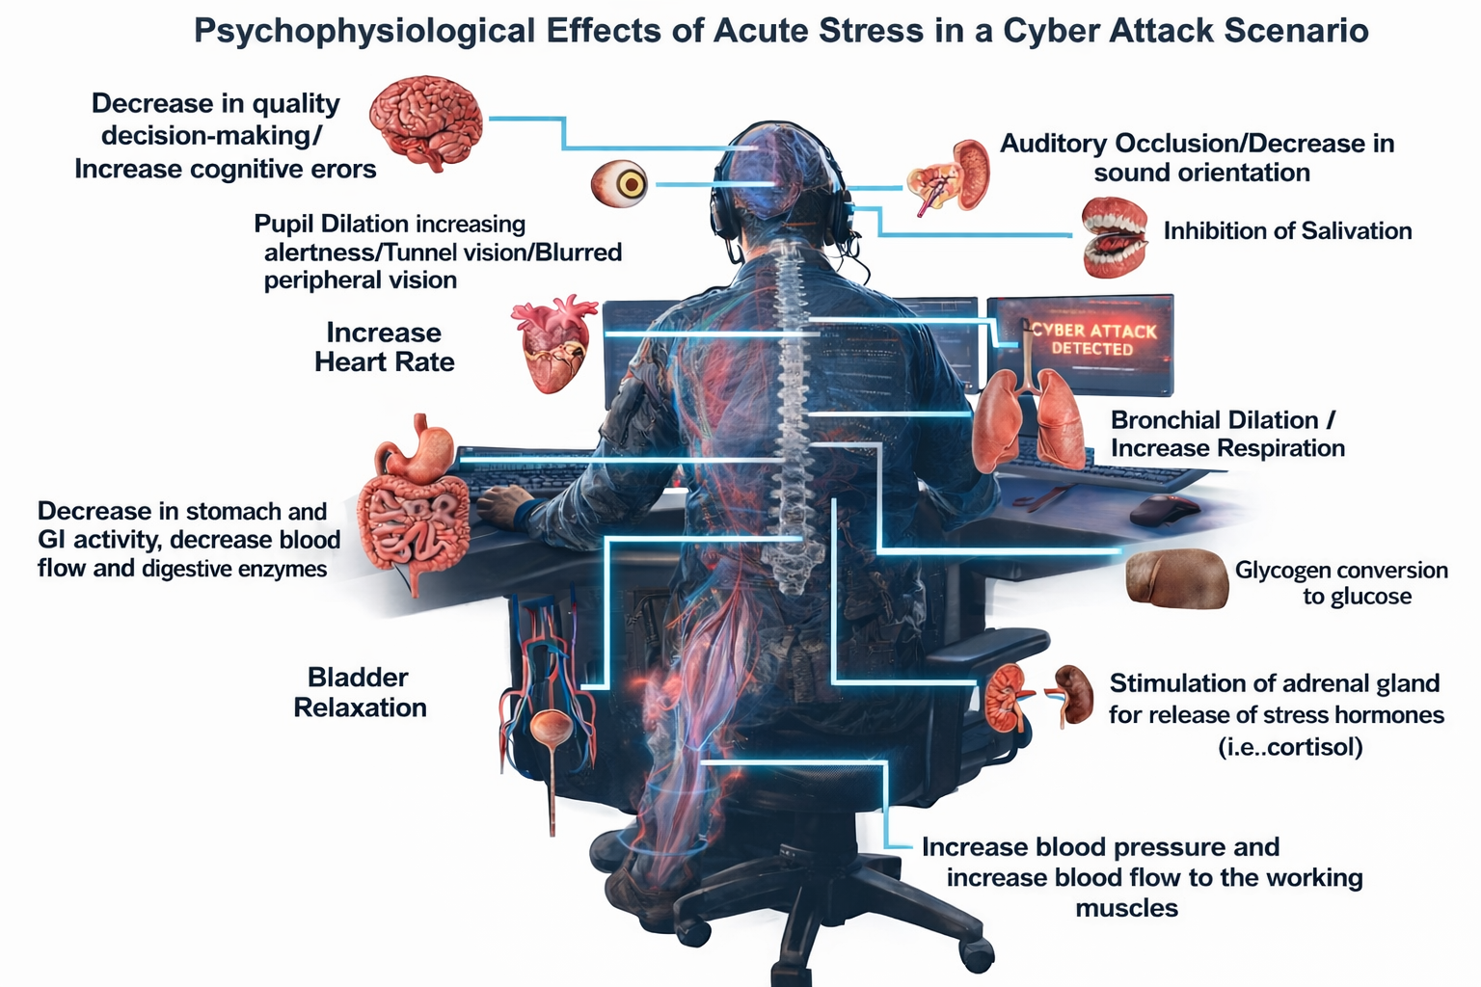
Figure 1: Psychophysiological Effects of Acute Stress on a Control Room Operator During a Cyber Attack (Various Organ responses). Image concept adapted from Stephenson et al., 2022.
  - Method
    - Context
The study is to be carried out in Politecnico di Torino, Italy, with engineering students and staff as participants. To be more realistic, three process scenarios of a formaldehyde production facility (similarly used by Amazu et al. 2025, see Figure 2) are designed, where operators are to monitor the process, deal with alarms and intervene as required. In addition, a sudden cyber-attack is introduced twice during each scenario. The attack simulated for each case is a Man-in-the-Middle (MITM) attack where an attacker alters process parameters to set them high or low at different points during each scenario. Given that this attack involves operational technology and is aimed at confusing the operator using the interface display, this experimental study further observes operators’ ability to identify and respond promptly, in addition to studying the potential effect on stress.

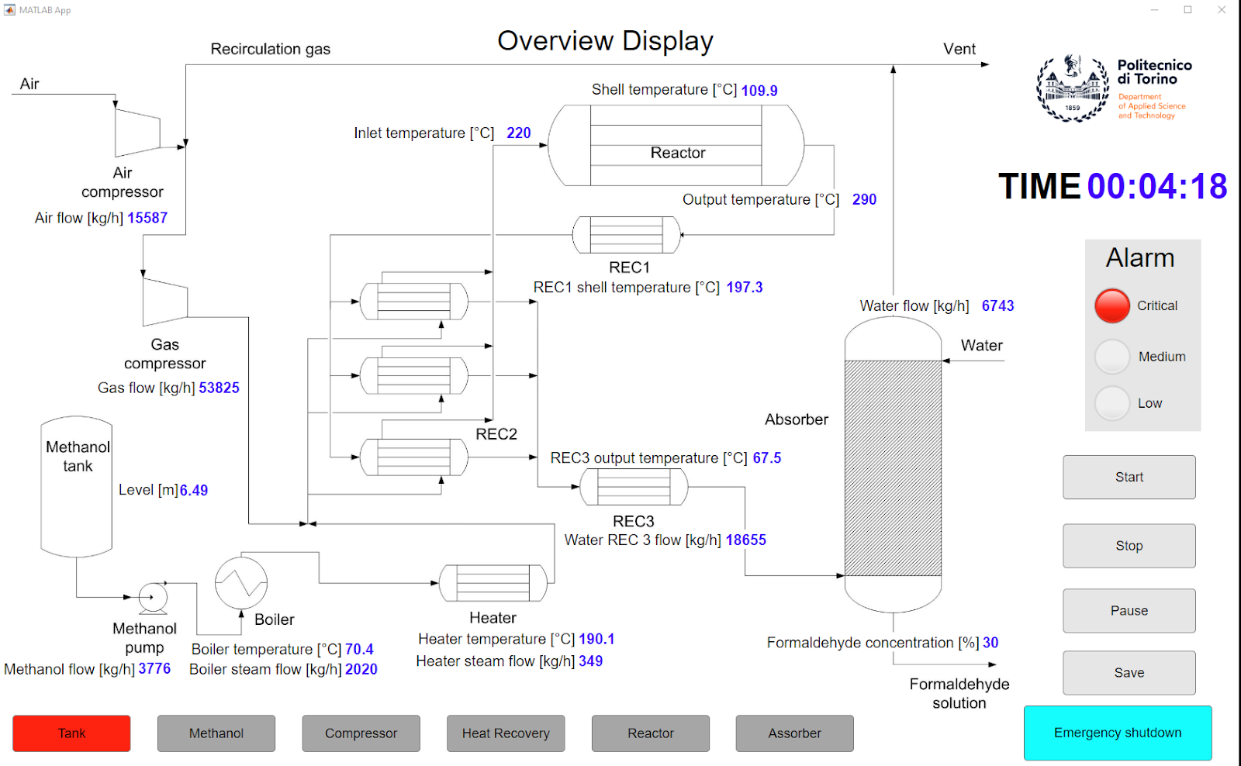
Figure 2: Overview display of the simulated formaldehyde production facility (Amazu et al., 2025).
The three scenarios increase in complexity, giving room to text for a realistic case of control rooms where, typically, there are multiple alarms that increase over time, which could require several interface navigation or intervention procedure searches. The sudden introduction of an attack further adds to this complexity, as would be in a realistic scenario. The first scenario acts as a training scenario, while the second acts as a bridge for the most important and realistic scenario (scenario 3). The support display, which contains the alarm list, some process graphs, etc., as adapted from a previous study, Amazu et al. (2025), was modified to fit the cyber-attack situation requiring communication between operators and a cyber team, as shown in Figure 3.
The operators would not be informed of the scenario or how it develops from case to case, but will be informed of the expected data collection involved and the study protocol.

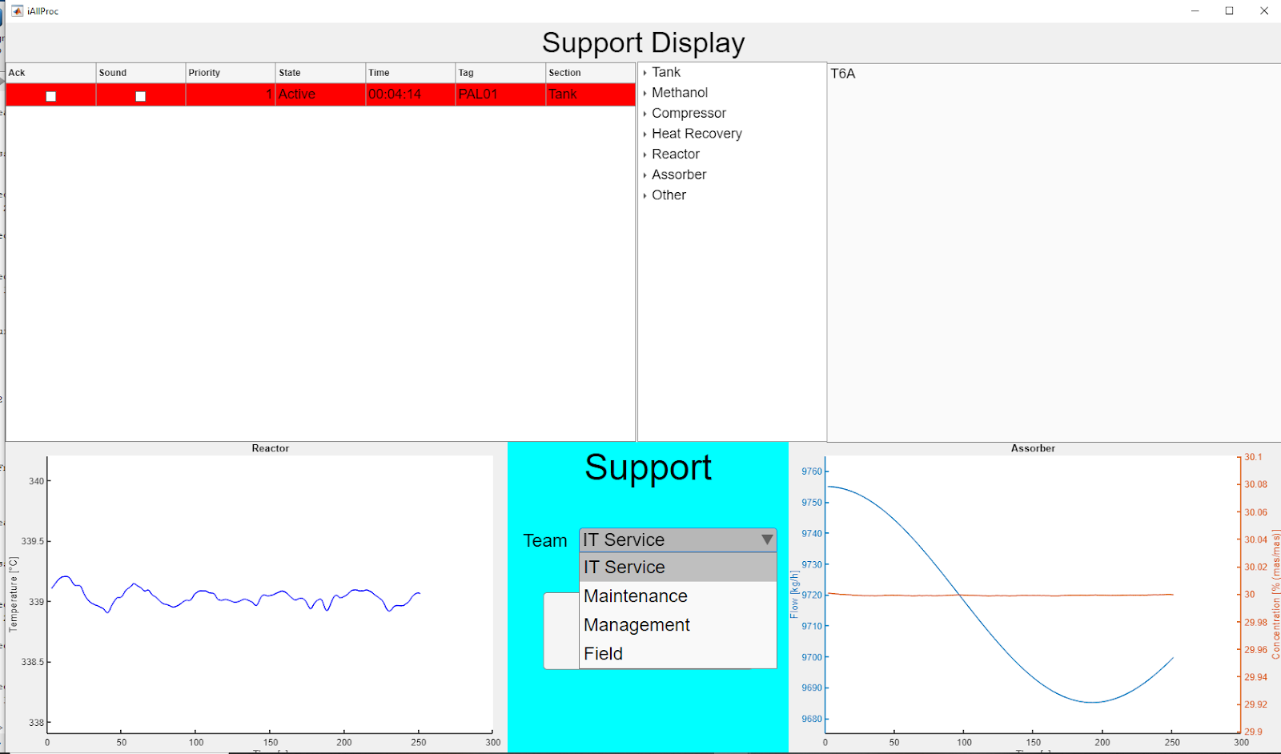
Figure 3: Redesigned support display from the original concept in Amazu et al. (2024). The new design contains information on the different support teams that can be contacted, depending on the identified issue (cyber-attack, system fault, etc.). Here, IT Service refers to the Cyber team.
    - Data Collection
Step 1: Prior test - Medical and Social History
A quick medical and social history of all operators participating in the experiment is to be collected using a pre-designed questionnaire. This enables the researchers to identify any underlying chronic illness or condition that could exacerbate their stress level (e.g. Hypertensive heart disease, Smoking, Alcohol, chronic use of any medication, etc.). All personal data collected during the experimental study will be anonymised and kept confidential following ethical guidelines.

Step 2: During & After test
Major physiological biomarkers are planned to be assessed using wearable devices (a wristwatch). For example, the HR (Heart Rate) and Heart Rate Variability (HRV).

- Heart Rate Variability measures the variation in timing between individual heartbeats (R-R interval) and serves as an indicator of the interaction between the body’s stress and relaxation responses. Lower HRV levels are associated with increased stress, whereas higher HRV levels typically reflect a more relaxed and well-recovered state. HRV measurements are collected before, during, and after the simulated cyber-attack scenario using the EmbracePlus Smartwatch in Figure 4. Researchers have used the same device to measure the selected biomarker (Albarran et al., 2024)
Heart rate refers to the frequency at which the heart beats, reflecting the force exerted by blood against the walls of the heart. It becomes particularly significant in fight-or-flight situations, such as during a sudden cyber-attack or the triggering of alarms.
In this study, the selection of pulse rate as a physiological biomarker is justified by its sensitivity to cognitive load and acute stress. As shown in Figure 5 in an experimental study by Mietkiewicz et al. (2024), pulse rate increases from baseline to task conditions. It rises further in unfamiliar or complex scenarios, particularly with multiple simultaneous alarms, indicating elevated stress that may reduce operator effectiveness. (Affecting operators decision marking).
Our study follows a similar case study approach but extends it by introducing a cyber-attack at two distinct points in the event timeline of each scenario. Unlike conventional process alarms, cyber-induced events introduce additional uncertainty and potential system unreliability, which are expected to amplify stress responses and further impact decision-making during emergencies. It is therefore a
future work to compare the outcomes and selected biomarkers of the referenced study with those observed when a cyber-attack scenario is introduced.
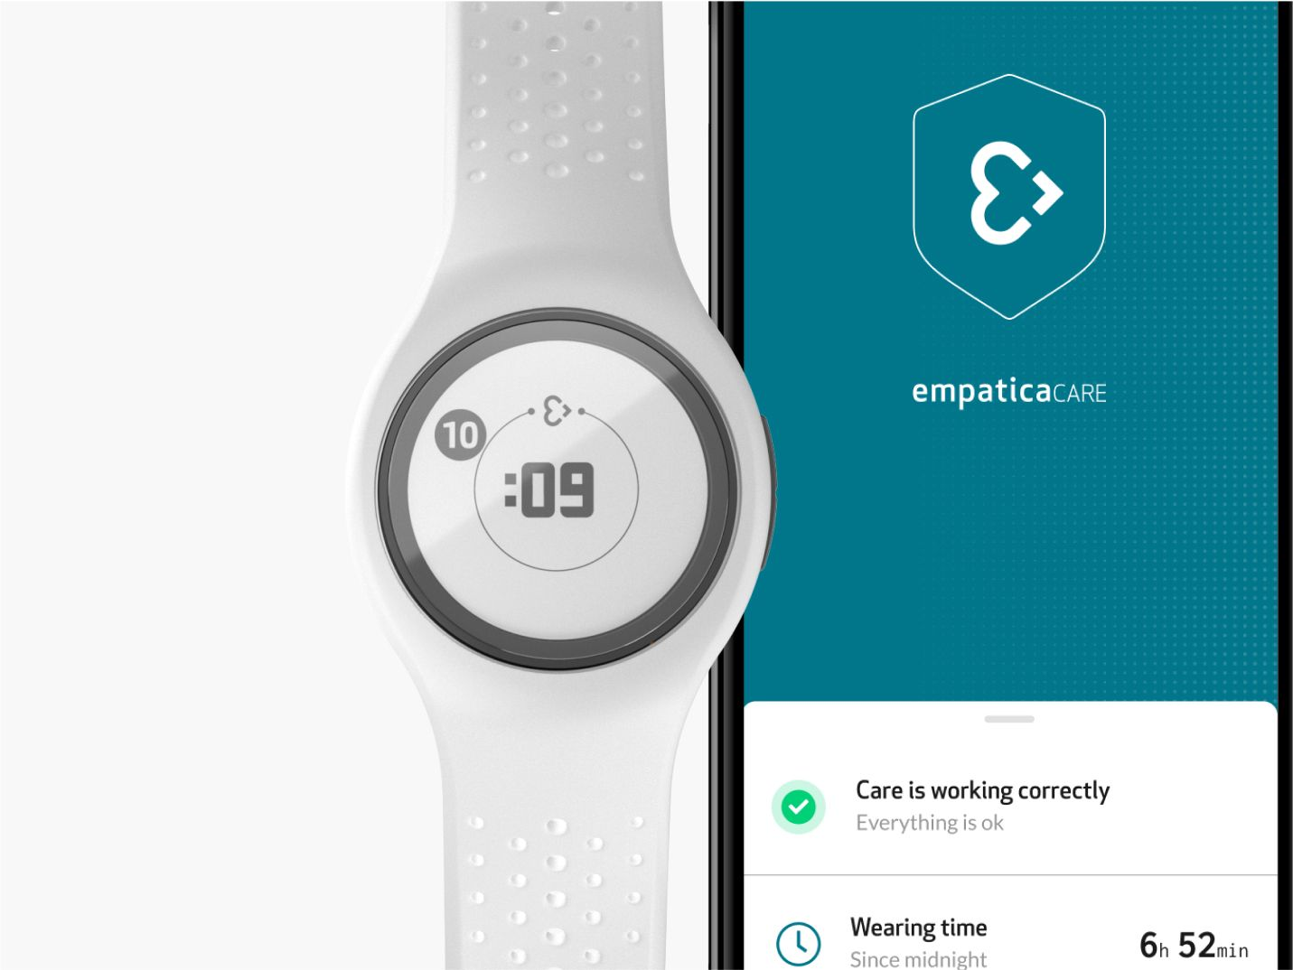
Figure 4: EmbracePlus Advanced Smartwatch for heart rate and HRV data collection (Empatica, 2026).
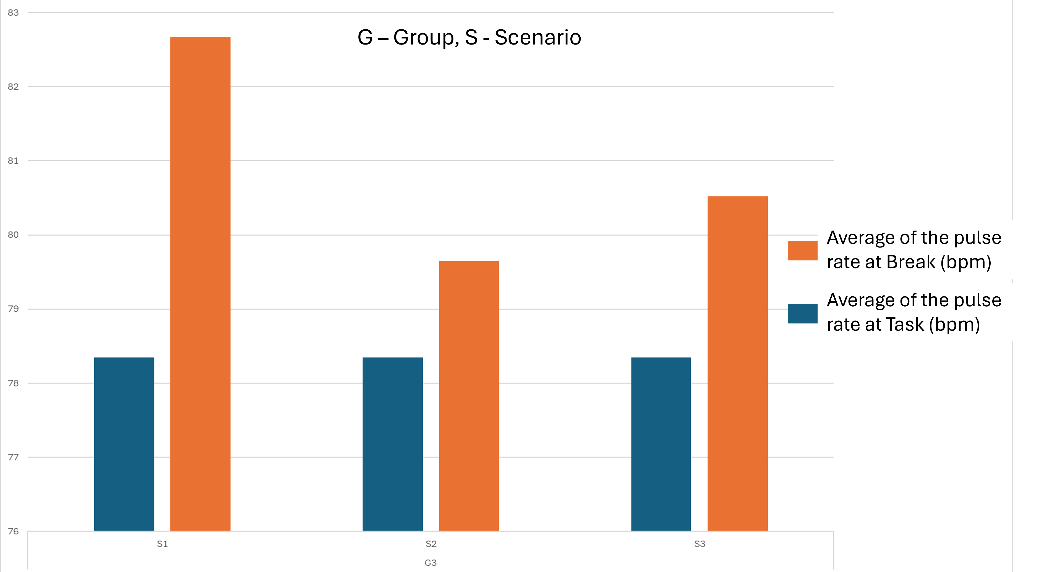
Figure 5: Average pulse rate for Group G3 during baseline (break) and experimental conditions (task) across scenarios (S1–S3), showing increased physiological arousal with task complexity and alarm conditions.
- Blood pressure (BP) is the force exerted by circulating blood against the walls of the arteries as the heart pumps blood throughout the body. It is measured using two values recorded simultaneously: systolic and diastolic pressure. Systolic pressure refers to the pressure when the heart is actively contracting and pumping blood, whereas diastolic pressure refers to the pressure when the heart is relaxed between beats. Acute stress, such as a sudden cyber-attack, can lead to an increase in blood pressure. This data will be recorded before and after the attack using the device as shown in Figure 6.

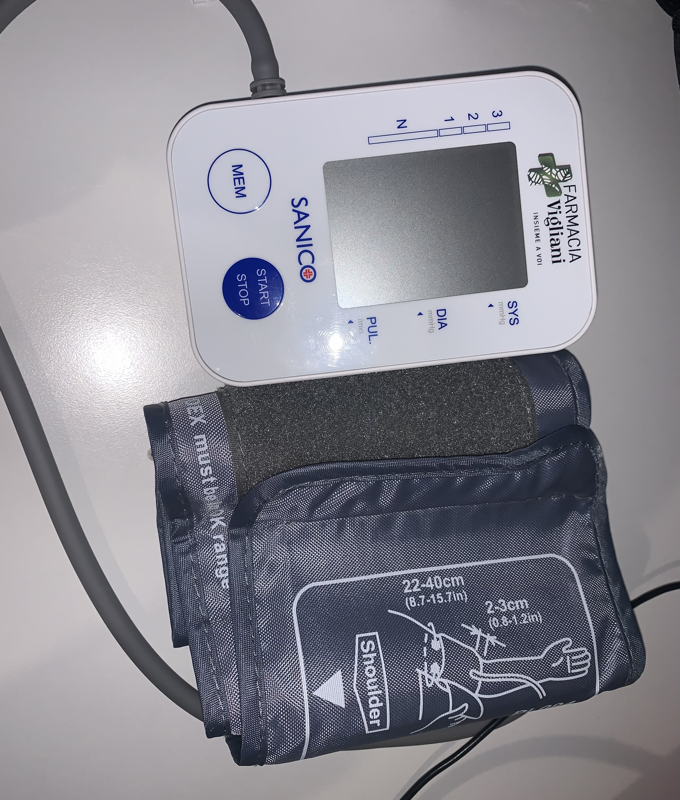
Figure 6: SANICO blood pressure monitoring device.
- Respiratory Rate: Respiration is simply the process of breathing in and out (inhalation and exhalation). It is measured in cycles per minute (cpm). The normal range varies between 12 and 24 cpm. Similarly, a fight-or-flight situation can increase the respiratory rate. Rapid breathing is called tachypnoea, a lower-than-normal respiratory rate is called bradypnoea, and difficulty in breathing is called dyspnoea. In this study, respiratory rate is measured using a wearable fitness tracker.

- Subjective Assessment is also done to assess perceived stress by handing out questionnaires to the operators after each test scenario. Cohen's perceived stress scale was used for this assessment and adapted from similar works by Haris et al. (2023).
  - Conclusions
This conceptual paper highlights the critical role of psychophysiological stress in shaping control room operators’ performance during cyber-attack situations. By integrating physiological biomarkers, subjective stress assessments, and performance measures within a simulated formaldehyde facility with low to critical experimental scenarios, the study aims to deepen understanding of how acute stress influences control room operators. The proposed approach underscores the importance of considering human factors alongside technical cybersecurity measures in control room settings. Following the experimental phase, further work will build on the findings to explore and develop an appropriate management framework that can support operators in high-stress cyber incidents and enhance resilience in cyber-physical systems.
Acknowledgments
This research received partial funding from the SERICS project (PE00000014) as part of the National Recovery and Resilience Plan (NRRP) administered by the Italian Ministry of University and Research (MUR), with support from the European Union through the NextGenerationEU initiative.
References
Albarran Morillo C., Shi H., Baldissone G., Demichela M., 2024, Customizing a Weighted Scale for Precision in Fatigue Assessment within the Process Industry, Chemical Engineering Transactions, 111, 193-198.
Amazu, C. W., Mietkiewicz, J., Abbas, A. N., Briwa, H., Alonso-Perez, A., Baldissone, G., Fissore, D., Demichela, M., Leva, M. C., 2025, Exploring the Influence of Human System Interfaces: Introducing Support Tools and an Experimental Study, International Journal of Human–Computer Interaction, 41(10), 6300–6317. doi.org/10.1080/10447318.2024.2376354.
Council of the European Communities. (1989) Council Directive 89/391/EEC of 12 June 1989 on the introduction of measures to encourage improvements in the safety and health of workers at work. Official Journal of the European Communities, L 183, pp. 1–13. Available at: https://eur-lex.europa.eu/legal-content/EN/TXT/?uri=celex%3A31989L0391
EmbracePlus, 2026, The world’s most advanced smartwatch for continuous health monitoring. (n.d.). www.empatica.com/embraceplus/
European Social Partners (ETUC, UNICE, UEAPME and CEEP). (2004) European Framework Agreement on Work-related Stress. https://ec.europa.eu/social/main.jsp?catId=521&langId=en&agreementId=1106
Harris, K. M., Gaffey, A. E., Schwartz, J. E., Krantz, D. S., & Burg, M. M., 2023, The Perceived Stress Scale as a Measure of Stress: Decomposing Score Variance in Longitudinal Behavioral Medicine Studies, Annals of behavioral medicine: a publication of the Society of Behavioral Medicine, 57(10), 846–854. doi.org/10.1093/abm/kaad015
Lazarus, R. S., & Folkman, S., 1984, Stress, appraisal, and coping. New York: Springer.
Mietkiewicz, J., Abbas, A. N., Amazu, C. W., Baldissone, G., Madsen, A. L., Demichela, M. and Leva, M. C. (2024) ‘Enhancing Control Room Operator Decision Making’, Processes, 12(2), p. 328. doi: 10.3390/pr12020328.
Phillips-Wren, G.; Adya, M., 2020, Decision making under stress: The role of information overload, time pressure, complexity, and uncertainty. J. Decis. Syst., 29, 213–225.
Stephenson, M. D., Schram, B., Canetti, E. F. D., & Orr, R., 2022, Effects of Acute Stress on Psychophysiology in Armed Tactical Occupations: A Narrative Review. International Journal of Environmental Research and Public Health, 19(3), 1802. doi.org/10.3390/ijerph19031802
World Health Organisation, 2023, Stress. World Health Organisation International. Retrieved February 4, 2026, from www.who.int/news-room/questions-and-answers/item/stress.

