 CHEMICAL ENGINEERING TRANSACTIONS  VOL. xxx, 2026 | A publication of  
The Italian Association
of Chemical Engineering
Online at www.cetjournal.it

Guest Editors: Valerio Cozzani, Bruno Fabiano, Genserik Reniers
Copyright © 2026, AIDIC Servizi S.r.l.
ISBN 979-12-81206-xx-x; ISSN 2283-9216

Dilution Effects Of A Steam Curtains On An Accidental Dense Gas Release
Giulia Tomelliniª, Oliver Odenwald^{b}, Florian Trimborn^{b}, Valentina Busini^{a,}*
ª Politecnico di Milano - Dipartimento di Chimica, Materiali e Ingegneria Chimica “Giulio Natta” - Piazza L. da Vinci 32 – 20133 Milan, Italy
^{b} Process Safety Engineering - BASF SE, RGU/BE, Carl-Bosch-Strasse 38, 67056 Ludwigshafen am Rhein, Germany
valentina.busini@polimi.it
Accidental releases of dense gases represent a critical hazard in the process industry due to their tendency to form ground-hugging vapor clouds with limited vertical dispersion. Substances such as isobutane, chlorine, and liquefied natural gas may generate clouds denser than ambient air, whose behaviour is governed by the balance between gravitational slumping and turbulent diffusion. After an initial collapse, dense gas clouds spread radially in a stratified layer, exhibiting a liquid-like creeping motion along the terrain and accumulating in low-lying or confined areas. Under weak wind or stable atmospheric conditions, dilution is strongly limited, leading to persistent hazardous concentrations at ground level. In such scenarios, upward‑directed steam‑curtain systems, which rely on high‑momentum flows to entrain and dilute flammable gases, may experience reduced effectiveness, particularly when obstacles or ducts are located near the release zone. Steam curtains are active mitigation devices that promote air entrainment through high-velocity vapor jets, combining aerodynamic, turbulent, and thermal effects. In this work, computational fluid dynamics simulations were performed using ANSYS Fluent® to investigate the interaction between a dense gas cloud and an industrial steam curtain system implemented in the BASF® facilities in Ludwigshafen am Rhein (Germany), with the aim of analysing the key mechanisms and variables influencing mitigation performance.
  - Introduction
Accidental events involving hazardous substances remain a critical issue for the process and chemical industries, due to their potential to generate severe consequences even when their occurrence rate is relatively low. Historical industrial accidents have shown that uncontrolled fires, explosions, or toxic gas releases may result in significant harm to human health, extensive damage to installations, and long-lasting environmental impacts. For this reason, regulatory frameworks such as the Seveso Directive (European Parliament and Council, 2012), promote a systematic approach to risk assessment and the implementation of preventive and protective measures aimed at limiting both the frequency and the severity of major accidents. Within this context, accidental gas releases pose a particularly complex challenge, especially when the released substances exhibit dense gas behaviour.
Under specific release conditions, certain chemicals may generate vapour clouds with a density exceeding that of ambient air, causing the cloud to remain confined near ground level. This behaviour may arise from high molecular weight compounds, low release temperatures, or phase-change phenomena occurring during depressurisation. Typical examples include isobutane, chlorine, ammonia, and liquefied natural gas. After release, the cloud initially undergoes a gravity-driven collapse, followed by a lateral spreading phase characterised by strong stratification and limited vertical mixing (Britter R.E. and McQuaid J., 1988). The resulting flow resembles a creeping, liquid-like motion along the terrain, favouring accumulation in depressions or confined spaces. Such conditions significantly hinder dilution, particularly in low-wind or stable atmospheric regimes, leading to persistent hazardous concentrations and an increased likelihood of ignition or toxic exposure. Consequently, the dispersion of dense gas clouds is governed not only by the release conditions but also by external aerodynamic factors, with air entrainment occurring predominantly at the cloud boundaries.
To mitigate the consequences of these scenarios, a variety of containment and dispersion strategies may be adopted, including both passive and active systems (Diaz-Ovalle et al., 2012; Lim et al., 2017; Van’t Land, 2018). Among active mitigation measures, steam curtains are commonly employed to promote dilution of flammable dense gas clouds (Schoten et al., 2000; Marsegan et al., 2016; Kulich and Herink, 2022). These systems generate high-velocity upward vapour jets through a series of nozzles, inducing turbulence, air entrainment, and thermal effects that enhance cloud dispersion. Compared to water-based solutions (Bara A. and Dusserre G., 1997), steam curtains can achieve effective dilution with lower mass flow rates; however, their performance is highly sensitive to multiple interacting parameters. Curtain geometry, nozzle configuration, jet momentum, release characteristics, and meteorological conditions jointly govern the overall mitigation performance. In addition, the interaction between vertically oriented steam jets and ground-hugging dense gas clouds introduces further complexity, making mitigation efficiency strongly dependent on positioning and alignment with the prevailing flow field (Tomellini et. Al, 2024; Tomellini et al, 2025).
Given the presence of dense flammable gases within industrial plants and the availability of pre-existing steam curtain installations, it becomes essential to investigate how such systems interact with realistic accidental release scenarios. This study aims to validate the above considerations by evaluating an existing steam curtain design implemented at BASF® in Ludwigshafen am Rhein (Germany), which is adopted as a reference configuration. Starting from this industrial layout, a hypothetical accidental dense gas release scenario is defined, and its consequences are assessed through computational fluid dynamics (CFD) simulations performed using ANSYS Fluent® (ANSYS Inc., 2013). This approach allows the systematic investigation of the interactions between the dense gas cloud and the mitigation system, providing wide flexibility in exploring the main interfering variables. The objective is therefore to analyse the effectiveness and limitations of the existing configuration, identifying the key parameters that influence the mitigation performance under different operating and environmental conditions.

  - Materials and Methods
The numerical investigation was developed by defining a set of representative accidental release scenarios involving a dense flammable gas cloud (i.e., isobutane deriving by a pool evaporation) (Britter R.E. and McQuaid J., 1988) interacting with an active mitigation system (i.e., a steam curtain). The thermophysical properties of isobutane and steam adopted in the simulations are reported in Table 1 and Table 2, respectively.
The steam curtain was modelled under operating conditions representative of the existing industrial installation, adopting the BASF® design previously investigated (Tomellini et al., 2024) for a steam supply pressure of 15 barg. Saturated steam at this pressure level was injected into the domain, with the corresponding mass flow rate defined consistently with the original BASF® specifications. In the CFD model, the geometric configuration of the curtain, including pipe layout and the dimensions of the duct where it is contained, was taken directly from the industrial installation on site (Tomellini et al., 2024), while the curtain itself was reproduced by an equivalent fissure representation was used. To ensure that the steam curtain reproduced the behaviour of the merged jets, the design preserved both the original BASF® injection pattern and its overall geometric footprint. In this configuration, the curtain is generated by a perforated pipe, with the steam flow rate determined by the governing design equations. Based on these constraints, the fissure dimensions were selected so that the total injection area and the momentum characteristics matched those of the original nozzle‑based configuration (see Figure 1a). Awbi (Awbi, 2003) and a single vapor‑jet simulation at 15 barg were used as a reference to interpret the jet development and merging conditions leading to plane-jet-like behaviour, supporting the adoption of the equivalent fissure approach. To implement this representation in a numerically consistent manner, the fissure was modelled by attaching a parallelepiped volume to the steam duct, ensuring that all injection surfaces were fully connected to the computational domain and avoiding the presence of floating or detached boundaries, which are not supported by the solver (ANSYS Inc., 2013).The computational domain was generated using ANSYS® Design Modeler, with dimensions selected to avoid boundary effects and to fully capture the cloud development and interaction with the mitigation system (see Figure 1 b.). Domain sizing was based on preliminary calculations of cloud width and jet height, obtained through standalone simulations of the isobutane pool release and single-jet behaviour. Pool evaporation rates and temporal evolution were evaluated using DNV® PHAST (DNV Software, 2011), a consequence‑analysis package widely used to model the effects of accidental releases of hazardous substances and support quantitative risk assessments, evaluate credible and worst‑case accident scenarios, allowing the determination of average mass flow rates suitable for steady-state CFD simulations. The maximum lateral extension of the cloud was then used to define the curtain length and domain width. The natural symmetry of the geometry was used to reduce computational cost. Detailed domain dimensions, including pool size, curtain position, fissure geometry, and overall domain length, are summarised in the corresponding geometry table.
Mesh generation was performed using ANSYS® Mesher, discretising the domain into finite volumes according to the Finite Volume Method. A non-uniform mesh was adopted to balance numerical accuracy and computational efficiency, with refined cells in regions of interest and progressively coarser cells toward the far-field boundaries. Face sizing was applied to the pool surface, the slit representing the steam curtain, and the duct hosting the vapour pipeline, while edge sizing was used along the ground wall and the symmetry plane to accurately resolve cloud propagation. Mesh parameters, including cell size and growth rate, are reported in Table 3 a. and b. Mesh independence was verified through a sensitivity analysis based on progressive local refinement; the final grid adopted for all simulations consists of approximately 13*10⁶ cells.
All simulations were carried out using ANSYS Fluent 2023® under steady-state conditions. Turbulence was modelled using the k–ω SST model within the Reynolds-Averaged Navier–Stokes (RANS) framework (ANSYS Inc., 2013). Convergence was assumed when energy residuals decreased below 10⁻⁶, while continuity, turbulence variables, and velocity components along the main dispersion axis reached residuals of the order of 10⁻³.

  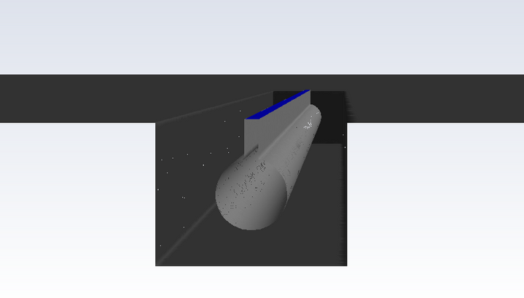 | z  y  x
Figure 1: a. Geometry of the equivalent steam curtain fissure (in blue) from which the steam comes out (represented by the blue arrow) at the height estimated at 8 cm distance, the pipeline (in light grey), and the duct in the ground (in dark grey); b. Schematic representation of the domain of the simulation.
Table 1 - Isobutane properties considered for simulations.
Isobutane pool diameter [m] | Pool surface [m²] | Evaporation Temperature [K] | Mass flow rate [kg/s]
2 | 6.24 | 261.5 | 0.27
Table 2 - Steam properties considered for simulations.
 | Fissure height respects the pipeline [m] | Steam pressure [bar] | Steam Temperature [K] | Real diameter [mm] | Flow rate single orifice [kg/s] | Flow rate per meter fissure length [kg/s] | Steam molar fraction from the fissure [mol/mol] | Fissure temperature [K]
SC 15 barg | 0.084 | 16 | 474.46 | 2.5 | 0.0096 | 0.57 | 0.15 | 322

Table 3 – a. Mesh parameters considered for the face sizing.
Face sizing | Pool | Symmetry edge | Steam  fissure | Pipe
Cell size [m] | 0.05 | 0.1 | 0.01 | 0.01
Growth rate | 1.05 | 1.05 | 1.05 | 1.05
Table 3 – b. Mesh parameters considered for the edge sizing.
Edge sizing | Symmetry edge
Cell size [m] | 0.1
Growth rate | 1.05

  - Results
The release scenario considered in this study is based on an evaporating isobutane pool with a diameter of 2 m, selected as a reference case to generate a dense gas dispersion at ground level. The analysis was conducted by evaluating the spatial extension of the isobutane cloud using the Lower Flammability Limit (LFL), assumed equal to 1.8% mol/mol (Rowley J. R. and Bruce-Black J. E., 2012), as the reference concentration for hazard assessment and risk quantification. The damage distance is therefore used as the primary parameter to evaluate the efficiency of the device. The results confirm that the dispersion of the dense gas cloud is primarily governed by wind-driven transport, with the cloud development closely following the prevailing wind direction (Britter R.E.and McQuaid J., 1988). The weather conditions were simulated considering a power law wind profile (CPSS, 2000) that assumes a urban environment, ground roughness fixed to 0.01 [m], and two reference wind velocities (i.e., at the reference height of 10 [m]), corresponding to 1 m/s and 3 m/s, which characterize the most typical low and moderate atmospheric transport regimes in Ludwigshafen am Rhein.

$$wind velocity={reference wind velocity\left(\frac{actual height}{10 \left[m\right]}\right)}^{0,25}$$

First, case scenarios were studied, avoiding the intervention of any form of protection device, and the dimensions of the clouds were estimated. In Figure 2, a comparison of the two isobutane cloud scenarios is proposed.
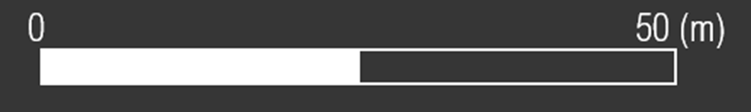  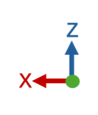  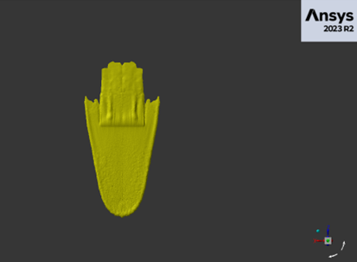  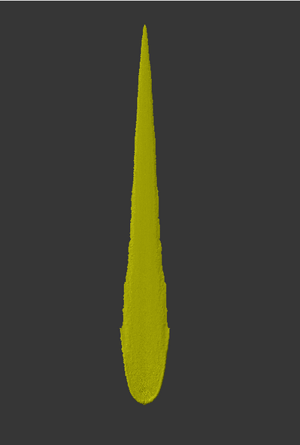  Wind  WIND |   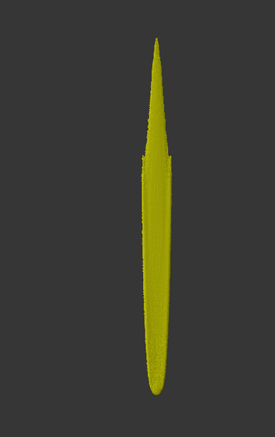  WIND |   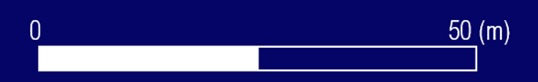
 |  | c.
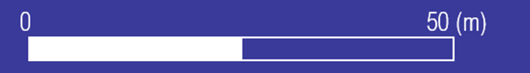

a. | b. | d.
Figure 2: a. Maximum extension of the flammable isobutane cloud moving with 1m/s wind velocity (in dark yellow); b. Maximum extension of the flammable isobutane cloud moving with 3 m/s wind velocity (in dark yellow). The figures illustrate the cloud footprint relative to the pool diameter, represented by the light-yellow circle; c. Side view of the maximum extension of the isobutane cloud moving with 1 m/s wind velocity (in dark yellow) respect to the pool (in red); d. Side view of the maximum extension of the isobutane cloud moving with 3 m/s wind velocity (in dark yellow) respect to the pool (in red).

Then, the effectiveness of the steam curtain was evaluated by positioning the mitigation system at two different locations along the dispersion path, corresponding to 25% and 50% of the maximum flammable cloud extension. A 6-meters long curtain was assumed as a steam curtain. This length was chosen to be at least as wide as the cloud at a certain distance. Due to the high density of isobutane relative to air and the low release temperature, the cloud exhibits a pronounced ground-hugging behavior, resembling a liquid-like flow along the terrain as shown in Figure 2 c. and d. This characteristic strongly limits vertical mixing and promotes accumulation in low-lying regions.
As shown in Figure 2, an increase in wind velocity leads to a general enhancement of cloud dilution, resulting in a reduction of the maximum extension of the flammable cloud up to 35% respect to the open-field scenario. Simulations performed at 3 m/s show a shorter cloud length compared to the 1 m/s cases, confirming the key role of wind-induced shear in promoting air entrainment. However, even under higher wind conditions, the dense gas core remains rich in isobutane, while dilution mainly occurs at the cloud periphery, where turbulent eddies facilitate interaction with ambient air.
The presence of the steam curtain introduces additional complexity in the dispersion dynamics. Figure 3 a. and b. illustrate representative results for the worst-performing cases at 1 m/s wind velocity, with the curtain positioned at 25% and 50% of the maximum extension of the flammable cloud.

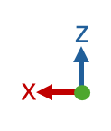    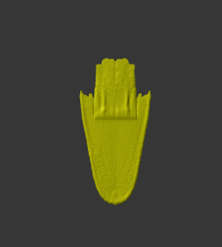  WIND  25 % of the maximum extension of the LFL |   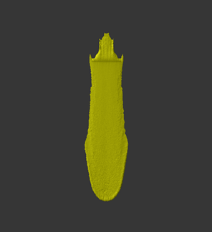  WIND  50 % of the maximum extension of the LFL
a. | b.
Figure 3: a. Isobutane cloud (in yellow) encounters perpendicularly a 6-meters long steam curtain at 25% of the maximum extension of the LFL moving with 1m/s wind velocity; b. isobutane cloud (in yellow) encounters perpendicularly a 6-meters long steam curtain at 50% of the maximum extension of the LFL moving with 1m/s wind velocity.

The primary purpose of the steam curtain is to ensure complete interruption and dilution of the flammable cloud at the specific location where it is deployed; under ideal operating efficiency, the cloud is therefore expected to be fully stopped at that point. In both configurations, the dense gas cloud is observed to partially overtop the steam curtain, with a noticeable reduction in propagation velocity but without complete arrest of the cloud advance. As shown in Figure 3a, the configuration of the curtain reduced the maximum cloud extension by approximately 70%, compared with the 75% expected under ideal operating conditions of the steam curtain (i.e., the cloud is not able to overcome the steam curtain). In Figure 3b, a reduction of 40% is observed, against an ideal value of 50%. In both cases, the cloud continues its trajectory for an additional 5–10% even in the presence of the protection device. In the open‑field scenario, the cloud never exceeded an enlargement of 5 m. In contrast, the presence of the steam curtain induces a three‑dimensional suction effect that promotes local entrainment and partial lifting of the cloud. This behavior is evident in Figure 3a, where the cloud reaches an enlargement of over 6 m in proximity of the curtain, compared with the open‑field case shown in Figure 2a; however, this effect is highly sensitive to curtain geometry and positioning. Excessive curtain width may locally enhance dilution but can also restrict lateral entrainment at the curtain edges, reducing overall effectiveness.
Furthermore, the physical presence of the steam supply duct acts as a partial barrier for the dense gas cloud. Due to the creeping behavior of the cloud, insufficient vapor momentum may lead to the formation of preferential flow paths beneath or around the curtain, effectively creating a bypass for the gas. This phenomenon is particularly evident when the curtain is positioned too close to the source term. In these configurations, gas accumulation upstream of the curtain causes a local widening of the cloud, limiting the beneficial effect of wind-induced dilution.
Insufficient dilution is observed in scenarios characterized by low wind velocity and limited steam injection. Under these conditions, the curtain is not sufficiently assisted by ambient shear, and the injected vapor is unable to generate the level of turbulence required to significantly reduce the cloud concentration.

  - Conclusions
This study investigated the interaction between a dense isobutane gas cloud and an industrial steam curtain system using CFD simulations based on a pre-existing BASF® configuration operating at 15 barg. The results highlight that the dispersion of dense gases remains dominated by their tendency to follow the terrain, with limited vertical mixing and strong sensitivity to wind conditions. While increasing wind velocity enhances dilution and reduces cloud extension, wind alone is often insufficient to fully mitigate dense gas hazards.
The steam curtain acts as an active mitigation system by promoting aerodynamic entrainment, turbulent diffusion, and thermally induced expansion. However, its effectiveness is strongly dependent on the balance between injected vapor momentum, ambient turbulence, and curtain positioning. In the investigated scenarios, the curtain was found to slow down the propagation of the dense gas cloud rather than completely dilute or stop it, particularly under low-wind conditions. The presence of the supply duct and the creeping behavior of the cloud may further reduce performance by creating bypass pathways when the injected vapor is insufficient.
Overall, the results confirm that steam curtains should not be considered as standalone mitigation measures for dense gas releases but rather as systems whose performance critically depends on environmental conditions and design integration. Effective mitigation requires careful alignment between curtain geometry, vapor injection characteristics, and prevailing wind field. The findings underline the importance of scenario-specific assessment when evaluating existing mitigation systems and provide insight into the limitations of upward-directed steam curtains when applied to ground-hugging dense gas clouds. At the same time, this work highlights the need to further refine the design criteria of such devices, to support future developments and improvements in steam curtain technology, suggesting that the key design driver could be the ability of the curtain to draw in sufficient isobutane and air, thereby establishing an effective diluting environment. Future optimization efforts should therefore focus on controlling and enhancing entrainment mechanisms rather than solely modifying the injection configuration.
Acknowledgements
This work was realised with the collaboration of BASF® Ludwigshafen am Rhein under a Collaborative Doctoral Partnership.
References
ANSYS Inc., 2013, ANSYS Fluent 2019 user’s guide (Lebanon, NH, USA).
Awbi H., 2003, Ventilation of buildings, E&FN Spon Press: Second edition.
Bara A., Dusserre G., 1997, The use of water curtains to protect firemen in case of heavy gas dispersion, Journal of Loss Prevention in the Process Industries, 10, 179-183.
Britter R.E., McQuaid J., 1988, Workbook on the dispersion of dense gases, HSE Books.
CPSS (2000). Code for Design of Structures for Wind Resistance (CPSS 2000). Ministry of Construction of the People’s Republic of China, Beijing.
Diaz-Ovalle C., Vazquez-Roman R., Lesso-Arroyo R., Mannan M.S., 2012, A simplified steady-state model for air, water and steam curtain, Journal of Loss Prevention in the Process Industries, 25, 974-981.
DNV Software, UDM Theory Document, Technical Report, DNV Software, London (UK), 2011.
European Parliament and Council, 2012, Directive 2012/18/EU (Seveso III) on the control of major-accident hazards involving dangerous substances, Official Journal of the European Union, L197, 1–37
Kulich M., Herink T., 2022, Risk and limitations of steam curtains protection in case of flammable gases leakage, Process Safety Progress, 41, 591-601.
Lim H., Um K. and Jung S., 2017, A study on effective mitigation system for accidental toxic gas releases, Journal of Loss Prevention in the Process Industries, 49, 636-644.
Marsegan C., V. Busini and Rota R, 2016, Influence of active mitigation barriers on LNG dispersion, Journal of Loss Prevention in the Process Industries, 44, 380-389.
Rowley J. R., Bruce-Black J. E., 2012, Proper application of flammability limit data in consequence studies, Institution of Chemical Engineers Symposium Series, 158, 443–452.
Schoten, H. H., Molag M., Duffield J. S., Powell-Price M., 2000, The use of fluid curtains for post-release mitigation of gas dispersion, Institution of Chemical Engineers Symposium Series, 147, 287–298.
Tomellini G., Pinciroli A., Odenwald O., Trimborn F., Busini V., 2024, Interaction of Steam Curtains with High-Pressure Jets, Chemical Engineering Transactions, AIDIC, ISBN 979-12-81206-11-3.
Tomellini G., Odenwald O., Trimborn F., Busini V., 2025, A methodology to design an effective steam curtain to mitigate an accidental release of a high‐pressure jet in a chemical plant, Journal of Loss Prevention in the Process Industries, 97, 105684.
Van't Land C.M., 2018 Safety in Design - Procedural, Active, and Passive Safety, John Wiley & Sons Inc., 2, 7-16.

