 CHEMICAL ENGINEERING TRANSACTIONS  VOL. xxx, 2026 | A publication of  
The Italian Association
of Chemical Engineering
Online at www.cetjournal.it

Guest Editors: Valerio Cozzani, Bruno Fabiano, Genserik Reniers
Copyright © 2026, AIDIC Servizi S.r.l.
ISBN 979-12-81206-xx-x; ISSN 2283-9216

The Interference of Natural Hazards on Security Systems
in Chemical and Process Facilities
Federica Ricci, Matteo Iaiani, Alessandro Tugnoli, Valerio Cozzani *
LISES – Laboratory of Industrial Safety and Environmental Sustainability. DICAM - Department of Civil, Chemical, Environmental, and Material Engineering. University of Bologna, via Terracini 28, 40131 Bologna (Italy)
valerio.cozzani@unibo.it
Physical Protection Systems (PPS) are essential to protect chemical sites against intentional attacks, yet current security assessment methods rarely consider the effects of natural hazards on security performance. This study examines the impact of natural hazards on 17 PPS security elements representative of detection, delay, and response functions in chemical and process facilities. Expert elicitation was used to estimate the probability of damage, failure, or impairment under seven hazard categories relevant to Natech scenarios. The results indicate that natural hazards can significantly reduce the availability and operability of security elements, with the most severe effects associated with floods and earthquakes. These findings support the inclusion of natural-hazard effects in security risk assessment and the development of more integrated safety–security management strategies for chemical sites.
  - Introduction
The security of chemical process and storage sites is a critical issue because intentional attacks may cause severe consequences when hazardous substances are handled or stored (Landucci and Reniers, 2019). These facilities may represent attractive targets due to the presence of flammable and toxic materials, and are often located near populated or environmentally sensitive areas. As a result, successful attacks may lead to toxic releases, fires, explosions, prolonged operational disruption, and significant environmental and societal impacts (Iaiani et al., 2021). To prevent and mitigate such threats, chemical facilities rely on Physical Protection Systems (PPS), including barriers, intrusion detection and surveillance devices, access control systems, communication infrastructure, and security personnel (Garcia, 2007). The effectiveness of PPS is commonly assessed through Security Vulnerability Assessment (SVA) and Security Risk Assessment (SRA) methodologies, such as those proposed by the Center for Chemical Process Safety (2003) and the American Petroleum Institute (2013). Existing approaches, however, generally evaluate security performance under nominal operating conditions, implicitly assuming the continuous availability and correct functioning of all protection elements.
This assumption may become inadequate when external stressors affect the site. In particular, natural hazards such as floods, earthquakes, wildfires, and extreme weather may simultaneously impair multiple systems and services, as widely documented in Natech studies (Ricci et al., 2021). Previous research has shown that natural events can damage safety barriers, utilities, and critical services (Misuri et al., 2021), and may also hinder emergency response (Ricci et al., 2024). Because safety and security often depend on shared infrastructure – including power supply, communications, access routes, and personnel – disruptions caused by natural hazards may also degrade the performance of PPS (George and Renjith, 2021). Evidence from past events in critical infrastructure confirms that natural hazards can compromise physical security functions by damaging surveillance systems, access-control infrastructure, and site accessibility (Evans et al., 2021). Despite this, the effects of natural hazards on physical security have received limited attention, and available studies remain scarce and largely restricted to case-specific analyses. Generalized evidence applicable to chemical and process facilities is therefore still lacking.
To address this gap, the present study applies an expert elicitation approach to estimate the probability of damage, failure, or impairment of a reference set of security elements when exposed to selected natural hazards. This approach was adopted because of the limited availability of empirical data and its suitability for the analysis of low-data, emerging problems (Hokstada et al., 1998). The results provide a first quantitative basis for integrating natural-hazard effects into the assessment of PPS performance and, more broadly, into security risk analysis for chemical sites.
  - Methodology
Figure 1 outlines the methodological framework adopted to evaluate the potential effects of natural hazards on security elements. The individual steps are described in the following sections.
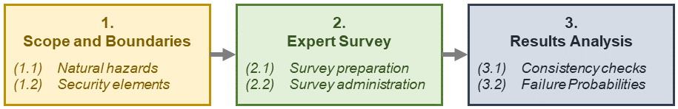
Figure 1: Methodology developed in the present study.
    - Scope and Boundaries
Step 1 (Figure 1) established the scope and boundaries of the analysis. The assessment addressed the effects of natural hazards on security-related components, including potential consequences and damage probabilities. To maintain feasibility, the analysis was limited to selected hazard classes and security elements.
Seven natural-hazard categories were retained based on their recognized potential to trigger Natech events through impacts on technological systems (Ricci et al., 2021). Table 1 summarizes the selected hazards and their corresponding impact modes.
Table 1: List of natural hazards considered in the present study and the corresponding impact modes.
ID | Natural hazards | Impact mode
NH1 | Earthquake | Peak ground acceleration [g]; Peak ground velocity [m∙s⁻¹]
NH2 | Flood / Storm surge | Water depth [m]; Water velocity [m∙s⁻¹]
NH3 | Intense wind | Wind speed [m∙s⁻¹]
NH4 | Lightning | Flash density at ground level [km⁻²∙y⁻¹]
NH5 | Heavy rainfall / Hail | Heavy rainfall [mm∙m⁻²]; Hail impact
NH6 | Ice / Snow | Low temperature [°C]; Formation of ice; Accumulation of snow [mm]
NH7 | Wildfires / Interface fires | Flame emissive power [W∙m⁻²]; Flame length [m]; Flame duration [h]

The security elements included in the study considered common physical protection system (PPS) used in chemical and process facilities. The selected categories are listed in Table 2. The included elements were based on the Sandia PPS framework (Garcia, 2007) and was extended with additional industrial security barriers identified in the CCPS SVA methodology (Center for Chemical Process Safety, 2003), the VAM-CF methodology (Jaeger, 2002), and API RP 780 (American Petroleum Institute, 2013). The analysis also included relevant operational factors, such as outdoor visibility and the effectiveness of external security personnel. Although these are not barriers, they can be significantly altered by natural hazards and may strongly affect overall security risk.
Table 2: List of security elements considered in the present study and consequences addressed in the survey.
ID | Security element | Consequence
SE1 | Fence | Damage
SE2 | Gates and doors | Damage
SE3 | Signal coverage | Low signal
SE4 | Security control center | Inaccessibility
SE5 | Main power supply | Unavailability
SE6 | Backup power supply | Unavailability
SE7 | Exterior sensors | Unavailability
SE8 | Interior sensors | Unavailability
SE9 | Automated personnel access control | Unavailability
SE10 | Closed-circuit television | Unavailability
SE11 | Surveillance drones | Damage
SE12 | Visibility | Low visibility
SE13 | Internal security personnel | Disruption
SE14 | Working personnel | Disruption
SE15 | External security personnel | Unavailability
SE16 | Access route to the site | Damage
SE17 | External security personnel performance | Impairment
  - Expert Survey
A structured expert elicitation was conducted to estimate the expected performance of the security elements listed in Table 2 during or after exposure to the natural hazards considered in Table 1. The online survey involved an international, multidisciplinary panel including academics, industry professionals, consultants, regulators, and facility managers. An initial section collected background information on the respondents, including years of experience, professional role, and expertise in safety and security. These data were used only to support documentation and interpretation of the results, while preserving respondent anonymity and methodological objectivity (Hokstada et al., 1998).
The technical section included one question for each hazard–security element combination. Questions were formulated according to the characteristics of the specific element and the relevant hazard impact mode. For each element, respondents were asked to judge the likelihood that the considered hazard would cause a defined adverse consequence specified in Table 2, typically damage, failure, or functional impairment. Responses were collected through the ordinal scale with verbal descriptors shown in Figure 3, adapted from Vagias (2006). A qualitative scale was preferred to direct numerical estimation in order to facilitate expert judgement and improve response consistency (Norrington et al., 2008). To reduce uncertainty-driven bias and avoid forced judgements, respondents were allowed to leave unanswered any item for which they considered their knowledge insufficient with respect to either the security element or the hazard under evaluation (Waters et al., 2022).
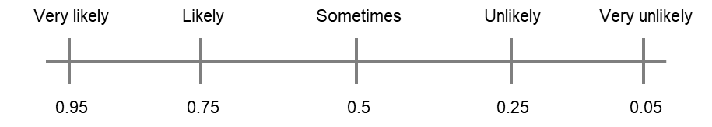
Figure 2: Ordinal scale with verbal descriptors used in the survey and the related quantitative translation used in the assessment of the responses.
  - Results Analysis
Following data collection, expert judgements were converted into numerical values to derive probability distributions for the consequences defined in Table 2. The conversion followed scales adapted from previous studies (Chockalingam et al., 2023), with each verbal response mapped to the corresponding value reported in Figure 2.
Several checks were then performed to determine whether response corrections or weighting procedures were necessary: robustness, response-style heterogeneity, distribution of responses across independent groups. In addition, a sensitivity analysis based on respondent weighting was conducted to assess the extent to which estimated damage probabilities depend on alternative assumptions regarding expertise(Greco et al., 2019). These analyses were used to establish whether response-style adjustment, statistical correction, or weighting was justified in the estimation of damage probabilities.
For each security element, the survey data were then summarized using the statistical indicators:
- Minimum (Min): lowest value observed in the dataset;
- Mean: arithmetic average of the observed values;
- Standard Deviation: indicator of data dispersion around the mean;
- Maximum (Max): highest value observed in the dataset;
- First Quartile (Q1): value below which 25% of the observation fall (25th percentile);
- Second Quartile (Q2): value separating the dataset into two equal parts (corresponds to the median);
- Third Quartile (Q3): value below which 75% of the observations fall (75th percentile);
The median probability was selected as the performance modification factor for each security element, representing the probability of occurrence of the consequence specified in Table 2. The mean was not adopted as the primary indicator because it is more sensitive to dispersed judgements and outliers, whereas the median provides a more robust measure of central tendency in this context (McAndrew et al., 2021).
  - Results
A total of 61 experts completed the survey, a sample size satisfactory for statistical analysis (Cooke and Goossens, 1999). The panel included both academic and non-academic respondents, with substantial professional experience: 69% reported more than 10 years of practice. Nearly half of the participants declared specific expertise in security, and almost all reported experience in safety. Although most respondents were based in Europe, the panel was characterized by broad international professional exposure.
Potential bias associated with individual response styles was assessed, and only negligible differences were observed. Group differences were also examined with respect to professional background, years of experience, and security expertise. Although isolated discrepancies emerged, these were specific to individual hazard–element combinations and did not indicate any systematic effect attributable to respondent category. This conclusion was further supported by the weighting and sensitivity analysis. Weighted estimates showed limited dispersion, close agreement with unweighted values, and consistently included the unweighted means within their ranges. Overall, the results proved stable across respondent profiles, and the final probabilistic analysis was therefore performed without applying weighting factors.
Experts evaluated the likelihood of the consequences identified for each security element under the considered natural hazards. For the sake of example, Figure 3 shows the results for lightning (panel a) and wildfire / interface fire (panel b). The results indicate that wildfire is associated with a comparatively higher probability of damage, with about 23% of responses falling in the high-probability range (e.g., “very likely” and “likely” answers), compared with an average of approximately 11% for the case of lightning impact.
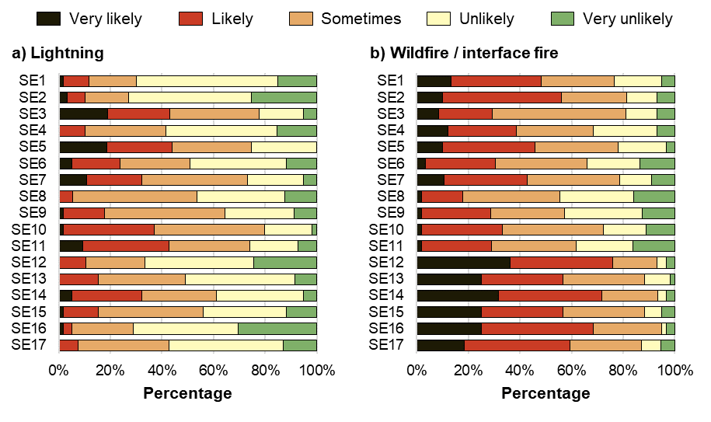
Figure 3: Survey answer concerning the likelihood of the considered consequences for each security element under (a) lightning and (b) wildfire / intense fire. Table 2 reports both the security element ID definition and the related consequence addressed in the survey.
The ordinal scale was translated into quantitative probability values to estimate the likelihood of the consequences identified in Table 2 for each natural hazard–security element combination. As a preliminary representation of the results, two natural hazards are reported as examples in Figure 4: lightning and wildfire / interface fire. In accordance with qualitative results, security elements under wildfire hazard show overall a higher failure probability with respect to lightning. Additional results can be found in Ricci et al. (2026). The full set of elicited probabilities was then processed to derive the statistical indicators adopted in the analysis. Specifically, for each security element and each natural hazard, the median of the probability distribution was selected as the performance modification factor, and the values are reported in Table 3.
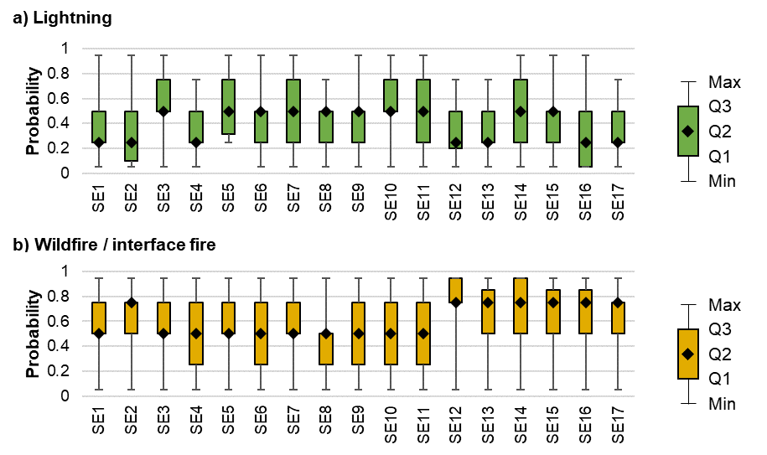
Figure 4: Estimated likelihood of the consequences for the security elements under (a) lightning impact and (b) wildfire / interface fire impact (see Table 2 for the security-element labels and consequences addressed).
The resulting performance modification factors show that the most severe effects are associated with the unavailability of working personnel (SE14) and damage to site access routes (SE16). In both cases, the highest values are observed for floods, with probabilities up to 0.95. High values are also obtained for the other natural hazards considered. Some security elements, however, appear to be only marginally influenced by hazard type. This is the case for external sensors (SE7), for which the estimated probability of damage remains relatively stable across all scenarios, at approximately 0.5. This result suggests a broadly similar vulnerability regardless of the specific hazard considered. By contrast, other elements exhibit a more hazard-dependent behavior. In particular, surveillance drones (SE11) and visibility (SE12) are more strongly affected by hazards associated with intense wind, heavy rainfall, and ice/snow. Under these conditions, the estimated impairment probability reaches 0.75, whereas it decreases to 0.25 for the other hazard categories.
Overall, the elicited results indicate the presence of two broad hazard groups. Earthquakes, floods, and wildfires are associated with the highest expected probabilities of damage, failure, or impairment of security elements. Conversely, intense wind, lightning, heavy rainfall/hail, and ice/snow are generally associated with lower expected impacts.
Table 3: Performance modification factor obtained for all the security elements and natural hazards considered in the present study. Consequences assessed for security elements are reported in Table 2. Acronyms for natural hazards are reported in Table 1.
ID | Security element | NH1 | NH2 | NH3 | NH4 | NH5 | NH6 | NH7
SE1 | Fence | 0.75 | 0.75 | 0.50 | 0.25 | 0.25 | 0.25 | 0.50
SE2 | Gates and doors | 0.75 | 0.75 | 0.50 | 0.25 | 0.50 | 0.25 | 0.75
SE3 | Signal coverage | 0.75 | 0.75 | 0.50 | 0.50 | 0.50 | 0.50 | 0.50
SE4 | Security control center | 0.75 | 0.75 | 0.25 | 0.25 | 0.25 | 0.50 | 0.50
SE5 | Main power supply | 0.75 | 0.75 | 0.50 | 0.50 | 0.50 | 0.50 | 0.50
SE6 | Backup power supply | 0.75 | 0.75 | 0.50 | 0.50 | 0.50 | 0.25 | 0.50
SE7 | Exterior sensors | 0.75 | 0.75 | 0.50 | 0.50 | 0.50 | 0.50 | 0.50
SE8 | Interior sensors | 0.50 | 0.50 | 0.25 | 0.50 | 0.25 | 0.25 | 0.50
SE9 | Automated personnel access control | 0.75 | 0.75 | 0.50 | 0.50 | 0.50 | 0.25 | 0.50
SE10 | Closed-circuit television | 0.75 | 0.50 | 0.50 | 0.50 | 0.50 | 0.38 | 0.50
SE11 | Surveillance drones | 0.25 | 0.25 | 0.75 | 0.50 | 0.75 | 0.75 | 0.50
SE12 | Visibility | 0.25 | 0.50 | 0.50 | 0.25 | 0.75 | 0.75 | 0.75
SE13 | Internal security personnel | 0.75 | 0.75 | 0.50 | 0.25 | 0.50 | 0.50 | 0.75
SE14 | Working personnel | 0.95 | 0.95 | 0.50 | 0.50 | 0.75 | 0.50 | 0.75
SE15 | External security personnel | 0.75 | 0.75 | 0.50 | 0.50 | 0.50 | 0.50 | 0.75
SE16 | Access route to the site | 0.85 | 0.95 | 0.50 | 0.25 | 0.50 | 0.75 | 0.75
SE17 | External security personnel performance | 0.75 | 0.75 | 0.50 | 0.25 | 0.50 | 0.50 | 0.75
  - Conclusions
Natural hazards can significantly degrade the effectiveness of security elements in chemical and process facilities and, if neglected, may lead to an underestimation of security vulnerability. Although they do not directly cause intentional attacks, they can weaken site protection and increase exposure to security threats. Natural hazards should therefore be considered within security risk assessment. In this framework, the results of the present study the development of security assessment approaches that explicitly account for the degradation of security functions under natural-hazard conditions, particularly during the recovery phase. Overall, the study highlights the need for more integrated safety-security risk management in chemical sites.
References
American Petroleum Institute, 2013. API RP 780 - Security Risk Assessment Methodology for the Petroleum and Petrochemical Industries.
Center for Chemical Process Safety, 2003. Guidelines for Analyzing and Managing the Security Vulnerabilities of Fixed Chemical Sites.
Chockalingam, S., Pieters, W., Teixeira, A.M.H., van Gelder, P., 2023. Probability elicitation for Bayesian networks to distinguish between intentional attacks and accidental technical failures. Journal of Information Security and Applications 75, 103497.
Cooke, R., Goossens, L., 1999. Procedures guide for structured expert judgment - EUR 18820 EN. European Commission, Luxembourg.
Evans, A., Horowitz, S., Le, T., Cohn, B., 2021. Impact of Extreme Weather Events on Physical Protection System Effectiveness for a Hypothetical Small Modular Reactor Facility: Systems Analysis and Considerations. Albuquerque (New Mexico) and Livermore (California).
Garcia, M.L., 2007. The Design and Evaluation of Physical Protection Systems, Design and Evaluation of Physical Protection Systems: Second Edition. Butterworth-Heinemann (Elsevier).
George, P.G., Renjith, V.R., 2021. Evolution of Safety and Security Risk Assessment methodologies towards the use of Bayesian Networks in Process Industries. Process Safety and Environmental Protection 149, 758–775.
Greco, S., Ishizaka, A., Tasiou, M., Torrisi, G., 2019. On the Methodological Framework of Composite Indices: A Review of the Issues of Weighting, Aggregation, and Robustness. Soc. Indic. Res. 141, 61–94.
Hokstada, P., Øien, K., Reinertsen, R., 1998. Recommendations on the use of expert judgment in safety and reliability engineering studies. Two offshore case studies. Reliab. Eng. Syst. Saf. 61, 65–76.
Iaiani, M., Casson Moreno, V., Reniers, G., Tugnoli, A., Cozzani, V., 2021. Analysis of events involving the intentional release of hazardous substances from industrial facilities. Reliab. Eng. Syst. Saf. 212, 107593.
Jaeger, C.D., 2002. Vulnerability Assessment Methodology for Chemical Facilities (VAM-CF). Chem. Health Saf. 9, 15–19.
Landucci, G., Reniers, G., 2019. Preface to special issue on quantitative security analysis of industrial facilities. Reliab. Eng. Syst. Saf. 191, 106611.
McAndrew, T., Wattanachit, N., Gibson, G.C., Reich, N.G., 2021. Aggregating predictions from experts: A review of statistical methods, experiments, and applications. WIREs Computational Statistics 13.
Misuri, A., Landucci, G., Cozzani, V., 2021. Assessment of safety barrier performance in the mitigation of domino scenarios caused by Natech events. Reliab. Eng. Syst. Saf. 205, 107278.
Norrington, L., Quigley, J., Russell, A., Van der Meer, R., 2008. Modelling the reliability of search and rescue operations with Bayesian Belief Networks. Reliab. Eng. Syst. Saf. 93, 940–949.
Ricci, F., Casson Moreno, V., Cozzani, V., 2021. A comprehensive analysis of the occurrence of Natech events in the process industry. Process Safety and Environmental Protection 147, 703–713.
Ricci, F., Iaiani, M., Tugnoli, A., Cozzani, V., 2026. The impact of natural hazards on the security of chemical sites. Reliab. Eng. Syst. Saf. 272, 112576.
Ricci, F., Yang, M., Reniers, G., Cozzani, V., 2024. Emergency response in cascading scenarios triggered by natural events. Reliab. Eng. Syst. Saf. 243, 109820.
Vagias, W.M., 2006. Likert-Type Scale Response Anchors. Clemson International Institute for Tourism & Research Development, Department of Parks, Recreation and Tourism Management. Clemson University.
Waters, E.A., Kiviniemi, M.T., Hay, J.L., Orom, H., 2022. Dismissing “Don’t Know” Responses to Perceived Risk Survey Items Threatens the Validity of Theoretical and Empirical Behavior-Change Research. Perspectives on Psychological Science 17, 841–851.

