 CHEMICAL ENGINEERING TRANSACTIONS  VOL. xxx, 2026 | A publication of  
The Italian Association
of Chemical Engineering
Online at www.cetjournal.it

Guest Editors: Valerio Cozzani, Bruno Fabiano, Genserik Reniers
Copyright © 2026, AIDIC Servizi S.r.l.
ISBN 979-12-81206-xx-x; ISSN 2283-9216
From Risk Assessment to Operation: Ensuring Safe LNG Bunkering for Passenger Vessels
Tomaso Vairoª*, Ivana Melillo^{b}, Nicole Colla^{c}, Alessandro Benvenuto^{d}, Margherita Pettinatoª, Bruno Fabianoª
ªDICCA Civil Chemical and Environmental Engineering Dept., University of Genoa, via Opera Pia 15, 16145 Genova, Italy
^{b}Grandi Navi Veloci S.p.A., via Balleydier 7, 16149 Genova, Italy
^{c}AXPO Italia S.p.A., via XII Ottobre 1, 16121 Genova, Italy
^{d}DIME Mechanical Engineering, Energetics, Management and Transportation Dept., University of Genoa, via Opera Pia 15, 16145 Genova, Italy
tomaso.vairo@edu.unige.it
This paper outlines the risk analysis framework of LNG bunkering for a passenger ship, covering the complete process from risk assessment to operational execution. The capability of the approach is validated in a real-world case study in Northern Italy. A structured safety analysis was carried out to identify key risks and establish safe operating conditions. These results represent useful guidance for defining procedures, safety measures, and emergency measures for bunkering activities. Additionally, the study documents the conducted bunkering operation, detailing coordination among stakeholders, such as the ship-owner, LNG supplier, maritime authority, classification society, and governmental agencies. The integrated involvement ensured regulatory compliance and effective risk management. Findings from the site-specific assessment confirmed that a rigorous, risk-based approach, combined with multi-stakeholders, enables safer and more efficient LNG bunkering for passenger vessels. The applicative case-study provides practical safety insights for ports and operators, developing LNG bunkering capabilities, in line with the ongoing energy transition paradigm, evidencing the need of further studies as well for explicit rules and procedural guidelines to standardize safety exclusion zones.
  - Introduction
The path toward maritime decarbonization is firmly set, as demonstrated by the increasing number of ships able to operate on alternative fuels. They account for 2851 ships out of 120,936 worldwide. Among them, 1539 LNG fuelled ships are already in the world fleet and 966 new ones are on order, and analogously the demand of ammonia-, methanol- and hydrogen-powered ships is continuously increasing (DNV GL, 2025). It stands to reason that the transition to new fuels in ship requires a corresponding development in port infrastructure and onboard fuel technology safety, given the existence of additional hazards (Fabiano et al., 2025). LNG represents a favoured new fuel technology option in the containership category, and its wide use is extending to the cruise ship sector with 25 ships on order. In fact, in the cruise ships market, propulsion by LNG as a possible fuel (with dual fuel engines installed on board) is becoming a more and more favoured option, requiring to deepen some safety issues that might be involved in the LNG bunkering operations (Vairo et al., 2021). Recent conflicts, i.e. Iran-Israel one (2026) and Russia-Ukraine war (2022-present), have caused a severe crisis in the liquified natural gas (LNG) market with striking price upset: in this regard, recalling a recent forecast model (DNV GL, 2025), the expected increased focus on energy security implies that the pace of the global energy transition speeds up. This paper outlines a risk-based framework for LNG ship-to-ship (STS) bunkering on passenger vessels, validated in Genoa's ferry terminal. LNG bunkering advances marine decarbonization, but Genoa's passenger terminals pose risks from concurrent embarkation, dense traffic, and urban interfaces. In such port complex systems, safety depends on the quality of interactions among components and the proper design of resilient systems maintaining performance under stress, disruptions, or unexpected conditions (Vairo et al., 2026). National regulations (MIT 2025; VVF-CP 2021) mandate Quantitative Risk Assessment (QRA) over deterministic approaches (UNI, 2022) for high-risk sites. As commented by Jeong et al., (2017), current regulations suffer ambiguities and lack of quantified safety requirements, particularly when establishing the safety zone for LNG bunkering. Given the peculiarities of Genoa port, bunkering operations could take place during the disembarkation/embarkation of passengers and vehicles, in the presence of other vessels, within a ferry terminal including workers and vulnerable structures. Therefore, deterministic approaches wouldn’t have been accurate enough to correctly assess the operation risk. This paper outlines a full-cycle analysis-from RA to execution- rooted on a risk-based framework, developed for analysing ship-to-ship (STS) LNG bunkering on passenger vessels in Genoa's ferry terminal. The probabilistic QRA has been obtained via Fault Tree Analysis (FTA) and Event Tree Analysis (ETA), allowing to define safety exclusion zones and SIMOPS limits (Fu et al., 2016).
  - Methodology
The methodology adopts ISO/TS 18683 (2021) for LNG bunkering risk, structured as sequential and interdependent steps. It integrates site-specific data via operational modifiers (α), ensuring transferability. The process is structured into sequential phases starting with identified hazards that feed into frequency calculations, which then branch into possible scenarios, whose physical consequences are modelled to yield quantifiable risk metrics. This information ultimately translates into practical operational rules. The main steps can be schematized as follows:
- Hazard identification;
- QRA;
- Definition of the Safety Zone and individual risk (IR);
- Definition of Simultaneous Operations (SIMOPS).

    - Port-Specific Operational and Regulatory Context
While the proposed framework enables structured identification and quantification of accident scenarios, LNG bunkering risk in port areas is strongly influenced by the operational and regulatory characteristics of the specific terminal. Passenger ports, in particular, present additional complexity due to simultaneous vessel movements, high human presence, and constrained manoeuvring spaces. Therefore, the risk model should explicitly incorporate port-specific operational modifiers, affecting both scenario frequency and consequence severity (Aneziris et al., 2020, 2022).
    - Operational Constraints and Traffic Interactions
The need to identify and consider in the assessment site-specific features was faced incorporating the following site-dependent elements into the analysis:
- Berthing configuration and mooring arrangement of both bunker and receiving vessels;
- Traffic density within the manoeuvring basin during bunkering;
- Tug assistance and pilotage procedures;
- Proximity of adjacent vessels and terminal infrastructure;
- Passenger embarkation/disembarkation operations (SIMOPS);
- Emergency response time and firefighting resource availability.
The analyzed elements affect the following items:
- Mechanical stress on transfer systems (hoses, manifolds);
- Probability of external impact or collision;
- Likelihood of delayed emergency isolation;
- Exposure of third parties and public areas.
To account for these aspects, a port operational modifier was introduced accounting for the actual site and specific port operational complexities, possibly increasing the release initiation probability, according to Eq. 1.
(1)
where: 𝑓_{TE, b𝑎𝑠𝑒,𝑖} = base frequency of i-th Top Event resulting from FTA (open sea, no SIMOPS);
α_{OP} = dimensionless coefficient related to port-specific operational complexity.
For the given pilot case-study, α_{OP} was conservatively evaluated considering the following features and port layout:
- Ferry terminal environment;
- Concurrent passenger operations;
- Presence of nearby berthed vessels;
- Restricted basin geometry.

The proposed ranges, tailored to the intrinsic characteristics of Italian urban ports, are conservatively calibrated even though await further empirical validation. Sensitivity analysis yields a baseline value of α=1.0 for greenfield sites, which scales according to site complexity. In the given application, a value of αOP=1.4 is adopted, with a sensitivity range of ±0.2.
The presented approach preserves the structure of the QRA framework, while improving transferability to other ports, where different operational maturity levels, or infrastructure layouts may justify alternative modifier values.
Table 1: Ranges of α_{OP} values as a function of Port complexity and layout.
Port Environment | Key Factors | α_{OP} Range | Characteristic
Low Complexity | Isolated STS, no traffic/SIMOPS, fast ER | 1.0–1.1 | Minimal external initiators
Medium  (Industrial Port) | Moderate traffic, no passengers, good spacing | 1.1–1.3 | Standard vessel traffic
High (Urban e.g. Genoa) | Dense traffic, passenger SIMOPS, constrained basin | 1.3–1.6 | +20% collision risk; +15% delayed ESD
Extreme (Shipyard/Multi-vessel Berth) | Adjacent hot work, high pedestrian density | 1.6–2.0 | +50% external fire / impact probability
    - Regulatory and Organizational Layer
In addition to physical configuration, the port Authority regulatory framework and coordination mechanisms significantly affect risk levels. The following governance factors were considered:
- Defined exclusion zones during bunkering;
- Communication protocol between ship, bunker vessel, and port authority;
- Pre-bunkering safety checklist validation;
- Weather monitoring and operational thresholds;
- Authority to suspend operations.
These measures can be mainly considered as risk reduction layers, preventing the development of a threat in a top event (TE) and were therefore modelled in the fault tree analysis as preventive safety barriers, both physical and non-physical. By embedding operational and regulatory characteristics directly into the probabilistic framework, the methodology can represent a preliminary attempt to overcome the traditional static QRA towards a more comprehensive assessment of the systemic facet of LNG bunkering risk in passenger ports.
  - Results and Discussion
  - Identification of credible accidental events
HazId identified 8 TEs, starting from the hazards that could cause a release from the LNG transfer system (Ovidi et al., 2018). The hazards involve all equipment between the manifolds and the vapour return, and auxiliary systems. The identified TEs were:
- TE01/02 - Release of LNG/NG during bunkering due to random rupture;
- TE03 - Release of LNG or NG during bunkering due to adverse weather conditions;
- TE04 - Release of LNG during bunkering due to valve failure;
- TE05 - Release of NG during bunkering due to thermal expansion on a segregated section;
- TE06 - Release of LNG or NG during bunkering due to overpressure caused by an external fire;
- TE07 - Release of LNG or NG after hose disconnection due to incomplete drainage;
- TE08 - Release of LNG or NG during gassing-up or cooling-down due to human error.
3.2 QRA
Every considered TE was investigated by developing FTA and ETA (Event Tree Analysis) for each LOC (Loss of containment) event, to obtain the frequency of accidental scenarios (ISO, 2021).
Figure 1 provides an example of the developed FT and ET for the applicative case-study. The TEs outcomes are mapped to final scenarios, branching on detection, isolation, ignition, dispersion.

Table 2: Failure rates.
Basic Event | Generic Rate | Quantity | Mission Time | Pilot port α_{OP} | Frequency
Gasket Leak | 5.0×10⁻⁶ y⁻¹ | 16 | 450 h y⁻¹ | 1.0 | 4.1×10⁻⁸
Hose Failure | 6.0×10⁻⁶ op⁻¹ | 1 | 100 op y⁻¹ | 1.3 | 7.8×10⁻⁷
External Impact | 10⁻⁷ h⁻¹ vessel⁻¹ | 0.5 h⁻¹ | 4.5 h op⁻¹ | 1.5 | 3.4×10⁻⁷
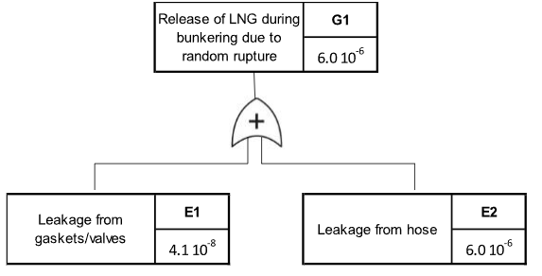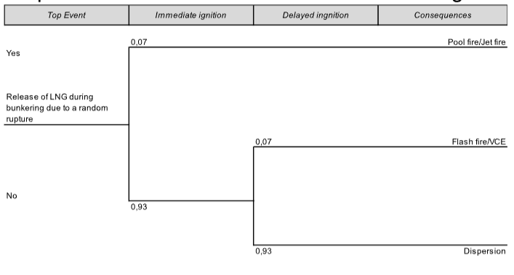
Figure 1: Worked example of the developed FT (left had side) and ET (right hand side).
Table 3 summarizes the main accidental scenarios identified. The final outcomes were assessed using validated consequence models relying on integral approach consequence analysis (Van Den Bosch and Weterings, 2005). Current availability of advanced simulation software, specifically Effect 11, (Gexcon AS.) was exploited to determine the maximum damage distances of hot scenarios, according to established threshold values
Table 3: Accidental scenarios summary
Scenario | Frequency  [occ y⁻¹] | Distance  [4kW m⁻² LFL⁻¹] | IR  [fatality y⁻¹] | Status
Jet Fire | 4.2×10⁻⁷ | 25 m | 1.3×10⁻⁷ | Acceptable
Flash Fire | 3.9×10⁻⁷ | 45 m | Zone-based | Safety Zone ​
VCE | 3.9×10⁻⁷ | 15 m | <10⁻⁸ | Acceptable ​

To define maximum risk contours, modelling conservatively considered following stability classes: D5 (day)/F2 (overcast). In order to account for the impact of the actual height of the release over the sea on the extent of the damage areas, three representative releases were considered in performing accident scenario simulations, i.e.,
- release at the height above sea level of the Lower Manifold of the Bunker vessel;
- release at sea level from the lowest point of the hose, conservatively considered to be 1 m;
- release at sea level from the manifold of the receiving vessel.
3.2.1 Definition of the Safety Zone and individual risk
The Safety Zone represents the critical boundary where explosive atmospheres could form following a maximum credible release (TE01/TE02). According to enforced Italian regulations (MIT 2025, VVF-CP 2021) the evaluation corresponds to the distance to the Lower Flammability Limit (LFL = 5% vol. for methane), considering the worst-case flash-fire scenario. Within this exclusion zone, strict controls prevent ignition sources, public access, and high-risk activities.
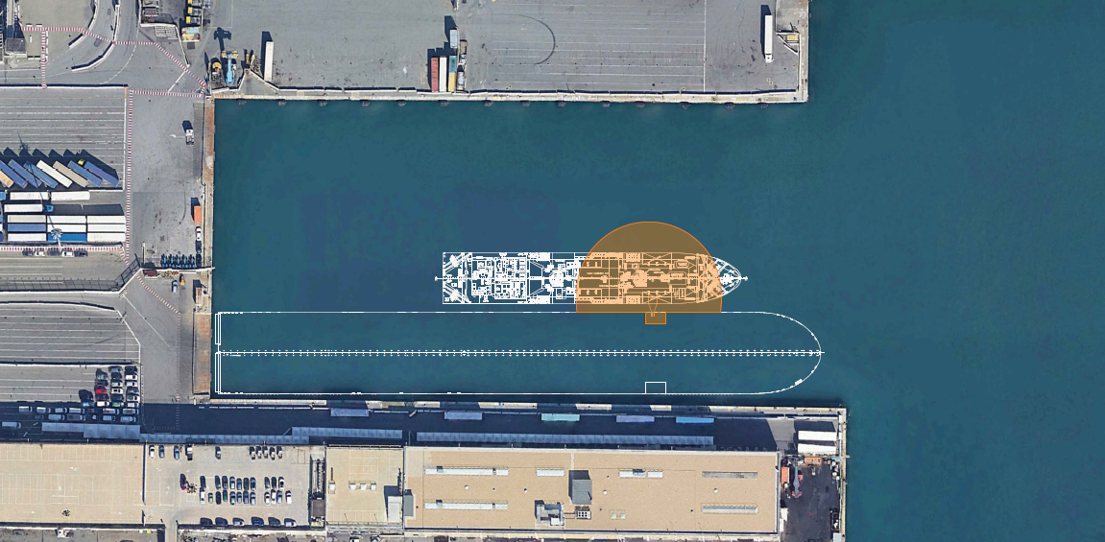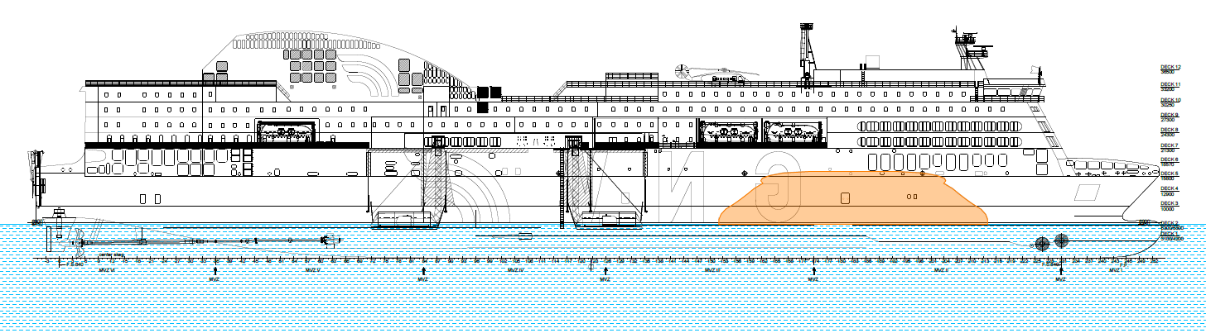
Figure 2: Safety Zone extent a (left hand side) top view; b (right hand side) - longitudinal view.
The Safety Zone extends 45 meters radius from the release point, as clearly depicted in Fig. 2 a,b showing respectively the top and longitudinal ship views. The overall safety zone encompasses onboard and external exclusion zone, as follows:
- Inside zone (0-45m): No personnel except essential crew; no hot work, vehicles, or smoking;
- Outside zone (>45m): Normal passenger embarkation allowed.
Considering the results of the performed simulations, the Safety Zone corresponds to the high-lethality damage area associated with the Flash fire scenario.
Practical implementation in the urban port needs integrating robust, risk-based mitigation measures, including potential structural shielding, strict ignition source controls, and enhanced emergency response planning within the potential impact distance:
- Bunker vessel → 45m exclusion radius clears adjacent berths;
- Passenger gangways → Outside zone (typically 60m+ from manifold);
- Terminal buildings → 200m+ distance, no-exposure;
- Tug boats → Stationed at safe distance during bunkering.
For the relevant scenarios, the individual risk IR was calculated, provided that all the safety procedures are strictly followed, obtaining the results summarized in Table 3 for all target groups.
Table 4: Individual risk for all considered target groups.
Target | Location | Jet Fire IR [y⁻¹] | Status
Crew | On deck near manifold | 1.34×10⁻⁷ | Acceptable​
Passengers | Gangway (outside Safety Zone) | <10⁻⁸ | Negligible
Terminal Workers | Quay, distance > 60m | <10⁻⁹ | Negligible
Public | Terminal buildings at distance > 200 m | <10⁻¹⁰ | Negligible

3.2.2 SIMOPS
To identify the simultaneous operations allowed during bunkering (SIMOPS), when the risk-based approach is used, VVF-CP 2021 matrix permits Category A operations for scenarios <10⁻⁶ occ/year. Category A operations (SIMOPS Category A) refer to the lowest-risk simultaneous activities permitted during LNG bunkering under Italian regulations, specifically when QRA scenarios have frequencies below 10⁻⁶ occurrences per year and medium/low consequences. These are typically low-hazard tasks outside or on the edge of the Safety Zone:
- Passenger embarkation/disembarkation (relevant key condition for Genoa ferries);
- Essential crew movements and monitoring;
- Non-sparking vehicle traffic for logistics (e.g., supplies);
- Cold maintenance or inspections;
- Normal terminal operations beyond exclusion zone.
Table 5 summarizes the results of the assessment covering SIMOPS.
Table 5: Outline of SIMOPS evaluation.
Location | Category A Allowed | Category B Prohibited
Inside Safety Zone (0-45m) | Skeleton crew only | Hot work, vehicle movement, passenger access​
Inside Safety Zone (0-45m) | Skeleton crew only | Hot work, vehicle movement, passenger access​
Terminal Buildings (>200m) | All normal operations | None

Simultaneous operations (SIMOPs) for the Port of Genoa, conducted alongside LNG bunkering, were identified through expert elicitation. In particular, these operations include passenger gangways positioned at least 60 m from the manifold, tugs maintained at a designated exclusion distance, and continuous VHF coordination with the Fire Brigade (VVF) and Coast Guard.
Table 6 provides a summary of the conservative results derived from the comprehensive risk assessment.
Table 6: Summary of the assessment procedure in the selected urban port.
Risk Element | Metric | Value | Regulatory Status
Safety Zone | Radius | 45 m | Defined per MIT/VVF
Dominant Risk | Jet Fire IR | 1.34×10⁻⁷ y⁻¹ | <10⁻⁶ Acceptable
SIMOPS | Category | A (outside zone) | Permitted
Public Exposure | All groups IR | <10⁻⁸ y⁻¹ | Negligible ​
  - Conclusions
The proposed QRA methodology applied to Genoa urban-port environment shows the requirements for safe LNG STS bunkering for passenger vessels, fully complying with Italian individual risk limits in the explored context, while clearly defining the extent of the Safety Zone and relevant SIMOPS constraints (Category A). The probabilistic approach, featuring detailed FTA/ET synthesis and port-specific operational modifiers (α_{OP}=1.3 for traffic and SIMOPS) represent an added value to deterministic analysis, making the framework transferable to other Italian ports potentially characterized by high passenger traffic density. The key result is that the first bunkering operation in Genoa ferry terminal was completed incident-free, within an effective research coordination among University of Genoa, Grandi Navi Veloci, AXPO, Port Authority, and Fire Brigade.
Further refinement of the overall approach may include:
- Standardize the α_OP modifier for urban ports upon validation on extended layout characteristics dataset.
- Implement STCW-specific SIMOPS Category A training for crews.
- Monitor real-world data to validate QRA frequencies, in the perspective of an overall dynamic resilience assessment.
A limitation of this preliminary study, also in view of other applications, is the need of accounting for additional LOC triggering causes, depending on their relevance for the analyzed context, e.g., man-induced accidents, due to high stress or lapses, collisions, harsh environment failures, extreme weather events. The pilot study can provide a general framework for the development of risk-based criteria and a practical benchmark for LNG bunkering implementation in Italian port environment. Additionally, if correctly implemented and validated through multi-stakeholder cooperation, this approach can facilitate effective port management, ensuring a safe maritime energy transition while upholding public safety regulations.

Acknowledgments
Funded by the European Union - NextGenerationEU and by the Ministry of University and Research (MUR),
National Recovery and Resilience Plan (NRRP), Mission 4, Component 2, Investment 1.5, project “RAISE -
Robotics and AI for Socio-economic Empowerment” (ECS00000035). Bruno Fabiano is part of RAISE
Innovation Ecosystem.
References
Aneziris O., Koromila I.A., Nivolianitou Z., 2022, Risk assessment for ship-to-ship LNG bunkering, Chemical Engineering Transactions, 90, 19-24
Aneziris O., Koromila I., Nivolianitou Z., 2020, A systematic literature review on LNG safety at ports, Safety Science, 124, 104595.
DNV AS, 2025, Energy Transition Outlook Maritime forecast to 2050, DNV AS Publ. Høvik, Norway
Fabiano B., Pettinato M., Currò F. Reverberi A.P., 2025, Safety concerns for ammonia as a green energy vector and the role of spray curtains for Its accidental release mitigation, Energies 2025, 18, 3412.
Fu S., Yan X., Zhang D., Li C., Zio E., 2016, Framework for the quantitative assessment of the risk of leakage from LNG-fueled vessels by an event tree-CFD, J. of Loss Prevention in the Process Industries, 43, 42-52
HSE, 2019, Failure rate and event data for use within risk assessments (02/02/19), Available at: http://www.hse.gov.uk. Accessed 15.04.2026.
ISO/TS 18683, 2021, Guidelines for safety and risk assessment of LNG fuel bunkering operations. International Organization for Standardization, Geneva, Switzerland.
Italian Ministry of Infrastructures and Transports (MIT) 2025. Linee guida per la disciplina del bunkeraggio Ship to Ship di GNL e Bio GNL nei porti italiani. Italian Ministry of Infrastructures and Transports.
Jeong, B., Lee, B.S., Zhou, P., Ha, S.-m., 2018, Determination of safety exclusion zone for LNG bunkering at fuel-supplying point. Ocean Engineering 152, 113–129.
Miranda A., Sanchez A., Marton I., Martorell S., 2025, Bunkering reliability index for LNG bunkering operations considering uncertainty, Journal of Loss Prevention in the Process Industries 93, 105485.
Ovidi F., Landucci G., Picconi L., Chiavistelli T., 2018, A risk-based approach for the analysis of LNG carriers port operations, In: Proceedings of the 28th European Safety and Reliability Conference (ESREL), 1655-1663, Taylor & Francis Group, London, UK.
Vairo T., Gualeni P., Reverberi A.P., Fabiano B. 2021, Resilience dynamic assessment based on precursor events: Application to ship lng bunkering operations, Sustainability 13, 6836.
Vairo T., Guarino S., Benvenuto A., Fabiano B., Setola R., 2026, Emergent risks in complex systems: A Bayesian perspective on uncertainty and prediction, Reliability Engineering & System Safety, 270, 112129.

