 CHEMICAL ENGINEERING TRANSACTIONS  VOL. xxx, 2026 | A publication of  
The Italian Association
of Chemical Engineering
Online at www.cetjournal.it

Guest Editors: Valerio Cozzani, Bruno Fabiano, Genserik Reniers
Copyright © 2026, AIDIC Servizi S.r.l.
ISBN 979-12-81206-xx-x; ISSN 2283-9216

CFD analysis of a realistic incidental scenario in a refuelling station: a comparison between LPG and hydrogen
Sara Ciria, Valentina Busini*
Politecnico di Milano, Department of Chemistry, Materials and Chemical Engineering "Giulio Natta", Piazza Leonardo da Vinci, 32, 20133, Milan, Italy
valentina.busini@polimi.it
Due to the constantly increasing energy demand and the necessity to find an alternative to polluting sources, hydrogen has been found as a viable alternative fuel, suitable for both the domestic and industrial usage. In the latest years, its suitability for the automotive sector has been investigated, leading to the conclusion that hydrogen might be the future of the transportation sector. However, because of its physical properties and reactivity, its handling denotes the growth of the safety issues already affective the usage of fossil fuels.
The aim of this paper is to simulate via CFD the leakage of LPG built on a realistic accidental scenario, occurred in Rome, Italy, on July 4th, 2025, with a simplified model. The simulation is then compared to a hypothetic scenario with the same geometric model, where hydrogen is the fuel and it is stored in the tank at its typical storage conditions for the gaseous phase. In this way, it is possible to check the difference in the dimension of the flammable cloud created and the values of overpressure generated by the two potential explosions.
The results of this comparison prove the need for more investigations on hydrogen safety if used for daily life applications, to determine which are the more suitable prevention and protection measures.
  - Introduction
Nowadays the world is facing a constant increase in the energy demand. However, this must be compatible with the targets imposed by law for the emissions in atmosphere to limit the emission of CO₂ (Suzuki et al., 2021), reach the net-zero goal and limit to 1.5°C the temperature increase, as stated in the Paris Agreement.
Given its nature of efficient energy carrier and substitute for fossil fuels, hydrogen was found as a viable alternative for providing energy at limited emissions, and its implementation would cover several applications, from the domestic to the industrial sector. However, its physical-chemical properties, such as wide explosive range, low minimum ignition energy (Suzuki et al., 2021), fast flame speed (Xiao et al., 2024) and high chemical reactivity, prove the presence of hazards in hydrogen handling. In addition, due to its nature it is complicated to detect the ignition source in presence of fires once a leakage has occurred and hydrogen has mixed with air because of its nature (Astbury and Hawksworth, 2007). The historical analysis on accidental scenarios involving hydrogen has shown, in fact, that most of them start with the release of the gas, and the consequent development of jet fires, flash fires, boiling liquid expanding vapor explosion (BLEVE). For these reasons, risk analysis is fundamental for the hydrogen economy.
Currently, one of the applications of intertest is the assessment of hydrogen refuelling stations (HRS), to support the transportation infrastructure and favour the spread hydrogen as fuel, instead of fossil fuels (e.g. Liquified petrol gas, LPG). This means that identifying all the hazards present in the station and the possible equipment failures is crucial for a correct estimation of the probability of occurrence of accidental scenarios, and for the application of the proper safety measures, in terms of prevention and mitigation of the risks. Indeed, the aim is to globally single out which are the safety barriers and distances required in each step of the design and construction of the refuelling station (Pique et al., 2017).
To evaluate the advantages of HRS, studies were performed to compare the feasibility of hydrogen as substitute (Casson Moreno et al., 2025). In this study, the comprehensive analysis of different fuels, such as compressed hydrogen (CH₂), liquid hydrogen (LH₂), LPG, liquefied natural gas (LNG), compressed natural gas (CNG), diesel and gasoline, confirmed hydrogen advantages for the environment. However, in terms of safety, LPG is still the best alternative. In fact, this technology has been already well implemented and validated, and the majority of the accidents in LNG refuelling stations which regard the storage tanks have already been analysed and assessed (Pique et al., 2022).
From the risk assessments performed, it was noticed that the typical mechanical failures involve vessels, pumps, compressors, pipelines and valves (Di Girolamo et al., 2023), resulting in fires and explosions (Giannelli et al., 2023). It is true that these scenarios are common also in HRSs, but the critical difference is in the storage conditions of the two fuels, being the pressure of CH₂ higher than the one of LPG (i.e., typically between 5 bar and 20 bar). In fact, HRSs are generally equipped with two levels of hydrogen compression, one at 200 bar for the first level of storage of the gas, and one at 700 bar for the dispensing of the gas.
In this paper, the comparison between an accidental leakage scenario of compressed hydrogen gas and LPG from a storage tank is presented, taking as reference a real accident occurred in Rome, Italy on July 4th, 2025. The aim is to compare the consequences of the two releases, and so highlight what is still missing for a safe shift towards HRSs.
  - Materials and methods
This section provides an overview of the scenario under investigation together with the construction of the model for the computational fluid dynamics (CFD) simulations of the LPG and hydrogen leakages, carried out through Ansys Fluent 2024R2.
    - Description of the scenario and construction of the geometry
On July 4th, 2025, an accidental explosion occurred at a petrol and LPG station in Rome, Italy. From a preliminary assessment performed to trace back the causes of the accident, it has been found that the refilling of the fixed underground tank of LPG might have been an initiator of the incident. This hypothesis finds support in several studies performed in the past years regarding which are the criticalities of the LPG chain and assessing the risks related (see the Introduction section). The phenomenon generated was a BLEVE. This means that the LPG inside the tank might have undergone excessive heating, becoming a superheated liquid above the boiling point and causing the rupture of the vessel due to the vapour expansion, with the further leakage.
A simplified model for a generic refuelling station was considered, and it includes the area for the storage, the area for the dispensers and the shop. For this analysis, it was assumed that the LPG discharge from the tank occurred in the area close to the shop, to consider a worse scenario for the safety of the people present in the store. The distance between the leakage and the area of the store and dispensers was set at 20 m. Only the environment above the ground was considered as domain and built as a box of dimensions 200x300x100 m³. In this way, the leakage of LPG was set to occur from a hole from the ground. Also, the presence of wind was considered in the domain, and was set as power law using the parameters of the atmospheric class D, which is one of the classes usually used for the environmental assessments of accidental leakage scenarios Ministry of the Environment, Italy, 1996). The same model was used for the simulation of the accidental release of hydrogen instead of LPG.
Figure 1 shows the geometric model used for the CFD simulations.

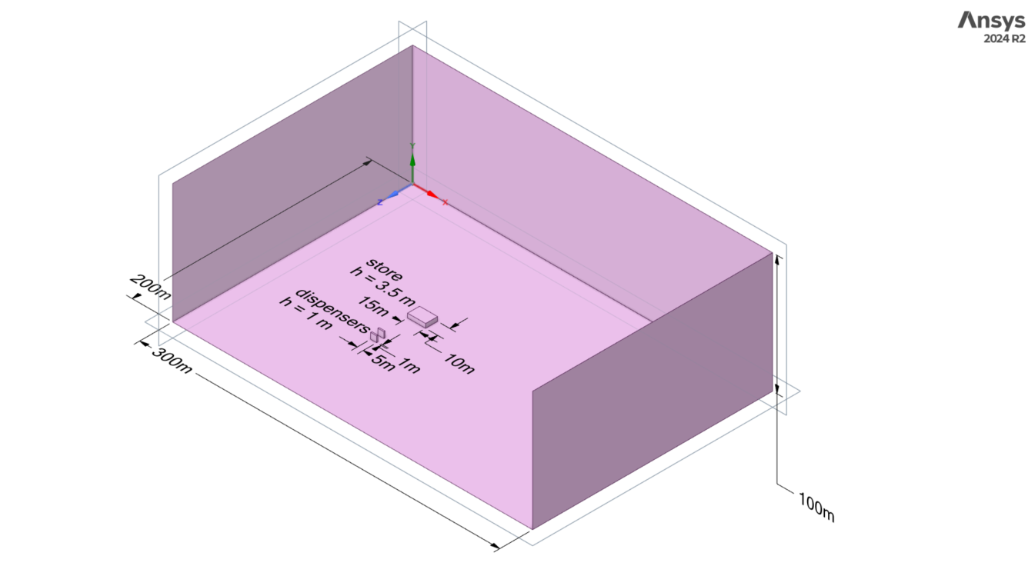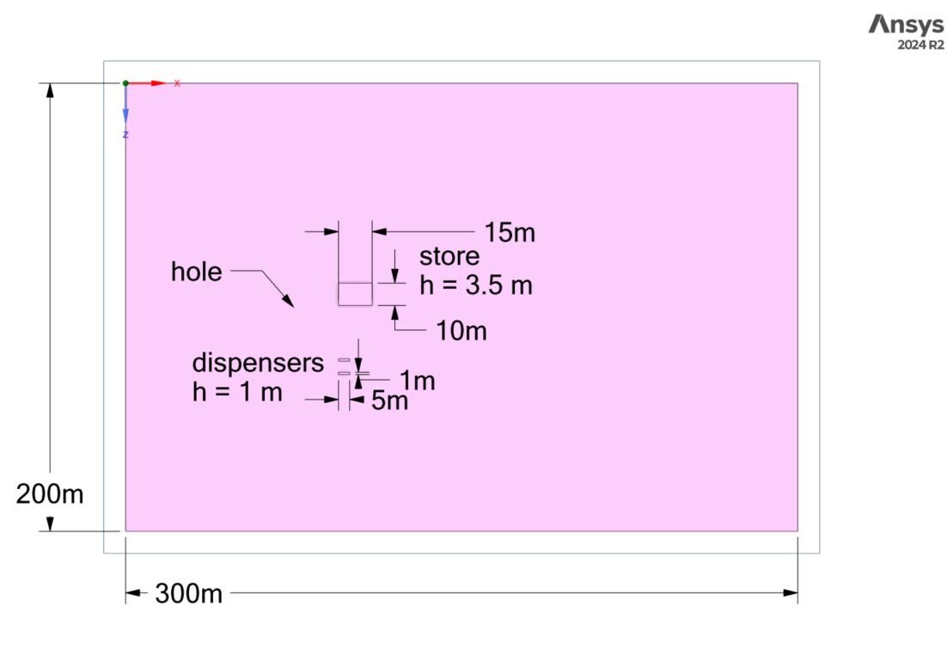
- (b)

Figure 1: (a) Close up on the geometric model for the CFD simulations with the measures of the box and the elements and (b) leakage position.

It was chosen to simulate the first 60 seconds of the release to analyse the difference between the LPG and hydrogen behaviours, since it was asserted that the event generated was a BLEVE, which is typical for being an abrupt event.
Table 1 reports the mass flux, the diameter of the surface of discharge and the composition of the two discharges, which were set in Ansys Fluent for the CFD simulation. A hole of 2 inches was set as leakage diameter. The values of mass flux and equivalent diameter reported in the table were estimated with the Birch correlation for the expanded nozzle theory (Birch et al., 1987), considering the storage and discharge chemical and physical properties typical of storage conditions of the two fuels (5 bar for LPG and 200 bar for hydrogen), as mentioned in the Introduction. These two different storage conditions imply that the release of hydrogen will occur at a sensibly higher pressure, which corresponds to a higher mass flux and equivalent diameter, resulting in a more catastrophic scenario, further enhanced by the larger limits of flammability.
Table 1: Properties of the releases
Hydrogen release simulation  (mixture of hydrogen and air) |  | LPG release simulation  (mixture of propane, butane and air)
Mass flux [kg/s] | 21.7 | Mass flux [kg/s] | 2.58
Equivalent diameter of the hole [cm] | 40.5 | Equivalent diameter of the hole [cm] | 7
Composition [-] | 1 / 0 | Composition [-] | 0.7 / 0.3 / 0

    - Mesh
The construction of the mesh was performed using the Body of Influence tool of Ansys (Ferrario and Busini, 2024), which helps with the refinement of the mesh in specific areas of the domain. Two meshes were created, the first with finer elements.
For this case study, an axis passing through the area of discharge was used for the definition of 5 bodies, and specific element size and growth rate values were associated to each body. Considering the overall height of the domain the bodies were created so that they reached respectively the height of 5 m, 10 m, 10 m, 25 m and 50 m. In this way, a small cell size was chosen for the mesh close to the release area, for the behaviour of the leakage defined by the calculation to be as close as possible to the real one. Thanks to the mesh independence analysis, once the height increased, as reported in Table 2, the cell size was increased as well to cover the boarder parts of the domain to avoid heavying the computational time, since those areas are less interested by the phenomenon. The table also reports the element size used for the leakage surface, which was not variated.
Table 2: Sizing of the elements of the mesh
 |  | Finer mesh |  | Wider mesh
Name | Height | Element size | Growth rate | Element size | Growth rate
Area of discharge | 0 m | 0.01 m | 1 | 0.01 m | 1
Core | 5 m | 0.025 m | 1.05 | 0.05 m | 1.05
Far_1 | 10 m | 0.05 m | 1.1 | 0.1 m | 1.1
Far_2 | 10 m | 0.1 m | 1.15 | 0.5 m | 1.15
Far_3 | 25 m | 0.75 m | 1.2 | 1 m | 1.2
Far_4 | 50 m | 1 m | 1.2 | 1.5 m | 1.2

Figure 2 shows the wider mesh created.


Figure 2: Effect of the Body of Influence tool in the construction of the mesh of the domain of simulation.
  - Results and discussion
The relevant data to observe are the ones related to the volume of the flammable cloud created by the mixing with air. Table 3 reports the flammability limits considered. The flammability limits for LPG are always given in as a range of values, provided that LPG composition might be slightly different depending on LPG application.
Table 3: Flammability limits of the two fuels
Gas | LFL | UFL
Hydrogen | 4% | 75%
LPG | 1.9% | 9.5%

Figures 3-8 show the contours of the flammable cloud formed respectively by hydrogen (on the left) and LPG (on the right) in air throughout time, given by the mesh with the element sizes reported in Table 2. The scales refer to the flammability limits reported in Table 3.

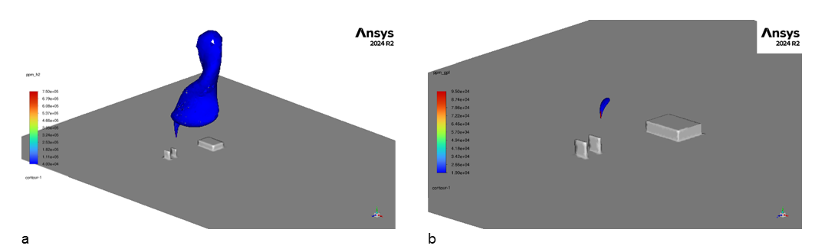
Figure 3: (a) Contour of the flammable cloud for the hydrogen leakage and (b) contour of the flammable cloud for the LPG leakage (right) at 10 seconds.

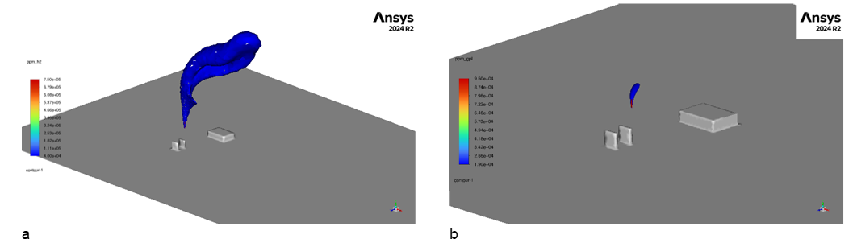
Figure 4: (a) Contour of the flammable cloud for the hydrogen leakage and (b) contour of the flammable cloud for the LPG leakage (right) at 20 seconds.
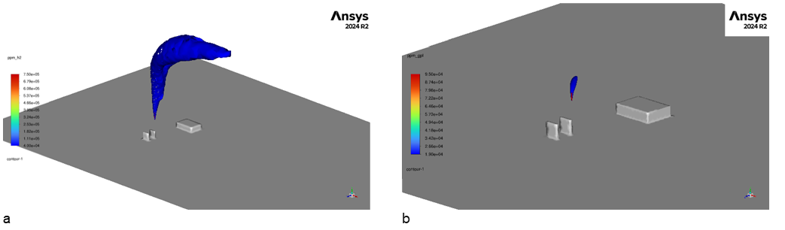
Figure 5: (a) Contour of the flammable cloud for the hydrogen leakage and (b) contour of the flammable cloud for the LPG leakage (right) at 30 seconds.

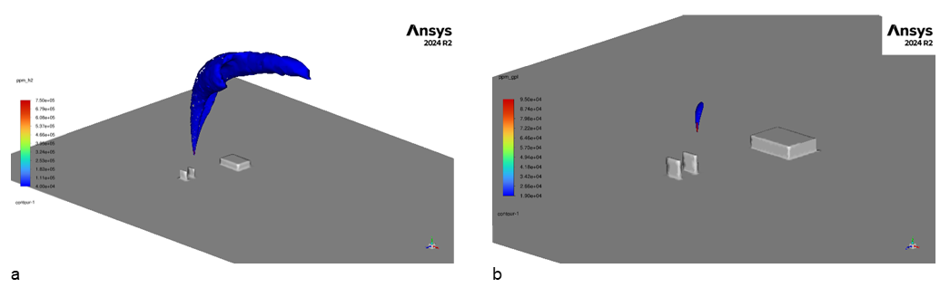
Figure 6: (a) Contour of the flammable cloud for the hydrogen leakage and (b) contour of the flammable cloud for the LPG leakage (right) at 40 seconds.

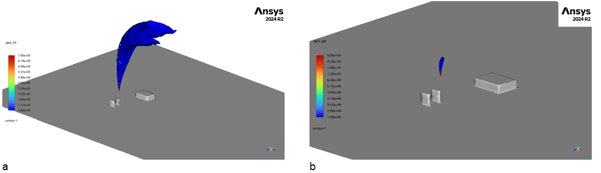
Figure 7: (a) Contour of the flammable cloud for the hydrogen leakage and (b) contour of the flammable cloud for the LPG leakage (right) at 50 seconds.

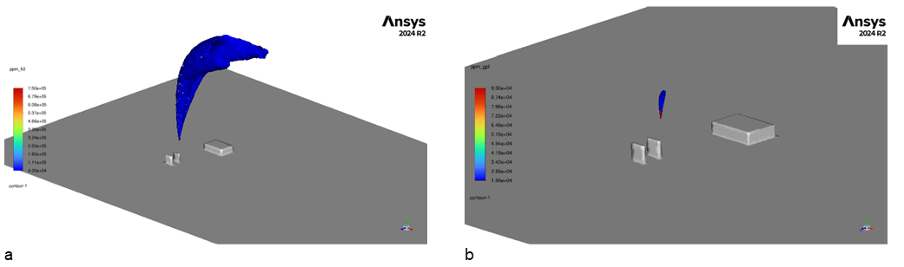
Figure 8: (a) Contour of the flammable cloud for the hydrogen leakage and (b) contour of the flammable cloud for the LPG leakage (right) at 60 seconds.

The contours show that the flammable zone created by hydrogen and air is greater than the one due to LPG and air, as expected given the values for the lower flammability limit (LFL) and upper flammability limit (UFL) ranges and the boundary conditions of the two discharges. In fact, in the first case, the cloud rises far above the area of the fuel dispensers and the store already after 20 seconds of release, and it results more turbulent. On the other hand, in the second case, the behaviour of the cloud does not show significant variations throughout the time, and the cloud is more confined.
The volume occupied by the cloud after 60 seconds of discharge is in the order of magnitude of 10,000 m³ in the case of hydrogen and in the order of magnitude of 10 m³ in the case of LPG.
The overpressure values calculated using the TNT Equivalent Method at the distance of 20 m from the leakage point resulted in almost 3.4 bar for the H₂ release scenario and 0.4 bar for the LPG release scenario.
  - Conclusions
The comparison between the scenarios of hydrogen and LPG discharges from the storage area of a generic refuelling station was presented in this study. Starting from a real case scenario, the consequences of the two accidental releases in the atmosphere were analysed and proved that the flammable area created by the mixture of hydrogen with air resulted in a volume three order of magnitude greater than the one created by the mixture of LPG with air. This is, of course, related to the different physical-chemical properties of the two fuels and highlights the need for more investigation on the topic, if hydrogen will serve as substitution for LPG as fuel in the future years.
References
Astbury, G.R., Hawksworth, S.J., 2007, Spontaneous ignition of hydrogen leaks: A review of postulated mechanisms, International Journal of Hydrogen Energy, 32(13), 2178–2185.
Birch A.D., Hughes D.J., Swaffield, F., 1987, Velocity Decay of High Pressure Jets, Combustion Science and Technology, 52(1–3), 161–171.
Casson Moreno V., Vianna S., Landucci G., 2025, An integrated assessment of the safety, economic, and environmental impacts of hydrogen refueling stations in comparison to conventional fuel stations, International Journal of Hydrogen Energy, 185, 151929.
Di Girolamo C., Carra S., Monica L., Tonti A., 2023, Risks in Loading and Unloading LPG at Storage Sites: Analysis of a set of Quasi-accidental Events, Chemical Engineering Transactions, 99, 343-348.
Ferrario F., Busini V., 2024, Statistical analysis of modelling approaches for CFD simulations of high-pressure natural gas releases, Results in Engineering, 21, 101770.
Gao X., Chen H., Zhou C., Xiong C., Pu W., Zeng T., Men J., Lv H., Zhao Y., Chen G., 2026, A review of safety risk management strategies for hydrogen refueling stations, Renewable and Sustainable Energy Reviews, 116297.
Giannelli G., Grillone G., Muratore A., Nastasi V., 2023, Risk Assessment of Lpg Release Scenarios, Chemical Engineering Transactions, 104, 127-132.
Ministry of the Environment. (1996). Criteria for the analysis and evaluation of safety reports concerning liquefied petroleum gas (LPG) and petroleum storage facilities. (Ministerial Decree of May 15th, 1996), Official Gazette, General Series, n. 113, July 9th, 1996 (in Italian).
Pique S., Weinberger B., De-Dianous V., Debray B., 2017, Comparative study of regulations, codes and standards and practices on hydrogen fuelling stations, International Journal of Hydrogen Energy, 42, 7429-7439.
Pique S., Quesnel S., Weinberger B., Nouvelot Q., Houssin D., Vyazmina E., Torrado D., Saw J.-L., 2022, Preliminary risk assessment of hydrogen refuelling stations in a multifuel context, Chemical Engineering Transactions, 90, 229-234.
Suzuki T., Shiota K., Izato Y., Komori M., Sato K., Takai Y., Ninomiya T., Mikaye A., Quantitative risk assessment using a Japanese hydrogen refueling station model, International Journal of Hydrogen Energy, 46, 8329-8343.
Xiao H., Li B., Shu C.-M., Dynamic risk analysis of hydrogen refueling station gas cloud explosions based upon the bow-tie perspective, 2024, International Journal of Hydrogen Energy, 82, 89-101.

