 CHEMICAL ENGINEERING TRANSACTIONS  VOL. xxx, 2026 | A publication of  
The Italian Association
of Chemical Engineering
Online at www.cetjournal.it

Guest Editors: Valerio Cozzani, Bruno Fabiano, Genserik Reniers
Copyright © 2026, AIDIC Servizi S.r.l.
ISBN 979-12-81206-xx-x; ISSN 2283-9216

Effect of water immersion on properties of biocarbon pellets
Liang Wang*, Jørn Bakken
ª SINTEF Energy Research, Sem Sælands vei 11, NO-7034 Trondheim, Norway
liang.wang@sintef.no
Biocarbon is considered a promising alternative to fossil carbon for metal production, primarily for its potential to reduce greenhouse gas emissions. However, native biocarbon is often brittle and lacks mechanical strength, which causes it to fragment or break into pieces, leading to the formation of fines and dust. This material loss, coupled with the risk of dust explosions and negative impacts on worker health, presents a significant challenge. Densification is an effective way to upgrade biocarbon into products (e.g., pellets and briquettes) with enhanced mechanical properties and increased mass/energy density. Nevertheless, short-term exposure to rain or high humidity during transportation and storage can negatively affect the quality of these densified products. In this work, we investigated the hydro-stability of biocarbon pellets through water immersion tests. The immersion time ranged from 10 minutes to 2 weeks. Following the immersion tests, the pellets were air-dried, with weight measurements taken regularly. The water uptake capacity (indicated by weight gain) of the biocarbon pellets increased gradually over the first half hour and then stabilized until the 1-hour immersion mark, after which it considerably increased with longer soaking times. During the air-drying process, the weight of the water-immersed pellets continuously decreased. The final weights after one week of air-drying were slightly lower than the initial weights, indicating material loss occurred during water immersion. The impact of water immersion on the mechanical properties was assessed using tumbler and hardness tests. The results clearly showed that water immersion had a significant negative impact on the durability of the biocarbon pellets. The mechanical durability of the studied pellets decreased from 97.64% to 96.13% after one week of immersion, and further to 91.76% after two weeks. Consequently, a greater amount of fines was generated after the tumbler tests as the immersion time increased. Furthermore, water immersion also caused a decrease in the hardness of the biocarbon pellets to varying extents. Results from this work indicate that densified biocarbon, such as pellets, requires proper storage and transportation protocols to avoid intensive contact with moisture and water. Even a short exposure time can have detrimental effects on mechanical properties and increase risks and vulnerabilities related to dust formation.
  - Introduction
The metal production industry is one of the most carbon-intensive sectors globally. The transition from fossil-based reductants to biocarbon is currently the most viable short-to-medium-term strategy for decarbonizing this industry. The utilization of biocarbon (frequently termed biocarbon in industrial contexts) for metal production represents a critical pathway toward sustainable metallurgy, with the great potential to reduce fossil CO₂ emissions by metal production processes. Biocarbon produced via pyrolysis of sustainable biomass offers a "biogenic" alternative (Gul et al., 2021). Under international carbon accounting CO₂ released from burning biocarbon is considered carbon neutral because it was recently captured from the atmosphere by the plants during their growth. While biocarbon presents a promising path for decarbonization, its integration into industrial steelmaking is constrained by immense scaling requirements. The metallurgical industries currently rely on the annual consumption of tens of millions of tonnes of metallurgical coal and coke. Consequently, displacing even a marginal percentage of this fossil-based carbon necessitates the development of a vast and reliable biocarbon value chain - a task that presents both supply of material with sufficient amount and consistent properties and complex logistical challenge (Wang and Skreiberg., 2023). The transportation of biocarbon from production facilities to final industrial users is a sophisticated logistical operation. Because biocarbon is lightweight, porous, and mechanically fragile, its supply chain requires specialized handling to prevent material loss, moisture contamination, and safety hazards like spontaneous combustion and dust formation (Wang et al., 2018).
Biocarbon is a refined carbonaceous solid produced via pyrolysis, typically within a temperature range of 500-700°C (Wang and Skreiberg., 2023). This process yields a product with high fixed carbon and low volatile matter. However, biocarbon with porous structure has low mechanical strength compared to coke, leading to potential structural collapse, fragmentation and dust formation during storage, transportation and handling along the value chain. Densification of biocarbon is an effective way to improve properties of this unique material. Densification transforms biocarbon with loose structure into regularly shaped, densely structured products like pellets and briquettes to overcome the inherent limitations of raw biomass and biochar (Wang et al., 2018). This process is critical for converting biocarbon into a high-quality "energy and carbon carrier" that can effectively substitute fossil fuels in industrial sectors. Densification can significantly elevate the bulk density of biocarbon (typically 0.2 to 0.4 g/cm³) into a more compact form, which can reach up to 1670 kg/m³ (Ngene et al., 2024). This transformation increases the volumetric energy density, meaning more energy can be stored and moved in a smaller volume. Higher density leads to much more efficient logistics. It reduces the physical space required for storage and allows for more cost-effective hauling over long distances (Riva et al., 2021). Densified products exhibit significantly higher mechanical strength and durability compared to the biocarbon with fragile structure. This allows the material to remain intact and resist fragmentation during the physical rigors of transport, loading, and unloading. Moreover, biocarbon pellets and briquettes, in comparison to biocarbon chips or powder, are standardized and homogeneous material. This uniformity facilitates automatic feeding and stable operation in standard industrial equipment. Mechanically compressing biocarbon substantially reduces dust generation and fines (Riva et al., 2021). This minimizes mass losses during handling and improves the safety of the working environment. Additionally, the regular shape and compressed nature of densified biocarbon promote homogeneous conversion behaviour and a longer reaction time, with achievement of greater thermal regularity (Riva et al., 2019). In brief, densification of biocarbon can increase bulk and energy density, reduce transportation and storage costs and improve mechanical strength and durability to prevent safety related issues related to formation of dust and fines.
However, densified biocarbon is susceptible to varying levels of mechanical degradation during storage, transportation and handling. This structural failure typically results from compressive and abrasive forces generated as the densified biocarbon interact with one another and the internal surfaces of transport vehicles (Ngene et al., 2024). Furthermore, physical attrition is exacerbated during high-energy transfer events, such as drops from conveyor belts, chutes, and bins, or during off-loading from trucks. Beyond mechanical strength, water resistance is a vital characteristic of the densified biocarbon (García et al., 2021). High moisture/water resistance is a prerequisite to ensure the densified biocarbon remain impermeable to water and maintain their physical form when exposed to environmental humidity or direct contact with water during transit. To the best of our knowledge, limited studies have focused on studying properties of densified biocarbon. Makgobelele et al., (2021) studied water resistance of the wood derived charcoal briquettes. Considerably better water resistance test results were obtained from the charcoal briquettes produced from addition of higher content of binder. In addition, exposure to water also affect structural integrity and caloric value of densified charcoal. However, the water resistance tests were conducted for a short period of time with only 2 hours (Makgobelele et al., 2021).
This study investigated water resistance and degradation of biocarbon pellets after they were immersed into water for different time. The pellets after water immersion tests were characterized regarding durability that is a key indicator of mechanical strength of the biocarbon quality. The results are important for ensuring the properties of biocarbon pellets and avoiding premature degradation, which are crucial for improving biocarbon value chain and increasing adoption of it for metallurgical applications.
  - Materials and method
In this work, the biocarbon was produced from Norwegian spruce saw dust through a pilot kiln reactor at temperature around 600°C. The produced biocarbon was crushed into powders and further pelletized. For a comparison purpose, biocarbon pellets were selected from two batches of densification processes for further studies.
    - Water immersion test
Water immersion tests were conducted by direct immersion of a single pellet in cold water. In accordance with the total immersion time, two kinds of tests were performed. For the first type of test, one pellet merged into the cold water was taken out and weighed in 10 minutes intervals over 1 hour. Afterwards, the same pellet was immersed in the cold water for the other 1 hour and weighed again. The pellet was then returned to the container to continue with the soaking in water. The same pellet was taken out again or weighing mass periodically for 12 hours, 24 hours and 1 week after the pellet sample was initially merged into the water. For the second type of test, one pellet was immersed into the water and kept in the container for 2 weeks continuously, which was taken out at the end of immersion test for measuring weight. During the weighing process, the pellet was held and gently shaken in the same ways (e.g., holding time and shaking times) over the opening of the container, in order to shake away water. The weight gain of one pellet was determined by weight measured after each water immersion time interval and the initial pellet weight. After the pellet was immersed into water, the integrity and structure changes of the pellet were continuously observed. In addition, the pellets after the first type water immersion test were also dried in air naturally to study loss of weight. One wet biocarbon pellet was loaded in a baker with measurement of with interval of 10 minutes in the first hour, 2 hour, 12 hours, 24 hours and 1 week. For each type of water immersion test, at least 6 pellets from pellet sample A and B were used. The average value of weight gain from the 6 pellets were plotted and displayed in Figure 2 below.
    - Durability of pellets
To evaluate impact of water immersion and further drying on the mechanical strength structural integrity of the pellets, durability (MD) was determined using an ISO Tumbler 1000+ (Bioenergy Institute, Vienna, Austria) in strict accordance with the ISO 17831-1 standard (Riva et al., 2021). The procedure involved loading a specific mass of pellets (mi) into a stainless-steel chamber, which was subjected to controlled mechanical stress via rotation at 50 rpm for 10 minutes (totalling 500 rotations). Following the tumbling cycle, the resulting material was screened through a 3.15 mm round-hole sieve to separate and remove the generated fines. The final mass of the intact pellets (m_{f}) was recorded to calculate the durability index using the following equation:
MD = 100x m_{f}/ m_{i}
Where:
- mi represents the initial pre-test sample mass.
- m_{f} represents the final mass of the pellets retained on the sieve post-test.
  - Results and discussion
    - Water immersion test
Figure 1 shows weight gain of biocarbon pellet sample A and B after water immersion tests at different time interval. Weight increase of sample A begins at 10 minutes water immersion and reaches approximately 24% by the end of the 10,080-minute (7-day) period. The data shows a relatively linear trend with an R² value of 0.9286. The same weight gain behaviour was observed from the pellet sample B as shown in the Figure 1. The graphs indicate a plateau or a "rather stable" weight gain period between 30 and 60 minutes of immersion. The initial 30 minutes likely involve the rapid filling of large surface macropores and the wetting of the pellet's exterior. Once the surface is fully saturated, the rate of water ingress slows down as it must then transition to internal transport mechanisms. In addition, as water enters the pellet, air trapped within the internal micro-pores can create back-pressure. This creates a temporary equilibrium where the water cannot easily displace the internal air, resulting in a stagnant weight gain until the air can slowly dissolve or escape (Ngene et al., 2024). Moreover, boundary water layer can also form on surface of the biocarbon pellet. It means a localized layer of high moisture may form around the pellet, temporarily slowing the diffusion rate until the concentration gradient changes enough to drive water further into the dense core (Makgobelele et al., 2021). After the 60-minute mark, specifically at 720, 1,440, and 10,080 minutes, both pellets show a significant further increase in weight. This is potentially because, over longer durations, water moves from the surface into the deeper micro-porous structure of the biocarbon through slow capillary action and diffusion. In addition, prolonged immersion can lead to the swelling of the biocarbon fibers or the breakdown of internal cell walls (Lee et al., 2020). This physical expansion opens up previously inaccessible internal volume, allowing the pellet to hold more water.
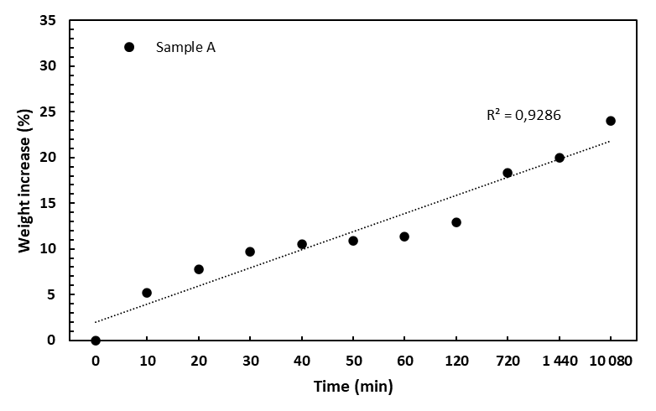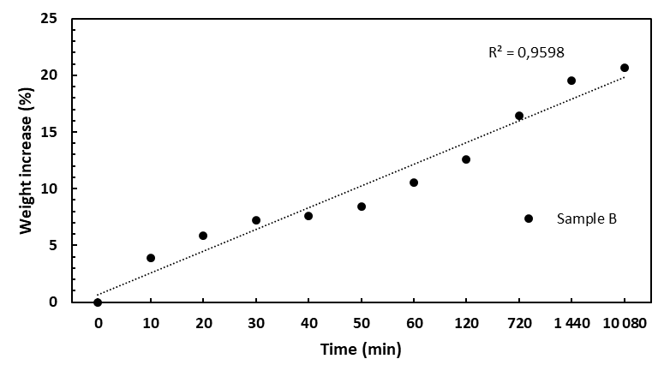
Figure 1: Weight gain of biocarbon sample pellet A and B after water immersion tests at different time interval
The Figure 2 illustrate a rapid decline in weight percentage relative to the initial weight as the drying time progresses. For the pellet sample B, after reaching a peak weight gain of roughly 21%, this sample loses weight more aggressively during drying. It crosses the 0% threshold much earlier than pellet sample A (around 720 minutes of drying) and ends significantly below the initial weight (approximately -2.5%) at the end of the test. The phenomenon where a pellet ends up lighter than its original state after a wetting-drying cycle can be attributed to several factors. During the immersion phase, water-soluble organic compounds or minerals within the biocarbon matrix can dissolve into the surrounding water (Ngene et al., 2024). When the water is removed during drying, these dissolved solids are gone, resulting in a net loss of mass. The physical stress of swelling (during immersion) and shrinking (during drying) can cause small fragments or "fines" to detach from the pellet surface. If these particles are lost in the water or during handling, the final weight will be lower than the initial weight. In addition, Immersion may displace gases trapped within the carbon pores. If the drying process effectively seals some of these pores or collapses the internal structure, the final density and mass could be altered.
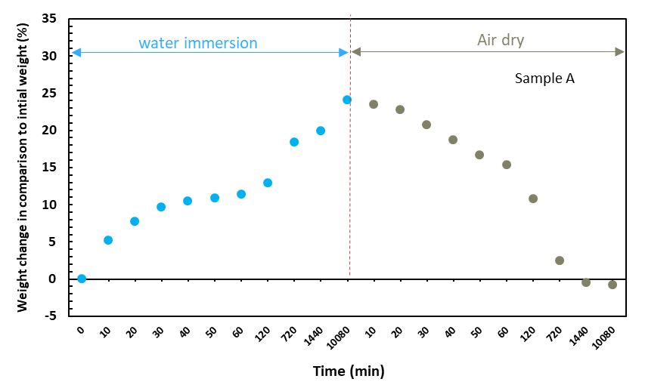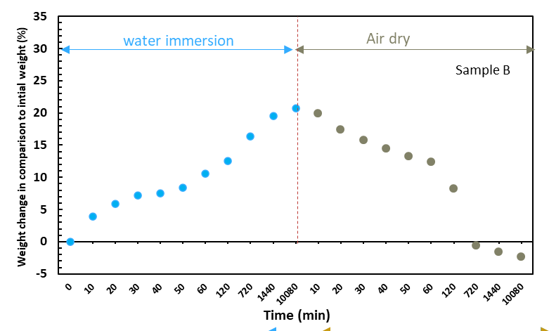
Figure 2: Weight gain and loss of biocarbon pellet sample A and B after water immersion tests and air dry at different time interval (each data point is average of 6 measurement)
    - Durability of the biocarbon pellets
The raw untreated, obtained from water immersion and further air dried biocarbon pellets were studied. Durability obtained from each individual raw untreated biocarbon pellet are plotted in Figure 3 below.
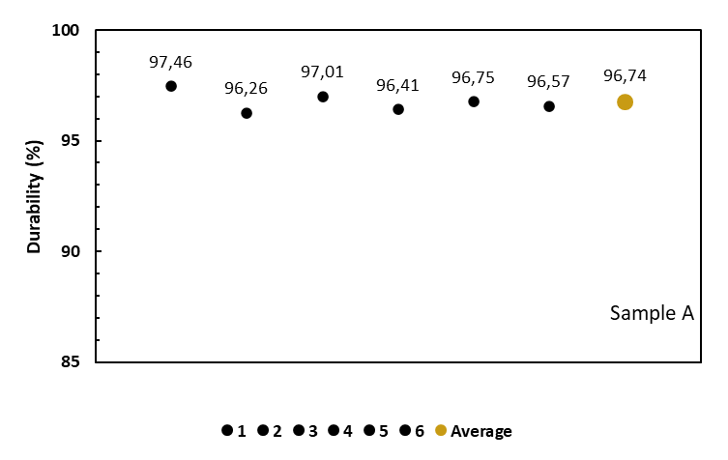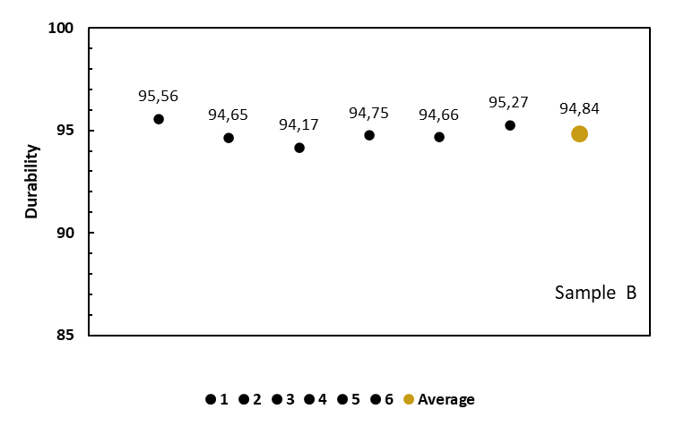
Figure 3: Durability of raw untreated biocarbon sample pellet
As shown in the Figure 3, the durability tests for both samples demonstrate that sample A generally maintains a higher physical integrity than pellet sample B. For the pellet sample A, individual durability scores range from a low of 96.26% to a high of 97.46%. The calculated average durability for sample A is 96.74%. The "slight variations" observed in the six individual test points for each sample (e.g., the dip to 94.17% in sample B) likely stem from minor inconsistencies in the manual pelletization process or local heterogeneities within the raw biocarbon material. High durability (above 95%, as seen in pellet sample A) indicates that the pellets can be transported via conveyors, trucks, or ships with minimal breakage. The higher durability also indicates that pellet A has lower tendency to generate of "fines" (dust). This reduces respiratory health risks for workers and minimizes the risk of dust explosions during storage, handling and transportation.
For the pellet sample A, durability drops from 96.74% in its "as received" state to 96.13% after one week of immersion, and further declines to 93.56% after two weeks of immersion and subsequent air drying as shown in Figure 4(a). For pellet sample B, this pellet shows a more significant sensitivity to water. Its initial durability of 94.84% falls to 94.06% after one week and sharply decreases to 91.76% when the immersion process is extended. The reduction in durability is mirrored by a corresponding increase in the generation of fines (small particles or dust produced during handling). For the pellet sample A, the weight percentage of fines nearly doubles from 3.22 wt% (as received) to 6.44 wt% after two weeks of immersion and drying (Figure 4(b)). On the other hand, for the pellet sample B, the generation of fines increases from 5.16 wt% to 9.24 wt%, indicating that nearly a tenth of the pellet’s mass becomes unstable after water exposure and drying. The data shown in Figure 4 indicates a clear trend: as the immersion time increases, the weight percentage (wt%) of fines also increases for both pellet types.
The generation of fines is the physical manifestation of the pellet's surface and internal structure breaking down. Prolonged exposure to water can dissolve or weaken the natural or added binders that hold the carbon particles together (Makgobelele et al., 2021). Once these bonds are compromised, particles easily shed from the surface during handling. Biocarbon is often porous. Water penetration causes the material to swell; subsequent air drying causes it to shrink. This repeated physical stress creates micro-cracks, making the pellet more brittle and prone to fragmentation. Water may wash out soluble components within the biocarbon matrix (Ngene et al., 2024). This leaves behind a more "honeycombed" or hollowed-out structure that lacks the density to resist abrasion, leading to higher fines generation.
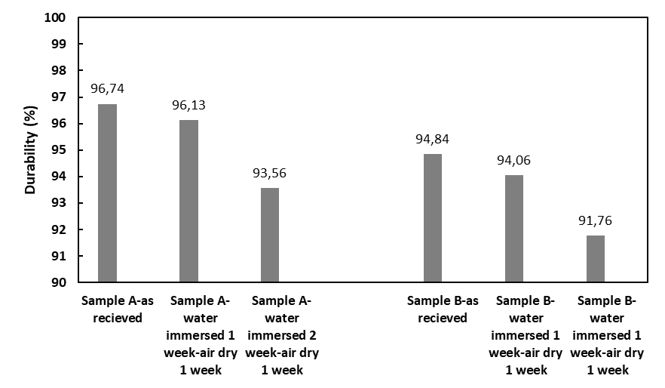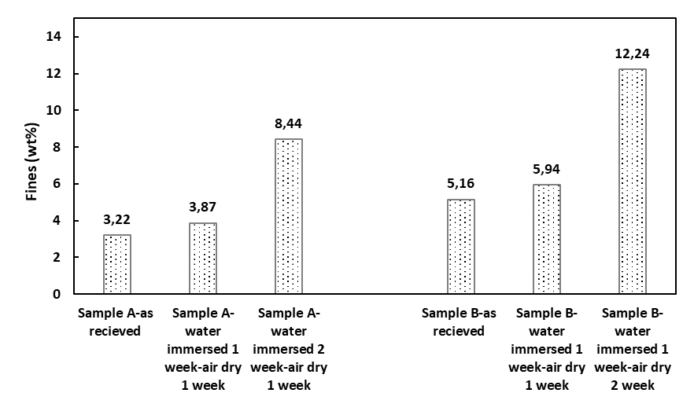
a
b
Figure 4: Durability (a) and fines generated after durability test (b) of biocarbon sample pellet before and after water immersion test and air dry
  - Conclusions
The comprehensive evaluation of two types of biocarbon reveals that moisture exposure and immersion duration are critical determinants of their structural integrity and logistical viability. The water immersion tests demonstrate a two-stage absorption process: an initial rapid uptake driven by the saturation of surface macropores and the pellet exterior, followed by a slower, more profound penetration into the deep micro-porous structure through capillary action and diffusion. A notable stabilization in weight gain between 30 and 60 minutes suggests a temporary equilibrium caused by internal air back-pressure and the formation of boundary water layers, which temporarily impede diffusion into the dense core. However, prolonged immersion-extending to 7 days-results in substantial weight increases of approximately 24% for sample pellet A and 21% for sample pellet B.
The subsequent air-drying phase highlights a significant risk of material degradation, particularly for sample B. Both samples exhibit a rapid decline in weight that eventually falls below their "as received" state, with sample B ending at approximately -2.5%. This net mass loss is possibly attributed to the leaching of water-soluble organic compounds and minerals, as well as the detachment of physical fragments caused by the mechanical stress of the swelling-shrinking cycle. Physically, sample pellet A demonstrates superior initial durability (96.74%) compared to sample pellet B (94.84%), making it more suitable for rigorous industrial handling and transport. However, water exposure severely compromises these practical handling limits for both types. As immersion time increases, durability scores drop significantly falling to 93.56% for pellet A and a critical 91.76% for sample pellet after two weeks. This degradation is directly mirrored by a sharp increase in fines generation, which nearly doubles for sample pellet A (3.22 wt% to 6.44 wt%) and reaches nearly a tenth of the total mass for sample pellet B (9.24 wt%).Ultimately, the generation of fines serves as a physical manifestation of internal structural failure caused by the weakening of binders and the creation of micro-cracks during moisture-induced stress. These findings indicate that while raw biocarbon pellets possess high initial durability, their high sensitivity to water necessitates strictly controlled, dry storage environments. Failure to protect these materials from moisture leads to increased waste through leaching and fines generation, while simultaneously elevating safety risks associated with dust explosions and respiratory hazards during industrial use.
Acknowledgments
The authors acknowledge support from the project Improving energy production and safety in biocarbon value chains (EnergyProSafe). The supports are through the funding from the Research Council of Norway (grant no: 353147) and financial support from the EnergyProSafe project industry partners.
References
Lee, J.S., Sokhansanj, S., Lau, A.K., Lim, C.J., 2020, Physical properties of wood pellets exposed to liquid water. Biomass and Bioenergy 142, 105748.
Gul E., Riva L., Nielsen H.K., Yang H., Zhou H., Yang Q., Skreiberg Ø., Wang L., Barbanera M., Zampilli M., Bartocci P., Fantozzi F. 2021, Substitution of coke with pelletized biocarbon in the European and Chinese steel industries: An LCA analysis. Applied Energy. 304, 117644.
García, R., Gil, M.V., Fanjul, A., González, A., Majada, J., Rubiera, F., Pevida, C., 2021, Residual pyrolysis biochar as additive to enhance wood pellets quality. Renewable Energy 180, 850–859.
Makgobelele, N.W., Mbaya, R.K.K., Bunt, J.R., Leokaoke, N.T., Neomagus, H.W.J.P., 2021, Evaluation of the mechanical properties of wood-derived charcoal briquettes for use as a reductant. Journal of the Southern African Institute of Mining and Metallurgy 121, 187–192.
Ngene, G.I., Bouesso, B., González Martínez, M., Nzihou, A., 2024, A review on biochar briquetting: Common practices and recommendations to enhance mechanical properties and environmental performances. Journal of Cleaner Production 469, 143193.
Riva L, Wang L, Ravenni G, Bartocci P, Buø T.V., Skreiberg Ø, Fantozzi F., Kofoed N. H. 2021, Considerations on factors affecting biochar densification behavior based on a multiparameter model. Energy. 221, 119893.
Riva L, Nielsen H. K., Skreiberg Ø, Wang L, Bartoccic P, Barbanera M, Bidini G, Fantozzi F. 2019, Analysis of optimal temperature, pressure and binder quantity for the production of biocarbon pellet to be used as a substitute for coke. Applied Energy. 256: 113933
Wang L., Skreiberg O., 2023, A Critical Review on Self-Heating and Self-Ignition of Biocarbon, Chemical Engineering Transactions, 105, 271-276
Wang L, Buvarp F, Skreiberg Ø, Bartocci P, Fantozzi F., 2018, A study on densification and CO2 gasification of biocarbon. Chemical Engineering Transaction. 65: 145-150.

