 CHEMICAL ENGINEERING TRANSACTIONS  VOL. xxx, 2026 | A publication of  
The Italian Association
of Chemical Engineering
Online at www.cetjournal.it

Guest Editors: Valerio Cozzani, Bruno Fabiano, Genserik Reniers
Copyright © 2026, AIDIC Servizi S.r.l.
ISBN 979-12-81206-xx-x; ISSN 2283-9216

Study on thermal stability and combustion characteristics of biocarbon
Liang Wangª, Reidar Stølen^{b}, Øyvind Skreiberg
ª SINTEF Energy Research, Sem Sælands vei 11, NO-7034 Trondheim, Norway
^{b} RISE Fire Research, Tillerbruvegen 202, 7092 Tiller
liang.wang@sintef.no
Biocarbon, produced from renewable biomass, possesses unique physical and chemical properties that allow its utilization in metal production to replace conventional reductants, thereby reducing the carbon footprint and enhancing sustainability in metallurgical industries. However, there are risk related self-ignition and firing of biocarbon with toxic emissions along values chains from production to end users. This study investigates the combustion characteristics of wood biocarbon using a cone calorimetry. During cone calorimetry tests, the heat release rate (HRR), peak HRR, total heat release (THR), mass loss, and CO and CO₂ release profiles were monitored for two particle size ranges: 0.5 ≤ d ≤ 1 mm and 4 ≤ d ≤ 6.3 µm. Significantly different results were observed based on particle size, demonstrating distinct flammability and combustibility behaviour. The smaller particle size yielded a higher THR 55.8 MJ/m², compared to the larger size (40.8 MJ/m²). Conversely, the smaller particles resulted in a lower peak HRR (28.7 kW/m²) than the larger particles (30.2 kW/m²). These differences are attributed to variations in bulk density and surface area within the sample holder. The higher bulk density of the smaller particles limits heat transfer but increases the total sample mass, thus increasing the THR. In both particle sizes, an ash layer formed on the surface, which likely hindered heat and mass transfer during the conversion of the underlying carbon material. These findings provide valuable data for assessing the ignition, combustion, and flammability properties of biocarbon. Results from the current study are valuable for assessing properties of biocarbon related to ignition, combustion and flammability.
  - Introduction
Biocarbon (often referred to as biochar or charcoal) is a renewable, carbonaceous material produced through the pyrolysis or carbonization of biomass materials. In the metallurgical industry, it serves as a promising sustainable alternative to fossil-based carbonaceous materials, such as coal and coke, which are traditionally used as energy sources and reductants to convert metal oxides into metal. The primary function of biocarbon in metal production is acting as a reductant (Wang et al., 2023). In processes like iron and steelmaking, solid carbon reacts with oxygen in the ore to produce metal, releasing gases in the process. Replacing fossil carbon with biocarbon offers several environmental and technical benefits. Biocarbon enables a biogenic carbon cycle, where the emitted during production is later sequestered by regrowing plants, significantly reducing the industry’s greenhouse gas footprint. Life Cycle Assessments (LCAs) indicate that replacing fossil reductants with biocarbon significantly lowers the global warming potential and carbon footprint of the resulting metal. Biocarbon is produced from largely available, low-cost renewable biomass, making it an economically attractive and sustainable resource (Gul et al., 2021). In addition, in comparison to conventional fossil reductant, the biocarbon typically contains lower content of sulphur. Upon using biocarbon, reduced sulphur emissions from metal production process can achieved (Wang et al., 2023). Furthermore, the properties of biocarbon are tailorable as the biocarbon production conditions (i.e., pyrolysis temperature, feedstock selection and post processing) allow control over fixed carbon content, porosity, and mechanical properties (Wang et al., 2023). While promising, because it is a reactive porous material, biocarbon can undergo self-heating and spontaneous self-ignition during storage and transport, leading to fire hazards. With the unique properties, biocarbon has distinctive combustion and conversion behaviours under oxidizing atmosphere (Wang et al., 2023). Despite growing interesting in using biocarbon for metallurgical applications, systematic investigations into biocarbon’s fire and combustion behaviour remain limited.
Cone calorimetry is widely used in fire science to quantify important combustion properties such as ignition behaviour, heat release rates, and gas emissions (Chaudhuri et al., 2025). When applied to biocarbon, this technique reveals how its unique physical and chemical characteristics influence flammability and combustibility - information essential for fire-resistant and safety engineering. Cone calorimetry studies on biocarbon investigate how biocarbon behaves under controlled heat fluxes representative of fire exposure. In addition, cone calorimetry enables a quantitative “fire profile” that can be compared across materials (e.g., biocarbon produced from different materials and under different condition) (Shanmugam et al., 2022). Das et al. examined the flammability of pine sawdust–derived biochar using a cone calorimetry. Notably, the biochar did not ignite under external radiant heat and resisted sustained combustion throughout the test duration (Das et al., 2017). This observation was related to the near-complete removal of volatile components during high-temperature treatment, leaving behind a stable carbon skeleton with minimal combustible gases. The tested material exhibited a low peak heat release rate (PHRR) of approximately 33 kW m⁻², a time to PHRR of about 305 s, and a total heat release of roughly 9 MJ m⁻²- values substantially lower than those of conventional polymeric materials (Das et al., 2017). Carbon dioxide emissions exceeded carbon monoxide emissions, consistent with progressive oxidation of the carbon matrix and subsequent conversion of CO to CO₂ in the presence of oxygen.
In contrast, Liu et al. investigated bamboo-derived biocarbon produced at relatively low carbonization temperatures (200–300 °C) and varying residence times. Their results demonstrated that combustion behaviour is highly sensitive to thermal processing conditions. Biocarbon prepared at lower temperatures exhibited shorter times to ignition and higher heat release rates, with PHRR values ranging between 55- and 135-kW m⁻² depending on processing parameters (Liu et al., 2014). Increased carbonization temperature and extended residence time reduced volatile matter content, thereby lowering heat release rates and enhancing fire resistance. Conversely, biochars produced at temperatures exceeding approximately 500 °C undergo extensive devolatilization, resulting in a rigid carbon framework characterized by strong C–C covalent bonding and improved thermal stability (Liu et al., 2014). Further insight into combustibility was provided by Wijayanta et al., who compared oak biochar and Taiheiyo coal under blast furnace conditions. Oak biochar produced at 564 °C demonstrated combustion behaviour broadly comparable to that of coal, although differences in volatile matter significantly influenced performance (Wijayanta et al., 2014). The oak biochar, containing 27 wt% volatile matter, exhibited substantially reduced combustibility relative to Taiheiyo coal, which contained 44.6 wt% volatiles. In the other work, Chaudhuri et al., studies combustibility of bamboo biochar using a cone calorimetry at a heat flux of 35 kW/m². The results showed that peak heat release rate (PHRR) of studied bamboo char is 47.6 kW/m² and a high total heat release (THR) of 67.8 MJ/m². Bamboo biochar produces lower levels of harmful pollutants than raw or torrefied bamboo (Chaudhuri et al., 2025). The average CO yield was 0.01015 kg/kg and the CO2 yield was 0.06917 kg/kg. The available literature demonstrates that the fire behaviour of biochar is not intrinsic but highly tuneable. Processing temperature, volatile content, structural evolution, and particle size collectively govern ignition, heat release, and overall combustibility of biocarbon. A more comprehensive understanding of these parameters is therefore essential for ensure biochar value chain with less safety related issues.
In this work, cone calorimetry was employed to evaluate the evolution of fire behaviours of biocarbon, with particular focus on effect of particle sizes. Key combustion characteristic parameters of biocarbon produced from the waste wood were obtained and assessed. In addition, release of CO₂ from the combustion process was monitored. The results from the current work are valuable for better understanding of fire behaviours of the biocarbon, which are important for safe and effective handling and utilization of biocarbon.
  - Materials and method
    - Biochar production
In this work, the biocarbon chips were produced from waste wood dust through a continuous pyrolysis reactor at a temperature around 600-650°C. For a comparison purpose, the produced biocarbon chips were sieved first and fractions with size in the range of 4-6.3mm and 0.5-1mm were used for further cone calorimetry tests. The sieved biochar was dried at 105 °C until the weight was stable.
    - Cone calorimetry test.
The flammability and combustibility of biochar sample was investigated using a using a Netzsch Taurus TCC 918 cone calorimeter (Weimar, Germany) in accordance with ISO 5660-1:2015. All tests were conducted under a constant external heat flux of 50 kW/m². Normally the standard protocol of running the cone calorimeter is for testing solid blocks according to ISO 5660. In this work, biocarbon chips were tested with a modified method. The biocarbon sample was loaded in a container with inner dimensions of 100(width) x 100(length) x 45 mm (height). The container was filled with the biocarbon with small and large particle sizes, with initial mass of 70 and 52 grams, respectively. Three type K thermocouples are embedded in the heating element of the cone calorimeter to provide feedback to PID controller to ensure the heater’s temperature stable, depending on the desired heat flux. To understand more details about thermal gradient and temperature profile of the loaded biocarbon sample, one thermocouple was placed in the middle of the biocarbon loaded in the container. Key results indicating combustion and flammability behaviours of biocarbon were obtained including t, peak heat release rate (PHRR), total heat release (THR), mass loss rate (MLR) and concentrations of O₂ and CO₂ in the flue gas.
  - Results and discussion
    - Temperature measurement and gas release
Figure 1 shows the biocarbon sample in the size range 0.5-1mm range before, during and after the cone calorimetry test. Throughout the test cycle, the biocarbon failed to ignite without observation of smoke and flame as well. Glowing of the biocarbon on top of the sample bed was observed along increase of measurement time. This is considerably different than reported in previous studies on cone calorimetry test on raw biomass with clear observation of flame related to intensive combustion of the tested material. The low and even no ignitability of the biocarbon can be related to near-complete removal of volatile components during high-temperature treatment, leaving behind a stable carbon skeleton with minimal combustible gases. Figure 1c shows the biocarbon after the cone calorimetry test with clear seeing of ash layer formed on top of the sample bed. Similar observations on the flammability and ash formation from cone calorimetry test of biocarbon have been reported in previous studies (Chaudhuri et al., 2025, Kaynak et al., 2025).

Figure 2 depicts temperature measured from the middle of the biocarbon sample bed in the container and the temperature measured from the cone and emitted smoke. The measured temperature changes along the temperature profile through different stages.
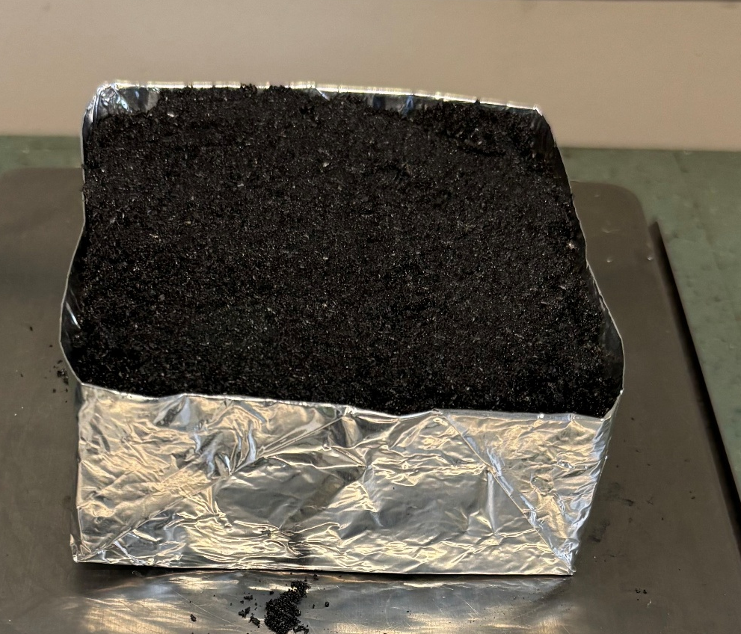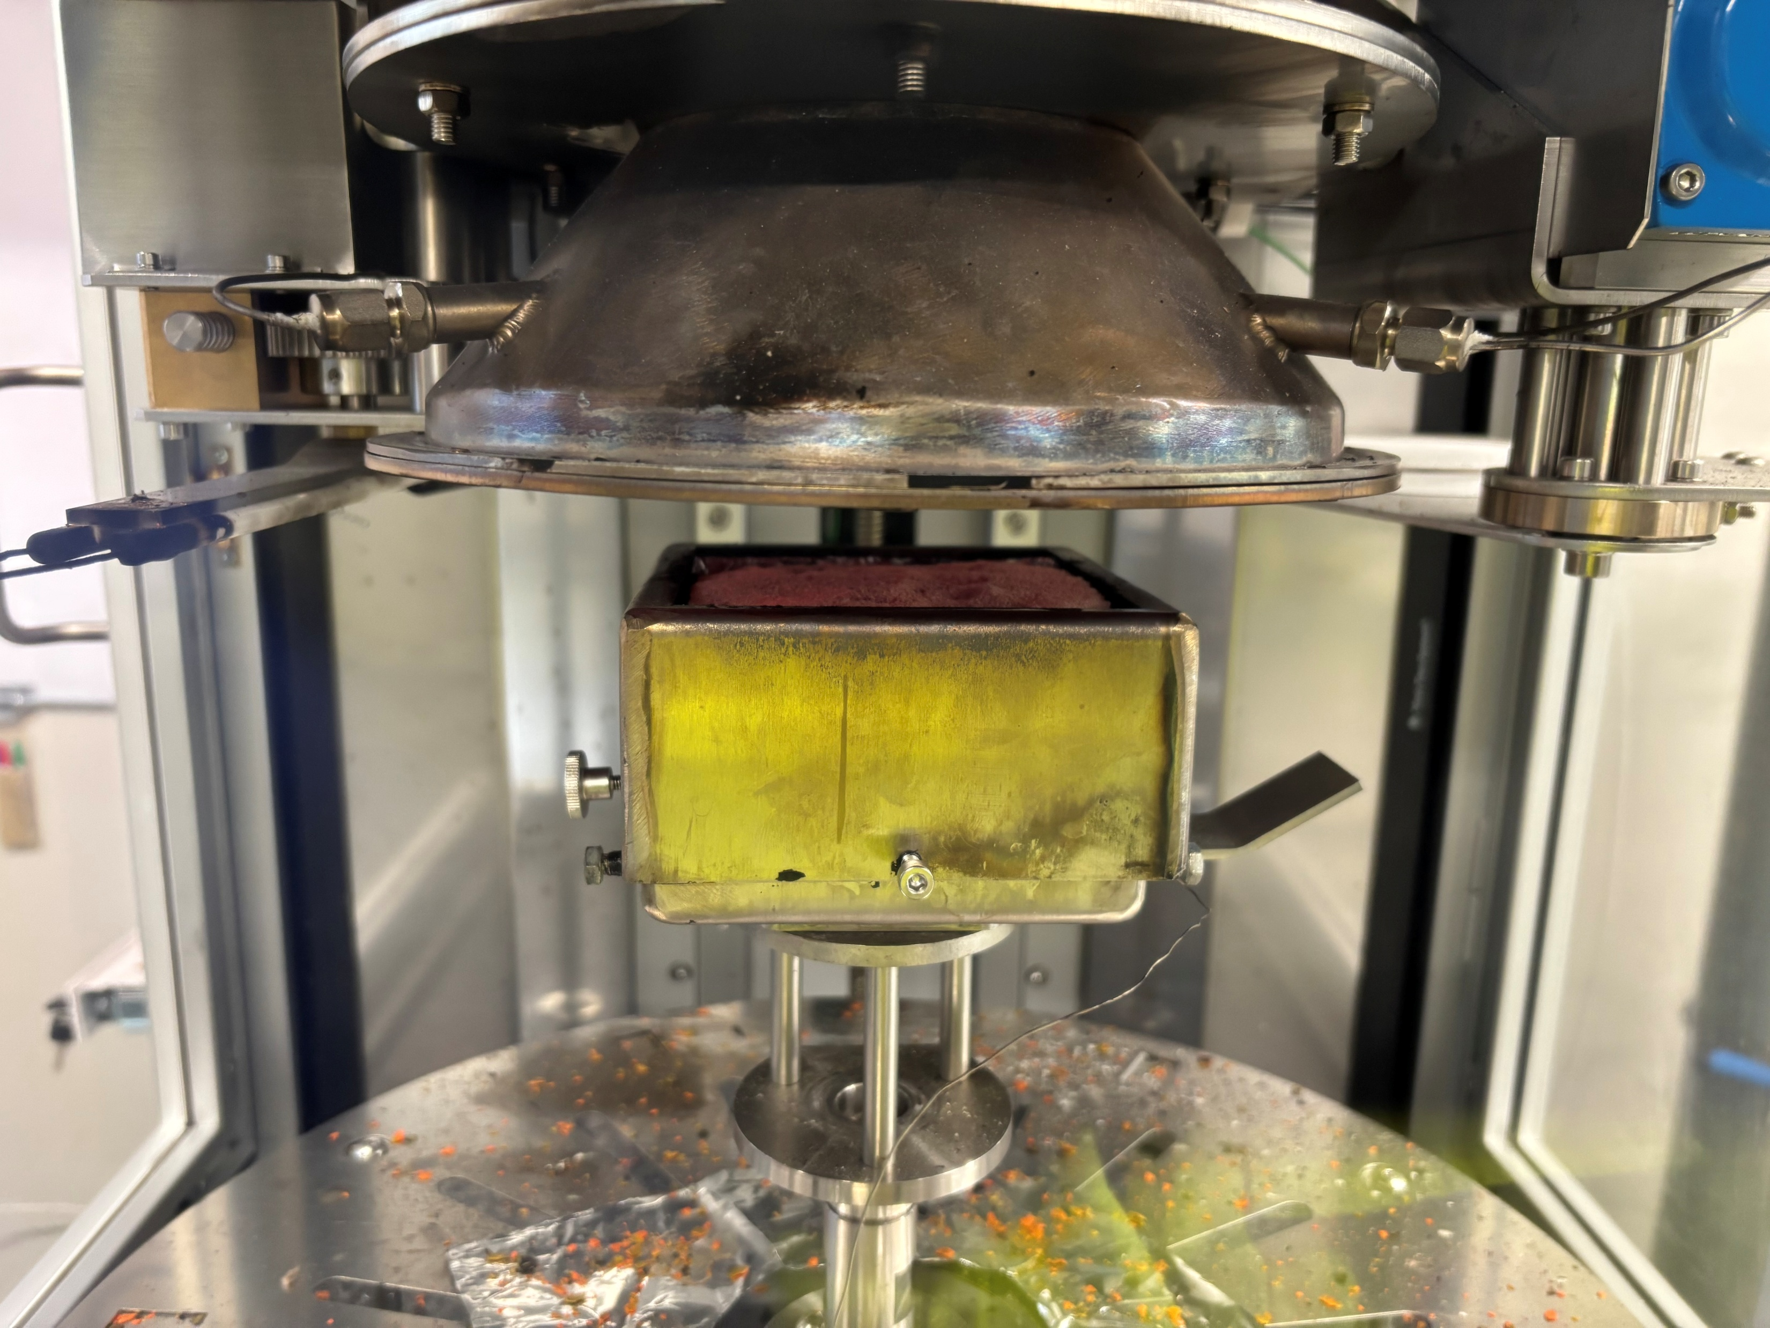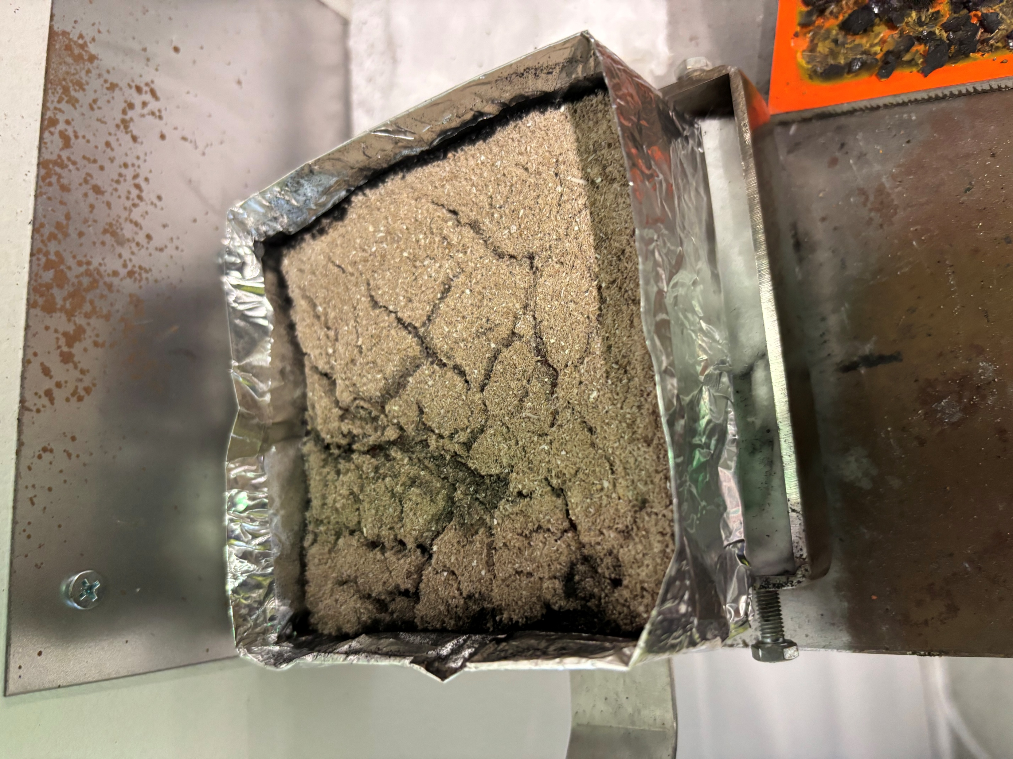
a
b
c
Figure 1: Photographs of biocarbon (BC) before, during and after cone calorimetry (CC) experiment
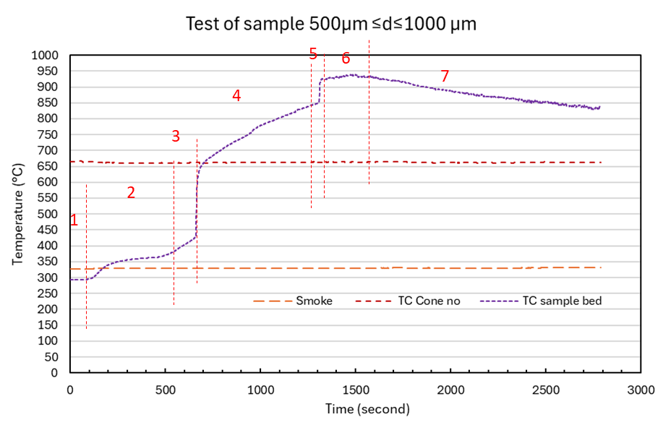
Figure 2: Temperature and gas release profile of cone calorimetry test on biocarbon sample with size in the range of 0.5-1mm
One should note, the container with sample inside was loaded on the sample holding platform before start of temperature measurement. Therefore, the biocarbon sample in the sample holder has been already heated to a certain degree. It explains the temperatures measured from the start of test is about 300 °C already. With increase of heating time, the measured temperature increases from 300 to about 350 °C (stage 1 and 2), this can be related to release of volatiles remained in the biocarbon. From time 550s to 700s, the measured temperature increases continuously, which increase sharply to temperature 650°C (stage 3). The temperature history in stage 3 indicates moving of reaction front from top downwards, and the temperature in the middle of the biocarbon sample bed increase quickly due to intensive combustion of the material. After stage 3, the measured temperature increases rather slowly (stage 4 and 5) and reaches peak value of 900 °C. It is probably related to further conversion of biocarbon and forming of ash. After reached the peak value, the measured temperature becomes more stable with slightly decrease, indicating heat distribution becomes more homogeneous and closing to the setting temperature.
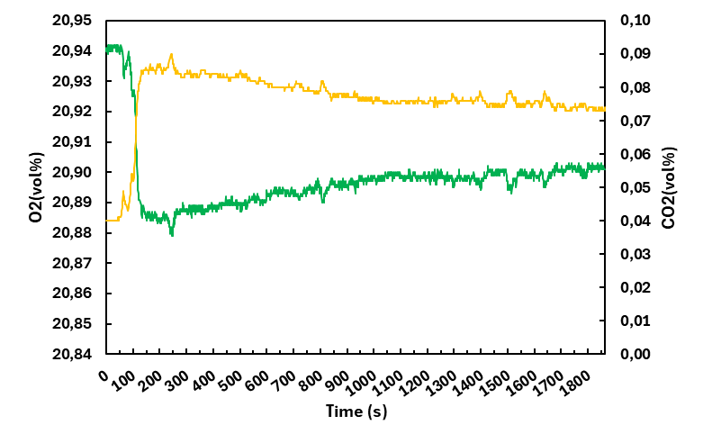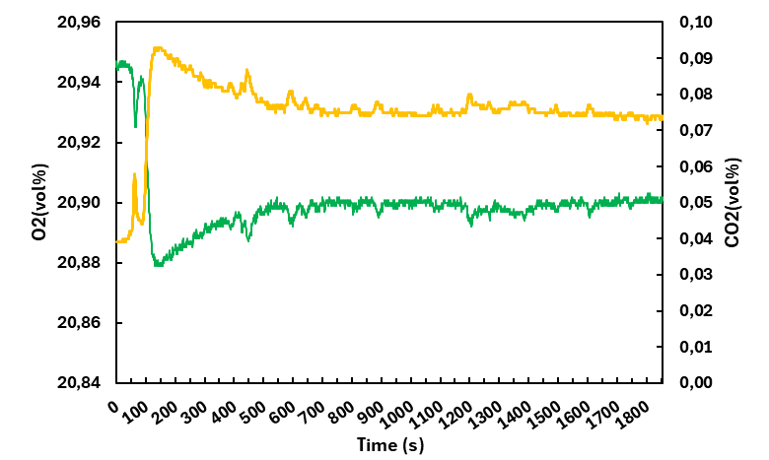

Figure 3: O₂ and CO₂ gas release profile from the cone calorimetry test on biocarbon sample with size in the range of (a) 0.5-1mm and (b) 4-6.3 mm
Figure 3 shows O₂ and CO₂ gas release profile from the cone calorimetry test on biocarbon sample with size The O₂ concentration in the flue gas drops quick in the first 200 s of test period, which reaches the lowest value and increases slightly without intensive changes to the end of the test. Whereas the CO₂ signals increased in parrel at the starting stage of the test, which slowly drops down further.
    - Biocarbon combustibility parameters
An important metric to describe the way materials burn is the heat release rate (HRR) value as obtained from one cone calorimetry test (Hu et al., 2021). As shown in figure 3, the HRR vs time curves for the biocarbon with small and large sizes followed a similar pattern. The HRR of the tested biocarbon goes up with the amount of heat generated, which attain their peak and thereafter decline slightly. There are two peaks of HRR can be observed at the time about 50s. It can be related to release of residual volatiles in the biocarbon, which burns to generate heat. The similar HRR vs time curves have been reported by the other work studying on combustibility of biocarbon produced from wood, olive and reed (Shanmugam et al., 2022, Das et al., 2017). In addition, the HRR values obtained from waste wood biocarbon have a good agreement with typical HRR values from 20 to 48 kW/m² (Shanmugam et al., 2022).
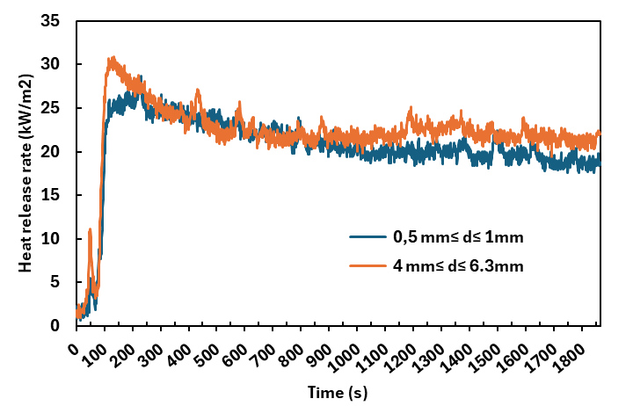
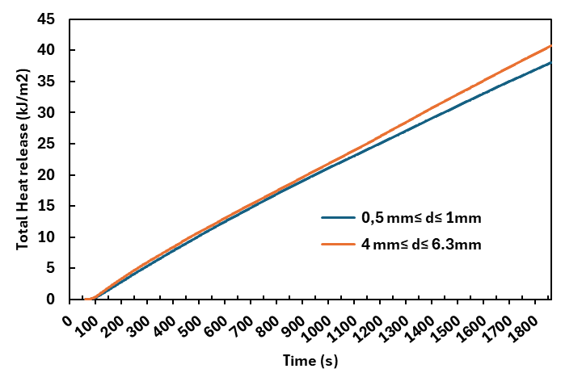
Figure 4: Plots of heat release rate (HRR) and total heat release vs time obtained from cone calorimetry test on biocarbon samples
The HRR vs time curves for biocarbon with smaller and larger sizes are slightly different. Relatively higher HRR peak values were obtained from the biocarbon with size in the range of 4-6.3 mm, which also generates higher HRR as the testing time is over than 1000 s. The total heat release profiles of the two studied biocarbon are depicted in Figure 4. The total heat release profiles of the two studied biocarbon are almost identical as the test time approaches 900 s. With increase of the test time, more heat was generated from the biocarbon with size in the range of 4-6.3 mm.
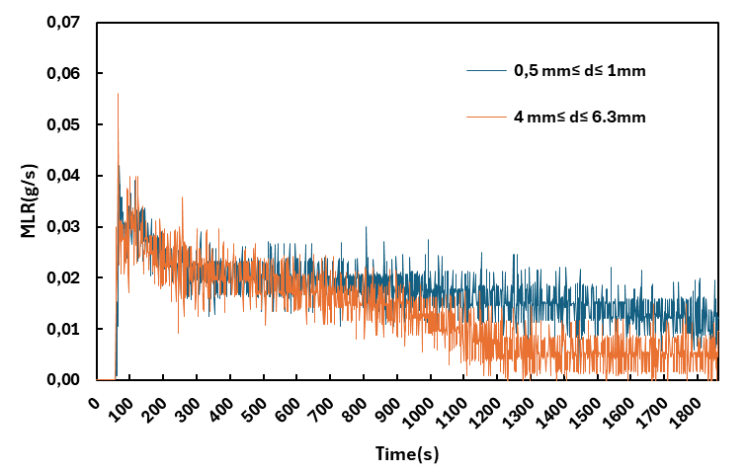
Figure 5. MLR vs time plots of biocarbon samples
The mass loss rate (MLR) patterns of biocarbon with different sizes are shown in Figure 5. The mass loss behaviour of the studied biocarbon are similar before the testing time reached 900 s. The MLR patterns indicates the maximum MLR took place about 100-120s, which correlate with intensive heat release in the same time period. It is interesting to see that the MLR of the biocarbon with larger size is lower than that of the particle with smaller sizes in the range of 0.5-1 mm. The difference of MLR for large and small particles can be linked to their physical properties. The smaller biocarbon particles normally have higher specific surface, which has better contact with oxygen and superior conversion efficiency with presence of oxidizing agent (Kaynak et al., 2025).
    - Correlation of MLR with HRR
Figures 3 and 4 show that the peak value of HRR and the respective maximum MLR occurred on the same period. However, from the figure 3, more intensive release of heat was detected from the biocarbon with larger sizes. On the other hand, the relatively low MLR was obtained from the biocarbon with larger sizes. It indicates that detected HRR is not only related to conversion of the material from the conducted cone calorimetry test for the current work. After each test, the sample was cooled down and taken out of the cone calorimeter. It was found for both tested biocarbon, even with different particle sizes, only part of the material combusted. The residues in the sample holder contains ash on the top, which cover the unburned carbon rich residues. Considering this, the ash layer formed on the biocarbon sample bed surface might affect the heat release and permeability to the residue carbon beneath the ash layer, which in turn affect combustion behaviour of them. The higher MLR obtained from the biocarbon with smaller sizes indicated slow continuous reaction. This is supported by the release of CO₂ as monitored from the conducted cone calorimetry tests. In the figure 3(a), the monitored CO₂ signals increase slightly but continually to the end of the test, which can be generated from the conversion of carbon. However, the heat generated from the slow conversion carbon can be small and consumed internally by the surrounding carbon matrix, which does not give contributions to the heat flux detected by the cone calorimetry (Hu et al., 2021).
  - Conclusions
In conclusion, this study utilized cone calorimetry to provide a comprehensive evaluation of the fire behavior and combustion characteristics of waste wood-derived biocarbon. The findings highlight significant differences between processed biocarbon and raw biomass, particularly regarding ignitability and heat evolution.
Kye findings from the present work include:
- Low Ignitability and Volatile Removal: Unlike raw biomass, biocarbon demonstrated a lack of sustained flaming or smoke during testing. Combustion was characterized by a "glowing" behavior on the sample surface. This is attributed to the high-temperature pyrolysis process, which removes the majority of flammable volatiles, leaving a stable carbon skeleton.
- Thermal Evolution: The material follows a distinct five-stage thermal profile. Initial heating is followed by a sharp temperature spike (reaching up to 900°C) between 550s and 700s, signaling the downward movement of the reaction front through the sample bed.
- Influence of Particle Size: Large biocarbon particles (4–6.3 mm) produced higher peak heat release rates (PHRR) and greater total heat release (THR) over extended periods.
- Small particles (0.5–1 mm) exhibited a higher mass loss rate (MLR). This is due to their higher specific surface area, which facilitates superior oxygen contact and conversion efficiency.
- The "Ash Shield" Effect: The formation of a surface ash layer plays a critical role in combustion kinetics. This layer acts as a physical barrier that limits oxygen permeability and heat release from the unburned carbon beneath it, potentially masking internal slow-conversion reactions.
Acknowledgments
The authors acknowledge support from the project Improving energy production and safety in biocarbon value chains (EnergyProSafe). The supports are through the funding from the Research Council of Norway (grant no: 353147) and financial support from the EnergyProSafe project industry partners.
References
Wang L., Skreiberg O., 2023, A Critical Review on Self-Heating and Self-Ignition of Biocarbon, Chemical Engineering Transactions, 105, 271-276
Gul E., Riva L., Nielsen H.K., Yang H., Zhou H., Yang Q., Skreiberg Ø., Wang L., Barbanera M., Zampilli M., Bartocci P., Fantozzi F. 2021, Substitution of coke with pelletized biocarbon in the European and Chinese steel industries: An LCA analysis. Applied Energy. 304, 117644.
Chaudhuri, P., Pande, R., Baraiya, N.A., 2025. From char to flame: Evaluating bamboo bio-char combustion via cone calorimetry and thermogravimetric analysis. Energy 314, 134313.
Shanmugam, V., Sreenivasan, S.N., Mensah, R.A., Försth, M., Sas, G., Hedenqvist, M.S., Neisiany, R.E., Tu, Y., Das, O., 2022. A review on combustion and mechanical behaviour of pyrolysis biochar. Mater. Today Commun. 31, 103629.
Das, O., Kim, N.K., Sarmah, A.K., Bhattacharyya, D., 2017. Development of waste based biochar/wool hybrid biocomposites: Flammability characteristics and mechanical properties. J. Clean. Prod. 144, 79–89.
Liu Z, Fei B, Jiang Z, Liu X. Combustion characteristics of bamboo-biochars. Bioresource Technology 2014;167:94–9.
Wijayanta AT, Alam MdS, Nakaso K, Fukai J, Kunitomo K, Shimizu M. Combustibility of biochar injected into the raceway of a blast furnace. Fuel Processing Technology 2014;117:53–9.
Hu, W., Feng, Z., Yang, J., Gao, Q., Ni, L., Hou, Y., He, Y., Liu, Z., 2021. Combustion behaviors of molded bamboo charcoal: Influence of pyrolysis temperatures. Energy 226, 120253. 3
Kaynak, E., Shanmugam, V., Johansson, J., Sykam, K., Gawusu, S., Osvaldová, L.M., Mensah, R.A., Jiang, L., Uraz, E., Lin, C., Das, O., 2025. Understanding the Reaction-to-Fire Properties of Biomass and Their Respective Biochars. ACS Omega 10, 44895–44902.

