 CHEMICAL ENGINEERING TRANSACTIONS  VOL. xxx, 2026 | A publication of  
The Italian Association
of Chemical Engineering
Online at www.cetjournal.it

Guest Editors: Valerio Cozzani, Bruno Fabiano, Genserik Reniers
Copyright © 2026, AIDIC Servizi S.r.l.
ISBN 979-12-81206-xx-x; ISSN 2283-9216

Managing Naphthenic Acid Corrosion in Atmospheric and Vacuum Distillation Units of a Petroleum Refinery

Giuseppe Chiofalo^{b}, Vincenzo Gazzotti^{b}, Antonino Giacobbeª, Giulia Lamattina^{b}, Alessandra Saraceno^{b} , Egnazio Ollà^{b}
ªDepartment of Engineering, University of Messina, Contrada di Dio, 98166 Messina, Italy
^{b}Raffineria di Milazzo S.C.p.A., Contrada Mangiavacca, 98057 Milazzo (ME), Italy

In recent decades, many oil refineries have focused entirely on flexibility, blending low-quality crude oils with sweet crudes or directly processing high-acidity and high-sulphur crudes. To monitor sulfidation and naphthenic acid corrosion, two years ago the Milazzo refinery installed a monitoring system, through ultrasonic corrosion probes, and a corrosion inhibitor injection system in the two atmospheric distillation units. Recently, these mitigation and control actions, have also been implemented in the vacuum distillation unit.
This work resumes the article published by Chiofalo et al. (2024), it shows the results obtained in two years of monitoring and it presents the first results recorded on the vacuum distillation unit.

  - Introduction
Today, the competitiveness of a crude oil refinery lies in its flexibility to process crude oils with different characteristics, ranging from sweet to low-quality crude oils. The O&G industry classifies crude oils according to the API Grade and to the sulphur content (Al-Moubaraki, 2021), as shown in Fig. 1: low-quality crude oils are characterized by high acidity and medium to high sulphur content; they are cheaper and therefore more profitable, but they involve greater corrosion phenomena, higher costs to ensure asset integrity and greater associated risk.

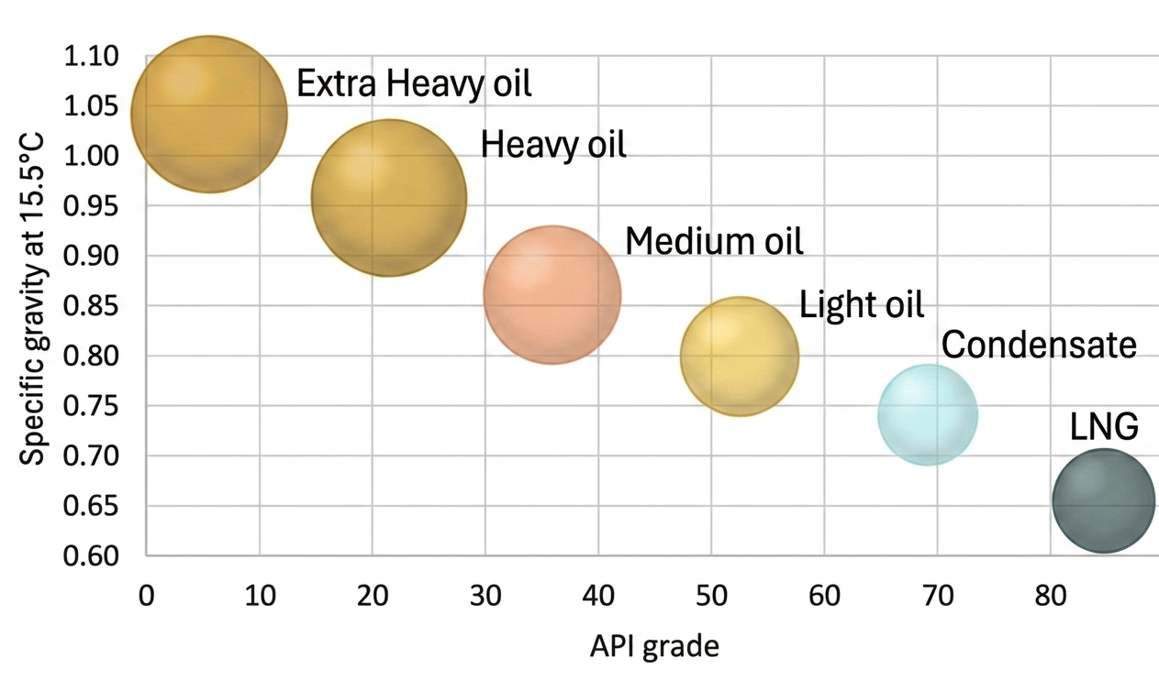
Figure 1. Classification of crude oils according to API grade and specific gravity (The engineering toolbox, 2026)
  - Damage mechanisms
The corrosiveness of low-quality crude oils (usually from California, Venezuela, India, China, and Russia, but also from offshore Brazil and West Africa) is primarily caused by their natural content of naphthenic acids and sulphur. While manageable at low temperatures, it becomes particularly problematic under high temperatures and flow velocities.
Naphthenic acids have the chemical formula ${R(CH_{2})}_{n}COOH$, where R is a cyclopentane or cyclohexane and n is greater than 12. Naphthenic acid corrosion is characterized by localized attacks in areas of high flow velocities or in areas where acid vapors condense; it is often devoid of surface corrosion products, leaving the base metal exposed. Carbon steel and low-alloy steels are easily attacked, but cases have also been reported on alloys that normally should not be susceptible (12Cr, 316 SS, 317 SS) and Molybdenum-containing stainless alloys (R.D. Kane et al, 2002).
The hot sulfidation mechanism consists in the reaction of sulfur compounds with metals, forming a layer of metal sulfide on the surface: this is a pseudo-passive layer, that is, semi-protective and not tenacious (Jayaraman & Saxena, 1995). The stability of this film depends not only on temperature and sulphur content, but also on the type of sulphur compounds present (elemental, amorphous, bisulfides, polysulfides), the flow rate, the chemical composition of the steel, the exposure time, the concentration of naphthenic acids, the concentration of dissolved salts, the concentration of oxygen, etc. (Philipp Schempp et al., 2019).

  - NAP acid crude oil project
This work will revisit the experience gained in the two crudes atmospheric distillation units (CDU) of an oil refinery (Chiofalo et al., 2024): approximately two years ago, a monitoring system using ultrasonic corrosion probes and a corrosion inhibitor injection system were installed at appropriate points in the high-risk plant sections. The same system was implemented in the vacuum distillation unit (VDU), which receives the atmospheric residue from the high-sulfur distillation unit.
A series of adverse scenarios were simulated, with both low- and high-sulfur crude oils and high TAN values. For hot sulfidation, the parameters considered to estimate corrosion rates and associated risk were sulfur, temperature, and metallurgy; for naphthenic acid corrosion, TAN and flow velocity were considered.
the variability of these parameters generated a dynamic and complex matrix for each scenario, identifying low, medium and high-risk sections. The high-risk sections were then analyzed for the placement of inhibitor injection points, while the medium-risk sections only had monitoring points. The criteria used for selecting injection points in high-risk sections are the same as those used for atmospheric distillation plants:

- For sections with temperatures >150°C, a dilution flow, called a carrier, must be used to ensure uniform distribution;
- For flows going toward the column, LVGO or HVGO carriers are used to prevent vaporization;
- The injectors must be positioned at the center of the line sections, so as to inject at the center of the flow;
- The nozzles are oriented to spray co-currently to the stream.

The inhibitor used belongs to the thiophosphate ester family, but the detailed formula is not available as it is covered by industrial license. It has a high affinity for iron and, when added to the process, adsorbs on the surface layers and forms an adherent and stable layer of iron phosphate $FePO_{4}$. There is no detailed information on dilution ratio, but in any section it is never less than 20:1.
Ultrasonic thickness sensors are used for monitoring, connected wirelessly to “bridges”, which in turn are connected to the remote server via cables. Depending on the positions, temperatures, and vibrations, these sensors can be clamp-on or magnetic.
  - Layout and injection system
Seven critical sections have been identified in the vacuum distillation unit; the monitoring and injection points are shown in Figure 2:
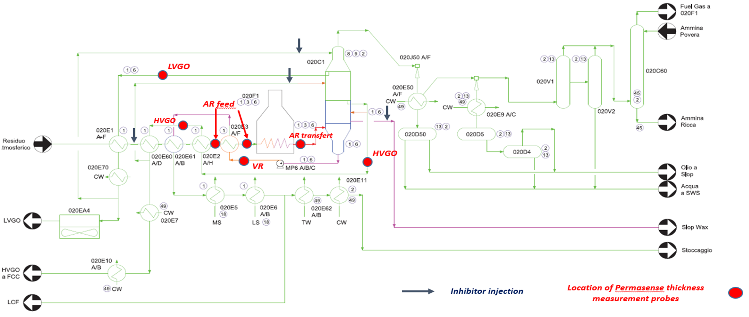
Fig. 2. Simplified P&I diagram of the vacuum distillation unit (VDU): UT thickness sensors and inhibitor injection points are indicated.
- Atmospheric residue feed. Six sensors are here installed, two downstream of the E2 A/F and E3 A/F feed preheating exchangers and four in the feed line to the furnace F1; there is one injection point at the inlet of the Atmospheric Residue preheating train, which protects the entire section.
- Heater F1. Two sensors are installed in the coils outside of the two radiant chamber of the F1 Heater (one on each outlet cross-over from each chamber). No injection points are foreseen, as the previous injection point protects this section.
- Transfer Line (from F1 to C1). Two sensors are installed on the C and G branches of the furnace outlet, which are made of carbon steel and clad in 316 SS, given the high temperatures; there are no injection points in this section.
- LVGO side cut. Two sensors are installed, on the delivery line of the P4 A/B pumps, one on the 8" common line and one on the 4" column inlet line; there is one injection point in the column pump around line.
- HVGO side cut. There are three sensors, two on the delivery line of the P5 A/B pumps and one downstream of the E2 A/H preheating exchangers; there is one injection point that protects both the pumparound in the column and the line that carries the HVGO in charge to the catalytic cracking unit.
- Slop waxes side cut. There is one sensor on the line that returns to the column, on the delivery of the P3 A/B pumps, which extract the paraffins from the lower plates of the column; there is one injection point in the outlet of the column, upstream of the P3 A/B pumps.
- Vacuum residue extraction. Two sensors are installed downstream of the P6 A/B pumps, which extract the vacuum residue, they send it to the preheating train exchanger and then to storage; no injection point are installed in this section.
  - Results
The measured thicknesses by each sensor were plotted as a function of time: 24 months were considered for the atmospheric distillation unit and 18 months for the vacuum distillation unit. A linear regression of the collected data was then carried out to obtain the average thickness of material lost and the slope of the line; the latter represents the average corrosion rate. The figure shows some trends observed for the VDU.

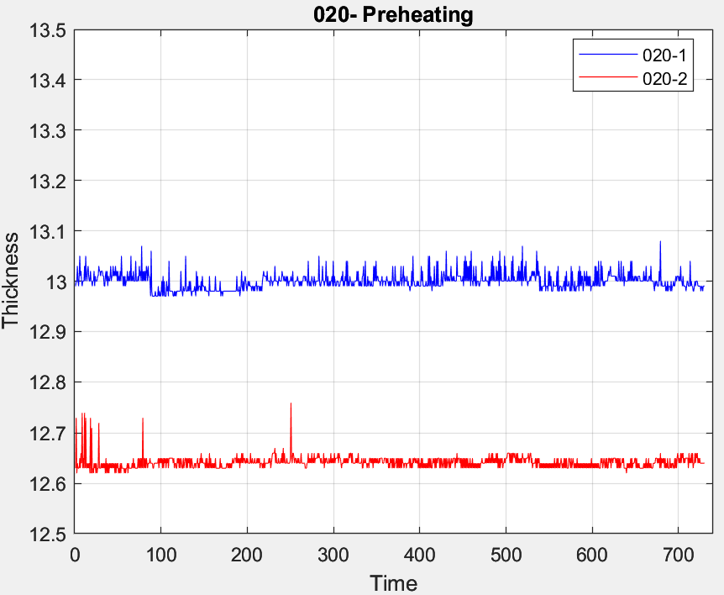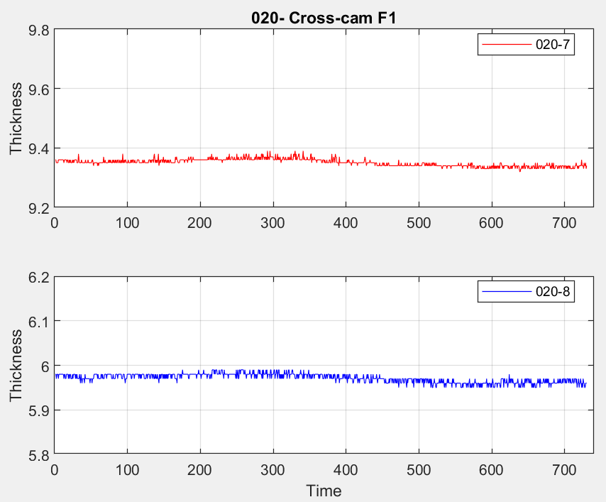
Fig. 3. Thickness trends for the VDU preheating and crossover cam furnace sections
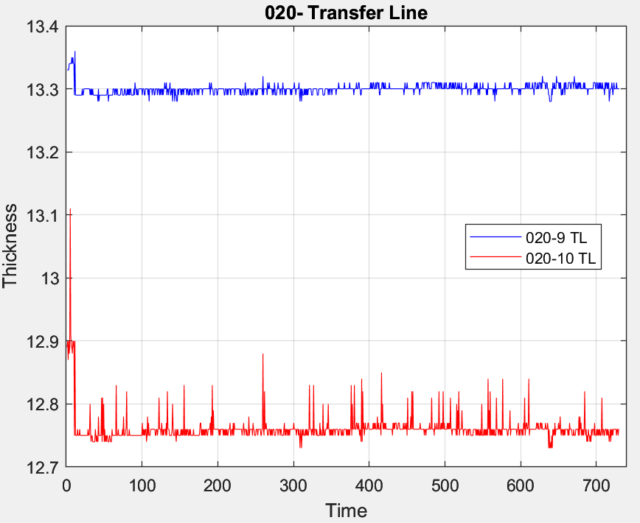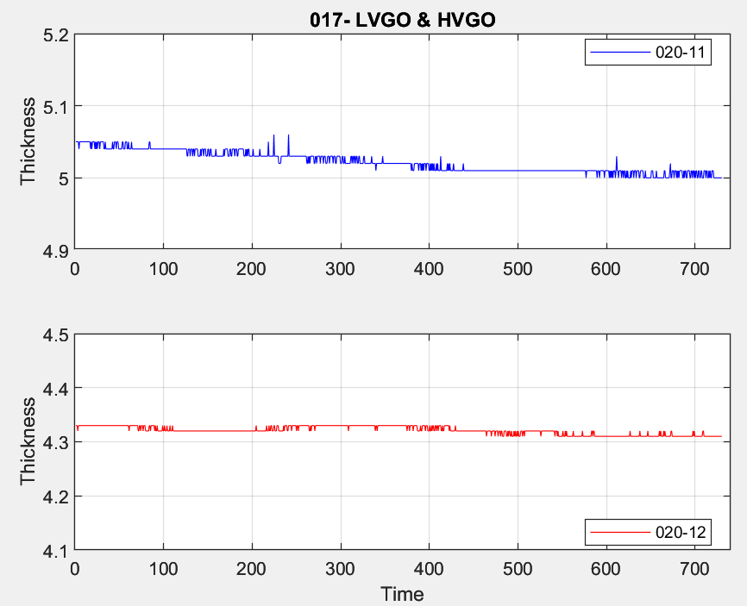
Fig. 4. Thickness trends for the VDU transfer line and side cuts sections
Then, four time ranges were taken into consideration, in which crude oils with high acidity and/or high sulphur content were processed; Tab. 1 shows the characteristics of the crudes feed to the two units (note that the atmospheric residue exiting the CDU is the feed entering the VDU).
Table 1: Characteristics of the crudes feed to the two distillation units in the considered time windows
 |  | CDU_4 |  | VDU
 | Period [day] | TAN [mgKOH/g] | S [%] |  | TAN [mgKOH/g] | S [%]
1st time range | 20 | 0.46 | 1.86 |  | 0.45 | 2.88
2nd time range | 10 | 0.60 | 1.87 |  | 0.70 | 2.98
3rd time range | 13 | 0.54 | 1.93 |  | 0.51 | 2.98
4th time range | 10 | 0.16 | 1.98 |  | 0.60 | 3.00
Tables 2 and 3 show the identified critical sections, the metallurgies, the design temperatures, the average thickness of lost material (in mm), the corrosion rate (in mm/y); the average corrosion rate was determined considering a one-year projection, that is, considering that the unit works for a whole year under those operating conditions; the latter was then compared with the expected value of the McConomy curves, reported in the API 581 Standard. This operation was repeated for all four time windows and for both plants.
Focusing on the CDU, it's possible to note that the amount of material lost is a few microns, as is obviously expected considering such short time ranges; it follows that the corrosion rates, considered as an annual projection, are very low and in some cases negligible. Even in side cuts with higher temperatures or higher concentrations of naphthenic acids and sulphur, there are no critical issues. However, there is some variability on some line sections, in terms of standard deviation around the mean measured thickness value: this is due to vibrations of the pipeline or the probe, measurement or signal transmission errors and sudden changes in operating temperature, which the probe has difficulty compensating for. This is confirmed by the fact that the average corrosion rates, measured over 24 months, remain low and constant.
Table 2: Results obtained for CDU on a 24-month reference period and comparison between the average CR measured and McConomy CR
 | Material | Design Temp [°C] | Time window | Average ∆s [mm] | Average CR [mm/y] | McConomy CR [mm/y] | RBI CR [mm/y]
Pre-heat | A335 P5 | 270 | 1st | 0.004 | 0.081 | 0.150 | -
 |  |  | 2nd | 0.000 | 0.009
 |  |  | 3rd | 0.004 | 0.103
 |  |  | 4th | 0.001 | 0.032
TL | A335 P5 | 365 | 1st | 0.003 | 0.057 | 0.510 | 0.250
 |  |  | 2nd | 0.001 | 0.035
 |  |  | 3rd | 0.003 | 0.086
 |  |  | 4th | 0.002 | 0.082
Medium P | API 5L Gr. B | 210 | 1st | 0.000 | 0.006 | 0.050 | 0.093
 |  |  | 2nd | 0.000 | 0.014
 |  |  | 3rd | 0.002 | 0.067
 |  |  | 4th | 0.003 | 0.107
LGO | API 5L Gr. B | 258 | 1st | 0.000 | 0.000 | 0.180 | 0.085
 |  |  | 2nd | 0.000 | 0.000
 |  |  | 3rd | 0.000 | 0.000
 |  |  | 4th | 0.005 | 0.165
HGO | A335 P5 | 350 | 1st | 0.002 | 0.038 | 0.510 | 0.100
 |  |  | 2nd | 0.000 | 0.000
 |  |  | 3rd | 0.002 | 0.050
 |  |  | 4th | 0.018 | 0.660
AR | A335 P9 | 358 | 1st | 0.002 | 0.078 | 0.250 | 0.040
 |  |  | 2nd | 0.001 | 0.020
 |  |  | 3rd | 0.011 | 0.295
 |  |  | 4th | 0.002 | 0.085
Table 3: Results obtained for VDU on a 18-month reference period and comparison between the average CR measured and McConomy CR
 | Material | Design Temp [°C] | Time window | Average ∆s [mm] | Average CR [mm/y] | McConomy CR [mm/y] | RBI CR [mm/y]
AR Feed | A335 P5 | 250 | 1st | 0.003 | 0.051 | 0.080 | 0.100
 |  |  | 2nd | 0.000 | 0.012
 |  |  | 3rd | 0.002 | 0.043
 |  |  | 4th | 0.009 | 0.330
Crosscam F1 | A335 P9 | 290 | 1st | 0.007 | 0.126 | 0.130 | 0.100
 |  |  | 2nd | 0.002 | 0.082
 |  |  | 3rd | 0.002 | 0.045
 |  |  | 4th | 0.001 | 0.046
TL | 316L cladd | 390 | 1st | 0.005 | 0.083 | 0.080 | 0.500
 |  |  | 2nd | 0.000 | 0.000
 |  |  | 3rd | 0.000 | 0.000
 |  |  | 4th | 0.000 | 0.000
LVGO | API 5L Gr. B | 170 | 1st | 0.003 | 0.051 | 0.200 | 0.040
 |  |  | 2nd | 0.002 | 0.067
 |  |  | 3rd | 0.003 | 0.070
 |  |  | 4th | 0.001 | 0.026
HVGO | A335 P5 | 290 | 1st | 0.000 | 0.000 | 0.150 | 0.100
 |  |  | 2nd | 0.002 | 0.055
 |  |  | 3rd | 0.002 | 0.069
 |  |  | 4th | 0.000 | 0.000
VR | A335 P9 | 260 | 1st | - | - | 0.080 | 0.100
 |  |  | 2nd | - | -
 |  |  | 3rd | 0.000 | 0.000
 |  |  | 4th | 0.000 | 0.000
Even in the VDU the thicknesses of lost material are on the order of microns and the corrosion rates are therefore very low and, in some cases, negligible. The cut where significant corrosion rates are expected, however, is the vacuum residue, which contains saturated hydrocarbons, aromatics, resins and asphaltenes, along with heavy metals and sulphur content up to 6%. As shown in the data reported in Table 3, the thicknesses of lost material are close to zero and the corrosion rate is negligible. The average corrosion rate, measured over 18 months in operation, is 0.058 mm/y, but calculating the slope over the periods examined, it is practically zero (as shown in the figure 5).

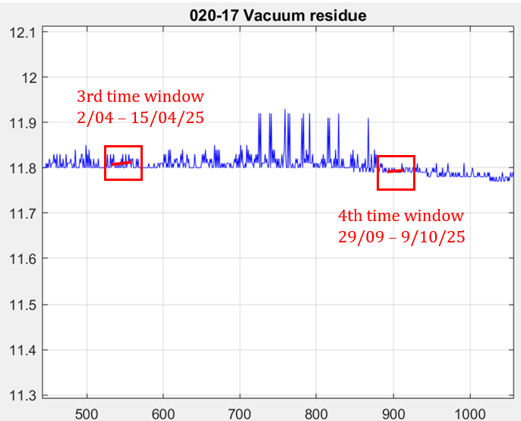
Fig. 5. Focus on the two time ranges in which acid crudes were processed.
  - Conclusions
During the examined period, the thickness losses due to corrosion have been negligible: given the sulphur content and the acidity of the processed crudes, the corrosion values ​​were compared both with the values ​​reported by the McConomy curves and with the values ​​estimated during the RBI update phase: they were lower in all cases. Reasons for this are: the corrosion inhibitor injected actually made it possible to control corrosion attacks; the McConomy curves are very conservative and they take into account worst-case scenarios.
References
Al-Moubaraki A.H., Obot I.B., 2021. Corrosion challenges in petroleum refinery operations: Sources, mechanisms, mitigation and future outlook, Journal of Saudi Chemical Society, 25, 10-14.
API RP 581 (American Petroleum Institute), 2016, Risk-Based Inspection Methodology, 3rd ed. API Publishing Services, Washington.
Chiofalo G. et al, 2024, Monitoring and Management of Naphthenic Acid Corrosion in Distillation Units of a Petroleum Refinery, Chemical Engineering Transactions, 111, 103-108.
Jayaraman A, Saxena RC, 1995, Corrosion and its control in petroleum refinery-a review, Corros Prevent Control, 42: 123-131.
Philipp Schempp et al., 2019, New approach for sulphidation prediction in crude oil refineries, EUROCORR 2019 - European Corrosion Congress, Seville
R.D. Kane et al, 2002, A Comprehensive Study on Naphthenic Acid Corrosion, Corrosion 2002 Conference, Paper n. 02555
The Engineering Toolbox, API Gravity: Definition, Calculation and Converter, <https://www.engineeringtoolbox.com/api-gravity-d_1212.html> accessed 8.02.2026

