 CHEMICAL ENGINEERING TRANSACTIONS  VOL. xxx, 2026 | A publication of  
The Italian Association
of Chemical Engineering
Online at www.cetjournal.it

Guest Editors: Valerio Cozzani, Bruno Fabiano, Genserik Reniers
Copyright © 2026, AIDIC Servizi S.r.l.
ISBN 979-12-81206-xx-x; ISSN 2283-9216

Towards a Phenomena-based HAZOP:
from Physical Principles to Consistent Identification of Hazards
Paolo Mocellin^{a,b,*}, Leonhard Urbas^{c}
ªDepartment of Industrial Engineering, University of Padua, Padua, Italy.
^{b}Department of Civil, Environmental and Architectural Engineering, University of Padua, Padua, Italy.
^{c}Process-to-Order Group, TUD Dresden University of Technology, Dresden, Germany.
paolo.mocellin@unipd.it
This paper presents a preliminary, phenomena-based framework to support the semi-automation of Hazard and Operability (HAZOP) studies. While traditional HAZOP remains a cornerstone of process safety analysis, it is inherently time- and resource-intensive and strongly dependent on expert judgment, which may affect consistency and completeness. The proposed proof-of-concept framework introduces a physics-informed backbone grounded in qualitative mass and energy balances, combined with a graph-based representation of process variables and their interdependencies. Starting from process flow diagrams, directed graphs are constructed to encode cause–deviation–consequence relationships, while routines are used to trace deviation propagation paths from process variables to predefined risk nodes. By anchoring deviations to first-principles behaviour, the approach aims to improve traceability and reduce subjective clustering in early-stage hazard identification. The framework is demonstrated on a standardised example derived from BS EN 61882 to illustrate the structure, scale, and characteristics of the algorithm-generated preliminary HAZOP (preHAZOP) output. The results indicate improved scalability and systematic coverage of interaction pathways, while confirming the continued need for expert review for contextualisation, filtering and validation. The present scope is intentionally limited to preHAZOP and a simplified case study, with qualitative risk indications and a focus on the interpretability of path-based results. Future developments will address quantitative extensions, automated clustering and ranking strategies, and application to more complex systems and data standards.
  - Introduction
Hazard and Operability (HAZOP) studies are widely recognised as a cornerstone of process safety management in the chemical and process industries. Since their original formulation, HAZOP has been systematically applied to identify hazards and operability issues by examining deviations from design intent through guidewords and structured team discussions (Lawley, 1974). Due to its systematic yet flexible nature, the methodology has become deeply embedded in industrial practice and safety standards, particularly for complex and high-risk installations (Kletz, 1999).
Despite its widespread adoption, traditional HAZOP presents several inherent limitations. The method is resource-intensive and highly dependent on expert judgment, making results sensitive to team composition and interaction dynamics (Dunjó et al., 2010; Baybutt, 2016). As process complexity increases, these dependencies challenge the scalability, reproducibility, and consistency of manual HAZOP studies, especially in early design phases (Mocellin et al., 2022).
Several methodological criticalities have been identified in the literature (Table 1). HAZOP primarily focuses on deviations around steady-state operation, potentially overlooking hazards arising during transient conditions such as start-up, shutdown or abnormal operation. Moreover, no Process Hazard Analysis method, including HAZOP, can ensure the identification of all possible accident scenarios, particularly those related to unknown phenomena or failure mechanisms. Another significant weakness is the clustering of causes, deviations, and consequences within single table entries, which may obscure causal relationships and hinder systematic comparison and prioritisation of risks (Single et al., 2019).
In addition to methodological constraints, human-related limitations play a key role in HAZOP outcomes. Cognitive biases such as groupthink, conformity pressure and satisficing behaviour may influence expert judgment, potentially leading to overlooked scenarios or underestimated risks, particularly under time pressure or cognitive overload.
Table 1: Main limitations of traditional HAZOP analysis.
Limitation category | Description | Key implications
Resource intensity | Strong dependence on expert time and availability | Limited scalability in early design phases
Human-related biases | Cognitive biases and group dynamics influence outcomes | Potential omission or underestimation of scenarios
Steady-state focus | Limited coverage of transient operating conditions | Incomplete hazard identification
Results clustering | Causes and consequences grouped in single entries | Reduced traceability and comparability
Limited reproducibility | Outcomes depend on team composition | Potential variability across studies

To address these challenges, various approaches have been proposed to support or partially automate HAZOP analyses, including expert systems, rule-based tools and graph-based models for deviation propagation and cause–consequence analysis (Klose et al., 2021; Cheraghi et al., 2022; Salimi et al., 2023). More advanced tools aim to digitise substantial parts of the HAZOP workflow while preserving expert validation (Cui et al., 2010). However, most existing solutions remain closely tied to predefined rules and often lack an explicit representation of the underlying physical phenomena governing process behaviour (Dunjó et al., 2010).
A complementary perspective is offered by phenomena-based approaches grounded in first-principles reasoning, such as mass and energy conservation. By explicitly linking deviations to physical and chemical phenomena, this perspective supports a more rigorous reconstruction of cause–deviation–consequence chains and improves traceability. Nevertheless, practical implementations integrating phenomenological reasoning into semi-automated HAZOP workflows remain limited.
In this context, the present work introduces a preliminary, phenomena-based framework to support the semi-automation of early-stage HAZOP activities, referred to as preHAZOP (Figure 1). The framework combines qualitative mass and energy balance considerations with a graph-based representation of process variables and their interdependencies, enabling automated tracing of deviation propagation paths from process flow diagrams to predefined risk nodes.

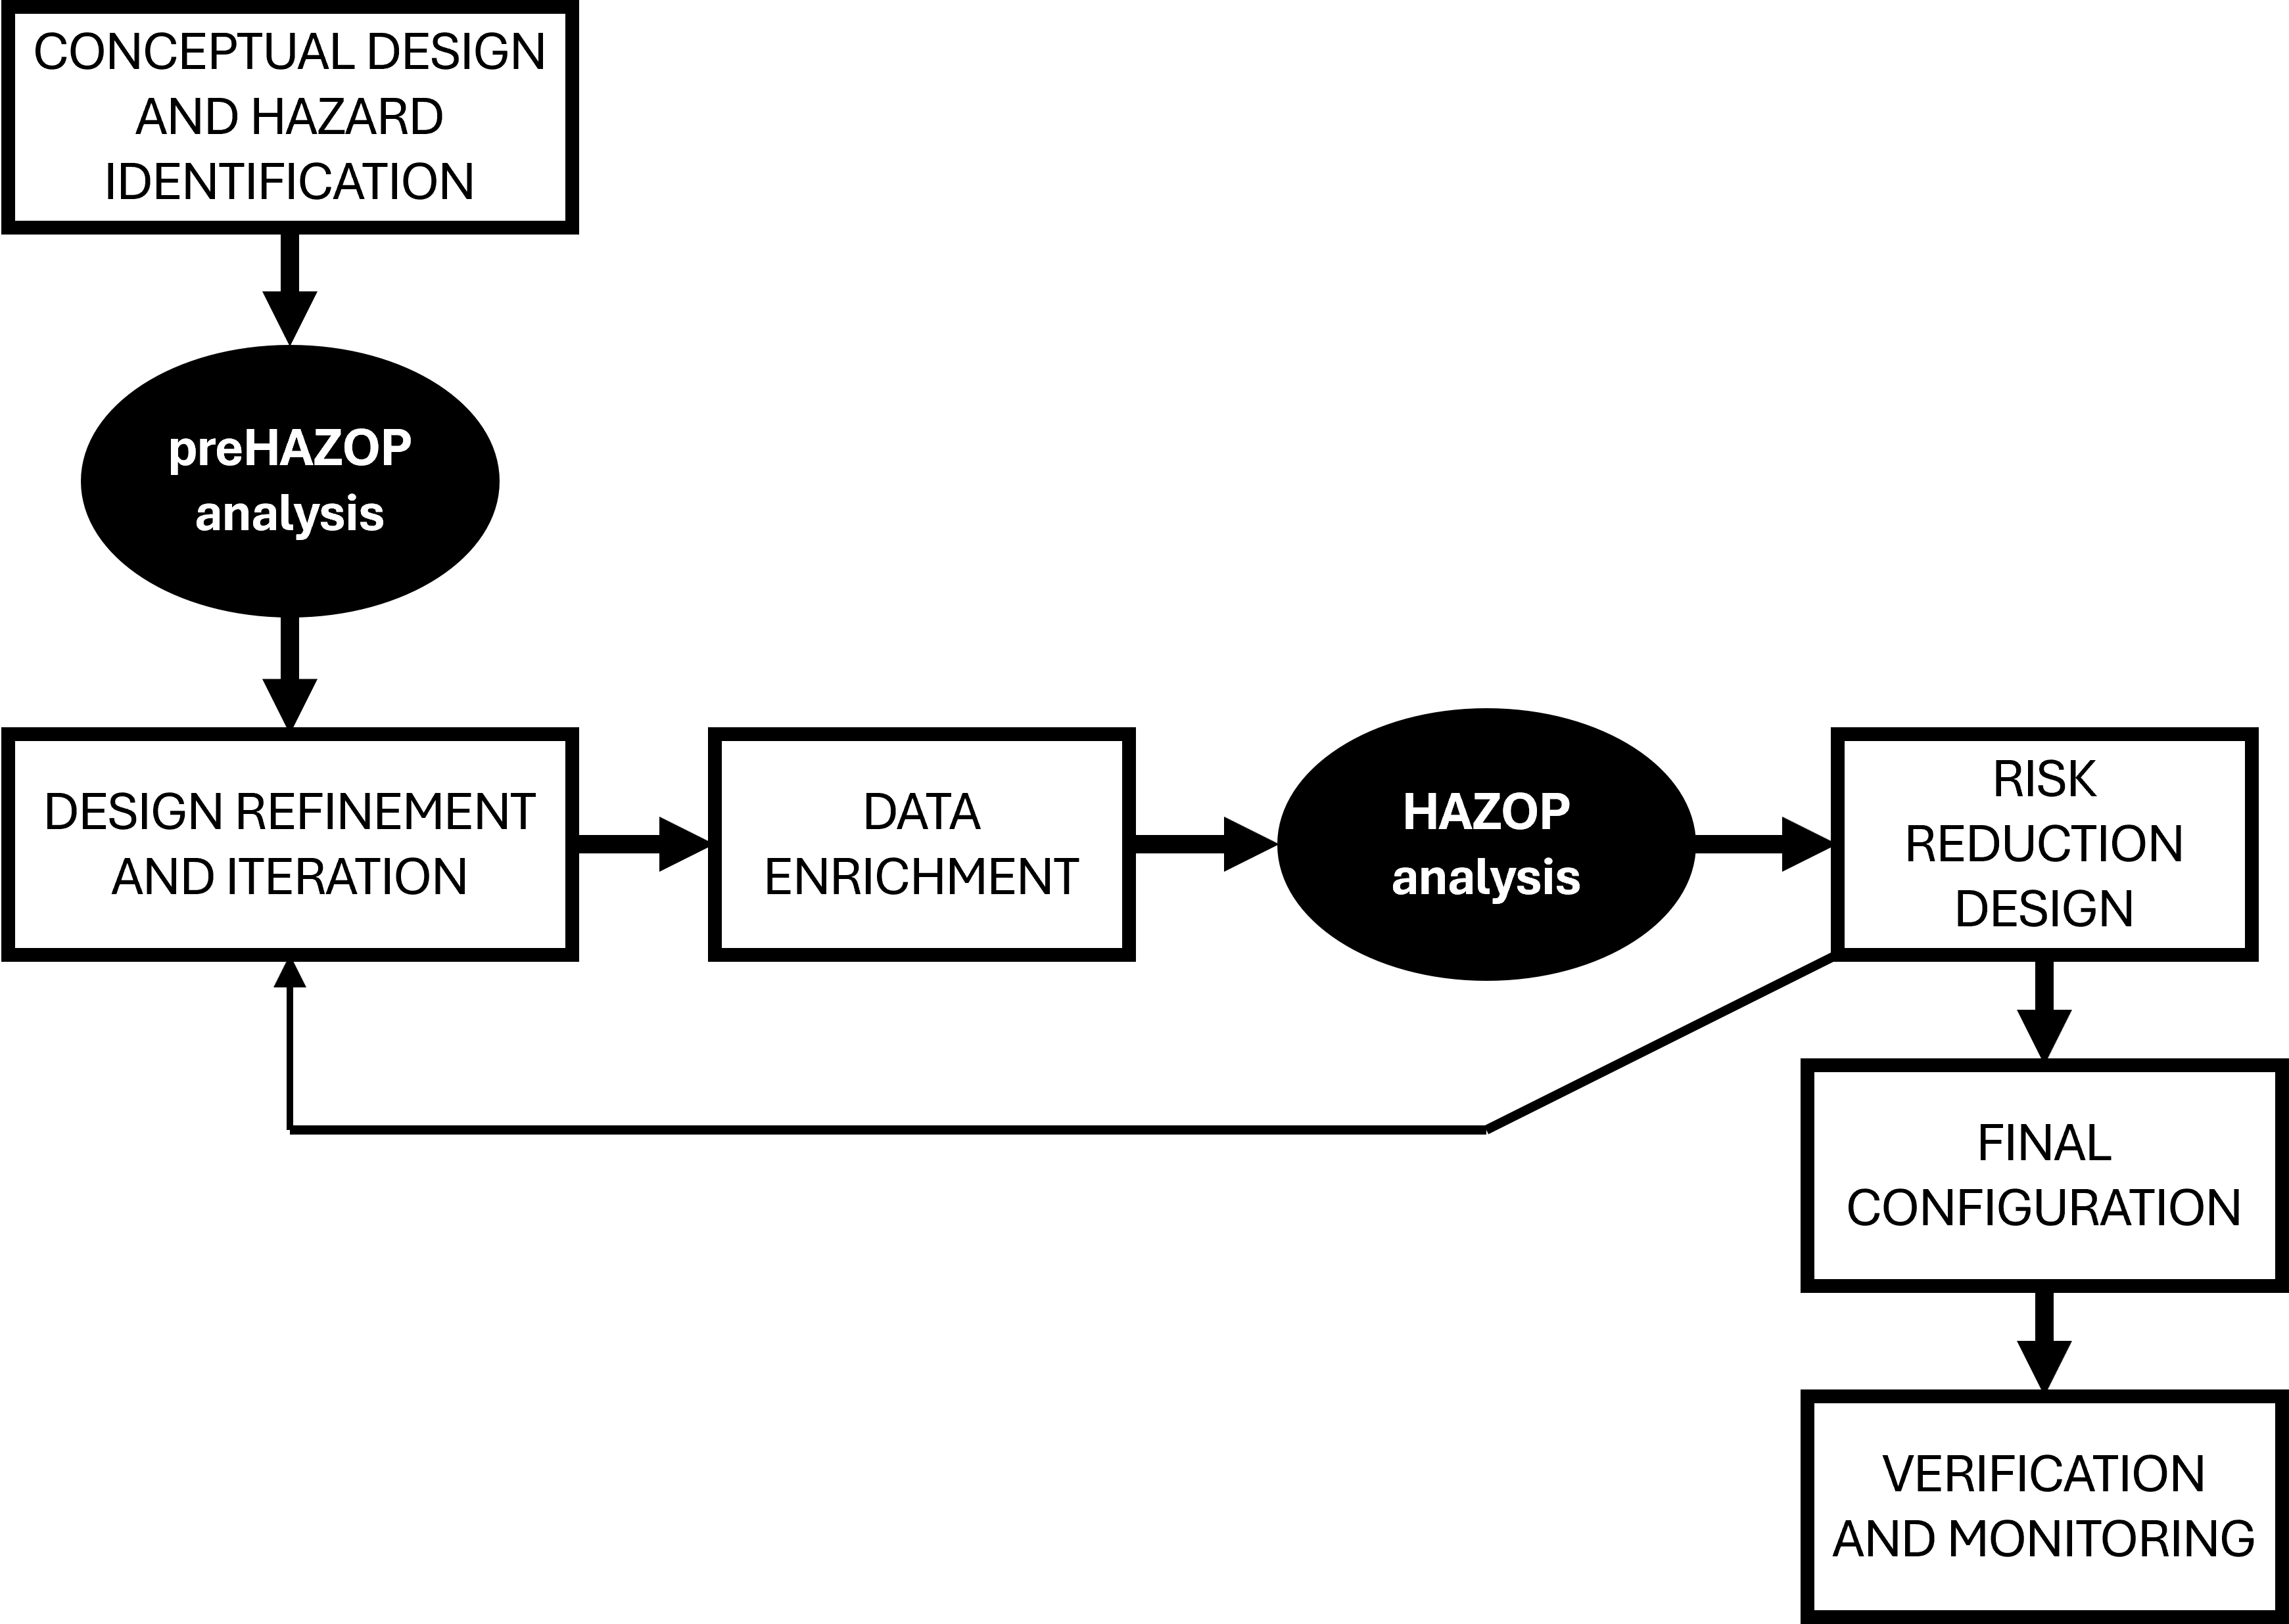
Figure 1: Positioning of preHAZOP and traditional HAZOP within the process development and safety analysis workflow. The proposed approach aims to support early-stage hazard identification and prepare subsequent team-based HAZOP activities.
The framework is demonstrated through a simplified case study based on a reference example from the BS EN 61882 standard (BSI, 2016). The scope is intentionally limited to preliminary hazard identification with qualitative risk indications, while future developments target quantitative extensions, automated result comparison, and application to more complex systems and data standards.
  - Framework overview
The proposed approach is conceived as a preliminary, phenomena-based support to early-stage HAZOP activities, hereafter referred to as preHAZOP (Figure 2). Its scope is intentionally limited to qualitative hazard identification and deviation tracing, with the objective of complementing, rather than replacing, traditional team-based HAZOP studies. The framework is designed to operate in early design phases when detailed process information may be limited but timely safety feedback is particularly valuable.

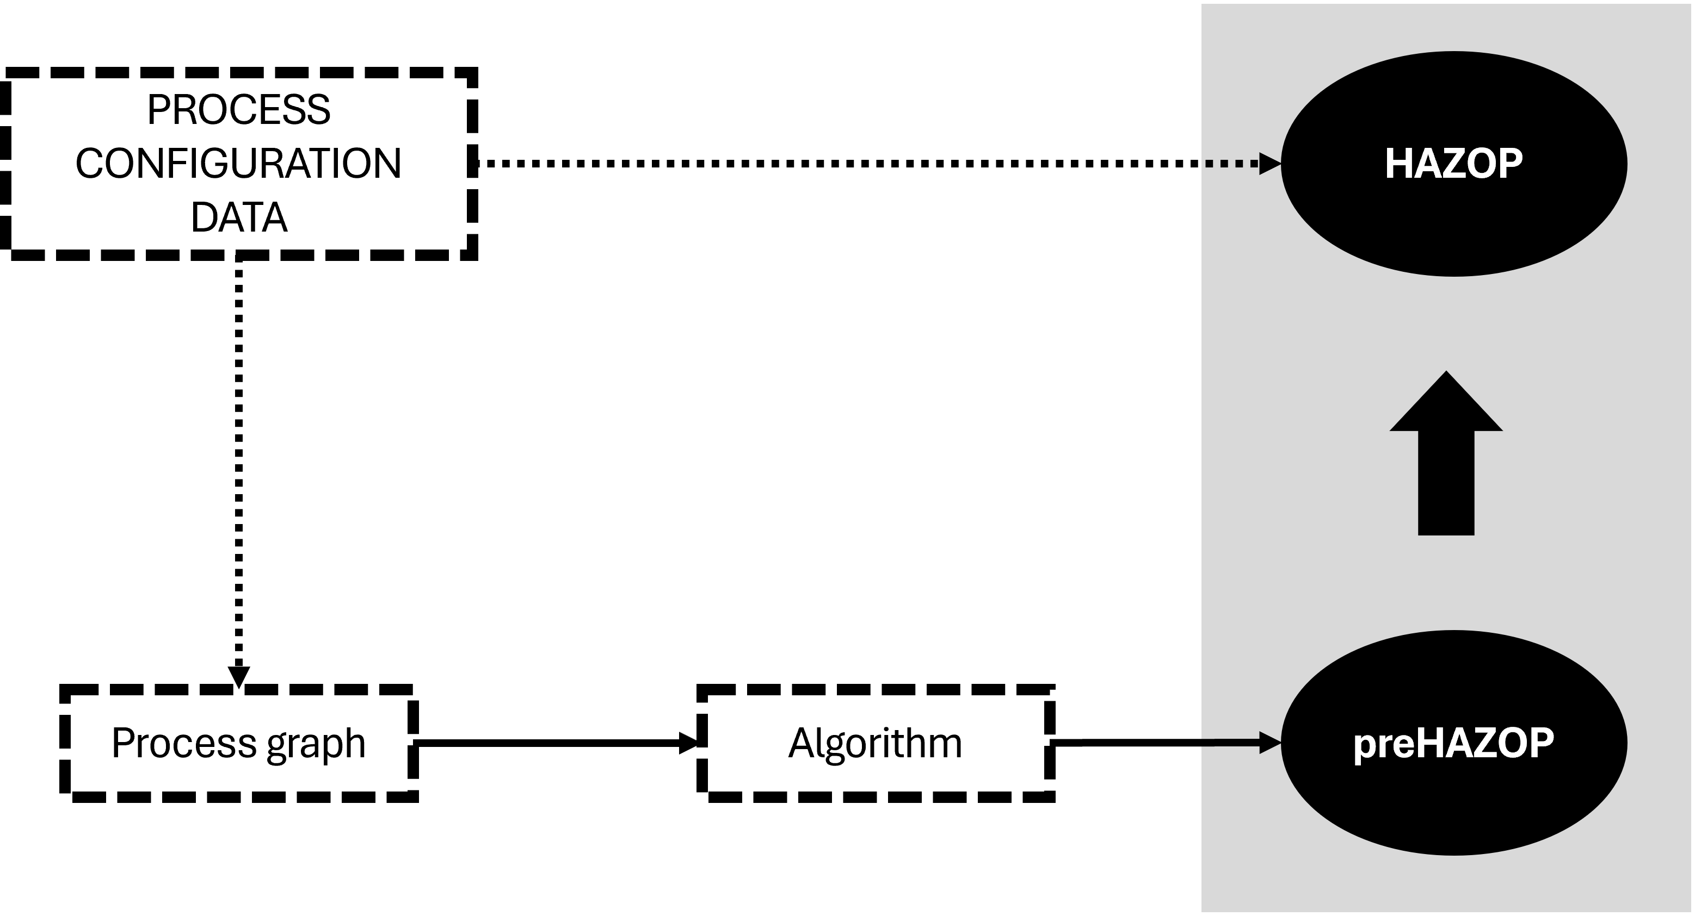
Figure 2: Overview of the proposed preHAZOP workflow. Starting from the process flow diagram (PFD), the system is mapped into a graph-based representation following predefined modelling rules. Automated routines then trace deviation propagation paths to generate a preliminary HAZOP (preHAZOP) table supporting early-stage hazard identification. Dashed arrows indicate steps performed by the user.
The main input to the framework is the process flow diagram (PFD), which provides the structural representation of the system and its design intent. Starting from the PFD, process variables and unit operations are identified and mapped into a directed graph according to predefined modelling rules. This representation enables an explicit and transparent description of interdependencies among variables across the system.
Based on the graph structure, automated routines are used to propagate deviations from selected process variables and to trace all feasible paths leading to predefined risk nodes. This allows the systematic reconstruction of cause–deviation–consequence chains without relying on predefined deviation libraries or subjective clustering. The resulting output is a preHAZOP table, in which each entry is associated with a specific propagation path and can be directly traced back to the underlying physical reasoning.
Expert review remains a central component of the framework. Human analysts are required to validate the relevance of the automatically generated scenarios, filter non-credible or non-significant results, and contextualise the findings within the broader process and organisational setting.
  - Phenomena-based modelling and automated preHAZOP generation
The approach adopts a phenomena-based perspective to support early-stage hazard identification by explicitly linking HAZOP deviations to the physical principles governing process behaviour. In this context, deviations are interpreted as qualitative manifestations of imbalances in fundamental conservation laws, primarily mass and energy balances. Unlike existing semi-automated HAZOP approaches primarily based on predefined rules or deviation libraries, the proposed framework anchors hazard identification directly to first-principles behaviour. This approach enables the systematic reconstruction of cause–deviation–consequence chains grounded in physical reasoning, rather than relying exclusively on predefined guideword–parameter combinations.
At a qualitative level, balance terms such as accumulation, inlet, outlet and generation or consumption are used to describe how deviations may originate and propagate within a system. For example, an increase in pressure in a closed volume can be interpreted as the result of mass or energy accumulation, while overflow scenarios may arise from increased inflow or reduced outflow. By reasoning in terms of balance contributions, deviations can be consistently related to their underlying phenomenological drivers, improving traceability and coherence in hazard identification.
To operationalise this reasoning in a form suitable for automation, the process is represented as a directed graph derived from the process flow diagram. Nodes represent different categories of variables, including process variables, accumulation terms, and risk-related quantities, while arcs encode qualitative causal relationships between them (Figure 3). Both direct and inverse correlations are considered, allowing the direction of deviation propagation to be explicitly captured. Unit operations and connecting elements are modelled as modular subgraphs, supporting scalability and reuse across different process configurations.
Based on the graph representation, automated routines are employed to propagate deviations from selected process variables through the network until predefined risk nodes are reached. Each admissible path represents a physically consistent cause–deviation–consequence sequence derived from the phenomenological relationships encoded in the graph. The automation focuses on systematically identifying and documenting these paths, rather than assigning quantitative risk metrics, in line with the preliminary scope of the framework.
The resulting output is a preliminary HAZOP (preHAZOP) table, in which each row corresponds to a distinct propagation path. For each entry, the originating process variable, intermediate accumulation or derivative nodes, and the associated risk node are explicitly recorded. By construction, this approach avoids result clustering, as causes and consequences are linked through traceable paths rather than aggregated into single qualitative statements. The preHAZOP table therefore provides a structured and reproducible overview of potential hazard scenarios that can be reviewed, filtered, and contextualised by expert analysts.
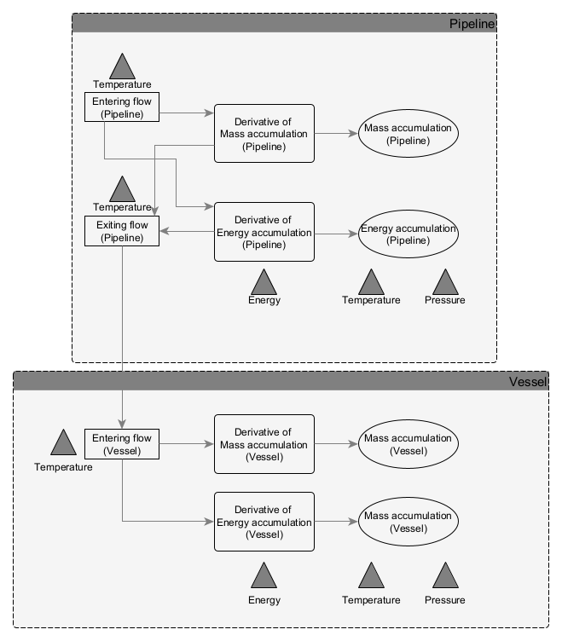
Figure 3: Graph-based representation of deviation propagation, showing how a deviation of a process variable is traced through accumulation terms to downstream risk nodes.
Overall, the combination of phenomenological modelling, graph-based representation and automated path tracing enables a systematic and transparent exploration of interaction pathways in early design phases. While expert judgment remains essential for validation and decision-making, the proposed approach aims to enhance coverage, consistency, and scalability of preliminary hazard identification activities.
  - Case study and algorithm-generated preHAZOP results
The proposed framework was demonstrated through a simplified case study derived from a reference example provided in the BS EN 61882 standard. The selected system consists of a basic process configuration including two feed lines supplying pure components to a reactor, which represents a typical benchmark scenario for illustrating HAZOP principles. The case study was not intended to reassess the standard HAZOP results, but to illustrate the structure, scale and characteristics of the output generated by the proposed phenomena-based preHAZOP framework.
Starting from the process flow diagram, the system was modelled using the graph-based representation described in the previous sections. Process variables, accumulation terms and risk-related quantities were identified and encoded according to predefined modelling rules grounded in qualitative mass and energy balance considerations. Deviations were then automatically propagated from selected process variables through the directed graph until predefined risk nodes were reached. Figure 4 illustrates an example of deviation propagation paths generated by the proposed framework, highlighting the explicit representation of cause–deviation–consequence chains.
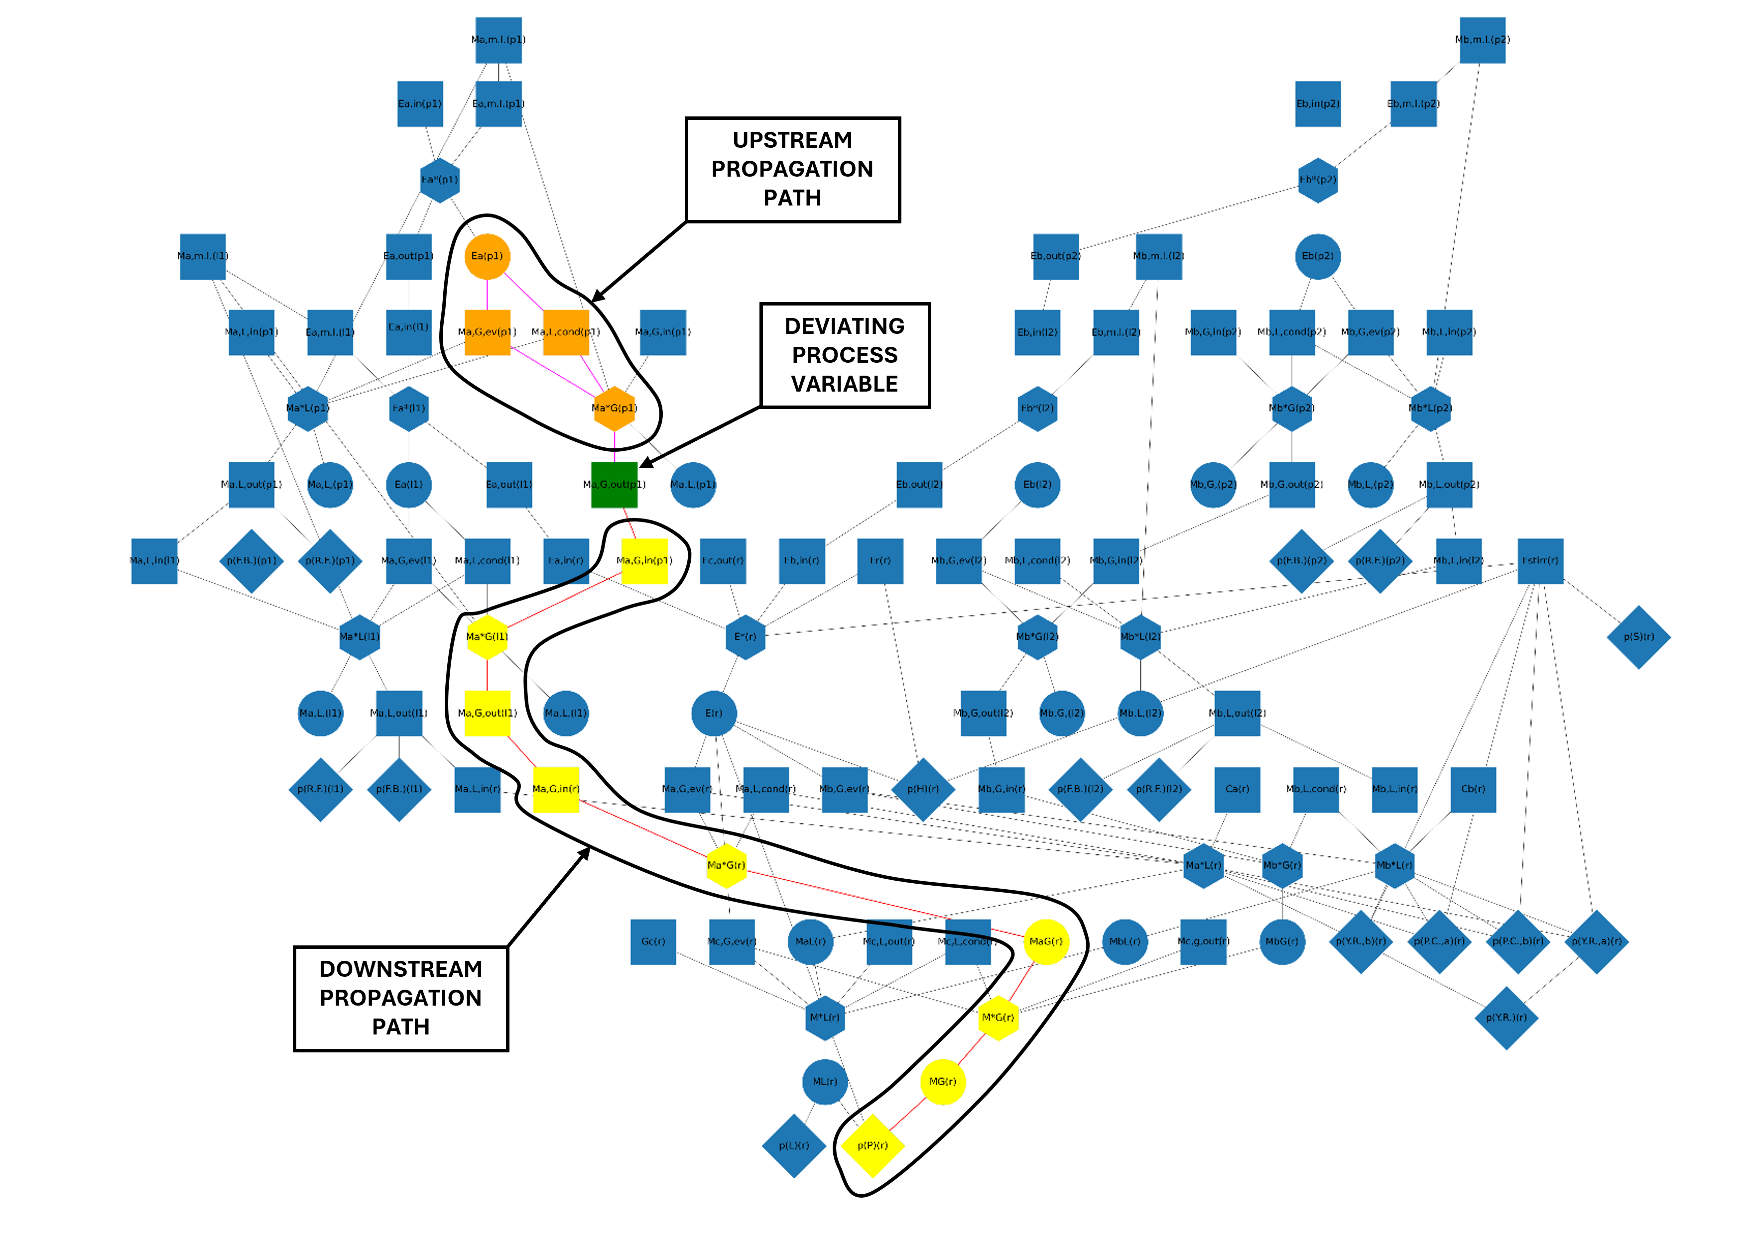
Figure 4: Example of the automated graph representation showing both downstream and upstream propagation paths for the process variable corresponding to the outlet flow of a selected component from the pump. The deviating process-variable node is highlighted in green, downstream nodes and arcs are shown in yellow and red, and upstream nodes and arcs in orange and purple.
The algorithm generated a total of 1,275 distinct cause–deviation–consequence paths in less than three minutes on a standard workstation. The main characteristics of the algorithm-generated output, in terms of scale, structure and intended use, are summarised in Table 2. Each generated scenario corresponds to a unique propagation path in the graph and is explicitly associated with the involved process variables, accumulation, or derivative terms, and affected downstream quantities. This output structure enables a detailed and transparent representation of how deviations may originate and propagate through the system, avoiding result clustering and preserving the underlying physical reasoning. In addition to the path-based representation, the generated results can be automatically organised into a tabular format consistent with the conventional HAZOP worksheet structure, facilitating expert review and integration with established HAZOP practices.
Table 2: Characteristics of the algorithm-generated preHAZOP output (case study).
Output characteristics | Description
No. of generated scenarios | 1,275 distinct cause–deviation–consequence paths
Computation time | < 3 min (single run)
Result granularity | One scenario per propagation path
Physical basis | Qualitative mass and energy balance reasoning
Traceability | Explicit graph path for each scenario
Contextual information | Upstream and downstream perturbed variables
Intended use | Support to expert review in early-stage HAZOP

In addition to identifying deviation scenarios, the generated preHAZOP output provides contextual information that is not always explicitly documented in traditional worksheet-based analyses. For each scenario, upstream and downstream perturbed variables are identified, together with the qualitative correlations responsible for deviation propagation. This information supports expert review by making interaction pathways and interdependencies among process variables explicit and traceable.
The results are intended to be interpreted as an exploratory preHAZOP dataset rather than a directly actionable HAZOP worksheet. Expert analysts remain responsible for filtering non-credible or non-relevant scenarios, contextualising the findings within the specific process design and operating conditions, and integrating the results into subsequent team-based HAZOP studies.
Within this scope, the case study demonstrates the ability of the proposed framework to systematically explore a large space of physically consistent deviation scenarios and to provide a reproducible, physics-informed basis for early-stage hazard identification.
By making deviation propagation paths explicit and reproducible, the proposed approach supports earlier identification of interaction-driven hazards that may otherwise emerge only during time-intensive, late-stage HAZOP sessions.
  - Conclusions
This work has introduced a preliminary, phenomena-based framework to support the semi-automation of early-stage HAZOP activities. By grounding deviations in qualitative mass and energy balance reasoning and encoding cause–deviation–consequence relationships within a directed graph, the approach provides a reproducible and physics-informed basis for preliminary hazard identification starting from process flow diagrams.
The case study demonstrates the capability to automatically generate structured deviation scenarios with explicit traceability. In the considered example, 1,275 distinct cause–deviation–consequence paths were identified in less than three minutes, each linked to a specific propagation path and affected upstream and downstream process variables. This granularity improves transparency and supports expert review by making interaction mechanisms explicit.
The scope is intentionally limited to preHAZOP and does not aim to replace team-based HAZOP. Expert judgement remains essential to filter non-credible scenarios, contextualise results and account for safeguards and organisational constraints not captured by the automated model. Current limitations include qualitative modelling assumptions and the absence of quantitative prioritisation. Future work will address quantitative balance-based indicators, automated clustering and ranking, extension to more complex systems and operating modes, and further validation on larger case studies.
By offering a reproducible, physics-informed starting point for hazard identification, the proposed framework contributes to bridging the gap between first-principles process understanding and practical HAZOP execution.
References
A. Klose, F. Kessler, F. Pelzer, M. Rothhaupt, D. Kostiuk, A. Kabashi, V. Forkel, L. Urbas, 2001, Representing Causal Structures in HAZOP Studies, 26th IEEE International Conference on Emerging Technologies and Factory Automation (EFTA).
P. Baybutt, Cognitive biases in process hazard analysis, 2016, Journal of Loss Prevention in the Process Industries, no. 43, pp. 372-277, 2016.
BS IEC 61882:2016, Hazard and Operability Studies (HAZOP Studies) – Application Guide, International Electrotechnical Commission, 2016.
M. Cheraghi, A.E. Baladeh, N. Khakzad, 2022, Optimal selection of safety recommendations: A hybrid fuzzy multi-criteria decision-making approach to HAZOP, Journal of Loss Prevention in the Process Industries, vol. 74, 104654.
J. Dunjó, V. Fthenakis, J. A. Vílcheza and J. Arnaldosa, 2010, Hazard and operability (HAZOP) analysis. A literature review, Journal of Hazardous Materials, no. 173, pp. 19-32.
T. Kletz, "HAZOP & HAZAN, 1999, Identifying and Assessing Process Industry Hazards, fourth edition, Institution of Chemical Engineers, Rugby (UK).
H. Lawley, Operability studies and hazard analysis, 1974, Chemical Engineering Progress, vol. 4, no. 70, pp. 45-56.
P. Mocellin, J. De Tommaso, C. Vianello, G. Maschio, T. Saulnier-Bellemare, L. D. Virla, G. S. Patience, 2022, Experimental methods in chemical engineering: Hazard and operability analysis-HAZOP, Canadian Journal of Chemical Engineering, 100(12), 3450–3469.
F.-F. Salimi, A. A. Safavi, L. Urbas, F. Salimi, 2023, A New Approach to HAZOP of Complex Chemical Processes, Elsevier.
J. I. Single, J. Schmidt, J. Denecke, 2019. State of research on the automation of HAZOP studies, Journal of Loss Prevention in the Process Industries, 62, 103952.

