 CHEMICAL ENGINEERING TRANSACTIONS  VOL. xxx, 2026 | A publication of  
The Italian Association
of Chemical Engineering
Online at www.cetjournal.it

Guest Editors: Valerio Cozzani, Bruno Fabiano, Genserik Reniers
Copyright © 2026, AIDIC Servizi S.r.l.
ISBN 979-12-81206-xx-x; ISSN 2283-9216

Index-Based Method for the Assessment of NaTech Risk from Extreme Weather Events Triggered by Heat Waves in Major Accident Hazard Establishments
Vincenzo Nastasiª, Giovanni Grilloneª, Domenico Di Fonzoª, Corrado Delle Site^{b}, Antonino Muratore^{c,}*
ªInail, UOT Palermo, Viale del Fante 58/D - 90146 Palermo, Italy
^{b}Inail, DIT, Via Ferruzzi 38/40 - 00143 Roma, Italy
^{c}Inail, UOT Como, Via Petrarca 4 - 22100 Como, Italy
*a.muratore@inail.it
Climate change and global warming are intensifying both the frequency and the magnitude of weather-related natural events, further increasing the likelihood of cascading sequences triggered by natural disasters. These events can lead to fires, explosions, and release of dangerous materials, resulting in severe consequences for Safety, Health, and Environment. Furthermore, heat waves generally affect wide geographical areas, potentially impacting many installations simultaneously. Increasingly frequent and intense heat waves can influence, mainly: Deformation of tanks, pipelines, and other equipment, compromising their structural integrity and increasing the risk of rupture and consequent loss of containment; Uncontrolled increase of internal pressure in process equipment, possibly exceeding design limits and leading to mechanical failure; Stability of certain chemicals, increasing the likelihood of uncontrolled reactions, fires, or explosions; Auto-ignition of materials and substances present in the plant; Performance of cooling systems, reducing their effectiveness and raising the risk of overheating of machinery and equipment; Proper functioning of instrumentation and safety systems; Acceleration of corrosion processes in metallic materials; Operational capabilities of personnel, increasing the probability of human errors and accidents. The aim of this paper is to propose a methodology for the preliminary assessment of NaTech risk induced by heat waves, to identify the most critical technical systems within a major accident hazard establishment. The proposed method is index-based and defined as:
IR_{hw} = f (IH_{hw}, IV_{hw}, IE_{hw})
where IR_{hw} (Heat Waves Risk Index), IH_{hw} (Heat Waves Hazard Index), IV_{hw} (Heat Waves Vulnerability Index) and IE_{hw} (Heat Waves Exposure Index).

Keywords: NaTech Risk, Index-Based Method, Major Accident Hazard, Extreme Weather, Heat Waves
  - Introduction to Heat Waves
The continuous increase in global temperatures due to atmospheric emissions of carbon dioxide and other greenhouse gases is driving climate change, leading to a rise in both the frequency and intensity of climatic events such as heat waves. According to the World Meteorological Organization (WMO), 2023 was the hottest year ever recorded, with the global mean temperature approximately 1.45 °C above pre-industrial levels. The Intergovernmental Panel on Climate Change (IPCC) confirms that since 1980 heat waves have increased in frequency, intensity, and duration, particularly affecting Europe, Asia, and North America. In Italy, data from Italian National Institute for Environmental Protection and Research (ISPRA) indicate that over the past 50 years the average temperature has increased by about 2 °C, with a growing incidence of extreme phenomena such as wildfires, droughts, and urban heat stress. Cities become true summer “heat traps” due to the urban heat island effect, which amplifies already high temperatures. Figure 1 shows: a) extreme high temperatures as global phenomenon (Ricci et al., 2020); b) the time series of mean global land temperature anomalies in Italy relative to the 1991–2020 climatological normal values (Report SNPA | 44 2025).

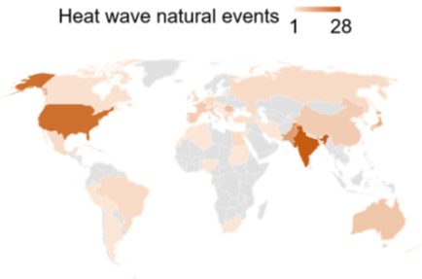  Fig. 1 a) (Data: Ricci et al., 2020) | 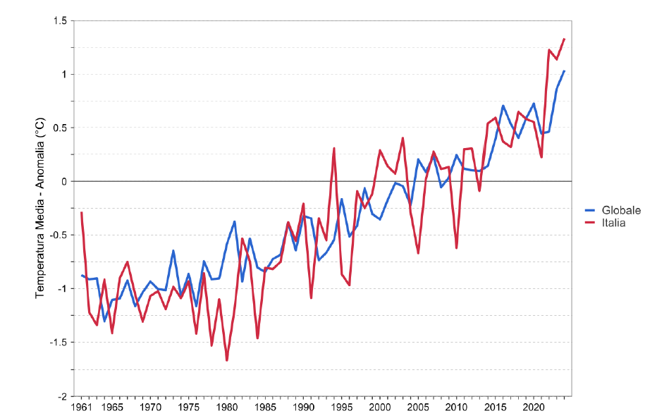  Fig. 1 b) (Data: Report SNPA | 44 2025)  Global  Italy  Mean Temperature – Anomalies (°C)

Figure 1. a) Extreme high temperatures; b) Time series of land temperature

According to the climatological definition, a heat wave is an event lasting at least six consecutive days during which the daily maximum temperature exceeds the 90th percentile of the distribution of daily maximum temperatures for the same period of the year over the reference climatological thirty-year period (1991–2020).
Heat waves are identified through indices representative of extreme conditions: a) number of tropical nights per year, with daily minimum temperature > 20 °C; b) number of summer days per year, with daily maximum temperature > 25 °C; c) number of torrid days, with daily maximum temperature > 35 °C; d) the Warm Spell Duration Index (WSDI), defined as the number of days per year with daily maximum temperature exceeding the 90th percentile of the distribution over the 1991–2020 climatological period, for at least six consecutive days.
In Italy, an increase in all these indices has been observed in the last 50 years (www.isprambiente.gov.it).
In this paper, for the purpose of describing heat waves, only the WSDI is used, as it specifically identifies the number of intense and prolonged heat events. The aim of this work is to focus on identifying the vulnerability of the main critical systems that are involved in a flood.
  - Effects of Heat Waves on Industrial Plants
Heat waves adversely affect industrial plants through a range of hazards. In the case of establishments with major accident hazards involving dangerous substances, these hazards may lead to fires, explosions, or releases of hazardous substances, with severe consequences for safety, human health, and the environment.
Moreover, heat waves usually affect wide geographical areas, thus potentially impacting many installations and giving rise to possible domino effects. The increasing frequency and intensity of heat waves may affect: a) the deformation of tanks, pipelines, and other equipment, compromising their structural integrity and increasing the risk of failures that may result in loss of containment; b) an uncontrolled increase in internal pressure within equipment, exceeding design limits and leading to equipment failure; c) the stability of certain chemical substances, increasing the risk of uncontrolled reactions, fires, or explosions; d) the self-ignition of materials and substances present on site; e) cooling systems, reducing their effectiveness and increasing the risk of overheating of machinery and equipment; f) instrumentation and safety systems; g) the acceleration of corrosion processes in metals; h) the operational capacity of personnel, increasing the risk of human errors and accidents; etc.
  - NaTech Risk Assessment Triggered by Heat Waves
According to the recent approach of the Intergovernmental Panel on Climate Change of the United Nations (IPCC, 2022), the concept of weather-related risk associated with heat waves and climate change is generally based on three fundamental components: hazard, vulnerability, and exposure. Risk arises when, at a specific location and time, a vulnerable receptor, defined as an entity susceptible to the consequences generated by a hazard, is exposed to a hazardous source. Authors introduce an index-based method to assess NaTech risk triggered by heat waves, with the aim of identifying critical units in major accident hazard establishments. The level of NaTech risk triggered by heat waves IR_{hw} depends on:
IR_{hw} = f (IH_{hw}, IV_{hw}, IE_{hw}) (1)
where:
IH_{hw} is the Heat Waves Hazard Index, related to annual mean anomalies of the WSDI occurring in a given area.
IV_{hw} is the Heat Waves Vulnerability Index, defined as the propensity of equipment and pipelines containing hazardous substances to be damaged because of heat waves. This index also includes organizational vulnerability, related to the level of organizational resilience of a given establishment and considering the operational capacity of personnel.
IE_{hw} is the Heat Waves Exposure Index, defined as the extent and severity of damage to receptors (people, assets, infrastructure, etc.).
Since determining the function f is quite complex in terms of time and resources, the authors, based on their institutional experience, propose the following simplified index-based method:
IR_{hw} = IH_{hw} * IV_{hw} * IE_{hw} (2)
To determine the NaTech risk level induced by heat waves IR_{hw}, the values of IH_{hw}, IV_{hw}, IE_{hw} must be defined. Each index is assigned an increasing value from 1 to 4.
Once the Heat Waves Triggered NaTech risk level for the main critical units has been identified, the operator of a major accident hazard establishment shall implement, within the framework of the Safety Management System, appropriate prevention and/or protection measures in order to reduce IR_{hw} within acceptable limits.
    - IH_{hw} - Heat Waves Hazard Index
Heat Waves Hazard Index depend on the basis of the annual mean anomalies of the WSDI observed in a given area. The WSDI specifically identifies episodes of intense and prolonged heat.
Figure 2 shows the time series of annual mean anomalies of the WSDI in Italy relative to the normal value for the 1991–2020 reference period (Report SNPA | 44 2025).
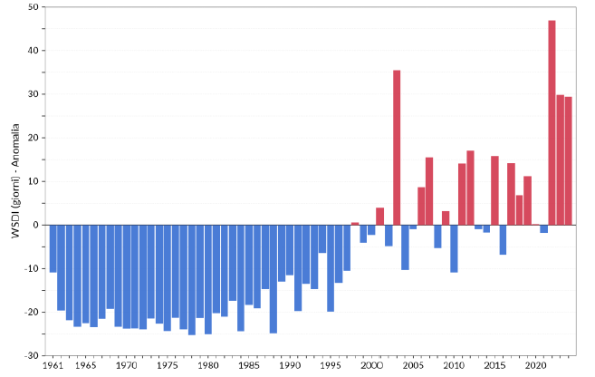
WSDI (days) - Anomalies
Figure 2. WSDI in Italy (Data: Report SNPA | 44 2025)
In 2023, for example, an increase of approximately 29 heat-wave days was observed in Italy compared to the average value calculated over the 1991–2020 reference period. For any geographical area, a specific time series of annual WSDI anomalies can be constructed, similar to that shown in Figure 2, in order to highlight the effects of climate change represented by heat waves. The authors relate the WSDI index (calculated over the last five years) referred to the IH_{hw} index using the values ​​reported in Table 1.
Table 1: Relationship between the Warm Spell Duration Index (WSDI) and Heat Waves Hazard Index IH_{hw}
WSDI | IH_{hw}
< 5 | 1
≥ 5 < 20 | 2
≥ 20 < 35 | 3
≥ 35 | 4
    - IV_{hw} - Heat Waves Vulnerability Index
To identify the Heat Waves Vulnerability Index of technical systems (IV_{hw}), the authors developed a framework that considers both the current scientific literature and their institutional experience derived from inspections carried out in major accident hazard establishments under Directive 2012/18/EU. A total of 204 records of NaTech events triggered by heat waves (Ricci et al.,2023) were collected from several databases (eMARS (1), MHIDAS (4), TAD IchemE (3), ARIA (141), NRC (55)). The identified accident scenarios were: a) fires (102 records, 50%); b) releases without further consequences (40 records, 19.6%); c) environmental contamination (31 records, 15.2%); d) multiple scenarios (6 past accidents, 2.9%); e) explosions (3 records, 1,5%); f) toxic dispersions (11 records, 5,4%); g) near miss (11 records, 5,4%). Bioprocess and chemical/petrochemical industries were the most vulnerable sectors, accounting for approximately 65% of the recorded events. Other vulnerable sectors included manufacturing (26 records, 12.7%), storage and warehousing (15 records, 7.4%), and rail and road transportation (14 records, 6.9%). Within bioprocesses, most accidents occurred in solid waste treatment plants and landfills. Regarding the equipment involved, the study highlighted: storage equipment (29.9%), waste disposal systems (25.5%), tankers (8.8%), machinery (6.4%), warehouses (5.9%), pipework (4.9%), valves and instrumentation (3.9%), process equipment (2.5%), and unknown equipment (12.3%).
The direct causes triggering the technological scenarios responsible for the final NaTech consequences were identified as: a) Pressure increase: in over 40% of the cases (82 records), loss of containment was caused by uncontrolled internal pressure increases exceeding design limits; b) Self-ignition: identified in 23 cases (11.3%), directly leading to fire scenarios; c) Material degradation: recorded in 14 cases (6.9%), due to high temperatures causing exothermic decomposition, polymerization, or other undesired reactions; d) Lens effect: identified in 11 cases (5.4%), occurring when glassy materials focus solar radiation onto confined areas; e) Power outage: recorded in 8 cases (3.9%), leading to abnormal process conditions.
On the eNatech database, a natural event caused by high temperature is reported and classified as a Natech Near Miss. On 13 August 2024, due to extreme summer heat, two chemical containers became swollen, posing a potential explosion hazard. The event occurred at an industrial facility located in Blaichach, Germany. The fire brigade managed to prevent leaks. Firefighters equipped with special protective suits and under respiratory protection cooled down the containers, preventing the explosion (eNatech, 2026).
Another relevant aspect concerns heat-sensitive substances, as classified under the Globally Harmonized System of Classification and Labelling of Chemicals (GHS), reported in Table 2 (Muratore et al., 2024).
Table 2: GHS, heat-sensitive substances
Hazard class | Code | Physical Hazard Statement
Flammable gases | H230  H231 | May react explosively even in absence of air  May react explosively even in absence of air at elevated pressure and/or temperature
Self-reactive substances and mixture and organic peroxides | H240  H241  H242 | Heating may cause an explosion  Heating may cause a fire or explosion  Heating may cause a fire
Self-heating substances and mixture | H251  H252 | Self-heating; may catch fire  Self-heating in large quantities; may catch fire

In addition to physical vulnerability, related to the physical and technological characteristics of plants, equipment, and hazardous substances (i.e., resistance), the authors introduce organizational vulnerability, linked to the level of organizational resilience of an establishment and the operational capacity of personnel. This requires specific and continuous worker training aimed at building a resilient organization capable of responding to events, monitoring ongoing conditions, anticipating risks, and learning from experience. Organizational vulnerability also includes the relevance of emergency plans that explicitly consider extreme temperatures (both low and high), considering existing early warning systems and clearly defining response actions. Based on these considerations, IV_{hw} is defined as the sum of Physical and Organizational Vulnerability Index, (Table 3).
Table 3: IV_{hw} = Physical Vulnerability Index + Organizational Vulnerability Index
Equipment Category | (1) Physical Vulnerability Index | (2) Organizational Vulnerability Index
Machinery (Pump and compressor) | 1-2 | 0-1
Pipework (Pipelines and pipeworks) | 1-2 | 0-1
Process equipment (Column, reactor, and heat exchanger) | 2-3 | 0-1
Storage equipment (Atmospheric and pressurized storage vessel) | 2-3 | 0-1
Road/rail tanker (Road tanker and rail tanker) | 2-3 | 0-1
Valves and instrumentation (Valves and control devices) | 1-2 | 0-1
Warehouses (Packed materials and spare materials) | 1-2 | 0-1
Waste disposal Landfill cells and piles of wastes | 2-3 | 0-1
(1) Higher values ​​are given in the presence of heat-sensitive substances (see Table 2).
(2) Higher values ​​are given in case of insufficient specific training of workers regarding the effects of heat waves, and in case of insufficient forecasting in emergency plans.
    - IE_{hw} - Heat Waves Exposure Index
For the determination of Heat Waves Exposure Index (IE_{hw}), human lives, environmental damage, economic losses, and other impacts are considered. Exposure is assessed based on the type and quantity of hazardous substances, their physical state, the type of activity (process, storage, etc.), and the expected event (explosion, toxic release, fire, dispersion of toxic fumes). A qualitative methodology based on expert judgment is proposed, assigning increasing weights from 1 to 4 according to the importance of surrounding land-use classes (authors suggest minimum 3 expert judgments and when possible, recommend 5 expert judgments). Higher weights are assigned to residential areas with continuous human presence, while lower weights are assigned to productive activities, prioritizing concentrated activities over extensive ones. The authors for determining IE_{hw} index propose the values ​​reported in Table 1.
Table 4. IE_{hw} as a function of heat waves.
Land use classes surrounding the establishment | IE_{hw}
Credible scenarios resulting from heat waves related events affecting technical systems, with consequences confined to within the establishment | 1
Credible scenarios resulting from heat waves related events affecting technical systems, with consequences both within and beyond the establishment, in agricultural areas (agricultural activities) | 2
Credible scenarios resulting from heat waves related events affecting technical systems, with consequences both within and beyond the establishment, in industrial areas | 3
Credible scenarios resulting from heat waves related events affecting technical systems, with consequences outside the establishment in surrounding areas with residential buildings and/or commercial activities involving a constant human presence | 4
  - IR_{hw} - Level of NaTech Risk triggered by Heat Waves
By applying the methodology described above, numerical values from 1 to 4 are obtained for IH_{hw}, IV_{hw} and IE_{hw}. Using Equation (2), a numerical value of Heat Waves NaTech Risk Index (IR_{hw}) can be calculated.
According to the methodology proposed in previous paper (Muratore et al., 2025):
(a) for IRhw > 32 risk level is unacceptable and immediate corrective actions are required.
(b) for 12 ≤ IRhw ≤ 32, corrective prevention, protection, and mitigation actions must be planned within defined
timeframes.
(c) for IRhw < 12, the risk level is considered acceptable, provided that critical systems are monitored and worker training and emergency plans for extreme temperatures are periodically updated.
  - Preventive, Protective and Mitigation Actions to Reduce IR_{hw}
The following preventive, protective, and mitigation actions are proposed to reduce the effects of heat waves (Schiaroli et al., 2024):
(a) the primary preventive action consists of performing a heat-wave risk assessment to identify critical technical systems, together with continuous monitoring of meteorological conditions
(b) regarding pressure equipment (tanks, columns, heat exchangers), units characterized by a low ratio between design pressure and operating pressure are the most critical. During the hottest periods, such equipment should, where possible, be operated at a lower operating pressure, thereby increasing the ratio between design pressure and operating pressure
(c) storage tanks containing liquid substances with low boiling points should be protected against excessive increases in internal temperature by avoiding direct exposure to solar radiation, installing specific protective systems, and installing and/or activating permanent or temporary cooling systems (e.g., water spray systems)
(d) the adequacy of venting systems should be verified, particularly for atmospheric tanks with cone roofs, as such tanks are especially vulnerable to these phenomena
(e) small atmospheric storage tanks have a higher surface-to-volume ratio and are therefore more vulnerable to the effects of solar radiation and increased ambient temperature. Accordingly, these tanks should be located in shaded areas
(f) the location of vents on atmospheric equipment used to store or process low-flammability combustible liquids should be carefully assessed. The potential release of flammable vapors from vents should also be considered for high-boiling-point combustible liquids. Indeed, under extremely high temperatures, even high-boiling-point liquids stored or processed in atmospheric equipment may exceed their flash point, generating flammable vapors that may ignite upon release
(g) the installation of specific protections against rim-seal fires should be considered for floating-roof tanks. High temperatures can increase the generation of flammable vapors in floating-roof tanks, which may escape through the gaps between the floating roof and the tank shell, thereby increasing the risk of ignition and rim-seal fires. Where not already present, the installation of dedicated gas and smoke detectors, as well as fire monitoring systems, should be considered
(h) the suitability of storage systems and process equipment used for heat-sensitive substances should be verified. Direct ignition of such materials, potentially leading to fires, has been identified as a cause of accidents triggered by heat waves. Substances classified as heat-sensitive are reported in Table 2. Storage systems and process equipment should be appropriately designed to withstand extreme ambient temperatures during heat waves without causing spontaneous decomposition of the substances. Adequate redundancy of cooling systems should also be considered
(i) the adequacy of fire detection and fire suppression systems in waste storage and treatment facilities should be verified, as the waste treatment sector has proven to be particularly vulnerable to fires during heat waves
(l) the adequacy of waste composition control should be verified. Depending on the type of waste, specific tests on stability, self-decomposition, and/or self-ignition during heat waves are of particular importance. The presence of glassy materials exposed to solar radiation in solid waste piles should be avoided, as this has been identified as a cause of accidents due to the lens effect. The potential reduction in water/moisture content of waste during heat waves should also be considered, as it promotes conditions leading to material self-ignition
(m)regarding personnel, specific training on heat waves related risks should be planned and periodically repeated. The provision of protective clothing, such as hats, sunglasses, and gloves, should be ensured, along with adequate ventilation in work environments.
  - Conclusions
At present, heat waves are considered natural events of lower intensity compared to hurricanes, earthquakes, floods, and similar hazards; consequently, they are often overlooked in NaTech risk assessments.
This is mainly due to limited awareness among operators of industrial establishments. Starting from the climatological definition of heat waves, this article proposes an index-based method to determine the level of NaTech risk triggered by heat waves, aimed at identifying critical technical systems in major accident hazard establishments. Based on the resulting risk level, when it exceeds acceptable limits, guidance is provided to operators on the implementation of appropriate corrective preventive, protective, and mitigation measures to reduce Heat Waves NaTech Risk Index within acceptable thresholds.
Finally, although the methodology is introduced using data collected in Italy, the proposed method can be applied to any geographical area.
References
eNatech, 2026: Natural hazard-triggered technological accidents database, European Commission Joint Research Centre, http://enatech.jrc.ec.europa.eu/.
European Union, 2012, Directive 2012/18/EU of the European Parliament and of the Council of 4 July 2012 on the control of major-accident hazards involving dangerous substances, amending and subsequently repealing Council Directive 96/82/EC (SEVESO III), Official Journal of the European Union, L197, p.1-37.
Muratore A., Grillone G., Bellissimo M., Giannelli G., Nastasi V., 2025, Index Method for the Assessment of Natech Risk from Storms, Chemical Engineering Transactions, 119, 439-444 DOI:10.3303/CET25119074.
Muratore A., Grillone G., Delle Site C., Giannelli G., Nastasi V., 2024, NaTech Risk from Floods. Vulnerability of Critical Technical Systems Containing Hazardous Substances, Chemical Engineering Transactions, 111, 559-564. DOI:10.3303/CET24111094.
Report SNPA | 44 2025, 2025, IL CLIMA IN ITALIA NEL 2024. Delibera del Consiglio SNPA n. 287/25 del 2.07.2025, ISBN 978-88-448-1265-2, Rome, Italy.
Ricci F., Casson Moreno V., Cozzani V., 2020, Analysis of NaTech Accidents Triggered by Extreme Temperatures in the Chemical and Process Industry, Chemical Engineering Transactions, 82, 79-84.
Ricci, F.; Casson Moreno, V.; Cozzani, V. NaTech Accidents Triggered by Heat Waves. Safety 2023, 9, 33. https://doi.org/10.3390/ safety9020033.
Schiaroli A., Ricci F., Tzioutzios D., Paltrinieri N., Cozzani V., Ustolin F., 2024, Natech Accidents Triggered By Heat Waves: Performance Of Safety Barriers. Proceedings of 34th European Safety and Reliability Conference, Jagiellonian University, Cracow, Poland, 23-27 JUNE 2024, ESREL2024, pp. 221-230, Edited Kolowrocki, Dabrowska. ISBN 978-83-68136-13-5 (printed), ISBN 978-83-68136-00-5 (electronic)
United Nations, 2021, Globally Harmonized System of Classification and Labelling of Chemicals (GHS), 9th ed., New York, NY, USA, Geneva, Switzerland.

