 CHEMICAL ENGINEERING TRANSACTIONS  VOL. xxx, 2026 | A publication of  
The Italian Association
of Chemical Engineering
Online at www.cetjournal.it

Guest Editors: Valerio Cozzani, Bruno Fabiano, Genserik Reniers
Copyright © 2026, AIDIC Servizi S.r.l.
ISBN 979-12-81206-xx-x; ISSN 2283-9216
Modular Protective Barriers for Gaseous Blast Tests of Pressure Vessels
Karsten Müller*, Georg W. Mair, Christian Sklorz, Nikolaos Lengas, David Pöhlig
BAM, Federal Institute for Materials Research and Testing, Berlin, Germany
karsten.mueller@bam.de
The article provides an overview of BAM's modular protection concept and the results of investigations that demonstrate its resistance to destructive tests on gas-filled pressure vessels.
During potentially destructive testing involving gas-pressurized systems, the hazard posed by high-velocity fragments or projectiles must be explicitly accounted for within the safety assessment. In certain cases, this consequence is intentionally induced to enable controlled demonstration, characterization, or measurement. In other cases - such as when evaluating resistance to extraordinary loads - it represents an unintended but probable consequence. In both scenarios, the implementation of protective measures is strongly advisable. These not only protect the test and measurement equipment but also allow for a reduction in safety distances for staff and may even reduce the need for more comprehensive organizational protective measures to protect the surroundings and the environment.
Prior to destructive testing of gas-filled pressure vessels, the overpressure wave and dissipation properties as well as the damage resistance of the protective barrier construction must be evaluated.
The robustness of the protective cubic system is validated by impact blast tests. The results demonstrate that the modular protective barrier exhibits sufficient resistance to both impact and thermal loading. The study confirms the system’s operational flexibility and its verified robustness with respect to pressure‑wave loading.
  - Introduction
Hydrogen energy technologies are advancing rapidly, driving significant growth across related industrial sectors. However, due to hydrogen’s wide flammability range, low ignition energy, and high diffusivity, its use introduces inherent explosion and fire hazards. At the same time, the development of robust engineering standards, risk-based design principles, and regulatory guidelines is essential to ensure the safe and reliable use of hydrogen systems such as pressure vessels filled with H₂.
The proposed modular system combines hollow steel profiles for pressure wave attenuation with concrete blocks in less exposed zones, enabling rapid, foundation-free and scalable deployment in controlled test environments. It is not intended to replace permanent explosion protection structures but offers greater flexibility, reusability and reduced assembly time.
  - Development of safety concept by a modular protective design
The protection concept was developed and validated in the TAHYA (2021) and DELFIN (2022) projects, assuming full rupture of gas-filled cylinders as worst-case scenario, see the European patent (2024).
The key advancement of the fragment protection lies in making the structural elements adaptable to different test configurations. The main idea was to construct system’s hollow steel profiles designed to absorb and deflect the pressure wave, while splinters of unpredictable size and shape are intercepted at the module’s surface. Larger fragments are halted entirely; smaller ones are deflected horizontally, reducing their range
    - Modular design elements
The steel blocks (Figure 1) consist of 8 mm thick hollow steel profiles and plates. A 2:1 modular format (100 × 50 × 50 cm) ensures compatibility with standard concrete blocks and enables flexible, foundation-free assembly.
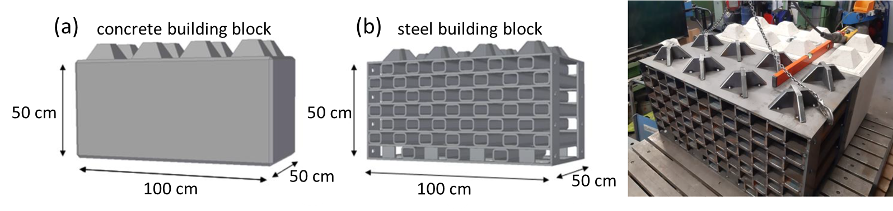

Figure 1. Modular building blocks made of concrete and steel: design, dimensions and realistic view.
This format, twice the width in length, proves ideal for launching the concept. While the manufacturing process of steel blocks can be standardised for automation the modular system is designed to incorporate cheaper conventional concrete blocks in areas not primarily exposed to pressure waves. This allows for the rapid, flexible and cost-effective construction of test enclosures, even without a foundation.
    - Modular protective enclosure
The modular protective barrier consists of eight layers of modular steel and concrete blocks, forming a 4 × 4 × 4 m structure with a usable inner volume of 3 × 3 m (Figure 2). It is intended for destructive CPV testing and to house a burner configuration. The splinter flight depends on the departure angle of possible splinters (ca. 60°). The shut-off radius depends on the flight of fragments and the pressure wave. The proposed barrier system acts as an enclosure around the test sample to reduce fragment flight distance reliably which were further developed in the Horizon 2020 research project SH2APED (2024).
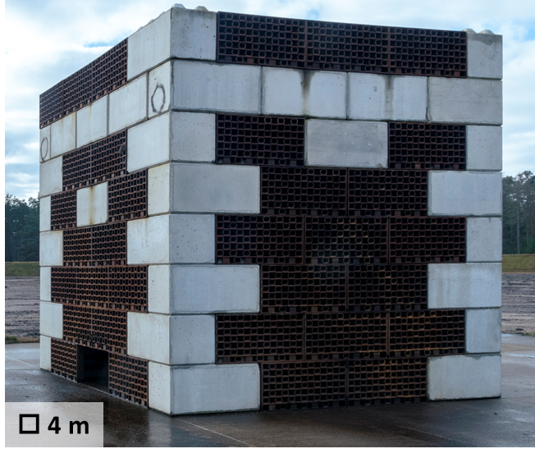
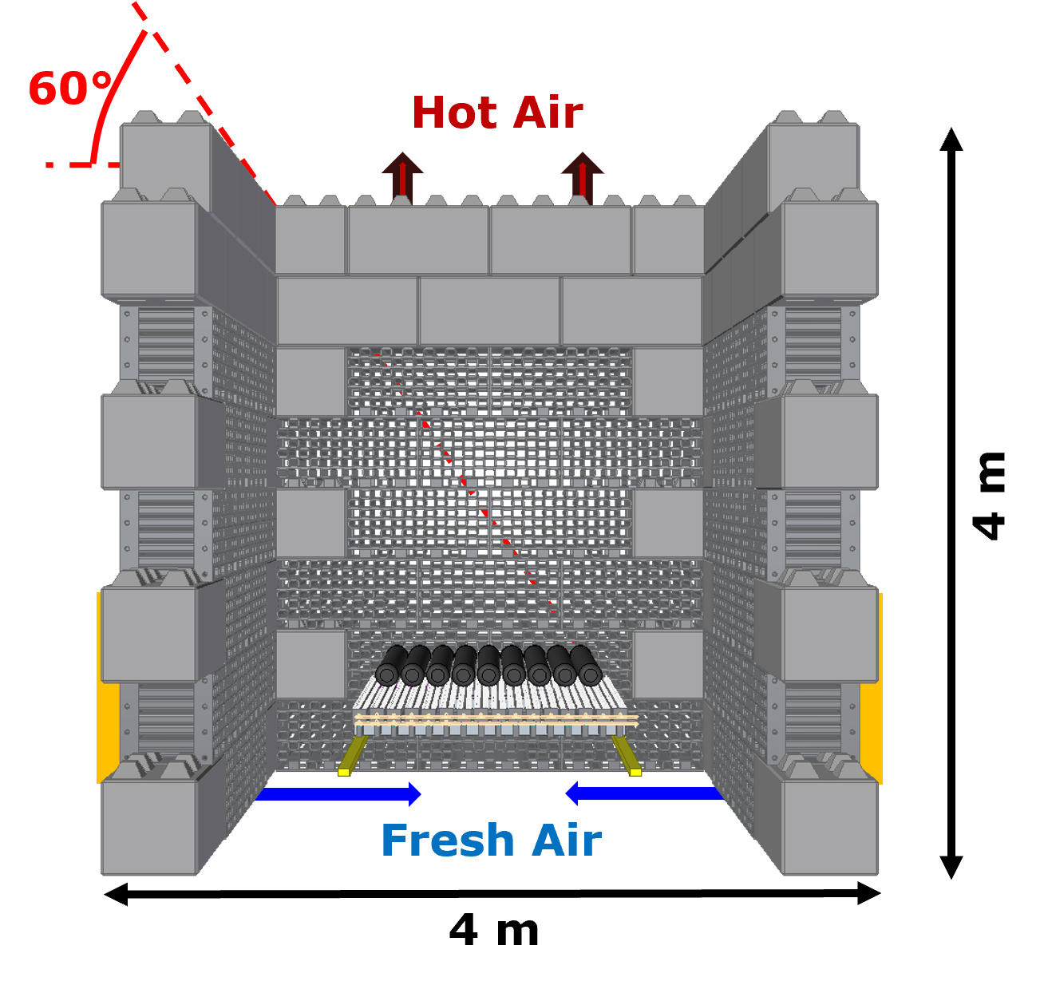

Figure 2. Modular protective enclosure for destructive pressure vessel testing (SH2APED, 2024).
  - Impact Blast Tests
The protective housing is expected to influence, direct or deflect the pressure wave propagation acting as a dissipative element. Qualification blast tests with explosive charges were conducted inside of the protective splinter barrier to assess its mechanical response by means of deformations, structural changes or collapses. The purpose of these tests was to evaluate the peak overpressure. Therefore, fragment trajectories and impact energies were not considered. As a comparison, free-field blast tests with the same explosive material were conducted to determine energy dissipation effects of the barrier.
    - Experimental Configuration
An explosive material of type NSP 711 is used for all blast tests. Overpressure peaks are estimated using modelling by Xue et al. (2019) with eq. (1)
(1)
With $p_{max,est}=$ estimated overpressure peak, $R_{g}=$ scaled distance, $R=$ distance from detonation point and $w=$ TNT equivalent of the explosive (Shirbhate and Gael, 2021).
Additionally, the H₂-gas equivalent mass of the respective blast was calculated according to eq. (2).
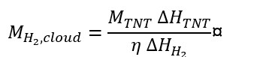 | (2)
where $M_{H_{2},cloud}=$ mass of H₂-gas in cloud, $M_{TNT}=$ mass of TNT equivalent, $∆H_{TNT}=$ Lower heat of combustion of TNT, $∆H_{H_{2}}=$ lower heat of combustion of H₂ and $η=$ Efficiency or “yield” of the explosion.
Both fragment/splinter barrier blast tests (S-tests) and free-field blast tests (F-tests) used identical NSP 711 charges in a free air burst configuration, which produces a more critical pressure wave than an equivalent hydrogen vapour cloud. The qualification tests are therefore conservative relative to realistic hydrogen pressure vessel rupture scenarios. TNT and hydrogen gas equivalences are given in Table 1. Hydrogen mass estimation accounts for the fraction of combustion energy contributing to blast wave generation (the "yield"), assumed at 1–10%, with 1% considered representative given that turbulent hydrogen release from a ruptured vessel creates large regions below the lower flammability limit. Lower heats of combustion are taken as 130,800 kJ/kg for hydrogen and 4,520 kJ/kg for TNT (Lopez et al., 2015).
Table 1: Blast tests: splinter barrier (S-Test) and free-field (F-Tests) conducted for each blast loading
Test No. | #1 | #2 | #3 | #4 | #5 | #6 | #7
TNT equiv. mass  [kg] | 1 | 1.5 | 2 | 2.75 | 3.65 | 4.8 | 10
NSP 711 mass  [kg] | 0.83 | 1.25 | 1.67 | 2.29 | 3.04 | 4 | 8.33
H₂-gas equivalent mass  [kg] | 0.86 …  ... 3.46 | 1.3 …  ... 5.18 | 1.73 …  ... 6.91 | 2.38 …  ... 9.5 | 3.15 …  ... 12.61 | 4.15 …  ... 16.59 | 8.64 …  ... 34.56

The explosive charge is decoupled from the ground and placed on top of a polystyrene block. It can be categorized as free air burst. In the free-field (F)-test, detonation happens above the surface of a reinforced concrete foundation with a solidly anchored steel plate. In the splinter-barrier (S-) -test, detonation happens above a steel plate used as protection for the concrete foundation. Details of the setup are given in Figure 3.
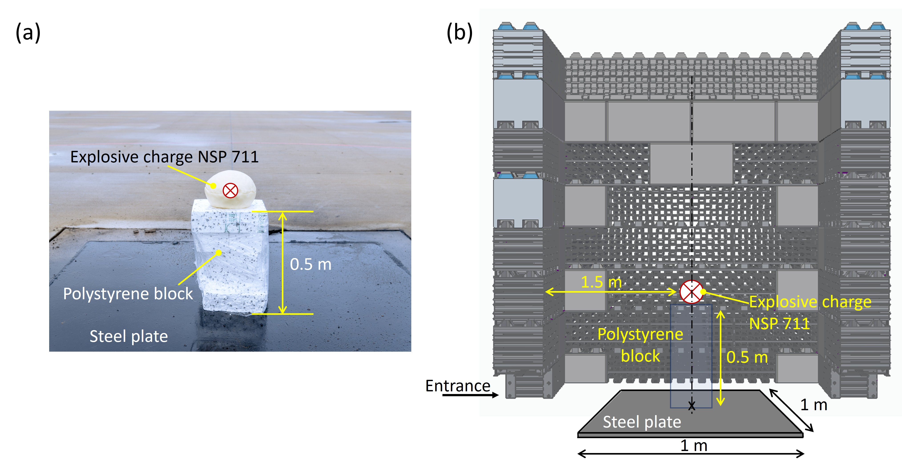
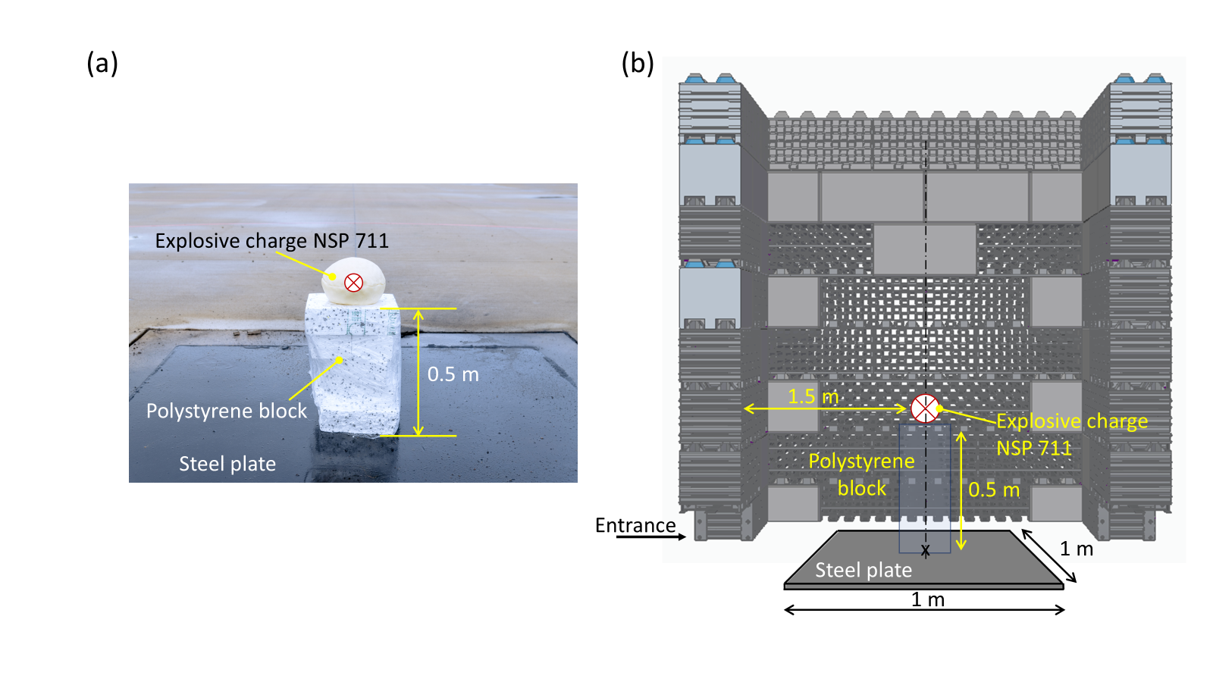

Figure 3. Positioning of the explosive charge NSP 711: (a) F-Test; (b) S-Test (Mair et al., 2025)
    - Blast pressure measurement
The sensor instrumentation and measurement programme evaluates structural integrity of the modular protective barrier system and quantifies blast wave damping and peak overpressure. It is complemented by pressure-time histories from pencil probe sensors, visual documentation via drone and camera inspection, high-resolution post-test 3D laser scanning, and C-Peak sound level measurements at the exclusion zone. In both, in free-field F-Test and within the protective barrier in S-Test, the shock wave propagation was recorded using pencil probes (420 mm in length, ~22 mm diameter) equipped with Integrated Electronics Piezo-Electric (IEPE) sensors. The placement of the pressure sensors was determined based on precalculated shock wave propagation, hence, according to the respective expected peak pressure amplitude values and pressure decreases (Xue et al., 2019). The pencil probes have a sensitivity of approx. 3000 mV/bar and a measurement range of 1.7 bar. Measurement positions are shown in Figure 4.
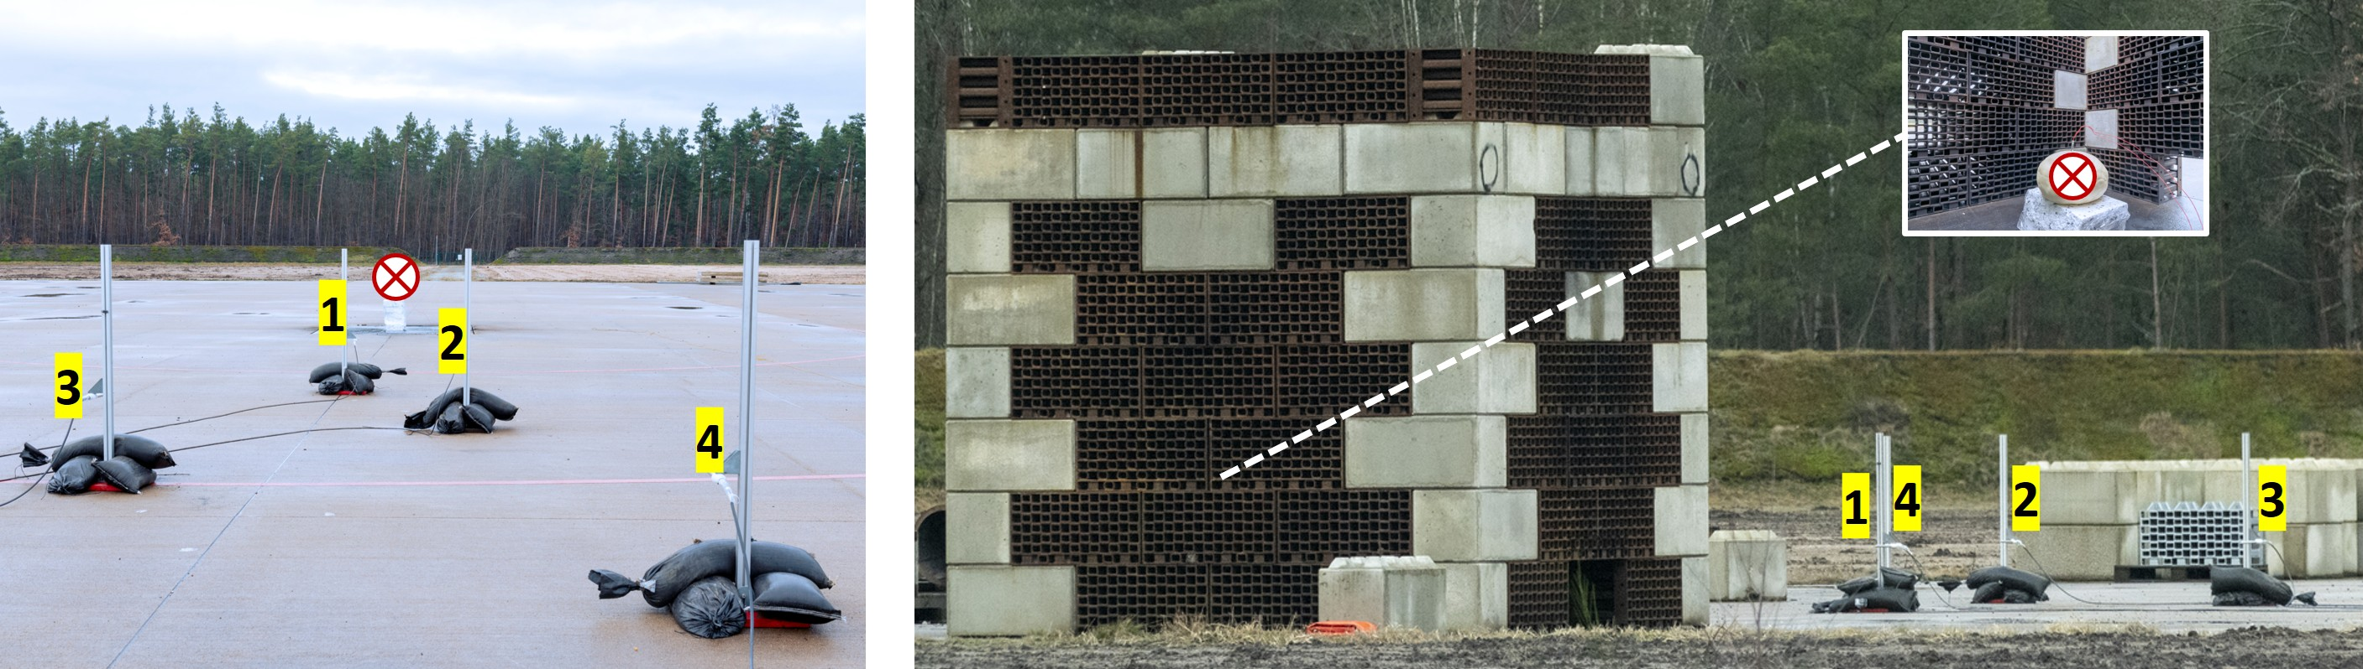

Figure 4. Positions of Pencil probes in free-field (left) and barrier tests (right).
The positions 1 to 4 corresponds to increasing sensor distances from the explosion centre in both, F-Tests and S-Test with 1 = 10 m ; 2 = 12.5 m ; 3 = 15 m ; 4 = 17.5 m. whereby the relative distance to the explosive charge is slightly greater, considering its shift from the orthogonal centre line. In Fig. 5 the test setup at the BAM Test Site Technical Safety is illustrated for the explosion tests carried out inside the protective barrier.
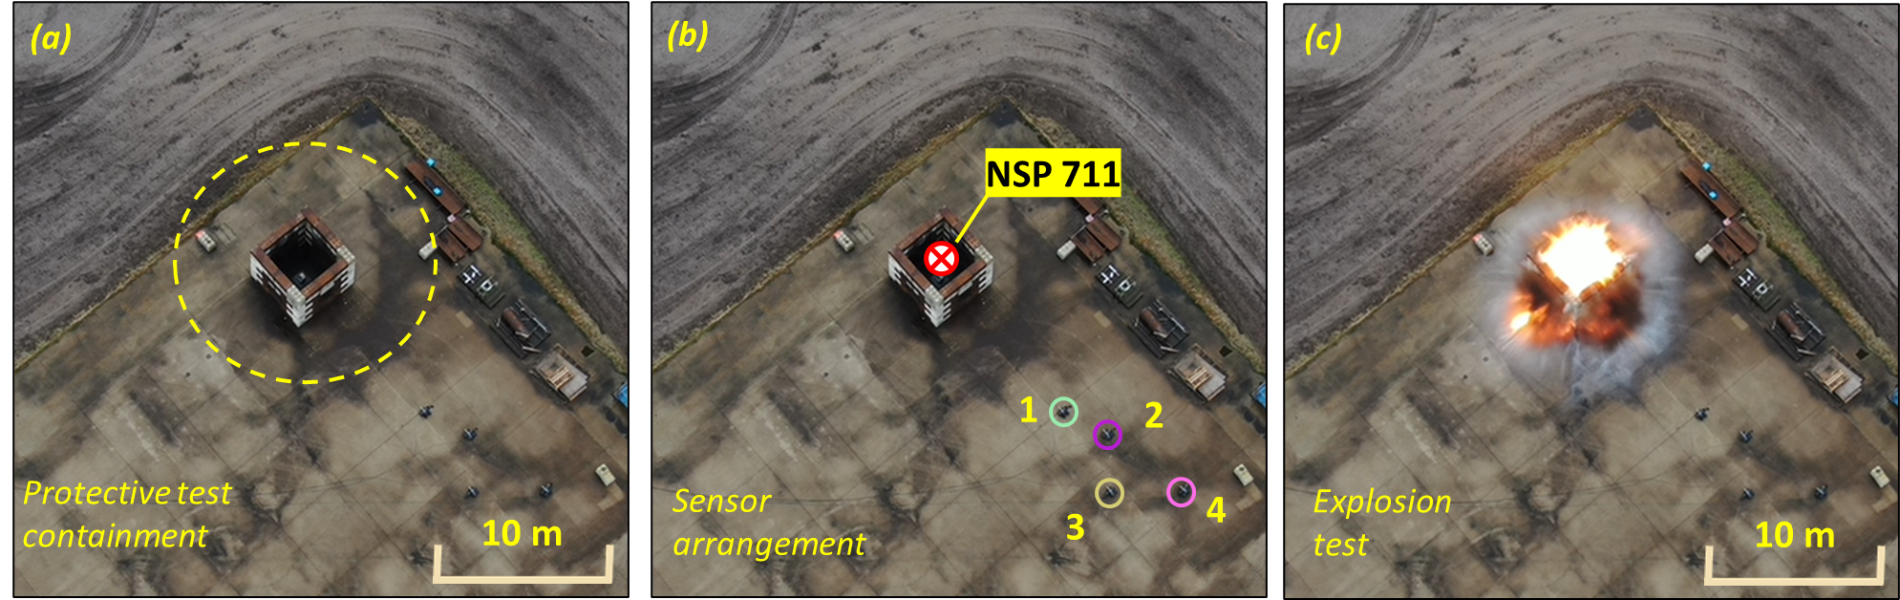

Figure 5. General view of impact blast test inside the protective barrier.
    - Results of blast pressure wave and peak overpressure
The pressure-time- and impulse-time-histories relating to blast pulses of all field- and barrier-tests have been evaluated at the different sensor positions. In Figure 6, free-field tests #1 to #7 and barrier tests #1 to #7 show increasing explosive charge. For both test arrangements, the overpressure values decrease with increasing distance. Across all charge levels (#1 to #7), overpressure is notably lower when the protective barrier is used.
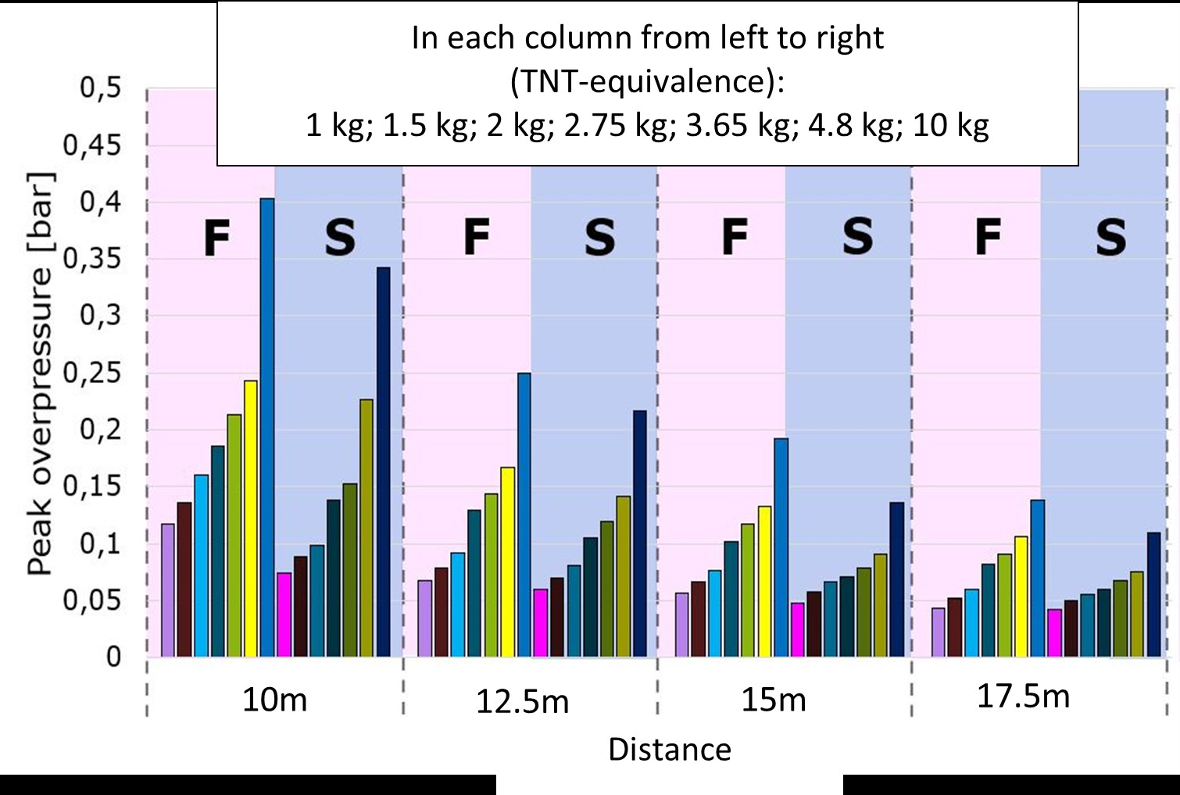

Figure 6. Comparison of the overpressure peak values for free-field tests (F) and barrier tests (S) at the respective measurement positions with distances (10 m/12.5 m/15 m/17.5 m).
Representative shock wave data are shown comparatively in Figure 7, with tests 7F and 7S for this highest explosive load with a TNT equivalent mass of 10 kg. The barrier consistently reduced peak overpressure at all measurement positions, demonstrating engineering-relevant mitigation. the barrier reduces the measured value at 10 m from a level associated with almost total destruction to below this critical range e.g. structural damage. For hydrogen-specific hazard distances, a nomogram approach (Kashkarov et al. 2020) provides a direct way for translating overpressure reduction to a reduction of exclusion radii.
A qualitative comparison of blast wave propagation between the free-field and the protective barrier scenarios is shown in Figure 8 by the images from blast test #7, which involved the highest blast load. The visual sequence on the right in Fig. 8 illustrates the directional spread of the blast wave. In the free-field, propagation is uniform, while within the fragment barrier, it is redirected orthogonally by the cube-shaped steel brick structure.
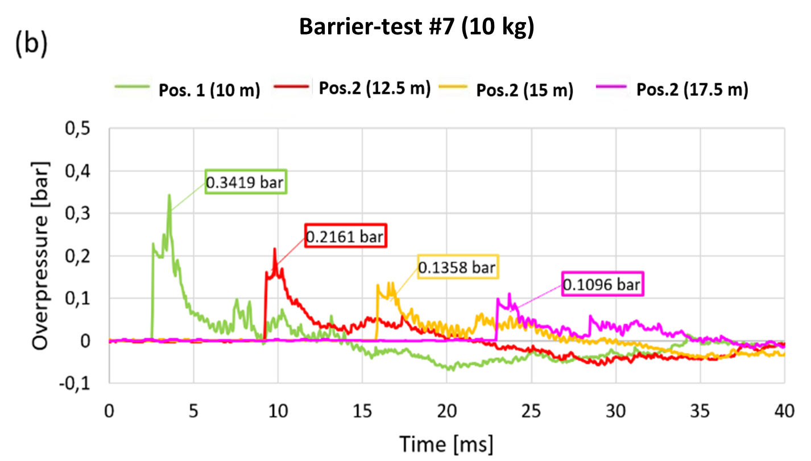
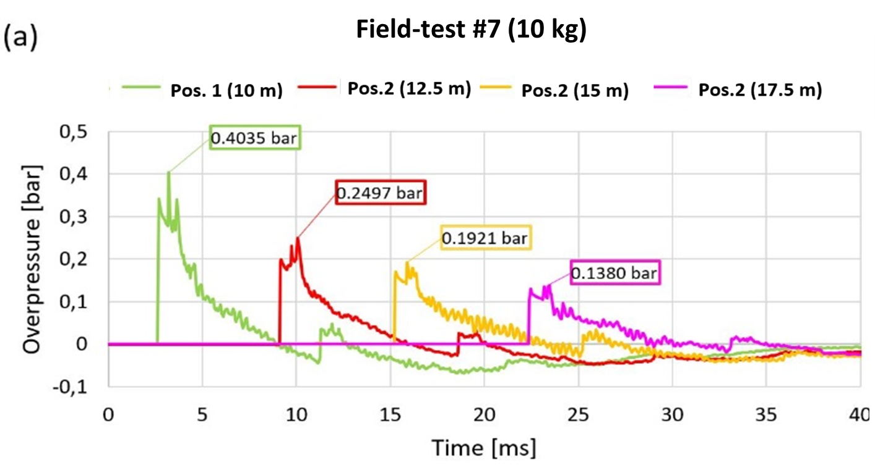

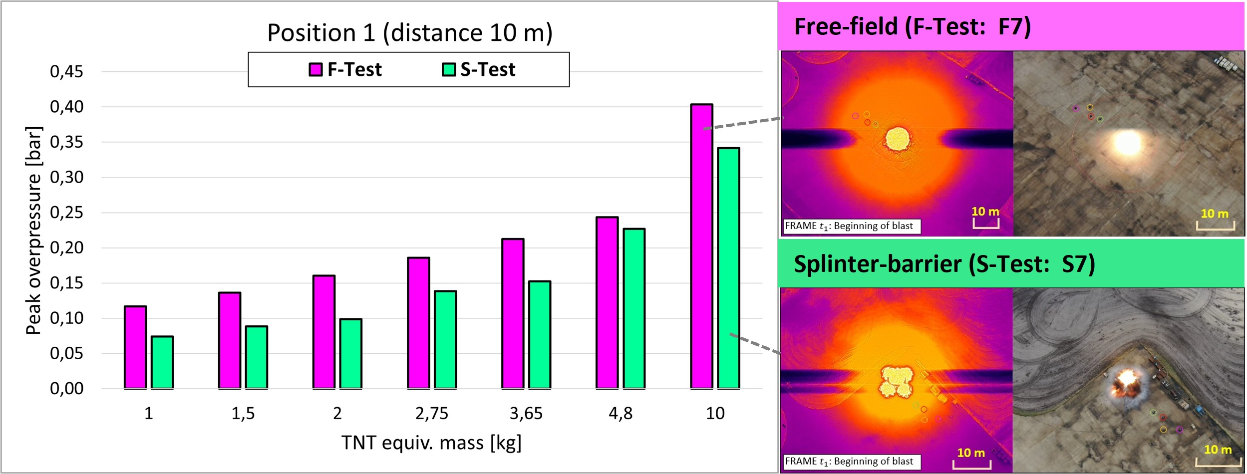
Figure 7. Overpressure-time data for maximum blast load for free-field test 7F (left) and barrier test 7S (right).

Figure 8. Comparison of the overpressure values for free-field tests (F) and barrier tests (S) for the highest blast load at the respective measurement positions 10 m/ 12.5 m/ 15 m/ 17.5 m.
Post-test inspection confirmed excellent structural integrity, with only minor relative displacements. No plastic deformation of the steel blocks was identified through 3D laser scanning. Relative displacements were minimal, which is notable given the magnitude of the applied blast loads. The maximum local displacement observed between two steel blocks in the second layer corresponds to the lateral clearance of 13 mm between the upper studs and the lower opening of a block, Fig. 9.

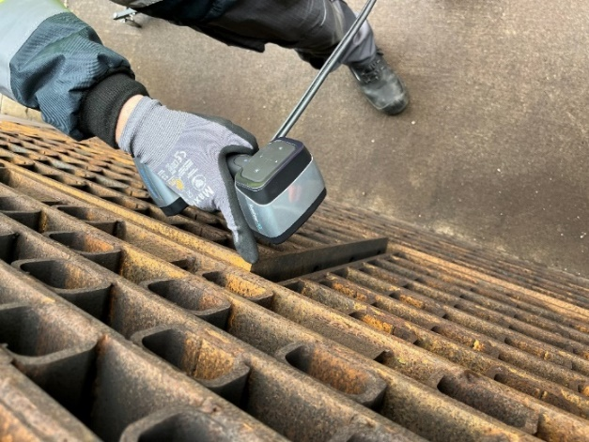
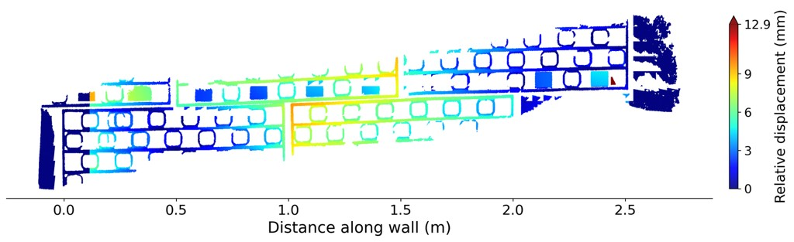

Figure 9. Post-blast 3D laser scan of steel block layer with corresponding relative displacement.
  - Conclusions
The modular barrier system at BAM test site is constructed from flexible blocks made of steel and can get combined with concrete blocks. The system has been qualified by impact blast and fire tests for fire resistance assessment of hydrogen composite pressure vessels. As part of the test series data analysis of pressure wave measurements, displacement measurements, thermal imaging and mapping demonstrate the full effectiveness and functional stability of the protective system design. The system provides a mechanical robustness against a pressure wave equivalent to 10 kg TNT without significant damage. Therefore, i.e. the structure can safely and repeatedly absorb the rupture of hydrogen pressure vessels with filling capacities up to 5 kg. Within thermal and explosive testing this enables reduced safety distances and other organizational efforts.
Nomenclature
M_{H2,cloud} – mass of H₂-gas in cloud, kg

M_{TNT} – mass of TNT equivalent, kg
p_{max,est} – estimated overpressure peak, MPa
R – distance from detonation point, m
R_{g} – scaled distance, m
δH_{H2} – lower heat of combustion of H₂, KJ/kg
δH_{TNT} – lower heat of combustion of TNT, KJ/kg
η – efficiency, -
ω – TNT equivalent of the explosive, kg

Acknowledgments
The initial experimental work was conducted within the DELFIN project, funded by the German Federal Ministry of Transport and Digital Infrastructure (BMVI). The blast-test investigations presented in this study were subsequently performed as part of the European SH2APED project under Grant Agreement No. 101007182. This project received support through the Horizon 2020 Research and Innovation Action (RIA), under the topic FCH-01-1-2020: Development of hydrogen tanks for electric vehicle architectures.
In addition, the explosive tests using NSP 711 were kindly conducted by the BAM Division “Conformity Assessment of Explosives and Pyrotechnics.”
References
DELFIN, 2022, Collaborative project, Research into alternative materials and manufacturing processes for cost- and weight-reduced pressure vessels made of continuous fibre-reinforced plastic (in German), Grant number 03B10104E/2, funded by NIP II research program of the German Federal Ministry for Digital and Transport.
EP 2024, European Patent EP 4043660 B1, System Module for Constructing a Splinter Wall and Flexibly Insertable Splitter Protection Cage, Patent Specification 2024/44, European Patent Office, 30 Oct. 2024
López E., Rengel R., Mair G.W. and Isorna, F., 2015, Analysis of high-pressure hydrogen and natural gas cylinders explosions through TNT equivalent method. Conference: 5th Iberian Symposium on Hydrogen, Fuel Cells, and Advanced Batteries (HYCELTEC), Tenerife, Spain, July 05-08, 2015. DOI: 10.13140/RG.2.1.2336.8401
Kashkarov, S., Li, Z., Molkov, V., 2020, Blast wave from a hydrogen tank rupture in a fire in the open: Hazard distance nomograms, International Journal of Hydrogen Energy, 45(3), 2429–2446. DOI: 10.1016/j.ijhydene.2019.11.084
Mair G.W., Kriegsmann A., Müller K., Sklorz C., 2025, A modular concept for protection against debris flight - design, properties and usage. Proceedings of the 11th International conference on hydrogen safety (ICHS 2025), Seoul, Korea, Sep 20– 25, 2025, 1428-1439.
SH2APED, 2024, EU project ref. 101007182, Storage of Hydrogen Alternative Pressure Enclosure Development (SH2APED), funded by Fuel Cells and Hydrogen 2 Joint Undertaking, FCH-01-1-2020.
Shirbhate, P.A., Goel, M.D., 2021, A Critical Review of Blast Wave Parameters and Approaches for Blast Load Mitigation. Arch Computat Methods Eng (28), 1713–1730.
TAHYA, 2021, EU project ref. 779644, TAnk HYdrogen Automotive (TAHYA), funded by Fuel Cells and Hydrogen 2 Joint Undertaking, FCH-01-3-2017: Improvement of compressed storage systems in the perspective of high volume automotive application.
Xue Z., Li S., Xin C., Shi L, Wu H., 2019, Modelling of the whole process of shock wave overpressure of free-field air explosion. Defence Technology (15), 815-820.

