 CHEMICAL ENGINEERING TRANSACTIONS  VOL. xxx, 2026 | A publication of  
The Italian Association
of Chemical Engineering
Online at www.cetjournal.it

Guest Editors: Valerio Cozzani, Bruno Fabiano, Genserik Reniers
Copyright © 2026, AIDIC Servizi S.r.l.
ISBN 979-12-81206-xx-x; ISSN 2283-9216

A Holistic Framework for the Assessment of Natech Risk and Resilience in the Chemical and Process Industry
Matteo Valente ^{a,}*, Federica Ricci ª, Paolo Gardoni ^{b}, Valerio Cozzani ª
ªLISES – Laboratory of Industrial Safety and Environmental Sustainability, Department of Civil, Chemical, Environmental and Material Engineering, University of Bologna, via Terracini 28, 40131, Bologna, Italy
^{b}Department of Civil and Environmental Engineering, Grainger College of Engineering, University of Illinois Urbana-Champaign, Urbana, IL, USA
matteo.valente6@unibo.it

The chemical and process industry (CPI) is highly vulnerable to natural hazards, which can trigger severe technological accidents (Natech events) with cascading impacts on society and the environment, including lengthy and costly post-disaster recoveries. Despite recent advances in Natech risk and resilience assessment, existing frameworks often fail to consistently capture interactions and external dependencies, such as the loss of critical supporting infrastructures, which can critically influence accident evolution and system performance. Based on the current state of the art in Natech research, this study identifies key aspects that should be incorporated into a comprehensive assessment of natural hazard impacts in the CPI. Drawing on evidence from past events and existing quantitative methodologies, the analysis highlights limitations in current approaches and emphasizes the need for a holistic framework. To address these gaps, relevant quantitative methods from regional risk and resilience analysis were examined to support the inclusion of external dependencies in the assessment of the loss of functionality. A notional case study is presented to demonstrate the applicability of the proposed framework, showing a marked reduction in system resilience when the unavailability of external supporting infrastructure is explicitly considered. The results underline the importance of integrating interdependencies and indirect failure pathways to improve Natech risk and resilience assessment in CPI.
  - Introduction
The operability of the chemical and process industry (CPI) is essential for the well-being and resilience of communities, since it serves as the backbone of numerous sectors such as medicine, agriculture, energy, and manufacturing by transforming raw materials into essential products. However, past events have highlighted the vulnerability of the CPI to natural hazards (Casson Moreno et al., 2019). In this sector, due to the presence of large quantities of hazardous materials, both extreme natural events (e.g., earthquakes, floods, and hurricanes) and low-intensity natural hazards (e.g., heat waves, cold waves, and lightning) may cause severe accidents involving fires, explosions, toxic releases, and environmental contamination (Krausmann et al., 2017). These accidents, known as Natech (technological accidents triggered by natural hazards), pose additional threats to society and communities, affecting post-disaster response and recovery phases (Suarez-Paba et al., 2020).
Natech events are typically high-consequence accidents, primarily due to the ability of natural hazards to cause rapid and multiple failures, thereby increasing the probability of severe domino accidents (Misuri & Cozzani, 2024). Recent studies have also shown that the simultaneous unavailability of external supporting infrastructure (e.g., power systems) and the failure of safety utility systems (e.g., emergency generators) can lead to severe Natech accidents triggered through indirect pathways (Misuri & Cozzani, 2021). The systemic impacts of natural hazards on bidirectionally interdependent systems (e.g., industrial plants, critical infrastructures, social systems) call for a holistic framework to comprehensively assess the causes and mechanisms that drive component and system failures and performance degradation, especially in the chemical and process industries. Although recent advances have been made in developing quantitative tools for assessing the resilience to natural hazards of this sector (Valente et al., 2024), the current frameworks for risk and resilience analysis still lack consistent integration and inclusion of external dependencies (Valente et al., 2025a).
To address these limitations, this study identifies and assesses the key aspects that should be included in a comprehensive assessment of the impact of natural hazards in the CPI. Furthermore, to account for external dependencies influencing the failure and loss of performance of components and systems in the CPI, the study reviews literature on regional risk and resilience analysis of critical infrastructure to identify relevant quantitative approaches. Based on the developed framework, a notional case study of a storage area is presented, demonstrating a significant decrease in resilience when the unavailability of external supporting infrastructure is considered. Compared to previous studies, this paper proposes a structured methodological workflow that explicitly integrates external infrastructure dependencies into a unified assessment framework, enabling a more comprehensive and consistent representation of Natech risk and resilience features.
  - Loss of functionality and Business Interruption
A comprehensive assessment of natural hazard impacts on industrial systems must account for all potential causes of loss of functionality and business interruption. These effects depend strongly on the hazard type, its intensity, and the spatial extent of its impact. For extreme events with large affected areas (e.g., earthquakes), the loss of functionality and downtime are not determined solely by direct physical damage to the facility (i.e., ordinary business interruption), but also by indirect effects, including the unavailability of external supporting infrastructure, supply chains, and social systems (i.e., contingent business interruption)(Nocera & Gardoni, 2019). The following sections summarize the main factors influencing loss of functionality and business interruption, together with available quantitative modeling approaches that can be integrated into system reliability analysis for risk and resilience assessment.
    - Physical damage to the plant and Natech accidents
Natural hazards may damage buildings, infrastructure, and equipment within the plant area. Although buildings and infrastructure may retain partial functionality depending on their damage state, chemical equipment and process components generally cannot be considered functional once damaged. As a result, production lines, or entire plant sections, are often shut down in the absence of redundancy. Several probabilistic fragility modeling approaches have been developed to quantify such damage, including binary failure models (Caratozzolo et al., 2022), lognormal fragility curves for multiple damage states (FEMA, 2024), and physics-based fragility estimates based on probabilistic capacity and demand models (Gardoni et al., 2002).
Clearly, damage to equipment and components may lead to the release of hazardous substances and Natech accidents. Assessing loss of performance in chemical plants, therefore requires explicit consideration of key Natech characteristics (e.g., multiple scenarios, depletion of safety barriers, domino effects) as well as the occurrence of indirect accident pathways caused by the failure of utilities and auxiliary safety systems. Quantitative tools for Natech risk assessment that can incorporate these features are available, for example Bayesian networks, fault trees, and modified event trees that integrate safety barrier gates (Misuri & Cozzani, 2024). To include the uncertainty of relevant variable (e.g., safety barrier performance factors) numerical simulations such as Monte Carlo methods could be used.
    - Emergency Shutdown and Blowdown
Evidence from past natural hazards highlights the importance of preventive emergency shutdown (ESD) and blowdown (EBD) procedures to mitigate hazard impacts and prevent escalation into Natech accidents (Necci & Krausmann, 2022). These procedures may be initiated manually by operators (e.g., in response to conditions not automatically detectable) or automatically through interlocks triggered by hazard intensity measures exceeding predefined thresholds.
It is therefore paramount to account for the activation of emergency logic in addition to direct physical damage when evaluating the probability of system failure. Considering these aspects is important to carry out a realistic estimation of both failure probability and downtime duration of the system.
Emergency logic can be incorporated into failure probability assessments using conventional reliability methods such as fault tree and reliability block diagram. However, for complex scenarios involving statistically dependent events, and large number of conditional probabilities, simulation-based approaches (e.g., Monte Carlo methods) may be required. In computationally demanding problems, variance reduction techniques such as importance sampling could be adopted.
    - Supply chain disruption
Supply chain disruption may lead to loss of functionality through the unavailability of raw materials or the inability to deliver products. Multiple components of the supply chain can be affected by natural hazards, including transportation infrastructures, suppliers, customers, and distribution hubs. Consequently, production may be interrupted either because the raw materials cannot be restocked or because products cannot be delivered. Thus, even physically undamaged facilities may be forced to reduce or suspend operations due to disruptions elsewhere in the supply chain.
Incorporating supply chain disruption into a fully probabilistic assessment requires extending the spatial scope of analysis to the entire hazard-affected region. A preliminary identification of interdependent industrial facilities is necessary to characterize the topology of the supply network. Nocera et al. (2024) proposed a mathematical framework to quantify regional-scale hazard impacts on supply chains by explicitly modeling dependencies between supply chain operations and the performance of structures and infrastructure. A more specific study was proposed by Tabandeh et al. (2024), who modeled the dynamic functionality of interacting industrial facilities and infrastructure as interdependent networked systems.
    - Damage to supporting critical infrastructures
Damage to external lifeline infrastructure and plant utility systems, such as electric power, water, and natural gas networks, can cause loss or reduction of plant functionality and significantly delay recovery and restoration (Valente et al., 2025b). The likelihood and duration of business interruption strongly depend on the hierarchical position of the plant within the broader infrastructure network and on the availability of higher-level systems. For example, electric power systems typically occupy the highest hierarchical level in infrastructure networks. As a result, even undamaged industrial facilities may experience loss of functionality due to failures in the power network (Alam et al., 2023), and indirect Natech scenarios may occur when coupled with the failure of on-site emergency generators (Misuri & Cozzani, 2021).
Modeling external dependencies in risk and resilience analyses requires defining system boundaries, network topology, and the types of interdependencies involved (Sharma et al., 2021). Depending on the objectives of the analysis, appropriate spatial, temporal, and hierarchical resolutions must be selected. When interdependencies are binary, connectivity analyses may be sufficient. However, more complex performance dependencies require interface mapping functions, such as logic gates, logistic curves, or perceptrons, to achieve high-fidelity representations once interdependence mechanisms are known (Sharma & Gardoni, 2022).
    - Social systems
Natural-hazard impacts typically extend beyond plant boundaries, and post-event restoration of the wider built environment and lifeline infrastructure can significantly constrain workforce availability and delay industrial recovery and restoration. Plants may experience relevant downtime due to shortages of workers and specialized crews (e.g., for debris removal), leading to delays in the adaptation and recovery phases. Also, such personnel are often prioritized for higher-hierarchy critical infrastructure essential for societal recovery or for securing hazardous areas.
Population displacement depends on multiple factors (Guidotti et al., 2019) and several probabilistic approaches have been proposed to estimate both displacement and workforce unavailability (e.g., Costa et al., 2022; FEMA, 2024; Rosenheim et al., 2021). These methods typically rely on national census data combined with models that estimate hazard-induced damage to buildings, critical infrastructure, and industrial facilities. The resulting information is used in iterative algorithms to predict population displacement in probabilistic terms (Costa et al., 2022), using, for example, logistic regression models (Guidotti et al., 2019) or damage-state thresholds (FEMA, 2024). For instance, (Nocera & Gardoni, 2019) combined spatial data on worker residences from the Longitudinal Employer–Households Dynamics Origin–Destination Employment Statistics (LODES) with building damage and casualty to estimate business interruption probability arising from workforce unavailability due to injury, fatality, or displacement.
  - Methodology
The methodology applied in this paper predicts the loss of functionality and recovery trend, integrating in the reliability analysis both the direct physical damage to plant items and the effects of the other systemic cascading damage to external critical infrastructure due to natural hazards.
First, the impact of the natural hazard is modeled by defining a sample space composed of mutually exclusive and collectively exhaustive (MECE) events representing structural damage states of plant equipment and external supporting critical infrastructure. For damage states involving hazardous equipment, the sample space is further decomposed to explicitly include Natech scenarios and possible domino effects. This is achieved using a modified Event Tree Analysis (ETA), incorporating safety barriers and their performance in preventing and mitigating accident escalation. The resulting event sequences remain MECE and enable a consistent probabilistic representation of multiple simultaneous and conditional failures. System failure probability is then computed by aggregating the probabilities of all mutually exclusive event sequences leading to loss of functionality of the system under analysis.
The recovery process is modeled by estimating the time required to restore full system functionality through a recovery activity network, accounting for damage repair, restoration works, and external infrastructure recovery.
  - Case study
A notional case study is developed to demonstrate the relevance of accounting for Natech scenarios and external supporting infrastructure in the resilience analysis of industrial installations exposed to natural hazards. The selected system is a storage area within a chemical complex, illustrated in Figure 1.
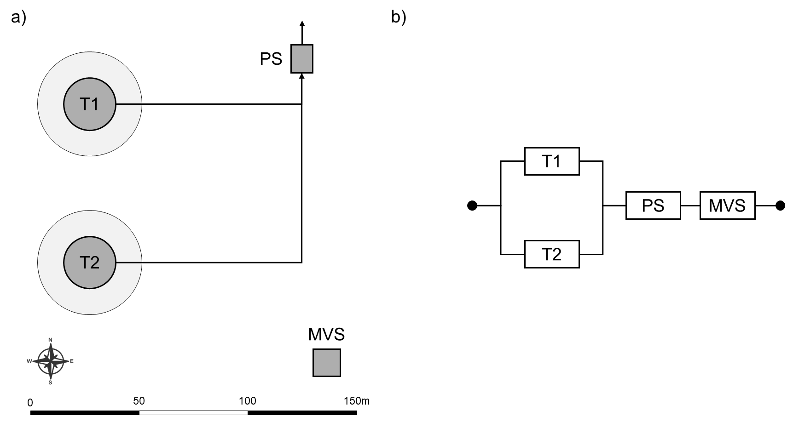
Figure 1. (a) Layout of the storage area considered in the case study. (b) Reliability block diagram of the storage area. T: atmospheric storage tank; MVS: Medium voltage substations; PS: Pumping station.

The storage area consists of two atmospheric storage tanks (T1 and T2) containing hexane, a pumping station (PS), and medium-voltage substations (MVS). The main characteristics of the equipment and inventories are summarized in Table 1. The following ambient conditions are assumed: air temperature 15 °C, air density 1.3 kg/m³, relative humidity 70%, and wind speed of 1.5 m/s at a height of 10 m. The natural hazard considered is an earthquake, characterized by different peak ground acceleration (PGA) levels to explore multiple damage and functionality loss scenarios. For simplicity, only the electric power network is considered as external supporting infrastructure. The storage area is assumed to be fully supplied by a thermal power plant located within the same chemical complex; therefore, the PGA affecting the power plant is assumed equal to that of the storage area.
Table 1: Data of the equipment items and of the tank inventories considered for the case study.
Item name | Equipment data | Inventory data
T1 – T2 | Unanchored on-ground steel tank  Diameter: 24 m  Volume: 4524 m³  Catch basin area: 1800 m² | Material: Hexane  Filling level: 0.8  Storage phase: Liquid  Inventory: 2371 ton
PS | Type: Pumping stations with unanchored subcomponents | Material: Hexane  Flow rate: 800 m³/day
MVS | Medium voltage substations with unanchored components | -

Figure 1b shows the reliability block diagram of the storage area. In addition to the system failure considering only structural damage of plant components (F_{SD}), two further contributors to system failure are considered: emergency shutdown activation (A_{ESD}) and external power supply unavailability (U_{EPS}). In generic terms, the system failure probability P_{f} conditional on the earthquake intensity measure (IM) can be written as P_{f} = P [F_{sys} | IM]. To evaluate the relative influence of each contributor, three configurations are analysed: (i) F_{sys} = F_{SD}, (ii) F_{sys} = A_{ESD} ∪ F_{SD}, and (iii) F_{sys} = A_{ESD} ∪ F_{SD} ∪ U_{EPS}. Specifically, automatic activation of ESD is considered with interlocks at PGA ≥ 0.17 g or when a loss of containment (LOC) occurs.
Fragility and recovery curves for plant equipment and the power generation facility are taken from (FEMA, 2024). Three main scenarios are considered: (i) solely structural damage caused by the natural hazard, (ii) inclusion of primary Natech events, and (iii) inclusion of domino effects. When structural damage leads to LOC, consequence analysis is performed using established models (Van den Bosch & Weterings, 2005). For the assessment of the domino effects, the method reported in (Misuri & Cozzani, 2024) was applied implementing a modified ETA to explicitly incorporate safety barrier performance. The safety barriers considered, along with their effectiveness, probability of failure on demand, and modification factors, are summarized in Table 2. To account for uncertainty associated with safety barrier modification factors, a Monte Carlo analysis is performed. At each simulation run, the modification factors are randomly sampled and the corresponding ETA is recomputed, allowing the propagation of uncertainty through the accident scenarios. The simulations are terminated when the coefficient of variation (CoV) of 0.05 is achieved for both the system failure probability and the recovery probability at selected time steps (i.e., every 200 days).
Table 1: Data considered in the quantification of the event trees. η: effectiveness; PFD: probability of failure on demand; 0: considering normal condition; ϕ: performance modification factor; PMF: Probability Mass Function; * Depending on the comparison between the time to failure (ttf) and time for final mitigation (tfm).
Safety barrier | Type | Gate | η₀ | PFD₀ | Source of uncertainty
Catch Basin | Passive | a | 9.99E-01 | 0 | ϕ, PMF from (Misuri et al., 2020)
ESD system | Active | a | 1 | 3.72E-04 | ϕ, PMF from (Misuri et al., 2020)
Emergency intervention | Procedural | c | 0;1* | - | tfm, PMF from (Ricci et al., 2024)
  - Results and Discussion
Figure 2 illustrates the effects of progressively including Natech-related mechanisms and external dependencies on system failure probability and recovery. Figure 2a shows the probability of failure as a function of PGA for the three modelling assumptions described in the previous section. Compared to the structural-damage-only case, accounting for ESD leads to consistently higher failure probabilities. This increase is mainly driven by single tank failure scenarios. When one tank is damaged and a loss of containment (LOC) occurs, the storage area is shut down for safety reasons, so the system is considered failed. In the baseline configuration (structural-integrity-only), the same event is not counted as a system failure because the functionality of the storage system is still maintained; therefore, these failure events are not captured in the system failure probability. The step increase in failure probability at PGA=0.17g corresponds to the threshold for automatic interlock activation. The most comprehensive scenario, which also considers the unavailability of the external electric power supply, exhibits the highest failure probabilities across the entire PGA range, highlighting the role of external infrastructure dependencies even at moderate hazard intensities. Figure 2b presents the recovery curves for the most complete configuration, i.e., including structural damage, ESD system, and external supply of electric power. Recovery curves were assessed for two earthquake intensity levels, PGA = 0.2g and PGA = 0.5g, for the three scenarios considered. For both intensity levels, recovery becomes progressively slower as additional Natech-related mechanisms are considered. This is mainly due to the increase in the amount of recovery work due to the damage caused by the Natech accidents and domino escalations.
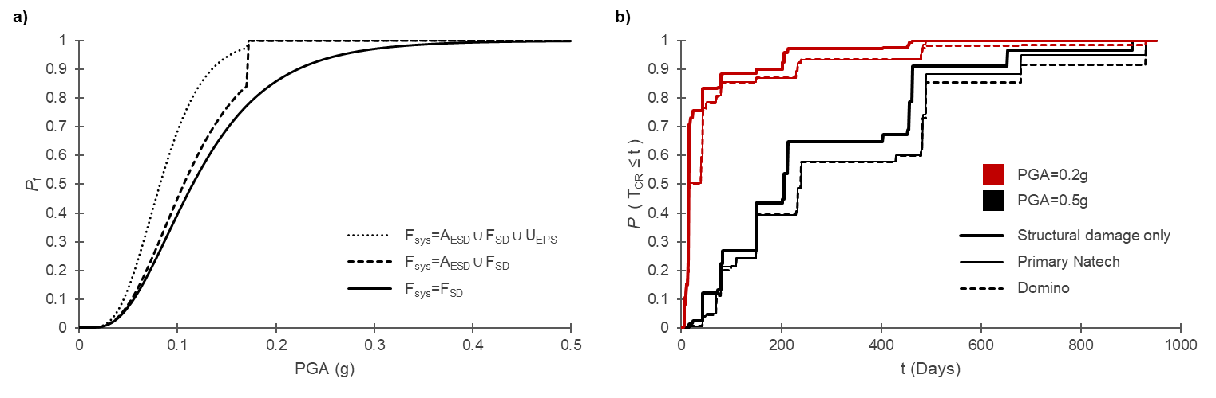
Figure 2. (a) Estimated probability of system failure as a function of peak ground acceleration (PGA) under different modeling assumptions. (b) Recovery curves for PGA = 0.2 g and PGA = 0.5 g considering different scenarios.T_{CR}: time to complete the full recovery.
  - Conclusions
This study highlights the limitations of current risk and resilience frameworks for the chemical and process industry, which often inadequately account for external dependencies and Natech-specific mechanisms. The case study results demonstrate that neglecting Natech scenarios and supporting infrastructure interdependencies leads to a systematic underestimation of failure probability and recovery time, thereby overestimating system resilience. These findings emphasize the need for a holistic quantitative resilience framework that provides the basis for developing computationally efficient methodologies for the analysis of chemical and process plants exposed to natural hazards.
References
Alam, M. S., Simpson, B. G., & Barbosa, A. R. (2023). Fragility and Recovery Models for Energy, Water, and Wastewater Systems for Seismic Regional Risk and Resilience Assessment: State-of-the-Art Review and Database. Natural Hazards Review, 24(4).
Caratozzolo, V., Misuri, A., & Cozzani, V. (2022). A generalized equipment vulnerability model for the quantitative risk assessment of horizontal vessels involved in Natech scenarios triggered by floods. Reliability Engineering & System Safety, 223, 108504.
Casson Moreno, V., Ricci, F., Sorichetti, R., Misuri, A., & Cozzani, V. (2019). Analysis of past accidents triggered by natural events in the chemical and process industry. Chemical Engineering Transactions, 74, 1405–1410.
Costa, R., Haukaas, T., & Chang, S. E. (2022). Predicting population displacements after earthquakes. Sustainable and Resilient Infrastructure, 7(4), 253–271.
FEMA. (2024). Hazus Earthquake Model Technical Manual, Hazus 6.1. Federal Emergency Management Agency.
Gardoni, P., Der Kiureghian, A., & Mosalam, K. M. (2002). Probabilistic Capacity Models and Fragility Estimates for Reinforced Concrete Columns based on Experimental Observations. Journal of Engineering Mechanics, 128(10), 1024–1038.
Guidotti, R., Gardoni, P., & Rosenheim, N. (2019). Integration of physical infrastructure and social systems in communities’ reliability and resilience analysis. Reliability Engineering & System Safety, 185, 476–492.
Krausmann, E., Cruz, A. M., & Salzano, E. (2017). Natech Risk Assessment and Management, Reducing the Risk of Natural-Hazard Impact on Hazardous Installations. Elsevier.
Misuri, A., & Cozzani, V. (2021). A paradigm shift in the assessment of Natech scenarios in chemical and process facilities. Process Safety and Environmental Protection, 152, 338–351.
Misuri, A., & Cozzani, V. (2024). A Roadmap for the Comprehensive Assessment of Natech Risk: Management and Control of Technological Accidents Triggered by Natural Hazards in the Framework of Climate Change. Elsevier.
Misuri, A., Landucci, G., & Cozzani, V. (2020). Assessment of safety barrier performance in Natech scenarios. Reliability Engineering & System Safety, 193, 106597.
Necci, A., & Krausmann, E. (2022). Natech risk management. Publications Office of the European Union, JRC129450.
Nocera, F., Contento, A., & Gardoni, P. (2024). Risk analysis of supply chains: The role of supporting structures and infrastructure. Reliability Engineering & System Safety, 241, 109623.
Nocera, F., & Gardoni, P. (2019). A ground-up approach to estimate the likelihood of business interruption. International Journal of Disaster Risk Reduction, 41, 101314.
Ricci, F., Yang, M., Reniers, G., & Cozzani, V. (2024). Emergency response in cascading scenarios triggered by natural events. Reliability Engineering & System Safety, 243, 109820.
Rosenheim, N., Guidotti, R., Gardoni, P., & Peacock, W. G. (2021). Integration of detailed household and housing unit characteristic data with critical infrastructure for post-hazard resilience modeling. Sustainable and Resilient Infrastructure, 6(6), 385–401.
Sharma, N., & Gardoni, P. (2022). Mathematical modeling of interdependent infrastructure: An object-oriented approach for generalized network-system analysis. Reliability Engineering & System Safety, 217, 108042.
Sharma, N., Nocera, F., & Gardoni, P. (2021). Classification and mathematical modeling of infrastructure interdependencies. Sustainable and Resilient Infrastructure, 6(1–2), 4–25.
Suarez-Paba, M. C., Tzioutzios, D., Cruz, A. M., & Krausmann, E. (2020). Toward Natech Resilient Industries. In Disaster Risk Reduction and Resilience (pp. 45–64). Springer.
Tabandeh, A., Sharma, N., & Gardoni, P. (2024). Seismic risk and resilience analysis of networked industrial facilities. Bulletin of Earthquake Engineering, 22(1), 255–276.
Valente, M., Ricci, F., & Cozzani, V. (2024). Resilience Assessment of Chemical Sites Exposed to Natural Events. Chemical Engineering Transactions , 111, 145–150.
Valente, M., Ricci, F., & Cozzani, V. (2025a). A systematic review of Resilience Engineering applications to Natech accidents in the chemical and process industry. Reliability Engineering & System Safety, 255, 110670.
Valente, M., Ricci, F., & Cozzani, V. (2025b). Analysis of past Natech Events in a Resilience Perspective. Chemical Engineering Transactions , 116, 97–102.
Van den Bosch, C., & Weterings, R. (2005). Methods for the calculation of Physical Effects Due to releases of hazardous materials (liquids and gases). Yellow Book, Committee for the Prevention of Disasters.

