 CHEMICAL ENGINEERING TRANSACTIONS  VOL. xxx, 2026 | A publication of  
The Italian Association
of Chemical Engineering
Online at www.cetjournal.it

Guest Editors: Valerio Cozzani, Bruno Fabiano, Genserik Reniers
Copyright © 2026, AIDIC Servizi S.r.l.
ISBN 979-12-81206-xx-x; ISSN 2283-9216

Dynamic Barrier Failure Pathways in Ammonia Bunkering: A Systems-Based Safety Analysis Framework
Tomaso Vairoª, Hans J. Pasman^{b}, Andrea P. Reverberi^{c}, Bruno Fabianoª*
ªDICCA Civil Chemical and Environmental Engineering Dept., Genoa University, via Opera Pia 15,16145 Genova, Italy
^{b}TEES Mary Kay O’Connor Process Safety Center, Texas A&M University System, College Station, TX 77843, USA
^{c} DCCI - Chemistry and Industrial Chemistry Dept., Genoa University, via Dodecaneso 31, 16146, Genova, Italy
brown@unige.it
Ammonia is emerging as a promising carbon-free marine fuel and a prominent candidate as effective and low-cost hydrogen carrier due to its high hydrogen content (17.65 %). NH₃ adoption introduces new safety challenges due to its high toxicity, corrosiveness, and complex behaviour under dynamic operational conditions. This paper presents a dynamic barrier failure analysis for an ammonia bunker vessel and associated bunkering operations, integrating temporal risk evolution with the performance of technical and organizational safety barriers. A hybrid-modelling framework, combining process-dynamic simulations, event-sequence modelling, and Bayesian inference, is developed to characterize how deviations, equipment malfunctions, human actions, organizational failure, and environmental perturbations propagate through the system over time. Preliminary results highlight a set of high-leverage precursor conditions, which significantly increase the likelihood of cascading barrier impairment.
  - Introduction
The maritime sector is undergoing a deep transition toward low- and zero-carbon fuels driven by stringent climate targets and related international regulations, implying the introduction of emerging hazards in port environments, mainly connected to storage and handling. Among the candidate fuels, ammonia has gained substantial attention due to its carbon-free combustion potential, established industrial supply chains, and compatibility with long-term energy transition strategies (Kojima, 2024). Additionally, ammonia is potentially advantageous to LH₂ for long-distance hydrogen transport, being a liquid at −33 °C (at atmospheric pressure),
(Ibrahim et al., 2023). even though the conversion of H₂ into NH₃ and the reconversion back to H₂ at the export destination involves energy losses (Pasman et al., 2024). Despite these advantages, ammonia poses severe safety concerns arising from its inherent hazards, rapid dispersion in loss of containment events and requires effective post-release mitigation measures (Fabiano et al., 2025). A recent example is provided by the explosion occurred on November 6th, 2025, at a hydrogen and nitrogen product manufacturer at the CF plant in Yazoo City, Mississippi, causing an ammonia leak forcing emerging evacuation of residents (The Associated Press, 2025). In this context, bunkering operations represent a particularly critical phase in the ammonia fuel lifecycle, as they involve transient configurations, strong coupling between vessels and shore or bunker units, and intense human–machine interaction under time pressure (Yang and Lam, 2024). Accident scenarios in such contexts are rarely the result of single-point failures; rather, they emerge from systemic interactions and time-dependent degradation of safety barriers (Khan et al., 2025a). Consequently, there is a growing need for safety analysis approaches that move beyond static, component-level risk models and explicitly address dynamic, system-wide behaviour. The proof-of-concept case study illustrates diagnostic inference; probabilities are illustrative conditionals, not real frequencies, and outlines a preliminary approach to dynamic, Bayesian, system-based safety analysis for ammonia bunker vessels and bunkering operations; it aims to (i) capture the temporal evolution of risk, (ii) represent uncertainty explicitly, (iii) model interdependencies among safety barriers, and (iv) support continuous learning from operational data, allowing the attainment of increased resilience (Vairo et al., 2021).

  - Theoretical background and Research Gap
    - Systemic and Barrier-Based Safety
Modern safety theory increasingly views accidents as emergent phenomena arising from the interaction of socio-technical system elements rather than as linear chains of component failures. In this perspective, safety is an emergent property maintained through the effective functioning of multiple, interdependent safety barriers. Barriers may be technical, human, or organizational, and their performance can degrade over time due to stressors, workload, and latent conditions. Ammonia bunkering involves multiple hazardous phenomena, including toxic vapor release, cryogenic or pressurized liquid exposure, material embrittlement, and potential escalation to fire or explosion under specific conditions (Hwang et al., 2026). Key risk contributors include hose and coupling failures, overpressure events, human error during connection and disconnection, inadequate gas detection coverage, and delayed emergency shutdown activation. Environmental factors such as wind speed, temperature, and vessel motion further complicate risk management (Wang et al., 2025). Ammonia bunkering is characterized by strong coupling between process dynamics, human decisions, and environmental conditions due to its batch type operation: connecting, flowing, disconnecting. Systemic safety approaches combined with Bayesian inference offer a natural way to represent these couplings and to move beyond static, availability-based safety arguments toward risk trajectories and leading indicators.
    - Bayesian and Systemic Safety Approaches
Bayesian methods offer a mathematically rigorous framework for probabilistic reasoning under uncertainty and for updating beliefs as new evidence becomes available (Vairo et al., 2023, 2026a). When combined with system-theoretic safety concepts—such as barrier management, control loops, and emergent risk—Bayesian models enable a shift from reactive risk estimation to proactive safety management (Khan et al., 2025a). Bayesian Networks (BNs) are well suited to modelling time-dependent processes and causal dependencies, making them a powerful tool for analysing complex socio-technical systems such as ammonia bunkering operations (Khan et al., 2025b). Considering that despite their potential, Bayesian systemic approaches remain underutilized in maritime fuel safety, especially for emerging fuels, this paper offers a preliminary perspective on a domain-specific framework tailored to ammonia bunkering in port areas.
  - Bayesian Systemic Framework
    - Model Architecture
The framework shown in Figure 1 adopts a system-based perspective in which safety is viewed as an emergent property arising from interactions among technical components, human operators, organizational structures, and the operational environment. According to the STAMP theoretical causality model, and its derived STPA unsafe control actions approach (Leveson, 2004), accidents are regarded as the result of loss of control, or barrier erosion over time, rather than as isolated failures requiring increased reliability. Safety barriers can be modelled as dynamic entities characterized by performance states rather than binary availability: they may degrade, recover, or fail depending on stressors, maintenance actions, operational demand, and latent conditions (Vairo et al., 2026b).
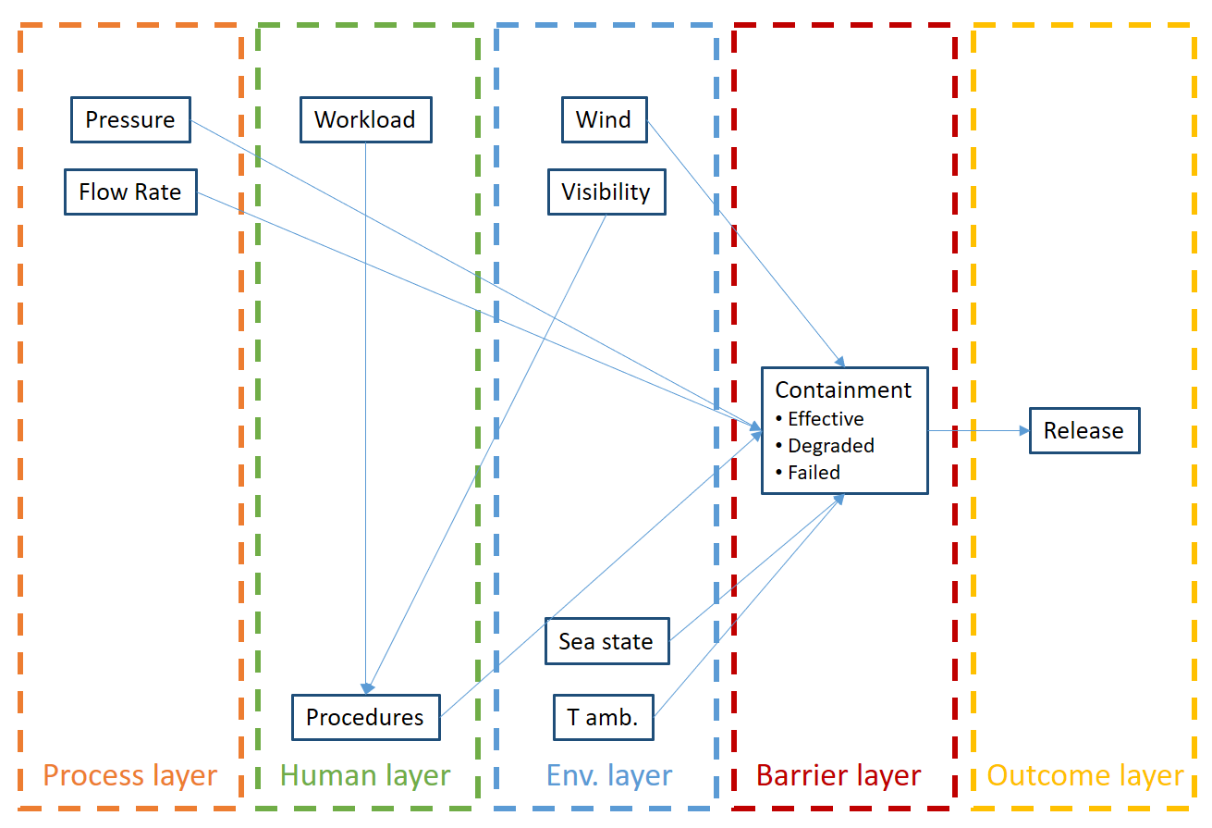
Figure 1: Conceptual framework architecture.
The layered Dynamic Bayesian Network is structured as follows.
- Process Dynamics Layer: pressure, temperature, flow rate, and inventory;
- Human and Organizational Layer: workload, training, procedural compliance, decision quality;
- Barrier Performance Layer: multi-state representations of technical and organizational barriers;
- Weather Layer: wind, rain, visibility, sea state, ambient temperature, hot/cold waves etc.;
- Outcome Layer: release magnitude, exposure, escalation, and consequences.
Each node is associated with a conditional probability distribution capturing causal influence from parent nodes and temporal dependence on its previous state. Safety barriers are modeled as multi-state entities (effective, degraded, failed), allowing progressive erosion and recovery, while dependences between the barriers and other system elements are explicitly represented, enabling prompt identification of common-cause and cascading effects. To this purpose, time is discretized into operational phases (preparation, connection, transfer, disconnection, post-bunkering) and transition models describe how system states evolve between phases, allowing the identification of critical windows corresponding to risk enhancement.
  - Applicative case-study in harbour area
The application refers to ammonia bunkering operation in port environment and focuses on analysing the safety implications of a set of operational deviation, Specifically, the worked example addresses the following research question: Given that a deviation from nominal operating conditions has been observed, how does this deviation propagate through the socio-technical system, affect safety barrier performance over time, and alter the conditional risk of hazardous outcomes?
As conceived, the analysis is therefore diagnostic and prognostic, rather than purely predictive. In this proof-of-concept, barriers are assumed present and initially functional. The analysis focuses on barrier (Table 1) degradation under stress, and the deviation challenges barrier performance margins, not on design adequacy.
Table 1: Passive, active, and procedural barriers.
Barrier category | Item | Reference layer | Role
Primary containment | Hose, seals, corrosion prevention system… | Barrier Performance | Preventive
Pressure (P) control | PCV, PRV, ESD | Process Dynamics | Preventive
Procedures | Checklists, instructions, PTW | Human/Org. | Preventive
Monitoring | Alarms, leak detection | Process | Detective
Gas detection | NH₃ sensor, logic system | Outcome | Mitigative
Emergency response | Contingency plans, spray curtains | Consequence | Mitigative

During a routine ammonia bunkering operation, the following non-nominal conditions (deviation) were recorded:
- Process deviation: P Bunkering exceeded its nominal operating range due to flow control fluctuations.
- Organizational deviation: Concurrent high operator workload resulted in reduced procedural compliance, including delayed cross-checks and incomplete verification steps.
No loss of containment occurred at the time of observation, and all technical safety barriers were initially functional. The deviation thus represents a credible but controlled upset condition, consistent with near-miss scenarios reported in early ammonia fuel demonstrations. It is noteworthy clarifying that the probabilities computed in the case study do not represent absolute accident frequencies or event occurrence rates. Instead, all probabilities in the BN represent conditional epistemic probabilities, i.e. the degree of belief about the system state and possible outcomes, given the observed deviation and model assumptions:
- Pr(B_{t}∣evidence) represents the posterior belief about the state of the containment barrier at time t, conditioned on observed process and human factors.
- Pr(Rt∣evidence) represents the conditional likelihood of different release magnitudes, assuming the deviation persists and propagates through the system.
    - Inference on barrier performance
The worked example is performed according to a structured, system-based reasoning process:
- Step 1 – Conditioning on an Observed Deviation. The model is conditioned on: High bunkering pressure; Low procedural compliance. The step represents the initial system state after the deviation has occurred, rather than a hypothetical initiating event.
- Step 2 – Inference on Barrier Performance. The observed deviation is propagated by BN to infer the posterior distribution of containment barrier states, capturing degradation mechanisms driven by stress and human performance. At this stage, the analysis answers to: Given what has already gone wrong, how likely is it that safety barriers are being weakened?
- Step 3 – Conditional Outcome Assessment. The inferred barrier state distribution is then used to compute the conditional distribution of release magnitudes. This step answers: If the system continues to operate under these conditions, how severe could the consequences become?
- Step 4 – Temporal Risk Evolution. The analysis is extended over multiple time steps, allowing the evaluation of risk trajectories under three possible evolutions, i.e., Persistent deviation, Partial recovery, or Active mitigation. The step is finalized to capture risk accumulation, stabilization, or decay, depending on operational response.
    - Prior probability
The model variables and the conceived states are summarized as follows.
Pressure P: P∈{Normal, High}; Procedural Compliance C: C∈{High, Low}; Containment Barrier State B: B∈{Effective, Degraded, Failed}; Release Severity R: R∈{None, Small, Large}.
Prior probabilities (Tables 2 and 3) reflect baseline expectations from EMSA safety assessments of ammonia systems (Jiang et al., 2024). CPrDs were elicited by a structured behavioral aggregation from domain experts, calibrated against literature on barrier degradation in bunkering (Khan et al., 2025a, b). The resulting CPrDs, summarized in Tables 4 and 5, emphasize the conditional dependencies rather than the absolute rates.
Table 2: Pressure. Table 3: Procedural compliance.
State | Probability
Normal | 0.8
High | 0.2
State | Probability
High | 0.85
Low | 0.15
    - Conditional probability distributions (CPrDs)
CPrDs are derived via expert elicitation informed by bunkering risk literature, as above mentioned. No direct empirical data exists for these exact conditionals due to limited ammonia bunkering history, justifying the hybrid approach.
Table 4: Containment Barrier CPrD.
Pressure | Compliance | Effective | Degraded | Failed
Normal | High | 0.97 | 0.03 | 0.00
Normal | Low | 0.70 | 0.22 | 0.08
High | High | 0.85 | 0.13 | 0.02
High | Low | 0.20 | 0.75 | 0.05
Table 5: Ammonia release severity.
Containment state | None | Small (few minutes release) | Large (several minutes release)
Effective | High | 0.97 | 0.03
Degraded | Low | 0.70 | 0.22
Failed | High | 0.85 | 0.13
    - Scenario evolution
The case study scenario introduces severe operational stress, even though without explicit hardware failure.
- Step 1 – Posterior over containment barrier. From the CPrD: Pr(B∣P=High,C=Low)=[0.20,0.75,0.05]
- Step 2 – Posterior over release severity. Using marginalization: Pr(R|P,C)=Σ_{B} Pr(R|B)P(B|P,C)
The corresponding values are: Pr(R=none) = 0.8405; Pr(R=Small) = 0.1245, Pr(R=Large) = 0.0350.
Observed evidence were categorized as P=High, C=Low. Given evidence of high pressure and low procedural compliance, posterior inference yields the following probabilities representing cautious estimate: No release: 0.8405; Small release: 0.1245; Large release: 0.0350. The worked example shows that non-negligible release probabilities can arise solely from barrier degradation driven by operational stress and human factors.
Table 6: Transition for barrier degradation.
B_{t} -> B_{t+1} | Effective | Degraded | Failed
Effective | 0.95 | 0.05 | 0.00
Degraded | 0.10 | 0.80 | 0.10
Failed | 0.00 | 0.00 | 1.00
Table 7: Transition for ammonia release.
Containment | None | Small | Large
Effective | 0.99 | 0.01 | 0.00
Degraded | 0.85 | 0.13 | 0.02
Failed | 0.10 | 0.50 | 0.40
On these grounds, it is possible obtaining a reliable estimate of the Risk trajectories (T) of the posterior release probabilities Pr(R_{t}|evidence up to t) and Pr(B_{t+1}), as summarized in Tables 8-10.
Table 8: Risk trajectories T for scenario A (High stress).
T | Pr(None) | Pr(Small) | Pr(Large) | Containment expected state
0 | 0.841 | 0.124 | 0.035 | Effective -> Degraded
1 | 0.725 | 0.200 | 0.075 | Degraded
2 | 0.600 | 0.250 | 0.150 | Degraded / Failed mix
Table 8 shows that risk escalates over time due to barrier degradation accumulation. Large release probability grows from 3.5% to 15%, providing the worst-case operational stress trajectory.
Table 9: Risk trajectories T for scenario B (Moderate stress).
T | Pr(None) | Pr(Small) | Pr(Large) | Containment expected state
0 | 0.841 | 0.124 | 0.035 | Effective -> Degraded
1 | 0.900 | 0.090 | 0.010 | Partially recovered
2 | 0.950 | 0.050 | 0.000 | Mostly effective
Table 9 clearly evidences that barrier partially recovers once pressure normalizes and compliance improves. Risk drops from 3.5% to 1%, demonstrating relevant sensitivity to human and process mitigation.
Table 10: Risk trajectories T for scenario C (Mitigated condition).
T | Pr(None) | Pr(Small) | Pr(Large) | Containment expected state
0 | 0.841 | 0.124 | 0.035 | Mostly effective
1 | 0.970 | 0.030 | 0.000 | Effective
2 | 0.985 | 0.015 | 0.000 | Effective

Table 10 shows that sustained high procedural compliance prevents barrier degradation. Risk rapidly decays, illustrating effectiveness of operational interventions. The results depicted in Figure 2 refer the “risk trajectories” for a large leakage, following an observed operational deviation. It can be inferred that even in the absence of an immediate failure, the probability progressively shifts from “no release” toward “small” and “large” release states when the deviation persists. A timely restoration of procedural compliance and process control leads to rapid risk reduction. According to “Leveson paradigm”, the focus is on identifying the scenarios that can lead to a loss before an accident occurs: system design implications in the performed test include improved alarm management, automation of pressure control, and staffing strategies to manage workload during critical phases.

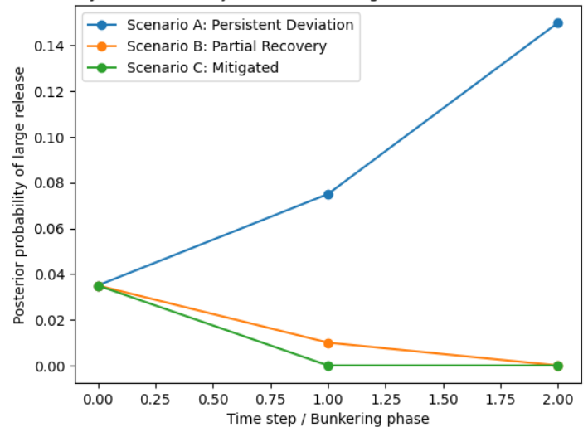
Figure 2: Dynamic evolution of the posterior probability Pr of a large ammonia release.
In this regard, the results should be interpreted as decision-support indicators providing information on evolving system vulnerability and early warning insight to operators and safety managers. The framework supports proactive safety management by enabling real-time risk monitoring, identification of leading indicators, and evaluation of mitigation strategies. Upon proper refinement and field validation with large dataset, it may provide a reproducible methodology for proactive safety assurance and resilience enhancement in fuel maritime operations and offer actionable insights for improving bunkering procedures, vessel design, and safety-management strategies, as the sector transitions to ammonia-powered propulsion. Validation requires operational data on process dynamics, barrier states, and precursors; frequency: post-operation or event-driven updates. Challenges include limited ammonia-specific data, multi-source integration, and real-time computation.
  - Conclusions
The Systemic – Bayesian approach represents a paradigm shift from static, compliance-driven risk assessment toward adaptive, learning-oriented safety management that could be supported by dynamic Bayesian network based on accident data, expert estimates, and stakeholder input. Good management will reduce risk by effective safety measures, such as training operators, safety zones, PPE, and emergency readiness While model development requires interdisciplinary expertise and data integration, the benefits in terms of insight, transparency, and proactive control are substantial. Challenges include data availability, model validation, and organizational acceptance, which must be addressed through iterative development and stakeholder engagement. The framework explicitly models barrier degradation mechanisms such as wear, corrosion, sensor drift, procedural drift, and cognitive fatigue. Dependencies between barriers are represented, allowing common-cause and cascading failures to emerge naturally from the model. The model identifies high-risk precursor conditions that precede barrier failure or LOC, supporting early intervention. Field validation via experimental trials in a pilot urban port is planned to expand operational datasets and refine parameters. When coupled with real-time data streams, the framework can function as a dynamic risk monitor, offering regulators and designers a structured means to evaluate compliance, robustness and resilience of ammonia bunkering systems.
Acknowledgments
The authors gratefully acknowledge funding by INAIL within the framework of the call BRIC/2025/ID21 (Project
GENIUS (GEstioNe Intelligente di nUove modalità Sostenibili di produzione, trasporto, distribuzione e utilizzo dell'idrogeno).
References
Duong P.A., Ryu B.R., Jung J., Kang H., 2023, Comparative analysis on vapor cloud dispersion between LNG/liquid NH₃ leakage on the ship to ship bunkering for establishing safety zones, J Loss Prev Process Ind, 85, 105167.
Fabiano B., Pettinato M., Currò F. Reverberi A.P., 2025, Safety concerns for ammonia as a green energy vector and the role of spray curtains for Its accidental release mitigation, Energies, 18, 3412.
Hwang I., Jeong B., Zhou P., Wang H., Mesbahi A., Jang H., Mujeeb-Ahmed M.P., Yang I., 2026, A PIDA-PDA integrated parametric approach for establishing safety zone for hydrogen, ammonia and LNG bunkering operations, Int J Hydrogen Energy, 206, 153212.
Ibrahim A., Paskevicius M., Buckley C.E., 2023, Chemical compression and transport of hydrogen using sodium borohydride, Sustain Energy Fuels, 7,1196-1203.
IMO, 2015, IGF, International code of safety for ships using gases or other low-flashpoint fuels, IMO ed.
IMO, 2025, Alternative Fuels Safety, Interim guidelines for the safety of ships using ammonia as fuel, IMO ed.
Jiang S., Laursen R., Semiz O., Skinitis P., 2024, Safety of ammonia for use in ships – part 2: Safety assessment and reliability analysis of main component, equipment, sub-systems and systems rev. 4. EMSA.
Khan R.U., Yin J., Wang S., Hussein M., Alqurashi Y., Al Sulaie S., 2025a, A system theoretic quantitative risk assessment for port ammonia bunkering operations, Int J Hydrogen Energy,172, 151217.
Khan R.U., Yin J., Wang X., 2025b, Fuzzy Bayesian risk assessment of system and component failures in ammonia bunkering. Ocean Engineering 338, 121960.
Kojima Y., 2024, Safety of ammonia as a hydrogen energy carrier. Int J Hydrogen Energy 50, 732–739.
Leveson N., 2004, A new accident model for engineering safer systems. Saf Sci 42, 237–270.
Pasman H, Sripaul E, Khan F, Fabiano B., 2024, Energy transition technology comes with new process safety challenges and risks - What does it mean? Process Saf Prog, 43(2), 226‐230
The Associated Press. 2025, U.S. News 6 November 2025: https://apnews.com/ accessed 15.05.2026.
Vairo T., Gualeni P., Reverberi A.P., Fabiano B., 2021. Resilience dynamic assessment based on precursor events: application to ship LNG bunkering operations. Sustainability 13, 6836.
Vairo T., Guarino S., Benvenuto A., Fabiano B., Setola R., 2026a, Emergent risks in complex systems: A Bayesian perspective on uncertainty and prediction, Reliab Eng Syst Saf, 270, 112129.
Vairo T., Pasman H.J., Magrì S., Pettinato M., Fabiano B., 2026b, From data to decision. AI powered proactive safety of landslide Natech events, Process Safety and Environmental Protection, 206, 108123.
Vairo T., Pettinato M., Reverberi A.P., Milazzo M.F., Fabiano, B., 2023, An approach towards the implementation of a reliable resilience model based on machine learning, Process Saf Environ Protection, 172, 632–641.
Wang Z., Tkalich P., Low B., Liu M., Christy E., Chen M., 2025, Numerical environmental impact assessment of accidental release of ammonia during bunkering in the Singapore Strait, J Hazard Mater ,494, 138677.
Yang M., Lam J.S.L., 2024, Risk assessment of ammonia bunkering operations: Perspectives on different release scales, J Hazard Mater, 468, 133757.

